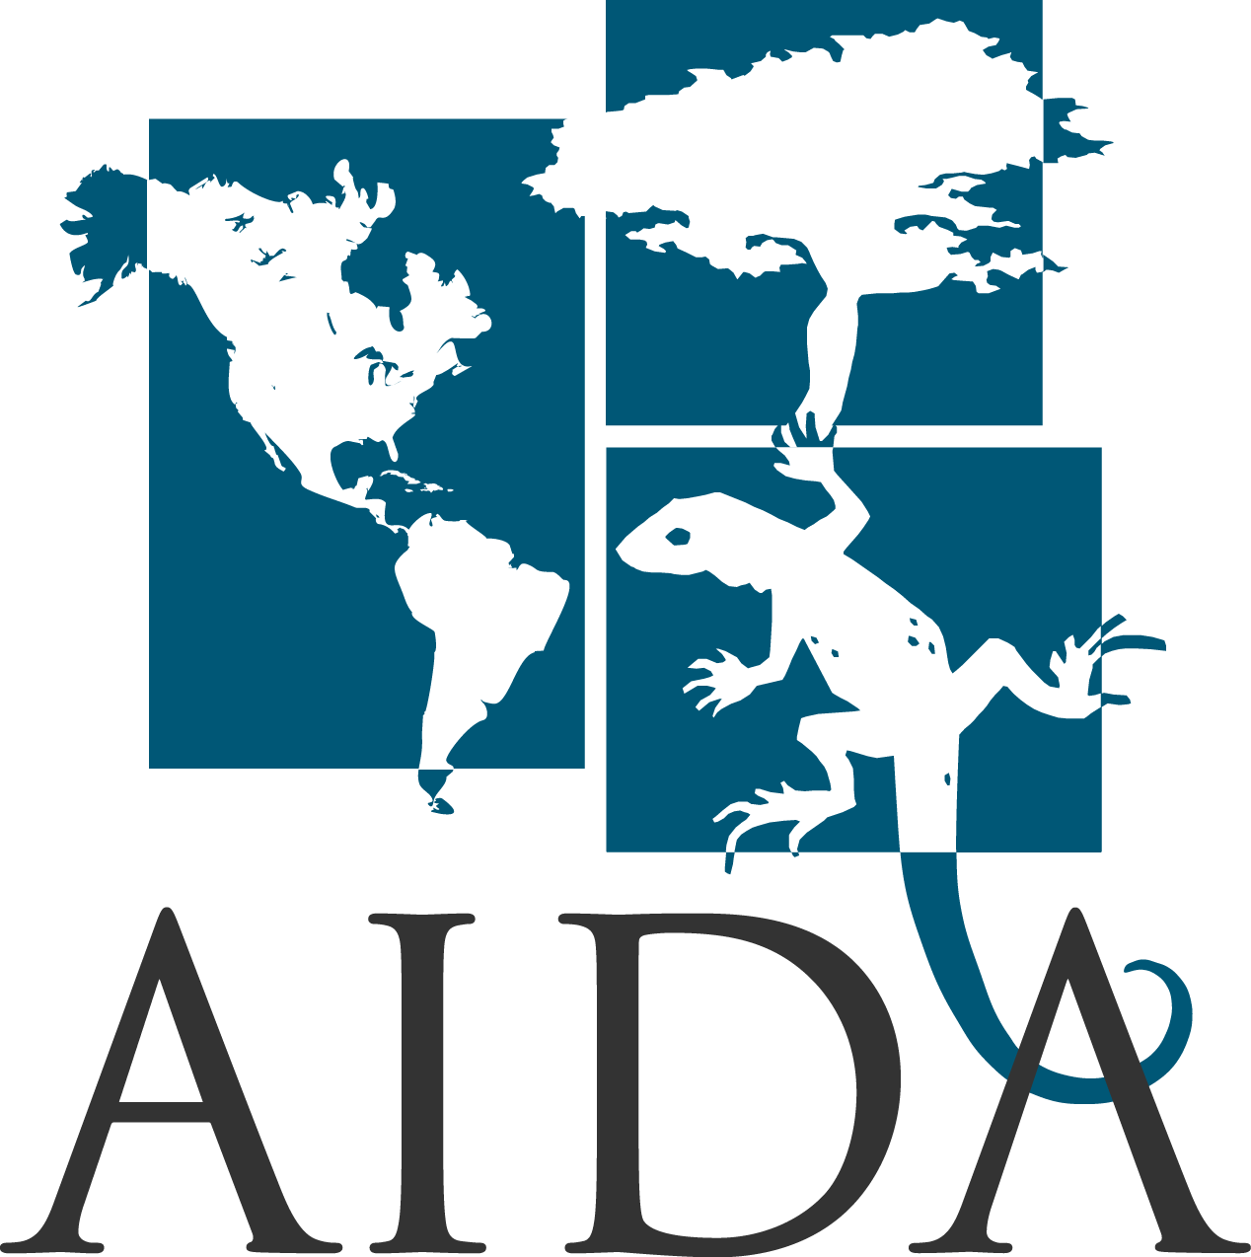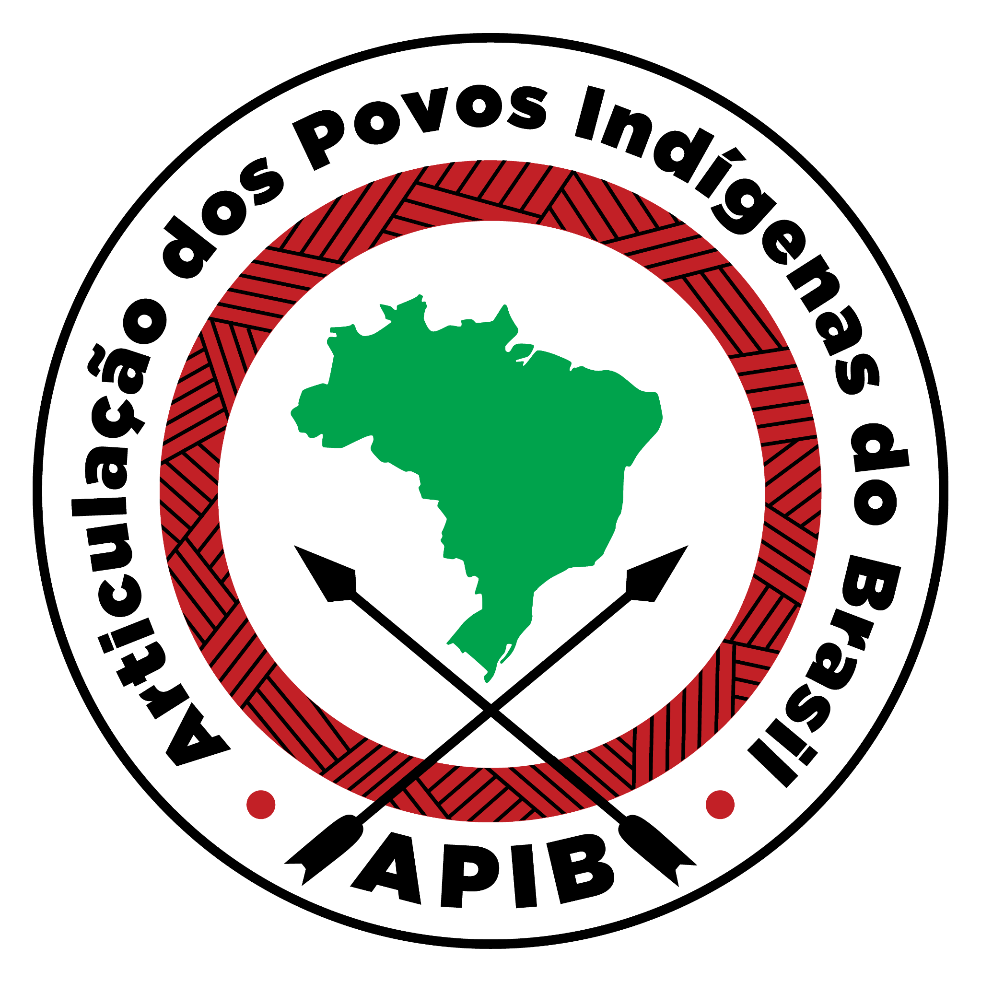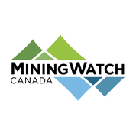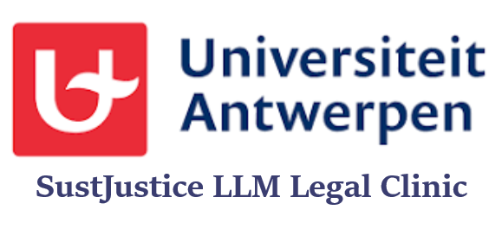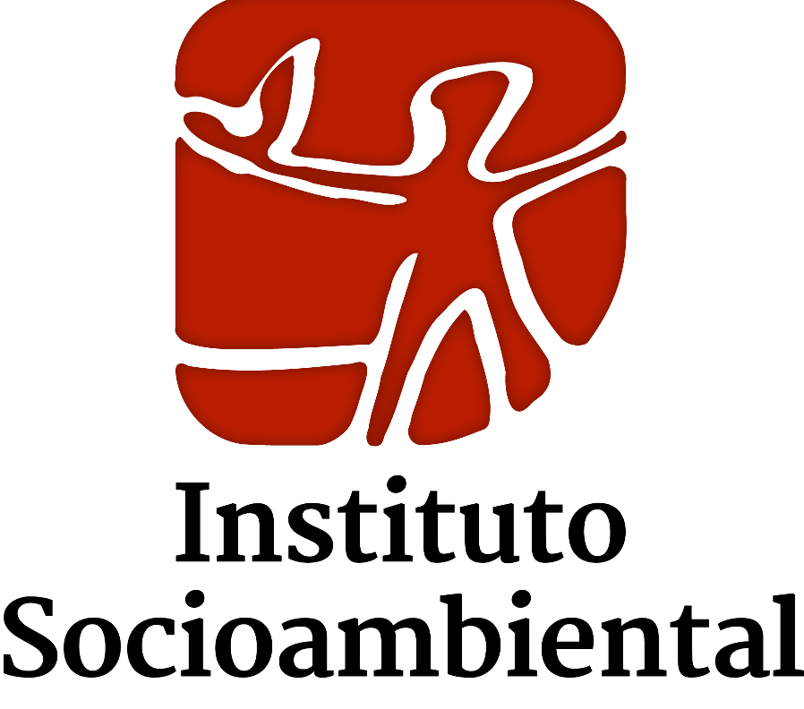


Secretariat of the Committee on Economic, Social and Cultural Rights
Office of the United Nations High Commissioner for Human Rights
Palais Wilson – 52, rue des Pâquis CH-1201
Geneva (Switzerland)
Re: Independent information on Brazil, submitted for consideration by the 74th Session of the Committee on Economic, Social and Cultural Rights (25 September - 13 October 2023)

1. INTRODUCTION
- This report is presented by the Volta Grande do Xingu Alliance, a network of the civil society organizations signing this document, whose purpose is to collaborate in defending the Volta Grande do Xingu region, in Pará, as a living and healthy socio-environmental territory, through respect and appreciation of the self-determination of its Indigenous Peoples, traditional communities and rural settlers.
- The purpose of this report is to present independent information to support the Committee's concluding observations on Brazil's compliance with the rights enshrined in the ICESCR and the measures related to the topic of Business and Human Rights, specifically in relation to the Committee's request to the country in paragraph 3.b) of the List of Issues Concerning Brazil (E/C.12/BRA/Q/3). To this end, the report will use the cases of Belo Monte and Belo Sun, in the state of Pará, as examples, and will point out: 1) the human rights violations committed by Brazil in these cases; 2) the failure of the Brazilian state to adopt effective measures to demand due diligence from companies in terms of human rights. Finally, the report will list recommendations for the Committee to consider when dealing with these issues in its observations on Brazil.

2. CASES
- The Belo Monte Hydroelectric Power Plant (HPP) is a large-scale infrastructure project for generating electricity, built under the federal government's Growth Acceleration Program (PAC), which began in 2011 with an installation license. In 2015, with Operating License No. 1317/2015, the Xingu River was definitively dammed and, shortly afterwards, in 2016, by detouring water from the Volta Grande do Xingu and by filling the reservoirs, the plant began operations. The Belo Monte HPP's operating license expired on November 21, 2021, when the Brazilian Institute for the Environment and Renewable Natural Resources (IBAMA), the licensing body for the project, determined that the company had not fulfilled its legal obligations to obtain its renewal. The renewal process is currently underway and the damage continues to accumulate without proper reparations for harmful impacts on affected traditional populations.
- Less than 50 km from the Belo Monte Hydroelectric Power Plant is the epicenter of interest of the Volta Grande Gold Project, operated by the Canadian mining company Belo Sun Mining Ltda, whose aim is to become the largest open-pit gold mine in the country. It should be noted that the main municipality affected is Senador José Porfírio (PA), as well as Altamira (PA) and Vitória do Xingu (PA). A series of studies and technical opinions indicate that the main populations affected are at least 25 riverside communities (from Ilha da Fazenda) who live on the banks of the Xingu, the Yudjá, Juruna, Xipaya, Xikrin, Curucaia and Arara Indigenous Peoples of the Volta Grande do Xingu, resettled groups (in Vila Galo, Ouro Verde and Ressaca) and peasant communities (more than 500 agrarian reform families). Currently, the project's Installation License (the second phase of the three-phase environmental licensing process) has been suspended, as judicial bodies have determined numerous violations and deficiencies in the consultation process with Indigenous Peoples and traditional potentially affected riverside communities. In addition, jurisdiction over the environmental licensing process is also under review as to whether it is state or federal.

3. HUMAN RIGHTS VIOLATIONS
3.1. Right to self-determination (Article 1)
- All peoples have the right to self-determination, as expressed in Article 1 of the International Covenant on ESCR. An Urgent Appeal sent to several UN Special Procedures Rapporteurs expressed some concerns at the countless verbal and physical abuses suffered by human rights defenders and organizations because of their opposition to the Volta Grande do Xingu Project.
- Belo Monte and Belo Sun have a direct impact on the Indigenous lands of “Arara da Volta Grande” and Paquiçamba, that were recognized as traditional territories by the Brazilian state in 2015 and 1991, and that have populations of 143 and 94 Indigenous people. Along the Xingu River, hundreds of Indigenous people who have not had their lands recognized and titled but are impacted by the project were marginalized, whether in the process of remediation of damage already caused by the Belo Monte, or in the process of recognizing the impacts and violations of the Free Prior and Informed consultation in the context of the Belo Sun mining project.

3.2. Right to adequate housing (Article 11)
- The right to adequate housing recognizes the need for everyone to have access to a sustainable standard of living for themselves and their families, which includes having a safe, quiet, and dignified place to live. In addition, forced displacement represent one of the most serious impacts in cases of installation and operation of infrastructure projects, according to the United Nations. Indigenous people and traditional communities are disproportionately affected by mega projects of infrastructure, as they lose their livelihoods, which are crucial to guaranteeing their way of life, culture, and identity, when they move.
- Between 2011 and 2015, due to the construction of Belo Monte and the subsequent filling of the reservoir, around 40,000 people were displaced from their homes and territories in the municipalities of Altamira and Vitória do Xingu (Pará). In 2017, the National Human Rights Council (CNDH) published a report that expresses that the communities were not properly informed about their displacement, did not participate in consultation processes on the of their new homes, which is manifested in the lack of recognition of "double dwelling" (in the city and in the “beiradão”/riverbank), the presence of more than one family nucleus per dwelling and the failure to guarantee access to the Xingu River.
- Nonetheless, studies have shown how the violation of the right to adequate housing, especially of river dwellers displaced to so-called collective urban resettlements, causes direct damage to their traditional ways of life and exposes them to cycles of violence (sexual, gender, physical and mental). There are indications that the resettlement has increased the harms of access to food (especially access to fish, vegetables), health (lack of and distance from services), access to drinking water and, especially, to the ways of life of traditional groups who depend on the river for their livelihoods. Even those who have returned to the "beiradão" (i.e. on the banks of the Xingu River) and the Arara, who had to move within their territory, denounced Norte Energia construction of houses that violate the principle of cultural appropriateness, which is crucial for the effective guarantee of the right to adequate housing, since they were built using materials other than those traditionally used and in locations far from the river.
- Furthermore, with the installation of the Volta Grande do Xingu mining project by Belo Sun S.A., whose operating license is suspended, it is estimated that at least three riverside communities - Ressaca, Galo and Ouro Verde - would be completely displaced. – and the the settlement Ressaca would be shrunk. Ressaca is one of the disputed territories in which Belo Sun seeks to operate.n 2016 the company signed an agreement with the Agrarian Reform Institute (INCRA) to illegally allow legal possession of public land. Currently, more than 500 families live in PA Ressaca and there are a series of accusations of the illegal purchase of plots of land, with at least 3,945 thousand hectares acquired irregularly by the mining company, facts which are set out in the Public Civil Action filed by the Federal Public Defender's Office and the Pará State Public Defender's Office.. Residents of the villages of Ressaca, Galo and Ouro Verde reported pressure and threats of eviction by the company .

3.3. Right to food, water, and a clean and healthy environment (Article 11)
- The traditional communities who live in the Volta Grande region depend directly on the Xingu River to guarantee their subsistence and therefore their right to healthy food and clean, safe drinking water , which are closely connected.
- In 2016, the Arara denounced the loss of more than sixteen tons of fish due to the installation of the Belo Monte dam and stressed the gradual loss of their way of life, ancestral knowledge and means of subsistence (especially considering traditional fishing). Along these lines, the Juruna also reported to have found thousands of dead fish with dried roe in their bellies, a fact that can be explained by the stress suffered by the fauna due to changes in water flows.
- Moreover, o The Federal Prosecutor (MPF) denounced that the construction of the hydroelectric dam caused the death of more than 85,000 fish - the equivalent of almost 30 tons - between 2015 and 2019, which would have been destroyed as they approached the Belo Monte turbines. This evidence, together with studies carried out by specialists, corroborates the report by fishermen who claim that the "fish are few and far between". Of the 198 riverine families involuntarily displaced by the Belo Monte HPP, living in the Curica-Costa Júnior, Paratizinho-Palhal and Trindade-Paratizão territories, 80% said they fished at least once a week in the river before the construction of the project and only 12%, in 2019, claimed that they continued with the practice.
- The Belo Monte operation has diverted at least 85% of the water from the Volta Grande (of the Xingu River) into a huge artificial canal. In addition, the drastic reduction in water flow overloads water supplies for drinking and irrigation, depletes healthy levels of fish and other aquatic life and blocks species migration regions.
- This serious situation of violation of the right to drinking water and healthy food, both structural elements of the traditional ways of life of riverside communities and Indigenous Peoples, which will be to be aggravated by the Volta Grande do Xingu Project that would lead to a socio-environmental 'collapse' in the region, due to the intensification of the impacts and violations already caused by the Belo Monte HPP. It should be noted that with this mining project, there is a substantial risk of toxic tailings being spilled into the Xingu River. This is because the project plans to recycle cyanide leachate, a substance used to separate gold, which could result in wastewater highly enriched with toxic elements such as arsenic and mercury. The result, the analysis of which is not included in the company’s official documents, could be the release of a mixture of wastewater that is highly toxic to aquatic organisms into the Xingu River in the event of a dam break (28% chance, according to experts) or leak, directly affecting the Arara Indigenous land of Volta Grande, with impacts that would extend over more than 98 km in length. The mining company never provided, in any currently public document, measures to mitigate the risk of groundwater contamination by toxic minerals.

3.4. Right to mental and physicil health (Article 12)
- In a report, the Psychology Institute of the University of São Paulo said that "absolutely everyone in the region reported cases of expulsion" from their homes, and that, according to her, they used these words to describe depression, various states of sadness, difficulty getting out of bed because they were discouraged. In addition, there are reports that the health of riverine communities is supported by the indiscreet use of medicines that put other aspects of the health of these groups at risk.
- Furthermore, the increase in violence, conflicts and tensions surrounding both developments have led to a sense of insecurity, "terror" and fear on the part of the river dwellers, who live with symptoms of anxiety and depression. It is important to point out that in mid-2011, when the Belo Monte was being built, the explosions from the construction site were heard and felt by all the communities living in the region. Belo Sun's exploitation foresees explosions 24 hours a day to extract gold from the earth, for at least 12 years. Such action generates not only new trauma, potential destruction of the environment, noise pollution that affects the mental health of the residents and the very structure of the houses, generating more fear and insecurity about the future.
- Barriers to access of health facilities, which are located only in the municipality of Altamira, also represent one of the main violations suffered daily by traditional and Indigenous communities.

4. THE BRAZILIAN STATE HAS NOT ADOPTED EFFECTIVE MEASURES TO OBLIGE COMPANIES IN ITS TERRITORY TO ACT WITH DUE DILIGENCE IN TERMS OF HUMAN RIGHTS IN THEIR ACTIVITIES, NOR HAS IT HELD THEM ACCOUNTABLE FOR THE VIOLATION OF THESE RIGHTS (PARAGRAPH 3.B OF THE LIST OF ISSUES CONCERNING BRAZIL)

- In this section we will show that the Brazilian state has failed to comply with its human rights due diligence obligations towards companies in terms of the authorization, installation and operation of the Belo Monte hydroelectric plant and the implementation of the Volta Grande mining project, carried out by the Canadian company Belo Sun LTDA. Both projects are located around the Xingu River, in the Volta Grande do Xingu region, in the state of Pará, one of the largest protected areas in the Brazilian Amazon.
- Brazil's actions in the case of Belo Monte are marked by its neglect of its obligations to supervise and oversee Norte Energia S.A., the company responsible for the hydroelectric plant. From 2009 to the present day, the Brazilian state has authorized the operation of the Belo Monte hydroelectric plant without complying with the legal socio-environmental commitments established between the company and the supervisory environmental agency - the Brazilian Institute for the Environment and Renewable Natural Resources (IBAMA). In an analysis of Technical Opinion No. 12868864/2022, issued by IBAMA in June 2022, of the 47 conditioning measures imposed on the company to ensure environmental sustainability and protection of the peoples and communities affected by the plant, 34 are still pending compliance at the Operating License No. 1317/2015 stage.
- Contrary to the precautionary principle and the special duty to prevent significant damage to the environment when it threatens the rights and way of life of traditional peoples, the Brazilian state authorized and issued all the licenses granted for the implementation, installation and operation of Belo Monte: 1) Preliminary License No. 342/2010; 2) Partial Installation License No. 770/2011; 3) Installation License No. 795/2011; 4) Operating License No. 1317/2015.
- In addition to failing to adequately supervise the licensing process for the project, Brazil also failed to fulfill its obligation to ensure and monitor that the company responsible adopted all appropriate measures to mitigate the damage. As pointed out in the previous section, the implementation and operation of the power plant has seriously jeopardized the human rights of the traditional peoples of the Xingu, especially the indigenous and riverine peoples, due to the reduction in the natural flow of the Xingu River at the VGX, caused by the detour of the natural course of the river for the operation of the Belo Monte HPP.
- The main measure proposed by the company to mitigate the impacts of damming the Xingu River was called the Consensus Hydrograph, a hydrological scheme that stipulated the minimum quantities of water that would need to pass through the Volta Grande do Xingu to guarantee the socio-environmental sustainability of the region. When the Preliminary License for the Belo Monte HPP was issued, the application of a hydrograph that guaranteed a flow of water to the region was established as a condition by IBAMA to authorize its implementation and operation.
- However, the quantities of water foreseen in this hydrograph presented by the company and authorized by the Brazilian state, prioritized the generation of energy from the hydroelectric plant over maintaining the minimum conditions of survival for the peoples and communities that depend on the Xingu River. IBAMA concluded in Technical Opinion No. 114/2009 that "there is no clarity as to the maintenance of minimum conditions for the reproduction and feeding of ichthyofauna, chelonians and aquatic birds, as well as whether the system will withstand this level of stress in the medium and long term". In addition, he said that the hydrograph presented would not constitute an adequate mitigation measure because the species of fauna and flora would be exposed to serious risks of extinction, as well as the physical and cultural permanence of the indigenous and riverside peoples of the region would be threatened because they depend on the maintenance of environmental conditions and navigability.
- Contrary to technical opinions, the National Water Agency (ANA) granted water availability for the stretch of the Xingu River for the construction site of the main Belo Monte dam. In this resolution, the Agency itself pointed out that the concession did not attest to the environmental integrity of the Volta Grande do Xingu for the execution of the Project. The decision demonstrates how the Brazilian state has neglected its duty of prevention even in the face of evidence of a serious risk of socio-environmental damage. Thus, the Consensus Hydrograph was maintained as a valid mitigation measure for the License that authorized the execution of the Belo Monte HPP (Preliminary License n. 342/2010).
- In 2019, when the plant was already operating at full capacity, the National Foundation for Indigenous Peoples (FUNAI) reaffirmed the unfeasibility of the hydrograph for Volta Grande in Technical Opinion No. 21/2019. The MPF also issued Technical Opinion No. 1930/2019, prepared by its expert body on the Consensus Hydrograph, in which it attested that it was unfeasible. In 2021, IBAMA also issued a new Opinion (No. 17/2021), in which it assessed that the complementary business studies presented were "inadequate" and recommended that they be returned for immediate readjustment.
- However, the environmental agency itself did not follow the evidence found by its technical staff and just eight days after issuing Opinion No. 17/2021, it signed Environmental Commitment Agreement (TCA) No. 3/2021 with the energy company. In this, it was agreed that the Belo Monte HPP could return to operating with the Hydrograph throughout 2021, provided that it complied with the counterpart of applying R$157 million in "additional mitigation and compensation measures" for the Volta Grande do Xingu.
- IBAMA's abrupt reversal of the decision to implement the Provisional Hydrograph occurred without the scientific and technical basis necessary to establish with certainty what the impacts would be resulting from the application of the Consensus Hydrograph. Once again, the state failed in its duties of supervision, inspection and mitigation. The TCA agreement was an inadequate and ineffective mechanism, as it did not consider that the financial allocation for additional mitigation measures would be insufficient in the face of the maintenance of the Hydrograph, which is the main source of the damage caused.
- The Consensus Hydrograph has also been challenged in court. On March 25, 2021, the MPF filed a Public Civil Action with the Federal Court in Altamira, based on the precautionary principle and the worsening of the environmental impacts already identified. The Federal Court ruled on June 17, 2021, in which it pointed out that the energy company had been in arrears with its commitment to present studies indicating technical and environmental feasibility since 2019, exposing the irresponsibility of the Brazilian state with its duties to protect, guarantee, prevent and supervise. In the same decision, it ordered the application of a flow regime sufficient to guarantee the effective ethno-environmental sustainability of the Volta Grande do Xingu, which was not being met by the hydrograph presented.
- It was only on May 3, 2022 that the company presented new information on the Complementary Studies. However, according to the independent Technical Opinion drawn up in August 2022 by a network of researchers in response to the MPF's request, there is still a lack of transparency regarding the data and methods presented. According to the opinion, there is not a single quantitative analysis of the ecological relationships in the aquatic and alluvial ecosystems in the Volta Grande do Xingu, not even correlational analyses, which allow an objective assessment of the socio-environmental risks arising from the application of the Consensus Hydrograph. Therefore, there is no proof of the viability of this hydrograph throughout the environmental licensing process and yet the Brazilian state continues to apply it.
- Brazil also failed to guarantee adequate consultation and participation of the indigenous and riverine peoples affected by the change in the river's course during the implementation of the Hydrograph. One of the recommendations of the MPF's Opinion is precisely the urgency of evaluating with all the actors involved ways of avoiding abrupt variations in the river's flow over days and weeks, as has been reported by riverine and indigenous residents.
- Faced with the worsening socio-environmental impacts and the maintenance by the Brazilian state of an ineffective mitigation measure to define the appropriate water level for the region, riverside and indigenous peoples have come together with a group of researchers and specialists to carry out their own independent monitoring. Since 2014, indigenous and non-indigenous researchers have been closely monitoring the occurrence of the fish reproduction phenomenon (known as ¨piracemas¨) and the impacts caused by the change in water flow. The Independent Territorial Environmental Monitoring (MATI-VGX) is carried out in partnership with the Socio-Environmental Institute and various researchers who are part of the network called Observatório da Volta Grande do Xingu.
- Based on the collection and processing of data over 8 years, meetings and public hearings with national bodies, MATI-VGX presented a proposal for redefining water volumes entitled "Hidrograma Piracema". This proposal was filed by the MPF in the process of renewing Belo Monte's Operating License, for analysis by IBAMA, which has yet to make a decision. To date, there is not enough water to ensure the survival and exercise of human rights of the Xingu peoples, which shows that Brazil has not adopted adequate and effective measures to demand compliance with due diligence parameters from the company responsible.
- The Brazilian state has limited itself to demanding that the energy company pay fines and compensation to the affected peoples. Throughout the environmental licensing process for Belo Monte, the serious socio-environmental damage and human rights violations caused did not prevent the licenses from being authorized, nor did they hold the company responsible for the violations.
- With regard to the legal actions related to the hydrograph, the use of the Suspension of Security appeal represents an obstacle to the realization of the judicial decisions that demand the alteration of the hydrograph and aim to contain the impacts caused by the HPP, being an issue of obstruction in access to justice. This issue was even addressed during the 150th regular session of the Inter-American Commission on Human Rights and demonstrates that the judicial remedies used have not been effective in demanding compliance with measures and obligations by the company.
- The pattern of non-compliance by the Brazilian state with due diligence measures in the activities of companies is also evident in the case of the mining project of the Canadian company Belo Sun, developed in the same region impacted by the Belo Monte HPP, the Volta Grande do Xingu.
- In this case, Brazil failed from the outset in its duty to regulate and supervise the project. The Belo Sun project had an administrative process marked by irregularities. Initially proposed in 2012 with the presentation of the Environmental Impact Assessment (EIA) and the Environmental Impact Report (RIMA), the project was the subject of eight lawsuits in various instances questioning the impacts of the work, the various breaches of environmental obligations and the threats and intimidation of local communities. More than 800,000 signatories have also signed a petition against the mining company.
- In 2016, the National Human Rights Council (CNDH) recommended that Belo Sun suspend land acquisition in the Volta Grande region, due to the social and economic impacts generated by this process. Complaints received about violations of the rights of the region's residents were collected at public hearings held by the councilors with the residents of Vila Ressaca and Ilha da Fazenda.
- According to the Pará State Ombudsman's Office, Belo Sun forged illegal contracts to buy and sell land in Vila Ressaca, Vila Ouro Verde and Vila do Galo to guarantee its presence in the territory. After these irregular contracts were signed, the local families were constantly monitored by the security company hired by Belo Sun.
- At the international level, the United Nations Working Group on Business and Human Rights signaled in its report on its visit to Brazil that the case was worrying. The UN Special Rapporteur on the rights of indigenous peoples, for her part, recommended that the Belo Sun project "should not be considered if there is potential for similar impacts [to Belo Monte] or if the affected indigenous peoples have not expressed their free, prior and informed consent following participatory social, environmental and human rights impact studies and good faith consultations”.
- Despite the irregularities and complaints, the Brazilian state authorized the Installation License (LI) for Belo Sun in 2017, which has been suspended by a court decision in two cases. In the first, judged in 2017, the TRF-1 decided to suspend the permit on the grounds that there had been no prior, free and informed consultation with the indigenous people affected, in accordance with ILO Convention 169. However, in a decision handed down on May 22, 2022 by the Altamira-PA Agrarian Court, it was again decided to suspend the license due to the lack of public participation and consultation with the riverside populations..
- The suspension of the license does not guarantee that the process will not be resumed and the Brazilian state has demonstrated its consent to the implementation of the project in other actions. Through the Ministry of Mines and Energy, Brazil qualified and enabled the Volta Grande Project under the policy of accelerating environmental licensing and designed to boost strategic projects. In this way, Belo Sun was selected to be one of the six projects that are part of the Policy to Support the Environmental Licensing of Investment Projects for the Production of Strategic Minerals - Pro-Strategic Minerals, created and qualified in the Investment Partnership Program by Decree 10,657/2021.
- In addition to the aforementioned recognition at the national level, in April 2022, the Federal Mining Agency (ANM) appointed a former director of Belo Sun to the position of regional manager of the National Mining Agency in Pará, responsible for the Volta Grande region.
- A company financial report reveals that R$4.5 million was spent on the purchase ofland rights in Brazil. These transactions were later made official through an agreement signed in 2021 with the National Institute for Colonization and Agrarian Reform (INCRA). The agreement provides for the opening up of almost 2,400 hectares of public land reserved for agrarian reform for mining by Belo Sun in exchange for a farm in Mato Grosso, trucks, laptops, GPS systems and a percentage of the mining profits. The legality of the agreement is being challenged in court due to the illegality of the land transfer contracts.
- In addition to failing to monitor the company's irregularities, the Brazilian state also failed to adequately regulate the environmental impact studies presented by the company. Expert analysis of the EIA/RIMA presented by the company indicates that the project is flawed, with a high risk of impacts and irreversible degradation.
- According to Biviany Rojas, "in 2015, Belo Sun complemented its research into mining resources in the region and confirmed that the size of the deposit is almost ten times larger than that identified at the beginning. This information, however, was never officially submitted to the environmental agency in Pará. If it were, the project would have to be re-evaluated, which would delay the implementation schedule promised to investors and would mean restarting the environmental licensing process".
- There is also a complete omission on the part of the company to present impact studies on indigenous communities living outside the demarcated indigenous lands (desaldeados). The failure to include these communities in the licensing process results in the lack of a specific impact assessment of the project on the indigenous component, as well as a violation of the right to prior, free and informed consultation. The sentence handed down by the TRF1 recognized the impacts on indigenous peoples and traditional communities, ordering a specific study and prior consultation with all affected peoples, including the displaced.
- The project also excluded other neighboring peoples who requested to be included in the licensing process, but were denied because they were more than 10km from the project, which, according to FUNAI, would not generate the presumption of impacts from the project.
- This restrictive interpretation by FUNAI and the EIAs presented by the company do not take into account the extent of the synergistic and cumulative impacts between the Belo Sun and Belo Monte projects. It ignores the technical analyses that indicate the seriousness of the impacts of the use of cyanide or the collapse of the dam - which would flood 41km along the river, which exceeds the 10km limit indicated by FUNAI. It also violates the environmental principles of prevention and precaution, since it refutes the possibility of impacts on this indigenous people and their territory, as well as seeking to remove from the state the power to order further studies to verify and assess the real impacts. The decision was the subject of a Recommendation by the Pará Public Defender's Office.
- FUNAI also failed to ensure that the consultation and participation of the affected peoples was carried out properly and safely during the presentation of the EIAs. The indigenous body proposed holding face-to-face or videoconference meetings between the indigenous people and the company so that it could present the Indigenous Component Studies of the Environmental Impact Studies (EIA-CI) on February 26, 2020, during the COVID-19 pandemic and before the peoples were vaccinated. In view of the violations of the Juruna People's Consultation Protocol and considering the seriousness of the COVID-19 pandemic, the DPU issued Recommendation No. 4302188 , recommending that FUNAI should refrain from authorizing, promoting, articulating and/or participating in meetings for the presentation and discussion of EIA-CIs and that, once health security conditions have been re-established, it should adopt all the necessary measures to ensure that the rules of free, prior and informed consultation are observed. SESAI also made a similar statement on March 12, 2021, by means of an official letter.
- These facts demonstrate the failure of the state to exercise its powers, as well as the lack of supervision and the validation of illegal acts, legitimizing the actions carried out by the company in the Volta Grande region. The new and unforeseen impacts of Belo Monte make the Volta Grande Project environmentally risky. This is an unbearable pressure on ecosystems, and therefore on the livelihoods of communities in the region. Authorizing the implementation of a mining project in a region already impacted by Belo Monte violates the state's obligations of prevention and precaution.

5. RECOMENDATIONS
- We present the following recommendations to the ESCR Committee in order to assist it in drafting its concluding observations to the Brazilian State at the 74th Session:
- Regarding the case of Belo Monte:
- In order to guarantee access to water and food security, as well as to comply with the human rights due diligence standards, the Brazilian State should:
1. Completely suspend any application of the so-called "Consensus Hydrograph" as it violates the access to water of hundreds of families and has culminated in several other economical social, cultural an environmental rights violations and threats;
2. Implement a Hydrograph based on scientific data and the traditional knowledge of the indigenous peoples and riverside communities, which allocates a sufficient volume of water in an ecologically appropriate format to guarantee the sustainability of the region and the human rights of the indigenous peoples and riverside communities. To this end, it must take into account the ecological criteria established in the MPF's Technical Opinion No. 02/2022, of August 11, 2022, and in the Piracema Hydrograph, which have already been presented to the Brazilian State.
3. Establish an independent technical committee with the aim of periodically evaluating and monitoring the established water flows and the other mitigation and compensation measures that are adopted. The State should also ensure that this participatory body is made up of both state entities (such as Ibama, FUNAI, ANA, MPF) and specialist civil society organizations working in the region, especially the indigenous peoples and riverside communities affected.
- In relation to the Belo Sun case:
- In order to guarantee the protection of ESCE rights of indigenous and traditional peoples in the Volta Grande do Xingu, the Committee is asked to recommend that the Brazilian State:
1. Prevent, mitigate and suspend the negative impacts on the human rights of the communities affected by the insertion of a gold mine in their territory. In particular, that the State adequately identifies and monitors the impacts generated by Belo Sun's project on the human rights of the affected populations before the start of the project's implementation, especially considering that the Installation License is being questioned.
2. Act accordingly to its environmental and human rights obligations, especially considering the precaution principle and prevention duty, and take reasonable measures that will prevent any further human rights violations, particularly in view of the real and immediate risk of cyanide use and the dam collapse. The state must inform the local population about potential risks related to the mining company's operations and take measures to ensure coordination and cooperation between the different administrative authorities to guarantee that the risks they become aware of do not reach a level of severity that endangers human lives.
4. Take the necessary measures to ensure that all people, groups and communities potentially affected by the project have access to the necessary bodies to participate effectively in the decision-making process.
5. With regard to the current licensing process, assess the need to modify its terms in order to preserve the physical and cultural survival of the affected communities and indigenous peoples.

VOLTA GRANDE DO XINGU ALLIANCE

Association of Brazil’s Indigenous Peoples (Articulação dos Povos Indígenas do Brasil - APIB)
Interamerican Association for the Defense of the Environment (AIDA)
Anistia Internacional Brasil
Amazon Watch

Earthworks
Instituto Socioambiental (ISA)
Mining Watch Canadá
Movimento Xingu Vivo Para Sempre
International Rivers
Law and Development Research Group and Institute of Development Policy of the University of Antwerp

An operating license contains a series of conditions, preparation programs and impact mitigation criteria that the company should meet. Adequate resettlement for riverside populations was included among those conditions. Brasil, MINISTÉRIO DO MEIO AMBIENTE. Licença de Operação nº 1317/2015. 24 de novembro de 2015. Disponível em: https://ox.socioambiental.org/sites/default/files/ficha-tecnica/node/202/edit/2018-06/LO_Belo_Monte.pdf
IBAMA. Administrative Process n. 02001.004247/2022-34. 2022.
The Volta Grande Gold Project represents a small part of the of the interests of Belo Sun in the region, which include 4 mineral concession requests, 58 exploration licenses and 16 extensions for operating licenses, covering an area of 172 thousand hectares in the “Três Palmeiras” Green Belt.
Associação dos Povos Indígenas do Brasil (2023) Relatório Mina de Sangue APIB.pdf (apiboficial.org);
If decided in federal court, the entire state licensing process could be declared null and void.
Enacted by the Brazilian State by Decree 591 from June 6, 1992. Available at: https://www.planalto.gov.br/ccivil_03/decreto/1990-1994/d0591.htm
Apelo urgente à Organização das Nações Unidas. Available at: Publico - Ameaça a Defensores e Defensoras - Xingu Vivo e Cooperativa dos Garimpeiros.pdf (socioambiental.org)
Instituto Socioambiental. Available at: https://terrasindigenas.org.br/pt-br/terras-indigenas/4302
Instituto Socioambiental. Available at: https://terrasindigenas.org.br/pt-br/terras-indigenas/3788
The term is defined by the CESCR as "the permanent or temporary removal against their will of individuals, families and communities from the homes and/or land they occupy, without the provision of and access to appropriate forms of legal or other protection".
Resolution 1993/77 of the UN Commission on Human Rights.
Magalhães, S. B., & Cunha, M. C. D. (2017). A expulsão de ribeirinhos em Belo Monte. Relatório da Sociedade Brasileira para o Progresso da Ciência (SBPC). São Paulo: SBPC. Available at: https://shorturl.at/juLN0
National Human Rights Council (CNDH). Report on the rights of the population affected by the implementation of the Belo Monte hydroelectric plant and the Belo Sun mining company, December/2017. Available at: https://xinguvivo.org.br/wp-content/uploads/2018/08/RelatriodeBeloMonteBeloSun_CNDH.pdf
The Belo Monte HPP's Basic Environmental Plan describes a series of resettlement programs to assist the displaced population. The largest of these is the Collective Urban Resettlement (RUC), five neighborhoods that have been built in Altamira (Laranjeiras, Jatobá, Água Azul, São Joaquim and Casa Nova). In addition, two collective rural resettlements were set up, as well as an option via compensation, in which it was up to the displaced families to buy a new home. Available at:https://www.norteenergiasa.com.br/pt-br/socioambiental/licenciamento-ambiental/programa-de-realocacao-e-reassentamento-prr
De Francesco, A., Brito, L. L., Corrêa, M. G., Lopes, R. D. B., & Scabin, F. (2021). Direito à moradia adequada e a UHE Belo Monte: o caso dos ribeirinhos no beiradão. Available at: https://bibliotecadigital.fgv.br/dspace/handle/10438/31323
Idem.
AIDA (2016). Belo Monte: the river may be dying but the search for justice never wills | Interamerican Association for Environmental Defense (AIDA) (aida-americas.org)
Associação dos Povos Indígenas do Brasil (2023) Relatório Mina de Sangue APIB.pdf (apiboficial.org); Associação dos Povos Indígenas do Brasil (2023) Réplica a Belo Sun. Disponível em: Réplica da APIB à resposta da Belo Sun sobre o relatório “Mina de Sangue” - Business & Human Rights Resource Centre (business-humanrights.org)
Created on September 3, 1999, the Ressaca settlement is located partly in the municipality of Altamira and partly in Senador José Porfírio and is surrounded by other land reform projects such as Assurini, located in Volta Grande; Itapuama; Itatá; and Laranjal. The settlement was the result of the allocation of part of Gleba Ituna, collected and registered by the union in 1982. In its creation document, the PA's area was estimated at 30,200 hectares and with the capacity to settle 340 families. Currently, after the site was adapted to the Rural Environmental Registry (CAR), the PA's area registered by INCRA is now 26.1 hectares, 4.1 thousand hectares smaller.
Amazon Watch. (2022). Risks on investing in Belo Sun. Available at: https://amazonwatch.org/assets/files/2022-12-risks-of-investing-in-belo-sun-pt.pdf
Estadão Incra abre assentamentos da reforma agrária para obras de transportes, energia e mineração - Estadão (estadao.com.br)
Brasil de Fato (2019) Instalação da Belo Sun, no Pará, é marcada por violações de direitos humanos (brasildefato.com.br)
"If installed, the Volta Grande Project will have an impact on Gleba Ituna, registered in the name of INCRA under number 23.073, book 2 AAT, folios 224, Municipality of Senador José Porfírio; and on the Ressaca Settlement Project, created through INCRA/SR (01) PA 67/99 of September 3, 1999, also in an area registered in the name of the municipality, under number 421, book 2-B, folios 228, District of Senador José Porfírio. Therefore, the entire overlapping area of the project is owned by INCRA". Defensoria Pública da União; Defensoria Pública do Estado do Pará. Ação Civil Pública 1000550-69.2022.4.01.3903, p. 14.
National Human Rights Council (CNDH). Report on the rights of the population affected by the implementation of the Belo Monte hydroelectric plant and the Belo Sun mining company, December/2017. Available at: https://xinguvivo.org.br/wp-content/uploads/2018/08/RelatriodeBeloMonteBeloSun_CNDH.pdf
Rede de Pesquisadores ISA, INPA, IGC USP e outros. Josiel Jacinto P. Juruna e outros pesquisadores locais da T.I Paquiçamba e comunidades ribeirinhas da VGX. Hidrograma Piracema: o Monitoramento Ambiental Territorial Independente da Volta Grande do Xingu (MATI-VGX) e os critérios ecossistêmicos para manutenção da vida. 2022. Santos, M. y Hernandez, F. (orgs), Painel de Especialistas: análise crítica do Estudo de Impacto Ambiental do Aproveitamento Hidrelétrico de Belo Monte (Belém: 29 de setembro de 2009), p. 45 [em diante: Painel de Especialistas]. Available at: http://philip.inpa.gov.br/publ_livres/Dossie/BM/Outros/Belo%20Monte%20painel%20especialistas.pdf.
AIDA (2016). Belo Monte: the river may be dying but the search for justice never will | Interamerican Association for Environmental Defense (AIDA) (aida-americas.org)
Instituto Socioambiental (2022). Disponível em: https://www.socioambiental.org/noticias-socioambientais/belo-monte-depois-de-peixes-sumirem-indigenas-e-ribeirinhos-elaboram
Federal Public Prosecutor's Office of Pará (2021). Criminal Investigation Procedure No. 1.23.003.000234/2019-95 Notice of Fact No. 1.16.000.002975/2019-75. Available at: https://www.mpf.mp.br/pa/sala-de-imprensa/documentos/2021/denuncia-234-2019-95.pdf
UOL (2023). Available at: https://www.uol.com.br/ecoa/colunas/noticias-da-floresta/2023/05/24/os-impactos-da-usina-de-belo-monte-sobre-os-peixes-do-rio-xingu.htm
De Francesco, A., Brito, L. L., Corrêa, M. G., Lopes, R. D. B., & Scabin, F. (2021). Direito à moradia adequada e a UHE Belo Monte: o caso dos ribeirinhos no beiradão. Available at: https://bibliotecadigital.fgv.br/dspace/handle/10438/31323
Amazon Watch (2022). Projeto maciço da Mina de Ouro Belo Sun bloqueado no Brasil | Amazon Watch
Amazon Watch. (2022). Risks on investing in Belo Sun. Available at: https://amazonwatch.org/assets/files/2022-12-risks-of-investing-in-belo-sun-pt.pdf. To better understand the location of the mining company and its proximity to the river, we recommend watching the following video:Alerta: Mineradora pode acabar de ver com a Volta Grande do Xingu do Instituto Socioambiental. Disponível em: <https://www.youtube.com/watch?v=LQTZO128ifk>
Evaluation of the Tailings Dam, Cyanide Use and Water Consumption at the Proposed Volta Grande Gold Project, Pará, Northern Brazil Steven H. Emerman, Ph.D., Malach Consulting, Available at: https://xinguvivo.org.br/wp-content/uploads/2020/06/Volta_Grande_Report_Emerman.pdf
AINDA (2020). Observações aos documentos associados ao licenciamento ambiental do projeto de mineração de ouro Volta Grande, Pará, Brasil. Available at: https://app.box.com/s/8qtfe5pvxyxwctkgm8jetdoxl9lf4acf
Instituto de Psicologia da Universidade de São Paulo (2017) Eu+1: Uma jornada de saúde mental na Amazônia - YouTube
Available at: https://amazoniareal.com.br/ribeirinhos-de-belo-monte/
Guarreschi, L. D. F. (2022). Da escuta à escrita: casos clínicos dos refugiados da barragem de Belo Monte (Doctoral dissertation, Universidade de São Paulo).
Between 2000 and 2015, the homicide rate increased by 1,110%, in the new neighbourhoods that met Norte Energia's demands. In 2019, there was a massacre in the local prison, with sixteen men butchered and 41 charred. Criminal factions have also migrated to Altamira, along with drug trafficking.
Instituto Socioambiental. Disponível em: https://terrasindigenas.org.br/pt-br/noticia/207052
De Francesco, A., Brito, L. L., Corrêa, M. G., Lopes, R. D. B., & Scabin, F. (2021). Direito à moradia adequada e a UHE Belo Monte: o caso dos ribeirinhos no beiradão. Disponível em: https://bibliotecadigital.fgv.br/dspace/handle/10438/31323
VILLAS-BÔAS, André J. A (Org.). De olho na bacia do Xingu. Instituto Socioambiental (ISA). São Paulo, 2012, p. 4. Available at: https://acervo.socioambiental.org/acervo/publicacoes-isa/de-olho-na-bacia-do-xingu.
The law establishes that IBAMA should only grant or maintain authorization for the project if all the conditions established between the company and the environmental inspection body are met, in order to guarantee the environmental and social sustainability of the project. CONAMA. CONAMA Resolution no. 237, published on December 22, 1997, art. 8. Available at: http://conama.mma.gov.br/?option=com_sisconama&task=arquivo.download&id=237
Brazil, IBAMA. Environmental Licensing Board. Technical Opinion on LO follow-up No. 12868864/2022-Cohid/CGTef/Dilic. June 23, 2022. Available at: https://ox.socioambiental.org/sites/default/files/ficha-tecnica//node/202/edit/2023-04/Parece_LO_2022-1.pdf
Brazil, MINISTRY OF THE ENVIRONMENT. Preliminary License No. 342/2010. February 1, 2010. Available at: https://ox.socioambiental.org/sites/default/files/ficha-tecnica/node/202/edit/2018-06/LP_Belo_Monte.pdf. Partial Installation License No. 770/2011. January 26, 2011. Installation License No. 795/2011. June 1, 2011. Available at: https://www2.mppa.mp.br/sistemas/gcsubsites/upload/41/Licenca%20de%20instalacao%20n_%20795_2015%20-%20Belo%20Monte(1).pdf. Operating License No. 1317/2015. November 24, 2015. Available at: https://ox.socioambiental.org/sites/default/files/ficha-tecnica/node/202/edit/2018-06/LO_Belo_Monte.pdf
Amazon Watch (2022). Projeto maciço da Mina de Ouro Belo Sun bloqueado no Brasil | Amazon Watch.
Brazil, Federal Public Prosecutor's Office (MPF). Expert report 2021. Case No. 1000684-33.2021.4.01.3903, p. 57-62. MINISTRY OF THE ENVIRONMENT. Preliminary License No. 342/2010. February 1, 2010. Disponível em: https://s3-sa-east-1.amazonaws.com/tcm-assets/norteenergia-pt-br/Licen%C3%A7a%20Pr%C3%A9via%20342-2010%20%20UHE%20Belo%20Monte.pdf.
Brazil, MINISTRY OF THE ENVIRONMENT. Preliminary License No. 342/2010. February 1, 2010. Available at: https://ox.socioambiental.org/sites/default/files/ficha-tecnica/node/202/edit/2018-06/LP_Belo_Monte.pdf.
IBAMA. Technical opinion no. 114/2009 - COHID/CGENE/DILIC/Ibama, of 23/11/2009, Subject: Belo Monte HPP. Ref: Technical analysis of the Environmental Impact Study for the Belo Monte Hydroelectric Project, process no. 02001.001848/2006-75. Brasília, DF, Brazil. 2009, p. 344-345.
Idem.
Brazil, MINISTRY OF THE ENVIRONMENT, ANA. Resolution No. 740, of October 6, 2009.
Brazil, MINISTRY OF THE ENVIRONMENT. Preliminary License No. 342/2010. February 1, 2010. Available at: https://ox.socioambiental.org/sites/default/files/ficha-tecnica/node/202/edit/2018-06/LP_Belo_Monte.pdf.
FUNAI. Technical Opinion no. 21/2019. MPF. Opinion. Appeal. Process. n. 1032546-28.2020.4.01.0000, of October 14, 2020. https://site-antigo.socioambiental.org/sites/blog.socioambiental.org/files/nsa/arquivos/parecer_mpf.pdf.
MPF. Technical Opinion no. 1930/2019. Opinion. p.13.
IBAMA. Technical Opinion No. 17/2021/COHID/CGTEC/DILIC, of February 1, 2021.
IBAMA. Environmental Commitment Agreement - TCA No. 3/2021-GABIN. Disponível em: https://ep00.epimg.net/descargables/2021/02/18/2a771023c405c99315ade721ef56557a.pdf.
FEDERAL JUSTICE OF THE 1ST REGION. Public Civil Action. Case no. 1000684-33.2021.4.01.3903: Federal Civil and Criminal Court of the Altamira-PA SSJ. 17/06/2021. Available at: https://www.mpf.mp.br/pa/sala-de-imprensa/documentos/2021/decisao_tutela_provisoria_hidrograma_hidreletrica_belo_monte_junho_2021.pdf.
FEDERAL JUSTICE OF THE 1ST REGION. Public Civil Action. Case no. 1000684-33.2021.4.01.3903: Federal Civil and Criminal Court of the Altamira-PA SSJ. 17/06/2021. Available at: https://www.mpf.mp.br/pa/sala-de-imprensa/documentos/2021/decisao_tutela_provisoria_hidrograma_hidreletrica_belo_monte_junho_2021.pdf.
Idem.
MPF. Technical Opinion 02/2022, of August 11, 2022. Ref: Letter No. 1473/2022/GABPRM1-TSCS-MPF. Administrative Procedure for the Protection of Unavailable Individual Interests No. 1.23.003.000279/2021-84.
Idem.
Idem.
Rede de Pesquisadores ISA, INPA, IGC USP e outros. Josiel Jacinto P. Juruna e outros pesquisadores locais da T.I Paquiçamba e comunidades ribeirinhas da VGX. Hidrograma Piracema: o Monitoramento Ambiental Territorial Independente da Volta Grande do Xingu (MATI-VGX) e os critérios ecossistêmicos para manutenção da vida. 2022. Santos, M. y Hernandez, F. (orgs), p.2.
They make up the Volta Grande do Xingu Observatory: Alberto Akama (Museu Paraense Emílio Goeldi); André Sawakuchi (Instituto Geociências, Universidade de São Paulo); Biviany Garzon Rojas (Instituto Socioambiental); Camila Ribas (Instituto Nacional de Pesquisas da Amazônia); Carolina Piwowarczy Reis (Instituto Socioambiental); Cristiane Carneiro (Universidade Federal do Pará); Eder Milene de Paula (Universidade Federal do Pará); Ingo Wahnfried (Universidade Federal do Amazonas); Jandessa Silva de Jesus (Instituto Geociências, Universidade de São Paulo); Janice Mariel-Cunha (Universidade Federal do Pará); Jansen Zuanon (Instituto Nacional de Pesquisas da Amazônia); Marcelo Camargo (Universidade de São Paulo); Marcus Wittmann (Museu Nacional, Universidade Federal do Rio de Janeiro); Markssuel Medeiros (Secretaria Municipal de Agricultura, Pesca e Abastecimento de Anapu); Vitor Cerqueira (Secretaria Municipal de Gestão do Meio Ambiente e Turismo); Priscilla Lopes (Universidade Federal do Rio Grande do Norte); Tânia Stolze Lima (Universidade Federal Fluminense); Thais Mantovanelli (Instituto Socioambiental).
IBAMA. Administrative Process n. 02001.004247/2022-34. 2022.
JUSTICE GLOBAL et al. Situation of the right to access to justice and the suspension of judicial decisions (ação de suspensão de segurança) in Brazil. Report presented during the 150th regular session of the Inter-American Commission on Human Rights. Washington, DC, March 28, 2014. Available at: http://global.org.br/wp-content/uploads/2016/03/Acesso----Justica-no-Brasil-Suspens--o-de-Seguran--a-Final.pdf
Belo Sun case table. Available at:<https://docs.google.com/spreadsheets/d/1P4dXLzCpCPFNGlSarPFlkwDEygx3h4mgJmwVo_26sew/edit#gid=0>
Map of conflicts over environmental injustice and health in Brazil, 26/06/2018. "On April 20, 2018, after a campaign mobilized by Avaaz, which gathered around 800,000 signatures, one of the main shareholders, the Canadian company Agnico Eagle Mines, sold its 19.14% stake in the enterprise. The company, which has been operating since 1953, is considered one of the most consistent companies in Canada's gold mining sector. In 2016, it invested 15 million Canadian dollars in Belo Sun". PA - Volta Grande-Belo Sun mining project threatens ways of life and survival of indigenous peoples, riverine communities and other traditional communities. Available at: <http://mapadeconflitos.ensp.fiocruz.br/conflito/pa-projeto-de-mineracao-volta-grande-belo-sun-ameaca-modos-de-vida-e-sobrevivencia-de-povos-indigenas-ribeirinhos-e-outras-comunidades-tradicionais/#cronolo
Ministry of Human Rights and Citizenship. National Human Rights Council (CNDH) requests suspension of license granted to Belo Sun Mineração project, 04/02/2017. Available at: <https://www.gov.br/mdh/pt-br/assuntos/noticias/2018/novembro/conselho-nacional-dos-direitos-humanos-cndh-requer-suspensao-de-licenca-concedida-a-projeto-da-belo-sun-mineracao>
CAMPELO, Lilian. National Human Rights Council warns of Belo Monte violations, 2016. Available at: <https://www.brasildefato.com.br/2016/10/17/conselho-nacional-de-direitos-humanos-alerta-sobre-violacoes-de-belo-monte/>
Initial Petition Public Civil Action No. 0005149-44.2013.814.0005. Available at: <https://drive.google.com/file/d/1-x4geRjpqVay7zHWuKCIuI4qznzG4RZt/view>
SILVA, ELELISON. Dossiê: expropriação e eco biopolítica e mineração no projeto de assentamento Ressaca, Volta Grande do rio Xingu. Projeto Nova Cartografia Social da Amazonia. Programa de pós-graduação em cartografia social e política da Amazônia. Belém, 2022. Pag. 43.
Statement at the end of the visit to Brazil by the United Nations Working Group on Business and Human Rights. Available at: https://www.ohchr.org/Documents/Issues/Business/WG_Visits/20151215_EOM_statement_Brazil_portuguese.pdf
Human Rights Council. Report of the mission to Brazil of the Special Rapporteur on the rights of indigenous peoples. A/HRC/33/42/Add.1. 8 de agosto de 2016.
Civil Appeal n. 0002505-70.2013.4.01.3903, filed by Belo Sun and the State of Pará seeking to reverse the first instance decision that declared the nullity of the preliminary license issued to the Volta Grande do Xingu Project. Available at:<http://observatorio.direitosocioambiental.org/wp-content/uploads/2022/08/APELACAO-CIVEL-N.-0002505-70.2013.4.01.3903.pdf>
Public Civil Action No. 0801861-11.2020.8.14.0005, brought by the Public Defender's Office of the State of Pará against the State of Pará and the Belo Sun company, which questions the lack of impact studies on the riverside territories of the Volta Grande do Xingu and the lack of prior consultation, in accordance with ILO Convention 169. Available at: <https://ox.socioambiental.org/sites/default/files/ficha-tecnica//node/218/edit/2020-08/DOC%2001-%20A%C3%87%C3%83O%20CIVIL%20P%C3%9ABLICA%20DPE%20X%20ESTADO%20DO%20PAR%C3%81%20-%20BELO%20SUN%20-%20RIBEIRINHOS%20VOLTA%20GRANDE%20XINGU-protocolado.pdf>
BELO SUN. Volta Grande Project qualifies for the Pro-Strategic Minerals Policy. Available at: https://blogprojetovoltagrande.com.br/blog/detalhe/id/68
Brazil. Decree No. 10.657, of March 24, 2021. DOI, Published: 25/03/2021 | Issue: 57 | Section: 1 | Page: 3.
Mining Observatory. Former director of Belo Sun takes over as ANM manager in Pará. Available at: https://observatoriodamineracao.com.br/ex-diretor-da-belo-sun-assume-cargo-de-gerente-da-anm-no-para/
Map of conflicts, environmental injustice and health in Brazil, 2018. PA - Volta Grande-Belo Sun mining project threatens the way of life and survival of indigenous peoples, riverine communities and other traditional communities. Available at: <http://mapadeconflitos.ensp.fiocruz.br/conflito/pa-projeto-de-mineracao-volta-grande-belo-sun-ameaca-modos-de-vida-e-sobrevivencia-de-povos-indigenas-ribeirinhos-e-outras-comunidades-tradicionais/#cronologia>
BRAZIL, INCRA. Clarification note. Published on 09/12/2021. Updated on 31/10/2022. Available at: https://www.gov.br/incra/pt-br/assuntos/noticias/nota-de-esclarecimento.
Idem.
Lawsuit No. 1001161-22.2022.04.01.3903 brought by DPE/DPU against the illegality of contracts for the sale of land for agrarian resettlement between INCRA and Belo Sun. Available at: <https://docs.google.com/spreadsheets/d/1P4dXLzCpCPFNGlSarPFlkwDEygx3h4mgJmwVo_26sew/edit#gid=0>
Federal Public Prosecutor's Office. Memory of the Meeting of 09/12/2021 between the Federal Public Prosecutor's Office, the Federal Public Defender's Office, the National Institute for Colonization and Agrarian Reform (INCRA) and the company Belo Sun Mineradora Ltda. Available at:<https://www.mpf.mp.br/pa/sala-de-imprensa/documentos/2021/ata_reuniao_mpf_dpu_incra_belo_sun_09-12-2021.pdf>
Rede Xingu+. Mineração Volta Grande (Belo Sun). Available at:<: <https://xingumais.org.br/obra/mineracao-volta-grande-belo-sun>
ROJAS, Biviany. Para quem a Belo Sun mente? Disponível em: <https://diplomatique.org.br/para-quem-a-belo-sun-mente/>
Federal Public Prosecutor's Office. Court hears Belo Sun case on the 25th and MPF defends prior consultation and federal licensing of the project. Available at:<https://www.mpf.mp.br/regiao1/sala-de-imprensa/noticias-r1/tribunal-julga-caso-belo-sun-no-proximo-dia-25-e-mpf-defende-consulta-previa-e-licenciamento-federal-do-projeto>
Federal Public Prosecutor's Office. Civil Appeal 0002505-70.2013.4.01.3903, mentioned in the Federal Public Prosecutor's Office memorial. Available at: <https://www.mpf.mp.br/regiao1/sala-de-imprensa/docs/0002505-70-2013-4-01-3903-e-0001813-37-2014-4-01-3903_memoriais_belo_sun.pdf>
Ministry of Justice and Public Security, National Indian Foundation and General Coordination of Environmental Licensing. Letter No. 50/2021/CGLIC/DPDS/FUNAI, response to ABEX letter of January 2021, 18/01/2021. Available at: <https://ox.socioambiental.org/sites/default/files/ficha-tecnica//node/218/edit/2021-03/Of%C3%ADcio%2050%20CGLIC.pdf>
Federal Public Defender's Office. Recommendation No. 4679103 - DPU PA/GABDPC PA/DRDH AP PA, p. 05. Available at: < https://apublica.org/wp-content/uploads/2022/02/dpu-recomendacao-belo-sun-05out2021-o-lobby-de-um-general-de-brigada-em-favor-de-mineradoras-canadenses-na-amazonia.pdf>
Federal Public Defender's Office. RECOMMENDATION No. 4679103 - DPU PA/GABDPC PA/DRDH AP PA, p.08. Available at:< https://apublica.org/wp-content/uploads/2022/02/dpu-recomendacao-belo-sun-05out2021-o-lobby-de-um-general-de-brigada-em-favor-de-mineradoras-canadenses-na-amazonia.pdf>
Available at: <https://xingumais.org.br/obra/mineracao-volta-grande-belo-sun>
Federal Public Defender's Office. RECOMMENDATION No. 4302188 - DPU PA/GABDPC PA/DRDH AP PA, p.06. Available at: <https://ox.socioambiental.org/sites/default/files/ficha-tecnica//node/218/edit/2021-03/RECOMENDACAO_N__4302188_.pdf>
Ministry of Health, Special Secretariat for Indigenous Health, Legal Unit of the Special Secretariat for Indigenous Health to the President of the National Indian Foundation. Official letter no. 145/2021/SEDAI/NUJUR/SESAI/MS, 12/03/2021. Available at:<https://ox.socioambiental.org/sites/default/files/ficha-tecnica//node/218/edit/2021-03/OFICIO_145%20SESAI.pdf>

