THEMATIC REPORT ON FAMILY LAW AND
MUSLIM WOMEN’S RIGHTS IN

MAURITANIA

84th CEDAW Session

February 2023

SUBMITTED BY:
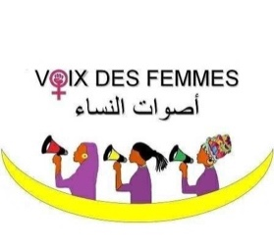  Voix des Femmes  Email: desfemmesvoix@gmail.com | ​​  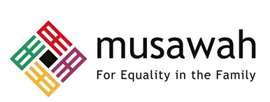  Musawah  15, Jalan Limau Purut, Bangsar Park, 59000 Kuala Lumpur, Malaysia  Tel: +603 2083 0202 Fax: +603 2202 0303  Email: musawah@musawah.org  Web: www.musawah.org

Table of Contents

A. INTRODUCTION 3
B. BACKGROUND, LEGAL FRAMEWORK AND CONTEXT 3
C. KEY ISSUES AND RECOMMENDATIONS 4
1. Spousal Inequality and Consent to Marriage 4
2. Child Marriage 6
3. Divorce and Matrimonial Property 7
4. Polygamy 9
5. Custody, Guardianship and Nationality 10

A. INTRODUCTION
Musawah, the global movement for equality and justice in the Muslim family, and Voix des Femmes (Women’s Voices), jointly submit this Thematic Report on concerns related to Muslim women’s legal equality in personal status matters, child marriage and nationality rights for consideration by the CEDAW Committee in its review of the Government of Mauritania, reporting before the 84th Session of the CEDAW Committee in February 2023. This is the CEDAW Committee’s fourth periodic engagement with Mauritania. Its last full review was in 2014. Mauritania acceded to CEDAW in May 2001 with reservations on Articles 13(a) and 16 of the Convention.
This report highlights key legal inequalities that Muslim women face in Mauritania in the personal status sphere and their resulting negative impact on women and girls, along with recommendations to address gaps. We encourage the Mauritanian government to continue its efforts in eliminating discrimination against women, particularly in the areas discussed subsequently.
We hope that the CEDAW Committee will utilize this report as a key resource during its constructive engagement with the State Party and use the recommendations to identify follow-up issues in its Concluding Observations.

B. BACKGROUND, LEGAL FRAMEWORK AND CONTEXT

The Islamic Republic of Mauritania is situated in northwest Africa on the Atlantic coast. Its population is 4.775 million (2.4 million males and 2.48 females), and average life expectancy is 63.24 years according to 2016 statistics. Mauritania is a republic, and the president is elected by popular vote for a term of five years. The official religion is Islam, as stated in the Constitution, and the Islamic Sharia is the foundation of legislations.

The Mauritanian Personal Status Code (PSC) is the main codified law that governs matters relating to marriage and family relations of the predominantly Muslim population in Mauritania. In the absence of codified laws that sufficiently address a particular matter of personal status of Muslims, generally, the rules of Maliki jurisprudence (fiqh) apply.

Mauritania has made a reservation on Article 16 of CEDAW relating to marriage and family relations as well as Article 13(1) regarding the right to family benefits, by stating that Mauritania “approves it in each and every one of its parts which are not contrary to Islamic Sharia and are in accordance with our Constitution.”

Women in Mauritania struggle against the traditional social system (patriarchy) and the Islamic system. Islamist movements started since the nineties, and succeeded in creating a parallel social system to the existing traditional one. The Mauritanian community is multiethnic and culturally diverse, where the social hierarchy enables privileged persons with power and authority to escape legal penalties for crimes like rape, assault, robbery. These persons are able to secure high profile jobs and better opportunities. Marginalized segments of society, however, including black people and other marginalized communities, are left vulnerable due to absence of protection and strong social networks.

Women in Mauritania acquire their value from their position in the social order in which they have grown up. Mauritanians are either Arab Berbers, or Maures, (Moors) who are further divided into Beydan (Bithan), or White Maure, and their former slaves, Haratine, who are black, and non-Arabs who are Wolof, Bambara and Fulas. It is noteworthy that Haratine are facing a complex situation being former slaves, and intersecting with other women in other forms of oppression. Therefore, Mauritania has women of varied and diverse backgrounds, each with her own story, due to which we cannot be all generalized as a part of a singular narrative, one law, one type of pain or suffering, one kind of violence, one expression, or one symbol. Nevertheless, women still intersect in their roles and the ruling system, and the patriarchal authority practiced on all.

Most anti-women practices are culturally and socially rooted, because the social system manipulates the religious and political systems to its advantage, and sometimes, seeks protection and justification of religion to legalize more restrictions on women. For example, in one of the ethnicities: women do not usually attend family gatherings; men are prioritized in education, and Female Genital Mutilation/Cutting (FGM) is a must-do tradition.

Another example of such manipulation of religion occurred during the drafting of a law on Gender Based Violence (GBV), presented by the government to the parliament in 2016. The parliament rejected the law on the grounds that it is against Sharia (Islamic law). In this regard, Voix des Femmes (Women’s Voices) conducted several interviews with parliament members on the issue, where most of them stated they had not read the draft and only voted against it because of the word “gender”, or after they listened to others’ comments. The same draft has been presented again to the Islamic Affairs Committee, affiliated with the parliament since 2017, that advised to modify the draft, put reservations on articles of marriage and divorce as being against Sharia (Islamic law), and recommended it to be presented again to the National Assembly for voting. However, it has not yet been passed.

Although the government mobilized to pass the draft to meet its international commitments and recurrent recommendations on violence, and made use of the official media to support it, the social system resulted in its failure, where the ‘Islamic’ and traditional systems became allies in countering the draft law.

C. KEY ISSUES AND RECOMMENDATIONS

Spousal Inequality and Consent to Marriage Articles 2, 16

Article 1 of the Constitution states that all citizens are equal before the law and prohibits discrimination on the several basis including sex. The Preamble to the Constitution declares the family as a basic unit of Islamic society. Article 16 of the Constitution obligates the State to protect the family.

However, despite the equality guarantee under Article 1 of the Constitution, the Personal Status Code provides for a marital framework based on ‘reciprocal’ or ‘complementary’ rights (as opposed to ‘equal’ rights) between the two spouses that in turn is based on the concept of male guardianship over women and children.

Article 56 of PSC provides that the husband is the head of the family while the wife is to assist him in the management of the family. This typically includes house chores and care for the children. In reality, this relationship of guardianship, granting the husband absolute authority within the family, often results in penalization for the wife for going out without a reason or not obeying her husband who is her ’guardian’.

The PSC also restricts the personal rights of married women in Mauritania as a result of the inherent concept of male guardianship over women and children that is built into the law. Article 57 of the Personal Status Law states that a married woman has the right to choose their own profession, “within the bounds permitted by Shari’ah” (without further explaining what these bounds are). This has opened the door for fatwas that discriminate against women, many fatwas have been issued to prohibit women from joining the army, judiciary or presidency. Moreover, Article 58 of the PSC gives a married woman the right to manage her property, but her husband can intervene if she decides to give away more than 1/3 of her assets. There are no corresponding restrictions on the personal rights of married husbands.

Regarding women’s consent to marriage, Article 5 of the PSC states that a woman cannot marry without the consent of her guardian (wali). Article 9 provides that a woman who has reached the age of majority may not be married without her consent and the consent of her guardian, but instead of requiring explicit verbal consent from the woman, it states that “the silence of a young girl equates consent.” If the guardian insists on withholding his consent without legitimate reason, the prospective bride may seek the authorisation of a judge to get married.

Culturally, the space women are given to choose their husbands is still limited to within the family or the tribe circles, but may extend to other tribes too. Women usually are not able to express the desire to get married to someone from outside those circles since it could likely lead to oppression from their families. Usually, once the family agrees, the guardian of the woman (typically the father) pursues all proceedings of the marriage.

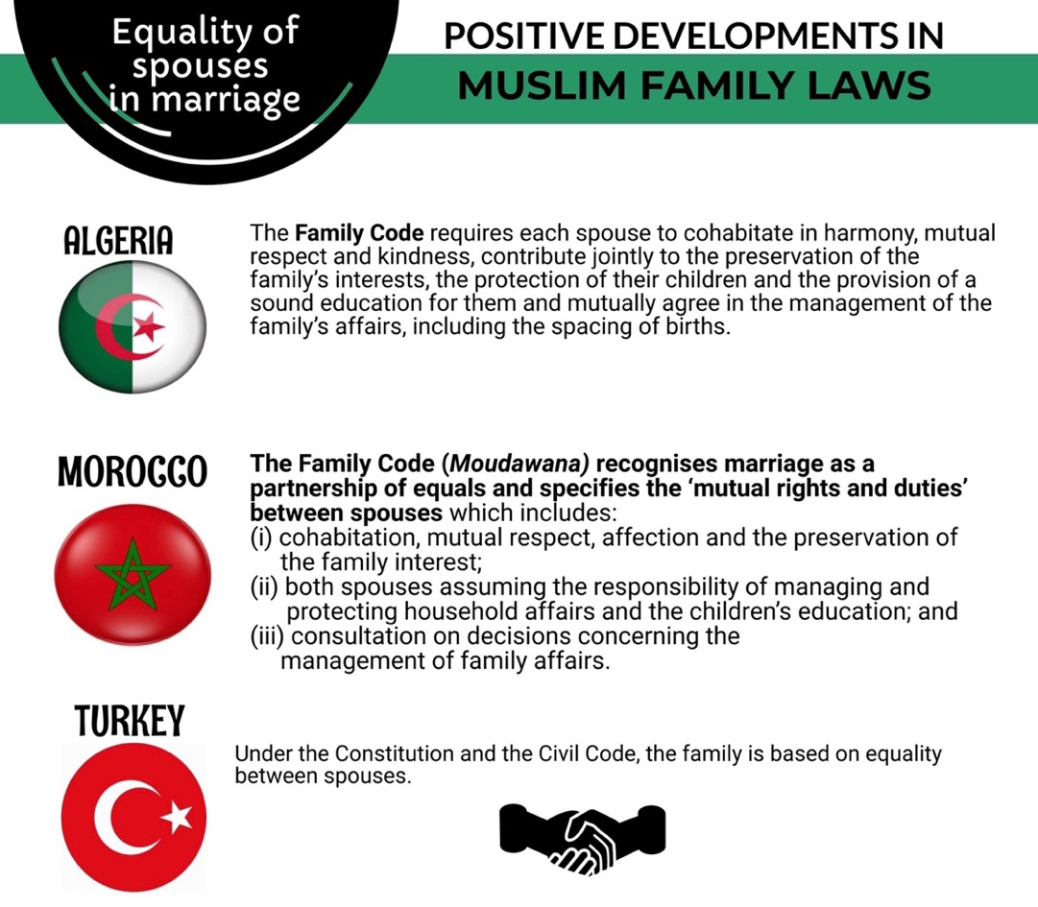
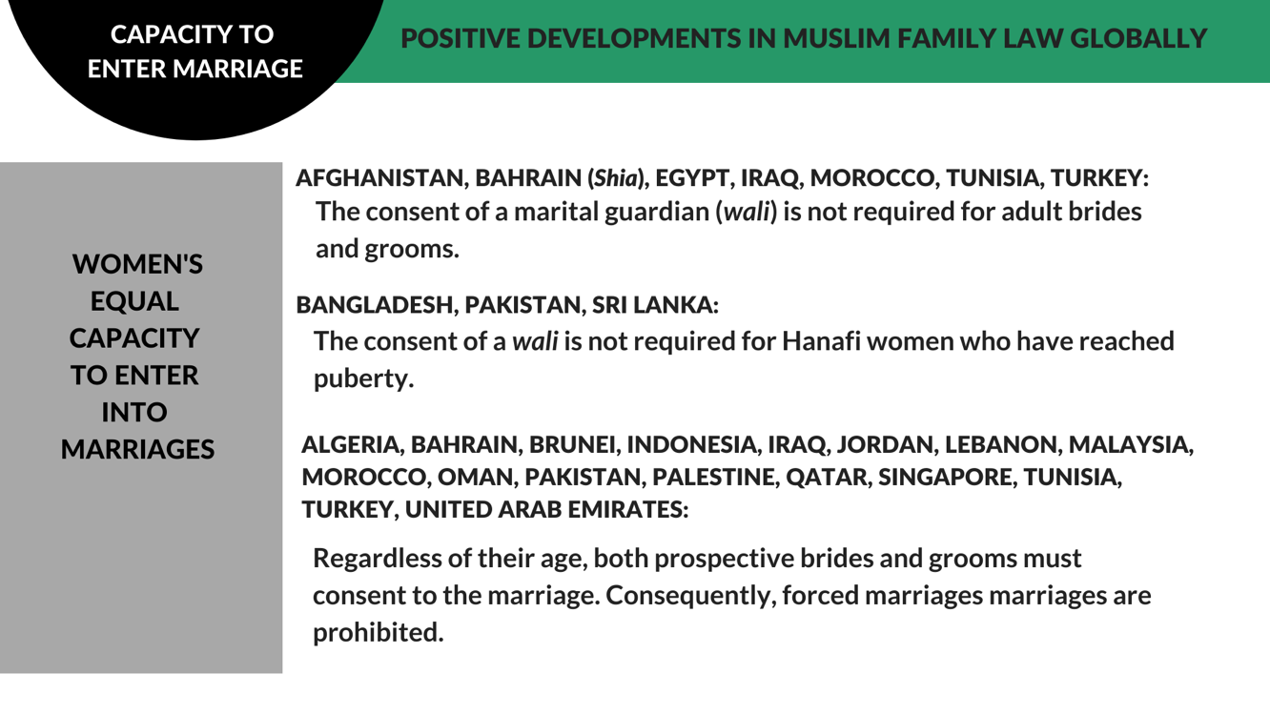

RECOMMENDATIONS
We recommend the CEDAW Committee urge the State party to:

- Amend the Personal Status Code and other relevant legislations, policies and development programs to grant and ensure spousal equality between men and women in all their spousal and personal rights in accordance with Mauritania’s international human rights obligations.

- Amend the Personal Status Code to give adult women equal rights to enter marriage on their own accord without requiring the permission of a male guardian or judge.

- Enforce penalties on those who conduct, enable, or fail to prevent forced marriages.

Child Marriage Article 16

According to Article 6 of the Personal Status Code, the minimum age of marriage is 18 for both men and women. However, Article 6 also permits a guardian to effect the marriage of a minor (or one who lacks capacity) under his guardianship, if he determines that it is in the minor’s interest. This is the legal gap that is used to continue the practice of child marriage in the country. Article 7 of the PSC provides that if a guardian authorised the marriage of the minor (or incapacitated person) purely in the interest of the guardian and not in the interest of the minor, the guardian would be subject to the penalties provided in the Penal Code.

Mauritania does not explicitly criminalize the practice of child marriage, which is especially common in rural and isolated places as well as in conservative families. Families get their girls married as children often to ‘preserve their honor’, due to fear of any illicit relationships. Child marriages often result in girls dropping out from schools, premature motherhood, and the pressure of shouldering complex social responsibilities.

Also, grown up women are sometimes forced to marry men they do not know to achieve specific social interests. This pressure can often be indirect, but many women end up acquiescing to the marriage only to escape the community’s negative outlook of women who do not get early wed. Women’s personality and presence in the public space is dependent on her marriage, so many women get married in order to have more freedom within the existing social system.

A woman cannot get married in case a man claimed he married her, even without any proof, till the marriage is over, according to Article 81 of the PSC.

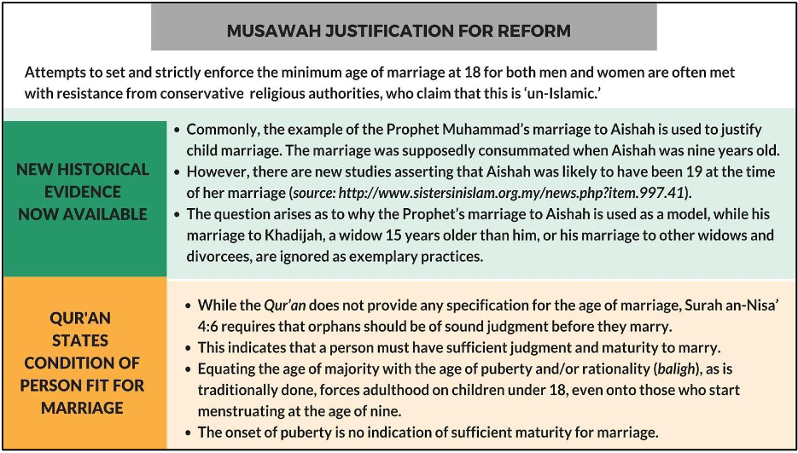

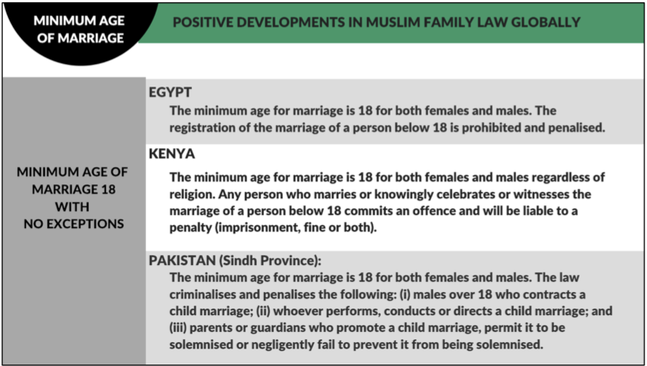

RECOMMENDATIONS
We recommend the CEDAW Committee urge the State party to:

- Repeal Article 5 of the PSC to prohibit child marriage of any person under the age of 18 without exception.

- Criminalize child marriage through specific legal provisions and deterrent penalties, and introduce penalties for guardians and marriage officiators who contract the marriage of a child.

- Provide targeted training programs to law enforcement officials, the judiciary, healthcare workers, and social workers to respond to reports of child marriage, and provide adequate support to victims.

Divorce and Matrimonial Property Article 16

The PSC provides for three different mechanisms for divorce: (i) unilateral repudiation (talāq); (ii) judicial divorce; and (iii) redemptive divorce (khul’). The marriage may also be annulled. In the case of unilateral repudiation (talaq), the divorce remains valid even if the wife objects or is not consulted for it.

The wife has the right to alimony during Iddat waiting period according to Article 84 of the PSC, but in reality, in many cases, husbands do not pay alimony. Women often decide to not resort to court proceedings for their alimony and their children’s maintenance due to prolonged legal proceedings. Moreover, women going to court are perceived as dissidents of the patriarchy. The amount for alimony is required to be identified according to the income of the husband and the status of the wife and children according to Article 144. However, the husbands often conceal their private properties and do not provide accurate details to escape paying family dues.

A woman may seek a redemptive divorce (khul’) by petitioning a court and pledging to pay compensation to the husband or forfeiting her financial rights. A judge can confirm khul’ but returns to a woman the amount she paid if he determines that she asked for khul’ due to harm or mistreatment by the husband. Following a divorce, the father is responsible for the financial maintenance of his children if the children do not have funds of their own.

In practice, divorce, similar to marriage, is restricted by traditions and customs, and in the case of divorce, the wife typically leaves the house immediately after divorce if the husband owns/rents the property, even if they have children. Consequently, the wife’s family often ends up having to bear the children’s expenses (including accommodation, education, health etc.) following the woman’s divorce.

There is no legal concept of matrimonial assets, but Article 73 provides that in the case of a dispute on assets and a lack of evidence regarding individual ownership, the wife’s claim shall be accepted with respect to assets ‘typically belonging to women’, without specifying what such goods include. Due to the lack of financial independence of most women in the country, they are left with very little financial stability upon divorce when they leave their husband’s house with their children, and become dependent on their own family for the financial support of themselves and their children.

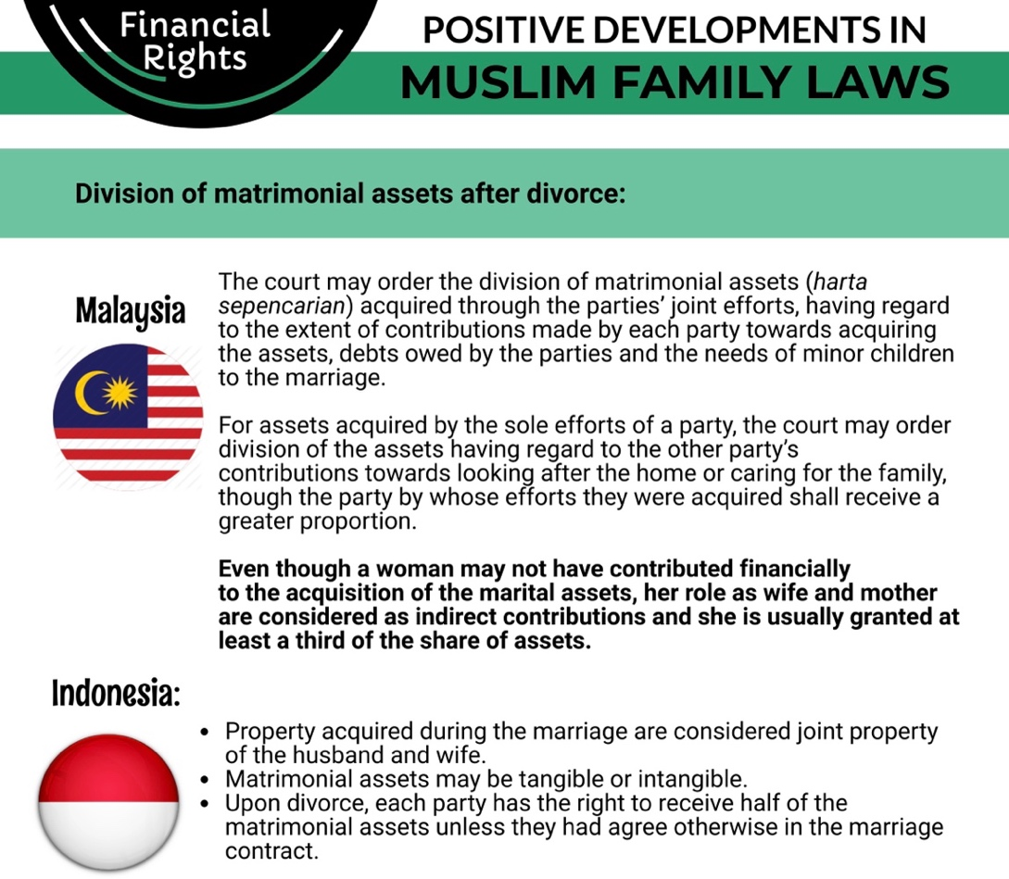

RECOMMENDATIONS
We recommend the CEDAW Committee urge the State party to:

- Amend the Personal Status Code to allow men and women the same right to divorce.

- Put in place deterrent penalties and legal provisions to ensure in practice the responsibility of financial maintenance of the husband’s children following divorce.

- Ensure an expedited adjudication/settlement of family dispute cases.

Polygamy Article 16

A Muslim man may marry up to four wives at one time. He is not required by law to seek the permission of the court or his existing wife or wives to enter into a polygamous marriage.

Articles 28 and 29 of the PSC provides that a woman may stipulate in the marriage contract that her husband cannot take another wife. If the husband breaches this term of the marriage contract, the woman has the right to petition for divorce and is entitled to the amount of mut’ah (compensation) that the judge determines.

However, polygamy in Mauritania is carried out mostly in secret, and the husbands do not document or register the marriage, leaving women in the marriage vulnerable and without any legal remedy available to them, since the previous wives are unable to prove the marriage, and the newer ones are unable to register their children with their husband. These women end up becoming single mothers with no legal recognition of their children, and are additionally at the risk of contracting sexually transmitted diseases from their husbands.

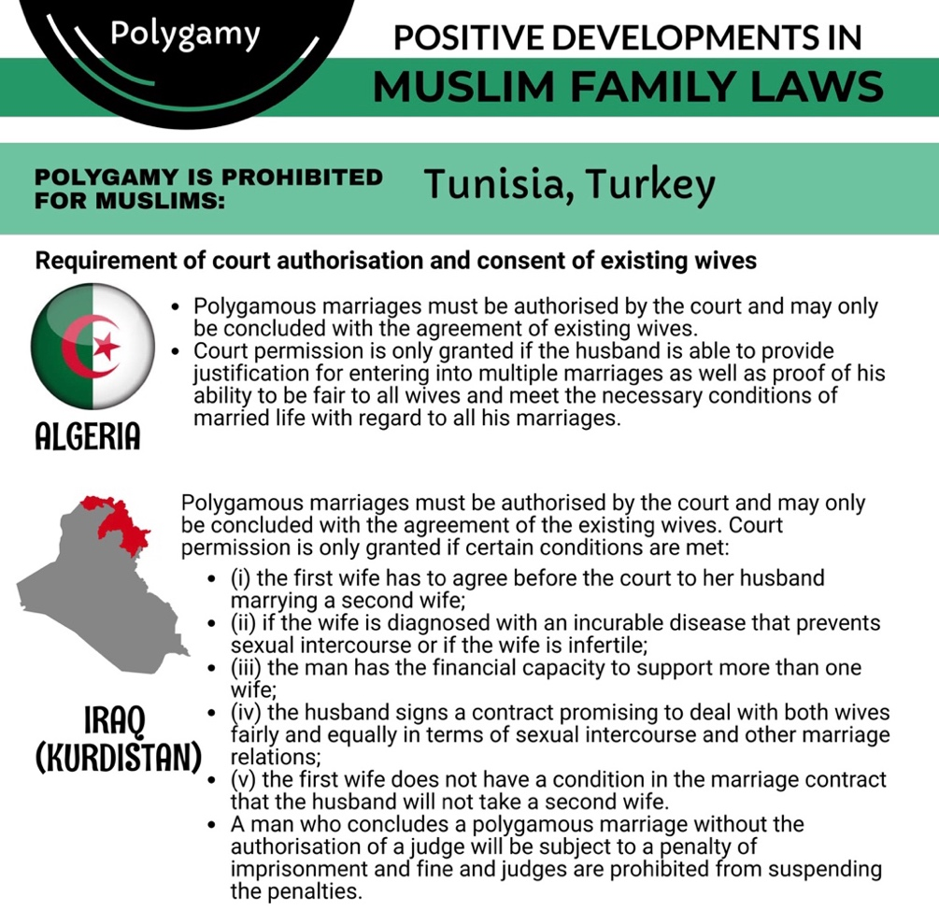

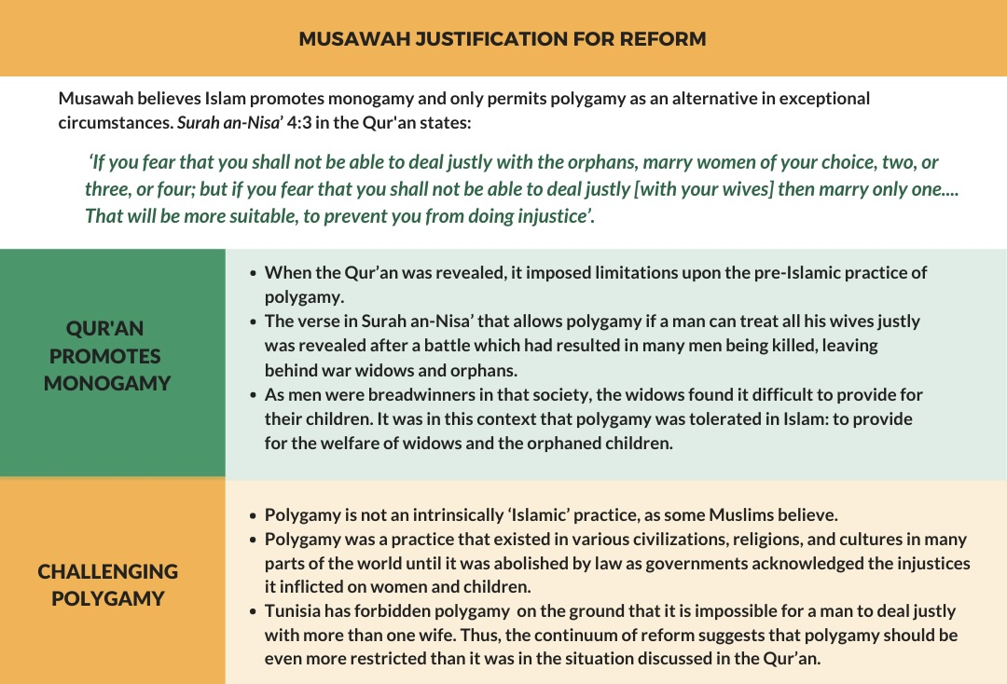

RECOMMENDATIONS
We recommend the CEDAW Committee urge the State party to:

- Introduce conditions in the Personal Status Law to restrict the practice of polygamy to minimize harm and injustice done to the wives and children, and in particular:

  - Require marriage officiators to notify a man’s existing wife at the time of contracting as subsequent marriage and to seek her consent; and

  - Include polygamy as a valid cause for judicial divorce.

Custody, Guardianship and Nationality Articles 9, 16

In the event of a divorce, a mother has priority over the custody of her daughter until she is married and her son until he reaches the age of majority. A judge may, however, award the father custody of the son as early as when he reaches seven if it is in the son’s best interest to do so. However, a mother immediately loses custody of her child if she remarries another man and her new husband is not closely related to the child.

A father has priority right over the guardianship of his children. As guardian, he is responsible for the child’s education and discipline in addition to the child’s property. Consequently, the wife cannot travel with her children abroad without the permission of their father/guardian, while the father can do so without any restrictions.

A Mauritanian man may pass his nationality to his non-Mauritanian wife upon marriage. However, the law does not specifically provide for a Mauritanian woman to confer her nationality to her foreign husband. Her foreign husband may obtain Mauritanian citizenship through naturalisation.

A Mauritanian father passes his citizenship to his children wherever they are born. A Mauritanian mother may only confer her citizenship on her child if: (i) the child was born in Mauritania; or (ii) the father’s nationality is unknown.

The Government of Mauritania in its 2013 report to the CEDAW Committee acknowledged the unequal nationality rights between women and men noting that with respect to children born abroad to a Mauritanian mother and a non-Mauritanian father, under Article 13 of the Nationality Code, Mauritanian nationality is not acquired by the child automatically, but on request. Moreover, Mauritania also acknowledged that non-Mauritanian husbands of Mauritanian women acquire Mauritanian nationality only after 10 years of marriage.

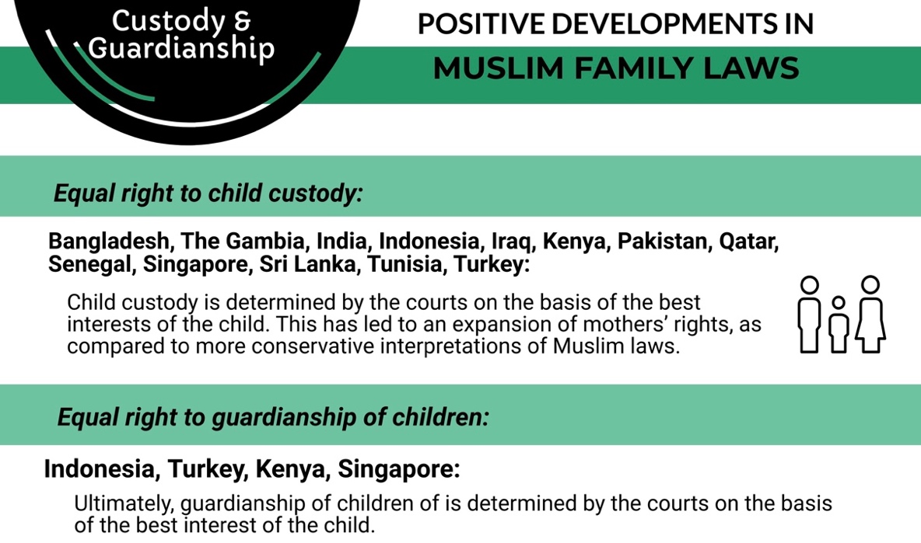

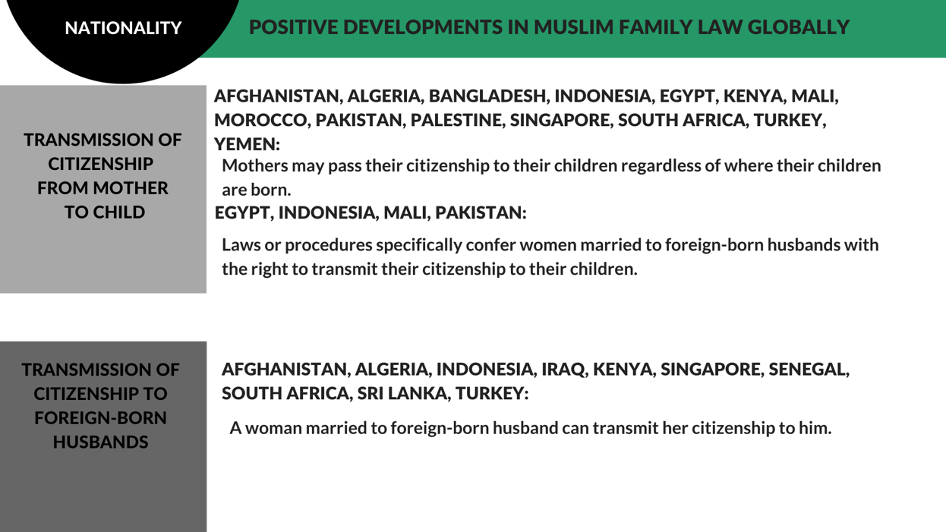

RECOMMENDATIONS
We recommend the CEDAW Committee urge the State party to:

- Amend the Personal Status Code to grant equal rights to both the mother and father for guardianship and custody of children, to be determined according to the best interests of the child.

- Amend the Personal Status Code to not deprive the woman of the right of custody upon remarriage.

- Grant equal nationality rights to both men and women with respect to passing citizenship to one’s spouse or children.

Personal Status Code (2001).
Article 311 of the Personal Status Code (2001).
Ratification Status, CEDAW, UN.org, https://treaties.un.org/pages/ViewDetails.aspx?src=IND&mtdsg_no=IV-8&chapter=4&clang=_en
Article 1 of Mauritania’s Constitution (1991), https://www.constituteproject.org/constitution/Mauritania_2012.pdf
Preamble; Article 16 of Mauritania’s Constitution (1991).
Articles 1, 55, 56 of the Personal Status Code (2001), http://www.justice.gov.mr//IMG/pdf/statutpersonnelarabe.pdf
Musawah Country Table: Mauritania (2017), https://www.musawah.org/resources/country-table-mauritania/
Article 57 of the Personal Status Code (2001).
Article 58 of the Personal Status Code (2001).
Article 9 of the Personal Status Code (2001).
Articles 8, 13 of the Personal Status Code (2001).
Article 45 of the Personal Status Code (2001)
Articles 28-29 of the Personal Status Code (2001)
Article 123, 126 of the Personal Status Code (2001).
Articles 122, 129-130 of the Personal Status Code (2001).
Articles 133, 178 of the Personal Status Code (2001).
Article 16 of the Nationality Code (1961), http://www.refworld.org/country,,,,MRT,,3ae6b5304,0.html
Articles 32, 72 of the Nationality Code (1961).
Mauritania State party report, U.N. Doc. CEDAW/C/MRT/2-3 (2013), paras. 77, 78, http://www.ohchr.org/en/hrbodies/cedaw/pages/cedawindex.aspx

