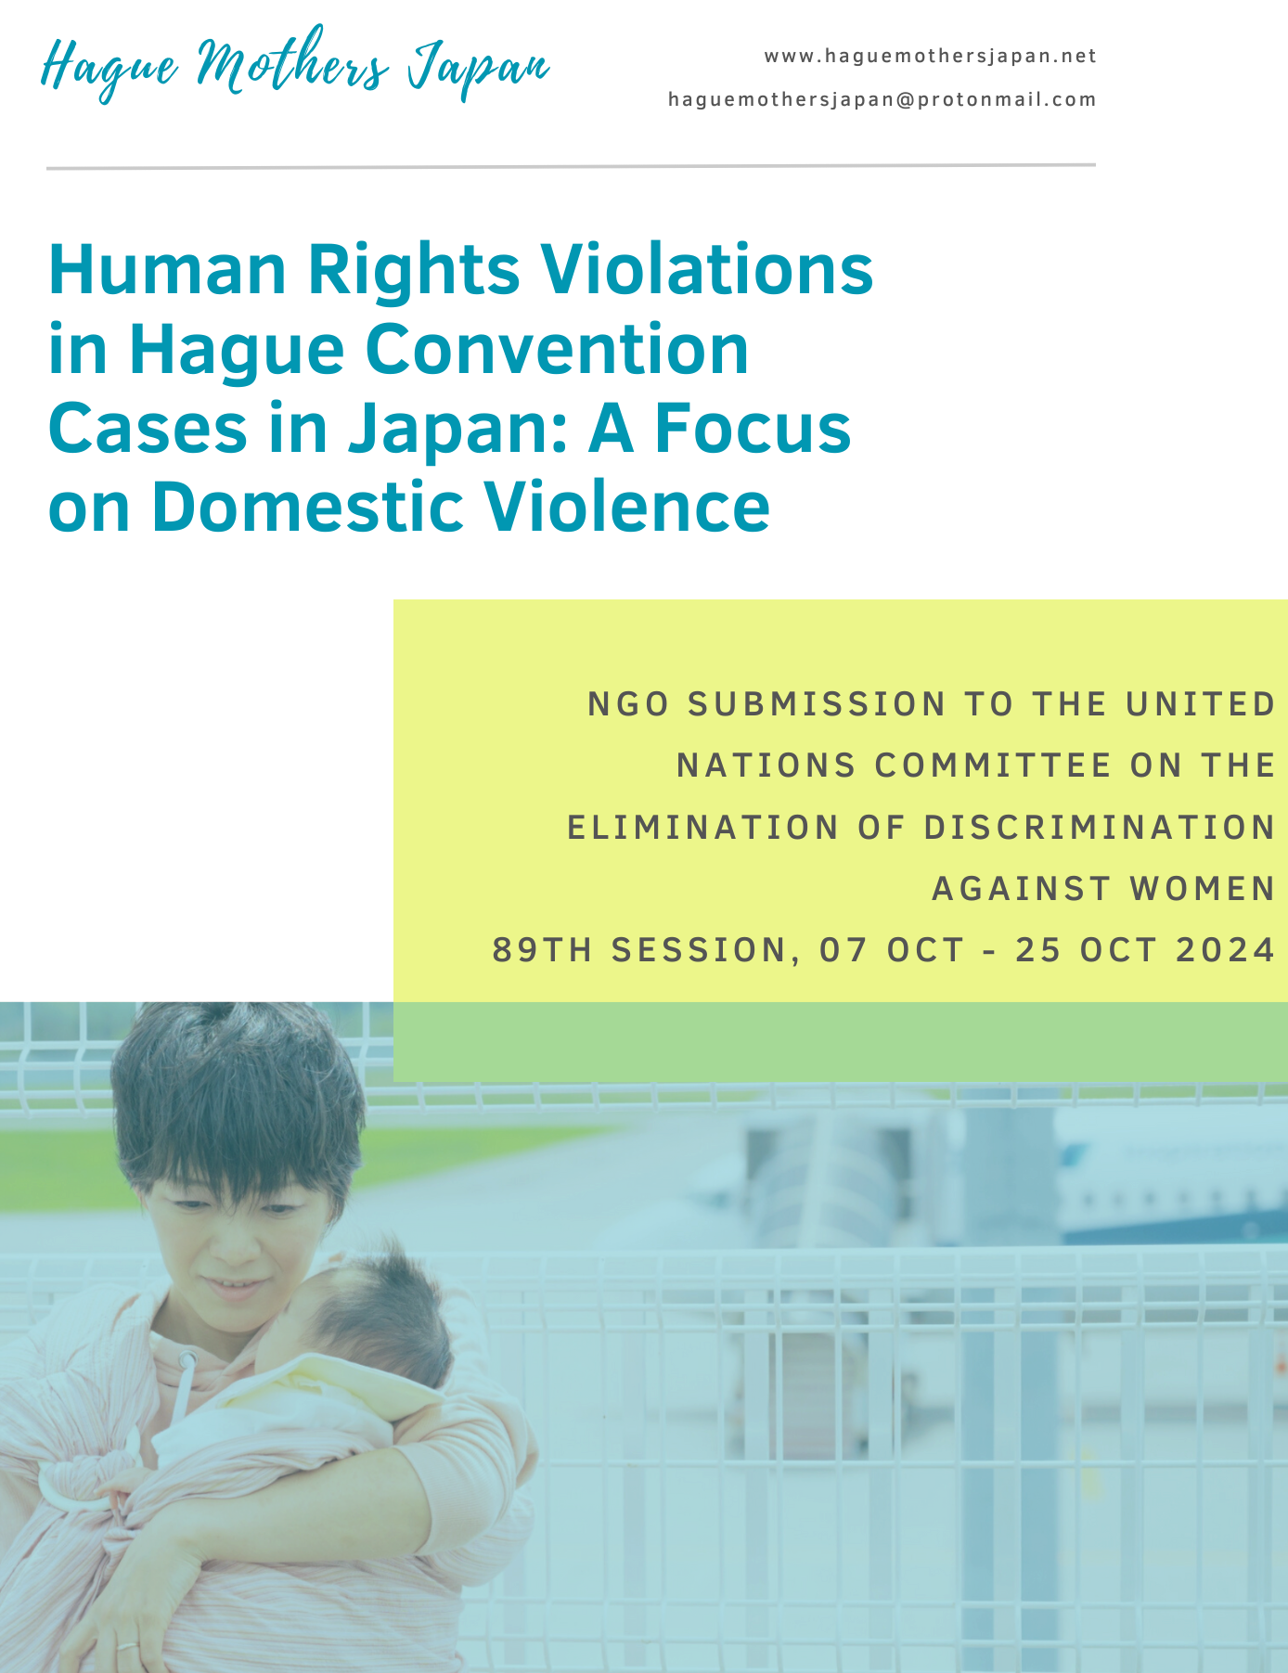

1. Introduction
This report examines the grave human rights violations arising from the misapplication of the Hague Convention on the Civil Aspects of International Child Abduction (“Hague Convention”) in cases involving domestic violence. This focus aligns with CEDAW's provisions under the Convention and the Committee’s General Recommendation No. 35 (2017), which updates General Recommendation No. 19. Although the Convention is designed to protect children, it is frequently misapplied, often to the detriment of women fleeing abusive situations. These women are frequently forced to return to unsafe environments, putting both their safety and that of their children at risk. Such circumstances discourage women abroad from seeking refuge with their families in their home country due to fears of legal, financial, and criminal consequences, including potential loss of custody. Despite CEDAW's recommendations to protect women from gender-based violence within judicial processes, the implementation of the Hague Convention in Japan has raised significant concerns. This report explores these issues and urges CEDAW to recommend measures to the Japanese government to enhance protections for Japanese women and children involved in international divorce cases.

2. Proposed Recommendations
2-1. Investigation into Cases Under the Hague Convention
An investigation should be conducted on past cases involving return applications under the Hague Convention, focusing on the following aspects:
- Domestic Violence (DV) Allegations and Evidence: Examine whether there were allegations and evidence of domestic violence, including physical, psychological, economic, social, and legal abuse.
- Impact on Safety and Welfare: Assess the impact of the Hague proceedings on the physical, mental, economic, and social well-being of the child, the applicant, and the respondent.
- Custody and Visitation Consequences: Analyze the effects of the Hague proceedings on the custody and visitation decisions following the proceedings.
Background:
Originally, the Hague Convention was drafted to prevent the abduction of children by non-resident parents (often fathers) from the resident parent. However, in practice, 84% of return applications under the Hague Convention are filed by fathers, and most of these cases involve mothers fleeing to protect the child from domestic violence. Article 13 of the Convention states that an order for the return of a child can be rejected if there is a “grave risk” of harm. Nevertheless, only 4 out of 135 cases resulted in non-return orders due to dangerous circumstances, such as domestic violence.
Some cases where victims of domestic violence were forced to return to their country, they fled from have led to dire consequences. These include being killed, facing severe criminal penalties, including jail time as "kidnappers," losing custody or contact with their child, and becoming homeless due to a lack of social and economic support, as they were economically and socially dependent on the abuser before the separation as an immigrant.
The Hague Convention has also been misused as a tool of legal abuse, perpetuating domestic violence. Even when a victim escapes domestic violence abroad and returns to Japan to seek refuge with family, invoking the Hague Convention can further entrap them further in the abuser’s control. The UN Special Rapporteur has highlighted that, in many countries, the Hague Convention obstructs the escape route for mothers and children fleeing domestic violence.
The domestic implementation of the Hague Convention (Act for Implementation of the Convention on the Civil Aspects of International Child Abduction, Article 1) is intended to serve the best interests of the child. Since the Hague Convention came into effect in 2014, there have been 342 applications as of May 2023. A thorough follow-up investigation of all cases should be conducted to determine whether the outcomes genuinely serve the best interests of the child.

2-2. Future Statistical Measures
Background:
In cases involving return applications under the Hague Convention, it is essential to collect statistics to verify the presence and extent of domestic violence affecting both the applicant and the respondent. An inquiry with the Supreme Court revealed that such statistics are not currently maintained in Japan. Given that many cases involve individuals fleeing from domestic violence, it is crucial that this data be collected moving forward.

2-3. Offer Mediation and ADR only after Evaluation by DV specialists
Background:
The Japanese government reports that “approximately 60% have been resolved through voluntary talks, in-court mediation, or amicable settlement in court proceedings.” This high rate of resolution is attributed to two main factors: (1) Since ratifying the Hague Convention, the Ministry of Foreign Affairs has established service agreements with several ADR institutions, providing free introductions and a limited number of sessions; and (2) In Japan, mediation is typically conducted simultaneously with trial proceedings. Consequently, while the global average for agreeing to return is 16%, Japan's rate is notably higher at 36%. This high figure, combined with the significant number of domestic violence cases discussed earlier, highlights a serious concern. CEDAW’s Recommendation No. 35 states that dispute resolution procedures, including mediation, “should be strictly regulated and allowed only when a previous evaluation by a specialized team ensures the free and informed consent of victims/survivors and that there are no indicators of further risks to the victims/survivors or their family members.” However, Japan currently lacks an evaluation system or specialized team for addressing gender-based violence against women involved in Hague proceedings while promoting ADR and mandating in-court mediation in all cases.
The voices of mothers who have fled from domestic violence, been subject to Hague proceedings, and forced to settle:
- “I felt compelled to agree on any terms he gives, including 50/50 shared custody and living in proximity to him even after the separation, so that I can stay in Japan, where I have family, friends, and employment. My lawyer warned me that I might have to return if I didn’t agree. But I returned home because he abused me in front of my child. I know I will be isolated with no social support if I return. It felt as if I were being forced to sign an agreement with a gun to my head.”
- “I fled to protect both myself and my child from my husband's abuse. During mediation, his lawyer strongly urged us to agree to return, saying, ‘Agree now to end this legal process, and I will secure an extension so you and your child can stay in Japan for a bit longer. Then, I will persuade him to allow you to live in Japan permanently with the time you’ve bought.’ Of course, his lawyer was unable to persuade him.”
It is highly questionable to label agreements made through mediation or ADR as amicable when respondents are fully aware that failure to agree might force them to return to the very place they fled.

2-4. Revise the Hague Convention Implementation Act
Background:
The Hague Convention Implementation Act, which governs the application of the Hague Convention in Japan, should be revised to include the following provisions:
- Clearly state that “return is not the default”: The Act should specify that returning a child is not the automatic or preferred outcome in every case.
- Align the definition of "grave risk" with domestic violence as defined by the Domestic Violence Prevention Act: The Act should ensure that "grave risk" encompasses the scope of domestic violence as outlined in the Domestic Violence Prevention Act.
- Explicitly state that return orders should not be issued when the primary caregiver is the respondent in incoming cases: The Act should provide clear guidelines that prevent return orders if the primary caregiver is the respondent in the case.
- Specify that criminal penalties or lack of social support for the primary caregiver upon return constitute grounds for non-return: The Act should outline that if the primary caregiver would face criminal penalties or lack adequate social support upon return, these factors should be considered valid grounds for a non-return decision.
Regarding points 1 and 2: Attorneys with extensive experience in Hague Convention cases have stated, “A single broken bone is not enough to be considered grounds for non-return; the victim must be near death and covered in blood.” Another attorney noted, “You cannot win a Hague case based on 'domestic violence.'” These quotes reveal that, under the current system, only extreme, life-threatening physical violence is often deemed sufficient to justify a non-return decision. As a result, victims of domestic violence may be forced to return to their home country, where they might have the support of family and friends, despite the escalating nature of abuse. The current system fails to provide adequate means for victims and children to escape the abuser’s control before irreversible harm occurs and to return to a safe environment where they can receive necessary support.
In 2023, our organization, in collaboration with 10 other organizations from 8 countries, collected 38,000 signatures on a petition titled “#ProtectHagueVictims: Stop the Misuse of the Hague Convention and Protect Children from Domestic Violence.” Following the petition's submission, Dr. Bernasconi, Secretary General of the Hague Conference on Private International Law (HCCH), remarked at the “Forum on Domestic Violence and the Hague Convention on the Civil Aspects of International Child Abduction" held in South Africa in June 2024. He stated that "domestic violence is the single most challenging factor in operating the Convention” and that “When there is a grave risk (…) a non-return is most likely the right and correct application of the Convention.” This acknowledgment suggests that countries worldwide are expected to revise their approach to domestic violence cases under the Hague Convention. Japan should also align its domestic laws with these anticipated global legal reforms.
Regarding points 3 and 4: Studies consistently demonstrate that a child's welfare is best served by a stable upbringing with the primary caregiver. The handling of Hague Convention cases should reflect current family law practices that prioritize the judgment of the primary caregiver. If the primary caregiver would face criminal penalties, social isolation, or other significant challenges that would hinder their ability to care for the child upon return, these factors should be considered valid grounds for a non-return decision.

2-5. Investigate the "Stuck Mother" Issue
Background:
Many cases have emerged where mothers, who are the primary caregivers of their children, wish to return to Japan temporarily or permanently with their children but are denied permission due to misinformation about Japan's legal system circulating abroad ("Stuck Mothers"). A survey of Japanese nationals living abroad should be conducted to better understand their circumstances.
The Japanese government should take proactive steps to address and correct misinformation disseminated by foreign media or official statements from foreign governments concerning Japanese mothers and Japan's family law system. Furthermore, establishing a consultation service to provide appropriate support, including issuing official statements to correct misinformation, would assist those who wish to return to Japan but encounter difficulties in doing so.
Our organization has received numerous reports from individuals who are unable to return to Japan with their children despite following proper legal procedures. These individuals often face discriminatory actions based on misinformation, such as claims that "Japan does not comply with the Hague Convention, so once they return, they will not come back" or "Japanese women prevent their children from seeing the other parent." In reality, 90% of petitions to the family court for mediation or a ruling to obtain visitation result in some form of visitation (source). The few cases where visitation is denied involve extreme circumstances, such as strong refusal from the child or clear evidence of abuse. Contrary to the portrayal by international media, shared parenting is possible when a minimum level of trust exists between the parents. The extended duration of the legal proceedings—one of the most frequent criticisms from non-resident parents regarding Japan's family law system—is attributed to the capacity issues of the courts, not the legal system itself.
Japanese women abroad who are "stuck" under the control of their abuser, even after separation or divorce, face not only language, social, and economic disadvantages as foreigners but can also experience repeated legal harassment over custody issues, difficulties with visa applications, or homelessness. In some cases, individuals have even resorted to suicide due to the lack of viable escape routes. There is an urgent need for systematic investigations and support systems for these Japanese nationals living abroad.

2-6. Disparities in Processing Petitions for Resident and Non-Resident Parents
Background:

While petitions for visitation or child support by a resident parent in Japan take several months to two years to process (note: this duration refers only to processing the application, with the actual procedures often extending over months or even years), applications by a non-resident parent in another country against a resident parent in Japan are accepted promptly. Although there is no official study explaining this disparity, it is suggested that in countries with which Japan does not have specific treaties, court documents must be mailed through multiple institutions, contributing to delays.
This system has been exploited in cases where non-resident parents repeatedly engage in legal harassment. Additionally, as modifications to established agreements can take years to process, the content of these applications often fails to keep pace with the child's development. This disparity must be addressed to ensure fairness and equality between the parties.

CEDAW/C/GC/35, D.32.(b): “Ensure that gender-based violence against women is not mandatorily referred to alternative dispute resolution procedures, including mediation and conciliation” and “The use of those procedures should be strictly regulated and allowed only when a previous evaluation by a specialized team ensures the free and informed consent of victims/survivors and that there are no indicators of further risks to the victims/survivors or their family members.”
Supreme Court of Japan. “Data on Hague Convention.” June 2024. Email.
Lowe, Nigel, and Victoria Stephens. “A Statistical Analysis of Applications Made in 2015 under the Hague Convention of 25 October 1980 on the Civil Aspects of International Child Abduction: Global Report.” September 2017, pp. 3.
Supreme Court of Japan.
﻿﻿A/HRC/53/36: “Custody, violence against women and violence against children - Report of the Special Rapporteur on violence against women and girls, its causes and consequences”, Reem Alsalem. 13 Apr. 2023, pp. 10.
Ministry of Foreign Affairs of Japan. “Implementation Status of the 1980 Hague Convention (Convention on the Civil Aspects of International Child Abduction) in Japan.” March 1, 2024. www.mofa.go.jp/mofaj/files/100643807.pdf
CEDAW/C/GC/35, D.32.(b)
“Hague Mothers at the Hague.” Hague Mothers, 10 Oct. 2023, www.hague-mothers.org.uk/2023/10/10/hague-mothers-at-the-hague/.
Dr. Christophe Bernasconi. Forum on Domestic Violence and the Operation of Article 13(1)(b) of the 1980 Child Abduction Convention, June 2024, South Africa.

