Assessment of Economic and Social Rights Fulfilment in the Lao People’s Democratic Republic
Submission from the Human Rights Measurement Initiative to the United Nations Committee on Economic, Social and Cultural Rights for the 78th Pre-Sessional Working Group, Geneva, September 2025.
I. Reporting Organisation
1. The Human Rights Measurement Initiative (HRMI) measures the human rights performance of countries, including the Lao People’s Democratic Republic (Laos). HRMI is an independent, not-for-profit NGO with its primary base of operations in New Zealand, and a second base in the United States at the University of Georgia’s Center for the Study of Global Issues (GLOBIS).
II. Assessment Methodology
2. HRMI uses the award-winning and peer-reviewed SERF Index methodology to measure the fulfilment of economic and social rights (ESRs).
3. This methodology uses bellwether indicator data from international organisations—such as the World Health Organization and UNICEF—and compares each country’s achievement to what other countries at the same level of income have achieved. In this way, HRMI measures progressive realisation of economic and social rights as defined in the International Covenant on Economic, Social and Cultural Rights (ICESCR). A country’s ‘income adjusted’ HRMI score is a measure of how well its government is converting its resources into good human rights outcomes for its people.
4. HRMI supplements these scores with qualitative information sourced by a secure, online survey of on-the-ground human rights experts, such as NGO researchers, journalists, and human rights lawyers and advocates. For more details on HRMI’s methodology, please refer to the resources on our website.
5. All HRMI’s data are published annually on the Rights Tracker and are freely available for non-commercial use under a Creative Commons License. HRMI’s Rights Tracker is a certified Digital Public Good with the Digital Public Good Alliance.
III. Overview of Economic and Social Rights Fulfilment in the Lao People’s Democratic Republic
6. HRMI’s most recent ESR scores for Laos measure its achievement as of 2022 and indicate a significant margin for improvement. They are shown in the graph below.
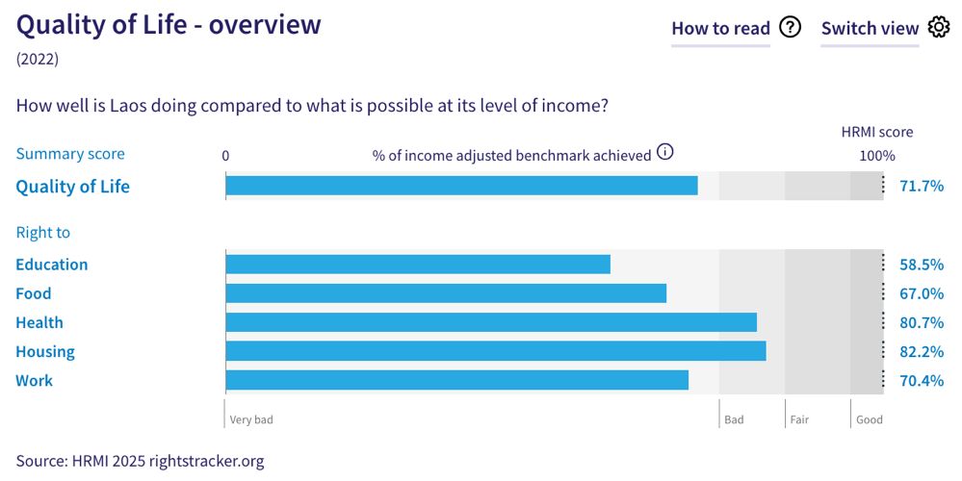
7. Laos’ scores for 2022 are as follows:
- Overall Quality of Life score = 71.7% (in the ‘very bad’ range)
- Right to education = 58.5% (‘very bad’)
- Right to food = 67.0% (‘very bad’)
- Right to health = 80.7% (‘bad’)
- Right to housing = 82.2% (‘bad’)
- Right to work = 70.4% (‘very bad’)
8. Laos scores 71.7% on overall ‘Quality of Life’ when scored against the 'income adjusted' benchmark. This score takes into account Laos’ resources and how well it is using them to make sure that the ‘Quality of Life’ rights of its people are fulfilled.
9. This score tells us that Laos is only doing 71.7% of what is possible to achieve currently with its existing level of resources. On an ‘income adjusted’ benchmark, any score less than 100% indicates that a country is underperforming, and not meeting its current obligations under international human rights law. Therefore, our assessment is that Laos has a very long way to go to meet its immediate economic and social rights obligations.
10. Notably, compared with other countries in East Asia, Laos is performing lower than average on ‘Quality of Life’ rights.
IV. Right to Education
11. HRMI defines the right to education in accordance with ICESCR Article 13 and CESCR General Comments 11 and 13. For low- and middle-income countries such as Laos, HRMI further breaks down the right to education into three areas of measurement: primary school enrolment, secondary school enrolment, and quality of education. Our scores (adjusted for income) indicate some challenges across these three areas as they lie within the ‘bad’ and ‘very bad’ ranges, with no score reaching the ‘good’ range.
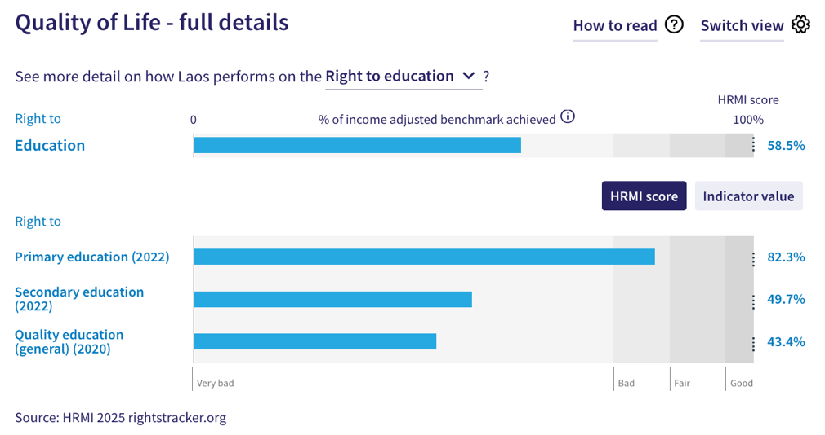
12. Laos is performing lower than average when compared with other countries in East Asia, and is placed sixth lowest among this group on the right to primary education. Laos’ score for primary education (adjusted for income) is 82.3%, which means that it is achieving only 82.3% of what is possible with its available resources. This score has declined since its peak of 92.1% in 2014. There was also a notable fall from its 2021 score to its recent 2022 score.
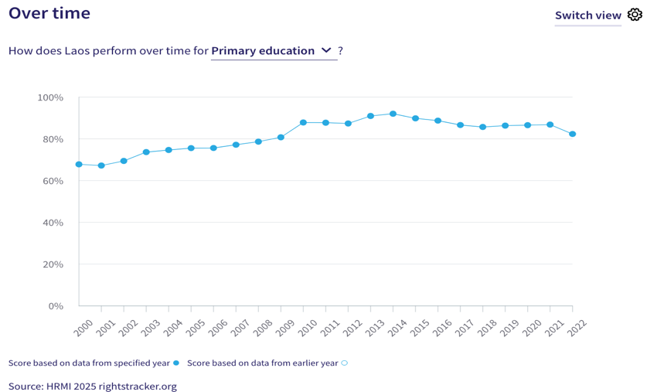
13. Our scores show that immediate action is needed to address the challenges to the right to secondary education in Laos. Its current ‘income adjusted’ HRMI score for this right is 49.7%, which falls well within the ‘very bad’ range. While this score has fluctuated over the past two decades, it peaked at 64.4% in 2016 and has since been on a sharp downward trend. Notably, Laos currently ranks last among other countries in East Asia on this right.
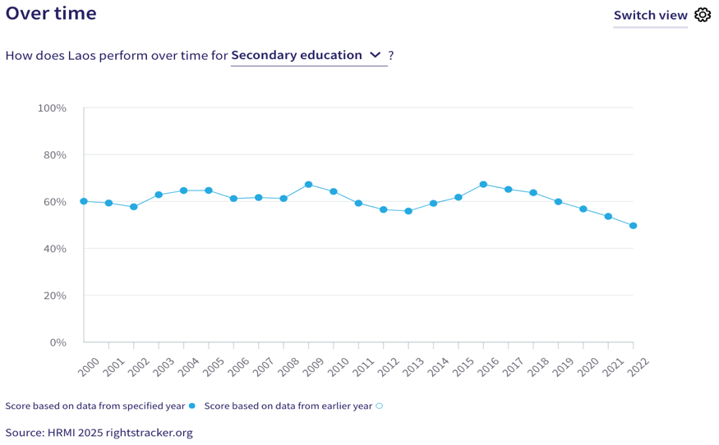
14. Laos’ quality of education score is 43.4%, which means that it is achieving only 43.4% of what is possible to achieve with its existing resources. This score falls in the ‘very bad’ range.
V. Right to Food
15. HRMI defines the right to food in accordance with ICESCR Article 11 and CESCR General Comment 12. For low- and middle-income countries such as Laos, HRMI uses a bellwether indicator of how many children are growing well (are not stunted). Laos’ score for the right to food is 67.0%, which means that Laos is doing 67.0% of what is possible at its current income levels to ensure the right to food for its people. This score draws on indicator data on child stunting rates from the UNICEF-WHO-World Bank: Joint child malnutrition (JME) database.
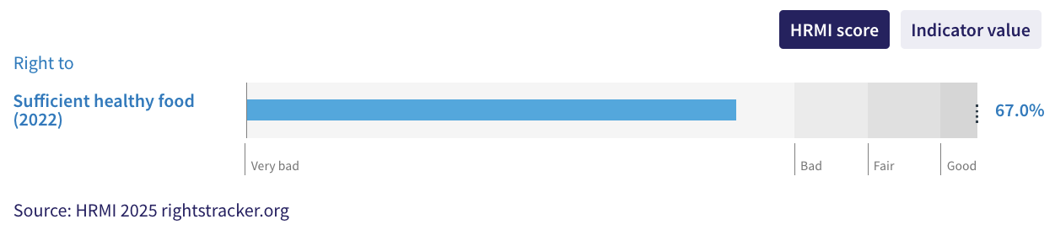
16. The right to sufficient healthy food in Laos has improved steadily since 2006, with the HRMI score rising from 41.0% in 2006 to 67.0% in 2022. While the upward trend indicates progress over the last few years, this score still falls in the ‘very bad’ range.
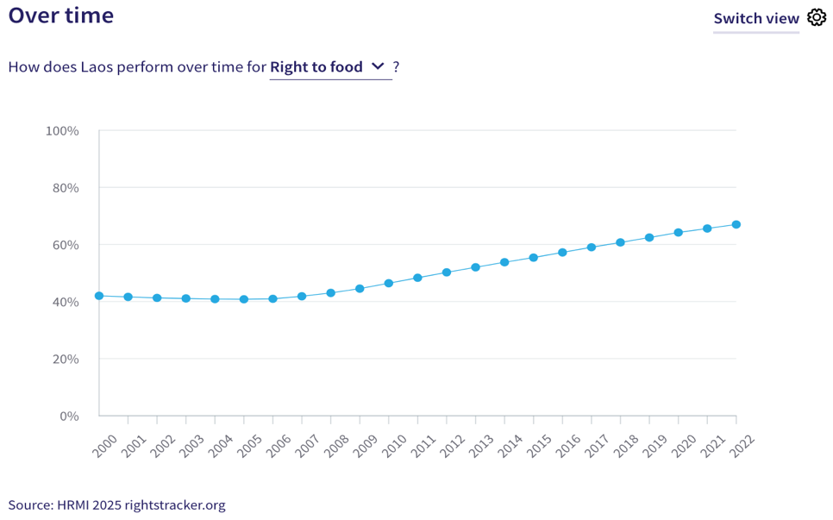
VI. Right to Health
17. HRMI defines the right to health in accordance with ICESCR Article 12.1 and CESCR General Comment 14. For low- and middle-income countries such as Laos, HRMI uses three indicators to measure the country’s achievement in child health, adult health, and reproductive health. Laos’ score on the right to health is 80.7% and falls in the ‘bad’ range. Overtime trends indicate that while this score showed some improvement over the past two decades, it has largely plateaued since 2017 with no marked improvement.
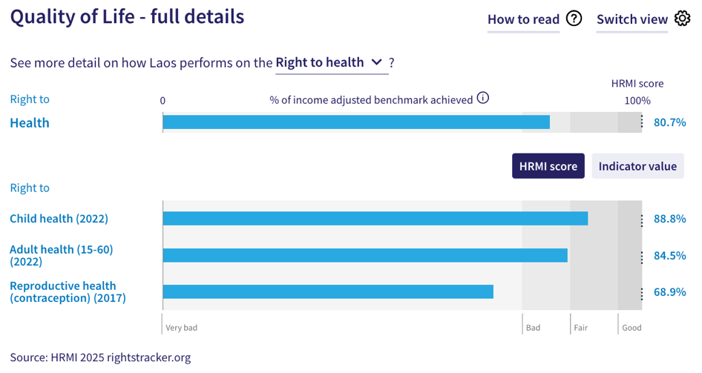
18. For low- and middle-income countries, HRMI measures the right to child health using the indicator of survival to age five. In Laos, child health has gradually improved over the 2000-2022 period, reaching a peak ‘income adjusted’ HRMI score of 88.8% in 2022. While this score is in the ‘fair’ range, Laos ranks second-lowest among other countries in East Asia on this right.
19. Laos scores an ‘income adjusted’ 84.5% for the right to adult health, indicating that it is doing 84.5% of what is possible with its current resources. This score is based on the indicator of adult (15-60) survival rate; according to the UNDP and Max Planck Institute Human Mortality Database, the adult survival rate in Laos was 82.9% in 2022. This score has seen minor improvements over the last two decades, and still falls in the ‘bad’ range.

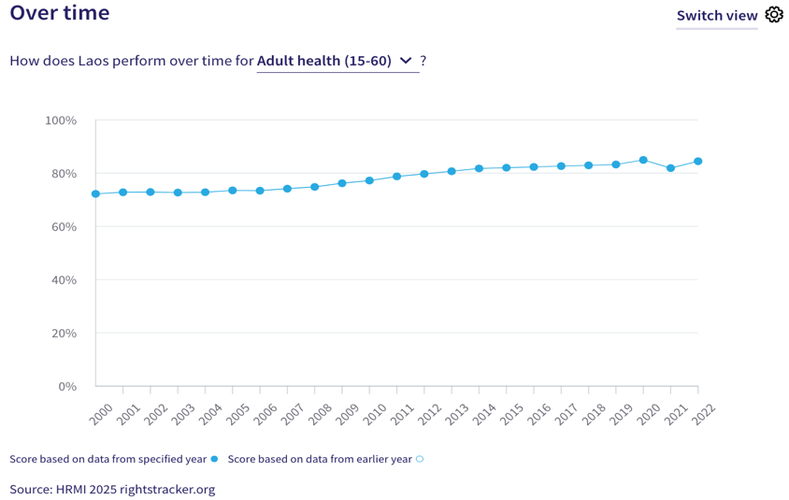

20. HRMI measures the right to reproductive health by the rate of modern contraceptive use. In 2017, which is the most recent available data, Laos reported a contraceptive use rate of 51.0%, which translated into its current HRMI score of 68.9%. This score falls in the ‘very bad’ range, and indicates that Laos has a long way to go to fulfil its immediate human rights obligations.
VII. Right to Housing
21. HRMI defines the right to housing in accordance with ICESCR Article 11.1 and CESCR General Comment 4. For low- and middle-income countries such as Laos, HRMI measures this right using the indicators of access to water on premises and access to basic sanitation (each household having its own improved toilet facilities). Laos has an ‘income adjusted’ HRMI score of 82.2% on the right to housing, which falls in the ‘bad’ performance range.
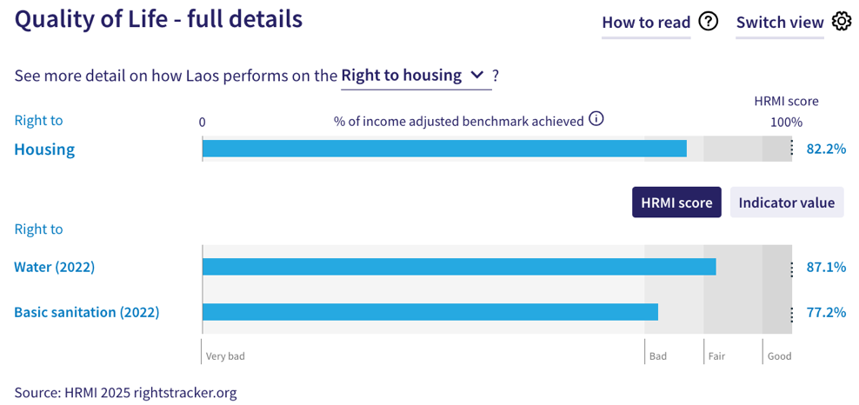
22. The WHO UNICEF Joint Monitoring Project (JMP) data show that 84.5% of households in Laos have access to water on premises as of 2022. Given what other countries with the same level of income have shown to be possible, Laos’ HRMI score for the right to water of 87.1% and falls in the ‘fair’ range. Over the last two decades, this score has shown consistent progress from 9.5% in 2000 to its current score of 87.1% in 2022. However, since 2019, this score has largely stagnated with no further improvements.
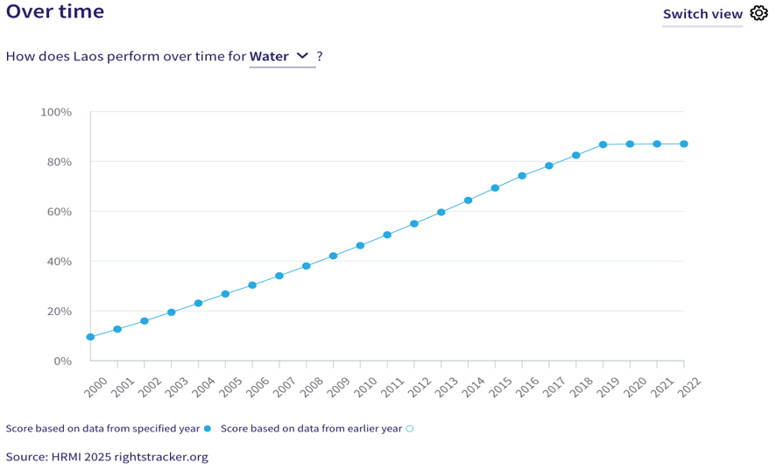
23. Laos’ current HRMI score of 77.2% on the right to sanitation falls in the ‘bad’ range. However, trends indicate that there has been encouraging progress on this right over the past two decades, with the score rising from 34.4% in 2000 to the current score of 77.2% in 2022. Despite earlier progress, there has been no measurable improvement in this score since 2019.
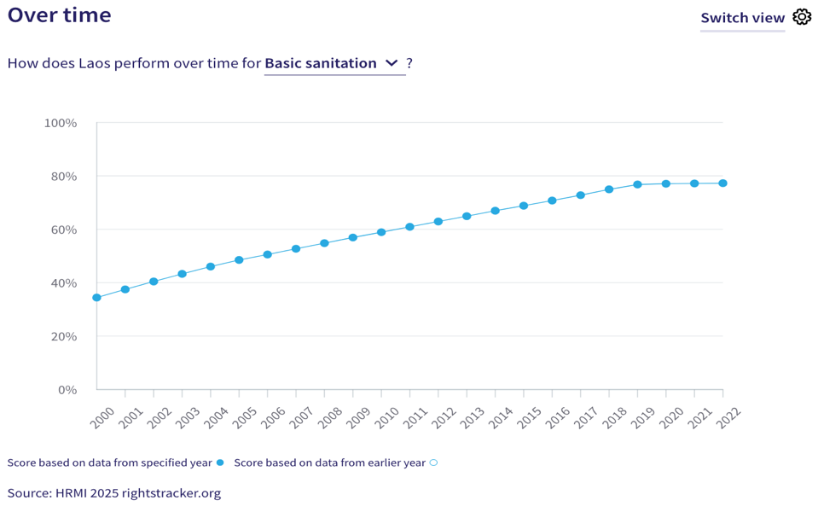
VIII. Right to Work
24. HRMI measures the right to work in accordance with ICESCR Articles 6 and 7. For low- and middle-income countries such as Laos, HRMI uses a subsistence income indicator to measure this right. According to World Bank PovcalNet data, 67.5% of people in Laos were classified as ‘not absolutely poor’ in 2018. This translated to an ‘income adjusted’ HRMI score of 70.4 on the right to work, which falls in the ‘very bad’ range.
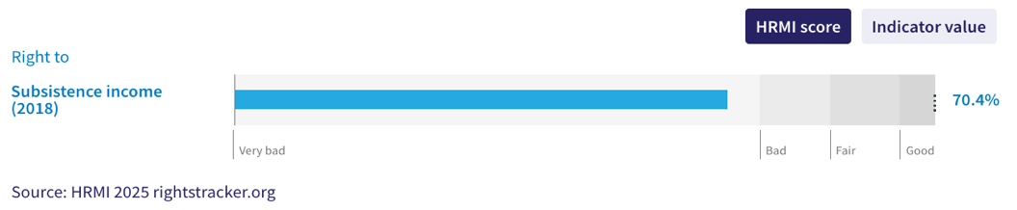
25. Over the last two decades, Laos has shown steady, albeit sporadic, progress on the right to work, improving from an initial HRMI score of 29.5% in 2000 to its current score of 70.4% in 2022. While this trend is encouraging, the current score still indicates that Laos has a significant ground to cover to meet its immediate obligations related to the right to work. Notably, Laos ranks second-lowest among other countries in East Asia on the ‘income adjusted’ right to work.
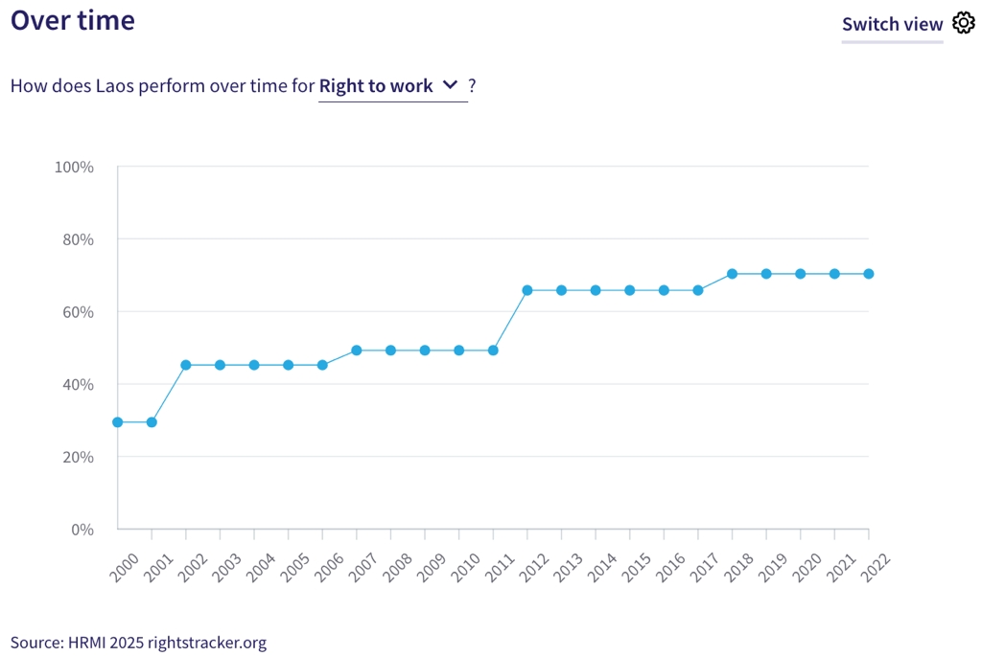
IX. Concluding Remarks

26. Laos’ best ‘income adjusted’ HRMI scores are for the right to child health and for the right to water, which fall in the ‘fair’ range, and indicate that Laos can still do more at its current income levels to ensure better child survival rates and access to water on premises. Its most concerning scores, however, are for the right to secondary education and the right to quality of education. Both these scores not only fall in the ‘very bad’ range, but have not shown any improvement over the recent years. In fact, trends indicate that the score for secondary education has steeply declined from 2016 to 2022.
27. Our analysis is that Laos is not constrained by resources from making considerable improvements in areas with low scores. It has the income available to make progress, and can prioritise to put it to use to improve the economic and social rights of its people.
28. We recommend that the Committee assure the State Party concerned that it has the available resources to make significant improvements, especially in areas of upper secondary school enrolment, quality of education, child stunting rate, and modern contraceptive use rate.
29. We also recommend the following questions:
- What steps will the State Party take to improve access to and enrolment in upper secondary education?
- What measures will the State Party take to enhance quality of education at all levels?
- What actions will the State Party take to reduce child stunting rates and ensure sufficient healthy food for children under the age of 5?
- What steps will the State Party take to lift access to modern contraceptive methods?
30. HRMI respectfully submits its data and findings on the fulfilment of economic and social rights in the Lao People’s Democratic Republic. We hope that this submission will serve as a useful resource to the Committee on Economic, Social and Cultural Rights for drafting specific and meaningful questions to the State party concerned during the CESCR’s 78th Pre-Sessional Working Group.

Visit HRMI’s website to learn more about our mission and work, https://humanrightsmeasurement.org/.
This content represents the opinions of the Human Rights Measurement Initiative. It carries no endorsement of the University of Georgia.
See HRMI’s methodology for measuring economic and social rights: https://humanrightsmeasurement.org/methodology and https://rightstracker.org/page/methodology.
Ibid.
HRMI 2025 Rights Tracker: https://rightstracker.org/
See Human Rights Measurement Initiative (HRMI) Digital Public Good Certificate, https://app.digitalpublicgoods.net/a/11781. The Digital Public Goods Alliance is endorsed by the UN Secretary General’s “Roadmap for Digital Cooperation”. It defines digital public goods as: “open source software, open data, open AI models, open standards and open content that adhere to privacy and other applicable laws and best practices, do no harm, and help attain the SDGs,” https://digitalpublicgoods.net/standard/.
HRMI 2025 Rights Tracker, https://rightstracker.org/country/LAO
The labels on the country charts of good, fair, bad, and very bad are used to give a general indication of how to understand the scores. HRMI’s income adjusted Quality of Life scores can be broadly interpreted as showing the percentage of the country’s obligation it has met, compared to what the best performing countries have achieved at each income level. A country scoring below 75% with a label of “Very bad” is failing to put in place the kinds of structures and policies that help people claim the right concerned, but the structures and policies in place most likely prevent many people from claiming their rights. See HRMI’s methodology for measuring human rights, https://rightstracker.org/page/methodology.
HRMI 2025 Rights Tracker, https://rightstracker.org/country/LAO
HRMI 2025 Rights Tracker, https://rightstracker.org/metric/esr?region=east-asia-pacific&subregion=east-asia
HRMI 2025 Rights Tracker, https://rightstracker.org/metric/education.
HRMI 2025 Rights Tracker, https://rightstracker.org/metric/tot-net-primary?subregion=east-asia
HRMI 2025 Rights Tracker, https://rightstracker.org/country/LAO?tab=report-esr.
Ibid.
HRMI 2025 Rights Tracker, https://rightstracker.org/metric/tot-sec-enrol?tab=report-esr&subregion=east-asia
HRMI 2025 Rights Tracker, https://rightstracker.org/country/LAO?tab=report-esr&qolFdScore=hrmi
Ibid.
HRMI 2025 Rights Tracker, https://rightstracker.org/metric/not-stunted
HRMI 2024 Rights Tracker, https://rightstracker.org/country/LAO?tab=report-esr&qolFdScore=hrmi&as=core
HRMI 2025 Rights Tracker, https://rightstracker.org/country/LAO?tab=report-esr&qolFdScore=hrmi&as=core
Ibid.
Ibid.
HRMI 2025 Rights Tracker, https://rightstracker.org/metric/under-5-survival?subregion=east-asia
HRMI 2025 Rights Tracker, https://rightstracker.org/metric/adult-survival?subregion=east-asia
HRMI 2025 Rights Tracker, https://rightstracker.org/country/LAO?tab=report-esr&qolFdScore=hrmi&as=core
Ibid.
Ibid.
Ibid.
Ibid.
HRMI 2025 Rights Tracker, https://rightstracker.org/country/LAO?tab=report-esr&qolFdScore=indicator&as=core
Ibid.
HRMI 2025 Rights Tracker, https://rightstracker.org/metric/work

