
Civil Rights Observer
Email: info@hkcro.org
Phone: +852 6693 5319
Facebook: www.facebook.com/hongkongcro

Submission to the Committee Against Torture
for the consideration of the fifth periodic report of
Hong Kong, China
October 2015
Introduction
- This submission aims to respond to the concerns of the Committee Against Torture raised in the list of issues in June 2015. This submission provides information of human rights abuse cases, observations on Hong Kong Government’s practices, and our recommendations to the Committee regarding various issues. The abuse cases mentioned in this submission are based on media reports, interviews by non-government organisations, and first-hand interviews conducted by the volunteers of Civil Rights Observer.
Issue 1: Degrading treatments to the arrested persons
Articles involved: Art 11
List of issues concerned: para. 16
1.1 Degrading treatments after the mass arrest of 511 protesters
- The Hong Kong Police arrested 511 protesters for unauthorised assembly from a peaceful sit-in immediately after the 1 July rally in 2014. All of the arrested persons were detained in the Police College in Wong Chuk Hang overnight, even though the place was not initially designed for such purpose.
- The arrested persons complained (1) they were not allowed to have access to lawyers; (2) not provided with food or water for several hours during detention; (3) detained in the police vehicle for several hours; as well as (4) their request to use toilet had been refused.
- It was reported only one telephone had been provided to the 511 arrested persons for contacting lawyers and family members.
- It was reported solicitors, barristers, three Justice of the Peace (namely, the Hon Frederick FUNG, the Hon Cyd HO and the Hon Charles Peter Mok), and members of the Legislative Council were refused admittance to visit the arrested protesters who remained detained in the Police College.
- According to Chapter 49, paragraph 3(d) and 3(g) of the Police General Orders, solicitor, barrister and Justice of the Peace are the authorised persons who can visit detained person in the course of their duty.
- Most of the arrested protesters were unconditionally released on the next day without facing any charges. As of September of 2015, only 25 out of the 511 arrested protesters were prosecuted for “participating and organising unauthorised assembly”.
Issues concerned:
- The arrested persons were detained in a place which is not designed for such purpose led to the failure of fulfilling basic human rights of the arrested persons.
- Detaining arrested persons in a place other than police station may have violated the Police General Orders.
- It is unlawful and unreasonable to refuse lawyers to reach their clients (ie. the arrested persons), and vice versa.
- The police unreasonably denied admission of the Justice of the Peace (JP) to visit the detained persons. The function of the JP of acting as an observer and person for redress has been jeopardised.
Recommendations:
- Express grave concern about detaining arrested persons in places that are not designed for such purpose.
- Urge the Hong Kong Government to establish a “service indicator” for evaluating the handling time to facilitate the request of arrested persons to exercise their rights, including the access to legal services, medical treatments, food, water, toilet, bathing, and any reasonable requests for basic human needs. The records of requests and the corresponding attainment should be well-documented.
- Urge the government to ensure the Justice of the Peace can visit detained persons at his will.

Issue 2: Violence against person by the Police
Articles involved: Art 10, Art 11, Art 12, Art 13
List of issues concerned: para. 13, 16, 21, 22
2.1 Arrested persons beaten by police officers in police vehicle
- It was reported the police arrested three protesters and a legislative assistant in a demonstration in the public assembly area of the Legislative Council on 13 June 2014. They alleged the police officers had beaten them inside a police vehicle. The entire incident lasted for around 20 minutes.
- The victims alleged the police officers had been verbally threatening them and interrogating them with questions like, “who is your boss?”, “what is the triad organisation you belong to?”.
- Deducing from the sound, the victims believed there were four to five police officers involved in the incident. They explained they could not recognise the facial appearance of the police officers because the police officers ordered them to keep their heads down and only look at the floor inside the vehicle. Also, the light inside the vehicle was switched off, and the windows were covered with curtains.
- A victim claimed he was demanded by the police officer to agree verbally that the injury of his mouth was caused by the dryness of his skin.
- A victim claimed the police demanded him to clean the blood from his ear and neck in the toilet. The police also asked whether he wanted to have access to a lawyer, while the victim was being ordered to clean up the blood on his neck. He was threatened and thus agreed not to request for a lawyer.
- Two of the victims have taken civil legal action against the Police for the assault.
Issues concerned:
- The interrogation by the police with abusive force could be considered as torture.
- The case has well-illustrated the difficulty for the victim to collect evidence of their abuse, due to the dominant power of the police.
2.2 Arrested person beaten by police officers in the street
- The case of Mr Tsang Kin-chiu is mentioned in paragraph 22 of the Committee’s list of issues.
- Mr Tsang was arrested while the police were taking action to disperse the protesters on Lung Wo Road, which was a protest zone in Admiralty on 15 October 2014. Mr Tsang was escorted to a place in the dark by a group of police immediately after the arrest. He was then beaten by a group of police officers for several minutes. The incident was captured by the video camera of a reporter crew and aired on news. Thus it gave rise to public concern.
- Mr Tsang claimed the injury to his spinal cord still has not recovered from the assault by the police.
- It was reported the Government refused to disclose the identity of the alleged seven police officers to Mr Tsang, claiming the criminal investigation is in progress. As a result, Mr Tsang was unable to take legal action against the police officers.
- Although the seven police officers had been already arrested for the assault since 26 November 2014, the Department of Justice claimed they have to further seek for legal advice before making any prosecution.
- The Department of Justice decided to prosecute both Mr Tsang and the seven police officers on 15 October 2015.
- According to the press release by the Department of Justice, Mr Tsang was charged with one count of assaulting police officers in the due execution of their duties, and four counts of resisting a police officer in the due execution of his duty, all contrary to section 36(b) of the Offences against the Person Ordinance, Cap 212 (OAPO).
- The said charges of assaulting police officers in the due execution of their duties alleges that at around 3:20am on October 15, 2014, Mr Tsang splashed liquid from a plastic container onto Lung Wo Road while he was on a planter at the embankment of the underpass on Lung Wo Road. As a result, a number of police officers were splashed with the liquid.
- Each of the said four counts of resisting a police officer alleges Mr Tsang resisted the police officers in the execution of their duties when they subsequently came to apprehend him at or near the planter.
- As regards of seven police officers, three are in the ranks of Chief Inspector, Senior Inspector, and Detective Sergeant, four are Police Constable and Detective Police Constables, they were charged with one joint count of causing grievous bodily harm with intent, contrary to section 17 of the OAPO. Furthermore, one of the Detective Police Constables was charged with one additional count of common assault, contrary to common law and punishable under section 40 of the OAPO.
- The said joint charge of causing grievous bodily harm with intent alleges the said seven police officers unlawfully and maliciously caused grievous bodily harm to Mr Tsang, with an intent to do him grievous bodily harm, outside the Lung Wui Road Government Building Pump Station East Substation, at around 3:30am on October 15, 2014.
- The said charge of common assault alleged that after Mr Tsang was assaulted by a Detective Police Constable inside an interview room, after he had been taken to the Central Police Station.
- The police officers whom Mr Tsang had been allegedly assaulted are different from the seven police officers who had allegedly assaulted Mr Tsang. The assaults, though proximate in time, were, in fact, different.
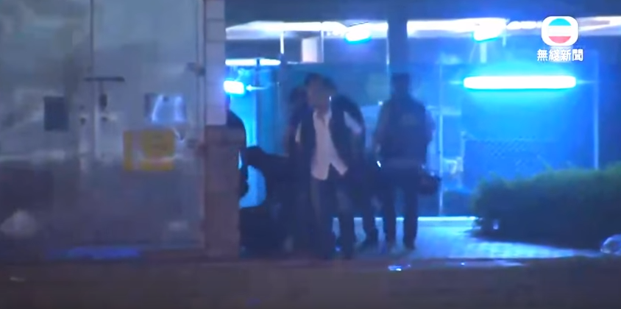
Photo 1: The incident of the police officers assaulting Mr Tsang Kin-chiu was captured by media’s camera, and aired on news. The full video is available at: https://goo.gl/xxM2fQ
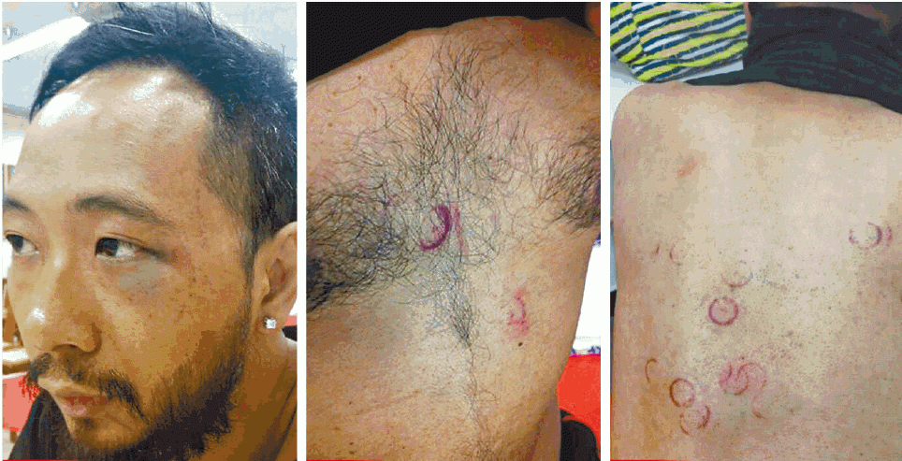
Photo 2: The injuries found on the body of Mr Tsang Kin-chiu: (left) the bruise around his left eye; (middle) the injury on his chest; (right) the injury at his back. The doctor believed that the injuries were caused by a hard and round object.
Source: Apple Daily,16 October 2014.
Issues concerned:
- The police officers who had allegedly assaulted Mr Tsang involved different ranks of police officers. It is observed they seemed to have different roles and division of labour in the incident, according to the video captured by the media camera. The alleged assault against Mr Tsang lasted for around four minutes, and the act of the police officers amounted to the level of torture.
- Assaulting police officer is an offence contrary to section 36(b) of the OAPO and section 63 of Police Force Ordinance, Cap 232. Although the elements of the offence in both Ordinances are almost identical, the Department of Justice has no clear prosecution policy regarding the selection of the offence from these two ordinances for prosecution.
- The section 36(b) of the OAPO carries heavier sentence for conviction. It is an excepted offence where suspended sentence is not available. The selection of the charges is inconsistent with the mild nature of the alleged action that Mr Tsang may have had.
2.3 The Magistrate suspected the police had assaulted the defendant
- It was reported the police arrested Mr Chan Pak-Shan, who was charged with assaulting the police officer, and failing to present identity document. Mr. Chan was not found guilty of both charges after the trial.
- The Magistrate stated there was a "reasonable possibility" that the police officer had assaulted Mr. Chan, which affected the integrity of his witness statement. The Magistrates stated the injury of Mr. Chan's eye was likely caused by a punch. The bruise on Mr. Chan's face and the scratches on his chest were unlikely caused by his resistance to the police, which was the initial reason for the arrest and charges.
Issues concerned:
- Cases have shown violence against persons by the police is not any individual case. However, it is questionable whether the current mechanism in handling complaints against police is effective.
- The Independent Police Complaints Council handled 316 cases of assaults by police officers in the year of 2013-14. However, there is no case found substantiated.
Overall Recommendations for Issue 2.1-2.3:
- Urge the Government to install video recording devices inside the police vehicles, and the areas of police stations used for the handling of arrested persons. The Police should maintain a good documentation of the records.
- Urge the Government to provide a prosecution policy for the selection of the offences of assaulting police in section 36(b) of OAPO and section 63 of Police Force Ordinance.
- Urge the Government to implement sufficient measures to prevent the abuse of forces by the police.
- Urge the Government to provide the police with sufficient education on the legal liabilities of the application of excessive force, as well as the malicious application of force.
- Urge the Government to provide the police with sufficient training on human rights, including the concepts of torture and cruel, inhuman or degrading treatment or punishment.
Issue 3: The excessive use of force by the police against protesters during “umbrella movement.”
Articles involved: Art 12, Art 13
List of issues concerned: para. 18(b), 22
3.1 Use of Tear Gas against peaceful protesters
- On 28th September 2014, thousands of protesters passed through the police cordon line and assembled peacefully on Harcourt Road in Admiralty. The police fired tear gas to disperse the protesters at 5:58 pm without sufficient prior warning, either verbally or by raising warning flags.
- The Police fired 87 tear gas canisters from evening until midnight on 28 September.
- It was reported a group of voluntary doctors and nurses issued a statement to condemn the Police for attacking the outdoor first-Aid station by tear gas, regardless of the first-aid function of the station, and its location is in fact situated far away from the heated protest zone.
- It was reported the police stopped and obstructed the volunteers during their delivery of medical supplies to the first-aid station.
- It was reported at least 41 people were sent to the hospital on that day, including 12 police officers.
- The crowd of protesters consisted of a significant number of elderly and teenager.
- It was reported a female student suffered from dyspnea, convulsion and painful eyes after breathing in tear gas. She was sent to the hospital by ambulance with the help of bystanders on the scene.
- It was reported a journalist was hit by tear gas projectile on his left thigh. He was sent to the emergency clinic and diagnosed as burn injury.
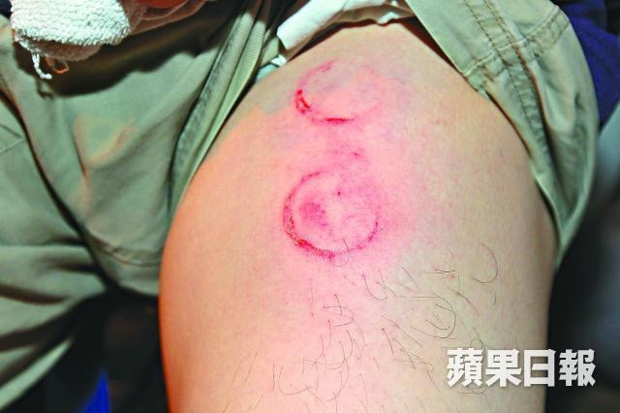
Photo 3: The injury of a journalist on his left thigh by the tear gas projectile.
Source: Apple Daily, 29 September 2014.

Issues concerned:
- The protest in Admiralty on 28 September 2014 was generally peaceful. The use of tear gas to disperse protesters is certainly excessive and disproportionate.
- The police did not stop firing tear gas canisters, even though the result obviously showed tear gas was ineffective in dispersing the protesters, due to the wind direction and environment. The use of force by the police did not have a clear objective and was without any restraints.
- The police did not provide medical support and remedies to the injured protesters in most cases.
Recommendations
- Express grave concern about the use of tear gas against peaceful protest.
- The Government should provide first-aid services to the protesters immediately after the use of force.
3.2 Abusive and excessive use of baton by the police
- The police’s use of baton should be considered as one of the most serious and worst abuses during the “umbrella movement”, which resulted in injuring dozens of protesters. The police took a tactical approach to strike protesters with baton collectively, in order to disperse the protesters in the street, and as a mean of crowd control. The police applied this approach during the night of 16 October 2014 and 1 December 2014 in the protest zone in Admiralty. It was also observed the police applied such approach to disperse the protesters in the protest zone in Mong Kok between 18 and 20 October 2014, 26 and 27 of November 2014.
- Bleeding wounds on the head was commonly found on the injured protesters who were struck by the police with a baton.
- At least 40 protesters were injured due to the police’s action between 18 and 20 October 2014, in which seven protesters were found with bleeding wounds on their heads. Some of the injured protesters claimed the police struck the baton to the crowd of protesters indiscriminately and resulted in having numerous protesters getting injured.
- It was reported a first-aid volunteer in the “Umbrella Movement”, Hung Chi-kin, was struck by a police’s baton over the back of his head when the police were dispersing the protesters on Lung Wo Road in Admiralty on 1 December 2014. He was found with retinal detachment in his right eye, and thus required a surgical treatment.
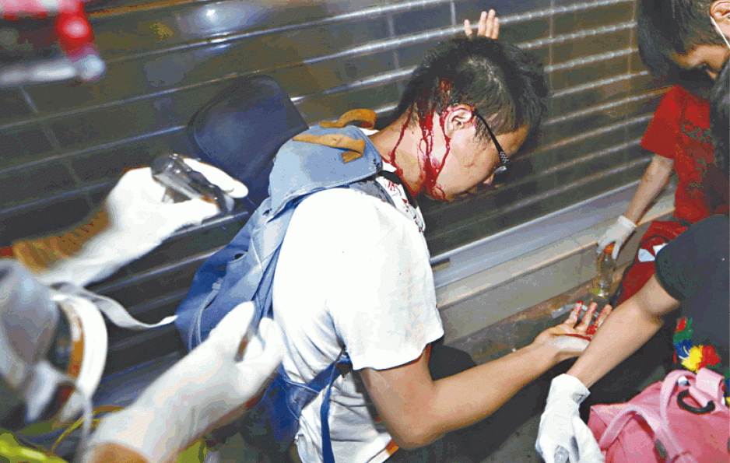
Photo 4: Number of protesters were being struck down by police with baton. Bleeding wounds were commonly found at their head.
Source: Apple Daily, 19 October 2014
Issues concerned:
- It is believed the aggressive approach and collective use of baton by the police officers were instructed and permitted by their commanders.
- Striking over the head of a person with baton should be considered as the application of lethal force, which the police have no justification to apply such force in the protest.
- There were media reports questioning the requirements of submitting a report after using batons during the umbrella movement, in which the report submission was later suspended. The suspension of such report removes an effective monitoring procedure to safeguard the proper use of the baton.
Recommendations:
- Express grave concern about the Police striking baton over the heads of protesters, which should be prohibited.
- Urge the Police to improve the transparency of the police’s principles on the use of forces, as well as the force continuum of the police’s weapons and techniques.
- The Government should provide the first-aid service to the protesters immediately after the use of force.
- Urge the Police to have a good documentation of the record of the use of forces by the police officers. The corresponding reasons, incidents, and injuries of the targets should be recorded.
- Urge the police to take a stricter approach in the use of baton.
- Urge the Police to provide the police officer with sufficient training on the use of forces and the legal liability of improper use of force.
3.3 Excessive use of OC foam
- The police have used OC foam against protesters in public assembly more frequently in the past few years. The use of OC foam by the police nowadays has become more than just a weapon for self-defense. It has now emerged as a non-lethal weapon to disperse protesters.
- In recent years, Police officers have deployed OC foam in a larger volume (Approx. 16oz) and a longer shooting range (6-10 meters) in public assembly. It was also found the police have equipped with backpack sprayers which can spray OC Foam in a large quantity (liters). In addition, it was found the police introduced “tear liquid” to disperse protesters in the “umbrella movement”.
- It was common that the police improperly applied OC foam on protesters, which resulted in the excessive use of force and created unnecessary suffering to the victims. Police’s malpractice in using OC foam including:
- Spray OC foam without sufficient warning;
- Spray OC foam continuously and excessively even when there was no aggressive action of the protesters, or the concerned action has already halted;
- The police removed the glasses and gloves of the protesters by hand, and directly spraying OC foam at their eyes;
- Spraying OC foam against protesters even the protesters have no aggressive action.
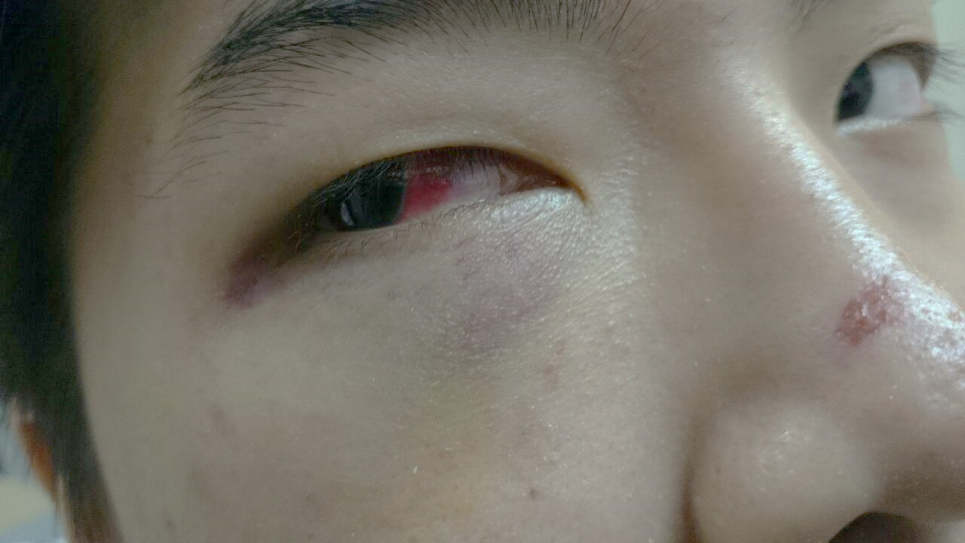
Photo 5: A protester claimed the police officer took off his goggles and sprayed OC foam at his eyes. He was also struck by baton on his face, and his chest was stepped by the police. Facial scratches were found and there was subconjunctival hemorrhage in his right eye.
Source: The organiser of Occupy Central with Love and Peace, 17 October 2014
Issues concerned:
- The spraying of OC foam lacks accuracy and precision, which indiscriminately attacks the people nearby the target.
- The police’s guidelines for the use of OC foam are not available to public access. It is difficult for the public to know whether the police have applied the force properly.
- The basic information of OC foam, “Tear Liquid”, or other similar weapons is not available to the public. It is difficult for the victims to obtain self-remedies.
- Remedies from the police for the victims suffered irritation from OC foam, “Tear Liquid”, or other similar weapons is not available in most incidents.
Recommendations:
- Urge the police to disclose the general guidelines on the use of OC foam to the public.
- Urge the police to provide information to the public on the basic remedial treatment for a person when he suffers irritation from OC Foam or “Tear Liquid”.
- Urge the police to take a stricter approach in the use of OC Foam or any similar weapons.
- The Government should provide the first-aid service to the protesters immediately after the use of OC foam, “Tear Liquid”, or other similar weapons.
Issue 4: Detaining the arrested persons for an unreasonably and unnecessarily long period
Article involved: Art 11
List of issues concerned: para. 16, 22

- By law, the police are empowered to detain an arrested person for a period of no longer than 72 hours. According to the police, the general principle is releasing the arrested person as soon as possible, and should not be longer than necessary for the investigation.

- Some of the protesters arrested during the umbrella movement were detained in a police station for 20 hours or more, even after they had completed the basic procedures after the arrest, including providing personal information and giving testimonies. Most of them were released without charges which prompted them to question whether the detention was necessary, as it was more like a punishment to them.

- It was reported the Convenor of Scholarism, Joshua Wong (17 years old at that time), who was one of the leaders in the umbrella movement, was arrested on 26 September 2014 for the unlawful entry of the square of Government Headquarter. Although the police had interrogated Wong for four times, and he had clearly shown his intent to remain silence, he was still not allowed to obtain the police’s bail and remained detained in the police station. Wong was released after 46 hours of detention by a habeas corpus granted by the high court.

- It was reported two male citizens have sought for compensation through civil action against the commissioner of the police for the unlawful arrest, detention and assault.The media reported a police officer assaulted the first applicant’s male genital organ which resulted in the applicant’s suffering of severe pain. Furthermore, the second applicant was arrested and assaulted by 6 to 7 police officers. He was detained in the police station for 48 hours, without any access to lawyers, and was continuously insulted by different police officers.

Issues concerned:

- Unnecessary detention infringes the liberty of the arrested person.

- The detention of an arrested person should be justified by legitimate reasons. It should not be used as a means of punishment by the police.

Recommendations:

- Urge the police to provide the reason for detention in writing to the arrested persons if the detention is over 12 hours.

- Urge the police to improve their procedures to avoid unnecessary detention.

Issue 5: Lack of a fully independent mechanism to receive and investigate complaints of police misconduct
Articles involved: Art 12, Art 13
List of issues concerned: para. 23(a), 23(b), 23(c), 23(d)
- Hong Kong has adopted a two-tier police complaint system. Regardless of their origin, all complaints against the Police are referred to the Complaints Against Police Office (CAPO) of the Hong Kong Police Force for handling and investigation. When CAPO has completed the investigation of a Reportable Complaint, it will submit an investigation report, together with relevant files, documents and materials, to the Independent Police Complaints Council (IPCC) for scrutiny.
- The independence of the complaint system is questionable because the handling and investigation of the complaints are taken solely by the CAPO.
- The victims have no confidence in the complaint system, and some of them are worried the information provided to the CAPO may be used to go against the complainant or others in criminal prosecution at a later stage.
- There were 316 complaints recorded in 2013-14 in relation to the assault by the police. However, 99 complaints were withdrawn and 164 complaints were considered as not pursuable.
- There was a complaint involving an alleged assault by a Police Superintendent during the discharge of his duties in Mong Kok in November 2014. The Superintendent was allegedly using a baton to assault a citizen. The case raised the public’s concern about whether the current complaint system is effective enough to monitor the police powers. There is a criticism that the CAPO intended to process the complaint slowly, in order to avoid forming a final result of the complaint before the retirement of the concerned Police Superintendent, which would allow him to escape from any disciplinary action should the complaint be found substantiated.
- On 22 July 2015, the IPCC decided the complaint against this Police Superintendent was found substantiated. However, as of 18 October 2015, the CAPO has not yet responded to IPCC’s decision on whether the CAPO agrees with the decision. It was reported the Superintendent has retired, with effect from 23 July 2015. Thus, he is not subject to any punishment or disciplinary action, unless the Department of Justice or the police decided to prosecute him for a criminal offence for the assault.
Issues concerned

- Hong Kong lacks a fully independent mechanism to receive and investigate complaints of police misconduct.
- Since the public has no confidence in this complaint system, the Government fails to provide remedies to the victims suffered from the detriment caused by the misconduct of the police.
- There is an absence of effective measures to ensure efficient cooperation between the CAPO and the IPCC.
Recommendation:
- Urge the Government to establish a fully independent mechanism to receive and investigate complaints. The mechanism should have the mandate to advise the Police as regards the sanction and follow-up actions in cases where a complaint has been found substantiated.
Issue 6: Searches conducted by the police
Article involved: Art 11
List of issues concerned: para. 18(a), 18(b)

3.1 Stop and search by the police
- The Police are empowered by law to stop a person for the purpose of identity check, ie. to demand such person to present an identity card. The Police are also empowered to stop and search any person in a public place if the police officer reasonably suspects such person have committed or intends to commit any offence. The identity card check and search are the actions commonly conducted by police officers patrolling in the street.
- According to the statistics provided by the Police, the police conducted an annual average of 371,027 times of identity card check and 1,800,850 times of stop and search action between 2008 and 2012. The government claimed more than 22,500 (i.e. 1%) offences are detected every year on average through such actions. The Government further claimed more than 7,400 wanted persons, over 4,500 illegal immigrants, overstayers and persons in breach of conditions of stay were arrested using these actions, from 2011 to 2012.
Issues concerned:
- According to the statistics, the successful percentage to detect offences by conducting identity card check and stop and search is only 1%. Half of the offences detected in the street can be simply done by identity card check, instead of the body search, for example, the detection of wanted persons and illegal immigrants. However, the number of stop and search conducted is much higher than the number of identity card check.
- The Police cannot justify conducting such a huge number of body search in the street. The Police’s policy to conduct large scale of identity card check and body search in the street is excessive and disproportionate.
Recommendations:
- Urge the police to minimise the number of identity card check and stop and search.
- Urge the police to take a stricter approach to decide on the necessity of conducting identity card check or stop and search.

Police General Orders, Chapter 49 Website: http://www.police.gov.hk/info/doc/pgo/en/Epgo049.pdf
Department of Justice, 15 October 2015 Website: http://www.doj.gov.hk/eng/public/pr/20151015_pr1.html
Reported in South China Morning Post on 19 May 2015 Website: http://www.scmp.com/news/hong-kong/law-crime/article/1803108/occupy-demonstrator-cleared-assaulting-police-pro-democracy?page=all
Reported in Apple Daily on 29 September 2014, Website: http://hk.apple.nextmedia.com/news/art/20140929/18883297
Reported in Apple Daily on 29 September 2014, Website: http://hk.apple.nextmedia.com/news/art/20140929/18883297
Reported by Radio Television Hong Kong on 26 September 2015 Website: http://news.rthk.hk/rthk/ch/component/k2/1213784-20150926.htm
Hong Kong Police Force, Guidance to an Arrested Person on Arrest and Detention Website: http://www.police.gov.hk/info/doc/pol/en/Pol-1128.pdf
Reported in SCMP on 28 September 2014, Website: http://www.scmp.com/news/hong-kong/article/1603471/scholarisms-joshua-wong-released-high-court-judges-instruction?page=all
Reported in Apple Daily and Metro Daily on 14 April 015 Website: http://hk.apple.nextmedia.com/realtime/news/20150414/53632033 http://www.metrohk.com.hk/?cmd=detail&id=274877
Reported in Hong Kong Free Press on 21 July 2015 Website: https://www.hongkongfp.com/2015/07/21/accused-superintendent-claims-he-used-baton-to-pat-protesters-in-occupy-assault-case/
Legislative Council Question on 30 October 2013, Stop and question or stop and search actions by Police Website: http://www.info.gov.hk/gia/general/201310/30/P201310300374.htm

