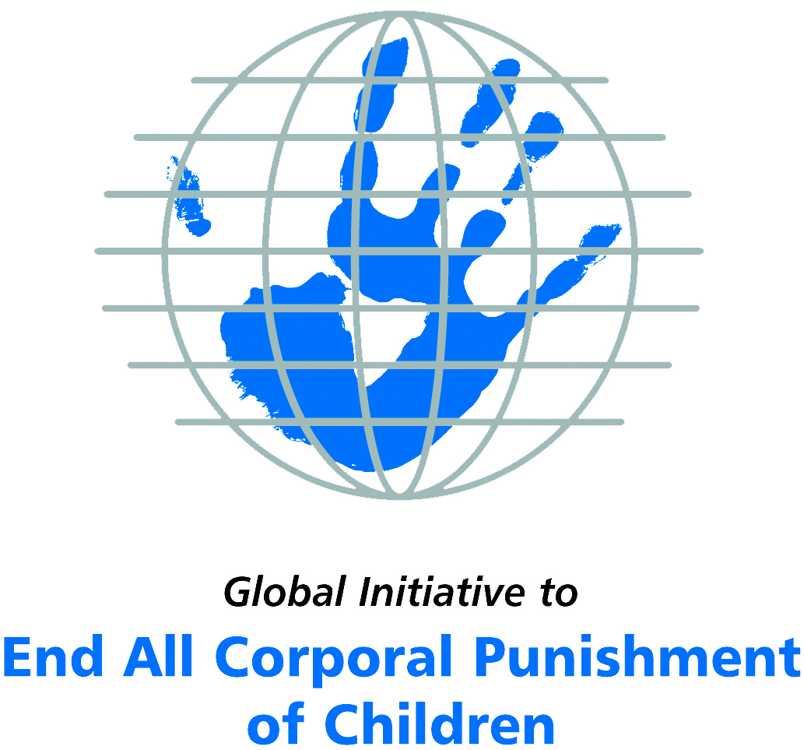
Briefing on Ecuador for the Committee on the Rights of Persons with Disabilities, 18th session, August/September 2017
From the Global Initiative to End All Corporal Punishment
of Children, June 2017
(a) About the Global Initiative to End All Corporal Punishment of Children
1. The Global Initiative (www.endcorporalpunishment.org) promotes universal prohibition and elimination of corporal punishment in fulfilment of states’ obligations under the UN Convention on the Rights of the Child and other international treaties. Our aims are supported by UNICEF, UNESCO, human rights institutions and international and national NGOs. Since 2002, the Global Initiative has regularly briefed the Committee on the Rights of the Child on this issue, and since 2004 has similarly briefed the Committee Against Torture, the Committee on the Elimination of Discrimination Against Women, the Committee on Economic, Social and Cultural Rights, the Human Rights Committee and the Human Rights Council; we have briefed the Committee on the Rights of Persons with Disabilities since the beginning of its work.

(b) Summary
2. Corporal punishment of children in Ecuador is not yet prohibited in the home and in alternative care and day care settings, in violation of the fundamental right of all children to protection from corporal punishment and other cruel or degrading forms of punishment, and there are reports of corporal punishment being used as a sentence for a crime in indigenous communities. It is unlawful in schools and penal institutions. A Bill which would prohibit is currently being discussed in the National Assembly.
3. With reference to articles 7, 15, 16 and 17 of the Convention on the Rights of Persons with Disabilities, and in light of the particular vulnerability of children with disabilities to corporal punishment by adults, the jurisprudence of the UN treaty bodies, the emphasis on eradicating this form of violence given by the UN Secretary General’s Study on Violence against Children and the importance of the issue to achieving target 16.2 on ending violence against children in the 2030 Sustainable Development Goals, we hope the Committee on the Rights of Persons with Disabilities will:
- include the issue of corporal punishment in its List of Issues Prior to Reporting for Ecuador, in particular asking: “what steps are being taken to ensure that legislation fully protect children with disabilities from all violent punishment, including in the home and as a sentence for a crime in indigenous communities?”;
- recommend to the Government of Ecuador, in the Committee’s concluding observations on the second-third report, that “legislation is enacted to explicitly prohibit corporal punishment of all children in all settings – including the home and within indigenous communities – and that measures are put in place to ensure the law is properly implemented”.
(c) Detailed briefing
The right of children with disabilities not to be subjected to corporal punishment
4. The Convention on the Rights of Persons with Disabilities confirms that children with disabilities should enjoy all human rights and fundamental freedoms on an equal basis with other children (art. 7). The Convention also states that all persons have the rights to freedom from torture or cruel, inhuman or degrading treatment or punishment (art. 15), to freedom from exploitation, violence and abuse within and outside the home (art. 16) and to respect for their physical and mental integrity (art. 17). The jurisprudence of treaty monitoring bodies, led by the Committee on the Rights of the Child monitoring the Convention on the Rights of the Child, is clear that these rights put an obligation on states parties to prohibit and eliminate all corporal punishment of children, including within the family.
5. As confirmed in the UN Secretary General’s Study on Violence against Children, children with disabilities are particularly vulnerable to violence, including corporal punishment, and corporal punishment is a significant cause of impairment among children. Yet the obligation to prohibit corporal punishment is frequently ignored or evaded by governments. The near universal acceptance of violence in childrearing together with deeply held views that parents and other adults have a “right” to physically punish children can challenge efforts to achieve prohibition. It also means that corporal punishment – at least to some degree – is not readily perceived as violence in the same way as, for example, sexual and other socially unacceptable forms of violence.
6. The newly adopted Sustainable Development Goals under the 2030 Agenda include target 16.2 on ending all forms of violence against children. Violent punishment is the most common form of violence against children: ending it through the adoption and implementation of legislation prohibiting it in all settings including the home is critical.

The legality of corporal punishment of children with disabilities in Ecuador
7. Corporal punishment of children in Ecuador is unlawful in schools and penal institutions, but children with disabilities may lawfully be subjected to physical punishment in the home, and in alternative care and day care settings. Corporal punishment may still be used as a sentence for a crime in indigenous communities.
8. Corporal punishment is lawful in the home. Article 67 of the Children and Adolescents Code 2003 defines ill-treatment of children, and article 76 states that abusive practices suffered by children cannot be justified on the grounds that they are educative methods or traditional cultural practices, but this is not interpreted as prohibiting all corporal punishment, however light, in childrearing. Provisions within the Constitution 2008, the Law against Violence against Women and the Family 1995, the Childhood and Adolescence Code 2003 and the Criminal Code 1991 protecting children for abuse are not interpreted as prohibiting all corporal punishment.
9. Corporal punishment is lawful in alternative care settings. There is no explicit prohibition of all corporal punishment in alternative care settings. Children are protected from some corporal punishment under articles 67 and 76 of the Children and Adolescents Code 2003.
10. Corporal punishment is lawful in some early childhood care and in day care for older children, including for children with disabilities. Corporal punishment is prohibited in preschool provision in articles 40 and 41 of the Children and Adolescents Code 2003 (see below), but it is not explicitly prohibited in other early childhood care and in day care for older children. Articles 67 and 76 of the Code protect children from some but not all corporal punishment.
11. Corporal punishment is unlawful in schools. Corporal punishment is explicitly prohibited in schools in articles 40 and 41 of the Children and Adolescents Code 2003.
12. Corporal punishment is unlawful as a disciplinary measure in penal institutions. Article 38 of the Penal Code 2014 states (unofficial translation): “Persons under the age of eighteen - Persons under eighteen years of age in conflict with the criminal law shall be subject to the Organic Code of Children and Adolescents”. This includes articles 40 and 41 (see above).
13. Corporal punishment is mainly unlawful as a sentence for crime. Corporal punishment is unlawful as a sentence for crime under the Constitution 2008, the Criminal Code 1991 and the Criminal Procedure Code, which make no provision for it although do not explicitly prohibit it. However, the Constitution allows indigenous communities to follow their traditional customary forms of justice providing that they do not conflict with the Constitution or with national laws. Media reports suggest that these can include corporal punishments such as whipping and dousing with cold water and other public humiliation.
14. Opportunities for law reform. The Government signalled its commitment to prohibition by clearly accepting the recommendations to prohibit corporal punishment in all settings made during the Universal Periodic Review of Ecuador in 2012. In November 2016, a Bill prohibiting corporal punishment of children was put before the National Assembly. Article 10 of the Bill states (unofficial translation): “…No corporal punishment shall be qualified as reasonable or moderate and its use is completely forbidden…” and extends the prohibition to (unofficial translation) “…the father, mother, family, legal representatives and persons responsible for the education or care of children and adolescents, people who work in education, social services, health, administration of Justice, in the public or private sector and any other person who has custody or responsibility of a child or adolescent.” In January 2017, the Bill was in the second Committee stage – the last phase before the final vote.

Recommendations by human rights treaty monitoring bodies and during the UPR
15. The Committee on the Rights of the Child has twice recommended to Ecuador that corporal punishment of children be prohibited in all settings, including the home – in its concluding observations on the state party’s second/third report in 2005 and on the fourth report in 2010.
16. In 2009, the Human Rights Committee expressed concern at corporal punishment of children in the family and other contexts in Ecuador and recommended that steps be taken to put an end to it, including the promotion of non-violent discipline and public information campaigns.
17. In 2010, the Committee Against Torture recommended to Ecuador that corporal punishment of children be prohibited in the home.
18. The Government accepted recommendations to prohibit corporal punishment in all settings including the family, made during the Universal Periodic Review of Ecuador in 2012.

Briefing prepared by the Global Initiative to End All Corporal Punishment of Children
www.endcorporalpunishment.org; info@endcorporalpunishment.org

Pinheiro, P. S. (2006), World Report on Violence against Children, Geneva: United Nations. See also Krug E. G. et al (eds) (2002), World Report on Violence and Health, Geneva: World Health Organisation
See, for example, The Star, 11 May 2003; Hemisphere, 22 March 2004; IPSNews.net, 26 May 2010
5 July 2012, A/HRC/21/4, Report of the working group, paras. 135(21) and 135(22)
Information given by ChildFund Ecuador, January 2017
13 September 2005, CRC/C/15/Add.262, Concluding observations on second/third report, paras. 37, 38, 39, 73 and 74; 2 March 2010, CRC/C/ECU/CO/4, Concluding observations on fourth report, paras. 7, 8, 9, 10, 45, 46, 47, 64 and 65
4 November 2009, CCPR/C/ECU/CO/5, Concluding observations on fifth/sixth report, para. 14
7 December 2010, CAT/C/ECU/CO/4-6, Concluding observations on fourth-sixth report, para. 18
5 July 2012, A/HRC/21/4, Report of the working group, para. 135

