SHADOW REPORT
FROM THE DEAF COMMUNITY OF CHILE
TO THE EIGHTH PERIODIC REPORT
OF THE STATE OF CHILE.

COMMITTEE ON THE ELIMINATION OF DISCRIMINATION AGAINST WOMEN C (CEDAW)

Participation of Non-Governmental Organizations (NGOs)
Geneva, Palais des Nations, Room XXIII
89th Session (October 7-25, 2024)
Pre-Session Working Group for the 91st Session (October 28-November 1, 2024)

ASOCH, ASOCIACIÓN DE SORDOS DE CHILE
Affiliated with the World Federation of the Deaf,
Representative: President Gustavo Vergara Navarro, gustavoverg@gmail.com.
Santiago, Chile.

AÜÜKINKO, ORGANIZACIÓN DE INTÉRPRETES DE COQUIMBO
Representative: Presidenta Karen Madariaga Cabrera, k.madariaga20@gmail.com
Coquimbo, Chile.

CECASOV, CENTRO DE ESTUDIOS PARA SORDOS DE VALPARAÍSO
Representative: Directora María Teresa Hidalgo Neira, mthidalgo.n@gmail.com
Valparaíso, Chile.

CENTRO DE PADRES Y APODERADOS COLEGIO DE SORDOS ANNE SULLIVAN
Representative: Presidenta Carin Correa, centrodepadresannesullivan1@gmail.com
Santiago, Chile.

CORPORACIÓN HIPOACUSIA DE CHILE
Representative: Presidente Irma Sandra Saavedra Martínez, contacto@corporacionhipoacusia.org
Valparaíso, Chile.

FEDERACIÓN DE DEPORTES DE SORDOS DE CHILE
Representative: President Sara Contreras Bahamondes, fedenaschile@gmail.com
Santiago, Chile.

GRUPO DE AMIGOS Y FAMILIARES DE SORDOS DE COQUIMBO.
Representative: Presidente William Ruiz Álvarez, clufasoco@gmail.com
Coquimbo, Chile

GRUPO DE AMIGOS Y FAMILIARES DE NIÑAS Y NIÑOS SORDOS EX COLEGIO ANGLICANO DE TEMUCO.
Representative: Coordinadoras Limena Vargas, limena_vargas@hotmail.com
Temuco, Chile.

ESILENSE, ACADEMIA DE ESTUDIO E INVESTIGACIÓN DE LA LENGUA DE SEÑAS
Representative: Director Alexis Vergara Estibill, alexis.estibill@gmail.com
Santiago, Chile.

TECHNICAL WRITING: Attorney Álvaro Jofré Contreras, alvarojofrecontreras@gmail.com
SOLE ANNEX: Mujer Punto de Equilibrio ASOCH 2024

Committee of Experts CEDAW,

As President of the Deaf Association of Chile, I extend my warmest greetings and respectfully submit, through this letter, the Shadow Report of the Deaf Association of Chile concerning the United Nations Convention on the Elimination of All Forms of Discrimination Against Women. This report specifically addresses the situation of Deaf women and is part of our activities commemorating the 100th anniversary of our organization, which will take place in October 2026.

We hope to contribute to improving the living conditions of women and urge you to advocate with the State of Chile for the full respect and promotion of the cultural and linguistic rights of Deaf individuals.

Sincerely,

Gustavo Vergara Navarro.
President.
Asociación de Sordos de Chile, WFD.

Santiago, Chile, september 9, 2024.

SHADOW REPORT FROM THE DEAF COMMUNITY OF CHILE TO THE EIGHTH PERIODIC REPORT OF THE STATE OF CHILE.

In terms of the rights of Deaf women, this Report will highlight the issues related to the violation of fundamental rights and freedoms, all stemming from a lack of awareness and omissions by the State regarding the respect and promotion of the cultural and linguistic rights of Deaf women.

This lack of awareness is reflected in the inadequate design of public policies that do not address the reality and needs of Deaf women, who are left invisible and marginalized.

In our view, better conditions can be created for Deaf women by respecting their identity as native sign language users and Deaf culture individuals.
This can be achieved by considering existing legal frameworks in Chile that address other cultural and linguistic minorities.

Index.
I. DEAF WOMEN AND POLITICAL LIFE.
II. DEAF WOMEN AND EDUCATION.
III. DEAF WOMEN AND EMPLOYMENT.
IV. DEAF WOMEN AND HEALTH.
V. DEAF WOMEN, JUSTICE AND PROTECTION AGAINST GENDER VIOLENCE.
VI. CONCLUSION TO THE REPORT.
VII. SINGLE APPENDIX: WOMEN AND THE BALANCE POINT.

RESUMEN EJECUTIVO.
Se evidencia la falta de representación de las mujeres Sordas en las instancias de participación política en materia de derechos de las mujeres informadas por el Estado en su Octavo Informe Periódico, tales como los Consejos Consultores del Servicio Nacional de la Mujer y del Ministerio de la Mujer. Se alienta al Estado a convocar a las organizaciones de personas Sordas para participar en ellos con representación.
Se evidencia la falta de accesibilidad a los programas y servicios del Estado en materia de educación por no implementarse en estos la lengua de señas. Asimismo, se denuncia la política estatal de destrucción de los cimientos de la comunidad Sorda, su identidad cultural individual y colectiva y la existencia de la lengua de señas, esto por la alienación forzada de los educandos Sordos a Establecimientos de Oyentes. Se recomienda al Estado dirigir los recursos económicos al apoyo de los Colegios de Sordos de curriculum común y proyecto intercultural bilingüe.
Se evidencia la falta de datos desagregados sobre la integración al mercado laboral de las mujeres Sordas. Se recomienda al Estado generar dicha cuantificación como primer paso para generar las respectivas políticas públicas que alivien la difícil situación económica de privaciones que sufren las mujeres Sordas de todas las edades.
Se evidencia la grave falta de acceso a los servicios médicos por causa de la falta de acceso a la información y comunicación con los médicos tratantes. Se exponen los casos de las mujeres Sordas embarazadas controladas en Hospitales del Estado y de la familia con el recién nacido en estado crítico, todos quienes no recibieron la información de los respectivos tratamientos lo que en definitiva fueron tomando por los médicos. Se recomienda al Estado destinar recursos para la capacitación en toma de conciencia de abogados y directores y para la contratación de intérpretes.
Se evidencia el no acceso a los programas del sector Justicia por sólo estar diseñados para usuarias oyentes, así como la inexistencia de adaptaciones de procedimientos judiciales para que las mujeres Sordas cuenten en juicio con intérpretes pagados por el Estado. Se recomienda destinar recursos para la capacitación en toma de conciencia de abogados, jueces, ministros, fiscales y defensores y para la contratación de intérpretes.
RÉSUMÉ EXÉCUTIF
Il est évident qu'il y a un manque de représentation des femmes sourdes dans les instances de participation politique concernant les droits des femmes, telles que les Conseils Consultatifs du Service National de la Femme et du Ministère de la Femme, comme le rapporte l'État dans son Huitième Rapport Périodique. Il est recommandé à l'État d'inviter les organisations de personnes sourdes à participer à ces conseils avec une représentation.
Il est également évident que les programmes et services éducatifs de l'État ne sont pas accessibles en raison de l'absence de mise en œuvre de la langue des signes. De plus, il est dénoncé que la politique de l'État détruit les fondements de la communauté sourde, son identité culturelle individuelle et collective, et l'existence de la langue des signes, à cause de l'assimilation forcée des élèves sourds dans des établissements pour entendants. Il est recommandé à l'État de diriger les ressources financières vers le soutien des écoles pour sourds avec des curricula communs et des projets bilingues interculturels.
Le manque de données désagrégées sur l'intégration des femmes sourdes sur le marché du travail est également évident. Il est recommandé à l'État de générer ces données comme première étape pour créer des politiques publiques afin d'atténuer les conditions économiques difficiles rencontrées par les femmes sourdes de tous âges.
La grave insuffisance d'accès aux services médicaux est évidente en raison du manque d'accès à l'information et à la communication avec les médecins traitants. Les cas de femmes sourdes enceintes surveillées dans des hôpitaux d'État et de familles avec des nouveau-nés en état critique, qui n'ont pas reçu les informations sur les traitements respectifs décidés par les médecins, sont exposés. Il est recommandé à l'État de consacrer des ressources à la formation des avocats et des directeurs, ainsi qu'à l'embauche d'interprètes.
Il est également évident que les programmes du secteur de la justice ne sont pas accessibles, car ils sont uniquement conçus pour les utilisateurs entendants, et il n'existe pas d'adaptations des procédures judiciaires pour que les femmes sourdes puissent bénéficier d'interprètes rémunérés par l'État lors des procès. Il est recommandé de consacrer des ressources à la formation des avocats, juges, ministres, procureurs et défenseurs, ainsi qu'à l'embauche d'interprètes.
EXECUTIVE SUMMARY
The lack of representation of deaf women in political participation instances related to women's rights, as reported by the State in its Eighth Periodic Report, is evident. This includes bodies such as the Consultative Councils of the National Women's Service and the Ministry of Women. The State is encouraged to invite organizations of deaf individuals to participate in these councils with representation.
There is a lack of accessibility to state education programs and services due to the absence of sign language implementation. Additionally, there is a report of state policies destroying the foundations of the deaf community, its individual and collective cultural identity, and the existence of sign language, due to the forced assimilation of deaf students into hearing institutions. It is recommended that the State allocate financial resources to support schools for the deaf with common curricula and bilingual intercultural projects.
There is a lack of disaggregated data on the integration of deaf women into the labor market. It is recommended that the State generate this data as a first step towards creating public policies to alleviate the difficult economic conditions faced by deaf women of all ages.
The severe lack of access to medical services is evident due to inadequate access to information and communication with treating doctors. Cases of deaf pregnant women monitored in state hospitals and families with critically ill newborns, who did not receive information about the respective treatments decided by doctors, are exposed. It is recommended that the State allocate resources for training lawyers and directors, as well as for hiring interpreters.
The lack of access to justice sector programs is also evident, as these programs are only designed for hearing users, and there are no adaptations of judicial procedures to ensure that deaf women have interpreters paid by the State during trials. It is recommended to allocate resources for training lawyers, judges, ministers, prosecutors, and defenders, as well as for hiring interpreters.

I. DEAF WOMEN AND POLITICAL LIFE.

1. Regarding the contents of article 7° of CEDAW, empirical evidence specifies what the focal points are for Deaf women in this matter:

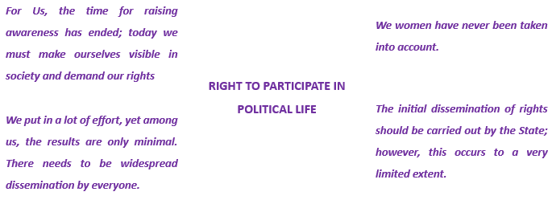
2. In its report, the State has informed this Committee about several instances of political participation and non-disaggregated data, which are observed as follows:
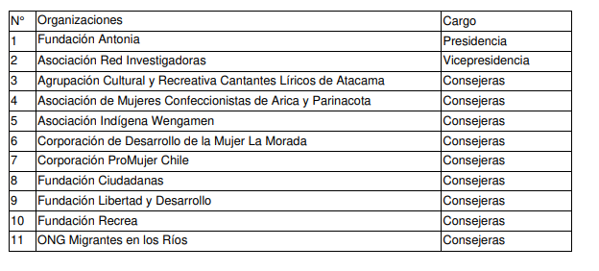
a) Council of the Civil Society (COSOC) of the National Women's Service: A consultative body aimed at incorporating the voice of citizens into the design and implementation of sectoral public policies. According to EXEMPT RESOLUTION NUMBER 946 OF NOVEMBER 7, 2023, for the period 2023-2028, its composition does not include any group of women with disabilities. Consequently, there is no representation of this sector, including the community of Deaf women in Chile, within the COSOC.

b) Advisory Council of the Ministry of Women and Gender Equality: Created by Law 20.820, its function is to advise the Minister in matters of public policy design. For the current period, it is formed without representation from organizations of women with disabilities or Deaf women.

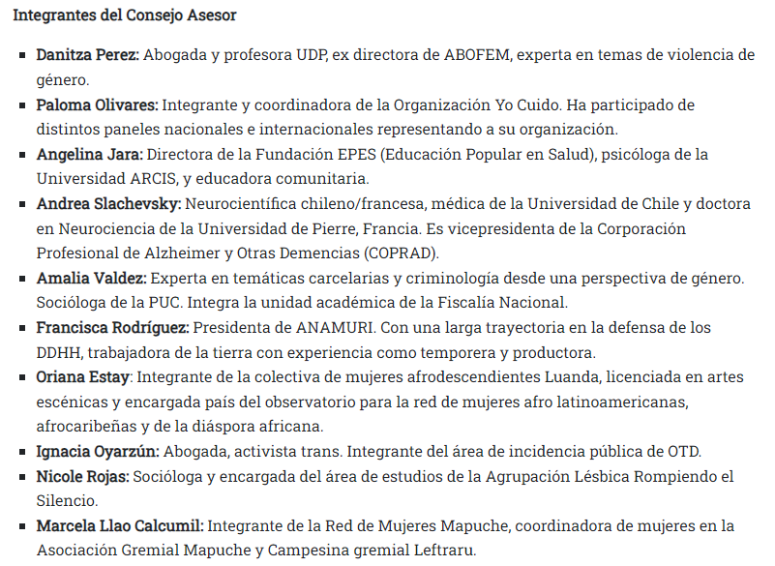

c) Undisaggregated Data: In the Report, the State refers to data on women's participation in the country's political and public life, including in the National Congress, Political Parties, Diplomacy, private company boards, and candidacies for public leadership positions. However, upon examination, there is a complete absence of disaggregated data for this particular group, and consequently, a lack of specific measures to promote the participation of women with disabilities and Deaf women.
3. RECOMMENDATION: To address this, it is recommended that the State invite Deaf organizations to facilitate their participation in Advisory Councils and generate disaggregated statistics for each category under review regarding Deaf women.

II. DEAF WOMEN AND EDUCATION.

4. Regarding the contents of Article 10° of CEDAW, empirical evidence specifies the key areas of attention for Deaf women in this matter as follows:
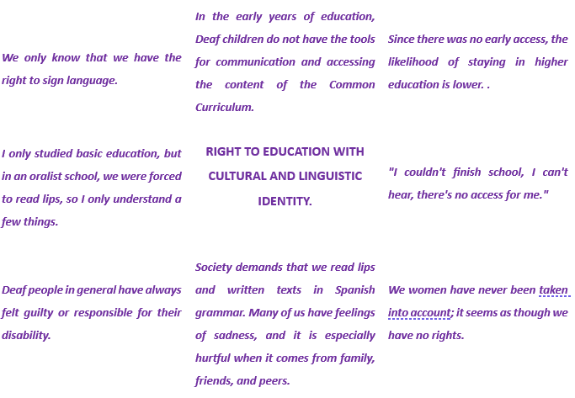
5. In its report, the State has informed this Committee about various public educational programs and services listed below.
6. Fulfilling a Dream Program: aimed at adult women who have dropped out of the education system to help them complete their interrupted studies; 'Better Adult' Program: targeted at women from the 60% most vulnerable demographic for job training; Protocol for Referral of Complaints of Irregularities: addressing rights violations of pregnant students in the school environment; Subsidy Program for Training and Specialization; all of which do not provide information on adjustments to be accessible to Deaf women, as they are designed solely with accessibility for hearing women in mind, excluding Deaf women.

7. LEARNING ON LINE and TV EDUCA CHILE programs, directed by the MINISTRY OF EDUCATION in 2020, aimed at providing distance education during the COVID pandemic. However, these programs were designed solely for hearing children, excluding Deaf children from their content. This led to complaints of discrimination and failure to meet proper functioning requirements under Law 18.838, which were dismissed by the NATIONAL TELEVISION COUNCIL, as it did not recognize the cultural and linguistic rights inherent to the dignity of Deaf children, namely:

a) Complaint CAS-38293-C9F7P4 of June 22, 2020;
b) Complaint CAS-41462-W8Q1W6 of July 20, 2020;
c) Complaint CAS-43543-P5B3F2 of July 28, 2020;
d) Complaint CAS-43813-C3K7L3 of August 09, 2020.

8. All these decisions were based on: “There would be no elements to establish a violation of the proper functioning of television services, according to the provisions of Article 40 bis of Law No. 18.838. For this reason, the National Television Council archives the records” . The dispute over jurisdiction in the matter is highlighted, with the NATIONAL TELEVISION COUNCIL stating: “The failure to include audiovisual communication mechanisms that enable people with hearing disabilities to access programming when appropriate, and particularly—as the complainant refers—a sign language interpreter box, in accordance with Article 62, letter j) of Law No. 20.422… this Council, as previously declared, is incompetent to address this issue, and SENADIS should appeal to the respective Local Police Judge, as stipulated in Article 57 of Law No. 20.422”; meanwhile the NATIONAL SERVICE FOR DISABILITY denies it.

9. THE SCHOOL INTEGRATION PROGRAM, implemented by Law 20.845 (2015), aims “to provide additional support to students with Special Educational Needs (SEN) of a permanent (associated with disability) or temporary nature who attend regular education establishments”. Under this program, the State pays Regular Educational Establishments (Hearing Schools) three times the amount of the subsidy for a “normal” student for each Deaf student they enroll, resulting in the following harmful effects:
FIRST. Harm to the student: The student is deprived of an academic environment with Deaf cultural peers, challenging linguistic peers, which prevents the development of the speech hemisphere of the brain and strips them of their cultural and linguistic identity. As explained by Hidalgo Neira, this can be described as follows:
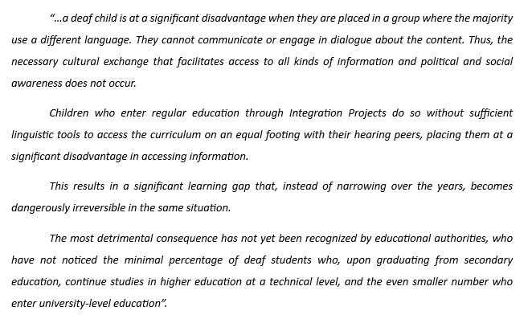

SECOND. Closure of Bilingual Intercultural Schools for the Deaf: Due to a drop in enrollment captured by regular schools, they have closed their doors or are about to do so. These include, among other cases:
a) School for Deaf Children of the Anglican Church of Temuco: Founded in 1981, it closed the school and its boarding facility in 2018, leaving 100 deaf indigenous girls from rural areas of 22 communes in the Araucanía region; 3 communes in the Los Ríos region; and 7 communes in the Los Lagos region without services.
b) Anne Sullivan School for Deaf Children in Santiago: Founded in 1852, it is the oldest school in the Deaf community in America. Today, parents are in conflict with the El Bosque municipality and the Ministry of Education over the use of the property, enrollment decline, and lack of maintenance of the infrastructure.
c) Study Center for the Deaf in Valparaíso: Directed by María Teresa Hidalgo Neira, educator, academic, researcher, and supporter of the Study and Training Center for the Deaf in Valparaíso, and developer of the intercultural bilingual education model for the Deaf in Chile. It is currently in a critical state of operation due to a sharp decline in enrollment caused by the migration of Deaf students to hearing schools.
THIRD. Damage to the Deaf community: Destruction of its foundations: The DEAF ASSOCIATION OF CHILE, approaching 100 years of uninterrupted operation, like other social organizations for Deaf people in Chile, was founded and has been maintained by Deaf individuals who met in Deaf schools, formed families, and communities.
10. Without Deaf schools, there will be no Deaf community, no Deaf culture, nor sign language, as evidenced by the following testimonies:
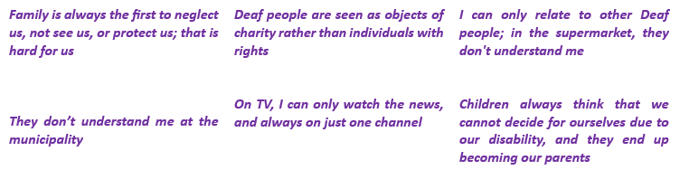

11. RECOMMENDATION. To correct the harmful public policies in Chile related to the Deaf community, it is recommended to replicate, where applicable, the legal framework for the recognition and respect of the cultural and linguistic identity of other minorities in the country, as reported by the State in paragraphs 95 and 96 about bilingual and intercultural educational services and policies.

III. DEAF WOMEN AND EMPLOYMENT.

12. Regarding the contents of Article 11° of CEDAW, empirical evidence, specifies what the areas of concern are for Deaf women in this matter:
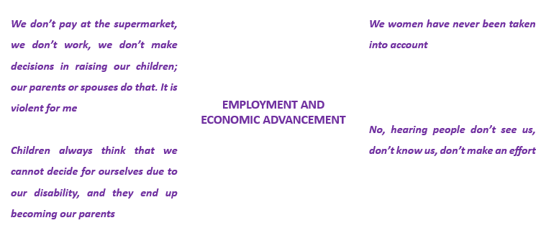

13. In its report, the State has informed this Committee about various data related to instances and mechanisms for promoting women’s participation in the labor market. It is noted that there is a lack of disaggregated data concerning Deaf women.
14. In practice, the employment of Deaf women is very challenging, and once achieved, it is highly exposed to abuse and mistreatment due to their triple status as women, persons with disabilities, and economically vulnerable. This situation is further exacerbated for Deaf women working in rural areas.
15. RECOMMENDATION. To address the aforementioned situation, it is recommended that the State generate the necessary data to begin designing public policies aimed at integrating Deaf women into the labor market.

IV. DEAF WOMEN AND HEALTH.

16. Regarding the contents of Article 12° of CEDAW, empirical evidence, specifies what the areas of concern are for Deaf women in this matter:
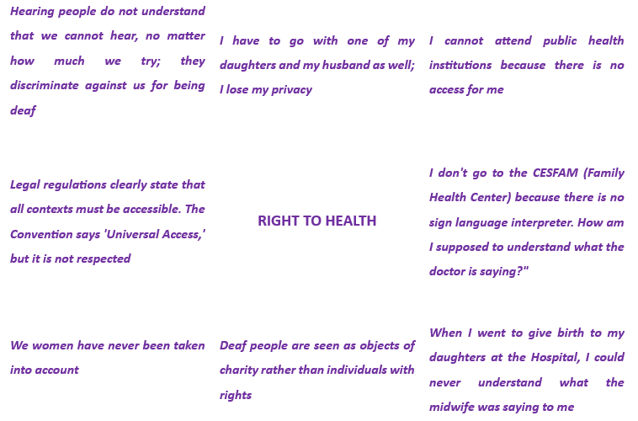

17. In its report , the State has informed this Committee about various public health programs and services, as observed below:
a) SALUDABLEMENTE, implemented in 2020 by the Division of Primary Care of the MINISTRY OF HEALTH, aims to provide “information on sexual and reproductive health, pregnancy, COVID immunization for pregnant women, and information on violence, shared responsibility, and self-care for pregnant women or new mothers”. However, its services are provided in a discriminatory format against Deaf women due to the lack of accessibility in Chilean Sign Language.

b) PROGRAM ON WOMEN, SEXUALITY, AND MATERNITY by the NATIONAL SERVICE FOR WOMEN AND GENDER EQUALITY; PROGRAM ON AFFECTION AND SEXUALITY by the MINISTRY OF EDUCATION; PSYCHOLOGICAL SUPPORT SERVICES for women who have been victims of sexual violence by the NATIONAL SERVICE FOR WOMEN AND GENDER EQUALITY. Their services are provided in a discriminatory format against Deaf women, as they are only accessible to hearing individuals and in Aymara, Rapa Nui, Mapudungun, and Quechua languages.

c) DOCUMENTS AND INFORMATION ON CONSENT FOR ABORTION IN THREE CAUSES: In 2021, the MINISTRY OF HEALTH distributed these documents through the national health network in accessible formats in the languages "Mapudungun, Aymara, Quechua, Rapa Nui, Creole, English, French, Portuguese" and in "Braille" but not in an accessible format for Deaf women. These documents and information pertain to the informed consent required by Law 21.030, which amends Article 119° of the SANITARY CODE, namely:
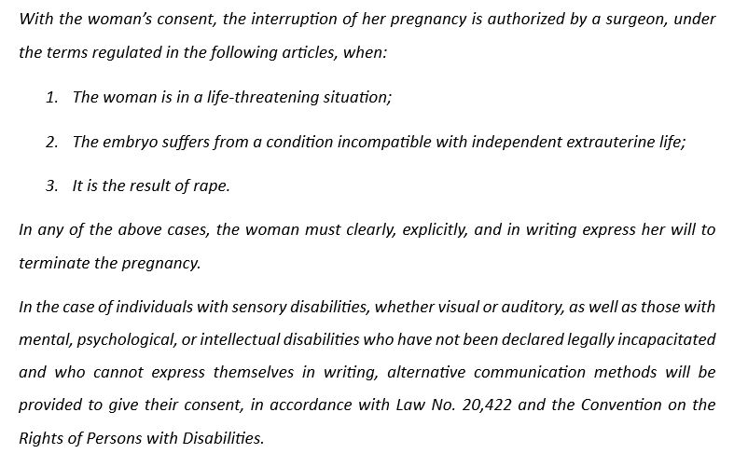

18. From the above, there is evidence of a legal normative conflict that undermines rights, between Article 119° of the SANITARY CODE, which prioritizes written consent, and Article 26 of Law No. 20.422, which recognizes Chilean Sign Language as the natural language of Deaf people.

19. In its report, the State acknowledges that it has not legally addressed the concept of "obstetric violence," resulting in the absence of "formal and systematic collection of instances of disrespect in gynecological-obstetric care" which would require and empower the MINISTRY OF HEALTH to "prevent, detect, and monitor the existence of violence against women in the context of health care, especially in primary care and during labor." In practice, this omission is evident in the following cases of obstetric violence that have been judicially processed with various jurisprudential outcomes:

a) ASOCH vs. ÑUBLE HEALTH SERVICE and SENADIS
20. "Protection Action 1280-2023" was filed before the Court of Appeals of Chillán in defense of a Deaf pregnant woman who, in her 35th week of pregnancy, had not received any medical attention in an accessible format with the assistance of a sign language interpreter. The action was also taken against the NATIONAL DISABILITY SERVICE (SENADIS) for failing to exercise the supervisory and sanctioning actions attributed to it by law.
21. The affected party initiated the case by filing the following formal complaint and its response:
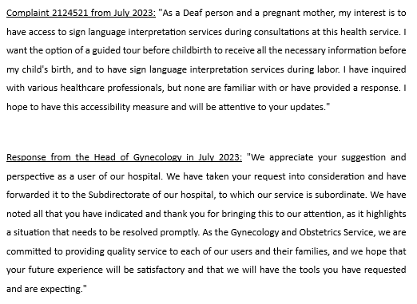

22. Regarding the State's response, it is important to highlight that:
a) The demand for respect of rights was taken by the State as merely a "suggestion," which might be addressed "in the future";
b) The same formal complaints can only be submitted in oral language and written format via the OFFICE OF INFORMATION, COMPLAINTS, AND SUGGESTIONS, which is also a violation of the cultural and linguistic identity and rights of Deaf women.

23. In practice, due to the lack of access to information, medical decisions are made and adopted unilaterally by the treating physician, deciding on the body and health of the Deaf woman and the unborn child.

24. The ÑUBLE HEALTH SERVICE reported to the Court denying the violation of the Deaf woman's rights. However, from the very statements made by the accused, it is evident that appropriate measures were not taken until mid-September 2023, with the estimated delivery date being mid-October 2023. The service confessed judicially that for 89% of the pregnancy period, there were no accessible sign language services to inform the Deaf pregnant woman about her progress and prenatal care.

25. Furthermore, the actual relocation of the Deaf pregnant woman from Chillán to Concepción, 100 kilometers from her home, constitutes a forced economic migration for the Deaf woman. She went to the Concepción Hospital upon learning that it had been judicially defeated by the ASSOCIATION OF DEAF PEOPLE OF CHILE in 2022 and had implemented sign language interpretation services for delivery.

26. In turn, the accused NATIONAL DISABILITY SERVICE, through Official Letter No. 1193-2023, dated September 29, 2023, signed by the Acting National Director of the National Disability Service, informed the COURT OF APPEALS OF CONCEPCIÓN that it has no legal competence to address the matter and that the complaint falls under the jurisdiction of the organs of Law No. 20,584, which regulates the rights and duties of individuals in relation to actions linked to their health care. This implies that:
a) It judicially denies having the supervisory authority granted by its organic law 20,422 Article 62(j);
b) It shows that its National Directorate has not undertaken efforts to obtain more supervisory powers;
c) It did not intervene in the litigation even after becoming aware of it, not assuming responsibility for the protection of women with disabilities;
d) It is unaware of the applicability of CEDAW and CRPD and adheres to the thesis that the Deaf woman must bear the cost of her interpreter.

27. The COURT OF APPEALS OF CHILLÁN rejected the protection action filed, accepting the defenses presented by both defendants. This decision was appealed to the SUPREME COURT, which rejected the appeal without providing reasons.

b) ASOCH vs. CONCEPCIÓN HEALTH SERVICE and SENADIS: “Protection Action 100326-2022” filed with the Court of Appeals of Concepción in defense of a Deaf pregnant woman who had not received any medical care during her pregnancy in an accessible format with the interpretation of a Chilean Sign Language interpreter recognized by the local Deaf community.

28. The affected individual was completely ignored by the respective instances of the Concepción Health Service. Consequently, with no other alternatives, she initiated judicial proceedings with the filing of the following formal complaint and its response:
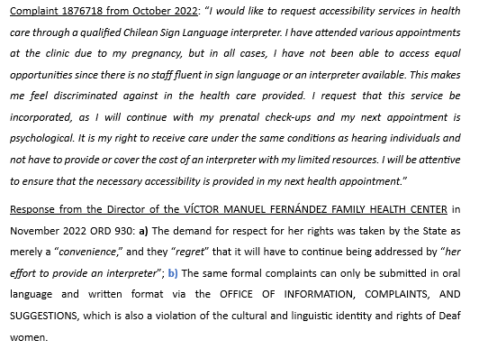

29. In practice, due to the lack of access to information, medical decisions are made and adopted unilaterally by the treating physician, deciding about the body and health of the Deaf woman and the unborn child.

30. Regarding this, the accused BIO-BIO HEALTH SERVICE informed the Court as follows:
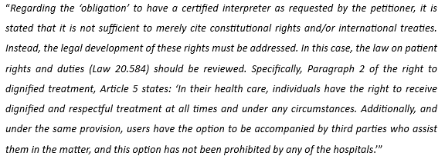

31. From the statements made by the accused, it is evident that:
a) They did not adopt appropriate measures for accessing information;
b) They do not consider themselves legally obligated to adopt accessibility measures;
c) They are unaware of the enforceability of CEDAW and CRPD;
d) They require the Deaf woman to bear the cost of her interpreter.

32. Additionally, the accused NATIONAL DISABILITY SERVICE reported to the Court as follows:
a) They declare judicially that they do not have the supervisory authority granted by their organic law 20.422, Article 62(j);
b) There is evidence that their National Directorate has not made any efforts to acquire the necessary powers to fulfill its legally defined purpose;
c) They did not intervene in the litigation even after becoming aware of it, thus not assuming responsibility for the protection of women with disabilities;
d) They are unaware of the enforceability of CEDAW and CRPD and adhere to the view that Deaf women should bear the cost of their interpreter.

33. In light of the evidence presented and the judicial confession of the accused, the COURT OF APPEALS OF CONCEPCIÓN accepted the protection action filed, declaring:
a) Regarding the accused Service of Health of Concepción: “The protection remedy presented in favor of the Asociación de Sordos de Chile (ASOCH) and YEXCENIA OLIVIA NEIRA ÁVILA is upheld, without costs. The Service of Health of Concepción, and specifically the Víctor Manuel Fernández Family Health Center, is ordered to immediately adopt the necessary accessibility measures and adjustments to ensure proper care for the specified patient and other individuals with hearing disabilities. This includes permanently providing a Chilean Sign Language interpreter for the health services required by this vulnerable group in our community.”
b) Regarding the accused National Disability Service: “It is also ordered that the National Disability Service ensure compliance with the previous obligation, by investigating the measures taken and reporting to this Court in case of any infringement.”

34. In the rationale of the ruling, the Court of Appeals of Concepción cites CEDAW, invoked by the complainant ASSOCIATION OF DEAF PEOPLE OF CHILE, as follows:
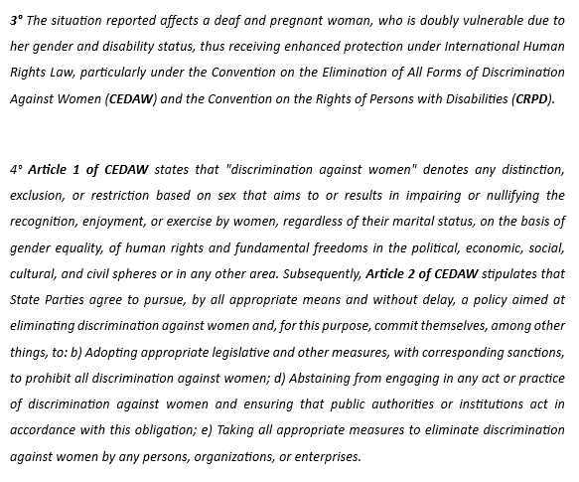

c) ASOCH vs. SERVICE OF HEALTH OF CONCEPCIÓN and SENADIS (II): "Protection Action 66839-2022" filed before the Court of Appeals of Concepción, in defense of a deaf mother and a deaf father of their newborn child with a critical health condition. With no other alternatives, they initiated legal proceedings in the case:
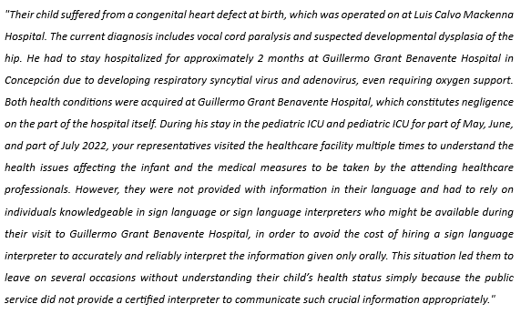

35. Regarding the matter, the accused SERVICE OF HEALTH OF CONCEPCIÓN reported to the Court the following:
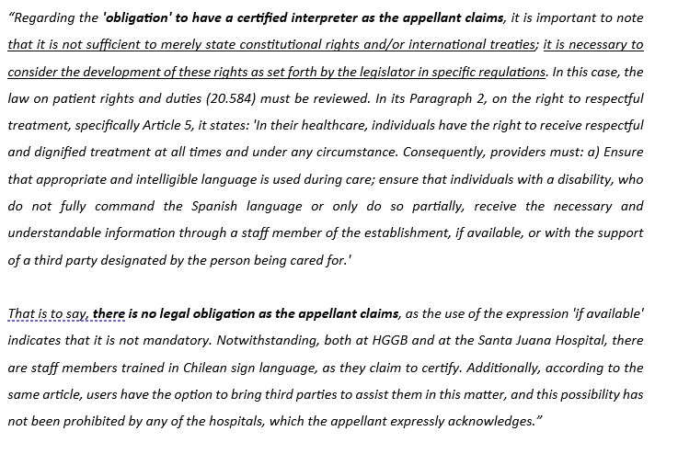

36. From the content of the statements made by the accused, it is evident that:
a) They did not adopt appropriate measures for accessing information;
b) They do not consider themselves legally obligated to adopt accessibility measures;
c) They are unaware of the enforceability of CEDAW (Convention on the Elimination of All Forms of Discrimination Against Women) and CRPD (Convention on the Rights of Persons with Disabilities);
d) They require the deaf woman to bear the cost of her interpreter.

37. In light of the evidence provided and the judicial admission of the accused, the COURT OF APPEALS OF CONCEPCIÓN accepted the protection action filed. In its resolution, it states:
a) Regarding the accused SERVICE OF HEALTH OF CONCEPCIÓN: “The protection action presented on behalf of the Asociación de Sordos de Chile (ASOCH) and YEXCENIA OLIVIA NEIRA ÁVILA is accepted, without costs. The Service of Health of Concepción, specifically the Víctor Manuel Fernández Family Health Center, is ordered to immediately adopt the necessary accessibility measures and adjustments for the proper care of the specified patient and other individuals with hearing disabilities, ensuring permanent availability of a Chilean sign language interpreter for the health care of this vulnerable group in our community, as needed”;
b) Regarding the accused NATIONAL DISABILITY SERVICE: “The National Disability Service is also ordered to ensure compliance with the previous obligation, to investigate the measures adopted, and to report to this Court in the event of any infringement.”

38. RECOMMENDATION. To address the situation previously evidenced, it is recommended that the State seek to reform the NATIONAL DISABILITY SERVICE to create a competent body to enforce the rights of deaf women and to train lawyers and health service managers nationwide in respecting the human rights of persons with disabilities.

V. DEAF WOMEN, JUSTICE AND PROTECTION AGAINST GENDER VIOLENCE.

39. Regarding the contents of Article 15° of CEDAW, empirical evidence specifies the areas of focus for deaf women in this matter:

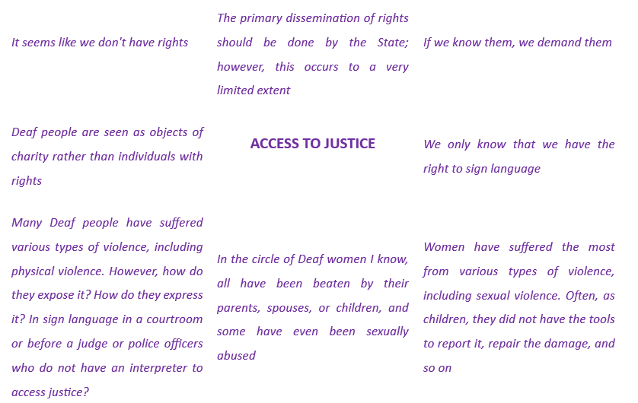

40. In its report, the State has informed this Committee about various programs and public services related to these matters, whose design only addresses the needs of hearing women, excluding deaf women, as observed below:
a) SERVICES OF THE MINISTRY OF WOMEN AND GENDER EQUITY: related to support and intervention in cases of violence against women, including CDA (Shelters); CARI (Comprehensive Reparation and Care Center); CDM (Women's Centers); CVS (Centers for the Care and Reparation of Women Victims/Survivors of Sexual Violence); CRH (Centers for the Reeducation of Men Who Commit Violence Against Their Partners); and the phone line 1455 (with web chat 1455 and WhatsApp +569 9700 7000);

b) SERVICES OF THE PUBLIC DEFENDER'S OFFICE: The report references the availability of defense attorneys, the Protocol for the care of foreign indigenous women deprived of liberty, and the Minimum Gender Equality Standards Manual, noting the following: b.1) Access to legal defense services is available orally through the following link: b.2) The Protocol for the care of foreign indigenous women deprived of liberty does not mention indigenous deaf women who are deprived of liberty nor does it have an equivalent focused on deaf women deprived of liberty; b.3) The Minimum Gender Equality Standards Manual, with its 19 pages and 9,905 words, does not contain any mention or provisions related to deaf women;
c) SERVICES OF THE MINISTRY OF JUSTICE: Regarding the Ministry of Justice's Mi Abogado Program, the State's report does not provide information on measures or adjustments related to accessibility for deaf women;
d) SERVICES OF THE JUDICIAL ACADEMY: Regarding these measures, the State's report refers to the Gender Equality and Non-Discrimination Plan. However, its 35 pages and 13,451 words do not contain any mention or provisions related to deaf women;
e) SERVICES OF THE PROSECUTOR'S OFFICE: Regarding these measures, the State's report refers to the Gender Equality Policy of the Prosecutor’s Office. Its 37 pages and 13,451 words do not contain any mention or provisions related to deaf women;
f) SERVICES OF THE JUDICIAL POWER: e.1) The Gender Equality and Non-Discrimination Policy, with its 62 pages, does not contain any mention or provisions related to deaf women using judicial services; e.2) The training conducted by the Technical Secretariat of Gender Equality and Non-Discrimination of the Supreme Court does not mention any provisions related to deaf women using judicial services; e.3) The study “Access to Justice for Women Victims of Violence Using the Judicial Power,” with its 256 pages and 99,389 words, does not mention any provisions related to deaf women using judicial services.

41. RECOMMENDATION. To address the lack of accessibility in public policies and programs within the Justice sector related to Deaf women, it is recommended to replicate, with necessary adjustments, the legal framework for the recognition and respect of the cultural and linguistic identity of other minorities in the country, such as:
a) Public Defender's Office, Protocol For The Care Of Indigenous Women Deprived Of Liberty, from the Public Defender's Office, page 40, states:

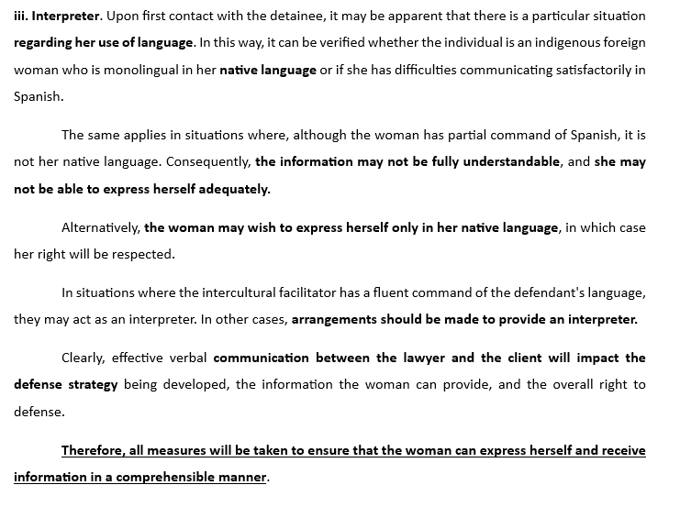

b) In the State's report, reference is made to The Study On Access To Justice For Women Victims Of Violence Using The Judicial Power, which states the following:
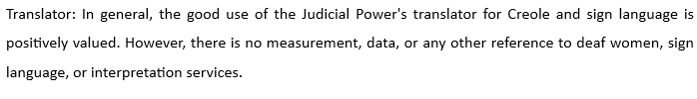

42. Indeed, we believe that initiatives that are respectful of and promote the cultural and linguistic rights of indigenous women can be effectively utilized to address the current situation of marginalization faced by deaf women using services in the justice sector. These women also have the right to the recognition and respect of their cultural and linguistic identity as deaf individuals.

VI. CONCLUSION TO THE REPORT.

43. In conclusion to the issues highlighted in this report, we believe that addressing them properly corresponds to the needs identified and prioritized in the Conversation and Workshop MUJER PUNTO DE EQUILIBRIO ASOCH 2024.

44. In this event, held in August 2024, 50 Deaf women participated, aged between approximately 25 and 80 years, coming from various communes in the Metropolitan Region, and in some cases, participants from other regions of the country.

45. These issues are fully detailed below and can be consulted in the single annex of this report:

IDENTIFICATION OF PRESENT NEEDS | - Need for Access to Information in Sign Language: This includes information related to health, education, social rights, and public services.  - Need to Develop Relevant Information and Strategies: This is to ensure accessibility and effective communication.  - Need for Education on the Recognition of Deaf People’s Rights: This involves educating individuals and institutions about the rights of deaf individuals.

PRIORIZATION OF  NEEDS | 1. Relevance: The need for access to information pertains to the deaf community. With such access, individuals can make free, informed choices and have equal opportunities in life, ensuring equity, equality of conditions, and opportunities.  2. Magnitude: This relates to the importance of promoting the recognition of the rights, culture, and condition of deaf individuals.  3. Urgency: This is based on several factors, primarily human rights, but also on the fact that in various contexts where there is no accessibility, there is a violation of rights.  4. Feasibility: There are laws and some programs that support accessibility practices. However, there is a lack of awareness about those that specifically aim to ensure accessibility. Therefore, it is feasible to develop strategies to promote these rights.

PRIORITIZED NEED | For deaf individuals, the prioritized need, based on its importance, is access to information.  This is essential for their everyday lives and the natural well-being that every individual deserves.  This need can be contextualized through both basic and complex examples:  - A woman who is deaf and is about to give birth.  - A student who is deaf attending a regular school with an integration program and needs to receive the academic curriculum.  - An adult who wants to apply for housing subsidies and needs to understand the requirements.  - A young person who wants to prevent pregnancy.  - An elderly person who wants to watch the news on television.  - The emergency response to an earthquake, a pandemic, or a curfew.  - A young person who wants to attend university.

VII. SINGLE APPENDIX: WOMEN AND THE BALANCE POINT.
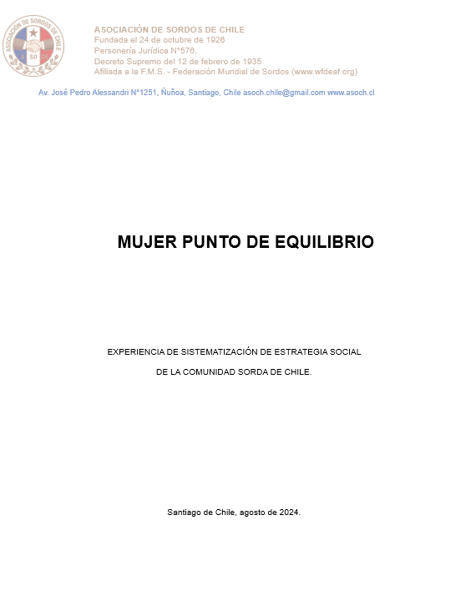

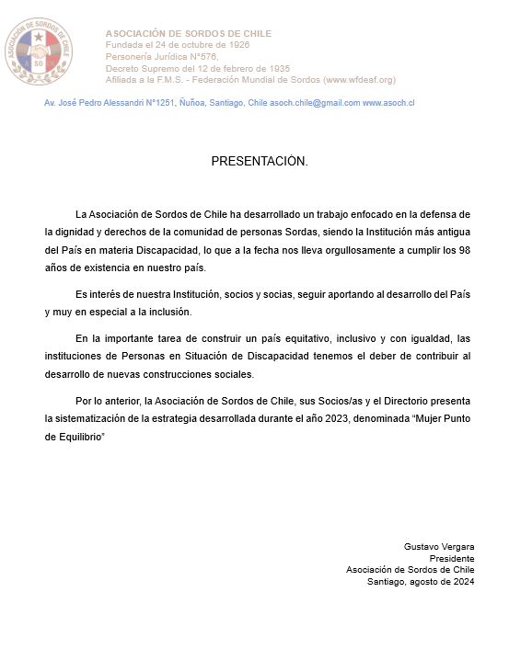

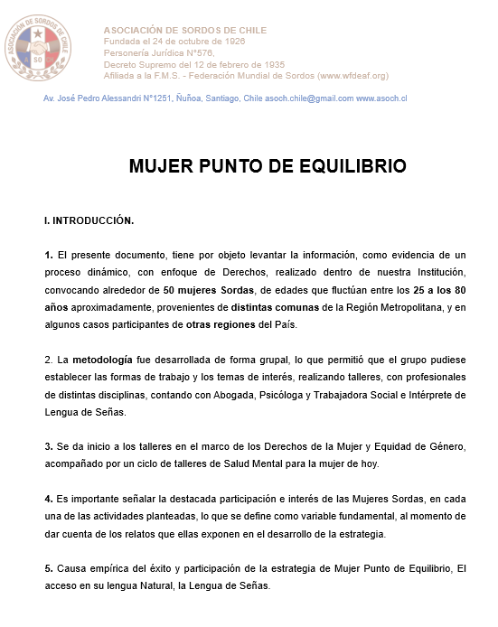

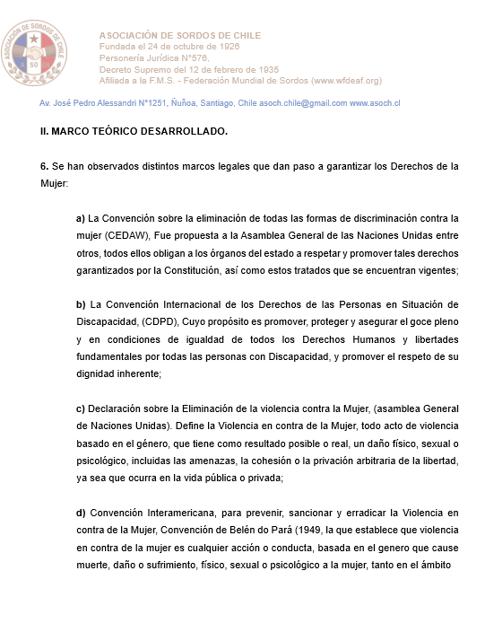

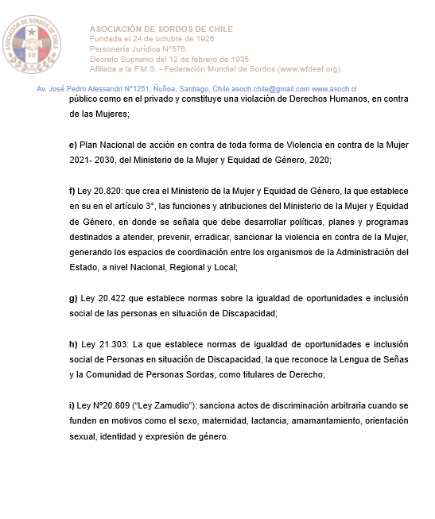

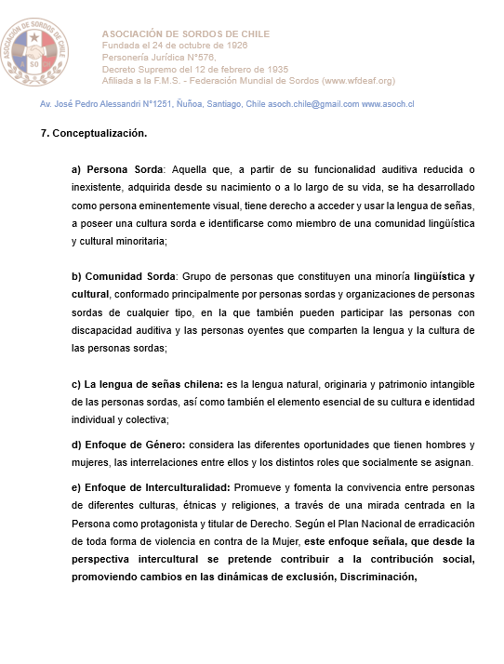

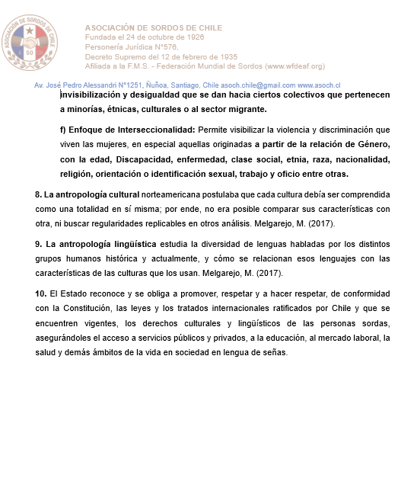

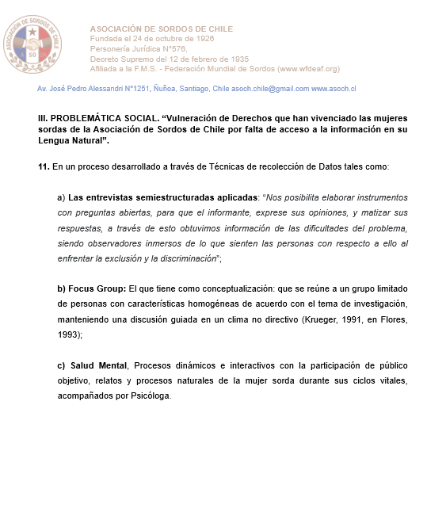

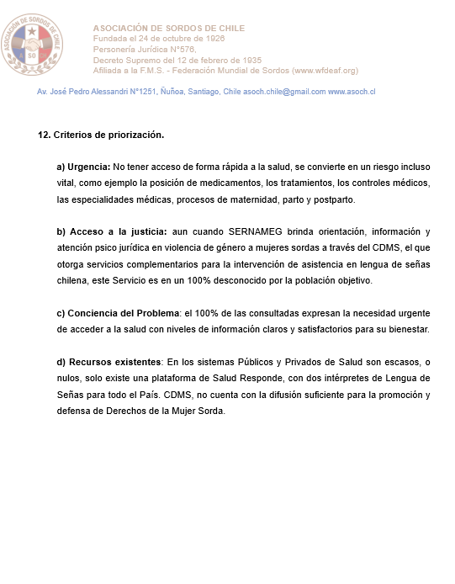

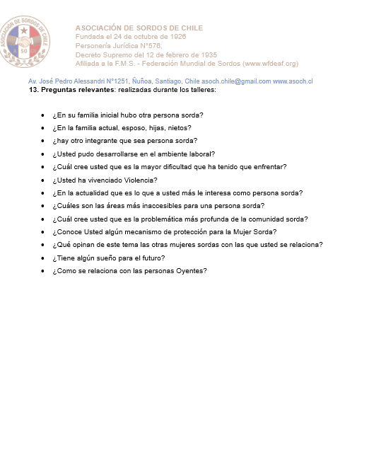

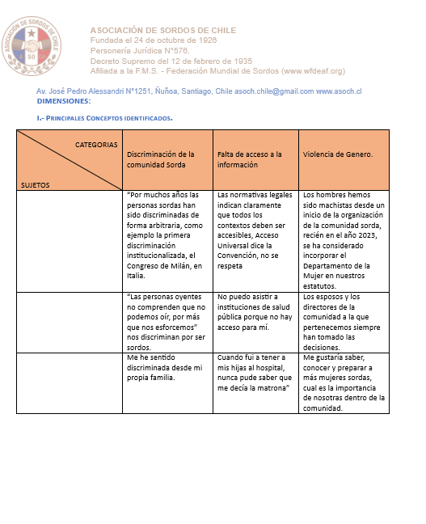

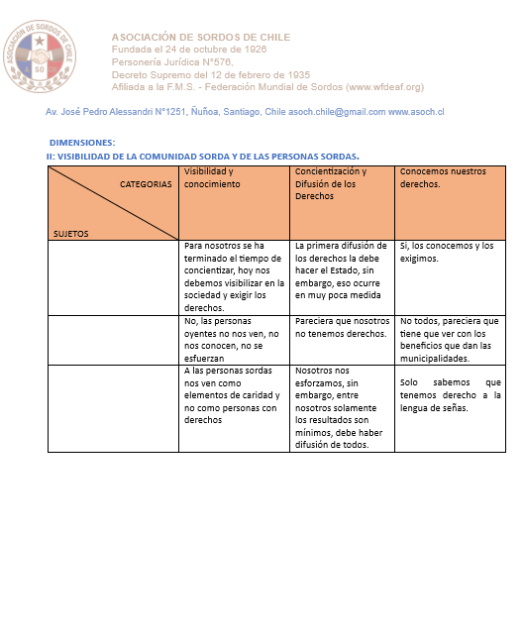

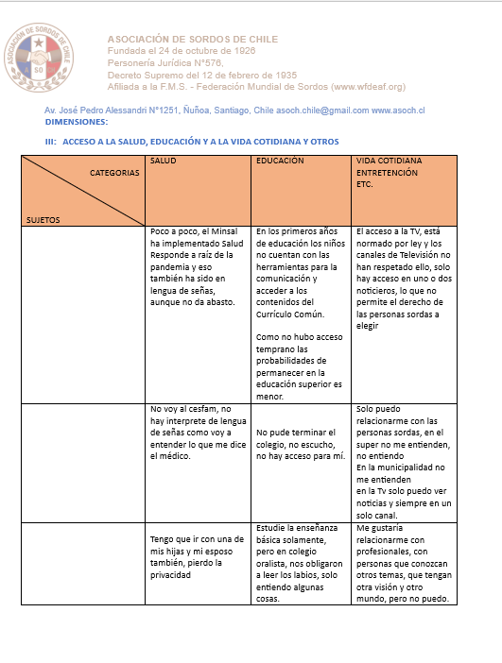

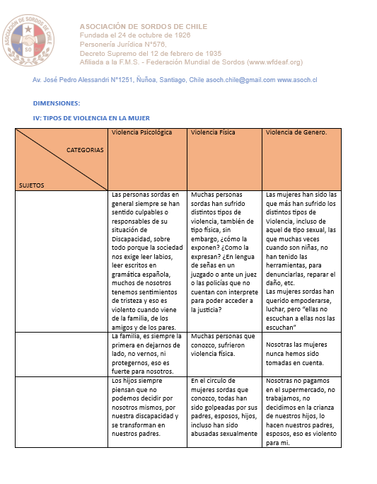

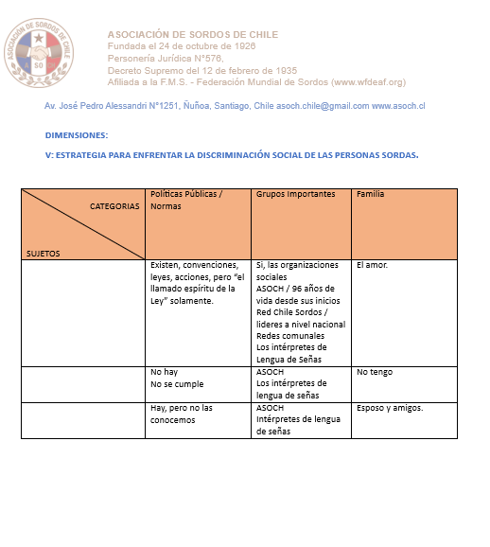

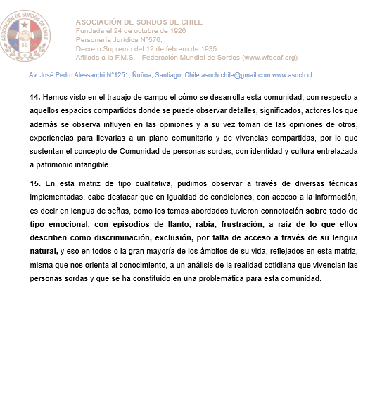

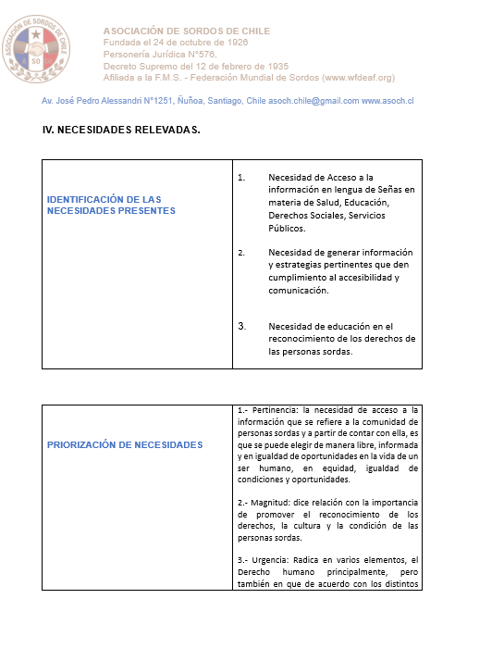

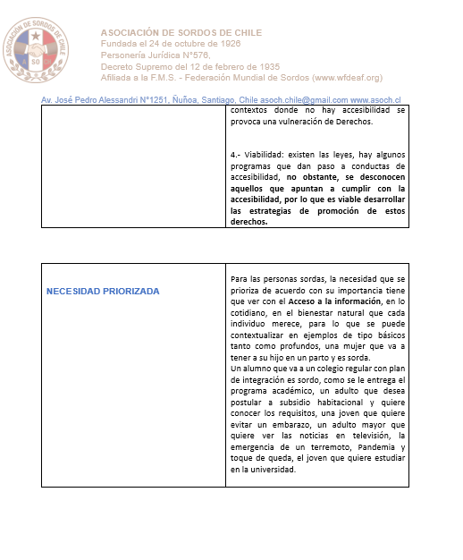

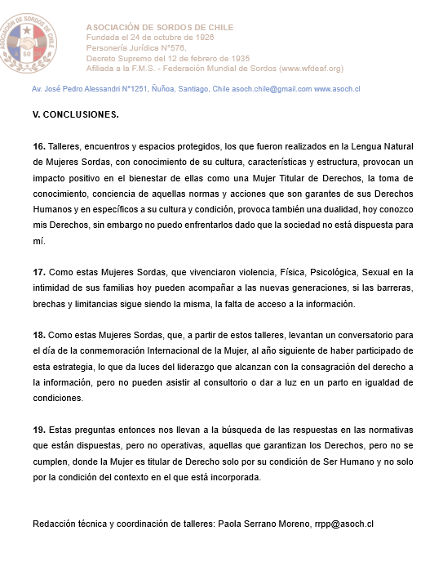

Numerales 57 y 58
Numerales 80 a 85
Numerales 97, 101, 105.
Rejected by decision made in CNTV Session on December 21, 2020.
Rejected by decision made in CNTV Session on December 31, 2021.
Rejected by decision made in CNTV Session on January 25, 2021.
Rejected by decision made in CNTV Session on November 23, 2020.
Numerales 92 y 93.
Docente, investigadora, Directora del Centro de Estudios para Sordos de Valparaíso, Chile.
MUJER PUNTO DE EQUILIBRIO ASOCH 2024.
WOMAN BALANCE POINT OF THE DEAF ASSOCIATION OF CHILE, 2024.
Numerals 108 a 127
WOMAN BALANCE POINT OF THE DEAF ASSOCIATION OF CHILE, 2024.
Numerals 97, 101, 105.
Numeral 137.
MUJER PUNTO DE EQUILIBRIO DE LA ASOCIACIÓN DE SORDOS DE CHILE, 2024.
Numerales 28 a 47

