Annex 10 - Free Legal Aid

Funds paid for the provision of free legal aid 2017 - 2019
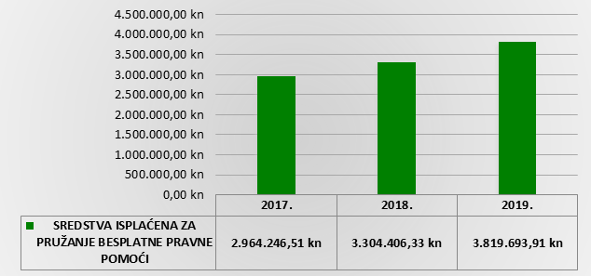

The ratio between the funds paid for primary and secondary legal aid 2017 - 2019
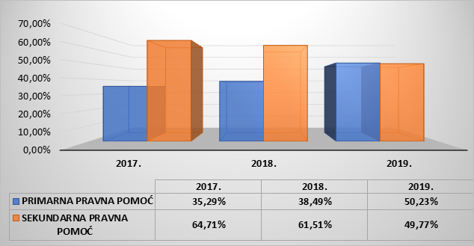
Source: Report of the Government of the Republic of Croatia on the Exercise of the Right to Free Legal Aid and the Use of Funds in 2019

