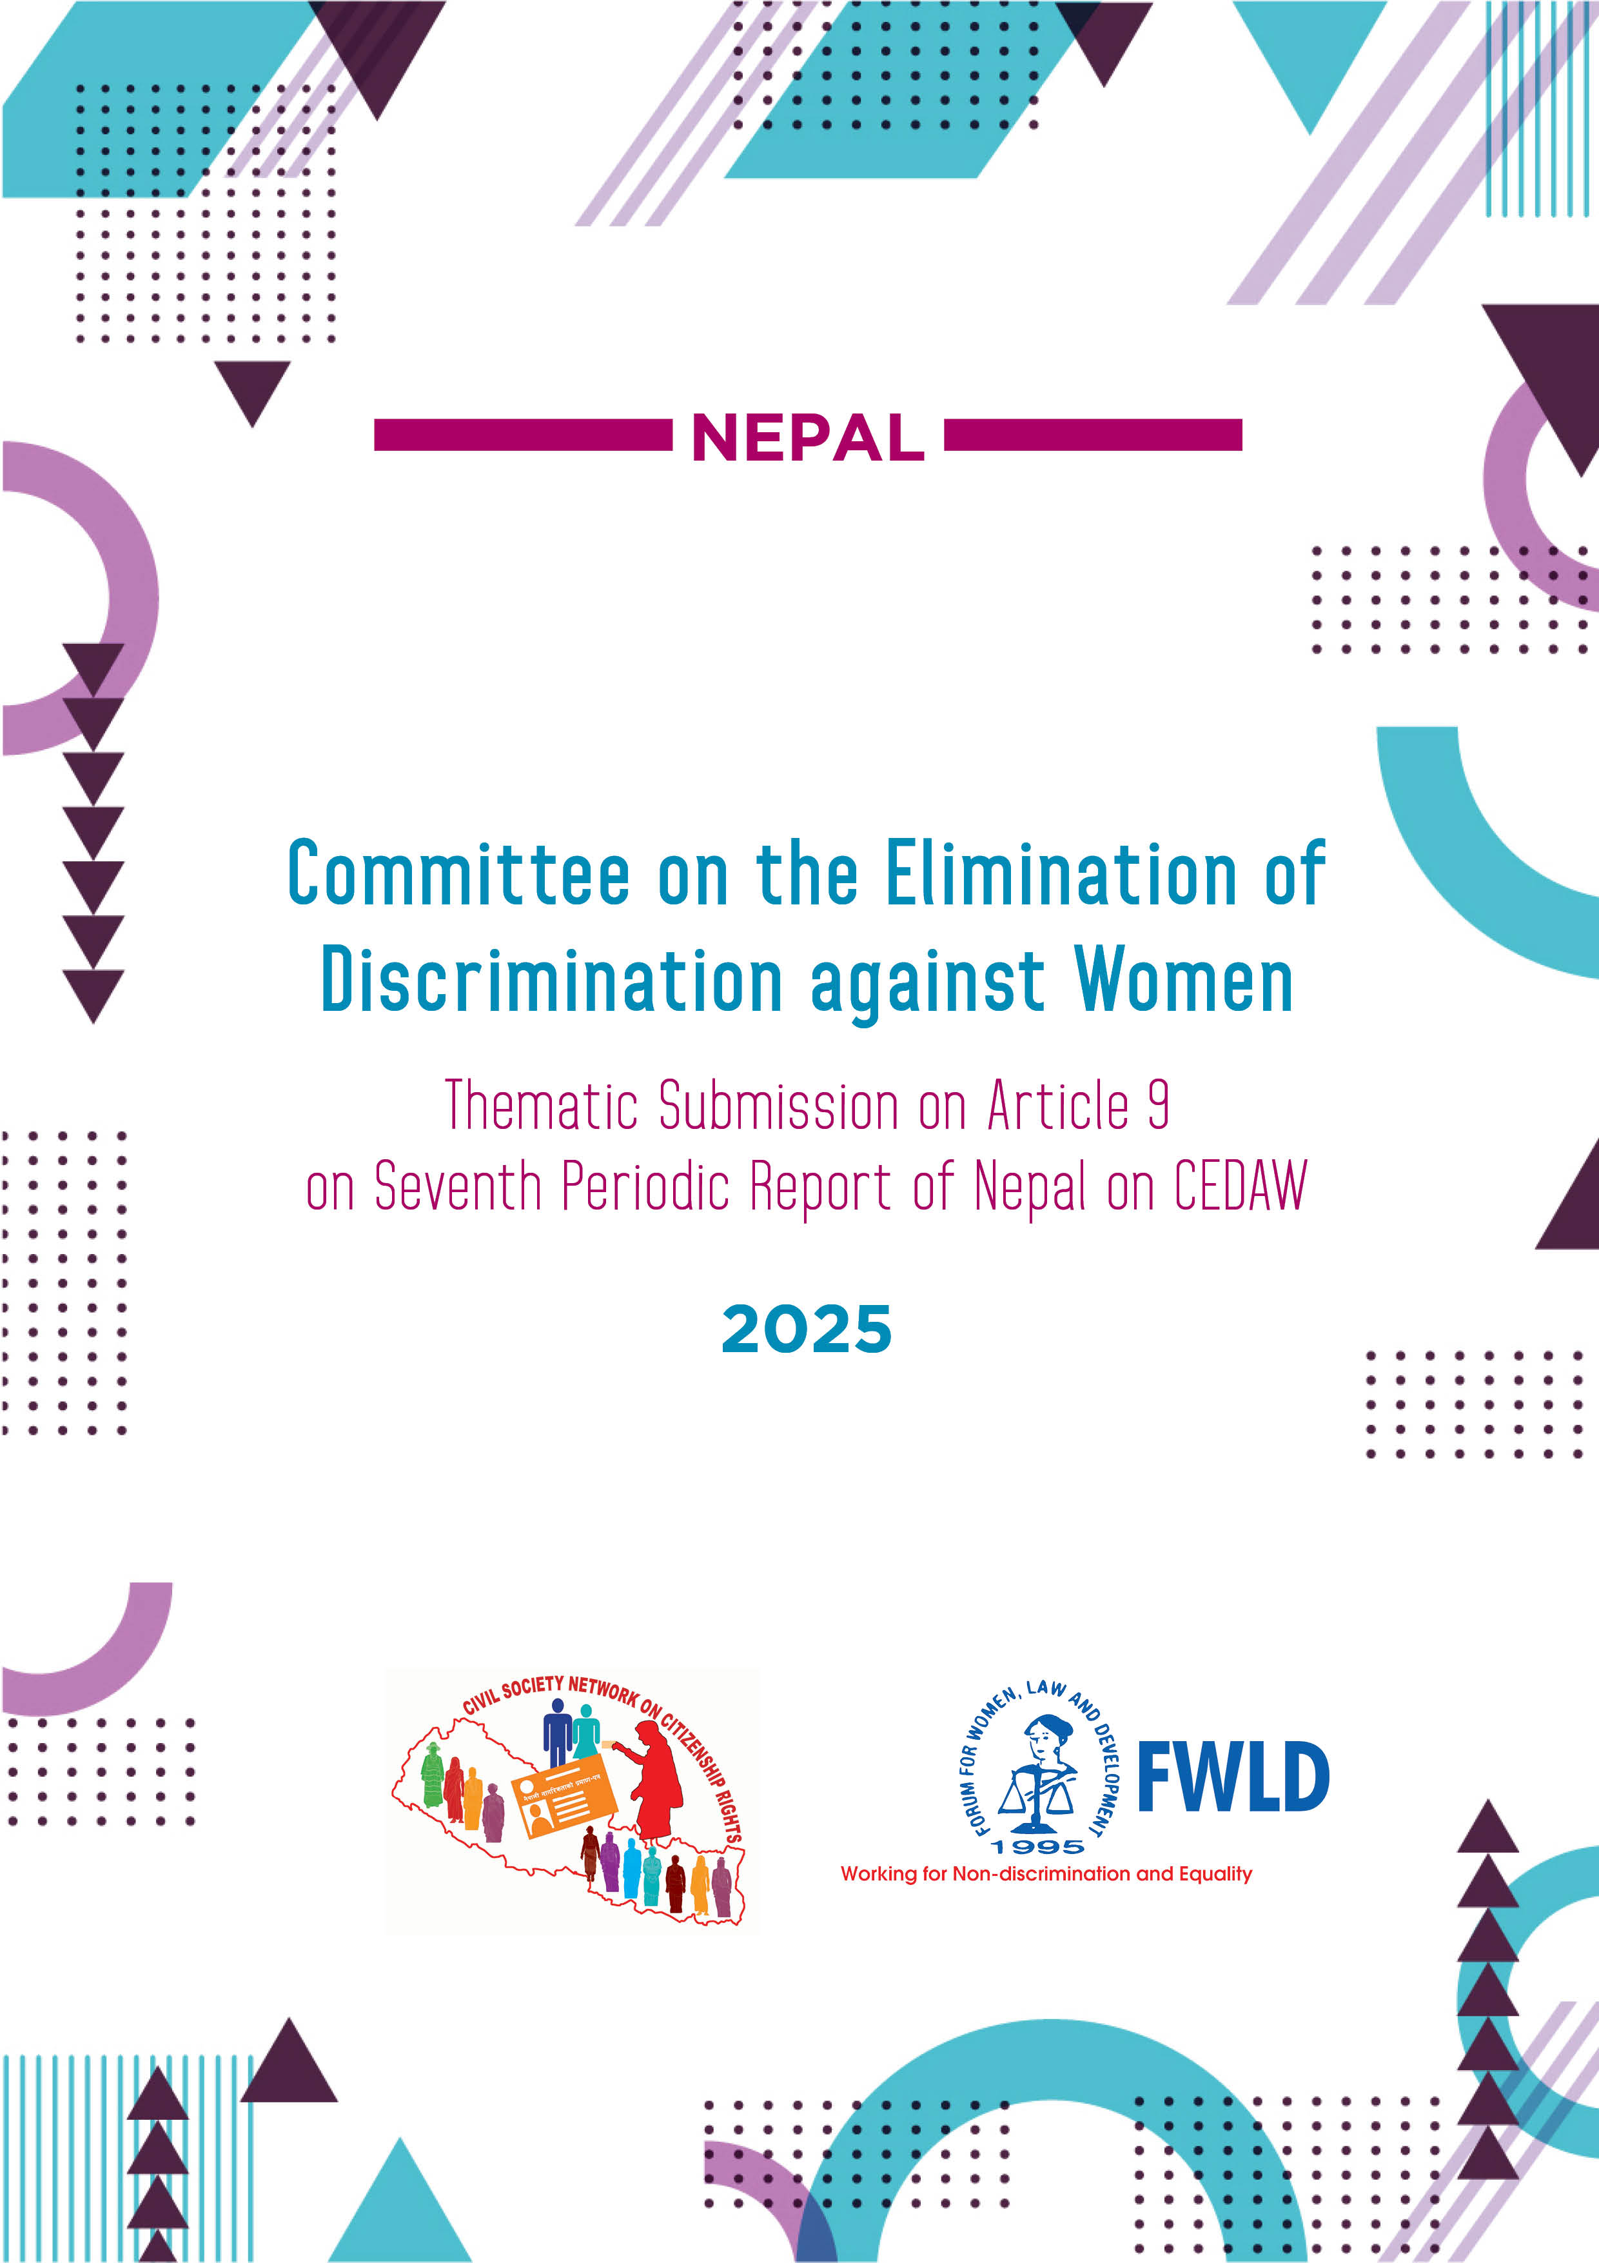

COMMITTEE ON THE ELIMINATION OF DISCRIMINATION AGAINST WOMEN
Thematic Submission on Article 9 on
Seventh Periodic Report of Nepal on CEDAW

CRITICAL AREAS OF CONCERN
- The Constitution fails to recognize Nepali women’s independent identity as mothers in transferring citizenship to their children. Articles 11(2), 11(5), and 11(7) categorize Nepali mothers as: Nepali mother with Nepali father, Nepali mother with unidentified men and Nepali mother with foreign father, undermining their independent identity.
- Article 11(3) stipulates that children born to parents who obtained Nepali citizenship by birth must have both a Nepali father and mother to obtain Nepali citizenship. While the Constitution grants Nepali men the right to confer citizenship to their foreign spouses, it does not grant the same right to Nepali women. Consequently, children of Nepali mothers, who acquired citizenship by birth are left in a statelessness situation, whereas for children of Nepali fathers in similar circumstances do not encounter this issue.
- Article 11(6) of Constitution and Section 5(1) of the Nepal Citizenship Act, 2006 permit a foreign woman who has a matrimonial relationship with a citizen of Nepal to obtain naturalized citizenship immediately, if she so desires, as prescribed by federal law.However, there is no provision for granting citizenship to the spouses of Nepali citizens other than foreign women, thereby excluding Nepali women or individuals from sexual and gender minorities from equally conferring citizenship to their spouses.
- Section 8(1) (a1) of the Nepal Citizenship Act, 2006 mandates a self-declaration with justification from a mother while applying for a citizenship, where the father is unidentified. Section 21(3c) further imposes penalties of 1 to 3 years of imprisonment, a fine ranging from 100,000 to 300,000 rupees, or both, if the self-declaration is later found to be false. This provision undermines the identity of mothers, criminalizes Nepali mothers for being a mother, and perpetuates stigmatization. Whereas no similar requirement exists for a Nepali father to provide a self-declaration when the mother is unidentified, creating direct discrimination between Nepali mother and Nepali father.
- Sections 21(3a) and 21(3c) of the Nepal Citizenship Act, 2006, outline different punishments for false self-declarations. If the father is a foreigner and the self-declaration is later found to be false, the punishment is between 6 months to 1 year of imprisonment, a fine of 50,000 to 100,000 rupees, or both. However, if the father is a Nepali citizen but unidentified, the punishment is more severe, ranging from 1 to 3 years of imprisonment, a fine of 100,000 to 300,000 rupees, or both. This disparity results in harsher penalties for the mother when the father is a Nepali citizen, even if he is unidentified.
- Despite amendments to the Nepal Citizenship Act and its Regulation (2006) allowing sexual and gender minorities to obtain citizenship certificates reflecting their gender identity, transgender and intersex individuals who previously acquired citizenship as male or female face discriminatory practices. They are often subjected to demeaning medical examination process to amend their sex and name on citizenship documents. Similarly, sexual and gender minorities seeking citizenship under the “other” category must undergo through such demeaning medical examination process. These barriers create undue obstacles, preventing them from obtaining citizenship that aligns with their gender identity and restricting their ability to fully exercise their rights.
- Although Section 8(1)(a) of the Citizenship Act, 2006, which restricted Nepali women, married to foreign men before obtaining citizenship, from applying for Nepali citizenship, was repealed through the amendments in 2023, Nepali women is such circumstances continue to face challenges in acquiring citizenship in practice. In contrast, Nepali men do not face similar obstacles.
- Children of Nepali migrant women or trafficking survivors born abroad are denied citizenship certificates, as Article 11(5) of the Constitution requires a person to be born in Nepal from a Nepali mother, and have a permanent domicile in Nepal, if a father is unidentified to qualify for Nepali citizenship. This leaves hundreds of children born to Nepali migrant women and trafficking survivors in foreign lands at risk of statelessness.
Pari, born in Bhaktapur, Nepal, faced significant hardships after her father’s death, including early marriage and domestic violence, which forced her to flee to Kuwait through irregular channels. There, she experienced exploitation, abuse, and an unplanned pregnancy while working as a domestic worker without legal status. During the COVID-19 pandemic, she returned to Nepal with the assistance of POURAKHI Nepal, which provided her with shelter, counseling, and basic support. Now working as a daily wage laborer, Pari struggles to support her daughter, whose lack of birth registration prevents her from enrolling in school and poses barriers to obtaining citizenship as a child born to a single mother abroad

- Although the new Constitution came into effect in 2015 and amendments were made to the Citizenship Act and Regulations in 2023, the delay in amending the Citizenship Certificate Distribution Guidelines, 2006, has hindered the implementation of both the Constitutional provisions and recent legislative changes. District Administration Offices still using unamended Guidelines in practice, preventing the practical application of the Constitutional provisions and the recent legislative changes.
- Non-implementation of court decisions and precedents, coupled with persistent discrimination perpetuated by a patriarchal mindset by the authorities, hindering women from exercising equal citizenship rights in practice.
- Though the laws allow either a mother or father to register the birth of their child, a police report is mandatory, in cases where the father is missing or unidentified, no such document is required for father to register his child.
- Despite the law permits either parents to register their child, a mother’s independent right to register her child is still constrained by administrative procedures, as the online application system requires the information of the father, and without it, the application process cannot proceed.
- The 2021 Nepal Census shows that 26 percent of children under five years of age do not have birth registration certificates. Insufficient application of the universality principle in birth registration excludes children whose parents lack legal identity documents, particularly children of stateless persons, refugees, migrants or sex workers from being registered at birth.
- The lack of national refugee legislation and/or a specific policy adversely impacts on refugee women and girls in Nepal despite this being noted by the Supreme Court in 2007. Tibetan long-stayerrefugee women lack registration and refugee identity documentation, particularly absence of birth registration for their children, heightening their vulnerability and leaving them unable to access many basic services. While Bhutanese refugees have had better access to documentation than Tibetans, the birth registration of Bhutanese refugee children was suspended in January 2024 due to a technical issue that the Government is working to resolve, this suspension leaves Bhutanese children without the necessary legal recognition. Moreover, children born to Nepali women married to refugee men face additional difficulties, as their births are not registered due to the father being a foreign national (refugee).

IMPLEMENTATION OF CONCLUDING OBSERVATIONS
- The Nepal Citizenship (First Amendment) Act, 2022 has been authenticated on May 31, 2023 and came into force to align with Constitution which ensures citizenship certificates to children of Nepali citizen mothers if the fathers are unidentified as well as children of Nepali citizens if one of them had acquired citizenship of Nepal by birth and both the parents are Nepali citizens.
- National ID and Civil Registration Act, 2020 and National ID and Civil Registration Regulation, 2021 came into force, allowing for the registration births through mother or father.
- Failure to implement the recommendation made to adopt amendments or repeals the discriminatory provisions in the Constitution of Nepal and other citizenship related laws of Nepal in order to guarantee that Nepali women independently can confer citizenship to their children independently and to their foreign spouses under same conditions as Nepali men.
- COs on establishing a complaint mechanism for citizenship application denials remained unimplemented.
- No national campaigns for the distribution of citizenship certificate were conducted to bridge the gap of people mainly women, lacking citizenship certificates to ensure proof of nationality.
- Process to accede the 1954 Convention relating to the Status of Stateless Persons and the 1961 Convention on the Reduction of Statelessness has not been initiated.

RECOMMENDATIONS
- Repeal discriminatory provisions particularly Article 11(5) and 11(7) of the Constitution that prevent Nepali women from transferring citizenship on an equal basis with men to their children, recognizing the independent right of each parent to pass citizenship by descent.
- Amend Article 11(3) of the Constitution to replace "Father and Mother" with "Father or Mother," ensuring equal rights for children of Nepali mothers and preventing statelessness.
- Amend Article 11(6) to guarantee Nepali women the equal right to confer citizenship to their spouses, on the same terms as Nepali men, thereby eliminating gender-based restriction and safeguarding women’s autonomy and independent identity.
- Remove the self-declaration and penalties for Nepali mothers to transfer citizenship to their children with unidentified fathers, ensuring both parents can confer citizenship on an equal basis without added terms, which aligns with Nepal’s constitutional commitment to gender equality and international commitments under CEDAW.
- Expedite the amendment of 2006 Citizenship Certificate Distribution Guidelines aligning it with Constitutional provisions and recent legislative changes and ensure its effective implementation.
- Guarantee the right of gender and sexual minorities to obtain their citizenship certificate and other legal identity documents recognizing their gender identity by eliminating demeaning and
- Implement court decisions and precedents related to granting citizenship on equal grounds by Nepali women.
- Ensure universal birth registration for all children regardless of the legal identity of the parents particularly children of stateless persons, refugees, migrant or sex workers from being registered at birth, in line with Nepal’s Constitution and international human rights commitments.
- Ensure birth registration and legal recognition for children of refugee women and Nepali women married to refugees, regardless of parental nationality, to support their rights, and access to basic services.
- Take necessary steps to ratify the 1954 Convention Relating to the Status of Stateless Persons and the 1961 Convention on the Reduction of Statelessness



Article 11(5), the Constitution: A person who is born in Nepal from a woman who is a citizen of Nepal and has permanent domicile in Nepal and whose father is not traced shall be provided with the citizenship of Nepal by descent. Provided that his or her father is held to be a foreign citizen, the citizenship of such person shall be converted into naturalized citizenship as provided for in the federal law.
Ibid, Article 11(7): Notwithstanding anything contained elsewhere in this Article, in the case of a person born from a woman who is a citizen of Nepal and married to a foreign citizen, the person may acquire the naturalized citizenship of Nepal in accordance with the Federal law if he or she has permanently resided in Nepal and has not acquired the citizenship of a foreign country.
Ibid, Article 11(6): A foreign woman who has a matrimonial relationship with a citizen of Nepal may, in case she so desires, acquire the naturalized citizenship of Nepal as provided for in the federal law.
Section 8(1), Nepal Citizenship Act, 2006: A person attaining the age of 16 years desiring to acquire Nepalese Citizenship Certificate by virtue of birth pursuant to Section 3 shall have to file an application in the prescribed form along with copies of the following documents to the designated authority. Section 8(1) (a1): A self-declaration by the individual and their mother, in cases where a person born in Nepal to a Nepali citizen mother, has resided in Nepal, and the father is unidentified.
Sukumaya Lama vs. Prime Minister and Council of Ministers et.al. Writ no. 069-WS-0013 filed on July 22, 2012 and still under the consideration of the Constitutional Bench of Supreme Court of Nepal.
Nepal Citizenship (First Amendment) Act, 2022
Nepal Citizenship (Third Amendment) Regulation, 2022
https://theannapurnaexpress.com/story/47046/?mibextid=xfxF2i
Krishtina Maharjan vs. the Ministry of Home Affairs et.al. Writ no. 078-WO-0853, decided on August 8, 2023; Sanumaiya Chhetri vs. the Ministry of Home Affairs et.al. Writ no. 077-WO-1106, decided on January 8, 2023. Both decisions have not been implemented yet.
The National ID and Civil Registration Act, 2020 and the National ID and Civil Registration Regulation, 2021
Annex 10, the National ID and Civil Registration Regulation, 2021: Necessary Documents to be Included in Birth Information Form, …(5): police report if the father is missing or his whereabouts are unknown
https://public.donidcr.gov.np/BirthRegistrationMain/BirthRegistrationMain?p=ob%2BACF2rxqibas5x2EjHV%20 A%3D%3D
National Population and Housing Census 2021 Available at: https://censusnepal.cbs.gov.np/results/population#birth_reg
Mahmood Rashid vs. the Ministry of Home Affairs et.al. Writ no. 0040 of 2064 BS (2007).
The Government of Nepal Ministry of home Affairs (NUCRA), REFUGEES IN NEPAL: A SHORT GLIMPSE, October 2019.
UNHCR Nepal Factsheet November 2024. The Factsheet reads as follows:…all descendants of long-staying Tibetans (of which an estimated 75% are currently undocumented) and the issuance of birth certificates for all refugee children
Consultations with Refugee Women for Shadow Report Preparation in Jhapa and Kaski dated on 28 December 2024 by FWLD.
The study shows that 26% of women lack citizenship certificate of Nepal whereas 13% men lack it. FWLD, ACQUISITION OF CITIZENSHIP CERTIFICATE IN NEPAL, 2014, p. 15

