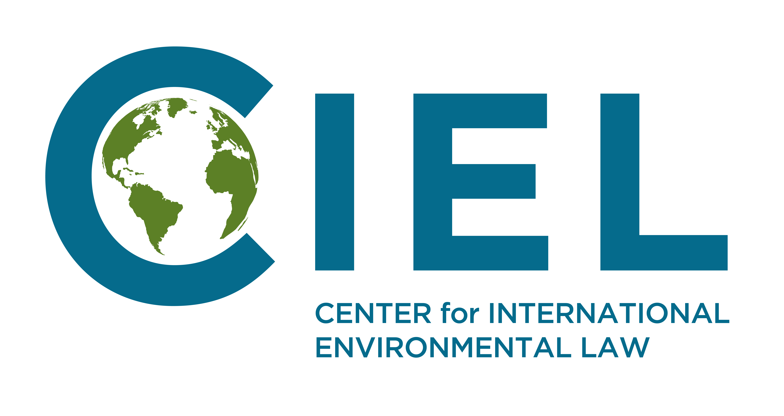
Briefing Note to the Committee on Economic, Social and Cultural Rights, prior to the adoption of the List of Issues Prior to Reporting

Ukraine climate mitigation and energy policy and its obligations under the International Covenant on Economic, Social and Cultural Rights.

Given the scale of projected climate impacts in Ukraine and abroad and the predictability of these impacts on economic, social and cultural rights, Ukraine’s obligations under the Covenant require that it reduce emissions of greenhouse gases adequately. Ukraine fails to uphold its obligations under the Covenant as it has not enacted adequate climate mitigation policies and has put forward a long-term development strategy that would imply a significant increase of emissions in stark contraction with any recommendation adopted by the Intergovernmental Panel on Climate Change (IPCC). In addition the government of Ukraine continues to subsidize coal extraction despite the fact that coal constitutes a very significant source of greenhouse gases emissions. It has also failed so far to put forward measures and policies to guarantee a just transition of the work force. In this context, we urge the Committee to invite Ukraine to:
- Provide information regarding its emissions reductions targets and long-term low greenhouse gas emission development strategy, how these targets are compatible with its duty to take action to advert dangerous climate change and the policies implemented to guarantee that domestic emissions are adequately reduced in line with scientific projections such as those laid out by the Intergovernmental Panel on Climate Change.
- Provide information regarding how the State Party is working to reduce the use of coal in its energy supply so as to reduce emissions of greenhouse gases from the energy sector effectively and what policies and measures are implemented to guarantee a just transition for the work force.

Emissions of greenhouse gases in Ukraine and current climate policies

The emissions of greenhouse gases of Ukraine have decreased significantly during the 1990-2000 period as a consequence of the economic crisis that resulted from the collapse of the Soviet Union. Since 2000, the emissions of the country have however largely stagnated, which indicates the absence of effective climate mitigation policies.
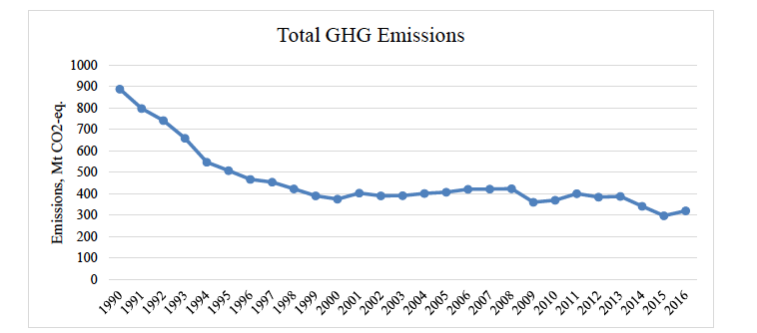
Figure 1: Emissions of Greenhouse Gases in Ukraine, 1990-2016 (Source: Ministry of Ecology and Natural Resources of Ukraine)
The largest share of domestic emissions of greenhouse gases in Ukraine results from the energy sector. This share remains comparatively high partly due to public policies. While other countries have committed to phasing out coal as soon as possible in order to cut emissions of greenhouse gases, Ukraine supports the coal sector, including through public subsidies and state-owned coal mines. Such measures undermine global efforts seeking to prevent the most dangerous levels of warming. The Intergovernmental Panel on Climate Change (IPCC) has highlighted that drastically reducing coal consumption phasing out coal is an imperative to maintain temperatures below the most dangerous thresholds. CESCR has recognized the importance of decreasing coal extraction and consumption in order to prevent climate-induced impacts on human rights. CEDAW and CRC have also reached similar conclusions when monitoring the fulfillment of obligations under their respective instruments.

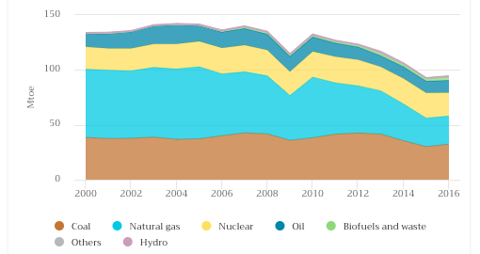
Figure 2: Breakdown of sources in the total primary energy supply of Ukraine , 2000-2016 (Source: International Energy Agency)
While many coal mines would be unprofitable without public subsidies, as demonstrated by the failure of coal mines to pay their employees when the government temporarily suspended subsidies in 2015, the government has not yet developed any comprehensive strategy to manage the closing of the mines and to ensure a just transition for miners and communities are accompanied. On the contrary, the government continues to communicate publically its support for coal mining and its intention to increase coal production in coming years.

This absence of policy to phase out coal and ensure a just transition is not only inadequate from the perspective of climate change and related human rights obligations, but it also undermine social and economic rights of the work force involved in the mining industry.

Climate policy objectives and emissions reduction targets
The mid and long term climate objectives of Ukraine are defined into documents submitted to the UN Framework Convention on Climate Change under the Paris Agreement. Ukraine has submitted a Nationally Determined Contribution laying out the level of its mitigation ambition for 2030, indicating that Ukraine’s emissions should not exceed in 2030 60% of their 1990 levels. Additionally, Ukraine also submitted a long-term low greenhouse gas emission development strategy. This document contains several scenario with different emission pathways. Among these, even the most ambitious scenario would be equivalent to stabilizing emissions by mid-century at levels similar to those of achieved today. These scenario thereby fail to project a pathway towards the low-carbon development in a manner that would uphold Ukraine’s responsibility to mitigate climate change adequately and to progress towards a full decarbonization of the economy sometime after 2050.
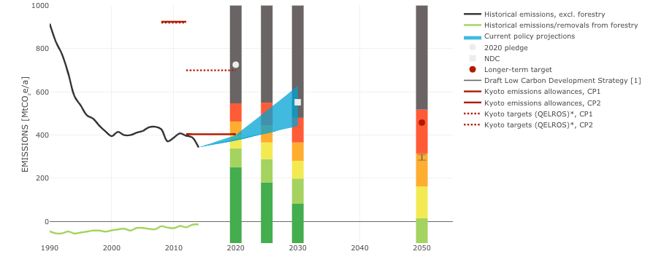
Figure 2: Projected emissions pathways and emission targets of Ukraine (Source: Climate Action Tracker)
Consequently, the independent scientific analysis provided by “Climate Action Tracker” suggests that Ukraine’s current policies as well as mid and long-term emission reductions targets are grossly insufficient. Alternative studies suggest that achieving a deep decarbonization in Ukraine by mid-century is feasible if adequate frameworks and measures are implemented, for instance to shift to renewable energy sources.
This short briefing note was prepared by the Center for International Environmental Law (CIEL) in cooperation with partners in the country under review. Please do not hesitate to contact us for any additional information: Sébastien Duyck sduyck@ciel.org (+41786966362)

See Powering Past Coal Alliance, https://www.canada.ca/en/services/environment/weather/climatechange/canada-international-action/coal-phase-out.html
Subsidies to state-owned coal mines amounted to about 100 million USD in 2018 according to the Ukrainian government. See https://www.ukrinform.net/rubric-economy/2493807-coal-sector-gets-uah-3-bln-in-subsidies-from-state-budget-this-year-groysman.html
IPCC Special Report on Global Warming by 1.5c, Summary for Policymakers, Figure SPM 3.b
See CESCR, Concluding Observation on Australia (2017), E/C.12/AUS/CO/5
See CEDAW, Concluding Observation on South Korea (2018) CEDAW/C/KOR/CO/8 and CRC, Concluding Observation on Spain (2018), CRC/C/ESP/CO/5-6.
See for instance the “Concept for the Reform and Development of the Coal Industry for the period up to 2020” announced by the government in 2017, http://mpe.kmu.gov.ua/minugol/control/publish/article?art_id=245211119
See: http://www4.unfccc.int/ndcregistry/PublishedDocuments/Ukraine%20First/Ukraine%20First%20NDC.pdf
See: https://unfccc.int/sites/default/files/resource/Ukraine_LEDS_en.pdf
See for instance https://ua.boell.org/en/2017/11/07/transition-ukraine-renewable-energy-2050

