

Submission to the Human Rights Committee at its 143rd Session

March 2025

Geneva, Switzerland

ALBANIA
Submission by:

ADF International
Rue Pré-de-la-Bichette 1
1202 Geneva, Switzerland

Web: www.ADFinternational.org
Email: UN@ADFinternational.org

ECOSOC Special Consultative Status (2010)

Introduction
- ADF International welcomes the opportunity to provide information on the implementation by Albania of its obligations under Articles 2, 3, 6 and 26 of the International Covenant on Civil and Political Rights (ICCPR).
- This submission highlights the urgent need for the government of Albania to intensify its efforts to eliminate prenatal sex selection and address the deeply ingrained son preference and daughter aversion that drive this practice.
- Prenatal Sex Selection
- Based on the latest report published by the Institute of Statistics of Albania on ‘Men and women in Albania, 2022’, the sex ratio at birth in Albania is 107 boys for every 100 girls born. The natural sex ratio at birth is estimated to be around 105 male births for every 100 female births. This skewed ratio indicates the continued prevalence of sex-selective practices, particularly prenatal ones, in the country.
- The combination of the shift towards a market economy following the political transition of 1991, the liberalization of induced abortion, and the increasing accessibility of ultrasound technology capable of detecting a child’s sex paved the way for the widespread occurrence of sex-selective abortions in Albania. This led to a rapidly skewed sex ratio at birth, peaking at roughly 111 males for every 100 female births between 2000 and 2020, ranking the country as having the fourth-highest average annual imbalance in the sex ratio at birth globally.
- A 2021 study published in the British Medical Journal, analyzing 3.26 billion birth records across 204 countries, forecasted that 12 nations with skewed sex ratios, including Albania, are expected to experience a deficit of 4.7 million women by 2030 due to sex-selective practices.
- The study emphasized the urgency of effective measures to accelerate the normalization of the sex ratio at birth back to natural levels and to mitigate the societal consequences of the growing surplus of males within the population, including the resulting ‘marriage squeeze’.
- The ineffectiveness of Albanian legislation in addressing the scourge of sex-selective practices, compounded by the deep-rooted culture of son preference within society, constitutes a grave human rights concern. This issue severely impacts the rights and status of women and girls in the country, undermining Albania’s ability to fully meet its international human rights obligations, including those under Articles 2, 3, and 6 of the International Covenant on Civil and Political Rights.
Legal framework
- Article 18(1)(2) of the Constitution of Albania states that all persons are equal before the law and that ‘No one may be unjustly discriminated against for reasons such as gender.’
- Article 54 of the Constitution further affirms that ‘Children […] have the right to special protection by the State.’ In this regard, Article 3 of Law No.18/2017 on the rights and protection of the child defines a child as any person under eighteen years of age. This provides an upper limit but does not provide a lower limit on when the status of ‘child’ attaches. Furthermore, Article 7 of said law stipulates that ‘The protection of the life of the child shall be guaranteed by law.’
- According to Article 1 of Law No. 8045 on the Interruption of Pregnancy, ‘The law guarantees respect for every human existence from the beginning of life. This principle shall not be violated except for cases when it is necessary and under the conditions specified in this law.’
- Article 2(1) of the same law explicitly states that in no case the interruption of pregnancy shall be considered a method of family planning. Furthermore, Article 2(6) establishes that ‘abortion is permitted only when the undesired circumstances in this law are verified to exist and in any case with the consent of the woman.’ The sex of the child is not listed among the circumstances permitting recourse to abortion.
- Relatedly, Article 37 of Law No. 8876 on Reproductive Health establishes that ‘During the use of assisted reproductive technologies, the selection of the sex of the future child is not permitted, except for cases when there is a possibility of inheriting illness connected with the sex.’ However, the law primarily enforces compliances through minor administrative sanctions, unless the violation results in a criminal offense, limiting its overall deterrent effect.
- In 2024, Albania’s Ministry of Health introduced a bill on sexual and reproductive health, proposing an extension of the legal window for abortion from the current 12 weeks to 14 weeks of pregnancy. This proposed extension raises concerns as it could further facilitate sex-selective abortions, particularly in the absence of monitoring and reporting mechanism within this timeframe.
- The most common form of prenatal diagnostics—ultrasound—becomes reliable for determining the sex of an unborn child from 12 weeks onward. However, newer non-invasive prenatal testing techniques can accurately determine sex as early as 7 weeks and are becoming increasingly accessible. The combination of earlier access to sex identification and delayed gestational limits for accessing abortion resulting from the potential adoption of the abovementioned bill could therefore result in a resurgence of prenatal sex-selective practices in the coming years.
Root causes of prenatal sex selection
- A range of social, economic, and cultural factors perpetuate Albania’s deeply entrenched culture of son preference. According to Kristina Voko, a psychology professor at the University of Tirana, one key reason behind son preference in Albania is that, ‘Boys are expected to support the parents financially, provide for their security and protect their honor, while girls are expected to provide emotional support and care for ailing parents. Although girls are seen as a great source of emotional support and affection for the parents, boys are seen as necessary.’
- The perceived economic value attributed to sons often surpasses that of daughters. Parents anticipate that sons will have better employment opportunities and higher incomes, contributing significantly to the family’s assets (including property, land, or family businesses). Boys are often viewed as a ‘working arm’ essential for families’ economic well-being, while girls are perceived as financial liability.
- Family name inheritance and lineage continuity also play a significant role in reinforcing son preference. Many parents see having a son as the only way to ensure the continuation of the family name and the retention of family assets. This belief is further compounded by harmful social norms that associate dishonor with living with a son-in-law rather than with one’s own son.
- Community norms further shape Albania's culture of son preference. The country’s collectivistic and honor-oriented social structure place significant importance on group welfare and social reputation. Strong sensitivity to and adherence to communal beliefs and norms exert pressure on family dynamics, particularly concerning childbirth and household composition. These influences are especially pronounced in rural areas and among vulnerable communities.
Lack of effective measures to prevent sex-selective practices in Albania
- Albania’s National Strategy for Gender Equality 2021-2030 comprises four strategic goals, one of which is specifically the reduction of all forms of harmful practices. However, despite the importance of this goal, the document lacks any specific reference to expected outcomes, measures, or indicators dedicated to the prevention and elimination of sex-selective practices.
- Furthermore, prenatal tests that determine the sex of the child remain legally available in Albania without specific requirements. Stricter regulations around the use of prenatal testing would serve as a valuable preventive measure to address the incidence of prenatal sex selection.
- In October 2023, Albania underwent its periodic review before the Committee on the Elimination of All Forms of Discrimination Against Women (CEDAW). During the review, the Committee inquired about Albania's strategies for addressing sex-selective abortions, specifically questioning the country's approach to research, monitoring, legislation, and policy-making at all tiers. Albania did not provide an answer. In its concluding observations, the CEDAW Committee noted with concern reported instances of coercive family planning practices, including sex-selective abortion, and recommended that Albania strictly enforce the prohibition of sex-selective abortions and establish services, including helplines, for women who are pressured into undergoing sex-selective abortions.
- Similarly, in November 2024, during its fourth cycle Universal Periodic Review, Albania received two recommendations on redoubling efforts to enforce laws prohibiting prenatal sex selection and developing programmes to tackle its root causes.
The prohibition of sex-selective practices in international human rights law
- Sex-selective practices constitute an egregious violation of the dignity and human rights of girl children.
- Article 2 of the ICCPR establishes the obligation to respect and ensure the human rights of all individuals without distinction of any kind. Article 3 explicitly guarantees the equal rights of men and women. Article 6 guarantees every human being the inherent right to life, which shall be protected by law, and further establishes that ‘no one shall be arbitrarily deprived of his life’. Furthermore, Article 26 requires States Parties to guarantee all persons equal protection before the law and equal and effective protection from discrimination on any ground, including on the basis of sex.
- To ensure greater compliance with its obligations under the ICCPR, Albania should strengthen its legal framework to eradicate sex-selective practices, investigate and hold the enablers of these grave human rights violations accountable, and to develop and support awareness-raising and education campaigns aimed at reshaping harmful socio-cultural narratives and affirming the inherent dignity and equal status of women and girls.
- Recommendations
- In light of the aforementioned, ADF International respectfully requests the Human Rights Committee to include the following recommendations in its Concluding Observations on Albania:
  - Enact and enforce comprehensive legislation that unequivocally bans sex-selective practices in all their forms and manifestations;
  - Strengthen and ensure the effective enforcement of Law No. 8876 on Reproductive Health to ensure that Article 37 violations constitute criminal offences;
  - Prohibit or introduce regulations around the use of prenatal sex determination for non-medical purposes within the legal timeframe for elective abortion;
  - Take effective legal, policy, and other measures to combat the culture of son preference, with special emphasis on the prevention of prenatal sex selection;
  - Redouble efforts to promote awareness-raising and educational initiatives to eliminate prejudices and harmful practices perpetuating the culture of son preference and daughter aversion;
  - Eliminate all forms of discrimination against the girl child and the root causes of son preference, including by developing programmes and policies that increase awareness of the value of the girl child and, concurrently, strengthen the girl child’s self-image, self-esteem, and status.

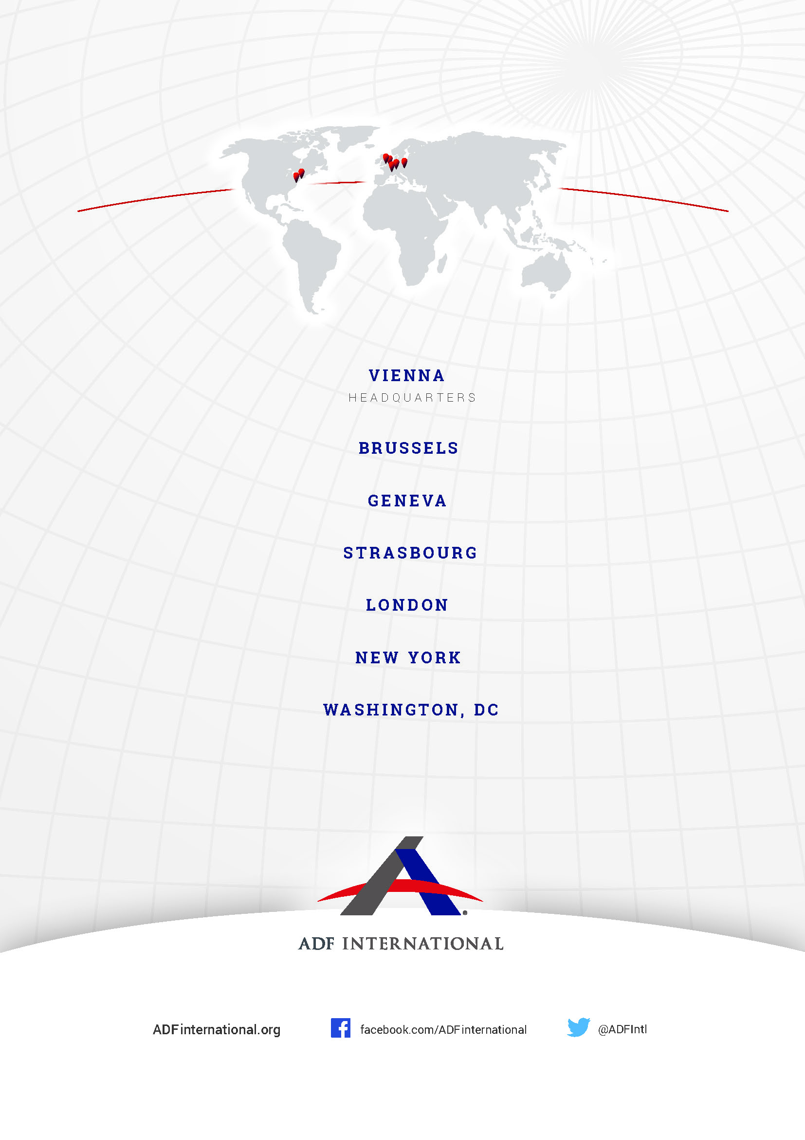

© 2025

INSTAT and UN Women, Burra Dhe Gra 2023 Men and Women, available at https://www.instat.gov.al/en/themes/demography-and-social-indicators/gender-equality/publication/2023/men-and-women-in-albania-2022/.
UN World Population Prospects, Sex Ratio, at birth (2024) available at https://ourworldindata.org/grapher/sex-ratio-at-birth.
Pew Research Center, Sidebar: Sex ratios around the world (23 August 2022) available at https://www.pewresearch.org/religion/2022/08/23/sidebar-sex-ratios-around-the-world/.
Fengqing Chao, et. al., Projecting sex imbalances at birth at global, regional and national levels from 2021 to 2100: scenario-based Bayesian probabilistic projections of the sex ratio at birth and missing female births based on 3.26 billion birth records, British Medical Journal Global Health, (Vol. 6 Issue 8, 1 Aug. 2021), available at https://gh.bmj.com/content/6/8/e005516).
Ibid.
Constitution of the Republic of Albania (January 2007, last amended February 2022) available at https://qbz.gov.al/preview/635d44bd-96ee-4bc5-8d93-d928cf6f2abd, Article 18.
Ibid., Article 54.
Law No.18/2017 on the rights and protection of the child (February 2017) available at http://qbz.gov.al/eli/ligj/2017/02/23/18-2017, Article 3.
Ibid., Article 7.
Law No. 8045/1995 (December 1995, last amended September 2024) available at http://qbz.gov.al/eli/ligj/1995/12/07/8045, Article 1.
Ibid., Article 2(1).
Ibid., Article 2(6).
Law No. 8876/2002 (April 2002, last amended September 2024) available at http://qbz.gov.al/eli/ligj/2002/04/04/8876, Article 37.
Gjergj Erebara, Plans to Allow Surrogacy in Albania Criticised by Opposition, Balkan Insight (23 April 2024) available at https://balkaninsight.com/2024/04/23/plans-to-allow-surrogacy-in-albania-criticised-by-opposition/.
Hilary Bowman-Smart et al., Sex selection and non‐invasive prenatal testing: A review of current practices, evidence, and ethical issues Prenatal Diagnostics 40(4) (10 October 2019) available at https://pmc.ncbi.nlm.nih.gov/articles/PMC7187249/.
Youssef Courbage, Surmortalité féminine chez les musulmans de Yougoslavie: Islam ou culture méditerranéenne? (1991) Population, 46, no.2, p.299-325; INED, Paris.
Besar Likmeta, Sex-Selective Abortion Trending in Albania, (25 January 2013) available at https://womensenews.org/2013/01/sex-selective-abortion-trending-in-albania/.
Elizana Zaimi et al., Aborti Selektiv me bazë gjinore në Shqipëri (2018) available at https://www.togetherforlife.org.al/wp-content/uploads/2021/02/Aborti-selektiv-me-baze-gjinore-ne-Shqiperi.pdf, pg. 13.
Ibid., pg.50.
Ibid.
UNFPA, Sex imbalances at birth in Albania, (2012) available at https://www.unfpa.org/sites/default/files/resource-pdf/UNFPA_report_Albania2012.pdf, pg. 79.
Ibid.
UN Women, National Strategy for Gender Equality 2021-2030, approved with Council of Ministers Decision No.400 dated 30.6.2021, available at https://shendetesia.gov.al/wp-content/uploads/2022/02/WEB_Strategjia-Kombetare-EN.pdf, pg.32.
CEDAW Committee, Summary record of the 2014th meeting, CEDAW/C/SR.2014, (26 October 2023) available at https://docstore.ohchr.org/SelfServices/FilesHandler.ashx?enc=6QkG1d%2FPPRiCAqhKb7yhskcAJS%2FU4wb%2BdIVicvG05Ryua5D8Aoc2xLOEQKE%2FdyFfEgRWEd0ohsCHQBw%2FKLqu%2BhNclp1S5XPgbKNsDBAqlluRx475n4F98SlWkf%2Fr%2F2eU, pg.5.
CEDAW Committee, Concluding observations on the fifth periodic report of Albania, (14 November 2023) available at https://docstore.ohchr.org/SelfServices/FilesHandler.ashx?enc=6QkG1d%2FPPRiCAqhKb7yhsgcjdm0xgERNaIXh22nhTUkMoJb44mLyrzZuxiXewUpnm6pofBrZXrvRTrhKijXht8vDxNAk70l42w%2BhaZJIXZQGVvO1OqnzlyY0wkwtvF2Z, pg.11.
Ibid, pg.12.
UNHRC, Report of the Working Group on the Universal Periodic Review - Albania (19 November 2024) UN Docs A/HRC/58/5, 124.120-121.
International Convention on Civil and Political Rights (adopted 16 December 1966, entered into force 23 March 1976) 999 UNTS 171 (ICCPR), Article 2.
Ibid., Article 3.
Ibid., Article 6
Ibid., Article 26.

