ALTERNATIVE CEDAW REPORT ON
WOMEN WITH PSYCHOSOCIAL DISABILITIES (WWPDs)
IN INDONESIA



Prepared by:
Revolusi dan Edukasi Masyarakat untuk Inklusi Sosial Indonesia (REMISI)

Written by:
Agus Hasan Hidayat
Nurul Safitri
Rina Refliandra
Samuel R. Hadi Utomo

Jakarta, August 2021

Table of Content

Table of Contents
Executive Summary 3
1. Legal Capacity 4
2. Access to Justice 4
3. Rights to Education 5
4. Right To Work and Employment 5
5. Right to Health 6
6. Deprivation of Liberty and social rehabilitation and Institutionalization as arbitrary detention centre 7
7. Gender Based Violence 9
8. Women with Psychosocial Disabilities and Torture other Cruel, Inhuman and Degrading Treatment and Punishment 12
9. Marriage and Family Relation 13
10. Situation during Covid-19 Pandemic 14
11. VIOLATION AGAINST CEDAW 14

Executive Summary

Indonesia Revolution and Education for Social Inclusion (REMISI) is an Organization for Persons with Disabilities focused on the rights of Persons with Psychosocial Disabilities in Indonesia. Remisi believes that it is obligatory to provide a CEDAW report to highlight the situation in Indonesia where WWPDs is experiencing a lot of discrimination and violence from various parties.

In this report, we describe ten significant issues faced by women with psychosocial disabilities in their lives, and the most crucial points that must be implemented by states parties to be able to protect, fulfil and respect the rights of women with psychosocial disabilities are:

  - The state does not commit to abolish the guardianship system in the civil code, deprivation of liberty, arbitrary detention, and the abolition of physical and mental health requirements that discriminate against workers with psychosocial disabilities.

  - The state must recognize the Legal Capacity for all types of disabilities and make a supportive decision-making program.

  - Revise Laws: on Marriage, on mental health, on disability, and all regulations legalizing forced institutionalization.

  - To enact the law on the elimination of sexual violence. To eliminate violence that occurs in institutions. To revise all regulations that prohibit all forms of institutionalization and forced treatment to persons with psychosocial disabilities and recognize the testimony of psychosocial disabilities as victims and witnesses of violence.

  - To progressively implement the deinstitutionalization program by designing social protection programs for persons with disabilities to live independently and return to the community.

  - To Ratify: OP CEDAW, OP CAT, OP CRPD, ILO Convention no.190, and recommendation 206.

  - The state conducts training for all levels of government officials regarding the rights of persons with disabilities, including psychosocial disabilities.

In Indonesia, WWPDs experience discrimination in their rights to education, employment, and health. WWPDs often experience various forms of violence from their families, closely related persons. Moreover, thousands of people with psychosocial disabilities are arbitrarily detained, locked up in rehabilitation institutions that resemble prisons. In confinement, they experience various forms of violence, such as being chained, beaten, abused, forced contraception and sterilization, raped and shackled. WWPDs are deprived of their freedom, and their human dignity is degraded.

Legal Capacity

Elimination of legal capacity and placement in the social rehabilitation centre for women with psychosocial disabilities (WWPDs) in Indonesia is legal in the Civil Code article 890. This problem causes various violations of the rights of persons with psychosocial disabilities, including forced treatment to mental hospitals without consent, the disappearance of the right to manage finances, having building ownership documents, entering into contractual agreements, inheritance, and other civil matters.

The practice of eliminating legal capacity has even been adopted under other laws in Indonesia. Mental Health Law No. 18/2014, persons with psychosocial disabilities are considered incapable of making decisions, then the approval of medical action can be carried out by the family or caregiver.

WM is a woman with a psychosocial disability. She was brought to a rehabilitation centre in West Java by her family in 2013. While she was doing a psychological assessment test, WM was immediately tied up and forcibly treated by the health workers to stay within the institution without her consent.

Informal disappearance of legal capacity is common in Indonesia. The majority of Indonesian people believe that WWPDs do not have mental capacity. They are considered unable to make good decisions because their minds are insane and are considered dangerous. This problem is considered normal by the community so they must be placed under the guardianship of the family.

Access to Justice

According to research from Community Legal Aid, district court decisions from 2011 to 2018 in Indonesia only had 13 cases of sexual violence brought to court. The number of lawsuits brought to court is not proportional to the number of cases that occur in public or private institutions. It highlights the failure of the state to provide optimal legal protection for WWPDs. Law enforcement agencies are less accessible to WWPDs victims to seek justice and protection.

Rights to Education

Women with psychosocial disabilities in Indonesia often drop out of school, especially at the higher education level, because there are no counselling service assistance facilities in educational institutions. Moreover, schools often do not provide reasonable accommodation when they face mental health problems. Problems that often occur in education are when students experience mental health problems, cannot take exams, complete assignments on time, or cannot attend school and do not get waivers.

Some WWPDs were dropouts from school/university due to mental disorders. The problem was because their study period had expired, had not yet graduated from university or getting unwanted pregnancy during high school. Another problem is that some universities still require a certificate of mental health as a requirement.

L is WWPD who was a 15-year-old girl with psychosocial disabilities who lived in Bandung, was expelled from her school in 2017 because she had several serious mental health problems. The counsellor at school spread the mental health problems experienced by L to her friends and teachers. She received strong stigma and it made her mental health problems worse, and she could not attend school and exams. Finally, L was expelled from school and had to move to another school.

In 2019, Remisi documented 67 similar cases of discrimination against WWPDs in educational institutions. The issuance of government regulations regarding reasonable accommodation for students with disabilities in 2020 has not been implemented and evaluated. Thus, cases of discrimination still frequently occur.

Right To Work and Employment

WWPDs is discriminated against in the right to get a job. In applying for a job, there is a mental health certificate needed as a requirement that must be fulfilled by every job seeker who wants to work as a civil servant, the state-owned enterprise, or in a private company. The mental health certificate as a requirement also applies to run for public office or applying for a candidate for a member of parliament.

The government systematically and structurally discriminates against persons with psychosocial disabilities regarding their right to work. The mental health certificate as a requirement is based on Government Regulation Number 11/2017 concerning the Management of Civil Servants. All ministries and agencies in Indonesia adopted the regulation.

Many WWPDs hide their disability identity in the workplace because of the stigma and will affect their positions and threaten to lose their jobs. Most WWPDs fear talking about their mental condition in the workplace. It makes WWPDs unable to access reasonable accommodation if it is provided. There are many cases of WWPDs prohibited from taking leave when they need treatment during relapse.

In 2019 a woman with a psychosocial disability with the initials M who works as a medical physician was fired from a public hospital in Jakarta on grounds of patient endangerment after being caught taking psychiatric medicine. M was fired from the hospital without any mistakes or wrongdoing and prior notice. M was afraid to report this case to legal aid because no regulation regulates job protection for people with psychosocial disabilities. In 2019, Remisi documented 48 cases of discrimination at work experienced by WWPDs and, the most cases are dismissal due to psychosocial disabilities.

Psychosocial disabilities are also excluded from various work and training programs provided by the government. Persons with psychosocial disabilities are not only discriminated against in training and the opportunity to obtain job certification. Moreover, Persons with psychosocial disabilities are eliminated from government and private sector programs aimed at persons with disabilities in various sectors.

Although Law No. 8/2016 regarding Disabilities stipulates a quota of two percent in the government and one percent in the private sector. All application processes require a Mental Health Certificate which becomes a barrier for WWPDS. In employment recruitment for the disability pathway for the government, there are requirements for applications for people with disabilities that are difficult to fulfil. For instance, disability certificates and uploading videos related to their disabilities. Various positions are not intended for people with psychosocial disabilities.

Right to Health

Remisi highlights several issues in the health sector that have not yet received equality against WWPDs. The Universal Health Coverage insurance system does not cover the cost of suicide attempts and self-harm. This discrimination is regulated in Presidential Regulation on National Health Insurance No. 28/2018 in Article 52 Paragraph 1 Letters i and j. These behaviours are the signs and symptoms caused by mental health problems experienced by numerous persons with psychosocial disabilities. The regulation was brought to the supreme court for judicial review in 2020 and, it was rejected.

RR is a woman with psychosocial disabilities. In December 2018, she attempted suicide and was brought to the Emergency Room at a Hospital in Balikpapan. RR was a member of National Health Insurance, but she did not get any treatment from the hospital because the case was a suicide attempt. Remisi documented 7 similar cases in 2020 that occurred in several cities in Indonesia.

The distribution of health workers such as psychologists and psychiatrists is still unequal and the distribution of medicines between urban and rural areas. Often WWPDs do not have a choice of health services so they are placed in non-medical social institutions and have no other option for treatment and care. Even if there are health workers, psychologist services in several health care places are still difficult and expensive to reach because not all are covered by the National Health insurance system which will definitely make it difficult for WWPDs to get the same access to health. Remisi documented 17 cases of discrimination in health services in various regions in Indonesia in 2019.

Various social care institutions, including government-owned institutions, accommodate a total number of patients that exceeds their capacity. As a result, treatment wards are overcrowded. Shaving the head as a solution to having lice or ulcers on their head is commonly practiced without their consent. In some institutions, WWPDs are treated in the same room as male residents. Remisi found a social care institution in Jawa Timur that combines male and female resident baths in a pool with poor sanitation.

Deprivation of Liberty and social rehabilitation and Institutionalization as arbitrary detention centre

Many WWPDs were forcibly taken to rehabilitation centres using handcuffs, chains, ropes, and tranquilizers. The arbitrary detention is regulated in articles 1 and 4 on Government Regulation No. 39/2012 concerning the implementation of social welfare, which states that the implementation of social welfare can be conducted coercively. The practice of arbitrary detention is usually implemented by the municipal police. The Government Regulation was adopted in many regions in Indonesia. Remise recorded 26 governor regulations, mayor regulations, and regent regulations in numerous regions in Indonesia. The regulations that legalize the deprivation of liberty can be seen in the table below:

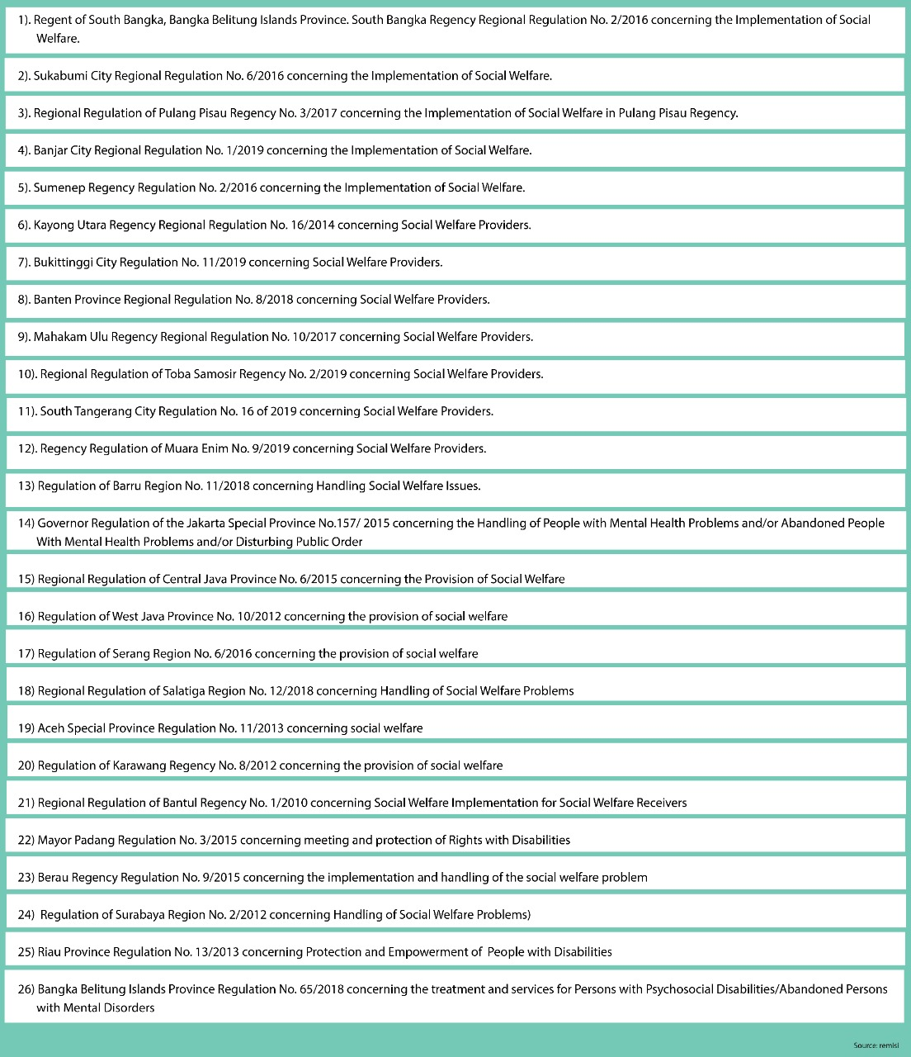

WWPDs can be placed in rehabilitation institutions without a medical assessment or diagnosis, and without a court ruling affirming under guardianship. Almost all residents encountered at the institution during our visit were detained without consent. Some of them were taken by the Municipal police or taken forcibly by their families. Human Rights Watch also reported the same thing in 2016.

Gender Based Violence

WWPDS relies heavily on family support due to difficulties in finding and keeping a job. Many WWPDS who do not have enough support, face all forms of violence and find it strenuous to have an independent life. Based on the 2020 annual report of the National Commission on Violence against Women, there was a significant increase in violence in the psychosocial disability group compared to the previous year, which total 3 of WWPDs. In 2020, 18 women with psychosocial disabilities were reported as victims of violence.

WWPDS faced Gender-based violence in various forms. It occurs in the family, public places, the workplace, schools, hospitals, and social care institutions. They are easily targeted as objects of violence in various forms. Violence against WWPDs is perpetuated by stereotypes in the community, and most people consider psychosocial disabilities are less than humans and deserve to be demeaned, ostracized and humiliated.

The violence they experience often occurs repeatedly due to the conditions they experience. It is common for WWPDs when they face violence and report the case, their statement is considered doubtful and often ignored. This phenomenon is often used by perpetrators for the act of many forms of violence. Remisi collected thousands of data on violence from 2016-2019 experienced by WWPDs. The majority of perpetrators of violence are closely related persons, including family. See the diagram below:

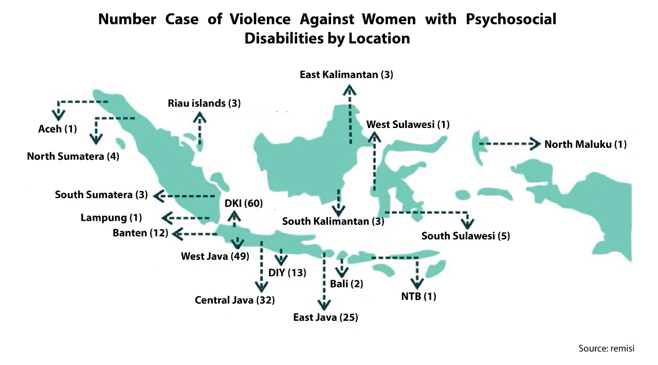

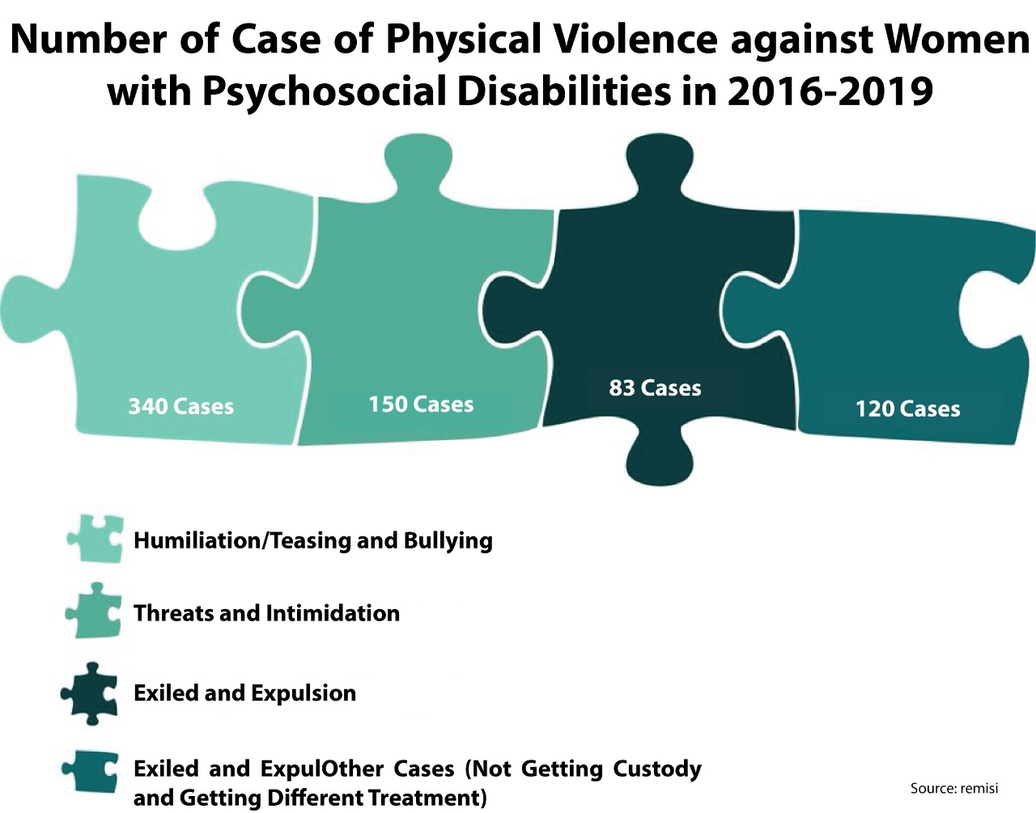

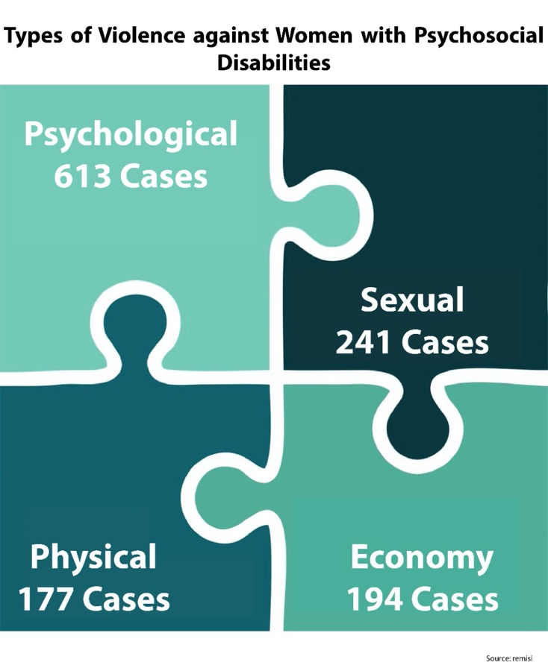

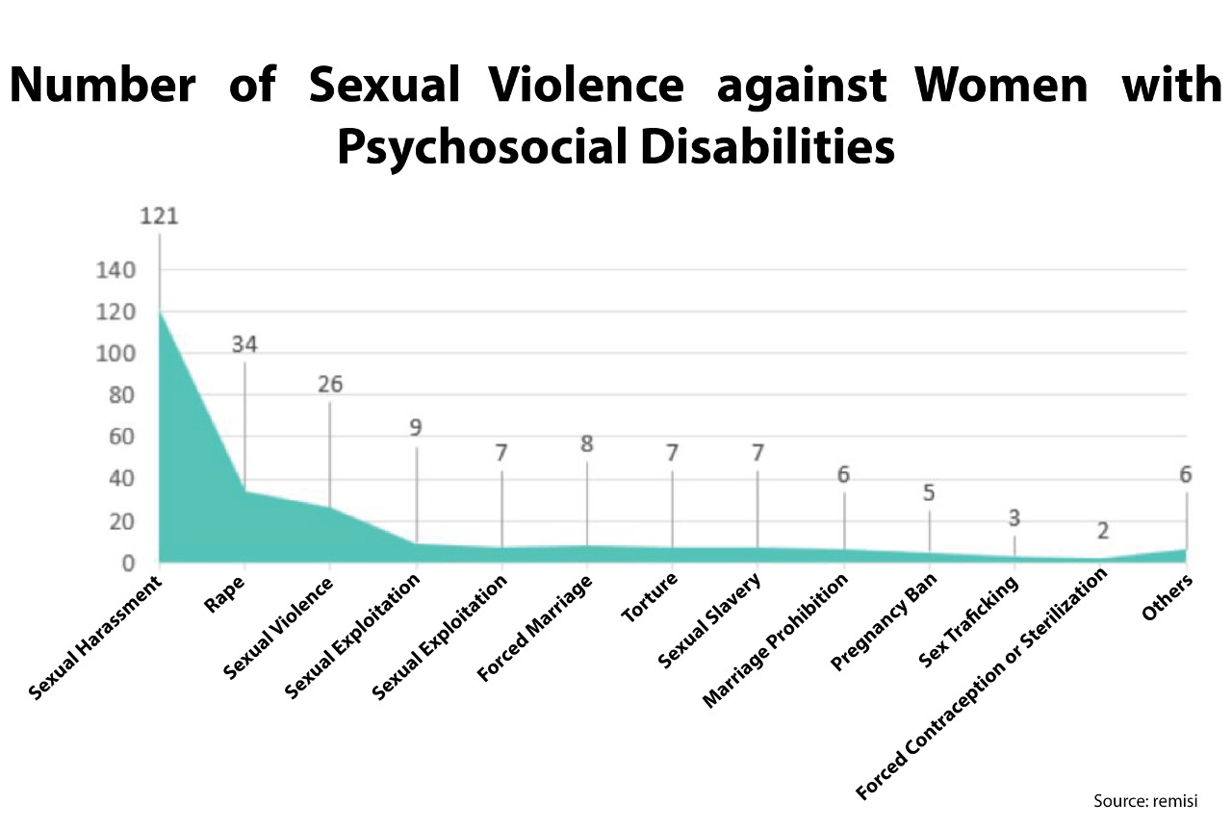

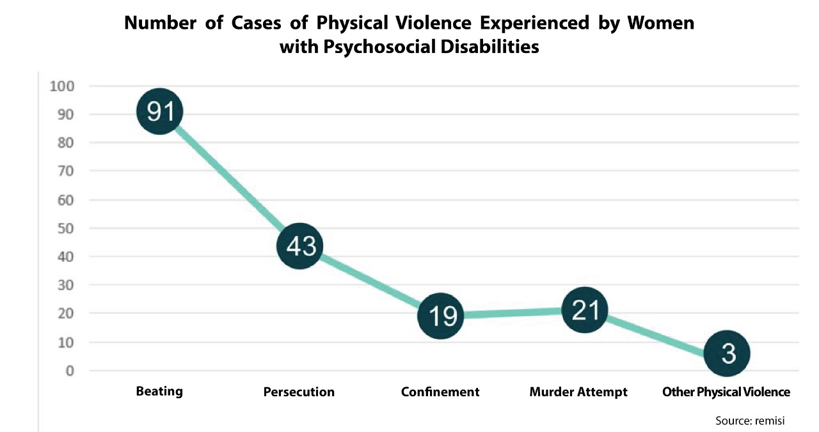

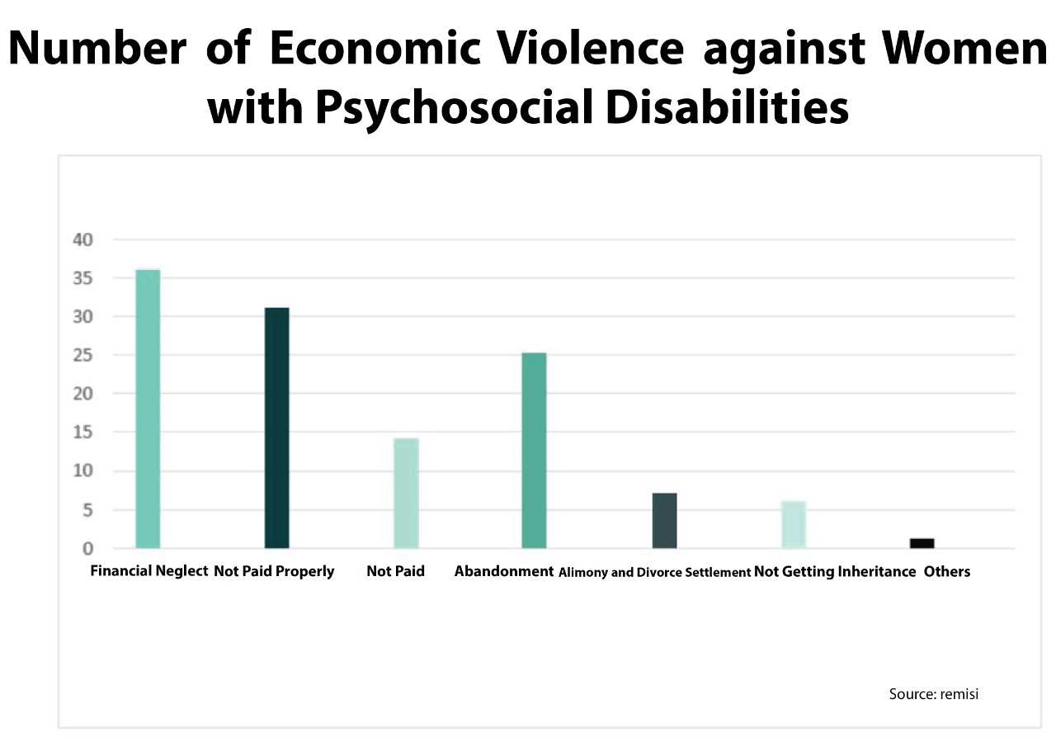

D is a WWPD. She experienced various sexual violence perpetrated by people closest to her. In 2013, D received forced sterilization in a hospital with consent from her parents only while she was on a threat from her family. Forced sterilization is considered as a solution by D's family because D has had several unwanted pregnancies.

Women with Psychosocial Disabilities and Torture other Cruel, Inhuman and Degrading Treatment and Punishment

Shackling is still a solution for families and rehabilitation centres. Indonesia has conducted a shackle-free program since 1977 by the ministry of health, and the practice is banned in mental health Law No. 18 of 2014. The process of shackling and others deprivation of liberty moved into public and private social care institutions. The government has not monitored the phenomena of deprivation of liberty, such as shackling comprehensively, especially within private social care institutions. According to a Human Rights Watch report, 57,000 people have been shackled, and about 15,000 of them are still alive as of November 2019.

According to the National Commission on Violence Against Women report in 2018, they found a WWPD in Purworejo forced to live in confinement and exile in the middle of the rice fields. Although shackling is also experienced by male PWPD, WWPDs have a higher risk in many factors. Several cases of WWPDs who were raped repeatedly while in shackling and became pregnant and after giving birth they automatically lost their babies. In addition, WWPDs who were in shackling also experienced other health problems such as fibroids and other reproductive health problems.

A patient who was under 18 years old became pregnant because she was raped, and the officer of the social care rehabilitation gave the baby after being born to the adoptive party. Commonly, WWPDs who become pregnant and then give birth in the institution will lose their child.

Remisi investigations in 9 private rehabilitation centres in 4 provinces in Indonesia found WWPDs locked up and chained. The majority of private rehabilitation centres are still placing the resident in a room with iron bars resembling a prison or cage. Some were tied with chains on their feet, and they do not know how long they can be detained or be released. An elderly of WWPDs at a rehabilitation centre in Tasikmalaya, who previously worked as a dentist, has lived there for five years. Her family is unknown and has never visited her in years. WWPDs can be imprisoned for life without a court ruling.

Our interview with the owner of one social care institution in Jawa Timur said there is no female officer, and he said there is no one who could teach WWPDs how to use tampons during menstruation. Blood is usually splattered on the floor of the room if there are WWPDs in periods. In private rehabilitation centres, there are still few female officers on duty at night, WWPDs are bathed in an open place that can be seen by other people.

Marriage and Family Relation

WWPDs experience discrimination in the marriage. It is regulated by Marriage Law No. 1/1974, in Article 4 Paragraph 2 point b wives can be divorced because they have a disability. This law has not yet been revised. In the divorce process, WWPDs often lose custody of their children, even if their children are still in need of breastfeeding.

According to our interviews with two judges from the religious court regarding child custody of WWPDs. One of them stated that "custodial rights of children automatically fall into the hands of the father even if the child still needs to breastfeed because the mother is considered not to have the ability to care for children".

AC is WWPD domiciled in Jakarta. A divorced her husband in 2014 and lost custody of her 2-year-old child because she was considered incompetent to take care of her child, although AC's psychological condition did not always recur because she was always under professional assistance and monitoring, had a good supporting system and economy.

Remisi collected data on WWPDs who were divorced due to psychosocial disabilities and data collection on divorce cases which resulted in WWPDs losing custody of their children based on the decisions of the religious courts and district courts taken from the website of the Supreme Court. See the table below:

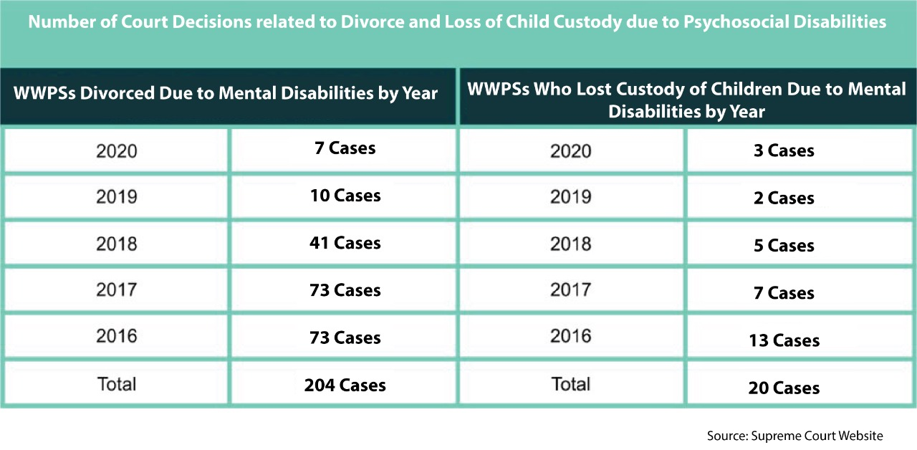

Situation during Covid-19 Pandemic

Remisi visited several social rehabilitation centres for people with psychosocial disabilities in 9 cities we highlighted the lack of knowledge about the Pandemic in almost all institutions. In one institution, the social rehabilitation officers claimed that no residents and staff nor the resident had been affected by Covid-19 while living in the social rehabilitation centre without any testing and tracing activities from the Health Service.

When we visited some private social care institution, none of the residents of the staff were wearing masks. They also do not implement health protocols. There is no vaccination to both the rehabilitation centre staff or the resident. One staff assure that there is no resident who is affected by Covid-19,

WWPDs who live in private social rehabilitation centres are not vaccinated and forgotten from vaccine programs where disability as vulnerable groups should be prioritized. A private institutions have strictly prohibited vaccines for their residents. In addition, there were several cases of higher mortality in a private rehabilitation centres during the Covid-19 pandemic.

Violation Against CEDAW

Numerous forms of stigma, violence, and discrimination against WWPDs reported above are violations against CEDAW particularly in these following articles:
- Article 1-5 on Discrimination
- Article 10 on Education and General Recommendation No. 36
- Article 11 on Employment
- Article 12 and General Recommendation No. 24 on Women and Health
- Article 15 on Legal Capacity
- General Recommendation No. 35 on Gender-Based Violence
- General Recommendation No. 29 on Marriage and family relations
- General Recommendation No. 33 on Access to Justice

Pictures situation WWPDs in State-owned and Private Social Care Institutions:

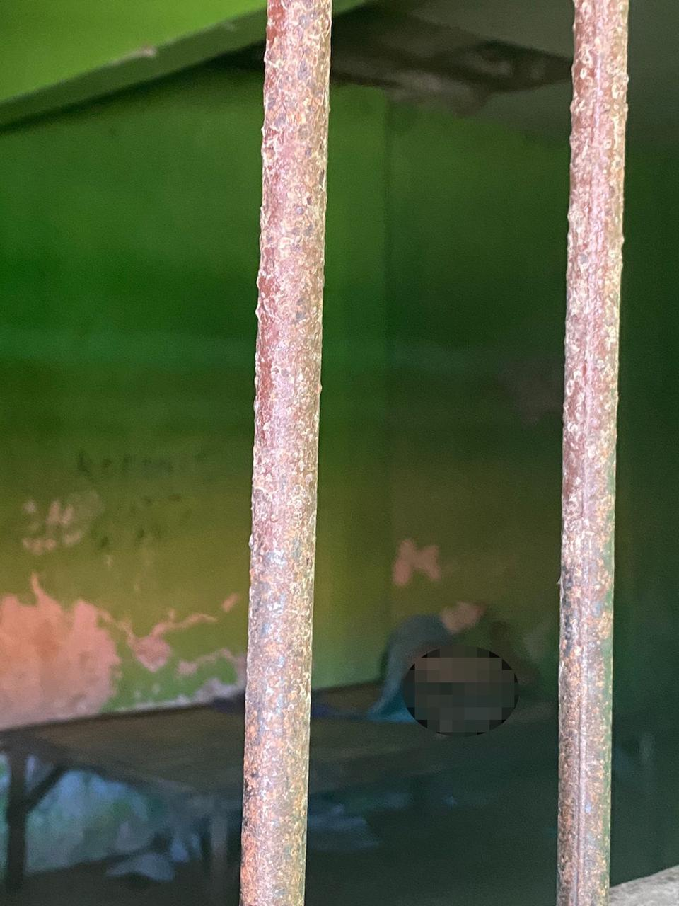
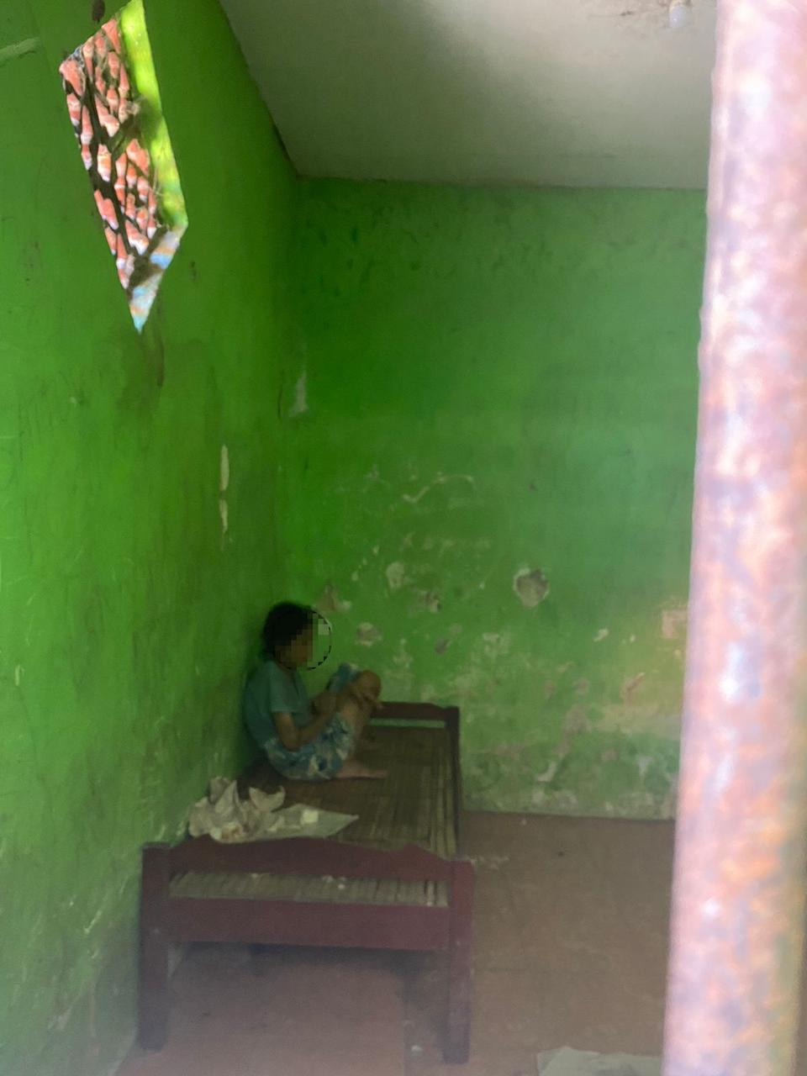
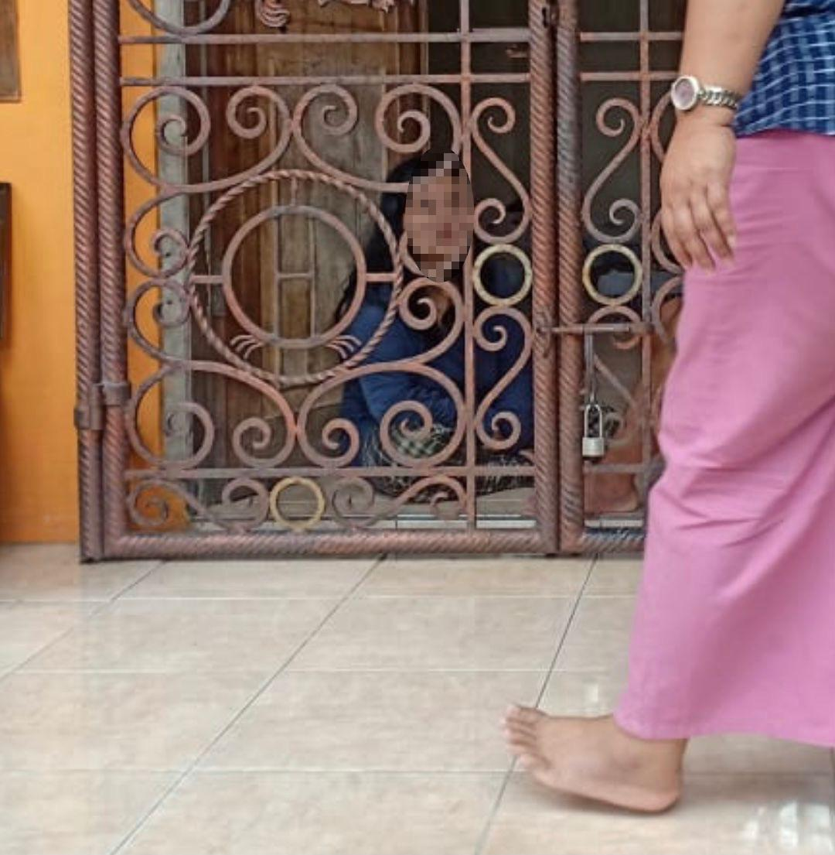
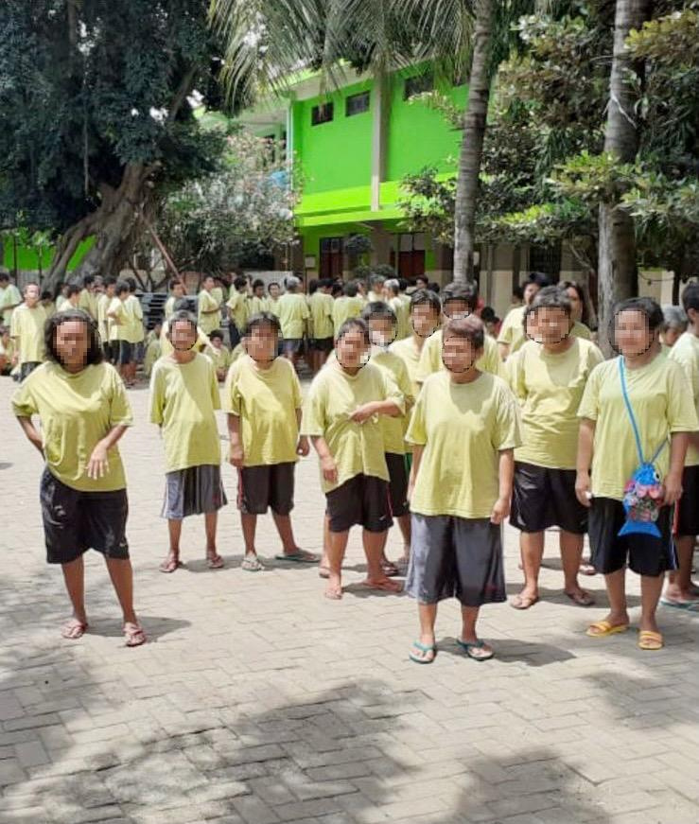

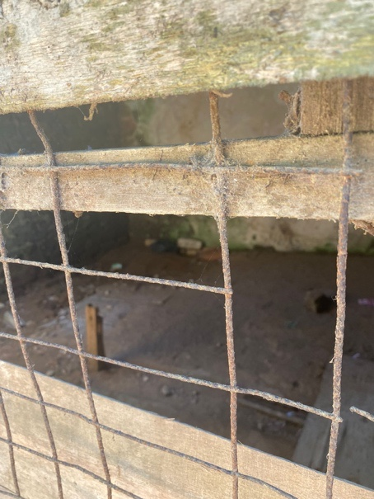

Facilities such as Kitchen, Bathroom Room and Cage in Social Care Institutions

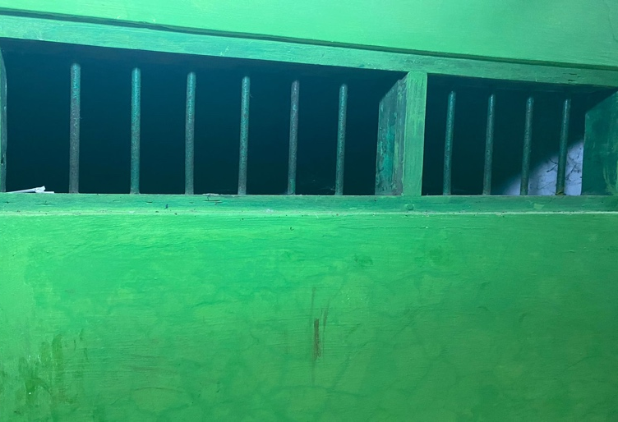
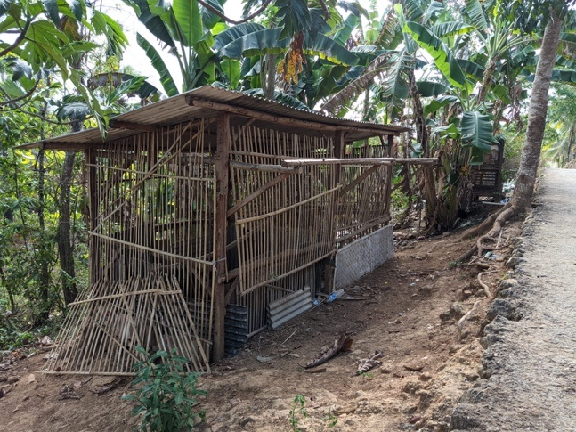

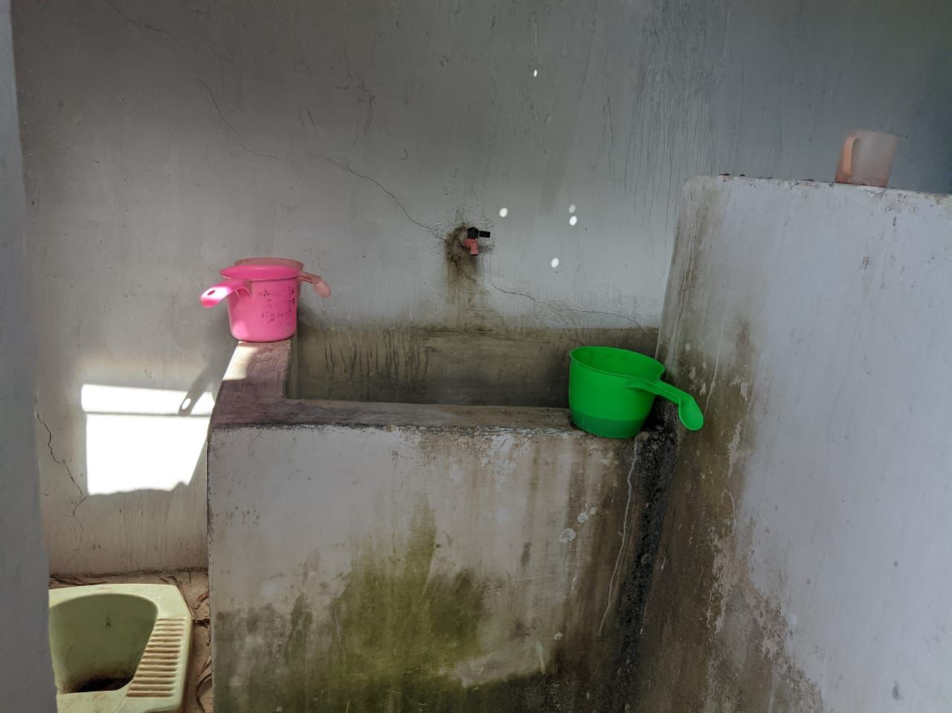
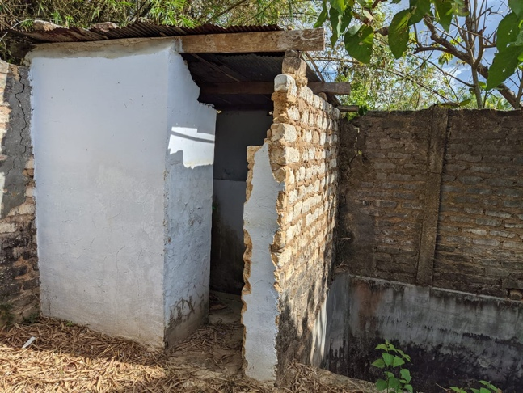

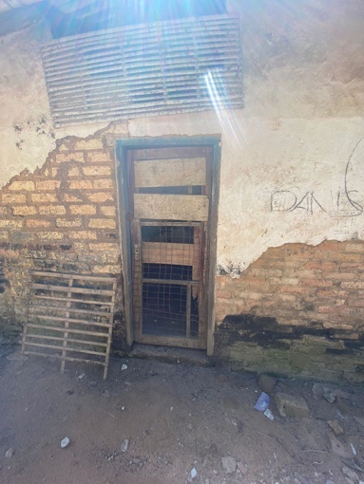
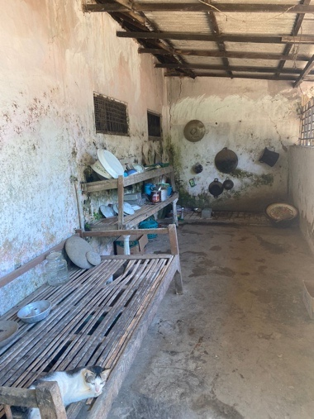
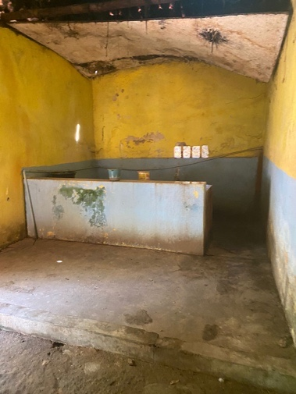

https://lbhmasyarakat.org/asesmen-hukum-pengampuan-indonesia-perlindungan-hak-orang-dengan-disabilitas-psikososial/
Interview with WM, former institution resident, in June 2019
Octavian, Yosua and Wirya, Albert. (2018). The state of human rights protection for the mentally disabled in the criminal justice system. LBH Masyarakat. &
Interview with L, a student from Bandung, in June, 2019
Interview with M, a doctor with psychosocial disability from Jakarta, in February, 2019
https://www.voaindonesia.com/a/organisasi-odha-dan-pekerja-seks-resmi-gugat-perpres-jkn/5537519.html
Interview with RR a National Health Insurance Member, in January 2019
Human Rights Watch. (2016). Living in Hell: Abuses against People with Psychosocial Disabilities in Indonesia. USA: Human Rights Watch.
https://komnasperempuan.go.id/catatan-tahunan-detail/info-grafis-catahu-2020-catatan-tahunan-kekerasan-terhadap-perempuan-tahun-2019
Interview with D a WWPDs, in June 2017
https://www.cnnindonesia.com/internasional/20201006104844-106-554832/lsm-as-catat-57-ribu-orang-indonesia-dipasung-karena-stigma
Chuzaifah et al. (2019). Hukuman tanpa Kejahatan (Punishment without Mistake). Jakarta: The National Commission on Violence against Women.
Interview with SD and AB a Judge in religious court, in August 2021
Interview with AC a WWPD, in January 2017

