THEMATIC REPORT ON MUSLIM FAMILY LAW AND
MUSLIM WOMEN’S RIGHTS IN
KUWAIT

88th CEDAW Session
Geneva, Switzerland
MAY 2024

SUBMITTED BY:

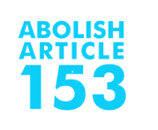

Abolish Article 153 | Musawah
B8 building, Second floor,  Ahmed al Jaber Street Sharq, Kuwait  Tel: +965 69964069  Email: info@abolish153.org  Web: www.abolish153.org |  | 15, Jalan Limau Purut, Bangsar Park, 59000 Kuala Lumpur, Malaysia  Tel: +603 2083 0202 Fax: +603 2202 0303  Email: musawah@musawah.org  Web: www.musawah.org

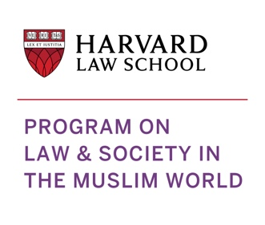
Program on Law and Society in the Muslim World
Harvard Law School
1535 Massachusetts Ave, Cambridge, MA 02138, USA
Email: plsmw@law.harvard.edu
Web: plsmw.law.harvard.edu

Table of Contents

A. INTRODUCTION 3
B. BACKGROUND, LEGAL FRAMEWORK AND CONTEXT 3
C. KEY ISSUES AND RECOMMENDATIONS 5
1. Gender-Based Violence 5
2. Women’s Legal Capacity to Enter into Marriage 8
3. Early and Child Marriage 9
4. Discrimination in Divorce Rights 11
5. Custody and Guardianship of Children 13
6. Nationality 13

A. INTRODUCTION

Abolish 153 Campaign, the Program on Law and Society in the Muslim World at Harvard Law School, and Musawah submit this joint Thematic Report on Article 16 and related concerns for consideration by the CEDAW Committee in its review of the Government of Kuwait, reporting before the 88th Session of the CEDAW Committee in May 2024. We hope that the CEDAW Committee will utilize this report as a key resource during its constructive engagement with the State Party and use the recommendations to identify follow-up issues in its Concluding Observations.

Kuwait ratified the CEDAW Convention on 2 September 1994 and placed reservations on Article 16, paragraph (f) regarding adoption, “inasmuch as it conflicts with the provisions of the Islamic Shariah, Islam being the official religion of the State,” and on Article 9, paragraph 2, which provides that States Parties shall grant women equal rights with men with respect to the nationality of their children, “in as much as it runs counter to the Kuwaiti Nationality Act, which stipulates that a child's nationality shall be determined by that of his father.” Kuwait had also previously placed a reservation on Article 7, paragraph (a), which was withdrawn in 2005. This is the CEDAW Committee’s fourth engagement with the State of Kuwait.

This report raises concerns with respect to Kuwait’s continued non-implementation of the Convention in the context of marriage and family rights of Muslim women and gender-based violence. This report highlights key legal inequalities that Muslim women face in the personal status sphere and their resulting negative impact on women and girls, along with gaps in protection from gender-based violence, including sexual harassment, with recommendations to address gaps. We encourage the Kuwait government to continue its efforts in eliminating discrimination against women and reforming its laws to protect the rights of women in the private and public spheres.

This report was drafted by Salma Waheedi on behalf of the submitting organizations. We would like to thank Sundus Hussein and Sheikha Alnafisi for providing substantive insights on the lived realities of Kuwaiti women and for reviewing the report.

B. BACKGROUND, LEGAL FRAMEWORK AND CONTEXT

Kuwait is located in the north of the Arabian Gulf, with a total surface area of 17,818 km² and an estimated population of 4.4 million, of which about one-third is Kuwaiti citizens. The total population of Kuwait is about 76 percent Muslim, of which an estimated 70 percent is Sunni and 30 percent is Shi’a (mostly Ja’fari or Twelver Shi’a). Non-Muslim religious communities, the vast majority of which are foreign workers, include Christians (estimated at 16 percent of the total population), Hindus, Sikhs, Buddhists, Jains, and other smaller groups.

Kuwait is an Arab constitutional hereditary monarchy, with a deeply conservative and predominantly Muslim population. The Constitution of 1962 establishes Kuwait as an independent Arab and Muslim State. Article 2 of the Constitution provides that Islam is the religion of the State and Islamic Shari’ah is a main source of legislation. Other relevant articles include Article 7, which states that justice, freedom and equality are the pillars of society; Article 8, which provides that the State shall preserve “the pillars of society and shall guarantee security, tranquillity and equal opportunity to all citizens,” and Article 9, which declares the family to be “the foundation of society,” and that the law shall strive to preserve it, strengthen its bonds, and protect motherhood and childhood within its structure. Article 29 of the Constitution of Kuwait emphasizes that people are equal under the law in rights and public duties and prohibits discrimination on the basis of sex, origin, language, or religion. Article 18 further states that matters of inheritance are to be governed by Shari’ah. The Constitution does not define Shari’ah explicitly, thereby leaving the interpretation, definition, and application of Shari’ah in the hands of the legislature and the courts.

The Judiciary Law of 1990 organizes the court system in Kuwait, which comprises Courts of First Instance, Courts of Appeal, and a Cassation Court, in addition to the Constitutional Court, which has exclusive jurisdiction over constitutional questions and elections disputes. Within each level, courts are divided into civil, criminal, commercial, administrative, and personal status court chambers, including Sunni and Shi’a (Ja’fari) personal status court chambers. The personal status (or family) courts in Kuwait have jurisdiction over marriage, divorce, inheritance, and other personal status matters. In 2015, Kuwait established family court chambers in each governorate. Non-Muslims may request that family courts adjudicate their disputes in accordance with the customary laws or religious laws of their own communities.

PERSONAL STATUS LAWS

There are two laws in Kuwait that govern personal status. The Kuwait Personal Status Act of 1984 is the primary codified law that governs matters relating to personal status, including marriage, divorce, custody, and inheritance, and is applicable to the majority Sunni Muslim population in Kuwait. In 2019, Kuwait enacted a separate law to govern personal status matters for the minority Shi’a Ja’fari population, the Ja’fari Personal Status Act of 2019.

The Personal Status Act is based on an amalgamation of rules taken principally from the four Sunni schools of jurisprudence (fiqh). In instances where the provisions of the Act do not sufficiently address a particular personal status question, a judge is instructed to adjudicate the dispute in accordance with the rules and general principles of Maliki jurisprudence. Article 346 of the Personal Status Act states that it shall apply to non-Muslims if different parties to a dispute adhere to different religions or sects; otherwise, non-Muslims may request that disputes be adjudicated in accordance with their own communities’ customary or religious laws.

Substantively, both personal status laws include provisions that discriminate based on gender and violate the State’s CEDAW commitments. In addition, women in Kuwait are accorded different sets of rights, based on the Muslim sect or religious community to which they belong, in contrast to constitutional protections and provisions of equality and non-discrimination that apply to all Kuwaitis.

THE PENAL CODE

The Kuwaiti Penal Code of 1960 includes various discriminatory provisions that violate the rights of women and girls. Specifically, the Penal Code:

- Permits violence against women in the form of a right to “discipline.”
- Provides for lesser penalties for violent “honor” crimes committed against women.
- Exempts an abductor from criminal liability if he marries the woman who he had abducted, provided that her guardian gives permission for the marriage.

The provisions above are in violation of Kuwait’s commitments under CEDAW, as well as its own constitutional provisions of human dignity and equality and its Domestic Violence Protection Act.

THE DOMESTIC VIOLENCE PROTECTION ACT

The passage of the Domestic Violence Protection Act of 2020 (hereinafter referred to as “the Domestic Violence Act”) marked a significant step towards enhancing the legal protections of women from violence. The Act includes provisions aimed at the prevention of and protection from gender-based violence in the family sphere. It criminalizes acts of domestic violence, including physical, psychological, sexual, and financial forms of violence, whether these are a specific action (or lack thereof) or a threat of violence. The Act also outlines procedural guidelines for reporting domestic violence and affords protections and support mechanisms for victims and survivors of violence.

Building on these developments, further steps that are needed in order to give effect to the protections in the Domestic Violence Act and to implement its provisions effectively. In addition, further legislative changes are necessary to address legal gaps in protection from sexual harassment and to remove the contradictory provisions in the Penal Code, which permit violence against women in the form of “discipline” and fail to punish honor crimes and abduction.

C. KEY ISSUES AND RECOMMENDATIONS

Gender-Based Violence

Domestic Violence Act

Kuwait enacted its first law addressing domestic violence in 2020, the Domestic Violence Act, in an important positive step towards protecting women from gender-based violence. Nevertheless, it is important that Kuwait continues to address gaps in legislation and implementation in order to strengthen the protection of women from violence.

A 2022 study has shown that an estimated 1,100 cases of domestic violence are reported each year, with women comprising 80 percent of victims of violence. Incidents of violence against women have reportedly increased by 40 percent between 2020 and 2022, and by August 2023, the number of domestic violence complaints exceeded 3778 since the passage of the Domestic Violence Act. In 50 percent of these cases, however, women withdrew their complaints due to societal and family pressure to “reconcile” with the perpetrator. Furthermore, it is important to note that reported cases represent only a fraction of the overall incidents of violence, according to experts and advocates.

The Domestic Violence Act defines domestic violence as “any form of physical, psychological, sexual or financial treatment – engaged in via commission, omission or threat – by one family member against one or more other members.” The Act includes important legal protections, including confidential reporting procedures for victims; procedures for the issuance of emergency protection orders in the case of a serious threat to the life, health, or safety of a victim; a provision instructing the Public Prosecutor to investigate and prosecute domestic violence incidents, and to initial criminal proceedings at the request of any “person or entity”; and sanctions for violations of emergency protection orders, which include both prison sentences and monetary fines.

Article 5 of the Act instructs the Supreme Council for Family Affairs to establish shelters for victims of domestic violence, ensure the provision of psychological, health, and family counseling and legal assistance services for victims, and establish a phone hotline to receive complaints. The same Article mandates the tracking and publishing of domestic violence statistics and indicators, development of plans and educational programs to raise public awareness on matters of domestic violence protection, and training of Government officials responsible for implementation of the Act. Article 23 of the Act mandates the creation of a support fund, for which resources shall be allocated partially from the budget of the Supreme Council for Family Affairs, to care financially for victims of domestic violence.

Notwithstanding these provisions, the law also contains some critical gaps in protection. The Domestic Violence Act does not specify concrete legal consequences for domestic violence as a crime in itself; rather, the sanctions in the law only cover failure to abide by an emergency protection order, thereby relying on the Penal Code to determine punishments for acts of domestic violence (see below for discussion of the contradictory provisions of the Penal Code). The Act also only protects from violence perpetrated by members of one’s family, including spouses, children, parents, siblings, and relations by marriage. It does not cover violence perpetrated by former spouses or by persons who are engaged in relationships outside of official marriage.

The State of Kuwait must take further action to implement the provisions of the law effectively. For example, while the Domestic Violence Act mandates the establishment of shelters to protect victims of domestic violence, currently there is only one operational shelter in Kuwait – Fanar Shelter, with its associated Fanar Counseling Center. Fanar Shelter was inaugurated in 2019 but became operational only in 2022, and continues to struggle with limited financial and human resources and therefore inadequate capacity to meet present needs. The current shelter lacks the necessary resources to provide medical, psychological, and legal support for victims of abuse; it has repeatedly rejected non-Kuwaiti women due to insufficient funding and staff; and it continues to reject victims who are seeking shelter along with their sons who are over 14 years old. The reason for rejecting women with sons over 14 is that the shelter does not have the space that would be needed to allow other female residents to refrain from contact with the young men, which is an important consideration in the context of Kuwait’s societal customs and norms. Moreover, the shelter is only able to accommodate victims for a limited period of time, and instead mandates that victims in the shelter be released to their families – who are often their abusers – if their “cases” are not resolved within two months.

To date, the government has lagged behind in fulfilling its legal commitments to offer public educational and awareness raising programs in relation to domestic violence protection. This is a critical gap, especially as studies point to alarmingly low levels of awareness among Kuwaitis of the risks and negative impacts of violence against women, and a similar low awareness among women of the available resources of support for victims and survivors.

There are currently no transparent and detailed indicators that track domestic violence incidents in Kuwait, which in turn makes it difficult to comprehend the extent of the issue or effectively plan responsive measures. Data gathering is a critical prerequisite to both developing preventative strategies and providing survivors with the necessary support.

Finally, while the Domestic Violence Act mandates the establishment of a fund to provide financial support and care for victims of domestic violence, to date the Supreme Council for Family Affairs has not designated financial appropriations to the fund, nor has it needed developed rules and mechanisms to govern the management and allocation of support resources to victims and survivors.

The Penal Code

Article 29 of the Kuwaiti Penal Code states that “no (criminal) offence is committed if the person exercising the right to discipline the other is entitled to do so by law, provided that the act has its limits and that its intentions are disciplinary.”

There is no religious justification in the Shari’ah that permits violence against women. Committing violence goes against Qur’anic teachings and the example of the Prophet Muhammad. One single phrase in one single verse in the entire Qur’an – the second part of Surat an-Nisa’ 4:34 – is commonly used to justify violence against women in Muslim family laws and practices, notwithstanding multiple conflicting interpretations of the meaning and importance of this verse in both classical and contemporary times. Moreover, the Qur’an views marriage as a solemn bond (mithaq ghaliz) of trust, commitment, and mutual care, and describes the marital relationship as a resting abode (sakan) built on affection (mawaddah) and compassion (rahmah). This Islamic vision of marriage cannot be achieved if any family member is exposed to harm.

Article 29 of the Penal Code further contradicts the prohibitions on all forms of violence in Kuwait’s Domestic Violence Act of 2020, as well as other provisions in the Penal Code itself, which punish acts that lead to bodily harm, injury, or permanent disability, respectively.

The inherent contradictions between the levels of protection contained in the Domestic Violence Act and in the Penal Code become particularly significant given that the Domestic Violence Act lacks specific legal sanctions for acts of violence, referring the question of punishment to the Penal Code. Whereas the Domestic Violence Act bars all forms of violence within the family – including physical, psychological, financial, and sexual violence – the Penal Code only includes punishments for physical acts of violence. As a result, many of the prohibitions of the Domestic Violence Act remain ineffective and without legal consequences. Marital rape is another prime example of this protection gap: while the Domestic Violence Act identifies “sexual violence” as a form of violence prohibited by the law, the Penal Code does not recognize “marital rape” as a specific punishable offense.

Sexual Harassment

Protection from sexual harassment remains a gap in the legislation of Kuwait. Neither the Domestic Violence Act nor the Penal Code provide specific protection from sexual harassment or recognize it as a form of violence against women. This is particularly a gap when it comes to the protection of women from sexual harassment that may not involve direct commission of a violent act.

Crimes of “Honor”

Article 153 of the Penal Code is an “honor” killing provision that provides for lenient sentences if a man murders his wife, mother, or daughter after having “surprised them” while engaging in sexual acts with a man outside of marriage. In these cases, the law treats the murder as misdemeanor offense and punishes the male perpetrator with a maximum of a 3-year prison sentence or a minor fine.

Article 153 violates Kuwait’s international commitments, including CEDAW commitments to protect women from violence, as well as Article 29 of Kuwait’s Constitution, which emphasizes the equality between all people and the prohibition of gender-based discrimination, and Article 34, which guarantees the right to fair trial and presumption of innocence until guilt is proven in the course of a fair trial. Further, Article 153 stands in opposition to the procedural guarantees afforded in Islamic Shari’ah in cases of accusations of adultery (zina), which requires four male witnesses to plainly see the act of sexual consummation before any legal punishment is ordered.

It is critically important that Kuwait abolishes Article 153 of the Penal Code and institutes strict legal consequences for all crimes against women, irrespective of the stated motive of the crime. This is particularly urgent in light of the alarming continuous rise in the number of Kuwaiti women murdered by their family members for so-called “honor” reasons, which some have called “a wave of femicide.”

Abduction of a Woman

Article 182 of the Penal Code exempts a man from punishment for abducting a woman if he marries the victim of abduction with permission of her guardian. The provision does not specify a role or agency for the woman in this matter and instead places the entire decision-making power in the hands of the abductor and the woman’s male guardian.

RECOMMENDATIONS
We recommend that the CEDAW Committee urge the State party to:

- Prioritize the urgent implementation of previous CEDAW Committee Concluding Observations urging the State Party to repeal Articles 29 (physical discipline), 153 (honor crimes), and 182 (abduction) of the Kuwait Penal Code of 1960.
- Introduce legislation to prohibit and punish all forms of sexual harassment.
- Amend and streamline the Domestic Violence Act and the Penal Code to eliminate all gaps in protection of women from violence and ensure effective sanctions for all forms of gender-based violence, including physical, psychological, sexual, and financial, in addition to threats of violence.
- Ensure full implementation of the Domestic Violence Act and give effect to its provisions, including those related to statistics and indicators, strategic planning, the introduction of educational and public awareness programs, and training of government officials.
- Expand the funding and resources dedicated to existing shelter facilities, provide additional shelter facilities, and engage civil society actors in developing related services and programs to meet the needs of domestic violence survivors.

Women’s Legal Capacity to Enter into Marriage

Kuwaiti laws continues to require adult women to obtain the consent of a male guardian before marriage. An adult woman cannot independently enter into a marriage contract.

The Personal Status Act of 1984, applicable to the Sunni majority in Kuwait, requires consent of both the bride and groom to the marriage, regardless of age. A bride, however, must also obtain the consent of her male guardian (wali) before entering into marriage. The guardian must be present at the time of officiating the marriage contract, and the law does not require the signature of a woman on her own marriage contract. A woman’s guardian may be her father, grandfather, brother, or other male kin in order of proximity, and a judge may act as guardian if there is no male kin. Forced marriage is prohibited and considered void under the Act, and in the case of a guardian’s unreasonable withholding of consent to marriage (‘adl), a judge may order the marriage to proceed.

Practically, however, it is difficult in Kuwait’s social context for a woman to publicly litigate in court against her family or guardian, and as a result, many women contend with submitting to the will of an authoritative guardian rather than risk public confrontation or ostracization from their own families. Similarly, bringing a case to invalidate a forced marriage is particularly challenging and may further place a woman at the risk of retaliation and violence.

The Shi’a Ja’fari Personal Status Act requires the consent of an adult woman’s father or grandfather in order to enter into a marriage contract. In the case of death of both the father and grandfather, a Shi’a woman may contract her own marriage. Article 22 prohibits forced marriages.

The registration of marriages is required, but non-registration does not necessarily invalidate the marriage, as the Act also provides that marriage may be proven by legal evidence. Registration of the marriage contract is required to prove a marriage and to hear any court case relating to a marriage or divorce, including maintenance, custody, and inheritance.

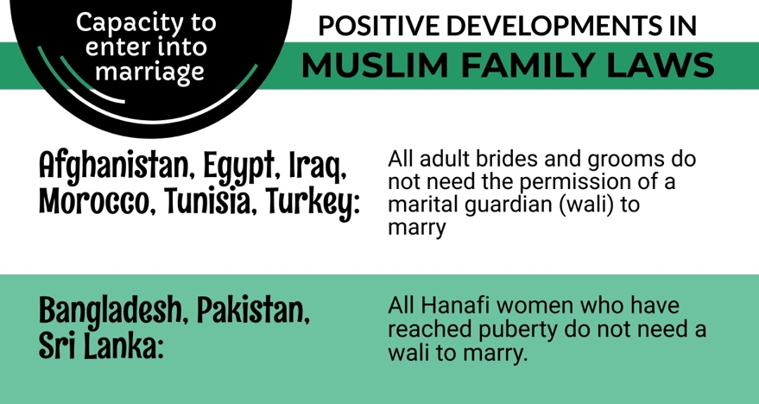

RECOMMENDATIONS
We recommend that the CEDAW Committee urge the State party to:

- Ensure that all women in Kuwait are accorded full legal capacity and right to enter into marriage, without requiring the permission of a male guardian, and without having to resort to court proceedings to obtain this right.

Early and Child Marriage

The Personal Status Act of 1984 does not specify a minimum age of marriage for either girls or boys. Article 24 of the Act merely requires that both parties have reached puberty for a marriage to be valid. However, Article 26 stipulates the ages at which a marriage contract can be officially registered, which are 15 years for girls and 17 years for boys.

The Ja’fari Personal Status Act similarly does not specify a minimum marriage age. Moreover, Article 23 of the Act permits a father, grandfather, or a judge-assigned guardian to contract the marriage of minors – with no minimum age specified – provided it was in the “interest of the minor.” The Article does not require any specific procedures for determining “interest,” nor does it provide for court supervision over the marriage of minors.

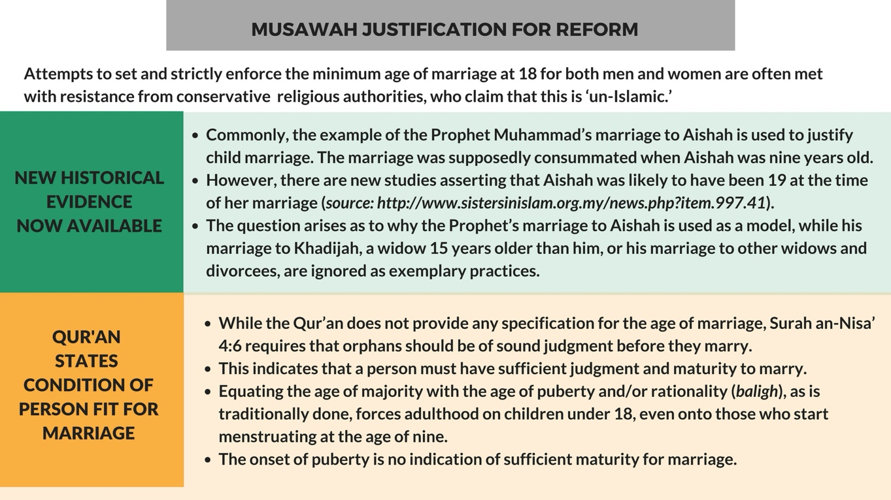

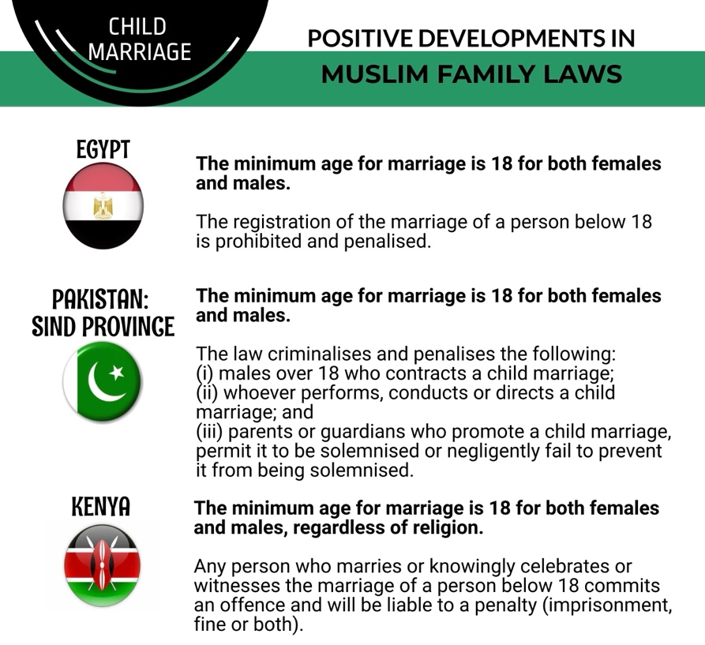

RECOMMENDATIONS
We recommend that the CEDAW Committee urge the State party to:

- Enforce 18 years as the absolute minimum age of marriage for Muslim girls and remove all legal loopholes that allow for exceptions and abuse.

Discrimination in Divorce Rights

The laws in Kuwait discriminate against women by constraining their access to divorce, in contrast to the unrestricted divorce rights granted to men. Specifically, these laws limit women’s ability to exit harmful and violent marriages and fail to protect the safety and wellbeing of women.
Kuwaiti laws provide for three different mechanisms for divorce:
- Unilateral repudiation (Talaq): A husband may unilaterally repudiate a marriage without a specific cause and without restrictions. A woman’s consent or presence is not required for a divorce to take place.

- Judicial divorce (Tatliq or Tafriq): A woman may initiate court action to seek a judicially ordered divorce based on limited, narrowly defined grounds.

For Sunnis, the Personal Status Acts provides that valid grounds for seeking judicial divorce by a wife include a husband’s failure to provide financial maintenance, absence for a year or longer, receiving a prison sentence of three years or more, and verbal or physical harm. In cases where a wife seeks divorce for harm, the Act mandates a reconciliation and mediation process before a divorce is granted , for which no time limits are specified; a judge may only order a divorce if the reconciliation process fails. The Act also requires that harm be proven by witness testimony (two men or one man and two women), a particularly burdensome requirement given that spousal harm and violence are most like to occur within the confines of the home when no witnesses are present.

The Shi’a Ja’fari Personal Status Act is significantly more restrictive in terms of the permissible grounds for a wife to seek a divorce. Notably, prolonged absence of a husband is not considered valid grounds for a wife to obtain a divorce. Rather, the Ja’fari Act specifically instructs an abandoned wife to “maintain patience and wait,” regardless of the duration of her husband’s absence. Under the Ja’fari Act, a wife may only obtain a judicial divorce order in cases where a husband’s death is suspected, and even then only after four years have passed from the date of court filing. In cases where a wife alleges harm, violence, or lack of financial maintenance by the husband, the Ja’fari Personal Status Act mandates a reconciliation and mediation process, following which a judge may order a divorce upon the recommendation of mediators. The Act does not provide guidance on the acceptable duration of a mediation process or means to prove harm.

(iii) Redemptive divorce (khul’): Under both Sunni and Ja’fari Personal Status Acts, a wife may seek a khul’ divorce, whereby she is granted a divorce in exchange for a mutually agreed compensation to be paid to the husband, which generally also includes renunciation of her post-divorce financial rights. If a husband does not consent to a khul’ divorce, the Court must then order a hearing and a reconciliation session, and a judge may order khul’ if the parties fail to reconcile.

A marriage contract may also be annulled in cases of physical illness that renders the continuation of marriage “impossible,” such as impotence or insanity, or if one spouse changes his or her religion.

There is a process to register divorces in Kuwait, but registration is not required in order for a divorce to be considered valid by law. While the Shi’a Personal Status Act requires the presence of two witnesses for a divorce to take effect, there are no witness requirements for Sunni divorces. According to practicing attorneys in Kuwait, the lack of uniform witness and registration requirements continues be problematic for women seeking to prove a divorce. There are also reported incidents of husbands divorcing their wives without informing them, often to avoid financial obligations.

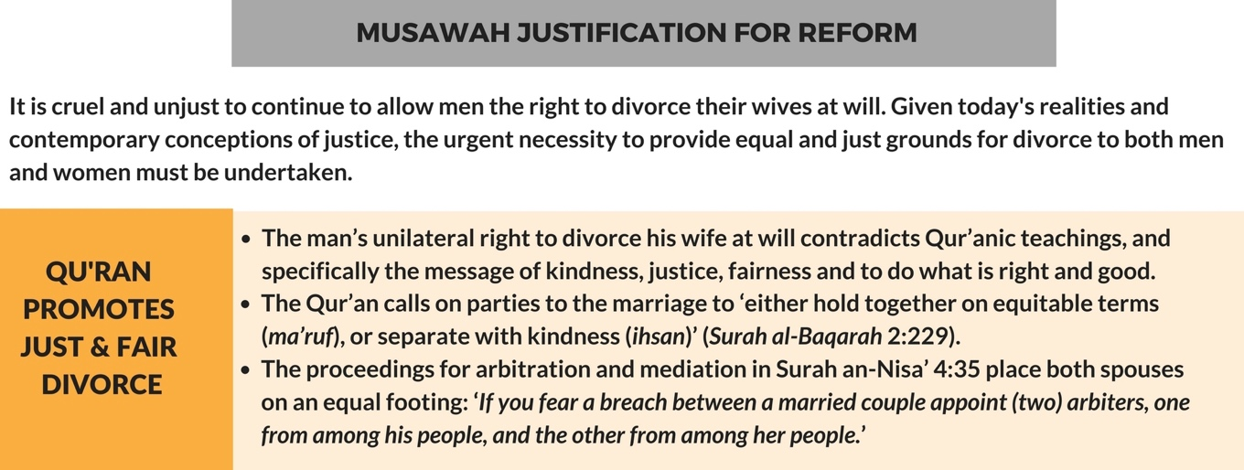

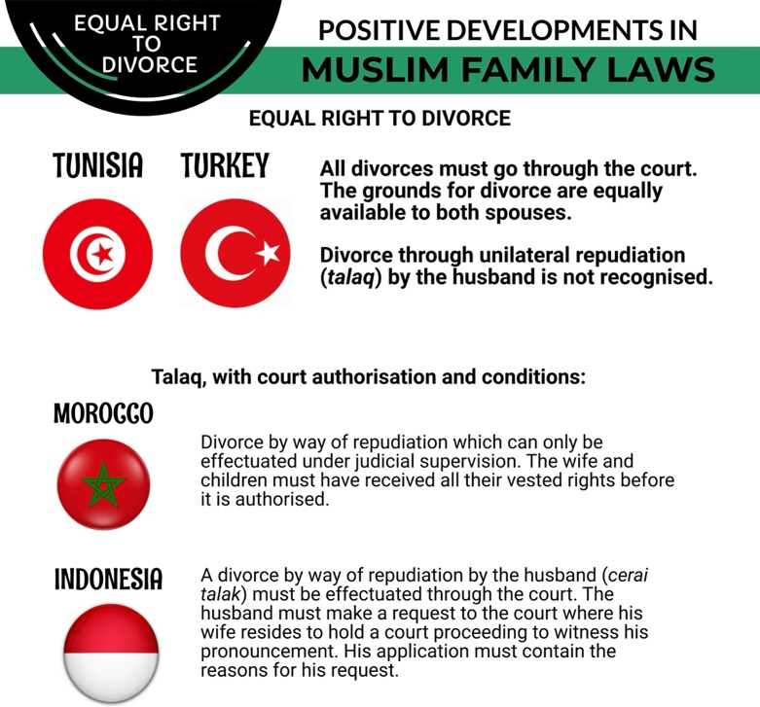

RECOMMENDATIONS
We recommend that the CEDAW Committee urge the State party to:

- Abolish a man’s unrestricted unilateral right to divorce.
- Enact legislative amendments to ensure that women and men have equal rights to divorce, that divorce only takes place in court and in the presence of both parties, and that registration of divorce is required in all cases.
- Amend the procedures for proving harm and domestic violence, including abolishing the witness requirement.

Custody and Guardianship of Children

Mothers have priority rights to custody of their children, with diverging rules in the Sunni and Ja’fari Personal Status Acts. A Sunni mother has priority rights to custody until a son reaches puberty and a daughter is married, and marriage is consummated. A Shi’a woman, by contrast, only retains custody of her children until the age of seven, after which custody reverts to the father until the age of puberty, defined in the law as fifteen years for a male child and nine years for a female. Upon reaching puberty, the Ja’fari Personal Status Act grants the child the right to choose his or her custodian. The laws of Kuwait also distinguish between custody and guardianship of children, reserving the latter, including financial guardianship, to a child’s father, grandfather, or other court-appointed guardian.

Under both Personal Status Acts, a mother loses custody of her children, which reverts to the father or the next in line as determined by court, if she remarries.

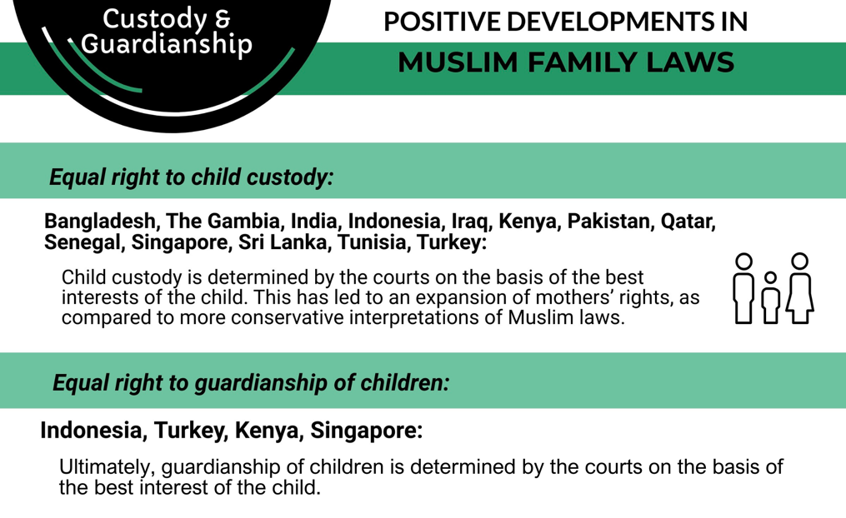

RECOMMENDATIONS
We recommend that the CEDAW Committee urge the State party to:

- Enact legislative amendments to grant equal rights to both the mother and father for guardianship and custody of children, to be determined according to the best interests of the child; ensure that a woman is not deprived of the custody of her children upon remarriage.

Nationality

The Kuwaiti Nationality Law includes several provisions that discriminate against women, in violations of Kuwait’s CEDAW commitments.

According to the Nationality Law of 1959, any person born in or outside Kuwait to a Kuwaiti father shall be a Kuwaiti national, irrespective of the nationality of the mother. Children born to a Kuwaiti mother and an unknown father may only be granted Kuwaiti nationality upon reaching the age of majority (21 years), “by Decree upon the recommendation of the Minister of the Interior.” On the other hand, children born to a Kuwaiti mother and a non-Kuwaiti father may only be granted nationality by Decree upon the recommendation of the Minister under strict conditions, namely that: (a) the children had maintained residence in Kuwait until reaching the age of majority, and (b) their foreign father had irrevocably divorced their Kuwaiti mother or had died. The law does not permit the nationalization of children born to a Kuwaiti mother and a non-Kuwaiti father before reaching the age of majority, but rather states that the Minister of Interior “afford to such children, being minors, the same treatment as that afforded to Kuwaiti nationals in all respects until they reach the age of majority.”

A foreign wife must be married to her Kuwaiti husband for a minimum of 15 years before she can apply to obtain Kuwaiti nationality, whereas the law does not provide a path for a foreign husband of a Kuwaiti women to acquire Kuwaiti nationality. A Kuwaiti woman who marries a foreigner may risk losing her nationality if she acquires the nationality of her husband.

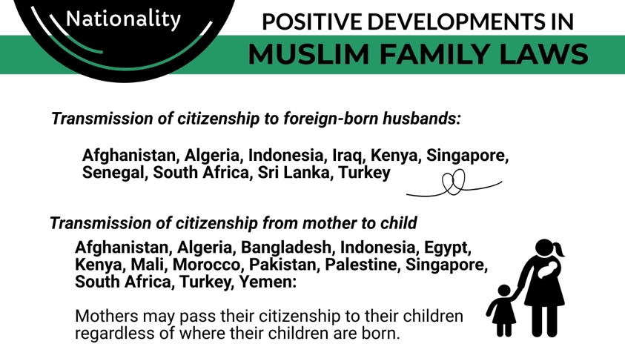

RECOMMENDATIONS
We recommend that the CEDAW Committee urge the State party to:

- Take immediate steps to repeal all discriminatory provisions in the Nationality Law and other relevant procedural guidelines that restrict a woman’s right to acquire, retain, and transfer citizenship on an equal basis with men.
- Recognize the independent right of each parent to confer citizenship based on lineal descent of their children.
- Revise the Nationality Law to ensure that Kuwait women can pass their citizenship to their children and foreign-born husbands, in accordance with guidelines and conditions that should be applicable equally to Kuwaiti men and women without discrimination.

United Nations Treaty Collection, Convention on the Elimination of All Forms of Discrimination Against Women (New York, 18 December 1979), Status as of 29 March 2024, https://treaties.un.org/Pages/ViewDetails.aspx?src=TREATY&mtdsg_no=IV-8&chapter=4&clang=_en.
Ibid.
“Kuwait.” The World Factbook, Washington, DC: Central Intelligence Agency, 2024, https://www.cia.gov/the-world-factbook/countries/kuwait/.
These are rough estimates, as there are no official statistics on religious and sect affiliation. 2022 Report on International Religious Freedom: Kuwait, US Department of State, 2022, https://www.state.gov/reports/2022-report-on-international-religious-freedom/kuwait/.
Ibid.
Articles 1, 2 of the Constitution of Kuwait (1962).
Article 2 of the Constitution of Kuwait (1962).
Articles 6-9 of the Constitution of Kuwait (1962).
Article 29 of the Constitution of Kuwait (1962).
See Salma Waheedi, “Litigating Women’s Rights in Gulf Monarchial Systems,” Arab Law Quarterly 36:4-5 (2022). For a full archive of the Constituent Assembly discussions, including discussion of the place of Shari’ah in the Constitution (in Arabic), see http://www.nationalkuwait.com/forum/index.php?threads/95593/.
Article 3 of the Kuwait Judiciary Law (1990); Constitutional Court Law (1973).
Articles 4, 6-8 of the Kuwait Judiciary Law (1990); Law No. 12 of 2015 Establishing the Family Court. Following the 2019 promulgation of the Ja’fari Personal Status Law, separate Sunni and Shi’a Ja’fari family court chambers were created, each to apply its respective legislation. See Kuwaiti Ministry of Justice Services Portal, https://www.moj.gov.kw/AR/pages/DeptProcedure.aspx?ItemID=98,
Kuwait Family Courts Law (2015).
Article 345.A of the Kuwait Personal Status Law (1984).
Kuwaiti Personal Status Law (1984), available in Arabic at https://www.e.gov.kw/sites/kgoarabic/Forms/QanoonAlAhwalAlMadaniyah.pdf
Kuwaiti Ja’fari Personal Status Law (2019), available in Arabic at https://www.aalawyer.co/wp-content/uploads/2023/12/قانون-الاحوال-الشخصية-الجعفري-الكويت-مبوب-.pdf.
These are the Shafi’i, Hanafi, Maliki, and Hanbali schools of Islamic jurisprudence (fiqh).
Article 343 of the Kuwait Personal Status Act (1984).
Article 346 of the Kuwait Personal Status Act (1984).
Article 29 of the Kuwait Penal Code (1960).
Article 153 of the Kuwait Penal Code (1960).
Article 182 of the Kuwait Penal Code (1960).
Article 1(2) of the Kuwait Domestic Violence Act (2020).
“1100 halat ‘unf dhid al-nisa’ fi al-Kuwait sanawiyyan,” (1,100 cases of violence against women annually), Alqabas, 29 August 2022, https://www.alqabas.com/article/5890865-يحدث-في-الكويت-1100-حالة-عنف-ضد-النساء-سنويا.
Ibid.; “3778 qadhiyyat ‘unf ‘usari fi thalat sanawat” (3778 Cases of Domestic Violence in Three Years,” Alanba, 17 August 2023, https://www.alanba.com.kw/1196155.
Ibid.
See Dr. Fatima Al-Salem, Attitudinal Survey on Violence Against Women in Kuwait: Detailed Report Prepared for Abolish 153, 20 July 2018, http://abolish153.org/community/RAMA/uploads/2018/11/Abolish-153-Attitudinal-Survey-on-VAW_English.pdf.
Article 1(2) of the Kuwait Domestic Violence Act (2020).
Articles 6-10, 17, 22 of the Kuwait Domestic Violence Act (2020).
Article 5 of the Kuwait Domestic Violence Act (2020).
Ibid.
Article 23 of the Kuwait Domestic Violence Act (2020).
Article 1(1) of the Kuwait Domestic Violence Act (2020).
Information documented by Abolish 153, March 2023.
Ibid.
See Dr. Fatima Al-Salem, Attitudinal Survey on Violence Against Women in Kuwait: Detailed Report Prepared for Abolish 153, 20 July 2018, http://abolish153.org/community/RAMA/uploads/2018/11/Abolish-153-Attitudinal-Survey-on-VAW_English.pdf.
Article 23 of the Kuwait Domestic Violence Act (2020).
Information documented by Abolish Article 153, March 2023.
Article 29 of the Kuwait Penal Code (1960).
Policy Brief 8: Ending Violence against Women in Muslim Families, Musawah, https://campaignforjustice.musawah.org/resources/policy-brief-8-ending-violence-against-women-in-muslim-families/
Ibid.
Articles 160-163 of the Kuwait Penal Code (1960).
See Section 1.3 of the Kuwait Penal Code (1960).
Article 153 of the Kuwait Penal Code (1960). The article provides for similar lenient treatment for the murder of the sexual partner of the women.
Ibid.
Article 29 and 34 of the Constitution of Kuwait (1962).
See, e.g., Nour Al-Mukhled, “The Wave of Femicide in Kuwait,” Fair Observer, 18 October 2021, https://www.fairobserver.com/region/middle_east_north_africa/nour-al-mukhled-kuwait-news-kuwaiti-violence-against-women-gulf-news-arab-world-43804/.
Articles 8-10 of the Kuwait Personal Status Act (1984).
Articles 8, 29-30, 37 of the Kuwait Personal Status Act (1984).
Ibid.
Article 29 of the Kuwait Personal Status Act (1984).
Article 25 of the Kuwait Personal Status Act (1984).
Article 31 of the Kuwait Personal Status Act (1984).
Article 56 of the Kuwait Ja’fari Personal Status Act (2019).
Article 57 of the Kuwait Ja’fari Personal Status Act (2019).
Article 22 of the Kuwait Ja’fari Personal Status Act (2019).
Article 92 of the Kuwait Personal Status Act (1984).
See website of the Kuwait Ministry of Justice, https://www.moj.gov.kw
Article 24 of the Kuwait Personal Status Act (1984).
Article 26 of the Kuwait Personal Status Act (1984). Non-registration of marriages can have significant negative consequences for women and girls, including inability to claim their financial rights or inheritance of their children.
Articles 102-110 of the Kuwait Personal Status Act (1984); Articles 158-164 of the Ja’fari Personal Status Act (2019).
Articles 120-138 of the Kuwait Personal Status Act (1984).
Articles 127-130 of the Kuwait Personal Status Act (1984).
Article 133 of the Kuwait Personal Status Act (1984).
Article 222 of the Kuwait Ja’fari Personal Status Act (2019).
Article 226 of the Kuwait Ja’fari Personal Status Act (2019).
Article 134-139 of the Kuwait Ja’fari Personal Status Act (2019).
Articles 111-119 of the Kuwait Personal Status Act (1984); Articles 185, 188-189 of the Kuwait Ja’fari Personal Status Act (2019).
Information obtained from Kuwaiti lawyers, March 2024.
Articles 139-145 of the Kuwait Personal Status Act (1984); Articles 215-217 of the Kuwait Ja’fari Personal Status Act (2019).
Articles 177-178 of the Kuwait Ja’fari Personal Status Act (2019).
Information obtained from Kuwaiti lawyers, March 2024.
Article 194 of the Kuwait Personal Status Act (1984).
Articles 243, 248-249 of the Kuwait Ja’fari Personal Status Act (2019).
Article 248 of the Kuwait Ja’fari Personal Status Act (2019).
Article 110 of the Kuwait Civil Law (1980).
Article 191 of the Kuwait Personal Status Act; Article 247 of the Kuwait Ja’fari Personal Status Act (2019).
Article 2 of the Kuwait Nationality Law (1959).
Ibid.
Article 5(2) of the Kuwait Nationality Law (1959).
Ibid.
Article 8 of the Kuwait Nationality Law (1959).
Article 10 of the Kuwait Nationality Law (1959).

