Assessment of CEDAW Rights Fulfilment in Tuvalu
Submission from the Human Rights Measurement Initiative to the United Nations Committee on the Elimination of Discrimination Against Women, Pacific Technical Cooperation Session, 2025.
This submission can be made public.
I. Reporting Organisation
1. The Human Rights Measurement Initiative (HRMI) measures the human rights performance of countries, including Tuvalu. HRMI is an independent, not-for-profit NGO with a primary base of operations in New Zealand, and a second base in the United States at the University of Georgia’s Center for the Study of Global Issues (GLOBIS).
II. Assessment Methodology
2. HRMI uses the award-winning and peer-reviewed SERF Index methodology to measure the fulfilment of economic and social rights (ESR), and an expert survey methodology to produce data on civil and political rights (CPR), and violations against a range of vulnerable groups, including women, girls, children, and single parent families.
3. Since 2019, HRMI has also produced expert survey data from Pacific countries and territories about specific human rights themes including violence against women, children, and other specific groups; the effects of the climate crisis on human rights; and Indigenous and cultural rights.
4. In 2021, HRMI produced an extra report on the effect of the Covid-19 pandemic and government responses on human rights conditions in a sample of countries, including Tuvalu.
5. For more details on HRMI’s methodology, please refer to the resources on our website. All HRMI’s data are published annually on the Rights Tracker and are freely available for non-commercial use under a Creative Commons License. HRMI’s Rights Tracker is a certified Digital Public Good with the Digital Public Good Alliance.
III. Discrimination Against Women in Economic and Social Rights in Tuvalu
6. HRMI’s income-adjusted Economic and Social Rights scores take into account Tuvalu's resources and how well it is using them to make sure its people’s rights are fulfilled.
7. These scores tell us that for the right to food, Tuvalu is doing 100% of what should be possible right now with the resources it has; however it is facing challenges in other areas. Since anything less than 100% indicates that a country is not meeting its current duty under international human rights law, our assessment is that Tuvalu has some way to go to meet its immediate economic and social rights duty.

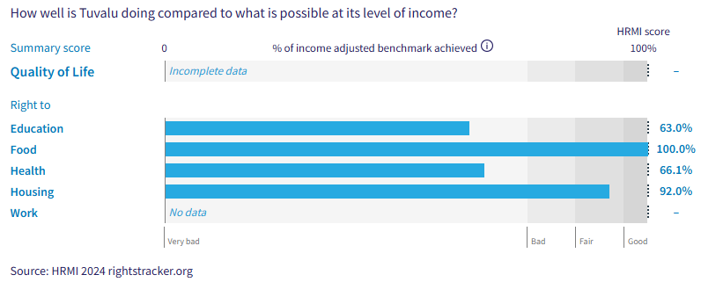
Right to education = 63.0% (‘very bad’)
Right to food = 100% (‘good’)
Right to health = 66.1% (‘very bad’)
Right to housing = 92.0% (‘fair’)
Right to work = No indicator data available in international databases.
This performance affects women and girls in the following specific ways.

Right to Education
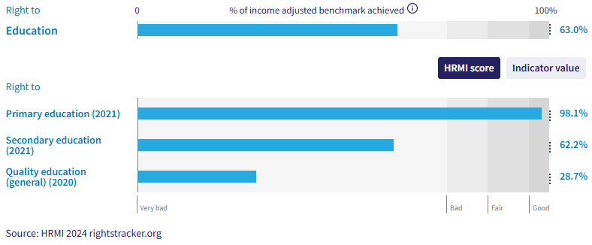
8. While Tuvalu scores well for primary school enrolment, its scores for secondary school enrolment and the quality of education provided in schools both fall in the ‘very bad’ range.
9. Expert respondents also noted that girls and members of single parent families were particularly likely not to enjoy their right to education.
Right to Health

10. Tuvalu’s score for the right to child health, based on the number of children surviving to age five, is in the ‘good’ range.

11. The score for right to adult health is in the ‘very bad’ range, affecting both men and women.

12. Expert respondents identified the following relevant groups as being at extra risk of not enjoying their right to health: people with disabilities; people with low social or economic status; people with specific health conditions. We note, therefore, that disabled women and girls, women with certain health conditions and women who face social and economic hardships are not fulling enjoying their right to the highest standard of health.

Right to Reproductive Health
13. Tuvalu’s scores for reproductive health are particularly poor.
14. Tuvalu’s rates of modern contraceptive use (according to data published by the United Nations Population Division) are at a very low 23.2%, leading to an income-adjusted HRMI score of 32.1%, falling in the ‘very bad’ range. This means that other countries with the same level of resources as Tuvalu have achieved very much higher rates of modern contraceptive use.

15. There has been no progress at all in modern contraceptive use over the last two decades.

16. All Pacific countries have low scores on this indicator, as demonstrated in the graph below, showing HRMI’s income-adjusted right to reproductive health scores for 12 Pacific countries and territories:

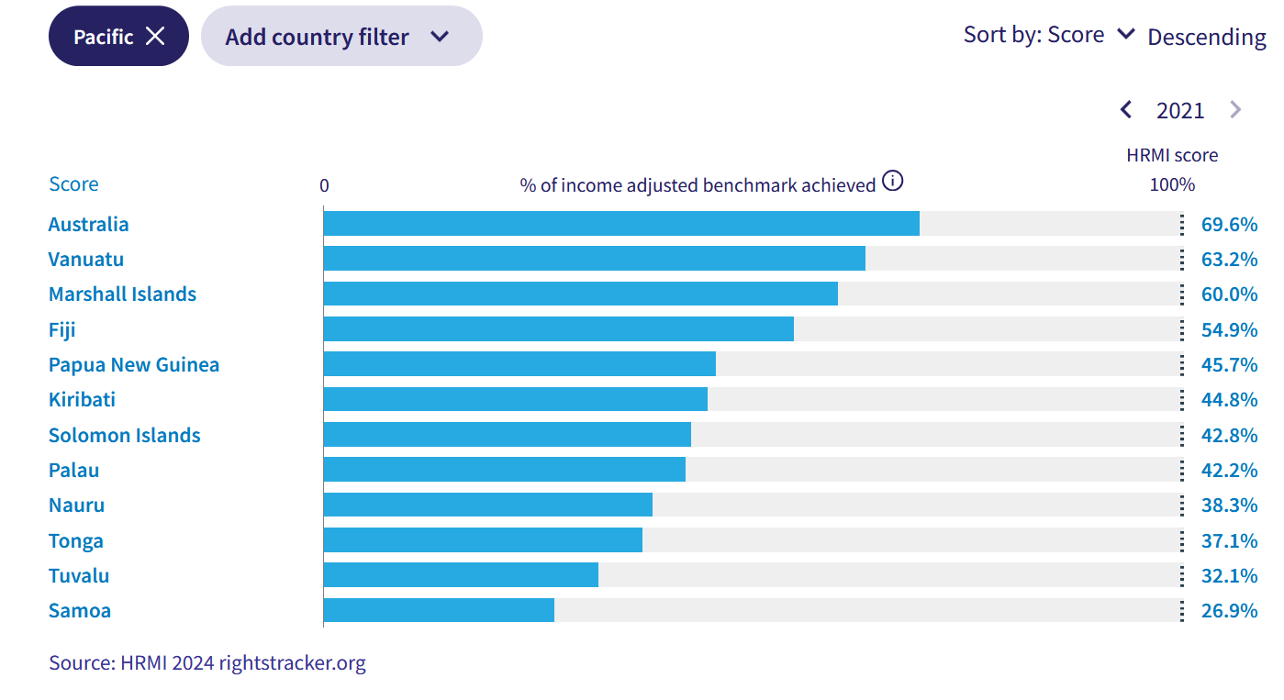

17. HRMI’s second indicator for reproductive health rights is rates of babies born at a healthy birth weight, which for Tuvalu falls in the ‘good’ range. According to the Organisation for Economic Cooperation and Development (OECD) and World Bank World Development Indicators data for 2019, 96.1% of babies were born at a healthy birth weight, leading to an income-adjusted HRMI score of 100%, indicating that Tuvalu is meeting its current obligations under international law for this right, and doing the best we have seen of any country at this level of resources.

Right to housing, water, and sanitation

18. Tuvalu’s scores for the rights to housing, water, and sanitation are in the ‘fair’ range, indicating some room for improvement.

19. Expert respondents identified the following relevant groups as being at extra risk of not enjoying their right to housing: people affected by climate change; people from particular social or cultural backgrounds; people with disabilities; people with low economic or social status.

Civil and Political Rights
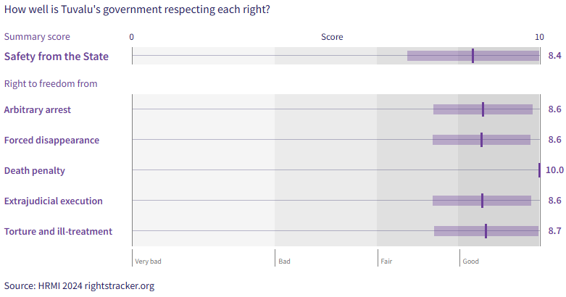
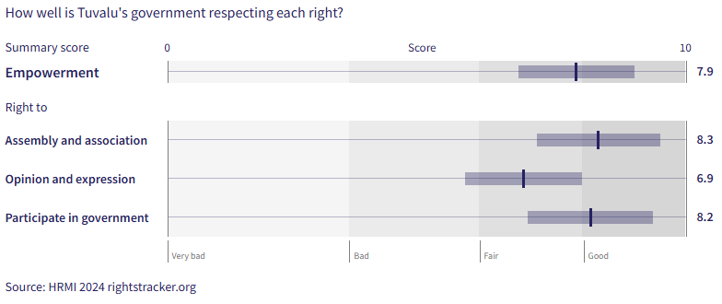

20. Tuvalu has generally very high scores for civil and political rights.

21. Of those people who are not enjoying these rights, human rights responders identified women and girls, children, LGBTQIA+ people, single parent families, street children or homeless youth, and people with disabilities as being at particular risk of violations.

Intersectionality
22. HRMI’s data for Tuvalu documents poor rights outcomes for a range of groups, including disabled people, Indigenous people, homeless youth and LGBTQIA+ people. Homeless women and girls, indigenous women and girls, disabled women and girls, and LGBTQIA+ women and girls face compounding challenges to their rights.

Climate Crisis
23. In 2019, in response to direct requests from Pacific human rights defenders, HRMI began producing data annually to document the effect of the climate crisis on human rights.
24. When asked in 2022 to describe the situation in Tuvalu in 2021, expert respondents noted that the effects of climate change have exacerbated issues in areas such as forced migration, land disputes and access to clean and safe water.

Indigenous Rights
25. In response to direct requests from Pacific communities, HRMI began producing annual data to track the rights of Indigenous people.

26. Human rights defenders have expressed concerns over the following:
- Tuvalu depends heavily on foreign aid which makes it difficult for individuals to make decisions.
- Urbanisation has affected cultural rights.

Violence
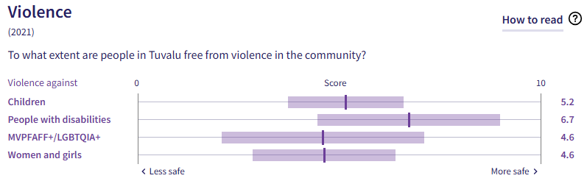
27. Again, in response to direct requests from communities in the Pacific, HRMI has been measuring rates of violence against four specific vulnerable groups since 2019: children; people with disabilities; MVPFAFF+/LGBTQIA+ people; women. The scores are shown in the graph above.

28. When asked to provide more context about violence against women in 2022, respondents said the following:

- Violence against women and girls has been normalised.

X. Concluding Remarks

29. HRMI respectfully submits its data and findings on elimination of discrimination against women in Fiji.

30. We hope that this Submission will serve as a useful resource to the Committee for drafting specific and meaningful questions to Fiji during the Pacific Technical Cooperation Session in Suva, April 2025.

Prepared by:
Thalia Kehoe Rowden
Sarah Bakewell

Visit HRMI’s website to learn more about our mission and work, https://humanrightsmeasurement.org/.
This content represents the opinions of the Human Rights Measurements Initiative. It carries no endorsement of the University of Georgia.
See HRMI’s methodology for measuring economic and social rights: https://humanrightsmeasurement.org/methodology and https://rightstracker.org/page/methodology.
Ibid
HRMI 2024 Rights Tracker, https://rightstracker.org/
See Human Rights Measurement Initiative (HRMI) Digital Public Good Certificate, https://app.digitalpublicgoods.net/a/11781 The Digital Public Goods Alliance is endorsed by the UN Secretary General’s “Roadmap for Digital Cooperation,” https://www.un.org/en/content/digital-cooperationroadmap/assets/pdf/Roadmap_for_Digital_Cooperation_EN.pdf. It defines digital public goods as: “open source software, open data, open AI models, open standards and open content that adhere to privacy and other applicable laws and best practices, do no harm, and help attain the SDGs,” https://digitalpublicgoods.net/standard/.

