EXECUTIVE SUMMARY

RURAL, INDIGENOUS, AFRO-ECUADORIAN, MONTUBIO WOMEN

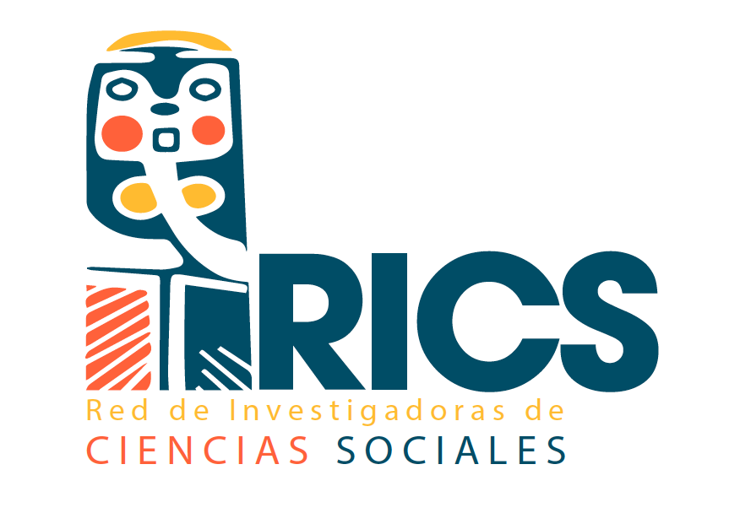

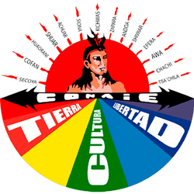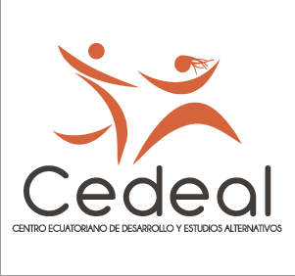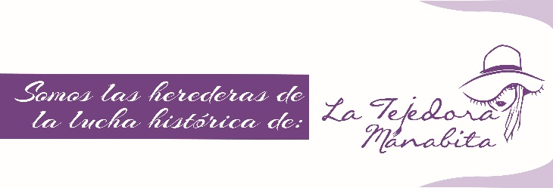

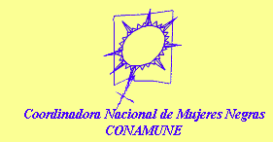

Con el apoyo de:
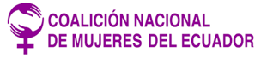
Septiembre de 2020

RURAL WOMEN
paragraph 18 LOIPR

- The diversity of women who work and live in the countryside has not been fully considered, since being peasant/rural and a woman supposes in many cases double or triple discrimination. Until the present there is no recognition of the different activities of rural women, mainly handicrafts, which means they encounter diverse needs not only related to agriculture, however remaining as rural. In an INEC survey, it can be found that rural women carry out other economic activities to support their family since most women are responsible for their homes. This is not only ignored by the State but also affects the visibilization of rural women in their diversity and specific needs. Until today, “Cholas” women continue to advocate for their recognition before the State.
- Civil society has denoted that rural women are often not able to own parcels of land since they regularly have no knowledge on how to recognize or administrate a territory also as of their own property (in case of marriage).
- The State has failed in bringing greater support and representation for rural women, encouraging them to fulfil their rights and politically participate. There are serious concerns on the lack of incentives for agroecological networks, mentioning that the Ministry in charge (MAG) has not developed proposals to strengthen small-scale production, where there is high participation of women.
- The State has limited access to agricultural loans and microcredits, making them inaccessible through requirements that are difficult for peasant women since they do not have the proper information and reach to them.
- There is undeniable discrimination and preoccupying precariousness of IESS (Social Security Institute) and the Peasant’s Social Security (Seguro Campesino), which threatens the stability of the labor, social and economic life of rural/peasant women. In occasions, rural women perform duties of housewives and farmers at the same time, nonetheless, peasant women are not considered as housewives under the definition provided by law, since this definition implies that women dedicate themselves exclusively to unpaid work in the home, while they generally not only performing these tasks but also have an additional economic activity.

INDIGENOUS WOMEN
paragraph 19 LOIPR

- Ecuador is a multicultural and plurinational country. The Constitution includes the right to prior, free and informed consultation on the public use of communal and ancestral lands of indigenous peoples and nationalities. However, at the moment there are not trustworthy and transparent prior consultation processes initiated by the State, even less with a gender perspective. This affects severely the life of indigenous women and has raised serious concerns on the environmental, social, cultural and economic damage extractive activities are bringing to indigenous women.
- Several foreign and national multinationals of mining, oil and timber nature have entered the country under the permission of the governmental authorities, aggravating and threatening the territorial, cultural and socio-economic integrity of the peoples and nationalities that for long periods have faced socio-environmental struggle, limiting and violating women’s collective rights that arise from international human rights law (Covenant 169 ILO).
- In Cotopaxi, Azuay, Morona Santiago and Carchi a worrying situation is reported due to the large-scale mining issue, as land rights have been granted to mining companies that in turn promote dependency and environmental exploitation, affecting in greater extent to indigenous women who are not able to achieve benefits from this concessions, threatening their education, health, customs, ecosystems and communitarian structure. Mining companies enter their territories by offering royalties that are distributed and administered through the State. However, the State is unable to prove that these royalties protected by the Mining Law are being distributed equitably and in an adequate manner, promoting the protection of identity, culture and territory where women develop with their families and communities. Moreover, these activities have created confrontations among indigenous communities or between men and women leaders.
- As an added concern, highlighted should be that indigenous women are still strongly stigmatized as part of the lower or lower-middle class. Besides, women continue to be mistreated by male patriarchal leaders in their own communities.

- Ordinary And Traditional Justice Conflict

- Progressively, the State has been limiting and dismantling the indigenous justice systems and failing to recognize its diversity and the women’s role in it, enabling them to participate and solve their needs. Thus, with preoccupation it is noted that Constitutional precepts that demand harmonization and co-existing of indigenous and ordinary justice is being not only ignored by the State but aggravated with conflicting and confronting acts against indigenous tradition with the use of ordinary enforcement measures.
- On the other hand, it should be noted that the State has been unable to equalize justice in a sense that women would be able to access indigenous justice, since this is managed mainly by patriarchal practices, excluding women from the decision-making, being even sometimes unfavorable for them. For example, inheritance of land is given to the male descendants, limiting access to land ownership by indigenous justice.

AFRO-ECUADORIAN WOMEN
paragraph 19 LOIPR

- Afro-Ecuadorian peoples have been subjected to long-standing human rights violations, regardless of their worldview and the use of their ancestral lands. The State has failed to prevail their rights and protect them from severe abuses socially, economically and environmentally.
- Despite their presence throughout all the national territory, they have resided in historically significant settlements. However, there have been massive migrations to larger cities and other regions of the country. Mainly, their migration is due to multinational agricultural, logging, mining and palm plantations projects taking place in their territories (e.g. Esmeraldas extractions). Many women that flee to the cities end working for white-mestizo families, generally in poor conditions and even without pay.
- Women’s groups have complained about the environmental effects mining has brought in their communities, where the extractive industry has taken advantage of the stigmatization they already suffer from, creating an environmental racism system.
- Since Afro-Ecuadorian women constitute 49% of the Afro-population they are subject to large-scale abuses and exploitation due to the intersectionality of gender, race, and social position within society, still largely stigmatized. There are gender pay gaps wherein the palm industry women receive lesser compensation for the same work, including violations of terms of employment and suffering severe abuses sexually and physically.

Recommendations:
To all State functions:
- Take the necessary measures not to harm Mother Earth, since all women are harmed and violated from it, therefore, the constitutional right to a healthy environment must be respected.
- Adopt a differentiated look to strengthen rural women.

To the Ministry of Agriculture, Ministry of Production and Commerce:
- Design and implement programs for agroecological practices and production, the right to land, access to territories in a sovereign and direct way for the harmonious benefit.
- Design and implement affirmative action mechanisms for rural and indigenous women whose labor rights have been violated by agro-exporting companies (non- traditional floriculture and fruitcultural) in the frame of the pandemic.
- Position food sovereignty as of main importance for peasant women and popular sectors.

To the Ministry of Urban Development and Housing:
- Provide alternative housing and adequate livelihoods to affected women and ensure that public and private companies implementing natural resource exploitation projects pay sufficient compensation to women living in territories and areas where these projects take place.
To the National Council for the Equality of Peoples and Nationalities:
- Strengthening community women's organizations, indigenous leaders not only watch over the rights of indigenous women, but also the rights of women throughout the country.
- Implement specific projects for the development of women in rural areas, an example would be projects in response to gender violence.
- Promote projects that call on women in rural areas to organize themselves politically or projects to make these women aim towards economic autonomy and strengthen their self-esteem.

Council of the Judiciary:
- Comply with the Constitution and strengthen the judicial function of indigenous authorities.
- Train ordinary judges in legal pluralism.

To the Ecuadorian State and international companies:
- The Ecuadorian state must implement and apply the normative framework regarding human rights and extractive activities, adopting reasonable measures to avoid restrictions on human rights, particularly those of women.
- The state must ensure that fair and meaningful consultations take place first between communities, particularly women who are most vulnerable. The latter, before the government negotiates with international organizations.
- Afro-Ecuadorians, Montubio and indigenous women should have the right to choose their development path: development with a focus on gender, culture and identity from which they can benefit fairly.
- The Ecuadorian state must ensure that both the government and private companies establish workshops, programs, policies and security mechanisms that fully inform and protect women.
To the National Council for the Equality of Peoples and Nationalities:
- Position the rights of Afro-Ecuadorian peoples on public agendas and policy.

Movimiento Nacional de Mujeres de Sectores Populares Luna Creciente.

