CLIMATE CHANGE AND WOMEN’S RIGHTS IN SOUTH AFRICA
NGO PARALLEL REPORT

SOUTH AFRICA’S REPORT TO THE 77TH PSWG FOR THE COMMITTEE ON THE ELIMINATION OF ALL FORMS OF DISCRIMINATION AGAINIST WOMEN

2 - 6 March 2020

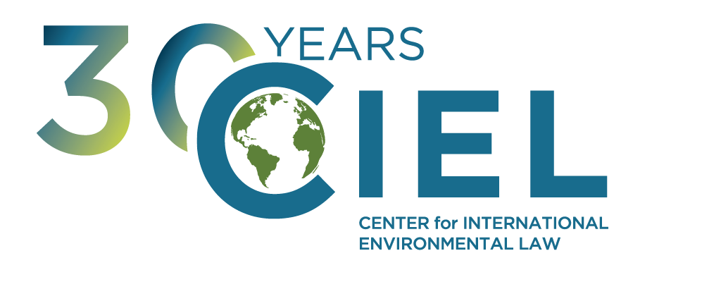
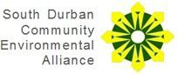

CENTER FOR INTERNATIONAL ENVIRONMENTAL LAW
THE SOUTH DURBAN COMMUNITY ENVIRONMENTAL ALLIANCE

country follow the trajectory set forth in South Africa’s Nationally Determined Contribution under the Paris Agreement, so as to prevent further disproportionate impacts on women in South Africa and extraterritorially,
2) Policies planned and implemented to guarantee that the rights of women - in particular rural women and women in situations of poverty - are guaranteed in the context of the expanding extraction of offshore petroleum exploration and drilling in the State party.
Measures implemented to ensure that the greenhouse gas emissions of the
1)
--- EXECUTIVE SUMMARY ---
Women disproportionately bear the burden of climate-related impacts while benefits expected as a result of fossil fuel exploration and extraction flow disproportionately to men. In this context, South Africa’s plans for large-scale offshore drilling to extract fossil fuels conflicts with the fulfilment of its obligations under the Convention on the Elimination of all forms of Discrimination Against Women as fossil fuels contribute significantly to dangerous climate change and investment in fossil fuels thereby exacerbate existing inequalities between men and women.
We therefore encourage the Committee on the Elimination of all forms of Discrimination Against Women to seek the following information from the government of South Africa in advance of its periodic review during its 77th Session:
SUBMITTING ORGANIZATIONS

The SOUTH DURBAN COMMUNITY ENVIRONMENTAL ALLIANCE (SDCEA) is an
environmental justice organization based in South Durban, South Africa. It is made up of 19 affiliate organizations and has been active since its formation in 1995. It is a non-government organization existing solely on finances sourced from funders and sponsors in order to remain totally independent. It makes no profit and exists solely for the benefit of the people it represents. It is a vocal and vigilant group active in lobbying, reporting and researching industrial incidents and accidents in this area.
The CENTER FOR INTERNATIONAL ENVIRONMENTAL LAW (CIEL) uses the power of law
to protect the environment, promote human rights, and ensure a just and sustainable society. CIEL seeks a world where the law reflects the interconnection between humans and the environment, respects the limits of the planet, protects the dignity and equality of each person, and encourages all of earth’s inhabitants to live in balance with each other.

CLIMATE CHANGE IMPACTS ON WOMEN: THE DUTY OF THE STATES TO REDUCE EMISSIONS IN LINE WITH INTERNATIONAL LEGAL FRAMEWORKS & CLIMATE SCIENCE
The adverse impacts of climate change constitute one of the most significant global threats for the enjoyment of human rights–especially those protected under the Convention on the Elimination of All Forms of Discrimination Against Women.1 The magnitude of these impacts will keep increasing as temperatures continue to rise and the consequences of climate change will have increasingly significant adverse impacts on human rights, and in particular the rights protected by this Convention.2
The IPCC’s Fifth Assessment report states that the effects of climate change are felt most acutely by “[p]eople that are socially, economically, culturally, politically, institutionally or otherwise marginalized”. The effects of climate change are disproportionately felt by these
groups3 and as women make up the vast majority of the world’s poor, are more dependent for
their livelihood on natural resources, have unequal access to decision-making processes, and often have limited mobility and networks, they are more vulnerable to the effects of climate change.
This is emphasised by the CEDAW Committee in their General Recommendation 37 (GR37) on the gender-related dimensions of disaster risk reduction in the context of climate change, which states:
“Women, girls, men and boys are affected differently by climate change and disasters, with many women and girls experiencing greater risks, burdens and impacts. Situations of crisis exacerbate pre-existing gender inequalities and also compound intersecting forms of discrimination against, inter alia, women living in poverty, indigenous women, women belonging to ethnic, racial, religious and sexual minorities, women with disabilities, women refugees and asylum seekers, internally displaced, stateless and migrant women, rural women, single women, adolescents and older women, who are often affected disproportionately compared to men or other women.”4
South Africa is particularly vulnerable to the impacts of climate change, it has warmed at a more substantial rate than the global average. A 2°C global temperature increase would equate to a 4°C rise in temperature for South Africa5, adversely impacting South Africa’s water and food security, health, human settlements, and infrastructure and ecosystem services.6 . The gender differentiation in access to social, economic and physical resources in Southern Africa has meant that this climate vulnerability gender gap is greater in this region, meaning
these climatic impacts will be disproportionately felt by women in Southern Africa.7 The
Committee has recognised the role of the State in mitigating and protecting women from the impacts of climate change. In its concluding recommendation to Guyana the Committee recommended:

- UN General Assembly, Convention on the Elimination of All Forms of Discrimination Against Women,December 1979, United Nations, https://www.un.org/womenwatch/daw/cedaw/text/econvention.htm
- Report of the Special Rapporteur on the issue of human rights obligations relating to the enjoyment of a safe, clean, healthy and sustainable environment, A/HRC/31/52, February 2016
- Human Rights Council, 30 June 2015, A/HRC/29/L.21, http://ap.ohchr.org/documents/E/HRC/d_res_dec/A_HRC_29_L21.docx
- As recognized in Draft General Recommendation No. 37 on Gender-related dimensions of disaster risk reduction in the context of climate change CEDAW/C/GC/37, paras 2.
- South Africa, South Africa’s Intended Nationally Determined Contribution (INDC) p.1, https://www4.unfccc.int/sites/ndcstaging/PublishedDocuments/South%20Africa%20First/South%20Africa.pdf 6 Ibid, fn 6
- AfDB, Climate Change, Gender and AfDB Development in Africa, November 2011, https://www.afdb.org/fileadmin/uploads/afdb/Documents/Publications/Climate%20Change%20Gender%20and%20Development%20in%20Africa.pdf

“that the State party review its climate change and energy policies, particularly those relating to the extraction of oil and gas, and develop a disaster risk reduction strategy that takes into account the negative effects of climate change on gender equality and on the lives of women and their families, especially those living in areas below sea level.”8
These impacts will be particularly felt by rural women in South Africa. Rural women experience higher levels of poverty, less access to land and credit, information and decision-making, adversely impacting their capacity to cope and adapt to climate change.9 Article 14 of CEDAW obligates States to take appropriate measures to eliminate discrimination against women in rural areas. In the Committee’s 2011 concluding observations to South Africa it recommended that it should “pay special attention to the needs of rural women”10considering that the needs of rural women are largely impacted by climate change this implicates a need for a greater focus on climatic impacts on rural women.
Additionally to its human rights commitments, South Africa has made a number of national and international commitments to protect the environment and mitigate climate change. Section 24 of the South African Constitution enshrines that “everyone has the right to an environment that is not harmful to their health or well-being and to have the environment protected for the benefit of present and future generations”11. This has a number of connotations, including the obligation of a state to provide ecologically sensitive services, including energy. South Africa has also ratified the Maputo Protocol on the Rights of Women in Africa, Article 18 of which establishes that all women should have the right to a healthy and sustainable environment12. This recognises the particular importance of a healthy environment for women to access their other rights, such as to food security due to the higher proportion of women reliant on subsistence agriculture and outlines the necessity of the participation of women in decision-making.
Furthermore, South Africa has ratified the UN Framework Convention on Climate Change and the Paris Climate Agreement and committed to limit the increase of temperatures well below 2°C above pre-industrial levels and to pursue efforts to limit the temperature increase to 1.5°C. The Special Report on Global Warming of 1.5°C (SR1.5) released by the Intergovernmental Panel on Climate Change (IPCC) in October 2018 underlines that emissions will need to be reduced even more stringently to maintain the temperature increase below 1.5°C and avert severe additional climate impacts. Along with four other UN Human Rights Treaty Bodies, CEDAW has clarified in a Joint Statement that policies to reduce emissions must “reflect the highest possible ambition”.13

SHORTCOMINGS OF THE SOUTH AFRICAN NATIONAL CLIMATE CHANGE POLICY

South Africa has committed to a peak-plateau-decline pathway in their nationally determined contribution (NDC) to reduce their emissions in the long-term. Following this, the National

- CEDAW, Concluding observations on the ninth periodic report of Guyana, July 2019, CEDAW/C/GUY/CO/9
- Heinrich Böll Stiftung: Southern Africa, Gender and Climate Change: South Africa Case Study, 2010 https://issuu.com/cimacnoticias/docs/caso_de_estudio_sud_frica
- CEDAW, Concluding observations of the Committee on the Elimination of Discrimination against Women, April 2011, CEDAW/C/ZAF/CO/4, p.9, para37 https://tbinternet.ohchr.org/_layouts/15/treatybodyexternal/Download.aspx?symbolno=CEDAW%2fC%2fZAF%2fCO%2f4&Lang=en
- The Republic of South Africa, the Constitution of the Republic of South Africa, 1996, P.9 (Section 24),
Https://Justice.Gov.Za/Legislation/Constitution/Saconstitution-web-eng.Pdf 12 Maputo Protocol, 2003, http://maputoprotocol.com/about-the-protocol
- Committee on the Elimination of Discrimination Against Women, Committee on Economic, Social and Cultural Rights, Committee on the Protection of the Rights,
of All Migrant Workers and Members of their Families, Committee on the Rights of the Child, Committee on the Rights of Persons with Disabilities, Joint Statement on "Human Rights and Climate Change", 16 September 2019, available at https://www.ohchr.org/en/NewsEvents/Pages/DisplayNews.aspx?NewsID=24998&LangID=E
.

Climate Change Response Policy (NCCRP), adopted in 2011, outlines a plan for continued emission growth until 2025, followed by a plateau until 2035, before absolute decline14. South Africa is currently predicted to have a 33%-39% increase in emissions above 1990 levels by 2030 if their current low economic growth continues15. Despite this constituting South Africa meeting the low end of its targets, this level of emissions rise is consistent with global warming of between 2-3°C, although, as mentioned, this temperature rise will be even more pronounced in South Africa. Therefore, the low ambition of South Africa’s emissions targets have been categorised by climate research institutes as “highly insufficient” to mitigate the impacts of climate change16 and so is incompatible with South African’s international commitments to prevent the most dangerous levels of climate heating as agreed under the Paris Agreement.

OFFSHORE OIL

Recent offshore oil investment shows plans to lock South Africa into high fossil fuel usage. Environmental licensing has been granted for offshore exploratory drilling for an area of approximately 88,000km17.
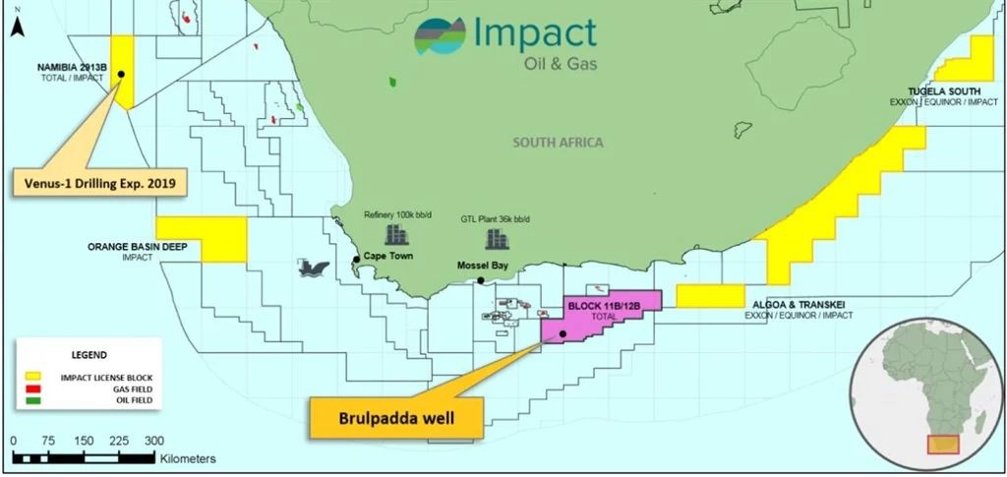

Figure 1: Map of licensing granted for offshore drilling in South Africa18

The threat to marine ecosystems, water pollution and air pollution associated with oil drilling impacts women’s lives and livelihood. The World Bank stated that “[t]he impact of the extractive industries is not gender neutral, women often bear a disproportionate share of the social, economic, and environmental risks” particuarly for subsistence fisherwomen, and those who rely on coastal spaces19. Moreover, given that fossil fuels reserves that are already exploited or under exploration worldwide contain more carbon than can be emitted to meet the objectives of the Paris Agreement, emissions reductions can only be achieved if emissions from fossil fuel consumption are significantly reduced and if the majority of oil, gas and coal reserves
and resources remain unexploited.20 The further expansion of the extraction of fossil fuels,

- National Climate Change Response Green Paper, Department Of Environmental Affairs, 2011, www.Climateresponse.Co.Za/Sites/Default/Files/Climate_change_greenpaper1.Pdf
- Climate Action Tracker, South Africa, December 2019, https://climateactiontracker.org/countries/south-africa/pledges-and-targets/ 16 Ibid, fn.15
17 Business Insider: South Africa, Helena Wasserman, February 2019, https://www.businessinsider.co.za/impact-of-brulpadda-2019-2 18 Ibid, fn.18
19 The World Bank, Gender in Extractive Industries, November 2013, http://www.worldbank.org/en/topic/extractiveindustries/brief/gender-in-extractive-industries 20 McGlade and Ekins, The geographical distribution of fossil fuels unused when limiting global warming to 2C,. Nature, 2015, 187-190.

including through licensing and infrastructure development is incompatible with the objectives of the Paris Agreement.

FOSSIL FUEL SUBSIDIES

South Africa’s continued use of public funds to subsidize fossil fuels and for new fossil fuel investment has created a context that strongly favours continued fossil fuel dependency.21 In 2013, South Africa spent over $270 million of public funds on new oil and gas exploration, a figure that has likely increased.22 National subsidies, investment by state-owned enterprises, and public finance for fossil fuels, which equates to approximately R56.6 billion a year for coal alone, has explicitly undercut South Africa’s ability to decarbonise and instead locking South Africa in to high fossil fuel usage.23 The continued subsidization of fossil fuels is linked to the vested political interests of the coal industry to lock South Africa into continued fossil fuel use.24 This has, despite the high potential for renewable energy, particularly solar, created an inhospitable environment for renewable energy investment slowing the growth of this sector25 and failing the criterion South Africa set in its 2003 Renewable Energy White Paper to ensure “an equitable level of national resources is invested in renewable technologies”26.
As Secretary-General António Guterres commented at the UN Climate Summit in 2019 this continued fossil fuel subsidisation essentially means funding climatic disasters and equates to taxpayers funding the external costs of carbon, including but not limited to, climate change impacts. The International Energy Agency (IEA) emphasised that even a partial reduction of fossil-fuel subsidies create 12% abatement needed by 2020 to make reaching the 2°C target even potentially feasible27. As a party to the Paris Agreement, South Africa has agreed to ‘[m]aking finance flows consistent with a pathway towards low greenhouse gas emissions and
climate-resilient development’.28 Continued fossil fuel subsidies reduce its ability to divest

from fossil fuel, severely undermining South Africa’s ability to transition into a low carbon energy and therefore compromising emission reduction. Additionally, this policy diverts public resources away from other social and economic policies that could contribute to the realization of the rights of men and women in the country. This policy facilitates South Africa being locked into a high emission fossil fuel pathway, increasing the threat for women from climate-induced human rights harms and the chance of failure to meet its international commitments.
  - PARTICIPATION OF WOMEN IN ENERGY POLICY

The incoherence between South Africa’s stated commitments and its climate action limits transparency and, therefore, avenues for women to adequately participate in climate decisions. Women and men have different energy needs and are differently impacted by energy resource management. Adequate participation of women in the planning of sustainable uses for resources and in climate and energy policy and the consideration of

21 Greenpeace, Powering The Future: Renewable Energy Rollout in South Africa, March 2013, https://www.greenpeace.org/africa/en/blogs/1467/powering-the-future/ 22 ODI, Fossil fuel exploration subsidies: South Africa, November 2014, https://www.odi.org/sites/odi.org.uk/files/odi-assets/publications-opinion-files/9266.pdf
- ODI, G20 coal subsidies: South Africa, June 2019, https://www.odi.org/publications/11369-g20-coal-subsidies-south-africa
- The Political Economy of Energy Policy in South Africa: From a Gender Agenda to a Class Project Working Paper: MSSRF / 2017 / WP / 12, December 2017, https://www.energia.org/cm2/wp-content/uploads/2018/07/Political-economy-of-energy-policy-in-South-Africa.pdf
- State of Renewable Energy in South Africa, 2015, https://www.gov.za/sites/default/files/gcis_document/201510/state-renewable-energy-south-africas.pdf 26 Department Of Minerals And Energy, Republic Of South Africa, White Paper on Renewable Energy, November 2003, Http://Www.Energy.Gov.Za/Files/Policies/Whitepaper_renewables_2003.pdf
- Redrawing the Energy-Climate Map, International Energy Agency, 2013
- UNFCCC, Paris Agreement. 2015 http://unfccc.int/files/essential_background/convention/application/pdf/english_paris_agreement.pdf

gender in formulating and implementing policy is well recognised as important to ensuring the protection of women’s rights.29

INCOMPATIBILITY OF SOUTH AFRICAN CLIMATE POLICIES WITH ITS OBLIGATIONS UNDER THE CEDAW

South Africa has failed to implement effective climate policies, particularly related to continued fossil fuel extraction and continued use of public funds to support fossil fuels constitutes not only a failure to meet its Paris Agreement obligations, but also an active contribution to exceeding a 2°C global temperature. This increases the threat of climate change for women in South Africa and extraterritorially. As the Committee has stressed in its concluding observation to Norway that the continued extraction of offshore “oil and gas by the State party and its inevitable greenhouse gas emissions undermines its obligations to ensure women’s substantive equality with men, as climate change disproportionately impacts women, especially in situations of poverty, since they are more reliant on natural resources for
their livelihoods than men and have lesser capacity to deal with natural hazards”.30 More
recently, the Committee also stressed that Guyana’s continued extraction fails to take into account the negative effects of climate change on gender equality and on the lives of women and their families.31

South Africa’s national and international commitments mark an obligation to implement a climate change strategy that not only protects women, particularly rural women, from climatic impacts but puts in place adequate mitigation action representing the “highest possible ambition”. This includes a duty for the State to prevent economic activities resulting in long-term harms for women’s rights. The policies of South Africa, as laid out in this parallel report, breach these legal obligations, contributing to increasing the global climate-induced risks for women.

RECOMMENDATIONS
In light of the information provided in this parallel report, , the undersigned organizations urge the Committee to seek the information from the government of South Africa in advance of its 77th Session in relation to:
- Measures implemented to ensure that the greenhouse gas emissions of the country follow the trajectory set forth in South Africa’s Nationally Determined Contribution under the Paris Agreement, so as to prevent further disproportionate impacts on women in South Africa and extraterritorially, and
- Policies planned and implemented to guarantee that the rights of women - in particular rural women and women in particular in situations of poverty - are guaranteed in the context of the expanding extraction of offshore petroleum exploration and drilling in the State party.

- Ibid, fn. 25
- CEDAW, Concluding observations of the Committee on the Elimination of Discrimination against Women regarding Norway, 22 November 2017, CEDAW/C/NOR/CO/9, para. 14 and 15.
- CEDAW, Concluding observations of the Committee on the Elimination of Discrimination against Women regarding Guyana, 30 July 2019, CEDAW/C/GUY/CO/9, para. 41 and 42..

