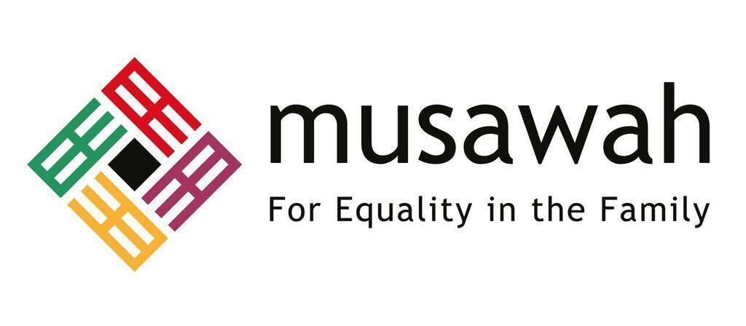

THEMATIC REPORT ON MUSLIM FAMILY LAW AND
MUSLIM WOMEN’S RIGHTS IN
TUNISIA

84th CEDAW Session
Geneva, Switzerland
FEBRUARY 2023

Musawah
15 Jalan Limau Purut, Bangsar Park, 59000 Kuala Lumpur, Malaysia
Tel: +603 2083 0202 Fax: +603 2202 0303
Email: musawah@musawah.org
Website: www.musawah.org

Table of Contents

A. INTRODUCTION 3
B. BACKGROUND, LEGAL FRAMEWORK AND CONTEXT 3
C. KEY ISSUES AND RECOMMENDATIONS 4
1. Spousal Inequality 4
2. Child Marriage 6
3. Marital Rape 8
4. Nationality 8
5. Inheritance 10

A. INTRODUCTION
Musawah, the global movement for equality and justice in the Muslim family, submits this Thematic Report on concerns related to Muslim women’s legal equality in personal status matters, child marriage and nationality rights for consideration by the CEDAW Committee in its review of the Government of Tunisia, reporting before the 84th Session of the CEDAW Committee in February 2023. This is the CEDAW Committee’s seventh periodic engagement with Tunisia. Its last full review was in 2010. Tunisia ratified CEDAW in September 1985 with a reservation that it shall not take any organizational or legislative decision in conformity with CEDAW where such a decision would conflict with the provisions of Chapter I of the Tunisian Constitution. Tunisia withdrew the rest of its reservations on Article 16, among others, in 2014.
This report highlights key legal inequalities that Muslim women face in Tunisia in the personal status sphere and their resulting negative impact on women and girls, along with recommendations to address gaps. We encourage the Tunisian government to continue its robust efforts in eliminating discrimination against women, particularly in the areas discussed subsequently.
We hope that the CEDAW Committee will utilize this report as a key resource during its constructive engagement with the State Party and use the recommendations to identify follow-up issues in its Concluding Observations.

B. BACKGROUND, LEGAL FRAMEWORK AND CONTEXT

The Republic of Tunisia is the northernmost country in Africa. Its population is 11.1 million. The official religion is Islam, as stated in the Constitution, and its language Arabic. Nearly 98.5% of Tunisia’s inhabitants are Muslims; 1% Christians and 0.5% are Jews. Among the Muslims, 98.7% are Sunni Maliki, 1% are Ibadhites, and 0.3% are Shi’i.

The judicial system is unified and religious courts were abolished in 1956. There are only civil court . All the civil courts are able to administer Muslim family law cases.

The Personal Status Code (PSC) in Tunisia is the main codified law that governs matters relating to marriage and family relations of the predominantly Muslim population in Tunisia. The development of the PSC is influenced by the Maliki jurisprudence (fiqh). This Code, promulgated on 13 August 1956, was a breakthrough for the rights of women in family law, with positive implications for women in the social, economic, political and cultural domains.

The Code abolished polygamy and instituted civil marriage with the explicit consent of both spouses, and gave men and women equal access to divorce before a court. Over the past decades, a number of legislative reforms have further strengthened the protection of women’s rights in the family. Among them, in 1993, the wife’s duty to obey her husband was replaced with the principle of reciprocal rights and duties of the two spouses. In 2007, the Personal Status Code was amended to harmonize the minimum legal age for marriage, now 18 years for both men and women. In 2010, the Tunisian nationality law was reformed, allowing women to transmit citizenship to their children in the same way as men. From 2011 until now, many amendments and reforms have promoted equality between the spouses; in 2017, mixed marriage for Tunisian women marrying a non-Muslim foreign national was made legal in Tunisia by the Circular n° 164 of the Ministry of Justice dated September 8th, 2017 abolishing the Circular n° 216 dated on November 5th, 1973. The Personal Status Code does not classify religious differences as a legal prohibition on marriage.

As a policy framework, the Peer Council for Equal Opportunities for Men and Women, which is an advisory body, was established by Government Decree No. 626–2016. Its main mission is to mainstream the gender approach in development policies and plans in Tunisia. Since the Law on Eliminating Violence against Women (No. 58, 2017) entered into force in 2018, a common framework agreement between government institutions and NGOs has been developed to support women victims of violence.

Despite these successive reforms, a significant number of discriminatory provisions remain in force that deny women equal rights with men. During marriage, women continue to suffer discrimination in their personal relations with their husband, who, according to Article 23, remain the heads of the household. This unequal status is reinforced by the reference in the same Article to customs and traditional practices with respect to the couple’s conjugal duties. Discriminatory provisions still persist in relation to divorce and custody; women lose custody of their children if they remarry after divorce, while men can retain custody.

Moreover, inheritance law, which is based on patriarchal and patrilineal family, remains discriminatory against women. Despite the absence of any restrictions bound to religion to prevent marriage or inheritance, which clearly demonstrates the will of the legislature to remove these barriers as also demonstrated by some case law in that regard, it is difficult to measure the real impact on women’s lives and to analyse the way judges have applied its provisions over the past 60 years. Information is often received about some progressive, but also many regressive judgments, whereby judges use the Sharia as a source of customary law in matters concerning family law and inheritance.

The laws that impact women’s rights are not limited to the family code. The Criminal Code went through successive reforms, which notably criminalized sexual harassment in 2004. With a view to guaranteeing women’s right to physical integrity, Section 207 of the Criminal Code was deleted because it recognized marriage ties as a mitigating circumstance when a husband murdered his wife or her partner upon catching them in an act of infidelity. The Tunisian new codes, which are the “Law on Eliminating Violence against Women”, 2017 (No. 58) and “Law on the Prevention and Control of Trafficking in Persons”, 2016 (No 61), guarantee more rights for women.

However, from 2011 until now, Tunisia is living at a time of political transition and at a very challenging point in its history. Women’s rights are seemingly at the core of a collision of views. According to academic research, while women generally enjoy personal freedoms under the law, societal pressure and the rise of conservative Muslim groups that are reportedly conducting campaigns “intending to ‘safeguard tradition’ by promoting regressive measures regarding women’s rights”, may serve as a restrictive force in this regard.

To achieve gender equality, Tunisian women still continue their struggle for equality in inheritance laws, for more recognition of unpaid female homeworkers, for more structural equality in economic and social life.

C. KEY ISSUES AND RECOMMENDATIONS

Spousal Inequality Articles 2, 16

Despite the equality guarantee of Article 21 of the Constitution, the Personal Status Code provides for a marital framework based on ‘reciprocal’ or ‘complementary’ rights (as opposed to ‘equal’ rights) between the two spouses that in turn is based on the concept of male guardianship over women and children. Article 23 of the PSC states that the husband, as head of the family, must provide for the needs of his wife and children based on his financial means. The wife must also contribute if she has the financial means to do so.

The PSC was amended in 1993 to remove the wife’s duty to obey her husband in 1993. Nevertheless, according to the UN Working Group on the Issue of Discrimination Against Women in Law and in Practice (UN Working Group), the law still “constitutes discrimination which violates the principle of equality” as husbands remain the legal heads of households. This is despite the role of the husband being confined to the maintenance obligation of his spouse and children because the status that is granted to the husband and father and the notion of customs and traditional practices give rise to certain abuses, in particular as regards the choice of domicile.

Additionally, while mixed marriage for Tunisian women marrying a non-Muslim foreign national was made legal, there is a likelihood that future spouses might face some challenges in practice as few public officials and notaries still refuse to conclude marriage contracts between a Tunisian woman and a foreigner who is non-Muslim. One mayor refused to conclude such a marriage in his municipality (El Kram, suburb of Tunis). The Minister of Local Affairs and the Minister of Foreign Affairs also terminated publications that restricted women’s freedom to choose her spouse, and required the civil states offices to release marriage contracts between Muslim women and non-Muslim men.

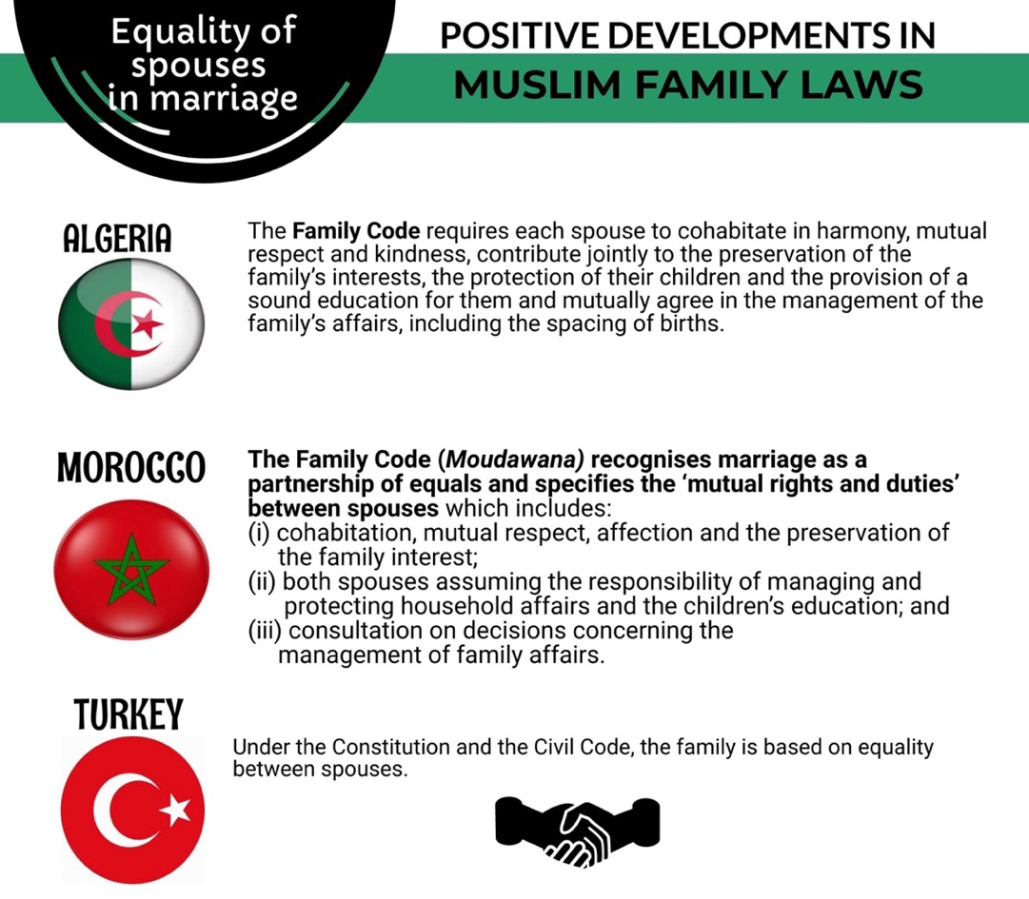

RECOMMENDATIONS
We recommend the CEDAW Committee urge the State party to:

- Amend the Personal Status Code and other relevant legislations, and enact policies and development programs to grant and ensure spousal equality between men and women in all their spousal and personal rights in accordance with Tunisia’s international human rights obligations.

Child Marriage Article 16

The minimum legal age for marriage is 18 for females and males as per Article 5 of the PSC. However, Article 5 also provides that a judge may permit girls and boys below 18 to marry for serious reasons and if it is in the best interest of both prospective spouses.

The law does not stipulate an absolute minimum age below which a marriage may not be authorised.

The minimum legal age for marriage is below the legal age of civil majority. Under Article 153 of the PSC, the legal age of civil majority is 20 for both females and males. A minor over the age of 17 attains adulthood by marriage with regard to his or her personal status and management of civil and commercial affairs.

Exoneration by marriage: Articles 227 and 239 of the Penal Code which exonerate a rapist if he married his victim, and exonerate a man from punishment for kidnapping a woman if he married her, were removed from the Penal Code in 2017.

In practice, judges generally allow marriage below the minimum legal age for marriage in cases of pregnant minors. Judges also generally allow marriage below the minimum legal age for marriage in applications relating to Article 227bis of the Criminal Code which allows a man who had sex with a minor girl over the age of 13 without physical coercion to marry her and at the same time terminate any criminal proceedings. In this regard, according to media reports, a Tunisian court, relying on Article 227bis of the Criminal Code, approved the marriage of a 13-year old girl to her 20-year old brother-in-law who made her pregnant despite the objections of their parents.

According to UNICEF’s 2016 State of the World’s Children Report, 2% of women aged 20-24 in Tunisia were first married by 18.

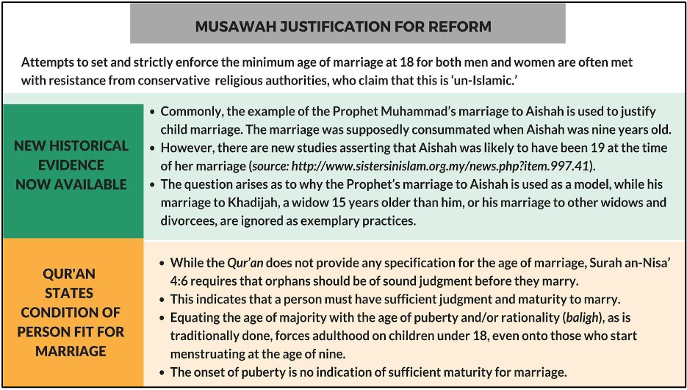

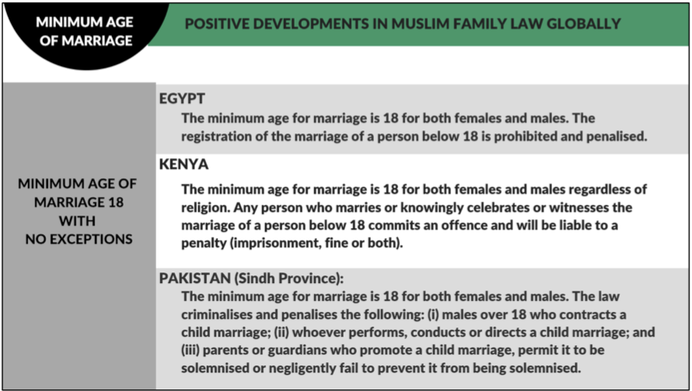

RECOMMENDATIONS
We recommend the CEDAW Committee urge the State party to:

- Amend the Personal Status Code to prohibit child marriage of any person under the age of 18 without exception.

- Criminalize child marriage through specific legal provisions and deterrent penalties, and introduce penalties for guardians and marriage officiators who contract the marriage of a child.

- Provide targeted training programs to law enforcement officials, the judiciary, healthcare workers, and social workers to respond to reports of child marriage, and provide adequate support to victims.

Marital Rape Article 16

Marital rape is not specifically criminalized in Tunisia. The Personal Status Code requires both spouses to “fulfil their marital obligations according to custom.” Article 13 of the PSC provides that “a husband cannot, if he has not paid the dowry, compel the woman to the consummation of marriage.” Concerns have been expressed that Articles 13 and 23 of the PSC may be interpreted to mean that once the dowry is paid, the husband may force his wife to sexual intercourse.

Tunisia has not adopted specific legislation to criminalise acts of domestic violence. Tunisia has indicated to the CEDAW Committee that marital rape can be prosecuted subject to the interpretations of the judge in each case. However, the police generally perceive sexual violence in a marriage as a private matter.

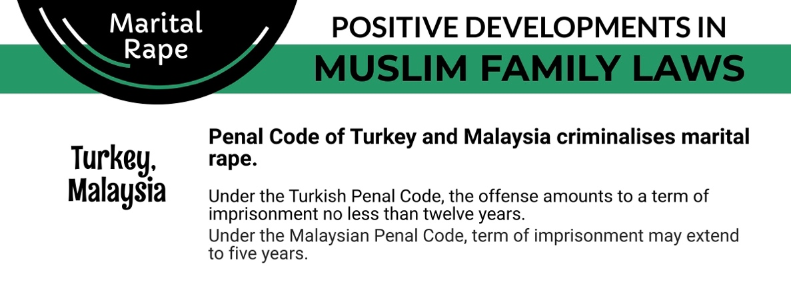

RECOMMENDATIONS
We recommend the CEDAW Committee urge the State party to:

- Explicitly criminalise marital rape through its inclusion in the Criminal Code.

Nationality Article 9

A Tunisian man automatically passes his nationality to his non-Tunisian wife if his wife loses her original nationality upon marriage to a foreigner. If his wife is able to retain her nationality upon marriage to a foreigner, she may claim Tunisian nationality by means of a declaration.

The law does not specifically provide for a Tunisian woman to confer her nationality to her foreign husband. The foreign husband of a Tunisian woman may acquire Tunisian nationality through naturalisation i.e., only by decree and only if he resides in Tunisia, has sufficient knowledge of the Arabic language and is morally upright. According to academic research, even if a non-Tunisian husband fulfils all the criteria for Tunisian citizenship, he often has difficulties obtaining it.

A Tunisian father passes his citizenship to his children wherever they are born. However, the law is ambiguous with regard to a Tunisian mother’s ability to confer her nationality to her children. A Tunisian woman married to a non-Tunisian husband may confer her nationality to their child if the child was born abroad.

However, there appears to be ambiguity in the law as to whether a Tunisian mother may transmit her nationality to her children if they were born in Tunisia. Article 6 of the Tunisian Nationality Code provides that a child born to a Tunisian father or mother is Tunisian. Article 7 provides further that a child born in Tunisia is Tunisian if his or her father or grandfather were also born in Tunisia. No mention is made of the maternal lineage. In contrast, Article 12 specifically states that a child born abroad to a Tunisian mother and a non-Tunisian father may claim Tunisian citizenship.

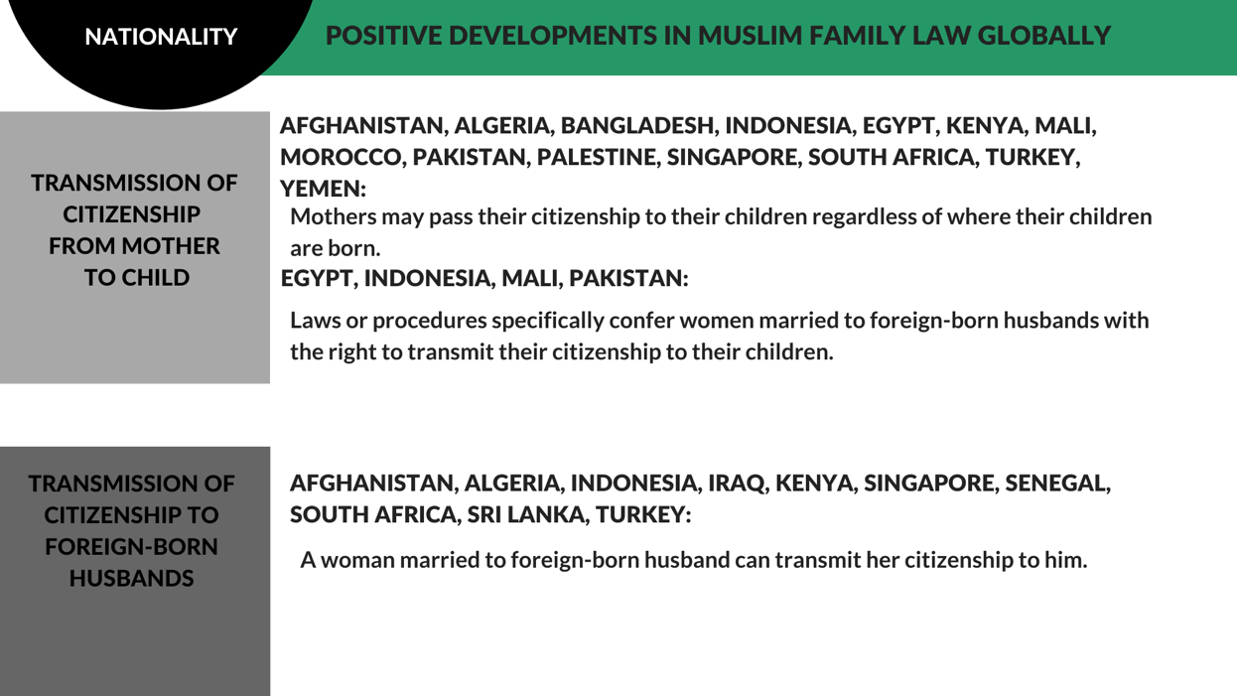

RECOMMENDATIONS
We recommend the CEDAW Committee urge the State party to:

- Amend the Tunisian Nationality Code 1963 to provide for a Tunisian woman to confer her nationality to her foreign husband.

- Amend the Tunisian Nationality Code 1963 to explicitly allow for a Tunisian mother to transmit her nationality to her children if they were born in Tunisia.

Inheritance Article 16

Generally, inheritance rights between women and men are unequal, although there are exceptions to the general rule.

The Personal Status Code defines the rules of inheritance, which follow traditional interpretations of Shariah. Women have a right to inheritance, but in many cases receive less than men. Articles 85-152 detail the inheritance shares. Daughters receive half the share that sons receive. In many instances, such as in the cases of widows and widowers and siblings, a woman is entitled to half the share of a man. An exception to the general rule includes Article 143bis of the PSC which permits an only daughter to inherit her parents’ estate in its entirety. In addition, following a court ruling in 2009, it is now possible for non-Muslim women to inherit from their Muslim husbands.

In rural areas in particular, however, women often renounce their inheritance in favour of male relatives, in order to keep property and land within the family. Some parents get around inheritance laws by gifting property or assets to daughters before they die; this practice is facilitated by tax exemptions granted on gifts made between parents and their children.

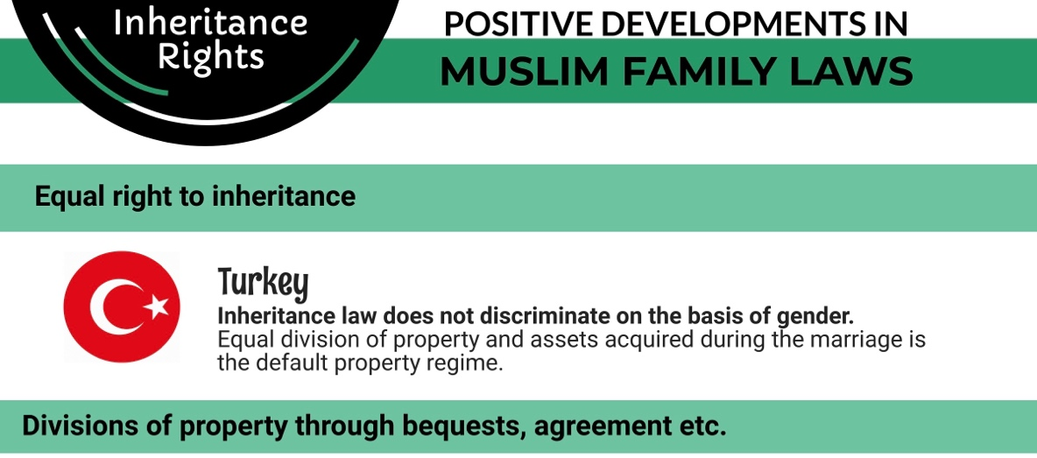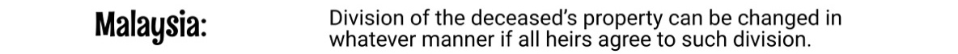

RECOMMENDATIONS
We recommend the CEDAW Committee urge the State party to:

- Amend the inheritance law to grant men and women equal rights to inheritance.

- Ensure through effective policies, awareness campaigns and development programs that women are not pressurized to renounce their inheritance in favour of male relatives.

This report has been prepared through significant inputs and information from Pr. Zahia Jouirou, Full Professor of Islamic and Gender Studies at the Tunisian University, Faculty of Letters, Arts and Humanities Mannouba, Tunisia.
UNDP, L’etat de L’aide Legale en Tunisie 2014 https://www.asf.be/wp-content/uploads/2014/06/ASF_Tunisie_EtudeAideLe%CC%81gale_2014_6.pdf pp 23-29
Mari Norbakk, “The Women’s Rights Champion: Tunisia’s potential for furthering women’s rights”, (CMI Report, 5, 2016), p. 9, https://www.cmi.no/publications/file/5973-the-womens-rights-champion.pdf
“Report of the Working Group on the issue of discrimination against women in law and in practice” 2013 https://www.ohchr.org/sites/default/files/Documents/HRBodies/HRCouncil/RegularSession/Session23/A.HRC.23.50.Add.2_ENG.pdf
UN Women, Ministry of Women, Family, Childhood and Seniors Republic of Tunisia, “Report of the Republic of Tunisia on Beijing Declaration and Platform for Action (BPfA) + 25” https://www.unwomen.org/sites/default/files/Headquarters/Attachments/Sections/CSW/64/National-reviews/Tunisia_En.pdf
See for example Civil Cassation Judgement n 31115m, 5 February, 2009; Tunis Appeal Court Judgement No 120, 6 January, 2004 and n 3351, 4 May 2004
Lilia Ben Salem, “Tunisia”, in Women’s Rights in the Middle East and North Africa: Progress Amid Resistance, eds. Sanja Kelly and Julia Breslin (New York, NY: Freedom House; Lanham, MD: Rowman & Littlefield, 2010), p.7, https://freedomhouse.org/sites/default/files/inline_images/Tunisia.pdf
UN Working Group Mission to Tunisia, U.N. Doc. A/HRC/23/50/Add.2 (2013), paras. 9, 35, http://www.ohchr.org/Documents/HRBodies/HRCouncil/RegularSession/Session23/A.HRC.23.50.Add.2_ENG.pdf
Article 23 of the Personal Status Code (1956), http://www.legislation.tn/sites/default/files/codes/Statutpersonnel.pdf
UN Working Group Mission to Tunisia, U.N. Doc. A/HRC/23/50/Add.2 (2013), paras. 31, 32, http://www.ohchr.org/Documents/HRBodies/HRCouncil/RegularSession/Session23/A.HRC.23.50.Add.2_ENG.pdf
Article 5 of the Personal Status Code (1956), http://www.legislation.tn/sites/default/files/codes/Statutpersonnel.pdf
Article 153 of the Personal Status Code (1956), http://www.legislation.tn/sites/default/files/codes/Statutpersonnel.pdf
Tunisia, The Penal Code, 2011 https://www.ilo.org/dyn/natlex/docs/ELECTRONIC/61250/60936/F1198127290/TUN-61250.pdf (in French) Noon Post, “New Legislation in Tunisia to Combat Violence Against Women”, 25 July 2017 https://www.noonpost.com/content/19032
Omar Fassatoui, “Women’s rights in Tunisia: The remaining legal inequalities”, (C.A. Perspectives on Tunisia, 1, 2016), p. 3, http://www.cap-lmu.de/download/2016/CAPerspectives-Tunisia-01.pdf
Omar Fassatoui, “Women’s rights in Tunisia: The remaining legal inequalities”, (C.A. Perspectives on Tunisia, 1, 2016), p. 3, http://www.cap-lmu.de/download/2016/CAPerspectives-Tunisia-01.pdf
Basma Atassi, “Tunisian court approves marriage of pregnant 13-year old”, CNN, 15 December 2016, http://edition.cnn.com/2016/12/14/middleeast/tunisia-court-child-marriage/; Harriet Agerholm, “13-year old girl forced to marry her “rapist” step-brother”, 19 December 2016, http://www.independent.co.uk/news/world/africa/rape-tunisia-13-year-old-girl-pregnant-article-227-child-marriage-womens-right-consent-a7483941.html
UNICEF, “The State of the World’s Children 2016”, Table 9, pp. 150-153, https://www.unicef.org/publications/files/UNICEF_SOWC_2016.pdf
The Advocates for Human Rights and MRA Mobilising for Rights Associations, “Tunisia: Women’s Rights“, Joint Stakeholder Report for the United Nations Universal Periodic Review, 2016, para. 14, http://mrawomen.ma/wp-content/uploads/doc/Tunisia%20UPR%20Submission%20FINAL.pdf
Omar Fassatoui, “Women’s rights in Tunisia: The remaining legal inequalities”, (C.A. Perspectives on Tunisia, 1, 2016), p. 3, http://www.cap-lmu.de/download/2016/CAPerspectives-Tunisia-01.pdf; The Advocates for Human Rights and MRA Mobilising for Rights Associations, “Tunisia: Women’s Rights“, Joint Stakeholder Report for the United Nations Universal Periodic Review, 2016, para. 14, http://mrawomen.ma/wp-content/uploads/doc/Tunisia%20UPR%20Submission%20FINAL.pdf
Articles 13-14 of the Tunisian Nationality Code (1963), http://www.legislation.tn/sites/default/files/codes/Nationalite.pdf
Articles 19-23 of the Tunisian Nationality Code (1963), http://www.legislation.tn/sites/default/files/codes/Nationalite.pdf
Lilia Ben Salem, “Tunisia”, in Women’s Rights in the Middle East and North Africa: Progress Amid Resistance, eds. Sanja Kelly and Julia Breslin (New York, NY: Freedom House; Lanham, MD: Rowman & Littlefield, 2010), p.4, https://freedomhouse.org/sites/default/files/inline_images/Tunisia.pdf
Articles 6, 7 of the Tunisian Nationality Code (1963), http://www.legislation.tn/sites/default/files/codes/Nationalite.pdf
Article 12 of the Tunisian Nationality Code (1963), http://www.legislation.tn/sites/default/files/codes/Nationalite.pdf
Omar Fassatoui, “Women’s rights in Tunisia: The remaining legal inequalities”, (C.A. Perspectives on Tunisia, 1, 2016), p. 3, http://www.cap-lmu.de/download/2016/CAPerspectives-Tunisia-01.pdf; Lilia Ben Salem, “Tunisia”, in Women’s Rights in the Middle East and North Africa: Progress Amid Resistance, eds. Sanja Kelly and Julia Breslin (New York, NY: Freedom House; Lanham, MD: Rowman & Littlefield, 2010), p.13, https://freedomhouse.org/sites/default/files/inline_images/Tunisia.pdf; UN Women, “Tunisia”, Spring Forward for Women Programme http://spring-forward.unwomen.org/en/countries/tunisia
Articles 85-152 of the Personal Status Code (1956), http://www.legislation.tn/sites/default/files/codes/Statutpersonnel.pdf
UNDP, UNwomen, UNFPA, ESCWA: Tunisia: gender justice and the law, UNFPA, 2019 https://arabstates.unfpa.org/en/publications/gender-justice-law-tunisia

