BRIEFING ON IRAQ FOR THE COMMITTEE AGAINST TORTURE, SESSION 73- April/May 2022
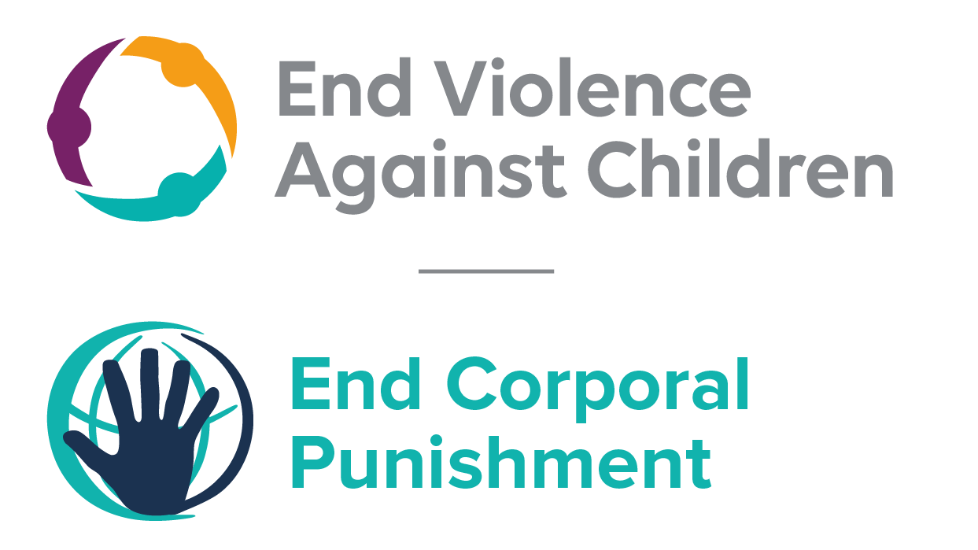
The Global Partnership to End Violence Against Children, March 2022

This briefing describes the legality of corporal punishment of children in Iraq. In light of the obligation under international human rights law to prohibit all corporal punishment of children, the recommendation of the UN Secretary General’s Study on Violence against Children, the repeated recommendations to prohibit all corporal punishment made to Iraq by the Committee on the Rights of the Child and other human rights treaty bodies, during the Universal Periodic Review in 2019, and considering the global commitment to ending all violence against children in the context of the 2030 Agenda for Sustainable Development, we hope the Committee will:
• in its concluding observations on the second report of Iraq, recommend that legislation is immediately enacted to explicitly prohibit corporal punishment of children in all settings including the home, and to repeal all legal defences for its use.

Summary of necessary legal reform to achieve full prohibition
Prohibition is still to be achieved in the home, alternative care settings, day care, schools and penal institutions.
The legal defence for the use of corporal punishment by parents and teachers in article 41(1) of the Iraqi Penal Code should be repealed and prohibition enacted of corporal punishment by all persons with authority over children.
Alternative care setting – Prohibition should also be enacted in legislation applicable to all alternative care settings (foster care, institutions, places of safety, emergency care, etc).
Day care – Corporal punishment should be prohibited in all early childhood care (nurseries, crèches, kindergartens, preschools, family centres, etc) and all day care for older children (day centres, after-school childcare, childminding, etc).
Schools – Corporal punishment should be prohibited in all education settings, public and private.
Penal institutions – Prohibition should be enacted in laws applicable to all institutions accommodating children in conflict with the law.

- Current legality of corporal punishment in Iraq
Note: Iraqi Kurdistan is an autonomous region within the federal Iraq Republic which has its own local government and parliament. It should not be confused with the province of Kurdistan, which is not self-governing.

  - Home: Corporal punishment is lawful in the home. Article 41 of the Iraqi Penal Code 1969 states: “There is no crime if the act is committed while exercising a legal right. The following are considered to be in exercise of a legal right: (1) The punishment of a wife by her husband, the disciplining by parents and teachers of children under their authority within certain limits prescribed by law or by custom….”. The Constitution 2005 states that “all forms of violence and abuse in the family, school and society shall be prohibited” (art. 29(4)) and that “all forms of psychological and physical torture and inhumane treatment are prohibited” (art. 39(1)) but neither these nor the provisions against violence and abuse in the Juveniles Welfare Law 1983 are interpreted as prohibiting all corporal punishment in childrearing.

  - In Iraqi Kurdistan, the Family Violence Law 2011 law defines domestic violence as “any abusive, coercive, forceful or threatening act or word, on basis of gender, that brings harm physically, sexually and psychologically and negatively affects the rights or freedom of an individual related to the family by marriage, law and kinship” (art. 1, unofficial translation). While this would appear to prohibit only gender-based violence, the following article includes in the list of types of violence “beating family members and children using any excuse” and “humiliation, insult, the use of swear words by parents, treating a member with inferiority, bringing harm, putting psychological pressure on them, violating the rights, and acting duress in marital cohabitation” (art. 2(12) and (13)). It appears that the law is not interpreted as prohibiting all corporal punishment in childrearing (unconfirmed).

  - The Government reported in 2019 that a Bill on Domestic Violence was before the Council of Representatives, and a draft law on the rights of the child was being prepared. A draft law on domestic violence relevant to central and southern Iraq is also under discussion. In 2019, the Federal Supreme Court ruled against an application which sought to find article 41 of the Penal Code to be unconstitutional. The Court found that the right of discipline of a husband, parents, and teachers was granted “within the limits of what is specified by Sharia, law and custom”. It ruled that the process of discipline as provided by article 41 is “variable in method and in its concept by time and place clearly, and does not mean in any way the concept of (the domestic violence) intended…”

  - Alternative care settings: Corporal punishment is lawful in alternative care settings under article 41(1) of the Iraqi Penal Code 1969 (see under “Home”).

  - Day care: Corporal punishment is lawful in early childhood care and in day care for older children under article 41(1) of the Iraqi Penal Code 1969 (see under “Home”).

  - Schools: Corporal punishment is lawful in schools under the confirmation of teachers’ “legal right” to discipline children in article 41 of the Iraqi Penal Code 1969. According to the initial report to the Committee on the Rights of the Child in 1996, school regulations explicitly prohibit corporal punishment but we have been unable to verify this information. In dialogue with the Committee on the Rights of the Child in 2015 the Government stated that corporal punishment is “strictly prohibited” but again gave no details.

  - Penal institutions: Corporal punishment is explicitly prohibited as a disciplinary measure in detention and prison facilities by CPA Memorandum No. 2 Management of Detention and Prison Facilities 2003, section 11(8): “Corporal punishment, punishment by placing in a dark cell, and all cruel, inhuman or degrading punishments shall be completely prohibited as punishments for disciplinary offences.” There appears to be no explicit prohibition in other institutions accommodating children in conflict with the law, including the Surveillance Centre, the Rehabilitation School for Preadolescents, the Rehabilitation Centre for Adolescents, and the Juvenile Rehabilitation Centre. The Juveniles Welfare Law 1983 is silent on the issue.

  - Sentence for crime: Corporal punishment is unlawful as a sentence for crime under the Coalition Provisional Authority (CPA) Order No. 7 Penal Code 2003, section 3(2), which prohibits torture and cruel, degrading or inhuman treatment or punishment, and the Constitution 2005. There is no provision for judicial corporal punishment in the Juveniles Welfare Law 1983. Act No. 5 of 2009 revoked Revolutionary Command Decree No. 109 of 18 August 1994, which stated that persons who had had their hand amputated for crime should be branded. The 2009 Act provided for compensation for to victims of amputation and disfigurement: Ministry of Human Rights data documents 200 persons who had been subjected to amputation of hands or feet and 102 who had been branded.

Recommendations by human rights treaty bodies and during the UPR
  - CRC: On two occasions, the Committee on the Rights of the Child has recommended to Iraq that legislation be enacted to explicitly prohibit corporal punishment in all settings: in its concluding observations on the state party’s initial report in 1998 and on the second-fourth report in 2015.

  - ECSR: On two occasions, the European Committee on Social Rights recommended that the Government prohibit corporal punishment in all settings: in January 2016 (Conclusions 2015) and in March 2020 (Conclusions 2019).

  - HRC: In its concluding observations on the state party’s fourth report, the Human Rights Committee recommended to Iraq that all laws and decrees providing for the imposition of cruel, inhuman and degrading punishments, such as amputation and branding be repealed.

  - UPR: At the third cycle of the Universal Periodic Review of Iraq in 2019, a recommendation to adopt legislation explicitly prohibiting corporal punishment was issued. The Government expressed partial support for the recommendation, stating it was “supported in that corporal punishment is prohibited in all circumstances save where corporal punishment is taken to mean the death penalty”.

Law No. 8/2011
22 August 2019, A/HRC/WG.6/34/IRQ/1, National report to the UPR, para. 190
21 November 2019, A/HRC/WG.6/34/L.11 Unedited version, Draft report of the Working Group, para. 13
9 October 2015, E/C.12/IRQ/CO/4, Concluding observations on fourth report, para. 40
8 April 2019, Fras Sami Rashied v Speaker of the Parliament, Federal Supreme Court, Ref. 27/federal/media/2019
9 December 1996, CRC/C/41/Add.3, Initial state party report, para. 106
27 January 2015, CRC/C/SR.1958, Summary record of 1958th meeting, para. 45
12 December 2013, CCPR/C/IRQ/5, Fifth state party report, para. 14
26 October 1998, CRC/C/15/Add.94, Concluding observations on initial report, para. 20
4 February 2015, CRC/C/IRQ/CO/2-4, Concluding observations on second-fourth report, paras. 38 and 39
19 November 1997, CCPR/C/79/Add.84, Concluding observations on fourth report, para. 12
20 December 2019, A/HRC/43/14, Report of the Working Group, para. 147(155)
26 December 2019, A/HRC/43/14/Add.1, Report of the Working Group: Addendum

