Shadow Report for the CEDAW mid-term report for the eighth periodic report of New Zealand

Prepared by The Backbone Collective

July 2020

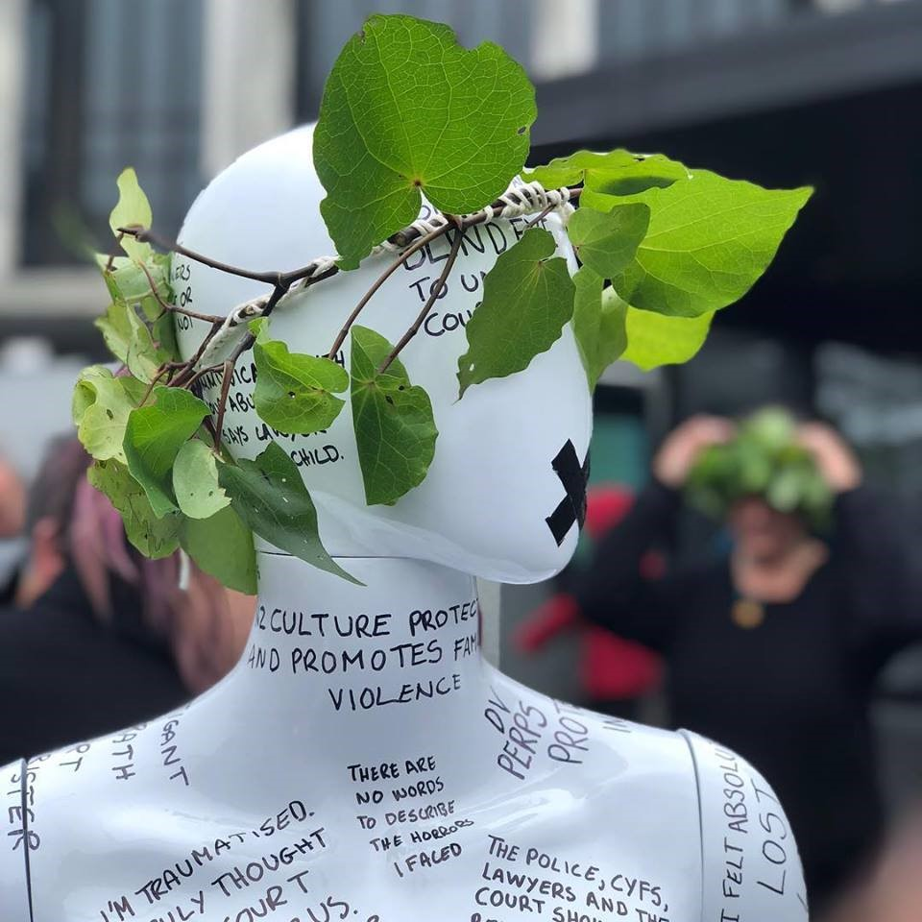
Image and artwork - ‘Untitled Woman’ by Sarah-Jayne Shine. From the No Shame No Silence Exhibition - mannequin with women’s voices inscribed delivered to parliament in November 2018.

Introduction
The following report has been prepared by The Backbone Collective on behalf of our 1700 +women members who are all victims-survivors of violence and abuse. This report is focused on the Committee’s recommendation in its eighth periodic report of New Zealand, released in June 2018.
- Para. 48 (a): Family Court system
Establish a royal commission of inquiry with an independent mandate to engage in wide-ranging evaluation of the drawbacks for women, the obstruction of justice for women and the hindrances to their safety inherent in the family court system and to recommend the legislative and structural changes necessary to make the family courts safe and just for women and children, in particular in situations of domestic violence.
The New Zealand Government has failed to implement Recommendation 48 (a). This report will provide evidence of this failure.

About the Backbone Collective
The Backbone Collective, a registered charity, was established in March 2017. Backbone’s primary purpose is to enable women to safely and anonymously tell the Government, others in authority, and the public about how the ‘system’ responded to them when they experienced violence and abuse, and how they need it to respond in order to be safe and rebuild their lives. Backbone’s mission is to help facilitate the continuous improvement of the system. We run online surveys for women victim-survivors and then write reports based on their responses making suggestions for system change. To date Backbone has conducted four surveys and produced five substantial reports detailing what women have been telling us about the Family Court.
In June 2018, Backbone submitted a shadow report to the UN CEDAW Committee providing information for 70th session, July 2018, eighth periodic report of New Zealand to alert the UN of the extraordinary levels of discrimination and abuse that New Zealand women are suffering via the Family Court process when they are victims of violence and abuse. We recommended that the United Nations send a special rapporteur to New Zealand to urgently investigate the way victims of violence and abuse are being responded to by the system (especially the Family Court). We explained that due to the serious and systemic issues that we had discovered we had been asking for a Royal Commission of Inquiry; It’s now been three and a half years since we started that call. Since our previous submission to CEDAW countless more women and children have been harmed by the Family Court system.
New Zealand women were elated when CEDAW’s recommendation 48(a) was released. We received many messages from women saying they finally felt heard, validated and hopeful that at last some action would be taken to fully investigate the Family Court response to women and children who had experienced violence and abuse. That sense of optimism was very short-lived!

New Zealand Government’s response to recommendation 48(a); A Review not a Royal Commission of Inquiry
The New Zealand Government has submitted in its mid-term report to the CEDAW Committee that the Ministerial Review into the 2014 Family Court Reforms was an adequate response to recommendation 48(a). Backbone strongly opposes this assertion.
CEDAW included in its concluding observations for New Zealand (in para 47) concerns about the Government’s planned Ministerial Review of the 2014 family justice system. ‘While welcoming the upcoming review of the Family Court announced by the Minister of Justice and Courts, the Committee is concerned that this review will be focused on the 2014 Family Court reforms alone, and will not examine the root causes of the systemic lack of trust and insensitivity to women victims of domestic violence apparently entrenched in the Family Court.’
In spite of CEDAW’s warning and recommendation 48(a), on the very day the recommendations were released (24 July 2018,) Minister Little announced in news media, in what appeared to be a unilateral decision, that there would be no Royal Commission of Inquiry into the Family Court saying, ‘the Government already has a fair idea of what the problems are’. Backbone was surprised that he was able to make this decision without Cabinet approval.
Backbone members (victim-survivors of violence and abuse) were outraged at Minister Little’s dismissal of the CEDAW recommendation and hosted a petition calling on the Government to uphold the recommendation. The petition attracted over 2000 signatures and was presented to parliament on 27 Nov 2018. Backbone never received a response from Minister Little to that petition.
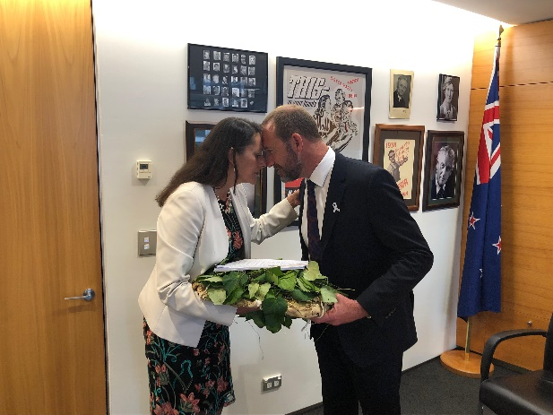
Member of Parliament Poto Williams in a hongi with Minister for Justice, Andrew Little as she gives him the kete containing signatures from over 2000 New Zealanders calling for the Government to uphold CEDAW’s recommendation 48 (a) following a hand over ceremony on the steps of parliament.
The Ministerial Review was not a response to CEDAW’s recommendation 48(a). Minister Little had already ordered a Ministerial Review into the Family Court Reforms. On 1 Aug 2018 he announced the Terms of Reference for ‘the rewrite of the 2014 family justice system reforms’ (the Review). The serious limitations of the Review have meant it could never, and did not, adequately or safely ‘examine the root causes of the systemic lack of trust and insensitivity to women victims of domestic violence apparently entrenched in the Family Court’ as recommended by CEDAW in the way a Royal Commission of Inquiry would have done.

Limitations of the Ministerial Family Court Review

Ineffective mechanism for fully investigating the culture, decisions and operations of the Family Court.
Backbone had been clear with the Government that the problems women and children victim-survivors were experiencing in the Family Court were not to do with the Family Court reforms of 2014, but ran far deeper and were due to the way the legislation was/is being implemented and the culture of the court. We prepared a thorough paper which was tabled at the Select Committee in early 2018 detailing why a Royal Commission of Inquiry was the only mechanism available to appropriately and fully investigate the Family Court. We argued an independent inquiry was needed, not a Ministerial one, that had the power to investigate and review the practices, procedures, standards and operations of the court and the role the judiciary and other court officials have played individually and collectively in the problems identified by women and children who have experienced violence and abuse. Furthermore, a Royal Commission would provide protection for the women and children who took part in the inquiry and have the power to subpoena documentation and witnesses, including judges and other professionals working in the court.

The Terms of Reference lacked any scope to adequately address CEDAW’s recommendation 48 (a). Instead they focused on issues that had been identified as a result of the 2014 Family Court Reforms including, delay, cost, forced mediation and lack of legal representation. There was only one point in the Terms of Reference that alluded to family violence and this was in relation to children, not women, and asked the panel to consider the extent to which the family justice system,
e) is evidence based and reflects research about what works best for children, including, for example, within the context of family violence and how this affects parenting and children; children with disabilities and/or disabled parents.
The Review Panel included no one with family violence expertise. The three panel members included a former Human Rights Commissioner (Chair) and two lawyers, one who was appointed to the Bench as a judge while she served on the panel.
An Expert Reference Group (ERG) established on 17 August 2018 to provide advice and information to the Panel, contained only one person who was a family violence expert (a retired academic focused on family violence). The remaining 10 members were mediators (3), lawyers (2) psychologists (2) kaupapa Maori expert (1), family law academics (2). Therefore, the vast majority of ERG members were stakeholders in the family law system (either they or the sector they represented were paid for services in the court) and therefore had a direct financial investment in the outcome of the review.
The submission process was not sufficiently safe for victim-survivors therefore limiting the scope of voices included.
Upon reading the Terms of Reference, Backbone was concerned about the safety of the submission process because the nature of the review as a Ministerial Review meant submissions would fall under New Zealand’s Official Information Act (OIA) and therefore be potentially available for public release. Backbone approached the Ombudsman’s Office on 3 August 2018, seeking clarification regarding the OIA legislation and how it would impact on the Review submission process. In response, the Ombudsman’s Office issued a position statement which made clear that submissions would fall under the OIA and would therefore be subject to release if an application was made to that effect. The Review Panel included information in their discussion document warning that submissions would be classed as Official Information and that submitters should therefore take care not to include any identifying information in their submissions, including Family Court documentation. It said people should outline in their submission any parts of it they wish to remain confidential and the reasons why and the Ministry of Justice would take these views into account when deciding on the release of submissions.
However, in light of the composition of the Panel and the submission process some victim survivors decided that the Review submission process was not safe for them and they could not participate. Backbone held concerns that the Review Panel report would be biased towards those who could safely submit (lawyers, mediators, psychologists, abusers etc.) but lack victim-survivor input thereby limiting the scope or effectiveness of any recommendations made.

Backbone attempted to improve the Review process
Backbone attempted to inform the Panel of the issues victim-survivors faced and undertook the following activities;
- On 7 August 2018 Backbone wrote to the chair of the Panel referring her to the CEDAW recommendation 48(a), our paper for the Select Committee on why a Royal Commission of Inquiry was the only appropriate mechanism for fully investigating the Family Court and provided copies of our five reports about the Family Court.
- We suggested a family violence expert be added to the Panel.
- We raised concerns about the safety of the submission process with the Panel and with the Ombudsman’s Office.
- We prepared a list of 24 questions for the Panel to gather more information about the safety of information, scope of participation and transparency of the Review to inform victim-survivors.
- Backbone prepared material to help victim-survivors understand the review process and the issues and risks involved in making submissions.
- We made two in-person submissions and one written submission describing the issues that hundreds of New Zealand women had shared with us about the systemic failure of the Family Court to respond appropriately and safely to cases where violence and abuse is alleged or confirmed.
- Backbone gathered submissions from 42 children and young people and collated these and shared them with the panel. In those submissions the children, who had all experienced violence and abuse, explained a range of experiences including that their involvement in the Family Court had made them less safe and had a harmful impact on their childhood, they felt they had not been listened to or believed, their views were not accurately reported to the Court, and professionals do not understand the risks they faced.

The Review Panel reports do not address the issues victim-survivors experience in the Family Court
In January 2019, a draft discussion report based on the submissions made to the Panel was released publicly which included some proposed recommendations. Backbone was extremely concerned that the document lacked any analysis or recommendations that would respond to the issues for women and children who are victim-survivors of family violence. In early February 2019, we met in person with the Panel and articulated those concerns. In our oral submission we reiterated the need for a specialist, separate response to cases where violence and abuse has been alleged or confirmed.
The Panel’s final report Te Korowai Ture ā-Whānau: The final report of the Independent Panel examining the 2014 family justice reforms, was released publicly on 16 June 2019.
The Report contains a wide range of recommendations. We accept that if implemented, the Family Court will likely be more efficient and effective for the straightforward cases that do not involve family violence. However, the Panel’s recommendations will not address the most central issue for victim-survivors – the culture and operation of the Family Court or the wide-ranging failures in the Family Court that Backbone has reported in the past three and a half years (including the lack of monitoring or accountability for those working in the Court, a lack of a family violence lens to view cases through, and the use of parental alienation accusations by those working in the court).
Recommendations 17-24 in the final report, which deal specifically with ‘family violence and children’s safety,’ fall well short in adequately addressing the issues of safety or justice that Backbone and many individual women raised with the Review Panel. Backbone is concerned that many of the recommendations are severely limited by the current culture of the Court which will prevent them being successfully realised and furthermore, some of the recommendations could be dangerous in cases of family violence. Backbone can supply more detail about the Panel’s recommendations and the constraints on them in the current context if required.
It is critical that the culture of the court is investigated and remedied, otherwise any recommended tweaks to existing legislation or regulations will make little impact. A recent Inquiry into the Family Law system in the United Kingdom has resulted in a report and implementation plan that, in contrast to New Zealand’s Review of the Family Court Reforms of 2014, focus on the culture of the court as the primary concern to ensure victims of domestic abuse are made safer.
The NZ panel report recommends two advisory groups be appointed, one a ministerial group and one for children however, there is no mention of an advisory group for victim-survivors of family violence.
Backbone believes that the Review Panel needed to recommend the following to help victim-survivors be safer:
- All Family Court cases to be screened for family violence at application stage.
- A separate pathway for family violence cases as a matter of urgency.
- Independent family violence specialists for adults and children to provide risk assessments to the court who are skilled in intimate partner violence, child abuse, child development and trauma and Tikanga Maori.
- The use of parental alienation accusations to be prohibited as recommended by CEDAW.
- An independent organisation be established that is tasked with monitoring the response to family violence and child protection cases in the Family Court.
- The special rapporteur to visit and investigate as recommended by CEDAW and/or that there be a Royal Commission of Inquiry into the Family Court.
Backbone heard from women victim-survivors who were devastated by the failure of the Review Panel’s report to address the failings of the Family Court to keep them and their children safe.
“It’s like that report was done to shut down the victims’ voice, because before that we were gaining some traction on people listening, with the UN report. But now the Noonan report has come out it’s basically said ‘oh there are some efficiency issues we could improve upon, but as far as domestic violence goes it’s not really as bad as all that.’”
— NZ woman who is a victim/survivor of family violence
“Like many women I did a lot of research before being desperate enough to use the court. I had heard how bad it was and I can honestly say I didn’t really believe it could possibly be as bad as women were saying. Let’s just say the reports and feedback I read were sadly right and I found myself in a shocking situation. Beyond comprehension…That has to change and the Government can’t just keep trying to put band aids on a system that is so broken. They know the issues. I know they are well aware of them. But perhaps, like me at the start of my journey, they just don’t realise how bad it is. Or perhaps the effort and money required to fix it is just too much for them to want to. I think the latter is true. There are too many people making too much money.”
— NZ woman who is a victim/survivor of family violence

Further action by Backbone following the release of the Panel’s final report
On the 16 June 2019 Backbone wrote an open letter to the Prime Minister - copying in other ministers and voicing our frustration at the silencing of family violence victim-survivors in the Panel’s final report. We recommended in that letter;
1.The urgent establishment of interim measures to keep women and children safe in Family Violence and Child Protection cases being brought before the Family Court.
2.The urgent establishment of a Royal Commission of Inquiry into the processes, procedures, conduct and culture of the NZ Family Court and Oranga Tamariki in relation to cases of family violence and child protection.
Backbone also wrote to Hon Minister Andrew Little requesting a meeting to discuss the limited outcome of the Family Court Review Panel report and to suggest the Government look to investigating how it could develop a new Family Court model for responding safely to cases where there was violence and abuse. Minister Little replied to our letter on 16 July 2019 stating;
“Your advocacy for a Royal Commission of Inquiry is well known to me. When the Government established the Noonan inquiry it did so to ensure a review would commence as early as possible. A Royal Commission could not be justified and the Government will not be establishing one in relation to the Family Court…I do not see the value in meeting again.”

Conclusion
Backbone has done all that we can to encourage the Government to implement Recommendation 48(a). However, our efforts to date have failed. There are no signs that the New Zealand Family Court has improved its response to victim-survivors and their children and we have little faith that the Review Panel recommendations will enable improvement within the current cultural environment of the court. Backbone hears from women everyday who share horrendous experiences of not being believed, being blamed for the violence and abuse, being accused of parental alienation, being forced to drop Protection Order applications in order to secure safer parenting orders for their children…the list of issues is long. The Government is well aware of the issues and has chosen not to take appropriate action to investigate or remedy them. As a result, children and women continue to be harmed.
A Royal Commission of Inquiry into the Family Court is now more urgent than ever because unless the culture of the Family Court is remedied, none of the recommendations made by the Review Panel will adequately or safely enable the court to improve its response to women and children victim-survivors.

https://www.backbone.org.nz/reports
https://www.tvnz.co.nz/one-news/new-zealand/andrew-little-rejects-un-womens-committee-call-royal-commission-into-new-zealand-family-court
https://static1.squarespace.com/static/57d898ef8419c2ef50f63405/t/5a94cc1a9140b78a0a3a5061/1519701025135/Submission+to+Justice+Select+Committee+January+2018.pdf
https://static1.squarespace.com/static/57d898ef8419c2ef50f63405/t/5b6136216d2a730eade03f1d/1533097505289/FamilyCourtRewriteTORS.pdf see also consultation document released by Ministry of Justice https://www.justice.govt.nz/assets/Documents/Publications/have-your-say-on-the-family-justice-system-english2.pdf
https://www.beehive.govt.nz/release/panel-appointed-re-write-2014-family-court-reforms
Mediators are contracted to provide an out of court service (Family Dispute Resolution Service) prior to court applications being accepted in the court. The Psychologists represent the section 133 Specialist Court Report Writers who are contracted by the court to undertake assessments in some Care of Children Act proceedings. Backbone has found that these court report writers are the group of professionals who most commonly accuse mothers who are victim-survivors of family violence of parental alienation – see pg. 37 https://static1.squarespace.com/static/57d898ef8419c2ef50f63405/t/5a3171c59140b743f5abbe36/1513189837189/Seen+and+not+Heard+Children+in+the+Family+Court+%281%29.pdf
https://static1.squarespace.com/static/57d898ef8419c2ef50f63405/t/5bac1db4c83025ead38d864b/1538006454923/letter+from+Ombudsman+Office+Sept+18.pdf
For example, read one woman’s open letter to the Panel https://www.backbone.org.nz/blog/safesubmissionsfamilycourtreviewpanel
This was not done.
We received a reply on 4 October 2018 declining our recommendations https://static1.squarespace.com/static/57d898ef8419c2ef50f63405/t/5bb66b5f71c10b155014b525/1538681698189/Letter+to+The+Backbone+Collective+-+Final.pdf
https://static1.squarespace.com/static/57d898ef8419c2ef50f63405/t/5bbfaaca9140b7b20d8ae0f5/1539287755796/Ways+To+Have+Your+Say+Final+Oct.pdf
https://static1.squarespace.com/static/57d898ef8419c2ef50f63405/t/5c634a80eef1a1c3543bffc1/1550011011531/Backbone+written+submission+to+FC+Review+Panel+-+FINAL.pdf
https://www.justice.govt.nz/assets/Documents/Publications/Strengthening-the-family-justice-system.pdf
https://www.justice.govt.nz/assets/Documents/Publications/family-justice-reforms-final-report-independent-panel.pdf
Maybe the Review Panel is acknowledging this themselves in para 102, ‘This report cannot deal comprehensively with all of the issues raised’?
https://assets.publishing.service.gov.uk/government/uploads/system/uploads/attachment_data/file/895174/implementation-plan-assessing-risk-children.pdf
We expressed concern to the Panel that family violence cases were perceived as ‘complex cases’ – characterised by difficult behaviour by the parties involved thereby preventing timely resolution of matters. We explained this is an inappropriate characterisation of family violence cases where victim-survivors have no control over the behaviour of the other abusive parent in relation to proceedings. However, responding to these cases as if they do (forced into counselling to change their responses etc.) will make future responses to victim- survivors even more dangerous.
Rosslyn Noonan was the Chair of the Review Panel.

