List of figures
Figure 1: Percentage of Population by Sex and Year
Figure 2: Uganda Male and Female Population by Age
Figure 3: Proportion of Respondents Who Have Been Victims of Discrimination, By Sex
Figure 4: Population aged 15-49 who Had Experienced Physical Violence Since age 15 by Wealth Quintile, 2011 and 2016
Figure 5: Percentage of Persons who Have Experienced GBV in the last 6 months, by Region (%)
Figure 6: Proportion of Women who have Experienced Physical Violence since age 15 by Education Level
Figure 7: Proportion of Women who have Experienced Physical Violence since Age 15, by Age Group
Figure 8: Male and Female Responses to Gendered Statements by sex (%)
Figure 9: Trends in Select Categories of SGBV
Figure 10: Proportion of women victims of FGM (female genital mutilation) over the last 15 years
Figure 11: Registered Incidents of Trafficking in Persons in 2018 compared to 2017
Figure 12: Composition of cabinet by sex (Numbers)
Figure 13: Gender Composition in Decision Making Positions in Public Service
Figure 14: Number of ECD Centres and Pre-Primary Schools in Uganda
Figure 15: Early Childhood Pupil Enrolment by Age
Figure 16: Students with Special Learning Needs by Grade, Sex and Impairment Type
Figure 17: Government-aided Schools by Region
Figure 18: Industry of Work for Working Population Aged 14-64 years, 2012/13 and 2016/17
Figure 19: Life expectancy for Men and Women in Uganda 96
Figure 20: Antenatal care by a skilled worker, Birth occurred in a health facility and Birth attended to by skilled health provider
Figure 21: HIV Infection Rate by Gender and Residence as of 2017 (%)
Figure 22: HIV prevalence by Age and Sex
Figure 23: HIV Prevalence by Region
Figure 24: Percentage of Women Owning Land: Rural and Urban Disaggregation
Figure 25: Agricultural Land Ownership by Household Members
Figure 26: Performance of the Ministry of Energy and Mineral Development in the implementation of the Local Content Policy for the FYs 2016/2017-2017/2018
Figure 27: Proportion of Women aged 15-49 who Had Experienced SGBV from 15 years of age, by Residence (2011-2016)
Figure 28: Head of Household by Residence
Figure 29: Head of Household by Age, Sex and Year

List of tables
Table 1: Population of Women in Uganda
Table 2: Nature/Category of Complaints Received by the Equal Opportunities Commission
Table 3: Complaints Registered by UHRC
Table 4: Perpetrators of physical violence among women and men aged 15-49 since age 15, 2011/16
Table 5: Male and Female Responses to Gendered Statements by Region and Sex (%)
Table 6: Male and Female Responses to Gendered Statements by Education and Sex (%)
Table 7: Numbers of Registered Victims of Trafficking, by Gender
Table 8: Summary Information of the General Prosecution Actions Carried out on the Cases Registered in 2018
Table 9: Number of Cases Registered and Taken to Court for 2017 & 2018
Table 10: Victims rescued and not rescued by the end of 2018
Table 11: Punishment Given per TIP Related Cases with Convictions by end of 2018
Table 12: Female Representation in the 10th Parliament
Table 13: District Women Members of Parliament as percentage of women MPs from 1989 to 2016.
Table 14: Women MPs by the type of seat in the 10th Parliament
Table 15 Composition of Parliament by sex from 1989 to 2021.
Table 16: Composition of the Local Government, 2016
Table 17: Composition of Staffing Positions in the Judiciary by Sex
Table 18: Women in Cabinet from 2001 to 2016
Table 19: Staffing Positions in Government Ministries by Sex
Table 20: Female Employment in the Public Sector
Table 21: Government Financing of the Education Sector in the Past Five Years
Table 22: Pre-Primary Teachers by Qualification
Table 23: Primary School Enrolment by Nationality, Grade and Sex
Table 24: Secondary Enrolment of non-Ugandans by Nationality and Grade
Table 25: Bank Account Ownership by Sex of Household Heads in Families where at least One Member has a Functional Financial Account (%)
Table 26: Participation of Women in the National Economy (Formal and Informal)
Table 27: Life expectancy for Men and Women in Uganda
Table 28: Maternal Mortality Ratio (MMR)
Table 29: Percentage of Women aged 15-19 who Have Borne a Child, by Age
Table 30: Percentage of Women Currently Using a Contraceptive Method
Table 31: Percentage of Pregnant Women making Antenatal Visits by Number of Visits
Table 32: Head of Household by Residence
Table 33: Head of Household by Age, Sex and Year
Table 34: Poverty by Region and Sex
Table 35: Average Time Spent on Unpaid Care Work per day by Age Group, Marital Status, Education and Employment (hours)
Table 36: Disability Type by Sex and Region
Table 37: Distribution of Persons with Disabilities by Age and Sex
Table 38: Gender Capacity Gaps and Needs in the Production of Gender Statistics

Annex 1: Population
Table 1: Population of Women in Uganda
Census Year | Male | Female | Total | Male % | Female % | Inter-Censal Period
1948 | 2,481,394 | 2,477,126 | 4,958,520 | 50.0% | 50.0% | 1931-1948
1959 | 3,236,902 | 3,212,656 | 6,449,558 | 50.2% | 49.8% | 1948-1959
1969 | 4,812,447 | 4,722,604 | 9,535,051 | 50.5% | 49.5% | 1959-1969
1980 | 6,259,837 | 6,376,342 | 12,636,179 | 49.5% | 50.5% | 1969-1980
1991 | 8,185,747 | 8,485,558 | 16,671,705 | 49.1% | 50.9% | 1980-1991
2002 | 11,824,273 | 12,403,024 | 24,227,297 | 48.8% | 51.2% | 1991-2002
2014 | 17,060,832 | 17,573,818 | 34,634,650 | 49.3% | 50.7% | 2002 – 2014
Source: National Population and Housing Census, 2014
Figure 1: Percentage of Population by Sex and Year
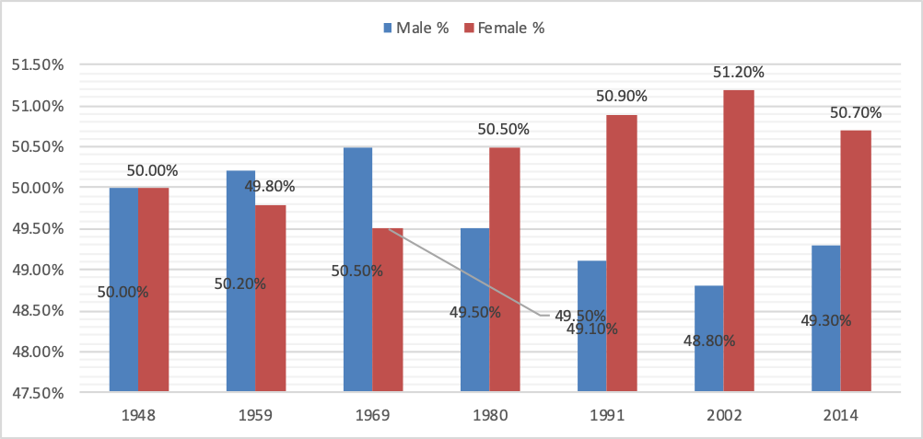
Source: National Population and Housing Census, 2014
Source: National Population and Housing Census, 2014
Figure 2: Uganda Male and Female Population by Age
Population Pyramid

6
4
2
10
12
8
10
8
6
2
0
4
4
-
0
5-9
10-14
19
-
15
24
20
-
29
-
25
34
-
30
-
39
35
44
-
40
49
-
45
54
-
50
-
59
55
60
-
64
65
-
69
70
-
74
79
-
75
84
-
80
-
85
89
90+
Male
Female

Annex 2: Discrimination
Table 2: Nature/Category of Complaints Received by the Equal Opportunities Commission
No. | Nature of Complaint | Females | Males | No. of Complaints | Female (%) | Male (%) | Total (%)
1 | Land | 64 | 83 | 147 | 43 | 57 | 100
2 | Employment | 13 | 47 | 60 | 22 | 78 | 100
3 | Pension | 11 | 36 | 47 | 24 | 76 | 100
4 | Minorities | 0 | 1 | 1 | 0 | 100 | 100
5 | Property | 66 | 30 | 97 | 69 | 31 | 100
6 | Education | 4 | 0 | 4 | 100 | 0 | 100
7 | Religion | 8 | 6 | 13 | 58 | 42 | 100
8 | Clean and Healthy Environment | 13 | 4 | 17 | 76 | 24 | 100
9 | Political Participation | 1 | 3 | 4 | 30% | 70% | 100%
 | Total | 180 | 210 | 390 | 46 | 54 | 100
Source: EOC Tribunal Records 2017/2018

Figure 3: Proportion of Respondents Who Have Been Victims of Discrimination, By Sex
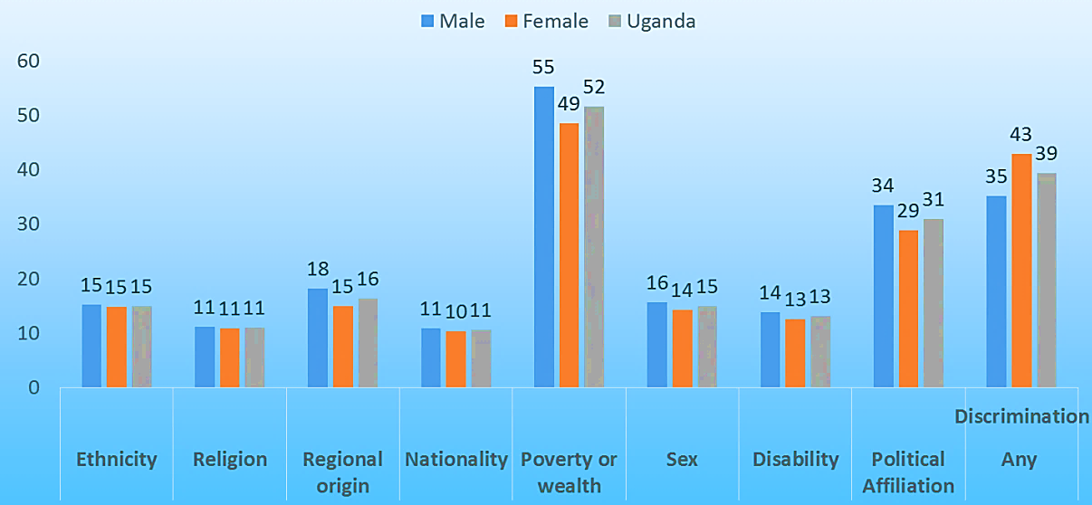
Source: UBOS, National Governance, Pease and Security Survey (2018)
Table 3: Complaints Registered by UHRC
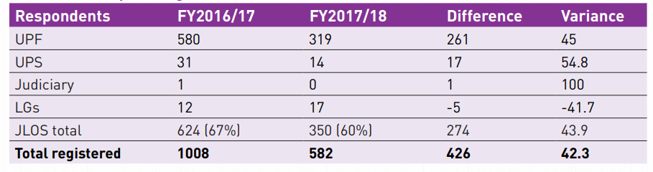
Source: UHRC (2017/18)

Annex 3: Violence against Women
Table 4: Perpetrators of physical violence among women and men aged 15-49 since age 15, 2011/16
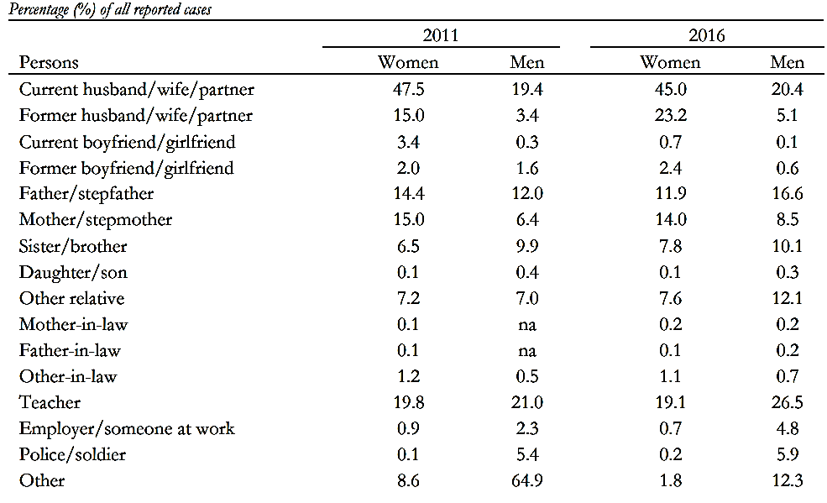
Source: UNHS 2011 and 2016
Figure 4: Population aged 15-49 who Had Experienced Physical Violence Since age 15 by Wealth Quintile, 2011 and 2016
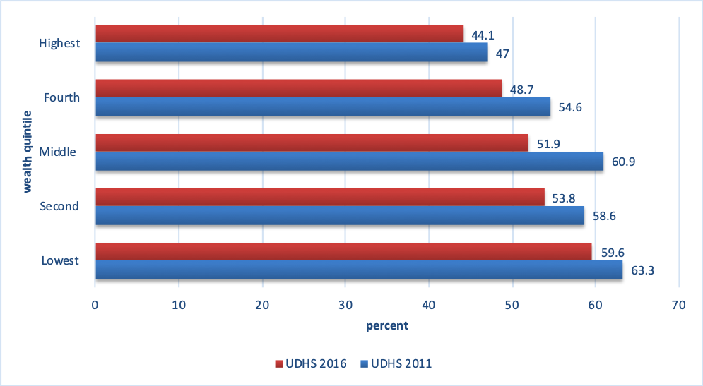
Source: UDHS 2011/2016
Figure 5: Percentage of Persons who Have Experienced GBV in the last 6 months, by Region (%)
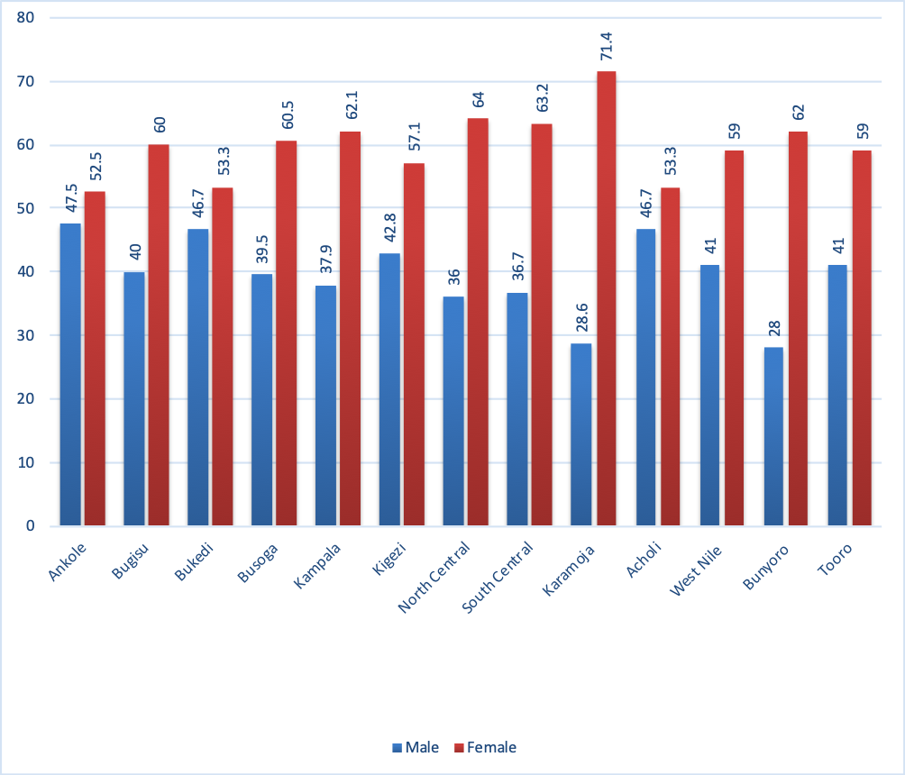
Source: Gender Assessment Survey, 2018
Figure 6: Proportion of Women who have Experienced Physical Violence since age 15 by Education Level
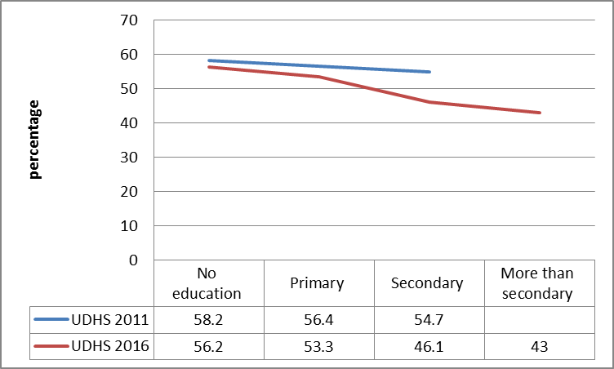
Source: UDHS 2011/2016
Figure 7: Proportion of Women who have Experienced Physical Violence since Age 15, by Age Group
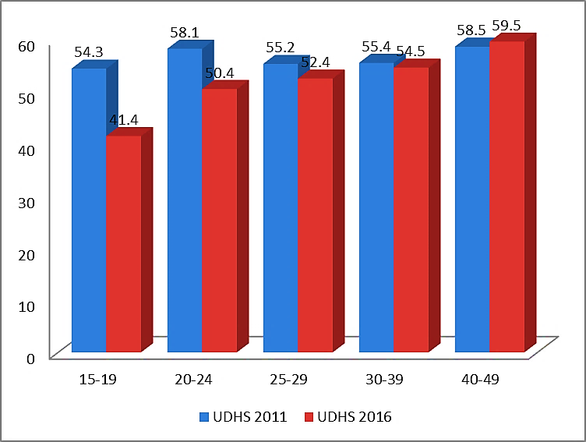
Source: UDHS 2011/16

Annex 4: Attitudes about Men and Women
Table 5: Male and Female Responses to Gendered Statements by Region and Sex (%)
Statements | Central |  | Eastern |  | Northern |  | Western
Statements | W | M | W | M | W | M | W | M
Both husband and wife should earn for the wellbeing of the family | 93 | 91 | 84 | 81 | 95 | 93 | 87 | 88
A woman’s role is to take care of her home and family | 76 | 79 | 79 | 77 | 84 | 81 | 86 | 78
Childcare is the mother’s responsibility | 71 | 63 | 72 | 67 | 82 | 69 | 82 | 72
Men always work outside as women do in the home | 62 | 66 | 58 | 60 | 48 | 51 | 77 | 77
Women should cook all the time | 66 | 66 | 66 | 66 | 53 | 50 | 79 | 74
Men do not know how to take care of a toddler without a woman | 73 | 68 | 71 | 66 | 83 | 82 | 78 | 69
Men and women must equally share household tasks and child care if both are working | 69 | 73 | 67 | 67 | 79 | 78 | 73 | 74
Men who are seen playing, dancing, singing with their children are considered | 64 | 58 | 62 | 57 | 63 | 52 | 74 | 71
Many women who are house wives would prefer to work outside the house if there were opportunities | 91 | 92 | 78 | 76 | 84 | 78 | 72 | 71
Men who are seen playing, dancing, singing with their children are considered less masculine | 87 | 85 | 87 | 82 | 93 | 89 | 70 | 68
Men’s work is more important than women’s work | 60 | 74 | 53 | 64 | 34 | 41 | 61 | 67
Men should help women with cooking | 68 | 70 | 62 | 60 | 75 | 77 | 58 | 63
Taking care of elderly is women’s responsibility | 55 | 49 | 50 | 48 | 62 | 54 | 63 | 51
Girls and boys should spend the same amount of time on domestic work | 69 | 64 | 75 | 67 | 69 | 67 | 60 | 52
Men must be responsible for household chores | 58 | 53 | 57 | 60 | 35 | 36 | 51 | 58
A man can cook dinner for his family | 66 | 65 | 60 | 58 | 77 | 82 | 45 | 57
A man who shares housework with his wife will eventually be overpowered by her | 41 | 44 | 39 | 44 | 24 | 25 | 44 | 49
Men who are seen playing, dancing, singing with their children are considered | 29 | 29 | 29 | 28 | 21 | 18 | 28 | 27
Girls under 18 years may be married | 10 | 14 | 17 | 20 | 14 | 10 | 14 | 9
Boys under 18 years may be married | 5 | 10 | 10 | 11 | 13 | 9 | 10 | 7
Source: UBOS Time Use Survey (2017/18)

Figure 8: Male and Female Responses to Gendered Statements by sex (%)

Source: UBOS Time Use Survey (2017/18)
Table 6: Male and Female Responses to Gendered Statements by Education and Sex (%)
 | No Education |  | Primary |  | Secondary |  | Above  Secondary
Statement | W | M | W | M | W | M | W | M
Both husband and wife should earn for the wellbeing of the family | 89.8 | 85.7 | 88.4 | 86.9 | 90.4 | 88.6 | 98.7 | 96.9
Many women who are house wives would prefer to work outside the house if there were opportunities | 78.9 | 68.5 | 79.7 | 77.9 | 86.1 | 84.9 | 91.9 | 86.8
A man can cook dinner for his family | 49.1 | 51.4 | 61.6 | 64.0 | 66.1 | 64.6 | 84.7 | 80.1
Men should help women with cooking | 55.7 | 57.3 | 65.6 | 67.7 | 68.8 | 64.3 | 82.3 | 81.9
Men and women must equally share household tasks and child care if both are working | 68.4 | 68.2 | 71.5 | 71.7 | 71.3 | 75.6 | 80.5 | 77.6
Girls and boys should spend the same amount of time on domestic work | 70.1 | 56.5 | 66.3 | 63.0 | 67.9 | 62.3 | 78.8 | 62.0
A woman’s role is to take care of her home and family | 84.8 | 82.2 | 82.5 | 79.9 | 76.5 | 77.5 | 71.8 | 70.2
Men always work outside as women do in the home | 64.6 | 75.3 | 64.8 | 66.7 | 57.2 | 58.8 | 45.4 | 48.6
Women should cook all the time | 76.1 | 75.0 | 67.8 | 68.5 | 62.8 | 60.6 | 36.9 | 40.9
Taking care of elderly is women’s responsibility | 65.6 | 57.6 | 58.8 | 52.3 | 50.9 | 47.8 | 31.3 | 29.7
Men’s work is more important than women’s work | 54.5 | 67.7 | 54.4 | 65.3 | 54.8 | 63.2 | 26.1 | 43.5
Source: Time Use Survey (2017/18)

Annex 5: Harmful Practices
Figure 9: Trends in Select Categories of SGBV
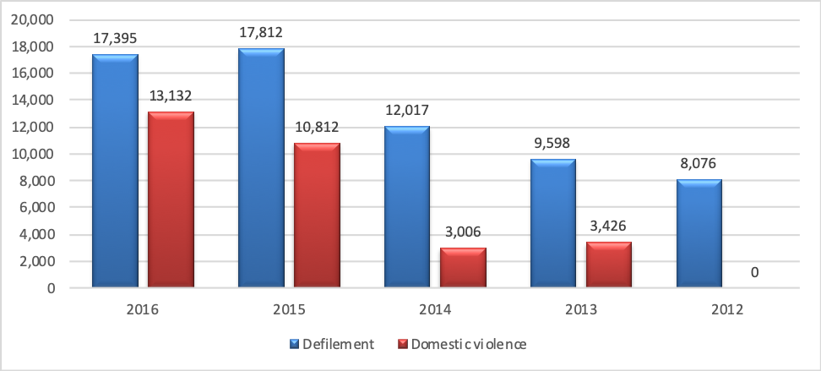
Source: JLOS, 2017:73 (JLOS Annual Performance Report 2016/17)

Figure 10: Proportion of women victims of FGM (female genital mutilation) over the last 15 years
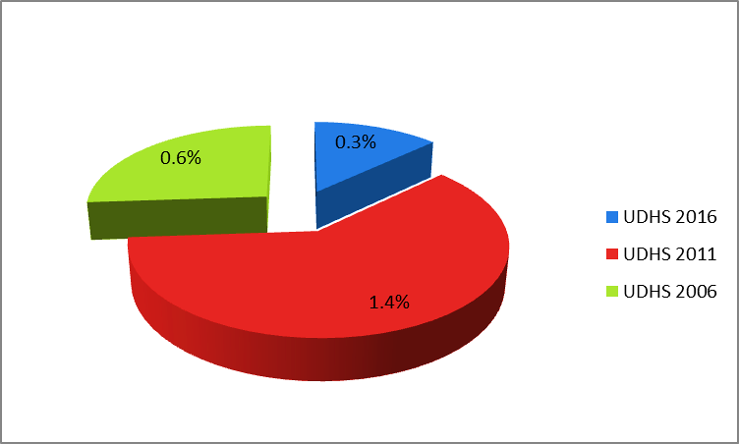
Source: UDHS Reports 2006/ 2011 / 2016

Figure 11: Registered Incidents of Trafficking in Persons in 2018 compared to 2017
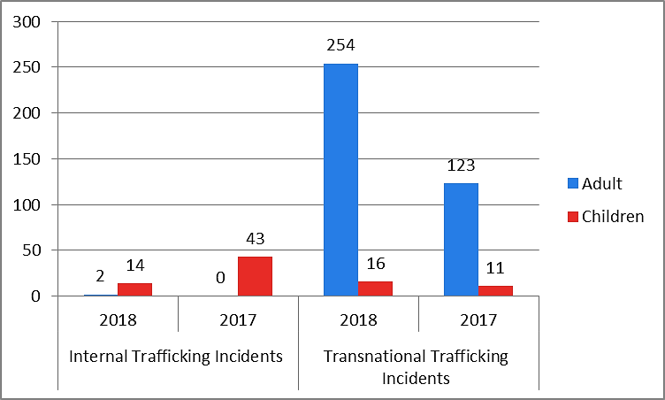
Source: MIA, 2018 (Performance report on countering TIP in Uganda)

Table 7: Numbers of Registered Victims of Trafficking, by Gender
Year | Internal Trafficking victims |  |  |  |  |  | Transnational Trafficking Victims |  |  |  |  | Grand Total
Year | Female Adults | Male Adults | Female Children | Male Children | Sub Total |  | Female Adults | Male Adults | Female Children | Male Children | Sub Total | Grand Total
2018 | 11 | 19 | 73 | 42 | 145 |  | 287 | 178 | 33 | 7 | 505 | 650
2017 | Nil | Nil | 93 | 13 | 106 |  | 197 | 9 | 15 | 28 | 249 | 355
Source: MIA, 2018 (Performance report on countering trafficking in persons in Uganda)

Table 8: Summary Information of the General Prosecution Actions Carried out on the Cases Registered in 2018
Total No of registered Cases / Incidents | No. of Cases Taken to court | No. of Sanctioned Case Files pending Court action | No. of Cases with Convictions | No. of Dismissed Cases | No. of Suspects taken to Court | No. of Suspects Convicted | Charges preferred against the Suspects for the Sanctioned Case Files
286 | 77 | 12 | 14 | 9 | 91 | 19 | Aggravated TIP (10)  - TIP (14)  - Promoting TIP (3)  -Conspiracy to traffic (1)  -Attempt to traffic(35)  -Illegal Recruitment (34)  -Unlawful possession of Passports(1)  -Child Stealing(1)
Source: MIA, 2018 (Performance report on countering trafficking in persons in Uganda)

Table 9: Number of Cases Registered and Taken to Court for 2017 & 2018
Year | Total Registered Cases | Total Taken to court by end of the year | Percentage of Cases taken to court by end of the year
2018 | 286 | 89 | 31%
2017 | 177 | 45 | 25%
Source: MIA, 2018 (Performance report on countering trafficking in persons in Uganda)
Table 10: Victims rescued and not rescued by the end of 2018
Internal Trafficked Victims |  |  |  | Transnational Trafficked Victims
Total Registered | Rescued or Intercepted by end of the year | Not Rescued by end of the year |  | Total Registered | Rescued or Intercepted by end of the year | Not Rescued by end of the year
145 | 142 | 3 |  | 505 | 458 | 47
Source: MIA, 2018 (Performance report on countering trafficking in persons in Uganda)

Table 11: Punishment Given per TIP Related Cases with Convictions by end of 2018
Charge Preferred | Total No. of Cases | No. of Cases with convictions | Nature of Sentences / Punishments offered per Case with conviction | Maximum Sentence Provided by the PTIP Act
Aggravated Trafficking | 10 | 2 | - 2 years Imprisonment (2) | - Life Imprisonment
Trafficking in persons | 14 | Nil |  | -15 years Imprisonment
Promoting TIP | 3 | 1 | - 90 days community service (1) | -7 Years Imprisonment
Conspiracy to traffic | 1 | Nil |  | - 7 Years Imprisonment
Attempt to traffic | 35 | 3 | - 14 Months Imprisonment (1)  - Fine of 200,000- (1)  - 4 Weeks Community service (1) | - 7 Years Imprisonment
Illegal Recruitment & obtaining money by false pretense | 34 | 4 | - 3 years imprisonment (1)  - 1 Year Imprisonment (1)  - Caution (2) | - Not provided for under PTIP Act
Unlawful possession of Passports | 1 | 1 | - 2 years imprisonment (1) | - Not provided for under PTIP Act
Child Stealing | 1 | 1 | - 1 year Imprisonment (1) | - Not under PTIP Act
Source: MIA, 2018 (Performance report on countering trafficking in persons in Uganda)

Annex 6: Participation in Public and Political Life
Table 12: Female Representation in the 10th Parliament
Categories | No. of MPs | Percentage
Constituency (Directly Elected) | 20 | 12.5
District Women Representatives | 122 | 76.3
Uganda Peoples’ Defense Force Representatives (UPDF) | 3 | 1.9
Workers’ Representatives | 2 | 1.3
Youth Representatives | 2 | 1.3
Persons With Disabilities Representatives (PWDs) | 2 | 1.3
Ex Officio Members | 9 | 5.6
Total | 160 | 100
Source: Parliament of the Republic of Uganda, 2018.

Table 13: District Women Members of Parliament as percentage of women MPs from 1989 to 2016.
Period | Parliament | Total No. of women MPs | No. of District Women MPs | District Women MPs as a % of Total Women MPs
1989-1996 | 5th | 38 | 34 | 89
1996 -2001 | 6th | 51 | 39 | 76
2001-2006 | 7th | 74 | 56 | 76
2006-2011 | 8th | 102 | 79 | 77
2011-2016 | 9th | 135 | 112 | 85
2016-2021 | 10th | 157 | 116 | 74
Source: Parliament of Uganda 2017
Table 14: Women MPs by the type of seat in the 10th Parliament
Type | Numbers | %age
District Women MPs | 116 | 74
Directly elected MPs at Constituency Level | 22 | 14
Women in Special interest groups | 19 | 12
Total Number of Women MPs | 157 | 100
Source: Parliament of Uganda 2017
Table 15 Composition of Parliament by sex from 1989 to 2021.
Period | Parliament | Total No. of MPs | No. of Men MPs | No. of Women MPs | Women MPs as a % of total MPs
1989-1996 | 5th | 267 | 229 | 38 | 14
1996 -2001 | 6th | 276 | 225 | 51 | 18
2001-2006 | 7th | 305 | 231 | 74 | 24
2006-2011 | 8th | 306 | 204 | 102 | 33
2011-2016 | 9th | 375 | 244 | 131 | 35
2016 -2021 | 10th | 449 | 292 | 157 | 35

Table 16: Composition of the Local Government, 2016
Position | Women | Men
District Chair persons | 2 | 98
Sub-county / Town Council / Municipal Division Chairpersons | 1 | 99
Directly elected District Councillors | 2 | 98
District Women Councillors | 100
Directly elected Municipal Division Councillors | 2 | 98
Municipal Division Women Councillors | 100
Directly elected Sub-county / Town Council / Municipal Division Councillor | 1 | 99
Sub-county / Town Council / Municipal Division Women Councillor | 100
Source: Uganda Electoral Commission
Table 17: Composition of Staffing Positions in the Judiciary by Sex
S/N | Designation | Females | Males | Total | %F | %M
1 | Chief Justice |  | 1 | 1 | 0.0 | 100.0
2 | Deputy Chief Justice |  | 1 | 1 | 0.0 | 100.0
3 | Justices of the Supreme Court | 4 | 5 | 9 | 44.4 | 55.6
4 | Justices of the Court of Appeal | 4 | 7 | 11 | 36.4 | 63.6
5 | Principal Judge |  | 1 | 1 | 0.0 | 100.0
6 | Judges of the High Court | 23 | 29 | 52 | 44.2 | 55.8
7 | Chief Registrar |  | 1 | 1 | 0.0 | 100.0
8 | Registrars |  | 3 | 3 | 0.0 | 100.0
9 | Deputy/Assistant Registrars | 24 | 21 | 45 | 53.3 | 46.7
10 | Chief Magistrates | 15 | 20 | 35 | 42.9 | 57.1
11 | Magistrates Grade I & II | 104 | 140 | 244 | 42.6 | 57.4
12 | Other Judiciary Staff | 656 | 672 | 1328 | 49.4 | 50.6
 | Grand Total | 830 | 901 | 1731 | 47.9 | 52.1
Source: EOC Report on the Status of Women Employment in the Public Sector in Uganda, March, 2018

Table 18: Women in Cabinet from 2001 to 2016
Women in leadership positions | 2001-2005 |  |  | 2006-2011 |  |  | 2011-2016 |  |  | 2016-2021
 | F | M | F% | F | M | F% | F | M | F% | F | M | F%
Cabinet and Minister of State | 51 | 15 | 22.7 | 14 | 58 | 19.4 | 25 | 54 | 31.6 | 25 | 55 | 31.2
Source: Ministry of Gender, Labour and Social Development

Figure 12: Composition of cabinet by sex (Numbers)
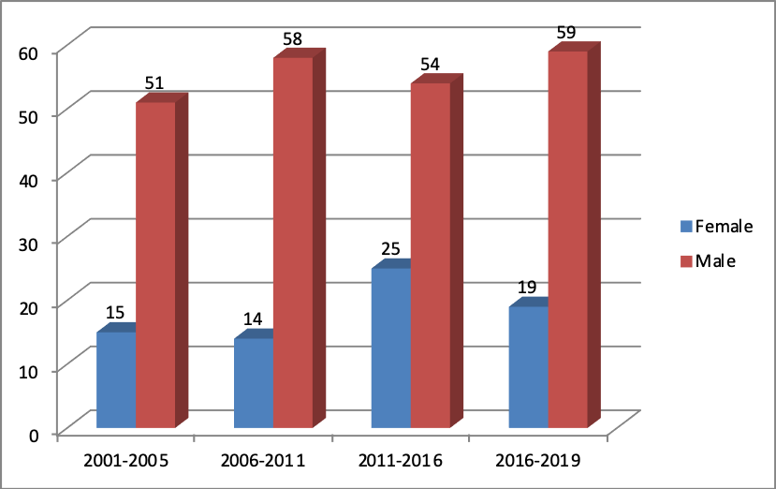
UBOS, 2017 (Women and men facts and figures)
Table 19: Staffing Positions in Government Ministries by Sex
S/N | Position | Female | Male | Total | %Female | %Male
1 | Permanent Secretary | 9 | 11 | 20 | 45.0 | 55.0
2 | Directors | 11 | 29 | 40 | 27.5 | 72.5
3 | Under Secretary | 11 | 16 | 27 | 40.7 | 59.3
4 | Commissioners | 30 | 126 | 156 | 19.2 | 80.8
5 | Assistant Commissioners | 61 | 172 | 233 | 26.2 | 73.8
6 | Principal Officers | 165 | 389 | 554 | 29.8 | 70.2
7 | Senior Officers | 351 | 646 | 997 | 35.2 | 64.8
8 | Officers | 885 | 948 | 1833 | 48.3 | 51.7
9 | Support Staff | 1417 | 2103 | 3510 | 40.3 | 59.7
 | Grand Total | 2940 | 4440 | 7380 | 39.8 | 60.2
Source: Computed by EOC from IPPS data set & MPSs, 2016/17
Figure 13: Gender Composition in Decision Making Positions in Public Service
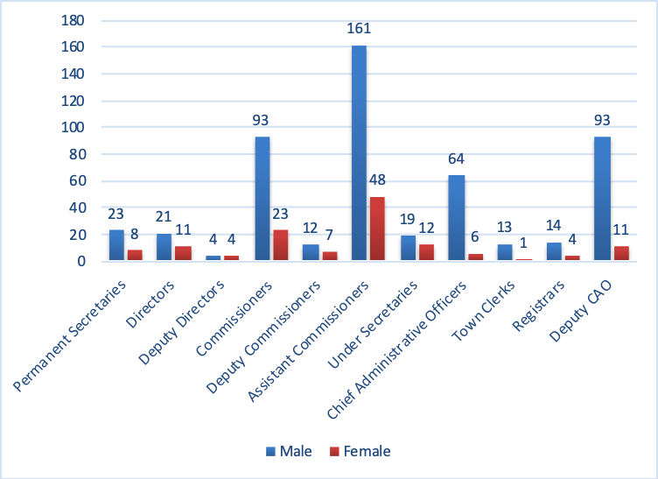
UBOS, 2017 (Women and men facts and figures)

Table 20: Female Employment in the Public Sector
S/N | Ministry | F | M | Total | % F | % M
1 | Ministry of Justice and Constitutional Affairs. | 150 | 135 | 285 | 52.6 | 47.4
2 | Ministry of Agriculture, Animal Industry & Fisheries | 216 | 384 | 600 | 36.0 | 64.0
3 | Ministry of Defense | 57 | 69 | 126 | 45.2 | 54.8
4 | Ministry of East African Affairs | 30 | 39 | 69 | 43.5 | 56.5
5 | Ministry of Energy and Mineral Development | 86 | 193 | 279 | 30.8 | 69.2
6 | Ministry of Finance, Planning and Economic Development | 193 | 267 | 460 | 42.0 | 58.0
7 | Ministry of Foreign Affairs | 159 | 180 | 339 | 46.9 | 53.1
8 | Ministry of Gender, Labour and Social Development | 132 | 132 | 264 | 50.0 | 50.0
9 | Ministry of Health | 160 | 270 | 430 | 37.2 | 62.8
10 | Ministry of Information & Communications Technology | 41 | 52 | 93 | 44.1 | 55.9
11 | Ministry of Internal Affairs | 307 | 468 | 775 | 39.6 | 60.4
12 | Ministry of Lands Housing and Urban Development | 228 | 277 | 505 | 45.1 | 54.9
13 | Ministry of local government | 51 | 100 | 151 | 33.8 | 66.2
14 | Ministry of Public Service | 109 | 125 | 234 | 46.6 | 53.4
15 | Ministry of Tourism Wildlife and Antiquities | 61 | 128 | 189 | 32.3 | 67.7
16 | Ministry of Trade, Industry and Cooperatives | 51 | 103 | 154 | 33.1 | 66.9
17 | Ministry of Water and Environment | 102 | 240 | 342 | 29.8 | 70.2
Source: EOC Report on the Status of Women Employment in the Public Sector in Uganda, March, 2018

Annex 7: Equality in the Field of Education
Table 21: Government Financing of the Education Sector in the Past Five Years
FY | None wage (bn) | Development Government (bn) | Development External financing (bn)
2014/15 | 127.393 | 53.115 | 223.373
2015/16 | 131.229 | 62.227 | 200.477
2016/17 | 145.367 | 105.797 | 396.921
2017/18 | 142.021 | 68.637 | 388.958
2018/19 | 187.938 | 66.897 | 336.892
Source: Ministerial Policy Statement 2013/14-2019/20

Figure 14: Number of ECD Centres and Pre-Primary Schools in Uganda
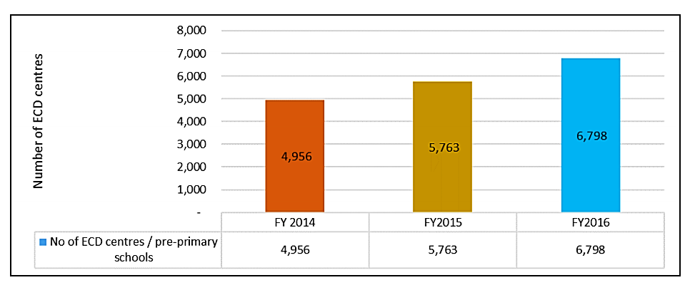
Source: Ministry of Education and Sports Education Abstract on the findings of the Annual School Census 2016 (2016)

Figure 15: Early Childhood Pupil Enrolment by Age
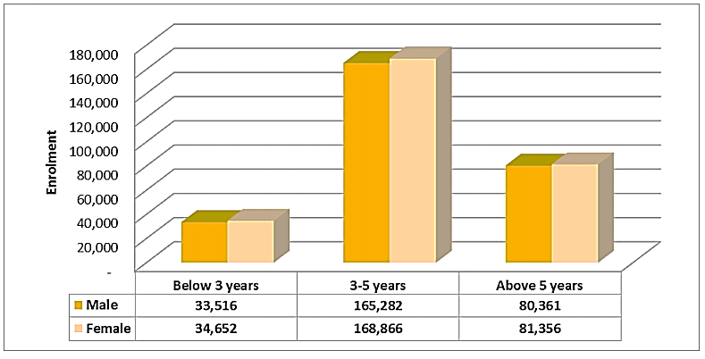
Source: Ministry of Education and Sports Education Abstract on the findings of the Annual School Census 2016 (2016)

Figure 16: Students with Special Learning Needs by Grade, Sex and Impairment Type
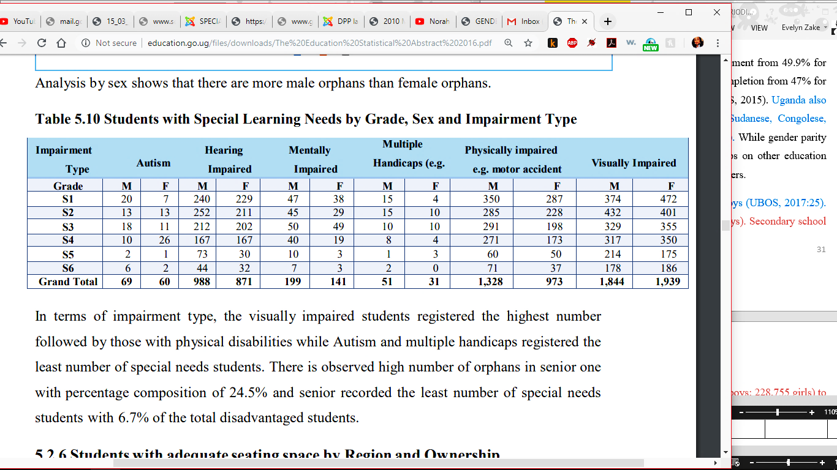
Source: Ministry of Education and Sports Education Abstract on the findings of the Annual School Census 2016 (2016)
Figure 17: Government-aided Schools by Region
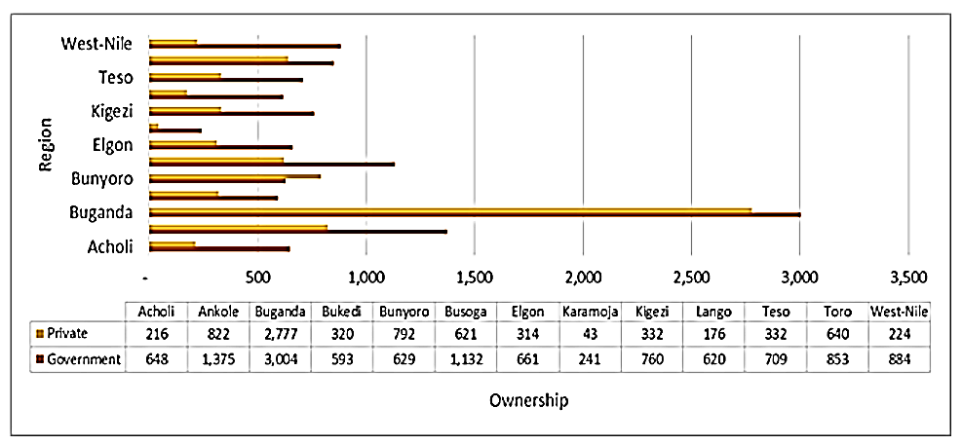
Source: Ministry of Education and Sports Education Abstract on the findings of the Annual School Census 2016 (2016)
Table 22: Pre-Primary Teachers by Qualification
Qualification | Female | Male | Grand Total
Certificate in Nursery Teaching | 1,625 | 337 | 1,962
Diploma in Nursery Teaching | 11,679 | 778 | 12,457
Diploma in Primary Education | 120 | 79 | 199
Grade II Teacher | 1,767 | 151 | 1,918
Grade II Teacher | 155 | 90 | 245
Grade IV Teacher | 1,126 | 644 | 1,770
Grade V Teacher including DSNE | 40 | 16 | 56
Graduate Teacher | 93 | 66 | 159
Licensed Teacher | 2,152 | 637 | 2,789
Trained care giver | 130 | 56 | 186
Grand Total | 18,887 | 2,854 | 21,741
Source: Ministry of Education and Sports Education Abstract on the findings of the Annual School Census 2016 (2016)
Table 23: Primary School Enrolment by Nationality, Grade and Sex
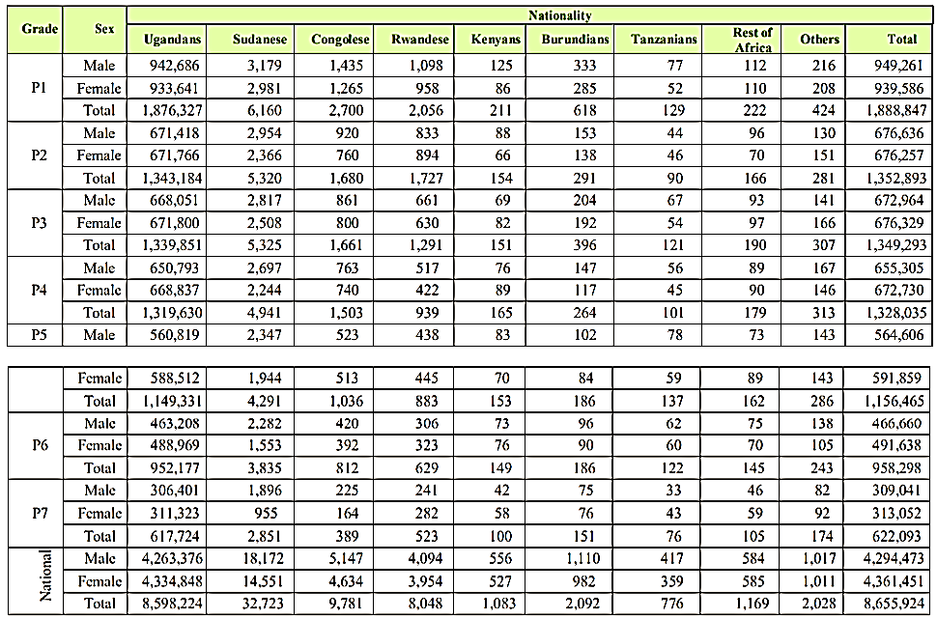
Source: Ministry of Education and Sports Education Abstract on the findings of the Annual School Census 2016 (2016)
Table 24: Secondary Enrolment of non-Ugandans by Nationality and Grade
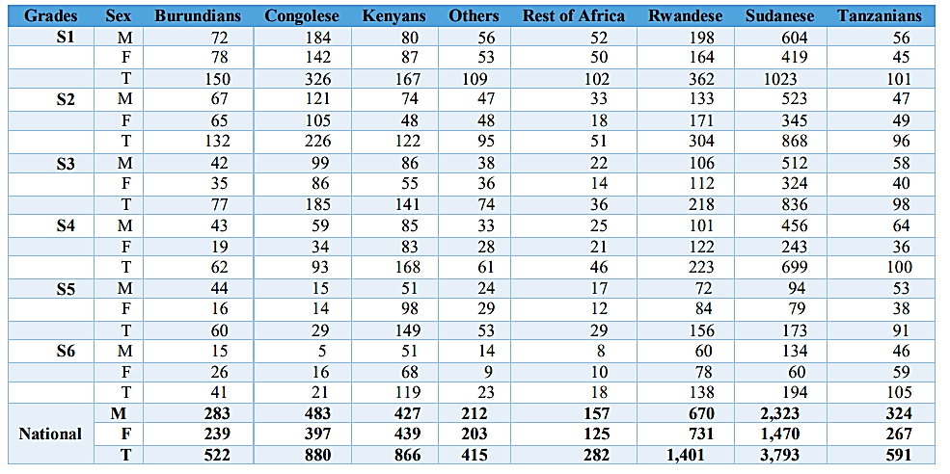
Source: Ministry of Education and Sports Education Abstract on the findings of the Annual School Census 2016 (2016)

Annex 8: Employment and Economic Empowerment
Figure 18: Industry of Work for Working Population Aged 14-64 years, 2012/13 and 2016/17
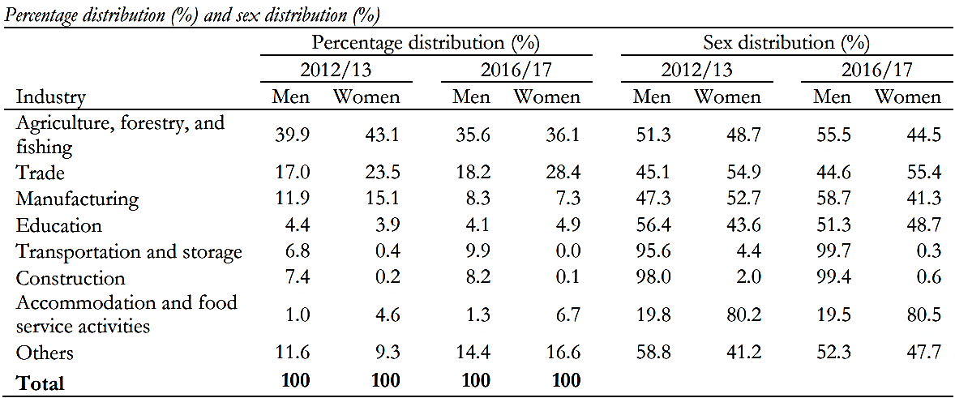
Source: UNHS Reports 2012/13-2016/17
Table 25: Bank Account Ownership by Sex of Household Heads in Families where at least One Member has a Functional Financial Account (%)
 | Male Headed | Female Headed | Total
Persons with a bank account only | 19.3 | 14.9 | 18.2
Persons with a financial account other than a bank | 2.9 | 2.4 | 2.8
Persons with both a bank account and an account from another institution | 0.8 | 0.5 | 0.7
None of the above | 77.0 | 82.3 | 78.3

Source: Equal Opportunities Commission (2017/18)

Table 26: Participation of Women in the National Economy (Formal and Informal)
Category | Percent
Labour force participation rate | 44.9
Proportion of working women in purely subsistence agriculture, forestry and fishing | 38.7
Employment to population ratio | 39.8
Status of employment
Paid employee | 26.3
Employer | 1.7
Own account worker | 57.8
contributing to family work | 14.1
Agriculture, forestry and fishing | 42.8
Production | 11.4
Service | 45.8
Occupation in the main job
Skilled Agriculture, forestry and fishing | 34.1
service and sales workers | 30.6
Elementary occupations | 14.6
Craft and related trades workers | 8.6
Plant and machine operators and assemblers | 1.8
Professionals | 6
Technicians and associate professionals | 2.4
Others | 1.9
Average daily usual hours of work on main job | 7
Median monthly cash earnings for persons in paid employment on the main job ('000) | 120
Proportion in informal employment outside agriculture | 85.6
Source: National Labour Force survey 2016/17

Annex 9: Healthcare
Figure 19: Life expectancy for Men and Women in Uganda
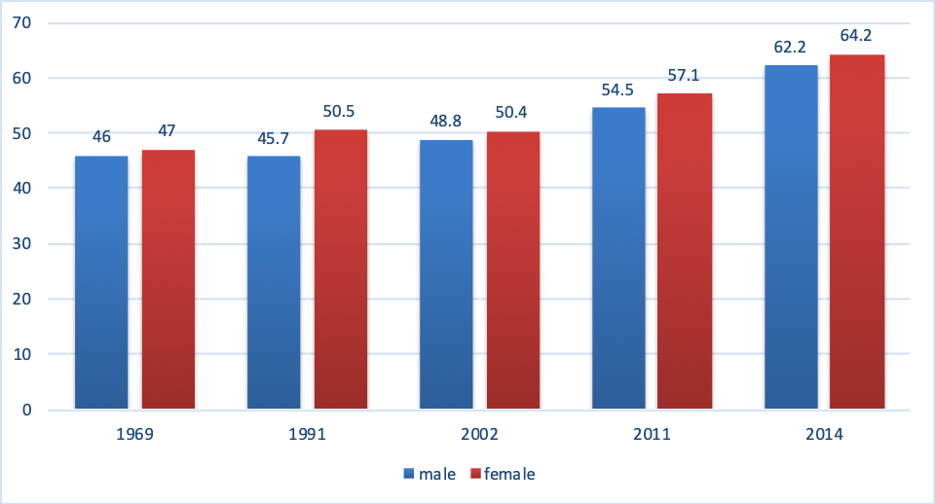
Source: Uganda National Population and Housing Census, 2014

Table 27: Life expectancy for Men and Women in Uganda
1969 |  | 1991 |  | 2002 |  | 2011 |  | 2014
Male | Female | Male | Female | Male | Female | Male | Female | Male | Female
46 | 47 | 45.7 | 50.5 | 48.8 | 50.4 | 54.5 | 57.1 | 62.2 | 64.2
Source: Uganda National Population and Housing Census, 2014

Table 28: Maternal Mortality Ratio (MMR)
UDHS | 2000/2001 | 2006 | 2011 | 2016
Maternal Mortality | 524 | 418 | 438 | 368
Source: Uganda Demographic and Health Survey, 2016

Figure 20: Antenatal care by a skilled worker, Birth occurred in a health facility and Birth attended to by skilled health provider
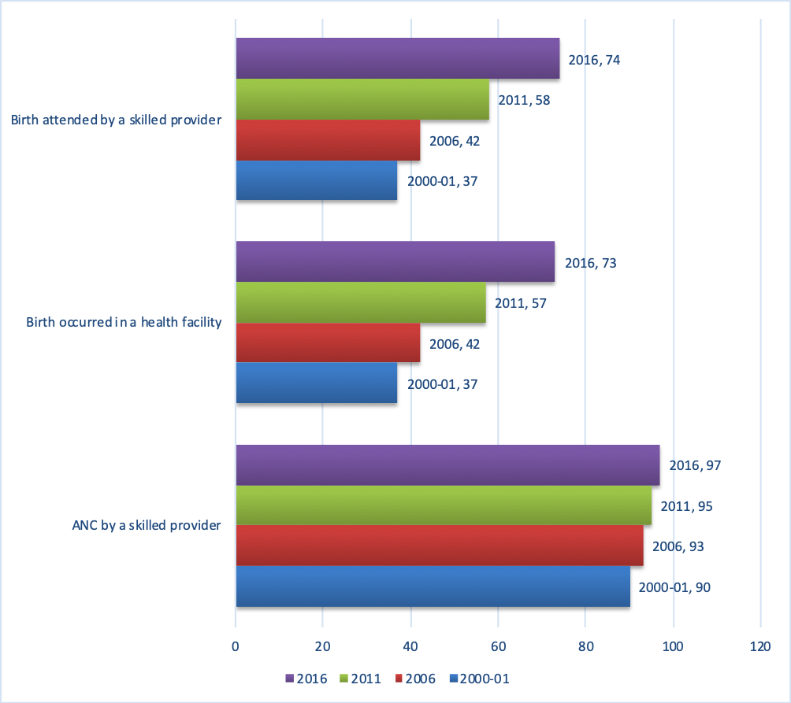
Source: Uganda Demographic and Health Surveys
Table 29: Percentage of Women aged 15-19 who Have Borne a Child, by Age
Age | Years
Age | 1995 | 2000-01 | 2006 | 2011 | 2016
15 | 7.7 | 3.3 | 1.9 | 1.6 | 1.6
16 | 22.1 | 12.9 | 8.5 | 8.5 | 5.5
17 | 43.3 | 23.2 | 23.5 | 20.8 | 15
18 | 64.7 | 54 | 41 | 37.4 | 33
19 | 70.8 | 61.2 | 58.6 | 57.6 | 45.8
Education level | Years
No Education | 48.5 | 59 | 50.2 | 44.5 | 29.8
Primary Education | 47.3 | 33.1 | 27.9 | 26.9 | 22.3
Secondary Education | 18.7 | 16.7 | 15.3 | 15.8 | 13.5
Total | 42.9 | 31.4 | 24.9 | 23.8 | 19.4
Source: (Uganda Demographic and Health Surveys)

Table 30: Percentage of Women Currently Using a Contraceptive Method
Age | Age | 15-19 | 20-24 | 25-29 | 30-34 | 35-39 | 40-44 | 45-49 | Total
Type of contraceptive method | Year | Percent Using a Contraceptive Method
Any method of FP | 1995 | 7.2 | 13 | 14.3 | 19.6 | 17.2 | 14 | 13.3 | 13.4
Any method of FP | 2000/01 | 10.4 | 22.3 | 24 | 25.1 | 24.5 | 23.1 | 13.2 | 20.1
Any method of FP | 2006 | 6.5 | 21.3 | 24.3 | 27.2 | 23.7 | 23.7 | 18.7 | 19.6
Any method of FP | 2011 | 6.8 | 22.1 | 31.6 | 33.5 | 34.5 | 32 | 17.5 | 23.6
Any method of FP | 2016 | 21.7 | 34 | 43 | 42.9 | 44.1 | 47.1 | 29 | 50.6
Any modern method of FP | 1995 | 3.4 | 6.3 | 9 | 11.5 | 10.4 | 8.6 | 5.7 | 7.4
Any modern method of FP | 2000/01 | 9 | 18.7 | 20.2 | 19.5 | 20.8 | 17.3 | 9.1 | 16.5
Any modern method of FP | 2006 | 5.2 | 17.2 | 19.7 | 22 | 18.7 | 17.2 | 13.1 | 15.4
Any modern method of FP | 2011 | 6 | 19.8 | 27.6 | 30 | 30.3 | 26.5 | 14.1 | 20.7
Any modern method of FP | 2016 | 20.7 | 31.1 | 38.7 | 38.6 | 39.5 | 40.4 | 23.4 | 47.1
Not currently using FP | 1995 | 94.8 | 82.8 | 80.3 | 78 | 81.3 | 82.8 | 86.9 | 84.6
Not currently using FP | 2000/01 | 89.6 | 77.7 | 76 | 74.9 | 75.5 | 76.9 | 86.8 | 79.9
Not currently using FP | 2006 | 93.5 | 78.7 | 75.7 | 72.8 | 76.3 | 76.3 | 81.3 | 80.4
Not currently using FP | 2011 | 93.2 | 77.9 | 68.4 | 66.5 | 65.5 | 68 | 82.5 | 76.4
Not currently using FP | 2016 | 78.9 | 66 | 57 | 57.1 | 55.9 | 52.9 | 71 | 49.4
Source: (Uganda Demographic Health Surveys, 1995-2016)

Table 31: Percentage of Pregnant Women making Antenatal Visits by Number of Visits
Number of Visits | Years
Number of Visits | 1995 | 2000-01 | 2006 | 2011
0 | 7.5 | 6.1 | 4.5 | 4.3
1 | 6.3 | 7.7 | 5.6 | 4
2—3 | 37.2 | 42.3 | 41.7 | 42.4
4+ | 47.2 | 41.9 | 47.2 | 47.6
Source: Uganda Demographic Health Surveys, 1995-2011 *The Uganda Demographic and Health Survey report, 2016 does not have the number of antenatal visits.

Figure 21: HIV Infection Rate by Gender and Residence as of 2017 (%)
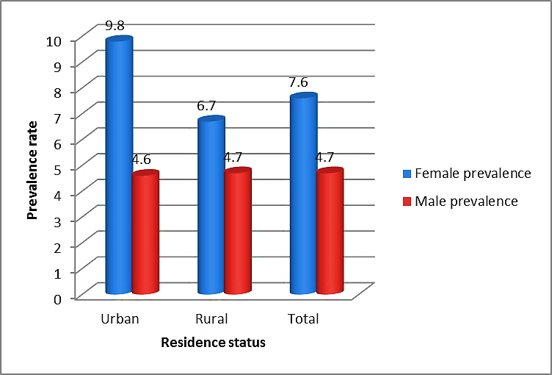
Source UPHIA 2016/17

Figure 22: HIV prevalence by Age and Sex
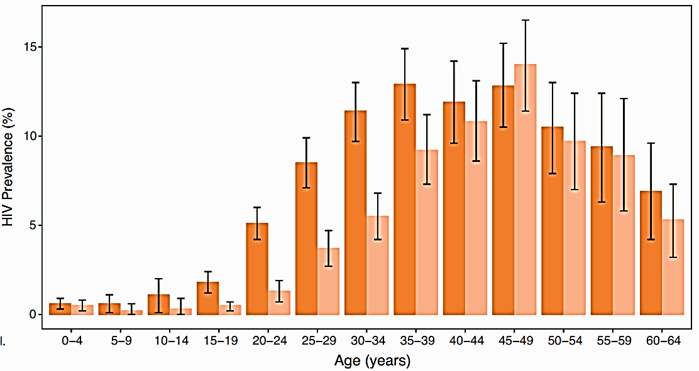
Source: UPHIA 2016/17
Figure 23: HIV Prevalence by Region
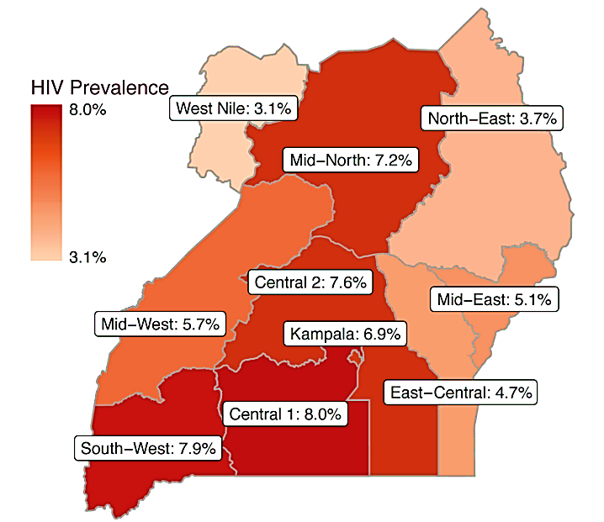
Source: UPHIA 2016/17

Annex 10: Rural Women
Figure 24: Percentage of Women Owning Land: Rural and Urban Disaggregation
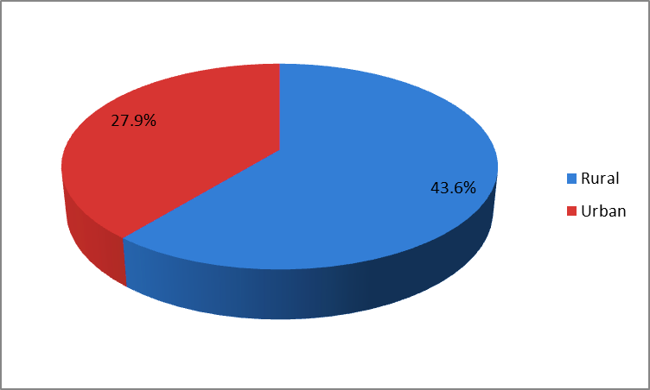
Source: UDHS 2016

Figure 25: Agricultural Land Ownership by Household Members
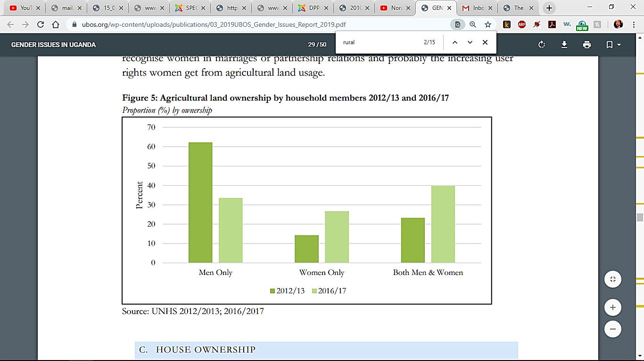
Source: UNHS Reports 2012/13-2016/17

Figure 26: Performance of the Ministry of Energy and Mineral Development in the implementation of the Local Content Policy for the FYs 2016/2017-2017/2018

Source: Equal Opportunities Commission (2017/18)
Figure 27: Proportion of Women aged 15-49 who Had Experienced SGBV from 15 years of age, by Residence (2011-2016)
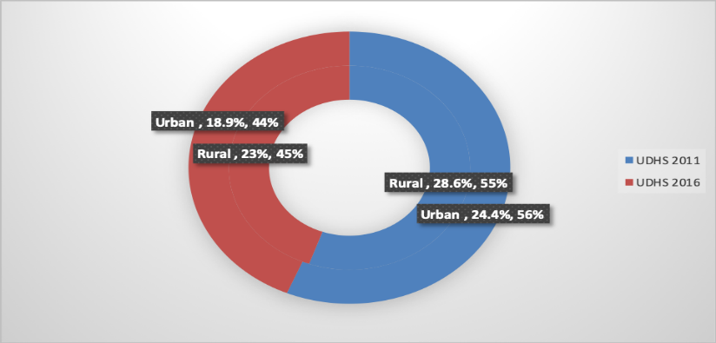
Source: UDHS 2011/16
Table 32: Head of Household by Residence
Residence | 1991 |  | 2002 |  | 2005/06 |  | 2009/2010 |  | 2012/13 |  | 2016/17
Residence | F | M | F | M | F | M | F | M | F | M | F | M
Rural | 28 | 72 | 22.3 | 77.7 | 26.4 | 73.6 | 29.1 | 70.9 | 29.8 | 70.2 | 29.6 | 70.4
Urban | 33 | 67 | 27.8 | 72.2 | 29.3 | 70.7 | 34.2 | 65.5 | 34.5 | 65.2 | 32.5 | 67.5
Uganda | 29 | 71 | 23.1 | 76.9 | 26.9 | 73.1 | 31 | 69.9 | 31.1 | 69 | 30.5 | 69.5
Source: (Census Report 1991, 2002; UNHS 2005/06, 2009/10, 2012/13, 2016/17)

Figure 28: Head of Household by Residence
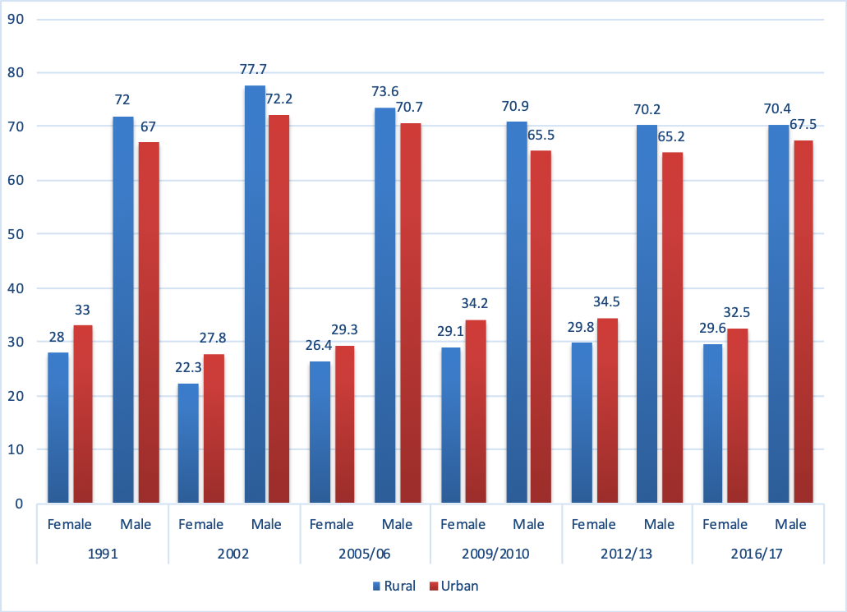

Table 33: Head of Household by Age, Sex and Year
Age | 1997 |  | 2002/03 |  | 2005/06 |  | 2009/10 |  | 2012/13 |  | 2016
Age | F | M | F | M | F | M | F | M | F | M | F | M
<18 | 0.5 | 0.4 | 0.6 | 0.3 | 0.5 | 0.3 | 0.4 | 0.4 | 0.4 | 0.5 | 0.4 | 0.3
18-25 | 11 | 17.7 | 12.7 | 16.3 | 9.2 | 13.1 | 12.1 | 14.4 | 7.5 | 9.5 | 7.7 | 10.4
26-49 | 52.1 | 57.8 | 59.3 | 62.9 | 50.3 | 62.6 | 51.9 | 62.4 | 21.1 | 30.4 | 31 | 22.4
50+ | 36.4 | 24.2 | 27 | 20.5 | 40 | 24 | 35.6 | 22.9 | 29.2 | 19.1 | 29.6 | 16.1
Source: (UNHS 2002/03, 2005/06, 2009/10, 2016/17)

Figure 29: Head of Household by Age, Sex and Year
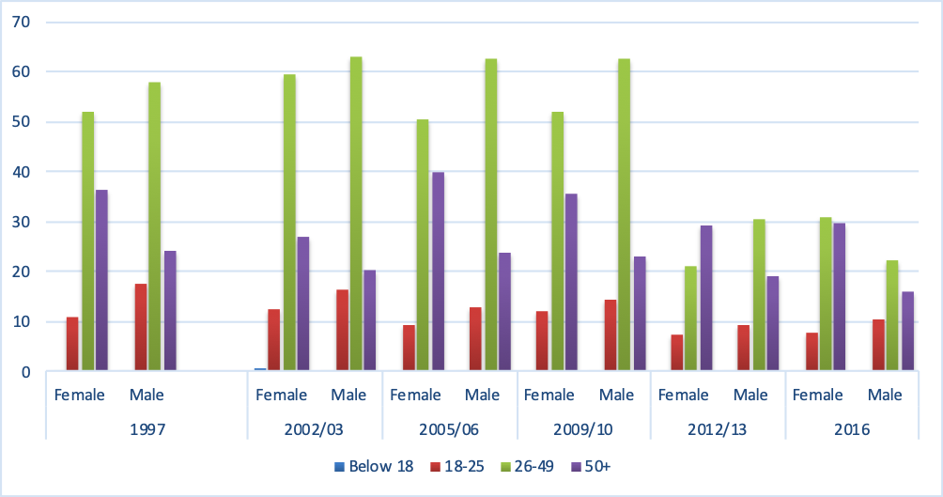

Table 34: Poverty by Region and Sex
Poverty Estimates
 | 2005/06 | 2009/10 | 2012/13 | 2016/17
Uganda | 31.1 | 24.5 | 19.7 | 27.0
Rural | 34.2 | 27.2 | 22.8 | 30.8
Urban | 13.7 | 9.1 | 9.8 | 15.2
Region
Central | 16.4 | 10.7 | 4.7 | 22.7
East | 35.9 | 24.3 | 24.5 | 42.7
Northern | 60.7 | 46.2 | 43.7 | 30.6
West | 20.5 | 21.8 | 8.7 | 19.1
Source: Uganda bureau of statistics (statistical abstract 2017); UNHS (2016/17)

Table 35: Average Time Spent on Unpaid Care Work per day by Age Group, Marital Status, Education and Employment (hours)
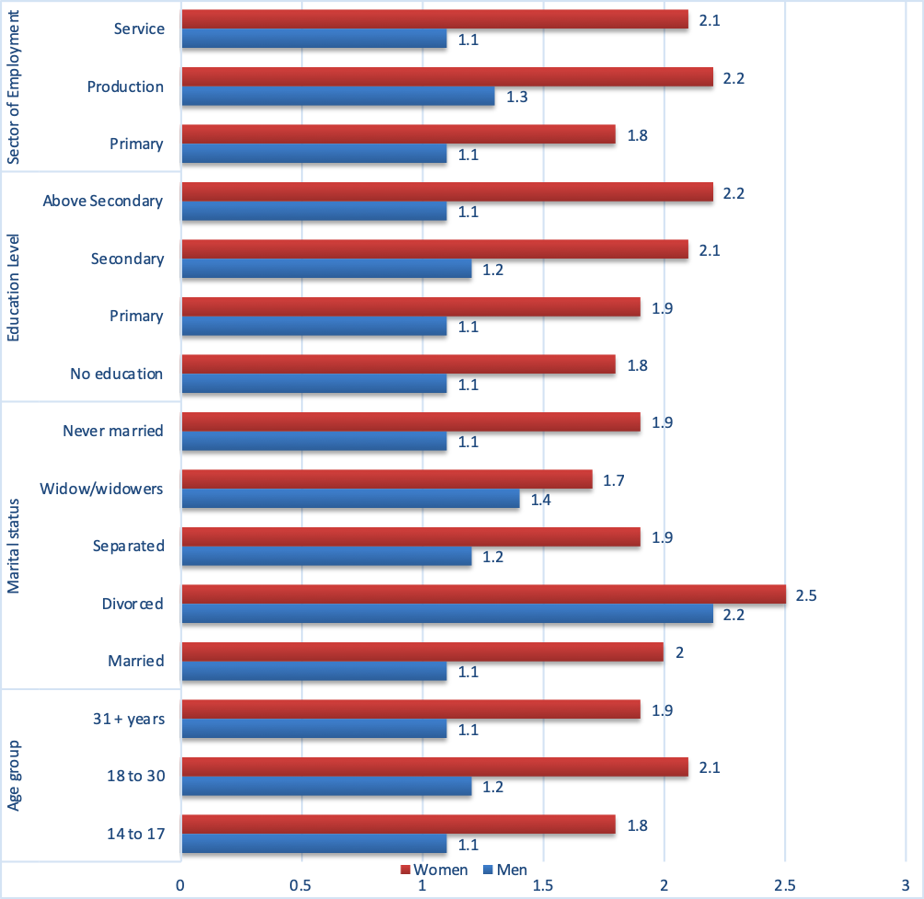
Source: Time Use Survey (2017/18)

Annex 11: Equality before the Law
Table 36: Disability Type by Sex and Region
Region/Residence | Male | Female | Both
Urban | 7.8 | 10.2 | 9.1
Rural | 12 | 14.9 | 13.5
Kampala | 5.5 | 7.1 | 6.3
Central1 | 7.6 | 10 | 8.9
Central2 | 10.6 | 13.7 | 12.2
Busoga | 10.6 | 14.1 | 12.4
Bukedi | 12 | 14.5 | 13.3
Elgon | 14.6 | 17.1 | 15.9
Teso | 13.7 | 16.5 | 15.1
West Nile | 11.2 | 13.1 | 12.2
Acholi | 14.3 | 17.5 | 15.9
Lango | 16.7 | 20.1 | 18.4
Karamoja | 8.3 | 10.2 | 9.3
Toro | 10.4 | 13 | 11.7
Ankole | 10.2 | 13 | 11.6
Bunyoro | 11.7 | 14 | 12.9
Kigezi | 11.1 | 15.3 | 13.4
Total | 11 | 13.7 | 12.4
Source: Gender Dimensions Monograph (2017) / National Population and Housing Census 2014

Table 37: Distribution of Persons with Disabilities by Age and Sex
Age | With no disability |  |  | With disability
Age | Males | Females | Total | Males | Females | Total
2-17 | 94 | 94.4 | 94.2 | 6 | 5.6 | 5.8
18-30 | 92.1 | 90.9 | 91.4 | 7.9 | 9.1 | 8.6
31-62 | 97.2 | 98.8 | 85.4 | 12.8 | 16.2 | 14.6
65+ | 38.7 | 30.6 | 34 | 61.3 | 69.4 | 66
Source: Gender Dimensions Monograph (2017) / National Population and Housing Census 2014

Annex 12: Capacity Building and SDGs
Table 38: Gender Capacity Gaps and Needs in the Production of Gender Statistics
Position | Gender capacity Gaps | Gender Capacity Needs
Position | Gender capacity Gaps | Training | Exposure tour | Technical Assistance
Senior staff in MDAs, HLGs, and Private sector | Limited experience in the understanding of the gender issues  Limited skills in interpretation of gender statistics | Training on gender mainstreaming, identification of gender issues and interpretation data | Visit to institutions with best practices in production and reporting gender statistics | Trainers to provide hands on support at the beneficiary place of work or another convenient venue.
Media and key data users | Limited skills in gender concepts, identification of gender issues, interpretation of data and reporting | Training in gender concepts mainstreaming, planning, budgeting, interpretation of data and reporting/ communication | Visit to UBOS and MGLSD | Organise sensitisation sessions and short-term trainings for key stakeholders
Planners in MDAs and HLGs | Limited skills in gender concepts, mainstreaming, planning, budgeting, data analysis, data interpretation and reporting | Training in gender concepts mainstreaming, planning, budgeting, data interpretation, and reporting,  Equipping the planners with specific gender communication skills | Visit to UBOS and MGLSD | Trainers provide hands on training for understanding of the gender concepts and production of gender data.
Staff involved in the production and utilisation of gender statistics | Limited skills in gender concepts, gender sensitive data collection, analysis and reporting | Training in gender concept, design of gender responsive data collection tools, gender data analysis, reporting and communication | Exposure visits to institutions with best practices in gender statistics production and dissemination | Organise short-term trainings
Source: Capacity Building Programme for Gender Statistics in the National Statistical System (2018/19-2022/23)

