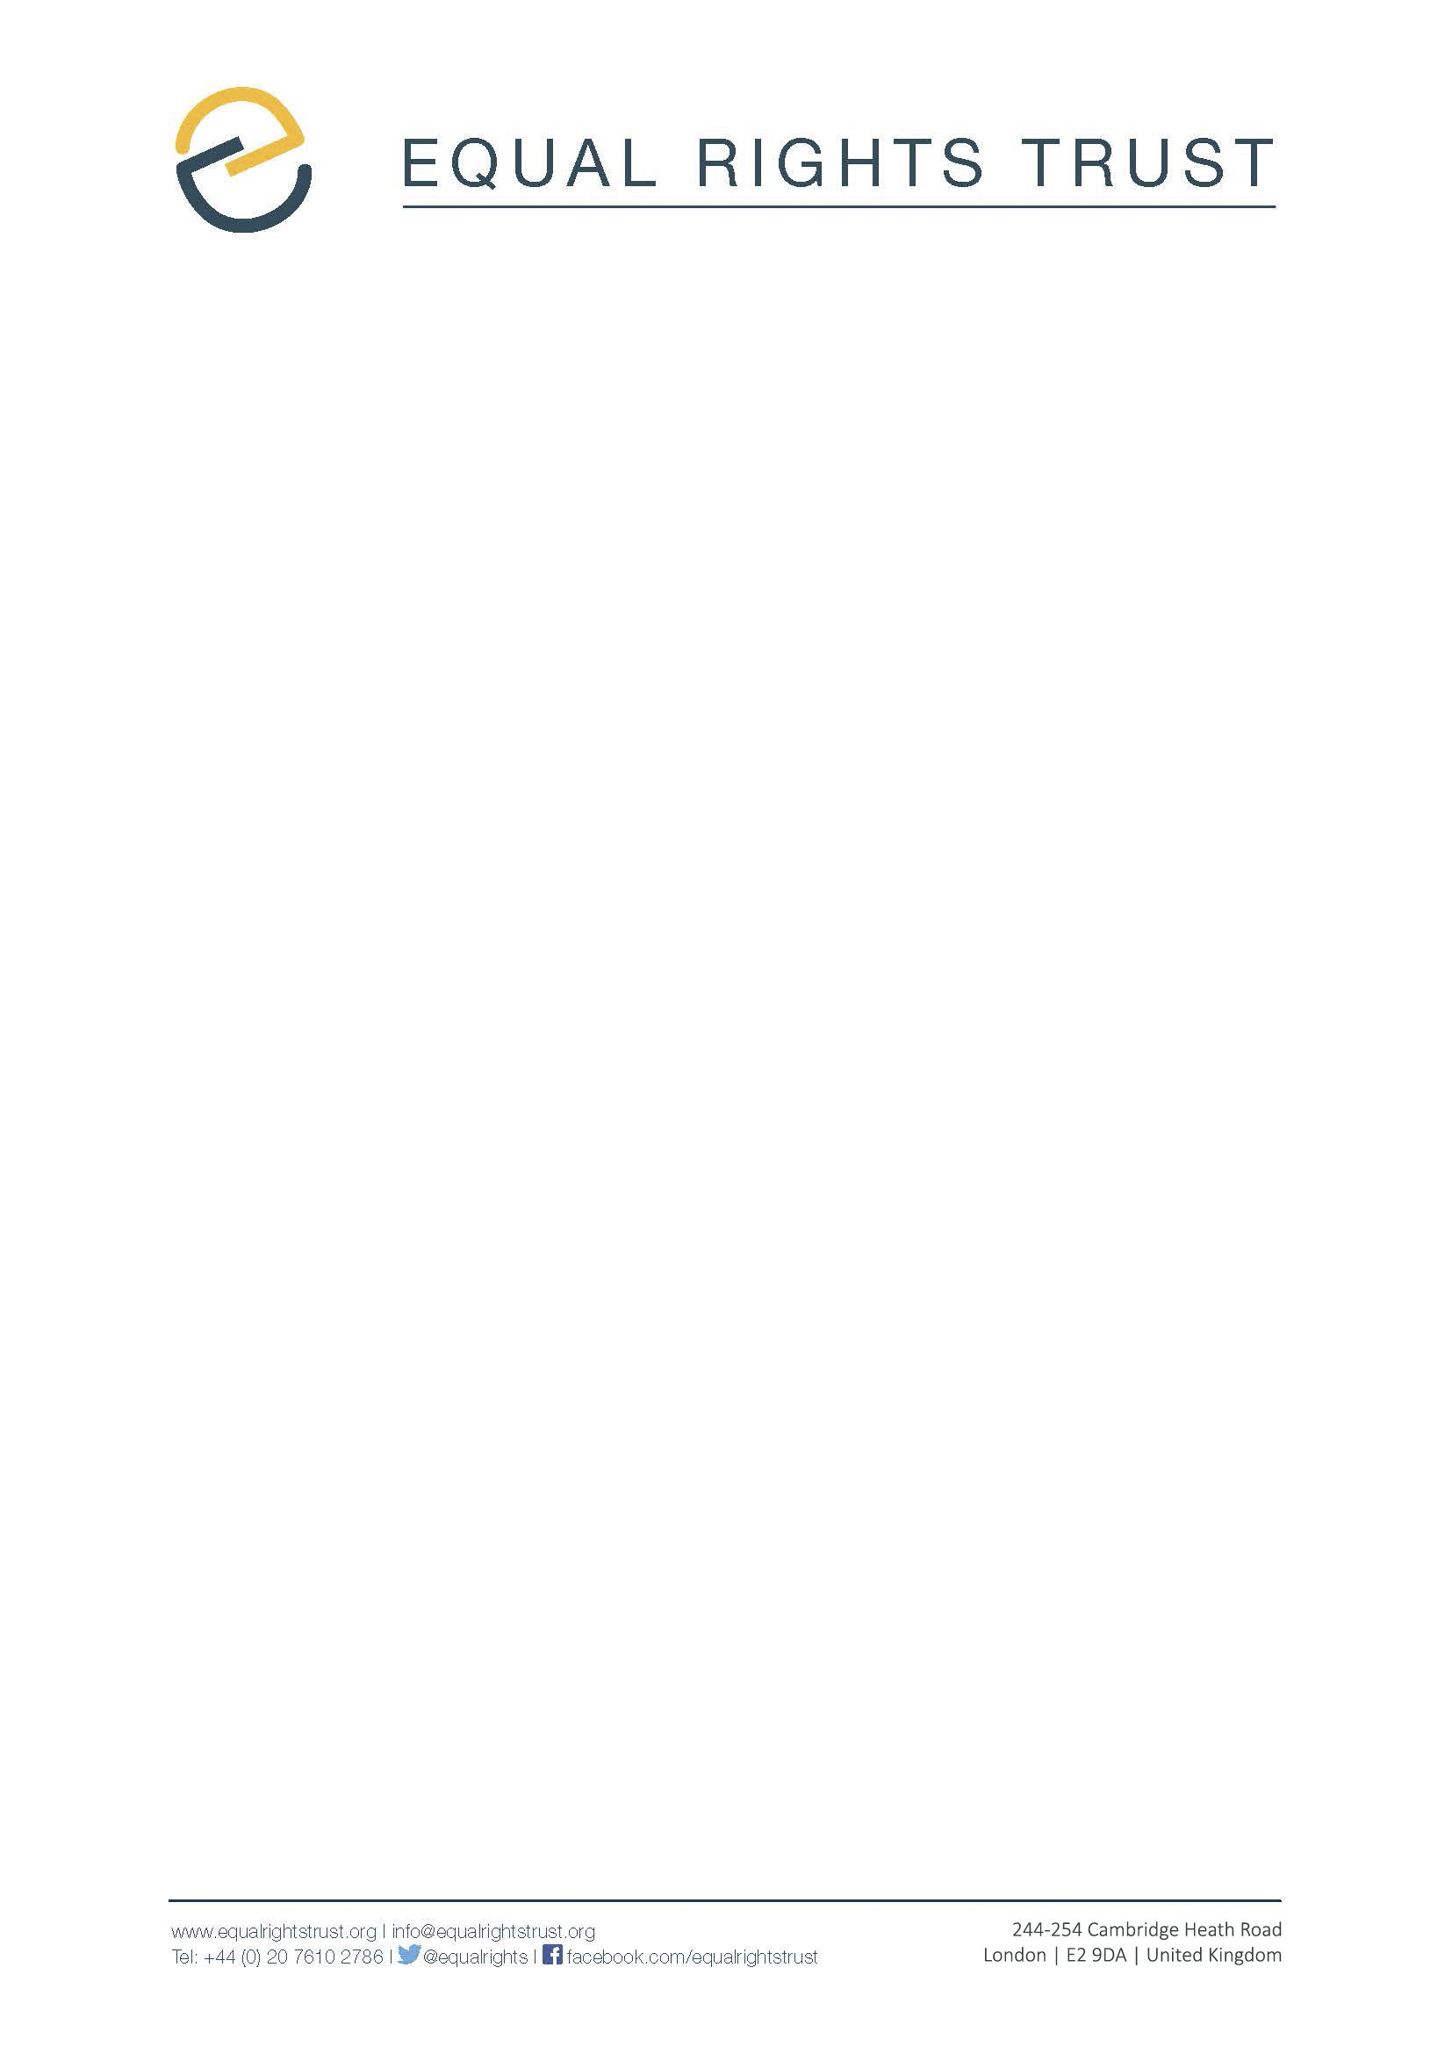

Submission to the 72nd session of the Committee on the Elimination of All Forms of Discrimination against Women in relation to the fourth periodic report of

Serbia
January 2019

Introduction
- The Equal Rights Trust (the Trust) makes this submission to the 72nd session of the Committee on the Elimination of Discrimination against Women (the Committee) in advance of its consideration of the fourth periodic report submitted by the Republic of Serbia (Serbia) on implementation of the Convention on the Elimination of All Forms of Discrimination against Women (the Convention).

- The Trust is an independent international organisation whose mission is to eliminate discrimination and ensure that everyone can participate in society on an equal basis. Over the course of the last decade, we have worked in partnership with civil society in more than 40 different countries, supporting efforts to secure the adoption and implementation of comprehensive equality laws. The Trust has been involved in supporting efforts to combat discrimination in Serbia since 2014. We are currently working in Serbia with two partners, the Association of Citizens Praxis, and the Sandzak Committee for Protection of Human Rights and Freedoms on a project that seeks to improve the effective implementation and enforcement of Serbia’s legal and policy framework on equality.

Forthcoming Study

- The present submission has been drafted on the basis of the forthcoming study, "Equality in Practice: Implementing Serbia's Equality Laws." The study has been prepared by the Trust and two expert consultants: Professor Nevena Petrušić, the inaugural Commissioner for the Protection of Equality in Serbia (2010-2015) and Professor of Law; and Ms Kosana Beker, Assistant to the Commissioner for the Protection of Equality in Serbia (2010-2016) and equality law academic. The Study forms part of a two-year project between the authors that seeks to increase protection from all forms of discrimination in Serbia through legal and policy reform.

- The study is based on extensive desk-based research; field research, conducted by five CSOs in multiple regions of Serbia; five focus group discussions, and 57 one-to-one interviews with a wide range of stakeholders, including the current Commissioner for the Protection of Equality, the director of the Office for Human and Minority Rights, public authority representatives, private sector representatives, and legal experts in the field of human rights and equality. The study was subject to an extensive validation process, which included a two-day validation conference held in Serbia in June 2018 where a Working Group comprising senior civil society representatives and representatives of marginalised groups interrogated the study's findings and collaboratively formulated its recommendations. Feedback received through this validation process and thereafter has since been incorporated into the study.

List of Issues

- As the Committee will be aware, in June 2018 the Trust submitted suggested questions for adoption by the Committee at its pre-sessional working group. That submission focused on four areas of concern regarding Serbia’s compliance with its obligations under Article 2 of the Convention: (a) public awareness of equality laws; (b) access to justice; (c) availability of timely and effective remedies; and (d) enforcement of equality laws by independent and competent bodies.

- The Trust welcomes the fact that, in its list of issues and questions, the Committee highlighted several concerns outlined in our initial submission. In particular, the Trust is grateful for the Committee’s questions on access to justice, and the effectiveness and independence of the Protector of Citizens (Ombudsman). In light of the Committee’s comments, and the state party’s response, the Trust has chosen to focus this submission on (i) key aspects of Serbia’s performance under Article 2 of the Convention and (ii) the specific issue of legal aid provision, which represents one of the primary barriers to securing access to justice for women experiencing discrimination within the state.

Serbia’s Performance Under Article 2 of the Convention

- As the Committee is aware, under Article 2 of the Convention, states parties agree to “condemn discrimination” and pursue a “policy of eliminating discrimination against women” using all appropriate means. To this end, they undertake to, inter alia, prohibit discrimination against women through legislation; guarantee the equal rights of women and ensure their effective protection through national tribunals; and take all appropriate measures to eliminate discrimination against women.

- According to the Committee, “Article 2 is crucial to the full implementation of the Convention” and the obligations under Article 2 are “inextricably linked with all other substantive provisions of the Convention.” As the Committee has recognised, the realisation of women’s rights under the Convention can only be achieved when there is a strong and effectively implemented legal framework to eliminate discrimination and enshrine equality between men and women. However, research undertaken by the Trust indicates that whilst Serbia has in place a strong system of equality legislation, the right to equality is undermined in practice by specific gaps in legal mechanisms and inadequate enforcement measures.

- The study makes several findings, which are of relevance to the Committee and the protection of rights to equality and non-discrimination as guaranteed by the Convention. Issues including, inter alia, poor accessibility to physical infrastructure; the non-availability of structural remedies in discrimination cases; limited Ombudsman enforcement powers; the judicial mis-application of equality laws; excessive court delays; and public mistrust in the judiciary, combine to undermine the enjoyment of the rights to equality and non-discrimination in practice.

Recommendation 1

Serbia’s legal and policy framework in practice is hampered by a number of factors including: (a) limited awareness of equality laws amongst both rights-holders and duty-bearers; (b) economic and physical barriers to access to justice; and (c) a lack of public confidence in the court system as an efficient and independent mechanism for redress.

The Authors urge the state party to adopt measures to address these barriers and ensure effective protection of the rights to equality and non-discrimination in practice.

Access to Justice and Legal Aid

- The availability and adequate provision of legal aid forms an important part of access to justice, which the Committee has recognised “is essential to the realisation” of Convention guarantees. In its General Recommendation No. 33, the Committee noted that there are six interrelated and essential components necessary to ensure access to justice: “justiciability, availability, accessibility, good quality, provision of remedies for victims and accountability of justice systems.” In order to ensure that justice systems are accessible to women, the Committee has recommended that states “remove economic barriers to justice by providing legal aid.” In particular:

States parties must ensure that women can invoke the principle of equality in support of complaints of acts of discrimination contrary to the Convention, committed by public officials or by private actors. States parties must further ensure that women have recourse to affordable, accessible and timely remedies, with legal aid and assistance as necessary, to be determined in a fair hearing by a competent and independent court or tribunal where appropriate.

- The comments and recommendations of the Committee in this respect, reflect prevailing understanding in international human rights law, and best practice.

- Despite making considerable progress in recent years in ensuring legislative protection from discrimination, Serbia has failed to ensure the effectiveness and enforceability of its national equality legislation. As discussed below, high court costs and a lack of access to legal aid impede women’s access to justice and the full enjoyment of Convention guarantees. Whilst, as acknowledged in the State’s response to the Committee’s list of issues, a legal aid law was drafted, as we set out below the law – which has subsequently been adopted – does not enjoy the broad support of civil society and does not fully discharge the state of its duties under Article 2.

The Law on Free Legal Aid

- For several years, Serbian civil society has advocated for the adoption of a legal aid law. A first draft bill (the “Bill on Free Legal Aid”) was presented to Parliament in 2011. At its 41st Session in March 2018, the Bill was publicly debated and the text harmonised. At its 42nd Session, held in November 2018, the Committee on the Judiciary, Public Administration and Local Self-Government considered a further 63 amendments, just one of which, was accepted. The final Law was adopted on 9 November, and entered into the Official Gazette four days later, although implementation has been delayed until 1 October 2019. Unfortunately, the Law suffers from defects that undermine its effectiveness in practice, and in some respects, may actually reduce the already limited access to justice for survivors of discrimination.

- Under Article 4 of the Law, legal aid is to be made available to all citizens, stateless persons, foreigners with permanent residence in the Republic of Serbia, and any other person entitled to legal aid under any other law or international treaty, who meets the conditions for financial social assistance under the Law on Social Protection, or child allowance under the Law on Financial Support to Families with Children. Individuals who fail to meet the conditions for financial social assistance or child benefit, may nevertheless qualify for legal aid, provided that they fall into one of thirteen categories of cases further detailed under Article 4. This includes, for instance, individuals seeking protection from domestic violence, persons seeking asylum, and persons seeking protection from forms of torture, inhuman or degrading treatment or punishment.

- Individuals who do not meet the financial eligibility criteria and fall outside of the narrow category of cases provided for via Article 4, will not qualify for legal aid under the Law. This includes, with some narrow exceptions, individuals challenging acts of discrimination. The rate at which eligibility for financial social assistance and child benefit is established is set at very low levels, effectively extending only to individuals in situations of extreme poverty. By contrast, the cost of civil litigation in Serbia, can run into thousands of Euros.

Legal and Court Fees Applicable in Discrimination Proceedings

A plaintiff seeks a finding of discrimination against a medical practice in relation to the refusal to provide health services on the ground of sexual orientation, and compensation for damages in the amount of EUR 3,000. The approximate costs of such a proceeding could amount to more than EUR 1,000, as follows:

- Drafting of lawsuit: EUR 50;
- Court fee for filing a lawsuit: EUR 150;
- Legal representation for at least three hearings, according to the Advocate’s Tariff: EUR 180 (EUR 60 per hearing);
- Fee paid to expert for assessment of damages: EUR 500;
- Court fee for decision: EUR 150.

- As noted by the Committee in its List of Issues, a new draft Law on Gender Equality has been drafted by the state. The law has already undergone several rounds of review and was recently submitted for comments to the European Commission. Unfortunately, although the law reportedly includes an Article on the provision of legal aid, the ambit and scope of this provision is unknown. According to the most recently published version, the law only provides for legal assistance to victims of violence, “in accordance with law”. Little is known about the potential adoption date of the law, and irrespective of the final draft, it is clear that it will only extend to instances of gender discrimination. Women who suffer from other forms of discrimination would still lack access to legal aid, which for reasons of clarity and accessibility, ought to be provided under a comprehensive legal aid law. Accordingly, it is the Trust’s submission that the draft Law of Gender Equality will not, even if passed, fully discharge the state’s obligation to ensure access to justice through legal aid provision in cases of all forms of discrimination women face. In any event, the draft’s future remains unclear.

- At present, none of Serbia’s three major pieces of equality legislation establish a right for victims of discrimination to free (or reduced cost) legal assistance. Although the Law on Civil Procedure permits the court to appoint a free legal representative where necessary for the protection of an individual’s rights, legal representatives will only be appointed where the conditions of Article 168 of the Law are met; i.e. where the court decides to exempt a party from paying the cost of proceedings due to their inability to pay. Research conducted by the Trust indicates that judges apply Article 168 inconsistently, in some cases precluding the appointment of legal representation, thereby limiting access to justice for victims of discrimination.

- Due to the shortcomings of the Law on Free Legal Aid, lengthy court procedures, and a lack of awareness regarding existing legal mechanisms for the waiver of court fees, victims of discrimination in Serbia, including women, are denied access to justice and the full realisation of Convention rights in violation of the state’s obligations under Article 2.

Recommendation 2:

The Trust is concerned that a lack of legal aid for victims of discrimination in Serbia impedes access to justice. In order to fulfil its obligations under the Convention, marginalised groups, including women, must have access to legal assistance to challenge violations of the rights to equality and non-discrimination. Eligibility criteria, including any financial means test, must be set at an appropriate level, to ensure that all groups in need of assistance have access to it, and are able to vindicate their rights in the courtroom.

In light of the Committee’s General Recommendation No. 33 (2015) on Women’s Access to Justice, the Trust recommends that Serbia amends the Law on Free Legal Aid, to ensure that all disadvantaged groups, including women, have access to legal assistance to challenge acts of discrimination, consistent with Article 2 of the CEDAW.

- The Trust would like to express our gratitude to the Committee for the opportunity to make this submission. We attach as an Annex an advanced copy of the study – which will be publicly launched on 12 February 2019 in Belgrade – for the Committee’s benefit and look forward to continuing to support the Committee as it assesses Serbia’s compliance with its obligations under the Convention.

Equal Rights Trust, Submission to the Pre-Sessional Working Group for the 72nd Session of the Committee on the Elimination of All Forms of Discrimination against Women in Relation to the Fourth Periodic Report of Serbia, June 2018.
Committee on the Elimination of Discrimination against Women, List of Issues and Questions in Relation to the Fourth Periodic Report of Serbia, UN Doc. CEDAW/C/SRB/Q/4, 3 August 2018.
Ibid., Para 3.
Ibid., Para 4.
Committee on the Elimination of Discrimination against Women, List of Issues and Questions in Relation to the Fourth Periodic Report of Serbia: Addendum, UN Doc. CEDAW/C/SRB/Q/4/Add.1, 29 November 2018, Paras 4-8.
United Nations Committee on the Elimination of Discrimination against Women (CEDAW), General Recommendation No. 28 on the Core Obligations of States Parties Under Article 2, UN Doc. CEDAW/C/GC/28, 2010, Para 6.
Equal Rights Trust, Equality in Practice: Implementing Serbia's Equality Laws, Forthcoming, p. 92.
Ibid., p. 96.
Ibid., p. 97.
Ibid., p. 104.
Ibid., p. 101.
Ibid., p. 102.
Ibid., Section 3.
CEDAW, General Recommendation No. 33 on Women’s Access to Justice, UN Doc. CEDAW/C/GC/33, 2015, Para 1.
Ibid., Para 14.
Ibid., Para 17(a). The Committee has further recognised that “the provision of free or low-cost legal aid” represents “a crucial element in guaranteeing that justice systems are economically accessible to women.” See Ibid., Para 36.
Ibid., Para 34.
See, for instance, the most recent General Comment of the Committee on the Rights of Persons With Disabilities, which recognises states obligations to provide legal aid in discrimination cases. Committee on the Rights of Persons With Disabilities, General Comment No. 6: Equality and Non-Discrimination, UN Doc. CRPD/C/GC/6, 2018, Paras 31(g) and 49(c).
Declaration of Principles on Equality, Equal Rights Trust, London, 2008, Principle 18.
Equal Rights Trust, Equality in Practice: Implementing Serbia's Equality Laws, Forthcoming, Section 2.
Committee on the Elimination of Discrimination against Women, Reply to List of Issues: Serbia, UN Doc. CEDAW/C/SRB/Q/4/Add.1, 29 November 2018, Paras 4-8.
Equal Rights Trust, Equality in Practice: Implementing Serbia's Equality Laws, Forthcoming, p. 90.
Ibid., pp. 90-91.
An amendment to Article 28 of the Law. See National Assembly of the Republic of Serbia, “42nd Sitting of the Committee on the Judiciary, Public Administration and Local Self-Government”, NARS, 6 November 2018, available at: http://www.parlament.gov.rs/42nd_Sitting_of_the_Committee_on_the_Judiciary,_Public_Administration_and_Local_Self-Government.35178.537.html.
The Law on Free Legal Aid, “Official Gazette of the Republic of Serbia”, No. 87/2018.
Law on Social Protection, “Official Gazette of the Republic of Serbia”, No. 24/2011.
Law on Financial Support to Families with Children, “Official Gazette of the Republic of Serbia”, No. 113/2017 and 50/2018.
The Law on Free Legal Aid, “Official Gazette of the Republic of Serbia”, No. 87/2018, Article 4(4-6).
For instance, individuals seeking protection from acts of gender-based violence. Ibid., Article 4(4).
Under the Law on Social Protection, for instance, an individual will only qualify for financial assistance where their income from assets or from other sources earns revenue less than the base-rate of 8,283 dinars (approximately EUR 70), as harmonised with biannual consumer index prices (data for 2018, published in “Official Gazette of the Republic of Serbia”, No. 31/2018).
Equal Rights Trust, Equality in Practice: Implementing Serbia's Equality Laws, Forthcoming, pp. 91-92.
Draft Law on Gender Equality, 14 June 2018, available at: https://www.minrzs.gov.rs/sites/default/files/2018-11/2._nacrt_zakona_o_rodnoj_ravnopravnosti_14.06.2018..pdf.
A term which is in itself extremely unclear. See Ibid., Articles 47 and 48.
Respectively, the Law on the Prohibition on Discrimination (LPD), “Official Gazette of the Republic of Serbia”, No. 22/2009; the Law on the Prevention Discrimination against Persons with Disabilities (LPDPD), “Official Gazette of the Republic of Serbia”, Nos. 33/2006 and 13/2016; and the Law on Equality Between the Sexes, also known as the Law on Gender Equality (LGE), “Official Gazette of the Republic of Serbia”, No. 104/2009.
Law on Civil Procedure, “Official Gazette of the Republic of Serbia”, Nos. 125/04 and 111/2009, Article 170, Para 1.
Ibid., Article 168.
Equal Rights Trust, Equality in Practice: Implementing Serbia's Equality Laws, Forthcoming, p. 92.
Ibid.

