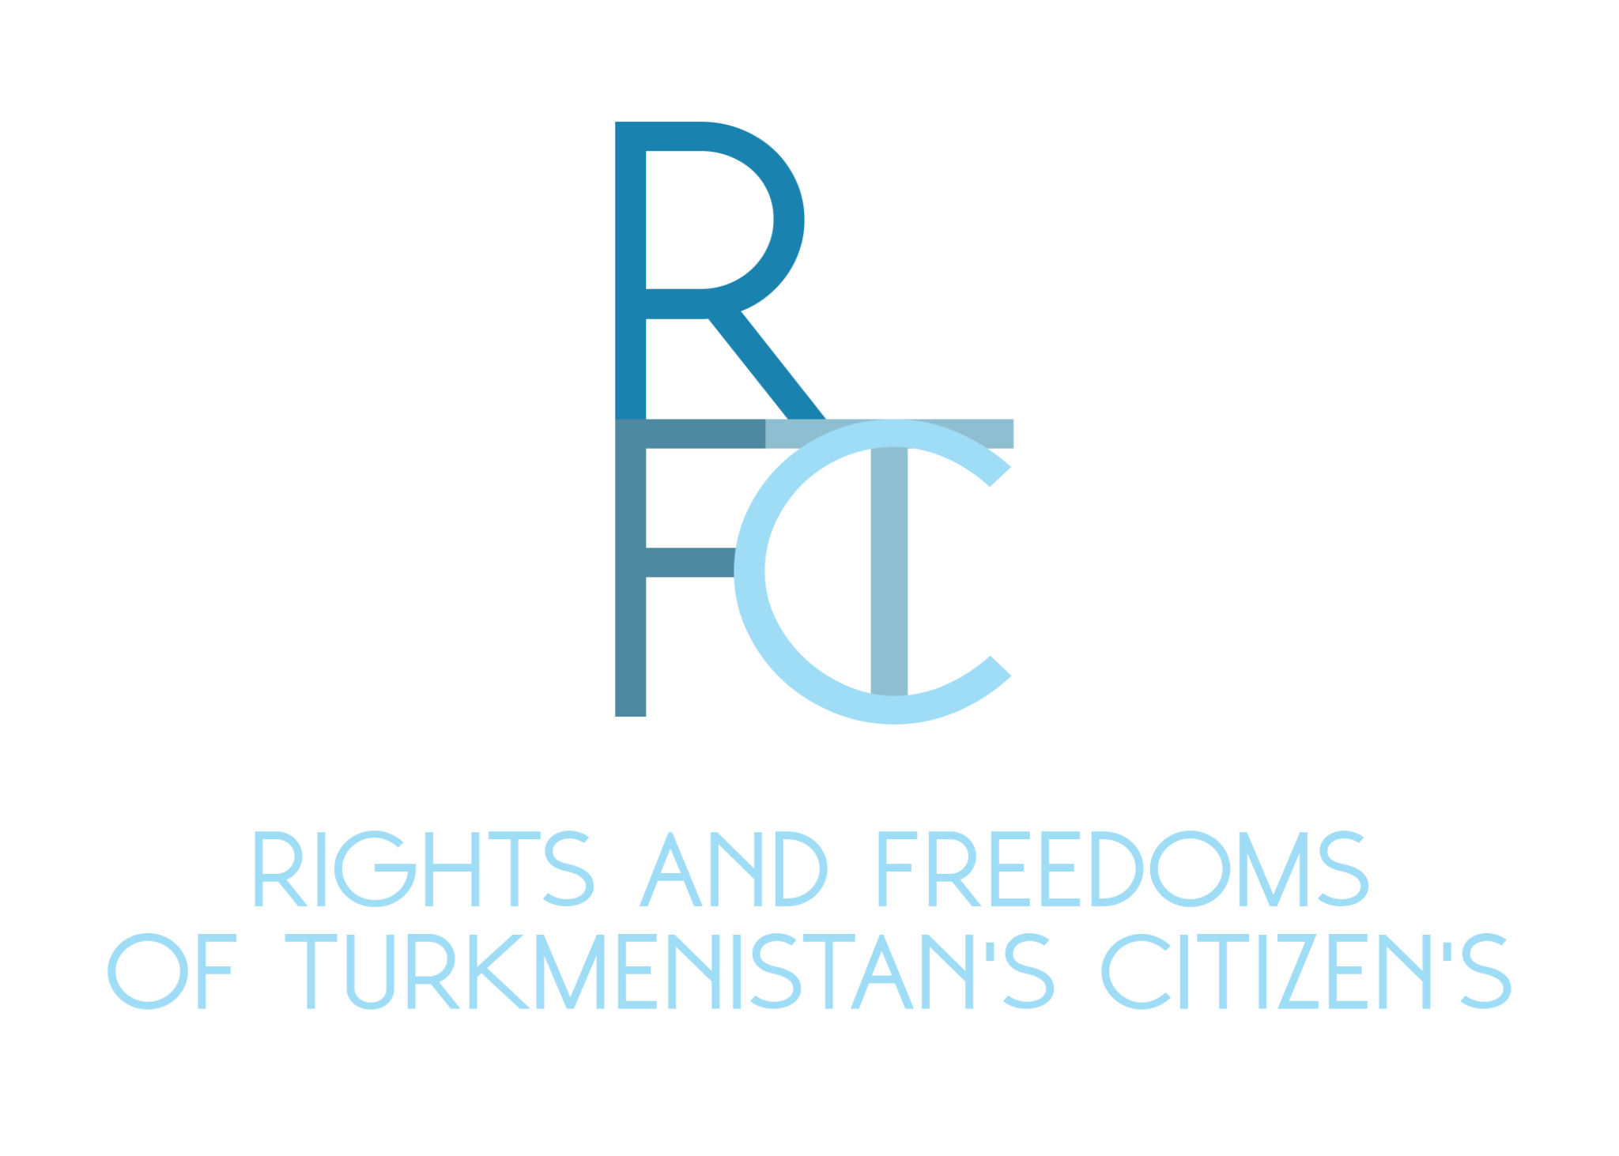

About the Organization:
"Rights and Freedoms of Turkmen Citizens," established in 2016 in Prague, Czech Republic, is devoted to addressing human rights violations, including a strong focus on women's rights and discrimination. Our organization, having achieved Special Consultative Status with the UN ECOSOC in 2021, employs a meticulous verification process for information from Turkmenistan. This involves collaboration with three reliable stringers in the country, who engage directly with affected individuals and families, especially those with imprisoned relatives. The information is collected through voice recordings or written notes and undergoes rigorous verification to ensure accuracy and reliability before we publish it.
Ensuring Women's Rights in Marital and Family Relationships:
As per Article 14 of Turkmenistan's Family Code, the state guarantees equal rights for men and women in forming a family. However, challenges exist, particularly for women desiring to marry foreign nationals, as the state creates obstacles. Polygamy, while practiced, results in typically one official marriage. In divorce cases, whether official or unofficial, the woman and her children often retain the family home, with the man providing financial support. Marriages in Turkmenistan, often based on kinship, both close and distant, make official divorces complex and sometimes unattainable despite mutual desire. There are instances of forced divorces, especially when a spouse is not of Turkmen nationality, reflecting a deep-seated issue within the societal and legal framework.
Gender Discrimination:
Article 26 of Turkmenistan's law guarantees protection of women's rights based on gender. However, discrimination persists, as evidenced by forced gynecological examinations conducted by police and special services on young girls to determine the presence of the hymen. Additionally, women who drive face significant discrimination. According to an unofficial directive from the country's leadership, women are hindered in obtaining or renewing their driver's licenses. Police officers have justified this by stating that women should not drive. From 2019 to 2021, women drivers were consistently refused jobs as taxi or public transport drivers, highlighting a systemic issue of gender discrimination in various aspects of daily life.
Discrimination in Government Participation and Appearance:
While Article 16 of the Law of Turkmenistan ensures women the right to participate in government, the reality is quite different. Turkmen women do occupy some leadership positions, but these roles are often merely symbolic, lacking any real decision-making power. Additionally, recent restrictions on appearance have been imposed on women working in budgetary organizations. They are required to adhere to a strict dress code, wearing only national clothes, covering their heads with scarves, and under their dresses, they must wear balaks (Turkmen national pants). Restrictions also extend to personal grooming, where women are prohibited from coloring their hair in light colors, undergoing nail extensions, or using bright nail coverings. This reflects a broader issue of control and suppression of women's freedom of expression and personal choices within the country.
Discrimination Based on National Identity:
Article 3 of the Law of Turkmenistan purports to ensure equal rights for women regardless of nationality. However, in practice, women with non-Turkmen surnames face significant discrimination. This is evident in the near absence of non-Turkmen women in government and leadership positions within budget organizations. Such systemic discrimination highlights the challenges faced by minority women in accessing equal opportunities and representation in public life.
Discrimination in Correctional Facilities:
In Turkmenistan's correctional facilities, female prisoners face severe persecution. They are often forced into sexual relations with the heads of the facilities and other officers. In addition to this exploitation, female prisoners do not have access to proper medical help. They are subjected to torture by prison officers and face extremely poor living conditions. During the COVID-19 pandemic, the situation worsened significantly due to the complete lack of treatment and oxygen, leading to numerous deaths among female prisoners. In cases where inmates developed symptoms like coughing, they were isolated in separate barracks without adequate medical care, resulting in a high mortality rate. This highlights the dire conditions and the absence of basic human rights within the penitentiary system.
Sexual and Domestic Violence; Coercion to Cohabit:
Articles 107, 110, 111, 132, 134, and 135 of the Criminal Code of Turkmenistan acknowledge the prevalence of domestic and sexual violence, yet such incidents are often overlooked by law enforcement agencies. Women typically do not report cases of domestic violence, and when they do, their complaints are not properly addressed. Authorities often suggest that these issues should be resolved privately between spouses. Additionally, the phenomenon of coercion to cohabit, particularly prevalent in the healthcare system, is a significant issue. Curators from the Ministry of National Security, assigned to every budget institution, are often involved in these cases. Furthermore, there has been an increase in cases of sexual violence against girls, frequently committed by close relatives of the President of Turkmenistan, indicating a deeply rooted problem of power abuse and lack of accountability within the highest echelons of government.
Persecution of Women Working with Human Rights Organizations:
Women who dare to provide information about violations of women's rights in Turkmenistan face severe repercussions from the authorities. They are subjected to interrogations and threatened with imprisonment and the loss of parental rights. In some cases, these women have suffered physical attacks, including being struck by cars or beaten by neighbors. For instance, in Turkmenabat, a young girl required hospitalization and long-term rehabilitation after being assaulted by minors because her grandmother cooperated with a human rights organization. This situation illustrates the dangerous environment for those who seek to expose and challenge human rights abuses in Turkmenistan.
Anti-Semitism:
Women of Jewish descent in Turkmenistan endure targeted persecution. They are systematically barred from working in state institutions, and if a Jewish woman marries a Turkmen man, he too faces persecution. The government propagates the notion that Jewish people are responsible for the country's problems, including human rights violations. A notable case involved a Turkmen citizen of Jewish descent who faced criminal charges, property destruction, and threats of sexual assault and imprisonment. Her residence in the capital was destroyed, with belongings either ruined or sold in local markets. This case exemplifies the anti-Semitic sentiments unofficially supported and disseminated by the government, contributing to a climate of fear and discrimination against Jewish women in Turkmenistan

