Rio de Janeiro, May 25, 2023

To the UN Human Rights Committee

REF: Brazilian State review on the implementation of the International Covenant on Civil and Political Rights

About Justiça Global

Founded in 1999, Justiça Global is an organization working for the protection and promotion of human rights and for the strengthening of civil society and democracy, in order to build a society that fully guarantees social, political, and civil rights, and that is free of racism, sexism or any other form of discrimination. Thus, the pillars of action that accompany Justiça Global’s institutional mission since its constitution are the commitment to social movements and social struggles, attention to the specificities of different groups and territories, and advocacy work and litigation at international human rights protection bodies.

This document systematizes the contributions of Justiça Global to Brazil’s review in the Human Rights Committee on the themes of Human Rights Defenders, and Political and Electoral Violence. Thirty years after the ratification of the International Covenant on Civil and Political Rights by Brazil and 15 years since the last compliance review, the country is still far from the full and effective guarantee of rights for its population.

The Program for the Protection of Human Rights Defenders was instituted by the Brazilian State in 2004 and initially regulated through Decree No. 6,044/2007, which established the National Policy for the Protection of Human Rights Defenders. After 19 years, the Policy for the protection of human rights defenders – today the Program for the Protection of Human Rights Defenders, Communicators, and Environmentalists (PPDDH) – underwent several changes, which, as a rule, weakened the policy, without its legal framework being approved by the National Congress. Bill No. 4,575/2009, which establishes the PPDDH, has been stalled in the Chamber of Deputies since 2018.

The existence of a normative framework is a historical demand of the Brazilian civil society. However, it is worth noting that, since the presentation of Bill No. 4,575/2009, the document has undergone changes without any discussion. In this sense, we recommend the elaboration of a new bill, with social participation, and that its processing is fast-tracked, so that the legal framework of the Policy for the Protection of Human Rights Defenders, Communicators, and Environmentalists is instituted.

The budget is another sensitive point in the PPDDH’s operation. According to data from the report “Beginning of the end? The worst moment of the Program for the Protection of Human Rights Defenders", prepared by Justiça Global and Terra de Direitos with information obtained through the Access to Information Act, in 2020, for example, the budget allocated to the PPDDH was BRL 9,140,968.00, but only 10.27% of this amount (R$ 938,726.00) was paid in the year, with most of the funds allocated to “unpaid commitments”.

The report “Critical views on protection mechanisms for human rights defenders in Latin America”, also developed by Justiça Global in partnership with Terra de Direitos, shows that most of the PPDDH budget has been allocated to the payment of human resources, travel expenses, and the maintenance of physical facilities, which weakens or even prevents the adoption of adequate protection measures for the defenders served by the program. For example, the state protection programs have allocated most of their resources to the maintenance of technical staff, in the following proportion: 74.76% in Bahia, 73.13% in Ceará, 65% in Minas Gerais, 60% in Paraíba, and 40% in Pernambuco, according to data from the same survey.

In addition to low institutionalization, reduction in resources and low budget execution, the PPDDH also suffers from the restriction of social participation. In April 2016, Presidential Decree No. 8724 was signed, which eroded the structure of the PPDDH. The document created the Program's Deliberative Council (CONDEL), but only provided for the participation of State bodies only, excluding the participation of civil society, which was previously a part of the PPDDH’s National Coordination.

Decree No. 10,815, of September 27, 2021, now provides for three seats for civil society organizations. Nonetheless, the incorporation of civil society representatives took place without parity. In 2022, a new regulation of the Program for the Protection of Human Rights Defenders was issued, Ordinance No. 507, of February 21, 2022, on the composition of the PPDDH’s Deliberative Council, providing for the participation of:

I - two representatives of the Ministry of Women, Family, and Human Rights, among which one will be the coordinator; and
II - two representatives from the Ministry of Justice and Public Security:
a) one from the National Secretariat for Public Security; and
b) one from the Federal Police;
III – one representative from the National Indigenous Foundation - Funai;
IV - one representative from the National Institute for Colonization and Agrarian Reform - Incra; and
V - three representatives from civil society organizations operating in the following thematic areas:
a) one working with human rights defenders protection;
b) one working with the protection and defense of the environment; and
c) one working with the protection of communicators.

This means that more than 70% of CONDEL's members are representatives of state bodies, making it impossible for it to operate in an equal, just manner. It is also important to point out that, although its participation has been provided for since 2021, civil society has not yet been incorporated into CONDEL.

Currently, civil society is in dialogue with the Brazilian government so that a new presidential decree is issued.

Finally, another worrisome issue is the lack of transparency, which prevents the population from monitoring and supervising the implementation of the policy.

In addition to violence against human rights defenders, Brazil has high numbers of cases of political and electoral violence. The data point to an urgent problem that compromises the effectiveness of political participation, political rights, and, above all, democracy. A survey conducted by Justiça Global and Terra de Direitos identified 869 cases of political and electoral violence between January 1, 2016, and December 31, 2022, 123 of which were murders.

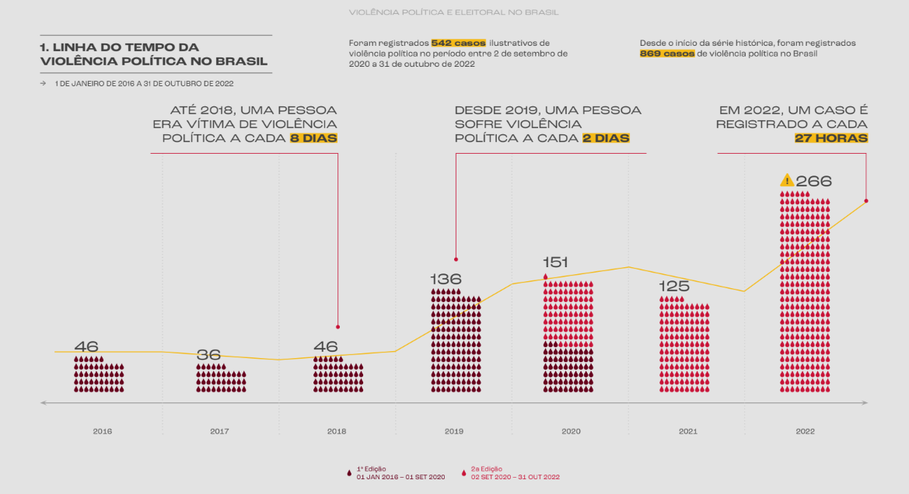

1. TIMELINE OF POLITICAL VIOLENCE IN BRAZIL
JANUARY 1, 2016 TO OCTOBER 31, 2022
542 illustrative cases of political violence were registered in the period between September 2, 2020, and October 31, 2022.
Since the beginning of the time series, 869 cases of political violence were registered in Brazil.
Until 2018 a person experienced political violence every 8 days
Since 2019, a person has experienced political violence every 2 days
In 2022, a case is registered every 27 hours
1st Edition
01 JAN 2016 - 01 SEP 2020
2nd Edition
02 SEP 2020 - 31 OCT 2022

The time series points out that until 2018, one person was a victim of political violence every 8 days in Brazil. Since 2019, every 2 days a person has suffered political violence. The average annual growth of cases of political violence from 2019 is over 60%. In 2022, the number of cases of political and electoral violence grew by more than 400% compared to 2018, when there were also general elections. The complete survey data is available here.

Political violence significantly affects vulnerable social groups, such as cis and trans women and the Black population. In recent years, it is possible to identify, among the motivations for violence, issues related to ideology and/or hatred, and issues regarding discrimination based on gender, race, and sexual orientation. Brazil must create measures to eradicate political and electoral violence, which, it is worth noting, is not restricted to incumbents and candidates, but is widespread in society, generating an environment of fear and intimidation.

We recommend that the Brazilian State create a national program to monitor cases of political and electoral violence; that it implements policies, with concrete results, to combat episodes of violence against parliamentarians in their workplace, with special attention to gender and racial violence; and that it promotes effective mechanisms for investigating complaints.

“Critical views on protection mechanisms for human rights defenders in Latin America.” Available at http://www.global.org.br/wp-content/uploads/2022/12/Olhares-Criticos-sobre-mecanismos-de-protecao-na-AL.pdf. Accessed on: 05/25/2023.
Today, in Brazil, only 11 of the 27 states have state programs to protect human rights defenders.

