Annex ‘A’

Report on the Consultation with Children on Child Rights conducted by the Ministry of Women and Child Affairs, April –May 2016

Introduction

The Ministry of Women and Child Affairs (MoWCA) conducted an island-wide consultation on rights of the child with the direct participation of children, with special focus on concluding observations and recommendations made by the Committee on the Rights of the Children at its 55th Session (13th September – 1st October 2010). The consultation was conducted with the participation of 1,577 children aged between 11 to 18 years from all 25 districts of the country. The purpose of the consultation was to understand children’s opinionson issues relating to child rights and to give an opportunity for children to raise their concerns. The consultation methodology was designed with technical support from Save the Children, National Child Protection Authority and other relevant government organisations, and the consultations were carried out by the Ministry of Women and Child Affairs in collaboration with District Secretariats.The cost of the project was approximately Rs. 1.5 million. This consultation has enabled the GoSL to better understand children’s perspectives on their rights and has revealed difficulties faced by children and issues that affect them.

These consultations were conducted with members of children’s clubs facilitated by the Ministry of Women and Child Affairs and CSOs Island-wide. The organizational structure for engagement with children has been formed at four levels; Village Level, Divisional Level, District Level and National Level. There are 3,649 Children Clubs at village level, which elect members for the 341 Children Councilsthat are established at the Divisional level. Representatives from the 25 District Councils are elected by over 14,500 members of the Children Councils at Divisional level. There are 175 elected representatives in the National Children Council, representing all (25) districts.

Methodology
A sample of 1,237 children were selected from the District Children Councils representing all (25) districts, and an additional 340 children from 11 State and Voluntary Alternative Care Institutions were chosen through purposive sampling. This process constituted between 50 to 100 children from each District Children Council, representing 3 main ethnic groups (Sinhala - 1,159, Tamil - 351, Muslim - 67) and 4 main religious groups (Buddhist, Hindu, Islamic and Christian). Children between the ages of 11 - 18 participated in this process, which comprised of 642 boys and 935 girls. The consultation was carried out island-wide, covering all the districts. The consultations with the Children Councils were held at district level. In addition, consultations were also held in 11 care institutions representing all (9) provinces of the country.

Data collection process
The design of the data collection process was carried out with the help of District Child Rights Promoting Officers (DCRPO) of 22 districts. The process commenced with an ice-breaking activity, namely, introducing-oneself-activity to encourage children to express their views in a more child friendly environment. Hence, child friendly activities were designed to educate children about child rights within specific clusters of the Child Rights Convention (CRC). This process was based on the principles of direct child involvement and their meaningful participation, child safety and equal opportunities regardless of gender, ethnicity and religious background of the children.

Self-administrated questionnaires based on Key Informant Interviews (KIIs) and Likert Scale were the key data collection tools that were used during the consultation. A questionnaire of 51 questions was compiled according to the clusters of the CRCand taking into consideration age-appropriate concepts and language to formulate questions that are designed for children’s different ages and abilities. The District and Divisional Children Councils as well as Institutions providing alternative care were informed about the process, and the selected representatives were prepared prior to the consultation process. The key resource utilized in this process was a child friendly version of the Concluding Observations by the Committee on the Rights of the Children on Sri Lanka State Party Report in 2010. The process followed a combination of child friendly activitiesand group work based on selected resources. Following the awareness sessions on clusters (Cluster 01, 03, 04, 05, 06, 07, and 08) and rights within each cluster, the questionnaires were administered by the Child Rights Promoting Officers (CRPO) on a one-to-one basis.

Cluster 1: General Measures of Implementation

Adequate government mechanisms to ensure children's rights
25% of children interviewed were highly satisfied with the government mechanisms to ensure children’s rights. 43% of children were happy with the efforts by the government, while 29% were partly satisfied with the efforts and mechanisms available. 3% of children felt that the current efforts were unsatisfactory for the true realization of children’s rights.

Children’s awareness of their rights
21% of children had a good understanding of their rights, while 31% had a fair understanding. 32% of children had a basic awareness of their rights. 16% of children interviewed had no awareness of child rights.

Awareness on Child Rights monitoring and reporting
47% of children had been sufficiently made aware of child rights monitoring and reporting systems, while 53% of children had no or very limited knowledge about these at different levels.

Role of media and private sector in promoting children’s rights
Only 19% of children agreed that media/private sector in Sri Lanka played an important role in promoting children’s rights. The majority (59%) believed that they played some role, while 22% felt that their role was insignificant.

Conclusion: The findings reflect that children are mostly aware of the government mechanisms/systems relating to education and health care of children in their respective Districts. Recent efforts of the government to improve children and community understanding of children’s rights and their protection have positively reflected in the responses provided by the children. There is still a remarkable capacity gap in the knowledge and understanding of child rights, child rights monitoring and overall reporting mechanisms. General Measures of Implementation are not fully reflected in the children’s responses which indicate that children have a limited understanding of the overall child rights infrastructure that provides necessary services for them; this may be as a result of limited outreach mechanisms for children in Sri Lanka.

Cluster 3: General Principles

Non-discrimination
36% of children strongly felt that children were not discriminated based on their socio-economic, cultural or ethnic backgrounds, while 53% of children felt that there were some elements of discrimination. 11% of children believed that there was an obvious discrimination against children based on the conditions mentioned above.

Adults listen to children and respect children’s opinions
36% of children felt that adults listened to their opinions and respected their views. However 42% of children believed that they are not heard sufficiently, while 22% felt that they did not listen to them at all.

Children’s access to information
31% of children felt that they had a very good access to information, while 37% believed they had satisfactory access. 20% of children had limited access to information, while 12% had no access.

Free health care provision for children
76% of children interviewed felt that they benefited from free health care provided by the government. 18% of children felt that they benefitted at times, while 6% of children felt that they did not benefit from free health care.

Conclusion: Children’s perspectives on the general principles were mostly related to their own life experiences within their family and community. Majority of the children believed that there are some level of discrimination within the family and society based on their socio-economic, ethnic, cultural or family backgrounds which reflect that majority of children still experience different levels of discrimination within the family and society. Their participation and independence are still limited within the family, school and society. All levels of government mechanisms guided by the principles of the CRC and enhanced capacities of parents, teachers and other key stakeholders on applying CRC principles in their engagement with children would improve the current situation.

According to the children’s views, the survival and development of children remain at a satisfactory level. This is reflected accurately in the indicators that were used to measure health and development of children. The GoSL has maintained substantial investments in health care over the past few years, which has resulted in widespread access to free health care, including lifesaving medications, vaccines and other early years health care needs both from hospitals/clinics and out-reach services.

Cluster 4: Civil Rights and Freedoms
Parent's influence in children's choice of religion
79% of children felt that parents influenced their choice of religion and they had to follow the parents’ religious beliefs. However, 21% believed that they should have the right to choose the religion of their choice, be it a different religion to that of their parents.

Children's active engagement within families on issues affecting them
33% of children strongly felt that they were not actively engaged in resolving issues that impacted them within the family circle, while 34% believed that their partial involvement was meaningful. 33% felt that they got involved meaningfully, while making decisions to resolve issues that affected them.

Children's independence and parental restrictions
25% of children felt that they had sufficient independence and parents did not impose limitations or control unnecessarily. 43% of children felt that they had some degree of independence, whilst another 29% felt that they had limited independence to develop their full potential. 3% of children felt they had no independence at all which was detrimental to their development and wellbeing.

Conclusion: Citizenship and legal documentation status of the children are still a concern among the plantation sector and war affected communities which has not been separately addressed in the consultation. Children’s identity, freedom of expression, freedom of thought, association and freedom of religion face significant limitations within the family and community. The social construction of childhood in Sri Lanka has played a significant role in creating such an environment for children. Our patriarchal society with a wide power divide between adults and children does not allow children to voice their opinions freely or adults to respect and respond suitably.

Cluster 5: Family Environment and Alternative Care

Ability of alternative care institutions to meet needs of children
49% of children in institutional care agreed that the institutions provided all necessary services to meet their diverse needs, while 19% somewhat agreed to the same. However, 32% of children in alternative care felt that the institutions did not adequately respond to the diverse groups of children who had faced specific vulnerabilities.

Opportunities provided by the institution for children to maintain contact with their parents
64% of children in institutional care agreed that the institutions facilitated contact with parents on a regular basis. 15% of children felt that their care institutions made some efforts to maintain family relationships, while 21% of children felt that no effort was made for them to maintain their links with parents and families.

Conditions of the alternative care institutions
A majority of 78% of children did not feel satisfied with the living conditions in their institutions. Only 22% of children felt that the institutions had adequate living conditions for their survival and development.

Respect and responsiveness to children’s opinions in institutional care

Only 10% of children interviewed felt that their opinions were sought, respected and responded to, by the care institutions. 15% of children felt that the institutions were sometimes respectful and responsive, while the majority of 76% of children believed that the institutions did not seek, respect or respond to their views or opinions.

Prevention of violence against children within institutional care
Only 30% of children believed that there were proper systems within the care institutions to prevent violence against children. A majority of 60% of children felt that there were no such systems in place, while 10% of children believed that a system functioned to a limited extent to prevent violence against children.

Provision of Psycho-social support in alternative care institutions
26% of children were satisfied with the level of mental health and psychosocial support (MHPSS) provided by the institutions while 74% children were neither satisfied nor not received adequate MHPSS during their stay in the institutions.

Protection of Privacy by the institutions
A majority of 79% of children felt that institutions did not protect or were not sensitive to their privacy. Only 21% of children felt that their privacy was protected and respected by the institutions.

Preparation for de-institutionalization
Only 30% of children agreed that they were being prepared through a care plan for de-institutionalization. The majority of children (70%) stated that there was no constructive plan for their de-institutionalization.

Conclusion - The findings strongly indicate that alternative care institutions in Sri Lanka are to be equipped and facilitated more to provide quality care for children who are needy. Dissatisfaction of more than two thirds of children interviewed reflect the urgency to develop their physical infrastructure and psychosocial services, and operate in a child friendly and child sensitive manner, to prevent secondary victimization and enable survival, care, protection, holistic development and reintegration of children back to society.

Cluster 6 - Disability, basic health and welfare

Awareness among children of the impact of drugs and alcohol
Only a small minority (15%) of children were aware of the impact of drugs and alcohol. 24% of children did not have sufficient awareness, while 62% of children were neither aware nor understand the impact of drugs and alcohol.

Children who are able to have a healthy, balanced diet
Only 13% of children stated they regularly consumed healthy, balanced and nutritious meals, while 26% felt that they sometimes consumed healthy, nutritious food. A majority (61%) of children did not have healthy, balanced diet.

State provision of development and rehabilitation services for children with disabilities
30% of children felt that there were some services offered by the State to serve the needs of children with disabilities. 70% of children felt that the State services were inadequate to meet the development and rehabilitation needs of children with disabilities.

Adequate parental attention and concern on children’s health care
An overwhelming 95% of children felt that their parents are concerned and provided sufficient attention to fulfil their health care needs. Only 5% of children did not feel that their parents showed sufficient concerns regarding their healthcare needs.

Conclusion – The current state of health care in Sri Lanka seems to be at a satisfactory level, especially in comparison to other South Asian countries, as depicted in the global health and development indicators. Reflecting the importance, the State has assigned the Health sector, parents and families to take health concerns of their children seriously and seek medical advice within their capacity. However, the state of nutrition of children is quite low (Low Birth Weight – 16.6%; Stunted (short for age-chronic malnutrition) – 18%; Wasted (low weight for height–acute malnutrition) – 14.7%) which is reflected clearly in the findings of this consultation. Moreover, in comparison with the emphasis on health, the State has not prioritized care and protection of children with disabilities, and this remains a significant challenge to realize the rights of children with specific vulnerabilities.

Cluster 7 - Education, Leisure and Cultural Activities

Free education for children
A large majority (86%) of children believed that they benefitted from free education provided by the State. While 11% of children felt they somewhat benefitted, 2% of children believed that they did not benefit from education provided by the State.

Inclusivity in Education
55% of children felt that the education system was inclusive and adequately supported slow learners and children with difficulties, while 31% agreed that there were some level of inclusivity in education. 14% of children felt that teachers did not sufficiently support children with difficulties or provided equal support to all children.

Opportunities for children to play
53% of children felt that they had sufficient opportunities to play within the family and school environment. While 33% of children were not satisfied with their current opportunities for play, 13% of children recorded that they did not have opportunities to play within home and school environments.

Conclusion: Children’s views have clearly reflected the impact of free education provided by the government of Sri Lanka. Indicators of education system are at a high level, which is clearly reflected in children’s views. Key concerns of children towards education system are quality and child friendliness. Accordingly, their stand on inclusiveness, freedom of expression, play, independence and level of participation shows negative reviews.

Cluster 8 - Special Protection Measures

Violence against children within the family
A majority of children (76%) indicated that they were aware that violence against children occurredwithin families. Only 24% of children stated they were not aware that violence and abuse against children occurred within families.

Awareness of protection from abuse and violence
68% of children were aware of violence and abuse against children and protective ways in such situations, while 32% did not have any awareness or education specifically on their own protective measures.

Awareness of State services to protect child victims of violence
Only 41% of children interviewed had a good understanding about existing services and key institutions that provided care and protection services for child victims. 59% of children had a very limited knowledge or no knowledge at all.

Risks of modern technology and social media in heightening children’s vulnerability to abuse and exploitation
62% of children believed that modern technology and social media contributed to the risk of children’s safety and protection, especially by those who exploited children online. 38% of children believed that modern technology might not be harmful, especially if children were taught the safe use of technology.

Stigmatization of child victims of violence and children in conflict with the law
70% of children agreed that children who were victims of abuse or in conflict with the law faced stigmatization within their own families, communities and schools. 23% of children believed that child victims and children in conflict with the law experienced some level of pressure, while 7% of the children were not aware of such situations where children face stigmatization as a result of being in contact with the law.

Conclusion - The results indicate that children are, to some extent, aware of the risk to safety, including the danger of technology. However, the awareness on available services and access to such services seem to be comparatively low. It is also significant that children are sensitive to the negative implications of stigmatization of victims and other children in contact with the law. The findings conclude that the State services for protection of children need to focus on improving access to quality services and initiating attitudinal changes among communities and service providers to prevent secondary victimization of children. This would enable children who are in contact with the law access service and exercise their rights without discrimination.

Recommendations of Children

- Equal opportunities and access to education for children who are most marginalized need to be ensured, especially by providing both adequate physical and human resources to schools in rural areas.
- The education system should be child friendly and child-centred and enable an environment where children are able to access adequate and quality supports according to their levels of skills and competencies.
- The education system should recognize the importance of leisure and play within the learning process, and achieve an optimum balance between structured education and flexible, practical learning spaces.
- Education should focus on cultivating holistic development of children, with due attention to developing attitudes, values, skills and personality.
- The education system should recognize and incorporate child rights and human rights education within the system.
- Children’s participation should be prioritized and mainstreamed at the time of decision-making in families, schools, children’s services and wider society.
- Child protection mechanisms need to be strengthened to reach the most marginalized children in the country.
- The identities of victims of abuse should not be published or exposed through mass media to protect the victims’ right to privacy and protection.
- Children should not be subject to corporal punishment at home and at school, and better disciplinary methods and guidance should be used by caregivers and teachers.
- Children should receive special care within public service institutions, especially in hospitals, police stations, courts etc.
- Existing alternative care facilities should be significantly improved to provide care and protection, rehabilitation and reintegration services aimed at child development and well

Photos of the Children’s Consultation held in Jaffna on 05 May 2016
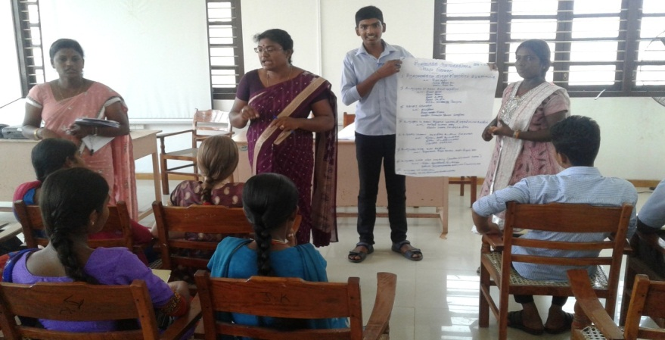
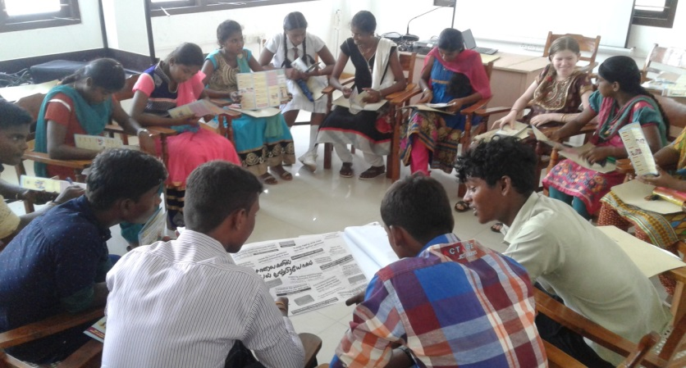
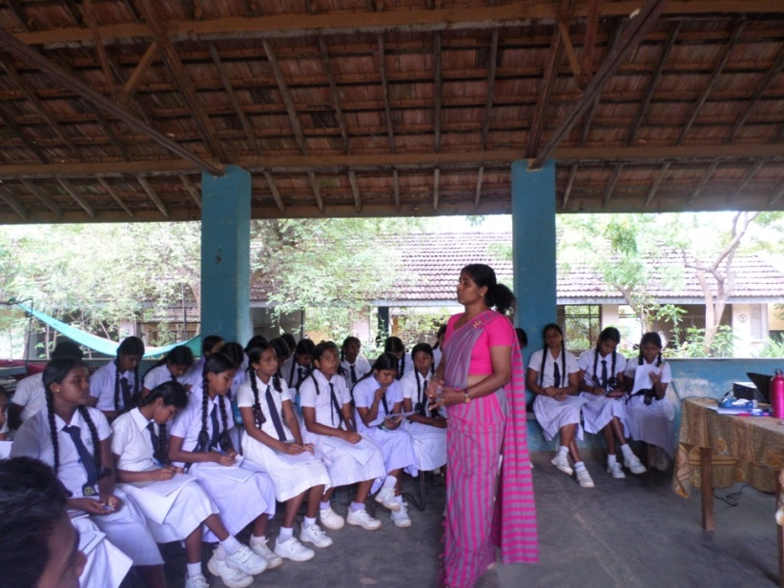
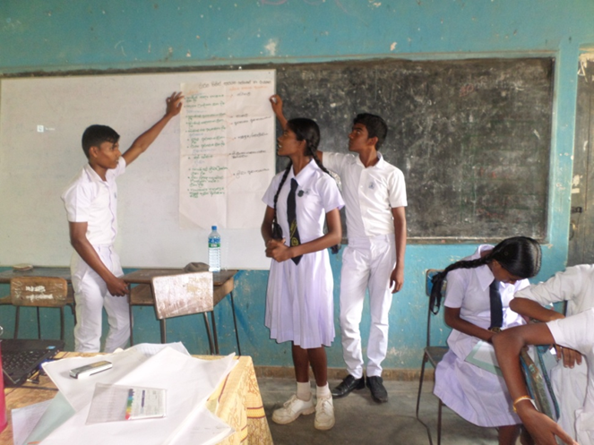
Photos of the Children’s Consultation held in Hambanthota, on 29 April 2016

