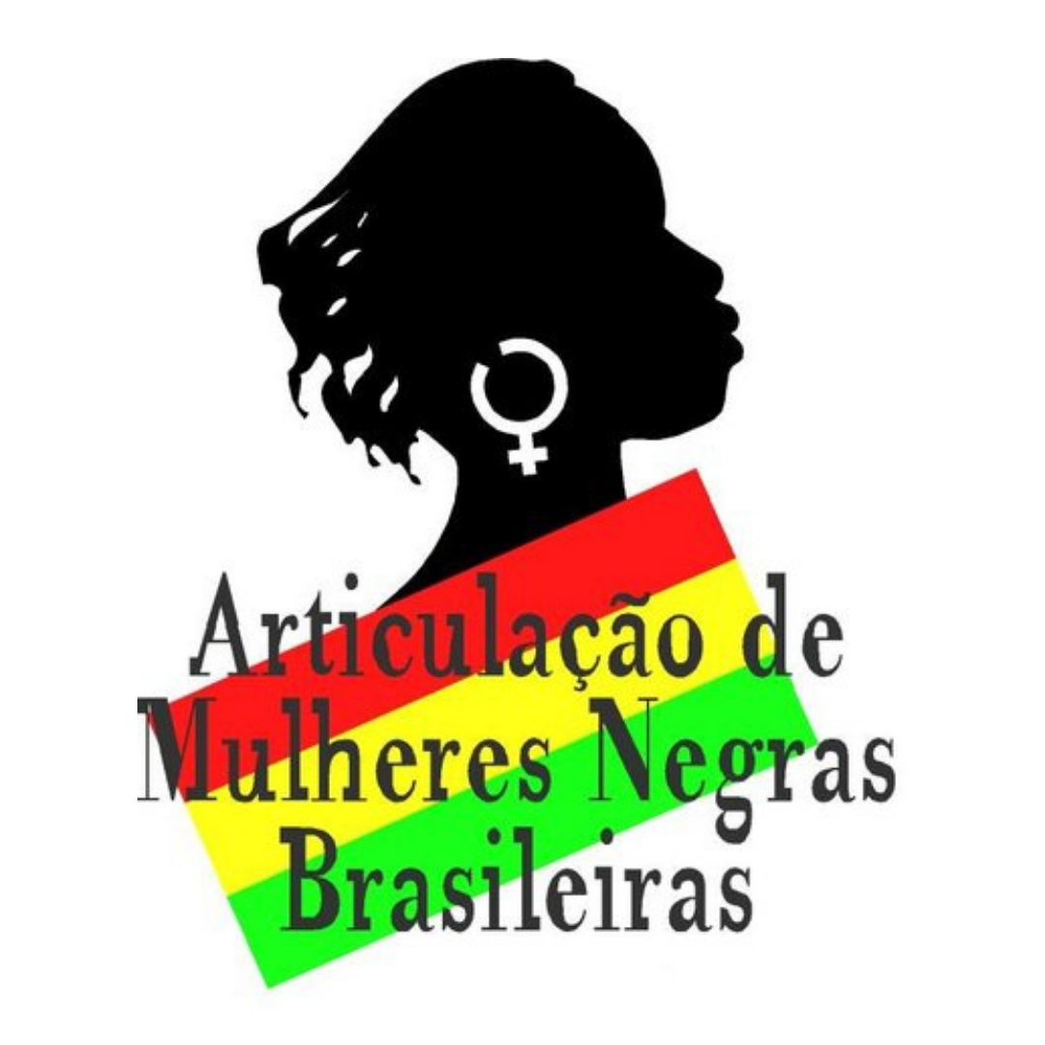

AMNB document to be presented at the CEDAW consultation - October 12, 2020

The year 2020 marks the 41st anniversary of the Convention for the Elimination of All Forms of Discrimination against Women (CEDAW). It is a milestone for the fight against different forms of discrimination and oppression against girls and women, particularly for those living in the more than 185 signatory countries.

This year also marks 25 years since the 4th World Conference on Women held in Beijing, which produced the platform of action adopted by 189 countries to promote gender equality and women's and girls' rights.

For many decades, the Black Women's Movement and the Black Movements in Brazil have taken action in the international sphere to ensure the human rights of African descendants in Brazil. We underscore our incidence in the 1st World Conference Against Racism, Racial Discrimination, Xenophobia, and Related Forms of Intolerance, in 2001. Our strategic incidence established new parameters for policies in Brazil, overcoming the principle of universalism. Instead, it highlighted the need for structuring more social policies focused on the most vulnerable, based on the guidelines approved by representatives of black and social movements and the 170 Heads of State or government who signed the Durban Declaration.

In the last two decades, the Black Women's movements and Black movements in Brazil have extensively denounced the deterioration of policies in national and international spaces. This performance materialized in conquests that structure Brazil as the State of the African Diaspora with the largest black population. Now, the moves take action in the scope of the United Nations (UN) Resolution 68/237, which institutes the Decade of People of African Descent (2015-2025), and also with regards to the Brazilian Federal Constitution of 1988.

This report is elaborated by the Articulation of Brazilian Black Women Organizations (AMNB), integrated by 60 organizations. It also returns to the recommendations they already presented during the 63rd Commission on the Status of Women (CSW), in March 2019, in New York. In this report, we highlight the following topics under consideration during the CEDAW consultation:

1. Violence Against Women and Feminicides

The homicide rate of women in Brazil is one of the highest in the world. In 2013, there were 4.8 homicides per 100 thousand women, which placed the country in the 5th position among 83 countries. Between 1980 and 2013, the numbers increased from 1,353 homicides to 4,762, which is equivalent to a growth of 2.3% per year. According to the publication Map of Violence 2015, between 2003 and 2013, the murder rate among black women increased in 54%, from 1,864 in 2003 to 2,875 in 2013. In

the same period, the number of homicides among white women decreased by 9.8%, falling from 1,747 in 2003 to 1,576 in 2013.

The investment made by the Brazilian government to confront gender-based violence has been dropping alarmingly, and the reduced budget that is destined to protect women has not been used. In 2019, although the amount of R$ 20 million (approximately 3.5 mi dollars) was reserved to that end, no resources were spent in the construction of Casas da Mulher Brasileira (Brazilian Woman's Houses), which provide multiple services to women victims of violence. In the same year, there was an increase of 7.3% in femicides compared to 2018. Now, domestic violence is deepening in the scenario of Covid-19, as many women are confined with aggressors in the period of social isolation. After five years of budget cuts in policies for women, the Human Rights Ministry has 425 million in authorized resources for 2020; however, less than 3% has been spent until May 2020. Black living in the periphery of cities and rural black women - particularly quilombola women - are the most vulnerable in the context of Covid-19. Human Rights Minister Damares Alves must carry out policies with these resources to alleviate the violence and socio-economic insecurity. Such resources could be in use, for instance, to make online education feasible for young black women, who suffer from digital exclusion in the context of social isolation.

2. Human Rights Defenders

In Brazil, there is a long history of violence against human rights defenders. The cases following are, in this sense, emblematic: the murder of _____ in 1983, for defending the rights of rural workers; the murder of _____ in 2005, for defending environmental causes; the murder of _____ by the police in 2014, a favela resident, defending her son's life; the murder of _____, a black lesbian woman beaten to death by the police in 2016; and the recent murder of _____, a councilwoman assassinated for defending the rights slum dwellers, young people and black women.

In recent years, the scenario of violence against human rights defenders has intensified. According to data from the Brazilian Committee of Human Rights Defenders, in 2016 alone, 54 defenders were murdered. According to data from the Comissão Pastoral da Terra (Pastoral Land Commission), from 1985 to 2014, 1,723 people linked to social movements fighting for land and agrarian reform in Brazil were murdered. Of these, only 109 cases were brought to trial, with only 32 defendants sentenced. There are no systematic data regarding the deaths of defenders of rights. Impunity is an aggravating factor in crimes against human rights defenders in Brazil.

3. Sexual and Reproductive Rights
The Brazilian public health system (Sistema Único de Saúde - SUS), which has free and universal access, is the only alternative for black girls and women to care for their health when it comes to guaranteeing sexual rights and reproductive justice, be it in acquiring contraceptives for protection and

safe sex, monitoring prenatal care or terminating of pregnancies resulting from violence, as provided by law.

In Brazil, the reactionary forces that currently occupy the power are on a journey to destroy the mandatory legal abortion services that assist women and girls victims of sexual violence in SUS, by action or inaction. Directive 2282/2020 of the Ministry of Health destroys the humanitarian perspective of care services for victims of sexual violence.

Maternal mortality rates disproportionately affect black women, as the provision of continuous and sufficient service is still a challenge. The high rates of maternal mortality represent a serious public health problem, unevenly affecting the Brazilian regions where black women are prevalent and the social classes with less income and access to social goods. It is one of the most serious violations of women's human rights, as it is a preventable tragedy in 92% of cases.

In the context of the pandemic, there is an increase in maternal mortality in Brazil. According to the Ministry of Health, by the end of August this year, 6 thousand pregnant women with Severe Acute Respiratory Syndrome (SARS) have been identified, of which 2.7 thousand are infected with the new Coronavirus. To that time, the country had recorded 221 pregnant women who died from SARS, 155 of which with COVID-19.

4. Rights and citizenship

The black population in Brazil has never experienced full access to rights and citizenship. Instead, the data reveal a dramatic situation. In Brazil, 30,000 young people are killed each year, 77% of whom are black (blacks and browns). The country has the third-largest prison population in the world, composed mainly of blacks.

The 2018 elections, repeating the pattern of previous elections, elected a mostly white and male Parliament. Only 15% of the elected are women. While it represented an important increase compared to 2010 (9%) and 2014 (10%), it stayed well below the 30% quota of candidates, even though women are half of the Brazilian population. In absolute numbers, of the 567 positions, only 84 women were elected, compared to 483 men. Among the elected, only were 13 black women: together, they will represent 2.5% of the Parliament.

In addition to the low representativeness of women, blacks and indigenous people, the Brazilian Parliament currently has articulations that are contrary to human rights, such as the military, ruralists, and religious fundamentalists who identify with conservatism, promoting racism and sexism.

The current situation is challenging for social movements, who are fighting against the advance of conservative right-wing forces, religious fundamentalism, racism, unbridled capitalist exploitation and the strategies to criminalize civil society organizations. The conservative forces disregard and violate the human right of diverse vulnerable sectors of the society, particularly of the black population and black women and girls. Conflicts over land, urban conflicts, ungrounded persecution, deaths, aggression and silencing are part of their strategies to intimidate and cause terror.

We demand that the Brazilian government should explain their actions to ensure the protection of the right to freedom in its broadest sense, guaranteeing freedom of movement, expression of opinion and beliefs, professing our beliefs, and creating associate without interpellation from the State. We demand compliance with the rules established in the Racial Equality Statute (Law no. 12,288 of 07/20/2010), as well as those that enable the implementation of the National System for the Promotion of Racial Equality (SINAPIR) concerning labor and employment relations, with fair and adequate remuneration, following the principle of racial, ethnic, gender equity, and non-discrimination by sexual orientation, gender identity, generation, disabilities, physical and mental condition, in the countryside or in the cities, for access and permanence in the jobs. Finally, we demand that the Brazilian Stat legally ensures the participation in community and union organization activities.

