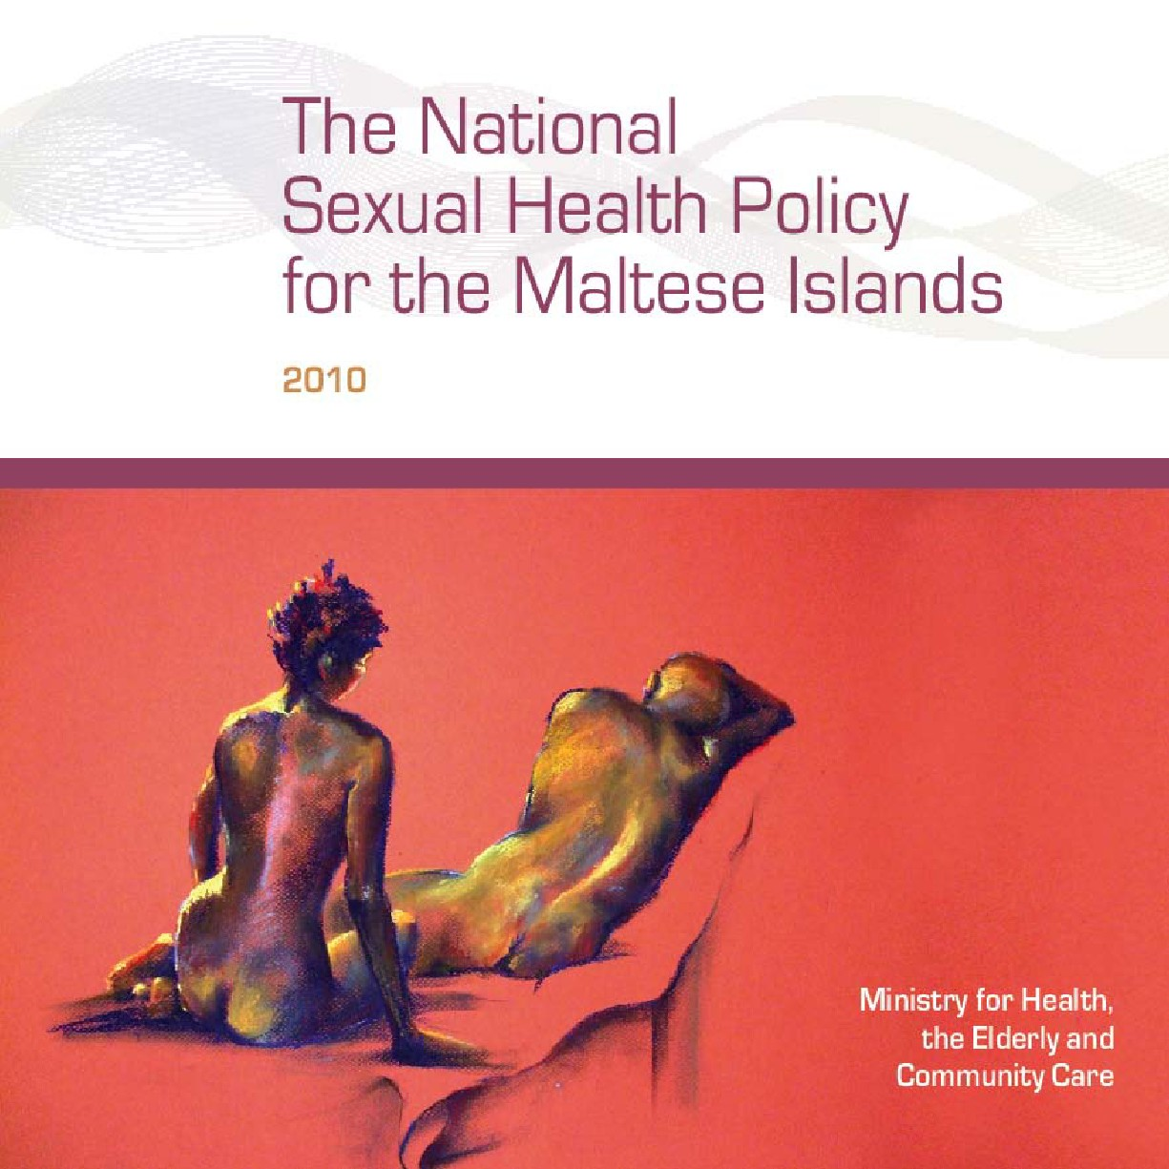

Contents
Sexual Health:
an Integral Part of Our Well Being ....................2
Introduction.................................................................5
Sexual health: a working definition ...................... 5
What are the consequences of sexual ill-health?.. 6
What are the indicators of sexual health? ............ 7
5. Medical and Health Services........................18
5.1 Primary prevention services ......................... 18
5.2 Secondary/tertiary prevention
and curative services .................................... 21
5.3 A one-stop-“shop” sexual health
service approach .......................................... 22
5.4 Training the relevant professions in sexual
health promotion ......................................... 23
1. Need, Principles and Remit of the Policy ...8
1.1 Why does Malta need a sexual ..................... 8
health policy? ................................................. 8
1.2 Principles and objectives ............................... 8
of the policy .................................................... 8
6. Sexuality and Relationships Education.....25
6.1 The purpose and goals
of sexuality education.................................. 25
6.2 Parental and guardian involvement .......... 27
6.3 The media .................................................... 27
2. Social and Behavioural Indicators
of Sexual Health .................................................10
2.1 Social indicators ........................................... 10
2.2 Behavioural indicators................................. 13
2.3 Knowledge factors ........................................ 14
7. Research, Evaluation
and Quality Assurance Policies ...................28
8. Future Considerations ....................................29
Conclusion.................................................................31
References ...............................................................33
3. Monitoring and Surveillance Policies ........16
4. Legislation ...........................................................17
1


Sexual Health:
an Integral Part of Our Well Being
There has been a long wait for a national sexual
health policy, and I take pride and feel privileged
to be launching it as the Minister for Health,
Elderly and Community Care. Sexual health is
an integral element of the health of all human
beings, and thus merits much attention. I am
confident this policy will finally seek to secure
such due attention.
In essence, this policy seeks to promote sexual
health as an essential and integral element of the
holistic notion of human well being. Categorically
it is not exclusively about contraception, or
disease prevention, but about the enhancement
of an important dimension of human health –
sexual health.
The policy draws on a set of principles of individual
and social rights and responsibilities of the human
being, underpinned by the values of respect and
dignity towards human life from the moment
of conception, and on the belief that the stable
family unit is the cornerstone of a healthy society,
respectful of social, sexual, religious and cultural
diversity. It has been informed by evidence located
in the local and international literature.
In view of the ministry’s conviction regarding
the significant value of the participation and
contribution of all entities, sectors, groups and
representatives of the entire population towards the
enhancement of health, a series of live workshops
over a period of months will complement the
publication of this policy. These workshops should
secure the referred participation and contribution of
all parties, within the Maltese islands.
I would like to take the opportunity to sincerely
ask you to accept this invitation and assist us
on our journey towards the development of the
subsequent sexual health strategy.
This sexual health policy, coupled with the
outcomes of the referred workshops will inform
the development of a sexual health strategy,
which would in turn, identify a set of targets,
goals, measures and deliverables for our nation
regarding sexual health.
I trust in your esteemed participation and
attention.
This document draws on a set of
principles of individual and social rights
and responsibilities of the human being,
underpinned by the values of respect
and dignity towards human life.
Dr Joseph Cassar
Minister for Health,
the Elderly and Community Care
2
3

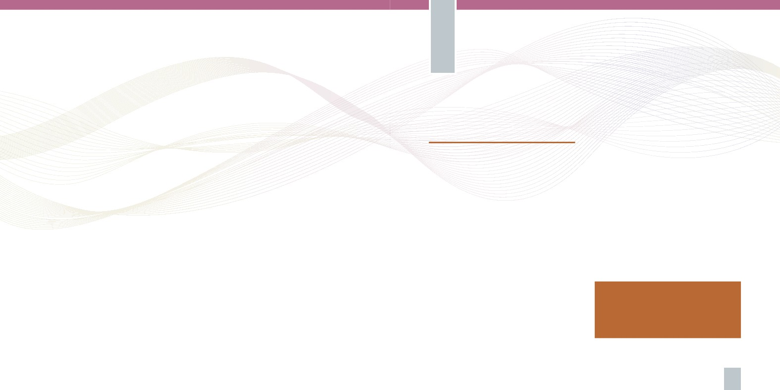
Introduction
Sexual health: a working definition
The true meaning and understanding of sexual
well-being remains to be culture- and context-
specific, and thus it is difficult to arrive at a
universally acceptable definition of the totality
of human sexuality.1 In view of its complex web
of biological, psychological, cognitive, social,
political, cultural, ethical, legal, religious and
spiritual factors, the following World Health
Organisation’s definition of sexual health is
presented as a step in this direction:
Copyright @ 2010
First published in 2010 by The Ministry for Health, the Elderly and Community Care
Ministry for Health, the Elderly and Community Care
Palazzo Castellania, 15 Merchants Street, Valletta, Malta
Tel: (356) 2122 4071
Fax: (356) 2299 2657
Email: permsec.hecc.mhec@gov.mt
All rights reserved. Except for the quotation of short passages for the purpose
of research and review, no part of this publication may be reproduced, stored
in a retrieval system, or transmitted in any form or by any means, electronic,
mechanical, photocopying, recording or otherwise,without the prior
permission of the publisher.
Production: Outlook Coop
Cover: original painting by Anna Galea
For the last 30 years, the concept of sexual health
has been invariably described to include these
basic three elements:
1. A capacity to enjoy and control sexual and
reproductive behaviour in accordance with a
social and personal ethic;
2. Freedom from fear, shame, and guilt associated
with false beliefs and misconceptions related
to sexuality, and other factors affecting sexual
response and relationships;
3. Freedom from organic disorders, diseases, and
deficiencies that interfere with sexual and
reproductive functions.
Sexual health is a state of physical, emotional, mental
and social well-being in relation to sexuality; it is not
merely the absence of disease, dysfunction or infirmity.
Sexual health requires a positive, respectful approach
to sexuality and relationships and the possibility of
having pleasurable and safe sexual experiences, free
of coercion, discrimination and violence. For sexual
health to be attained, the sexual rights of all persons
must be respected, protected and fulfilled. 2,3,4
For sexual health to be attained and
maintained, the sexual rights of all
persons must be protected, respected
and fulfilled.
4
5

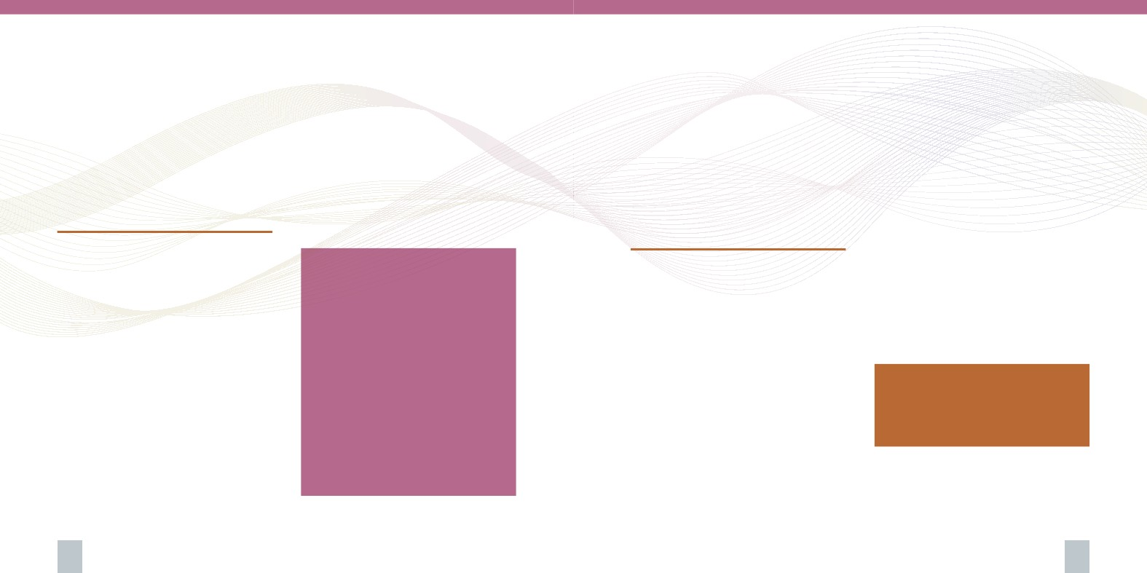
The notion of sexual health implies a positive and
responsible approach to human sexuality and sexual
relationships and goes well beyond the absence of
disease. The purpose of sexual health care should be the
enhancement of life and personal relationships, as well
as pleasurable and safe sexual experiences.5 Equally
so sexual health care should value and nurture respect
towards abstinence.
• Bacterial vaginosis and premature delivery
• Pelvic inflammatory disease caused by
Gonorrhoea and Chlamydia, which can lead to
ectopic pregnancies and infertility
• Recurrent genital herpes
• HIV/AIDS and other Sexually Transmitted
Infections (STIs)
• Cervical and other genital cancers
• Hepatitis, chronic liver disease and liver cancer
• Premature loss of life
Poor sexual health characteristically translates
into significant costs to a country. In turn,
preventing poor sexual health significantly
contributes towards the better and more effective
use of finite resources of a country. It follows that
protecting, supporting and restoring sexual health
is important for both the social well-being and
economic growth of a country.
It is against this backdrop that a national sexual
health policy is being presented.
What are the consequences
of sexual ill-health?
Sexual health has a strong impact on a person’s
personality, life and role in society. It is directly
affected by a range of physical, psychological,
cognitive, socio-cultural, religious, legal, political
and economic factors. An individual may have
little or no control over such factors.
There is a clear relationship evidenced between
sexual ill-health, poverty and social exclusion.6,7
Among the most severe consequences of poor
sexual health are:
• Psychological consequences of sexual coercion,
exploitation and abuse
• Unplanned pregnancies
• Being disadvantaged within established
standard educational systems
• Poor educational, social and economic
opportunities for teenage mothers
What are the indicators
of sexual health?
Facts and Figures
Teenage pregnancies in Malta
• Between the year 2000 and 2009,
936 babies were born to Maltese
mothers under 18 years of age
• These amount to just under 2.5 %
of all babies delivered over the
10 year period
• 5% of all teenage mothers within the
same period were young adolescent
girls aged <15 years (who delivered
a total of 47 childbirths between
2000-2009)
Source: National Obstetrics Information System, Dept. of Health
Information and Research (2010)
Sexual health relates to educational, ethical,
medical, social and cultural components and
characteristics which may vary between different
countries. Standards of sexual health depend on
a complex interaction of many of these factors.
Therefore, these must be taken into account in the
measurement and enhancement of sexual health
in any given context.8
Following the International Conference on Population
and Development in 1994, various international
agencies identified a number of indicators and
predictors that reflect the overall sexual health of
different populations. 9,10,11,12,13 Some of the indicators
are measures of health status (outcome or impact
indicators), while others are intended to capture
‘processes’. The major indicators of sexual health
identified can be classified as those related to:
• Social and behavioural factors
• Monitoring and surveillance policies
• Legislation
• Medical and health services
• Health education
• Evaluation and quality assurance polices
Reference to these indicators in the specific
context of Malta provide the cornerstones of
this policy which seeks to direct a strategy set to
protect and enhance sexual health in the country.
Standards of sexual health depend on
a complex interaction of many factors
which may vary between different
countries.
6
7

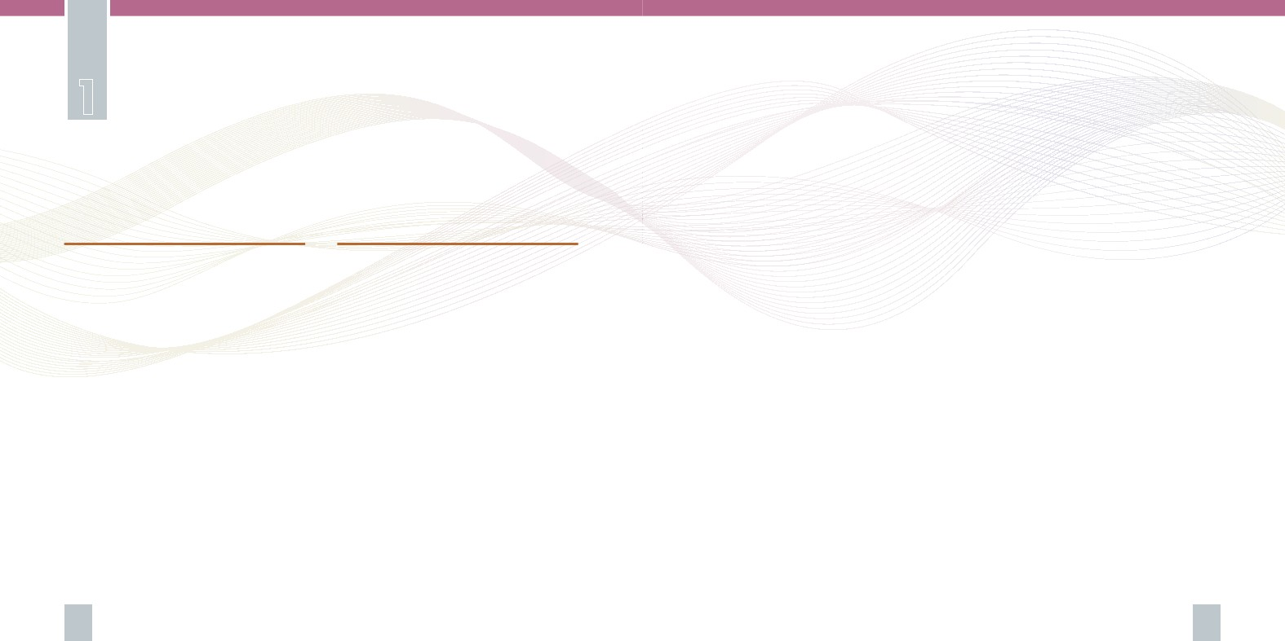
Need, Principles and Remit
of the Policy
The aim of the policy is therefore to inform and
direct the development of a comprehensive
evidence based national sexual health strategy
for the attainment of maximum health and well
being of all the population, drawing on the core
principles noted above.
The objectives are:
• To establish the need for research to secure
accurate data specifically pertaining to the
Maltese islands
• To determine the provision of adequate and
equitable health and social services and support
which match the current needs
• To map the monitoring, surveillance and legal
framework
• To provide optimal services through competent
and skilled staff supported by adequate
resources
• To identify and evaluate the role and
contribution of the media
• To collate and evaluate the social, cultural and
religious dimensions of sexual health, within
the specific context of Malta
• To enhance further co-operation with other
countries and entities
• Project and plan to address the challenges of the
future
The attainment of excellence across the health
and education sectors is a key goal of the
Government. Tackling people’s sexual health in
a concerted manner at national level is one of
the tools with which Government may attain its
vision for the health sector.
This is Malta’s first national policy for sexual
health. It illustrates the determination and
commitment to address key challenges faced
by Maltese society today, which are largely
characterised by increased individualisation and
the secularisation of sexuality.15
1.1 Why does Malta need a sexual
health policy?
The past century has witnessed a widespread
liberalisation in sexual attitudes across the
western world, as regards for example birth
control, pre-marital sex, teenage pregnancies,
single parenthood, cohabitation of non-married
partners and sexual diversity. The reasons for this
unprecedented shift in attitudes and behaviours
are complex and wide-ranging. Across different
contexts, these changes have been met by varying
degrees of support or concern. Often, attitudes
towards aspects of sexual behaviour are diverse
and even polarised across one context, with
consequent difficulties for the promotion of better
sexual health through the provision of a uniform
structure of sexual health services and education,
in that context. Needless to say, this poses a greater
challenge for strategic planning.14 A national
sexual health policy seeks to provide a consistent
framework within which the referred sexual
health services and education may be strategically
planned and delivered, across the country.
8
1.2 Principles and objectives
of the policy
The principles guiding this policy are
underpinned by human rights and social justice
principles. The core principles stemming from this
philosophical approach are:
• Respect and care towards human life from its
conception
• Individual rights and responsibilities in the
context of the broader society
• Adequate, accessible and accurate information
and education which is equally accessible to all
members of a population, enabling informed
choices
• Freedom from exploitation and abuse
• Freedom of expression
• Psychological and physical expression of one’s
sexuality in the context of a sound family unit
is valued as an essential cornerstone of a society
whilst respecting diverse lifestyle choices
9


Social and Behavioural Indicators
of Sexual Health
2.1 Social indicators
2.1.i Sexual Violence
Specific harmful sexual practices such as sexual
violence and domestic violence including marital
rape, have been identified to be indicators of
sexual ill-health. The incidence16 of sexual
violence reported to law enforcement and/or
health professionals is thus one of the indicators
of the degree of sexual ill-health in a given
population or community. The public’s opinion,
perceptions and social attitude towards sexual
and domestic violence are also identified as other
indicators of sexual health.
2.1.ii Substance Abuse
A significant body of literature has shown a
strong association between substance abuse and
risky sexual practices. For example, research17,18,19
has shown that the likelihood of young people
engaging in unplanned intercourse increased
with higher alcohol use. In particular, the
likelihood of engaging in unprotected sex and/
or having multiple sexual partners appears to
be consistently high amongst adolescents who
frequently drank until they reached a state
of inebriation. Particularly for girls, weekly
drunkenness-related drinking was associated with
multiple partners.
These research studies provide evidence which
notes a significant association between unplanned
and unprotected intercourse with multiple sexual
partners, and an increasing frequency of alcohol,
tobacco and cannabis use, both in the bivariate
comparisons and the multivariate models. Out
of all substances explored (alcohol, tobacco and
cannabis), the evidence suggests that alcohol use
was most strongly associated with unplanned
intercourse, and was also identified as the strongest
risk factor for having had multiple sexual partners.
Compared with students who reported not having
had unplanned sex when under the influence of a
substance, those who reported having done so were
almost four times more likely to have had multiple
sexual partners. It was also reported that those
who had engaged in unplanned sexual intercourse
under the influence of alcohol were twice as
likely to report inconsistent condom use. In the
qualitative analysis, engaging in unprotected sexual
behaviours was only second to aggressive behaviour
and physical fighting in terms of the perceived
consequences of alcohol consumption. Calls for the
comprehensive combination of alcohol education
and sexuality and relationships education in early
adolescence echoes through the reported research
studies.
2.1.iii Sexual Competence
Sexual competence is a composite indicator
referring to whether sex is consensual, with no
regret, protected against STIs and unplanned
pregnancy, and to whether the decision to
practice any form of sexual activity is made
autonomously. 20, 21 There is much debate upon
the role of education in developing sexual
Facts & Figures
Close to a third of sexually active young
people in Malta aged 14-16 years had
sexual intercourse at least once under
the likely influence of alcohol or other
substances. No significant gender
differences were noted.
Source: Bugeja, R. (2010) Assessing young people’s learning needs
related to sexuality and relationships on the Maltese islands: a multi-
dimensional approach. Unpublished Thesis submitted for the degree of
Doctor of Philosophy. University of Southampton: United Kingdom
competence, particularly in relation to the potential
contribution that educational programmes may
make towards the development of attitudes, values
and lifestyles which are believed to be conducive to
optimal sexual health, as for example, fidelity and
respect.
Facts and Figures
10% of all Maltese teenagers aged
15-16 years reported having
unprotected sex because of a personal
alcohol problem (European average: 8%)
Source: ESPAD (2007), SEDQA (2009) – Foundation for Social Welfare
Services, Ministry for Social Policy
2.1.iv Sexuality Education
The incidence of adolescents who have received
sexuality and relationships education in schools has
also been identified as one of the social indicators
of sexual health. Sexuality education has been
commonly defined as a lifelong learning process
starting in childhood, with a potential to promote
positive sexuality by enhancing young people’s
knowledge and understanding (cognitive domain);
10
11

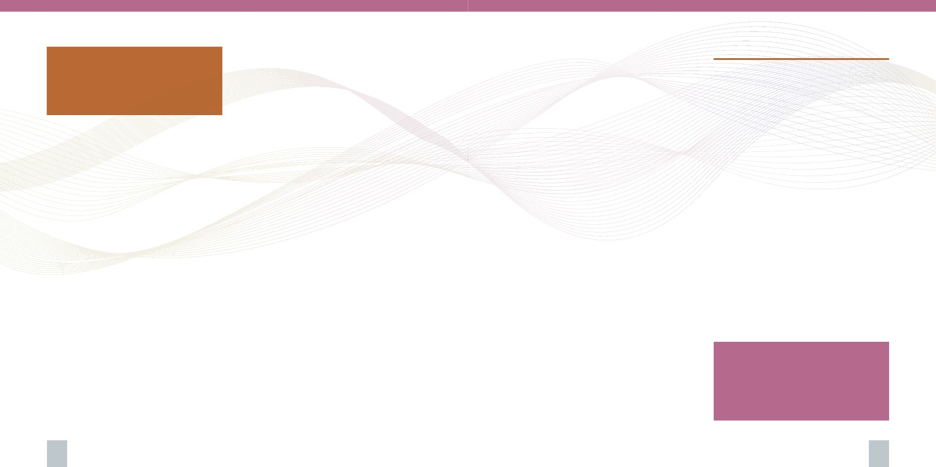
Sexuality education has been
commonly defined as a lifelong learning
process starting in childhood, with a
potential to promote positive sexuality
has been persistently characterised by varying
levels of agreement and disagreement across
individuals, entities, religions, cultures and so
on.28
Initially, debates about sexuality education focused
on whether to teach sexuality education in schools
or entrust it exclusively to parents. The major issue
arose around the notion that young children have
a natural innocence which may be prematurely
lost as a result of lessons designed to raise their
sexual awareness and thus might cause an ill-effect
on their behaviour. Despite the lack of empirical
evidence supporting this notion to date, it still
dominates some circles of discussion regarding the
teaching of sexuality to the young. 29, 30, 31
Wellings et al.32 had examined the relation
between sexuality education and early sexual
experience with a sample of 18,876 British
participants and concluded that the data provided
no significant evidence to support the prevalent
concern that provision of school sex education
might hasten the onset of sexual experience.
Using data from a nationally representative
survey among 2019 never-married males
and females aged 15–19 years in the United
States, Mueller et al.33 found that sexuality and
relationships education had effectively reduced
adolescent sexual risk behaviours when provided
before sexual initiation. A review of 53 studies to
examine the impact of HIV/AIDS education on
young people’s sexual behaviour concluded that:
“The overwhelming majority of reports reviewed […]
regardless of variations in methodology, countries
under investigation, and year of publication, found
little support for the contention that sexual health
education encourages experimentation or increases
sexual activity.“34
Another recent comprehensive review of studies
which explored the impact of sexuality and
relationships education on sexual behaviour
suggests that comprehensive programmes may
actually delay sexual intercourse and increase
protection against sexually transmitted infections
and unplanned teenage pregnancies35. In
conclusion, the evidence strongly suggests that
comprehensive sexuality education does not
hasten the onset or increase sexual activity.
Such effective programmes essentially provide
the learner with the opportunity to explore and
embrace varying values, including abstinence
from genital expression of intimacy while
exploring other ways of demonstrating affection;
as well as being in long-term, loving, mutually
faithful sexual relationships.
2.2 Behavioural indicators
In the past three decades or so there has been
considerable focus on the sexual behaviour and
knowledge of young people especially those aged
15 – 24. Behaviour and knowledge are widely
considered to be major determinants of conception
rates, STIs and HIV transmission, and other
sexual health outcomes. Academic and scientific
literature reveals a number of key behavioural and
knowledge factors commonly used to assess and
measure the sexual health of young people.
2.2.i Sexual activity and age
at first sexual intercourse
Early sexual debut has long been associated with
risk behaviours such as substance abuse, multiple
partners and unprotected sexual intercourse.
These behaviours constitute the most significant
factors contributing to STIs and unplanned
pregnancies. 36, 37, 38 Therefore, age at first
intercourse has been shown to be an important
indicator of the possible outcomes of young
people’s sexual health, and thus young people’s
learning needs.
developing or strengthening interpersonal
and relationship skills (behavioural domain);
explaining and clarifying feelings, attitudes and
values (the affective domain) in relation to their
sexual development; and increasing comfort with
their own developing sexuality. 22, 23, 24 25
Since its conception at the beginning of the
20th century, sexuality education has provoked
numerous debates which have drawn much
attention to its controversial moral dimension.
Amongst other aspects such as the development
of self respect and the development of respect
towards other persons, sexuality education also
addresses the private and intimate life of the
learner and has to do with emotions related to
intimacy, pleasure, affection, anxiety, guilt and
embarrassment. Therefore it is inescapably a
value-laden activity.26 Values has been defined
as principles and fundamental convictions by
which people judge beliefs and behaviours to be
good, right, desirable or worthy of respect.27 In
comprising such moral dimension the debate
Facts & Figures
5% of all sexually active Maltese
population had more than
one sexual partner.
Source: EHIS, 2008
12
13

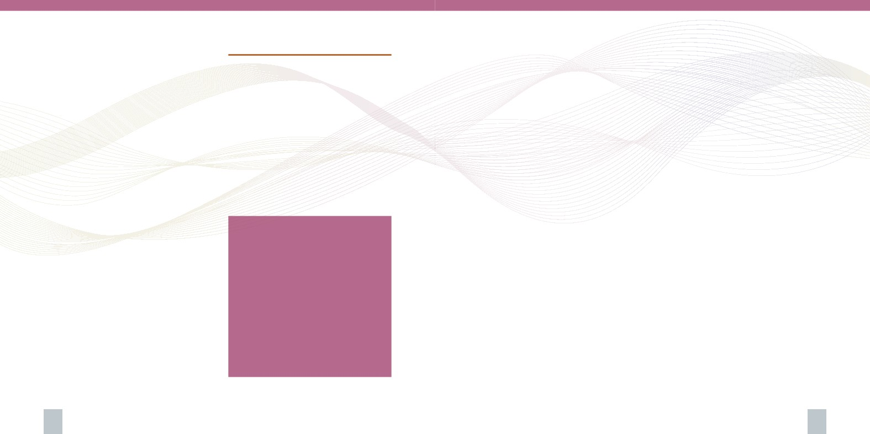
2.2.ii Number of sexual partners
The incidence of multiple sexual partnerships has
also been addressed in the literature, especially
that which explores the sexual health of men and
women aged 15-24 years. The evidence indicates
an association between having multiple partners
and an increased risk of becoming infected with
STIs39. However further research in this area is
indicated.
2.2.iii Contraception use
The literature identifies the use of contraception
among sexually active adolescents as being
a significant determinant of young people’s
sexual health, not only in terms of prevention
of unplanned pregnancies, but also – in the
case of barrier methods of contraception– in the
prevention of STIs. 40 The scientific literature
to date has largely focused on the use of
contraception by young individuals engaging
in sexual intercourse the first time, and on the
consistent use of condoms among sexually active
unmarried adolescents. Further research studies
regarding the use of contraception is indicated.
2.3 Knowledge factors
2.3.i Awareness of sexually transmitted
infections, including HIV, their modes
of transmission and their methods of
prevention
The people’s knowledge and awareness about
sexually transmitted infections and ways of
preventing them is another indicator of sexual
health within a given community. The prevalence
of who correctly identifies STIs, ways of preventing
their sexual transmission, and of who rejects
misconceptions about sexual diseases is an
indicator of sexual health.
2.3.ii Awareness of sexual health screening
and treatment services
The prevalence of people’s awareness of sexual
health services, together with access and use of
such services including those for the treatment
of STIs, sexual dysfunction, sexual violence and
infertility has also been identified as another
indicator of sexual health.
2.3.iii Awareness of all contraception and
fertility awareness methods
Some research studies have shown a significant
association between knowledge of contraception
methods and safer sexual behaviour. 41 Another
body of evidence indicates that knowledge in
itself is neither sufficient nor a precursor for the
adoption of safer practices, be they abstinence
or artificial methods of prevention from STIs and
unplanned pregnancy. 42, 43, 44 A threshold has
also been suggested beyond which knowledge
does not impact on behaviour. 45 It seems that
there is still a lot of uncertainty around this issue
which merits further research. However, there
appears to be a common consensus that people
need this kind of knowledge to enable them to
make informed decisions about their sexual
behaviour.46
Facts & Figures
The most commonly used methods
of contraception among the sexually
active population in Malta are:
• Withdrawal method (20.3%)
• Condom (18.9%)
• Natural Family Planning (5.5%)
• Contraceptive Pill (4.1%)
• 65.3% of the sexually active
Maltese population claimed not to
have used any contraception at all.
Source: EHIS, 2008
Downs et al.47 compared knowledge of STIs
between adolescent females who had contracted
an STI and girls who never did. The findings
of this study significantly suggest that the
participants who contracted a STI knew more
about one’s diagnosed specific STI than about
other STIs. They also appeared to learn about STIs
primarily after diagnosis, when it is too late not
only for effective prevention, but also for early
detection or prompt treatment of their disease.
The researchers argue that if adolescents knew
this information earlier, they would be more likely
to recognise symptoms earlier, routinely screen
for STIs in the absence of symptoms, seek earlier
treatment and thus avoid complications, and
avoid infecting their partners. Evidence regarding
social indicators, behavioural indicators and
facets of knowledge arising from and pertaining
to the specific context of Malta is still in its
infancy. Research activity in this direction is
indicated.
14
15

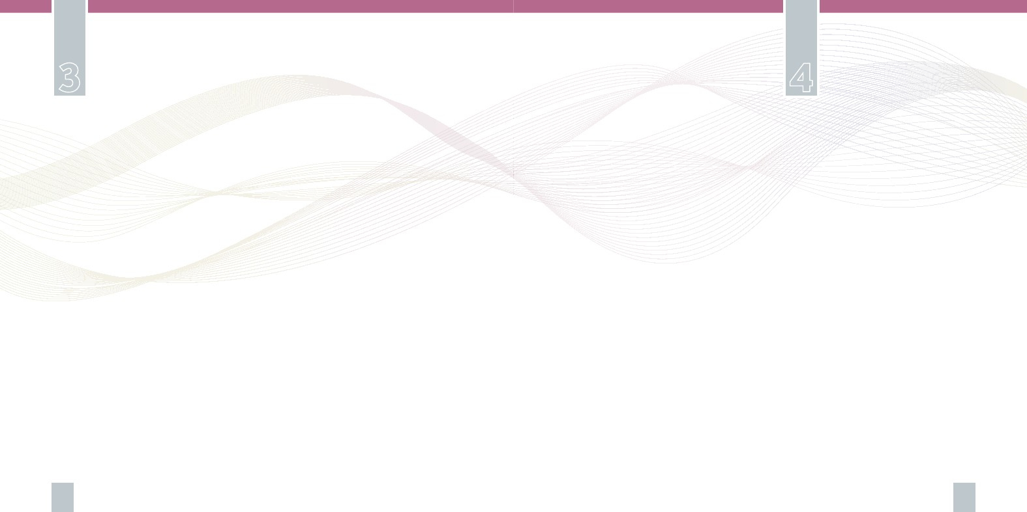
Monitoring and Surveillance Policies
According to WHO estimates there are possibly
13,000 new cases of STIs per year in Malta. The
GU clinic issues an annual report which indicates
an increasing number of service users over the
years since its conception in the year 2000. This
may have resulted mainly from the increased
awareness and availability of services, and
also the increased frequency of infections. The
dearth in the availability of empirical evidence
to explain the increasing use of the GU clinic
strongly suggests the need for research in the area.
Moreover, these noted gaps in the data available
call for more efficient and effective measures on
case notification and a systematic approach at
identifying prevalence.
Legislation
There are a number of direct or indirect references
to sexual health in the Maltese legislation. Articles
198 and 201 of the Criminal Code (Cap IX) deal
with rape and carnal knowledge with violence, while
article 197 deals with prostitution and article 208A
deals with pornography.
Abortion is illegal in Malta and punishable at law
under Section 241-243A of the same Code. Sexual
harassment is also regarded as an offence under
Maltese Law and is regulated by the Equality for
Men and Women Act (Cap 456) as well as Article
29 of the Employment and Industrial Relations Act
(Cap 452).
Furthermore there is the Education Act which
indirectly stipulated a mandate for the teaching
about sexuality in all schools in Malta, by way of
Objective 6 of the National Minimum Curriculum48
which is a legally binding document.
As with other sexual health indicators, the
legislative framework within which sexual health
is maintained and enhanced across a population
needs to be comprehensively studied, evaluated and
revised periodically and accordingly. This policy
highlights the need for such an exercise in the
context of Malta.
17
The social and behavioural indicators identified
in Chapter 2 present the areas regarding which
a comprehensive systematic audit and review
of the situation in Malta is needed. The referred
social and behaviour indicators are to be given
much importance in attempting to address the
sexual health of the population. Coupled with
comprehensive exploratory research activity, the
indicated audit and review initiatives need to endorse
robust methodological approaches. In turn, rigour
in the adopted approaches will allow the findings
of such audit and exploratory initiatives to serve as
the pillars of local strategies and projects related to
sexual health in the country.
The social and behavioural factors indicated above
also call for the surveillance of domestic violence,
substance abuse, adolescent birth rates, sexually
transmitted infections, related diseases (such as
pelvic inflammatory disease and cervical cancer) and
infertility. Furthermore, they also indicate the need
for service use surveillance, such as GU clinic yearly
attendees and uptake of cervical screening tests.
The planning and commissioning of the indicated
research initiatives to an authorised entity,
preferably endorsing the contribution of experts
in sexual health field, is recommended. Potential
entities are the University of Malta, and the
Research and Initiative Division, within the Malta
Council for Science and Technology
Statutory reporting of the main Sexually Transmitted
Infections (Syphilis, Gonorrhoea, HIV and Chlamydia)
in Malta was introduced in 2004. Notifications are
received at the Infectious Disease Prevention and
Control Unit (IDCU) within the Health Promotion
and Disease Prevention Directorate. The frequency
of such diseases in Malta relies on reported cases
by physicians. The numbers notified every year are
possibly an underestimation of the true numbers in
the general population. Furthermore, the true burden
of illness at community level remains unknown since
many cases are asymptomatic and hence do not
seek medical attention. In addition, cases may not be
referred for testing.
16

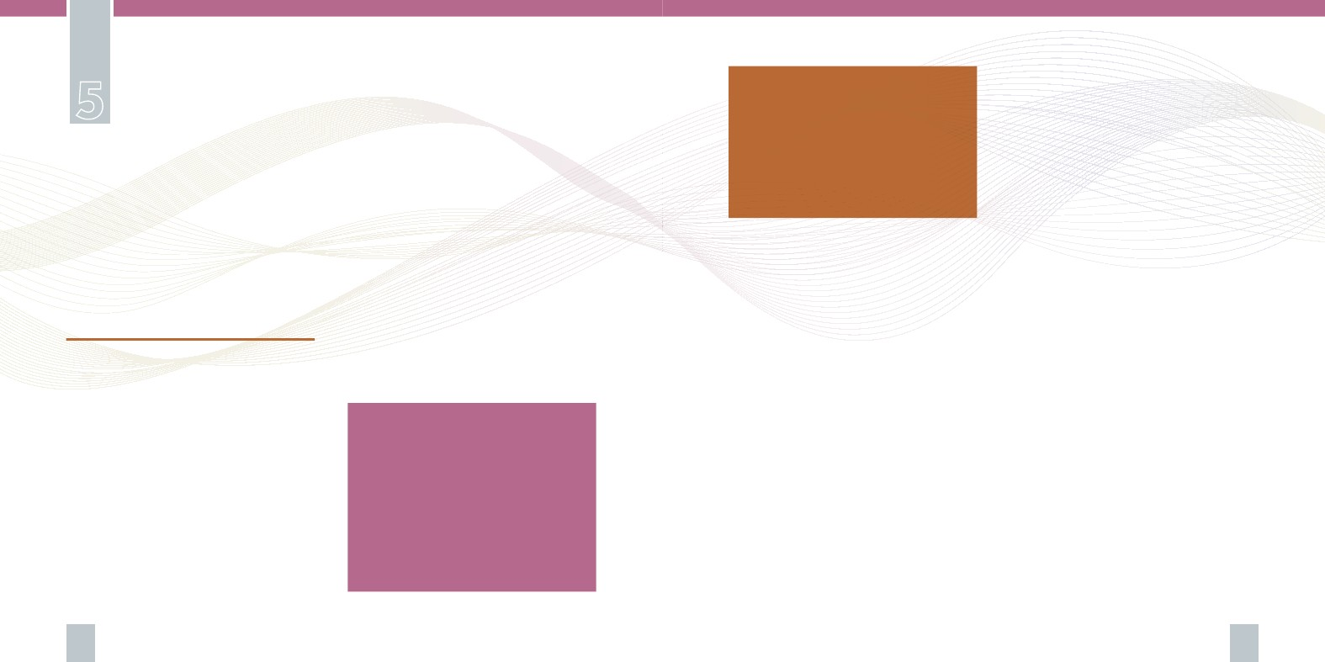
Medical and Health Services
The milieu, ethics, moral and
cultural values, personal choices
and prevalent lifestyles in a context
need to determine the planning and
development of any campaign, since
sexual health is influenced by all such
factors and facets of a society
Close collaboration with stakeholders should
enhance the establishment of such campaigns
directly within the specific environments relevant
to the particular age groups, different groups
or target populations that they are respectively
meant to address.
In essence, such initiatives will aim to:
• empower the population to adopt responsible
attitudes and behaviour for its own health and
the health of others;
• promote healthy life-styles;
• increase sexual health education among
all age groups but especially the young and
adolescents;
• increase awareness of when to seek the
necessary professional care and support.
5.1.ii Behaviour Change
The Health Promotion and Disease Prevention
Directorate in collaboration with the stakeholders
in the field will seek to enable people to
appreciate and protect their sexual health
through responsible behaviour and lifestyles.
Programmes and initiatives will:
• Educate about relationship skills and
the dynamics taking place within sexual
relationships;
• Address gender issues;
• Increase awareness on personal sexual health
and responsibility towards one’s sexual health;
The social and behavioural sexual health
indicators identified in this policy call for a
number of timely preventive and interventional
medical and health services.
5.1 Primary prevention services
Effective sexual health education needs to aim
at lifelong learning approaches which provide
educational programmes aimed at all age groups,
and focused programmes targeted at those
groups identified as being at risk. Innovative
approaches, encompassing the contribution of
all related entities within the health, education
and social sectors, are required so as to be
able to reach specific target populations and
especially vulnerable and high risk groups, in
the most efficient and effective way possbile.
The contribution of respective specialist themes,
securing the relevant expertise would need to be
sought accordingly.
5.1.i Raising Awareness
Sexual health campaigns need to be aimed at
raising awareness and increasing knowledge,
enabling informed choices and providing
opportunities for changes in behaviour. These
campaigns should seek to give people correct
and appropriate information about their sexual
health and the relevant services available.
National information campaigns are to provide
a backdrop for more targeted local prevention
Facts & Figures
• Only 3% of young people aged 14-16
years could correctly identify three
STIs (HIV/AIDS, Gonorrhea and
Chlamydia) from a list of common
infections. Girls were significantly
more knowledgeable than boys.
Source: Bugeja, R. (2010), Unpublished Thesis submitted for the degree
of Doctor of Philosophy. University of Southampton: United Kingdom
efforts. It is imperative that all information,
education, communication and skills-based
prevention programmes are planned and
developed against the specific context in which
they would be delivered, that is specific targeted
contexts within the wider national context. The
transposition of a campaign across different
contexts is believed to compromise the efficacy of
a noted effective campaign in one context. The
milieu, ethics, moral and cultural values, personal
choices and prevalent lifestyles in a context need
to determine the planning and development of
any campaign, since sexual health is influenced
by all such factors and facets of a society.
The Health Promotion and Disease Prevention
Directorate within the Ministry of Health will seek
to enhance its efforts in sexual health promotion.
It will maintain its position of responsibility for
the planning, managing, delivery and evaluation
of such campaigns, in collaboration with the key
stakeholders working in this area.
18
19

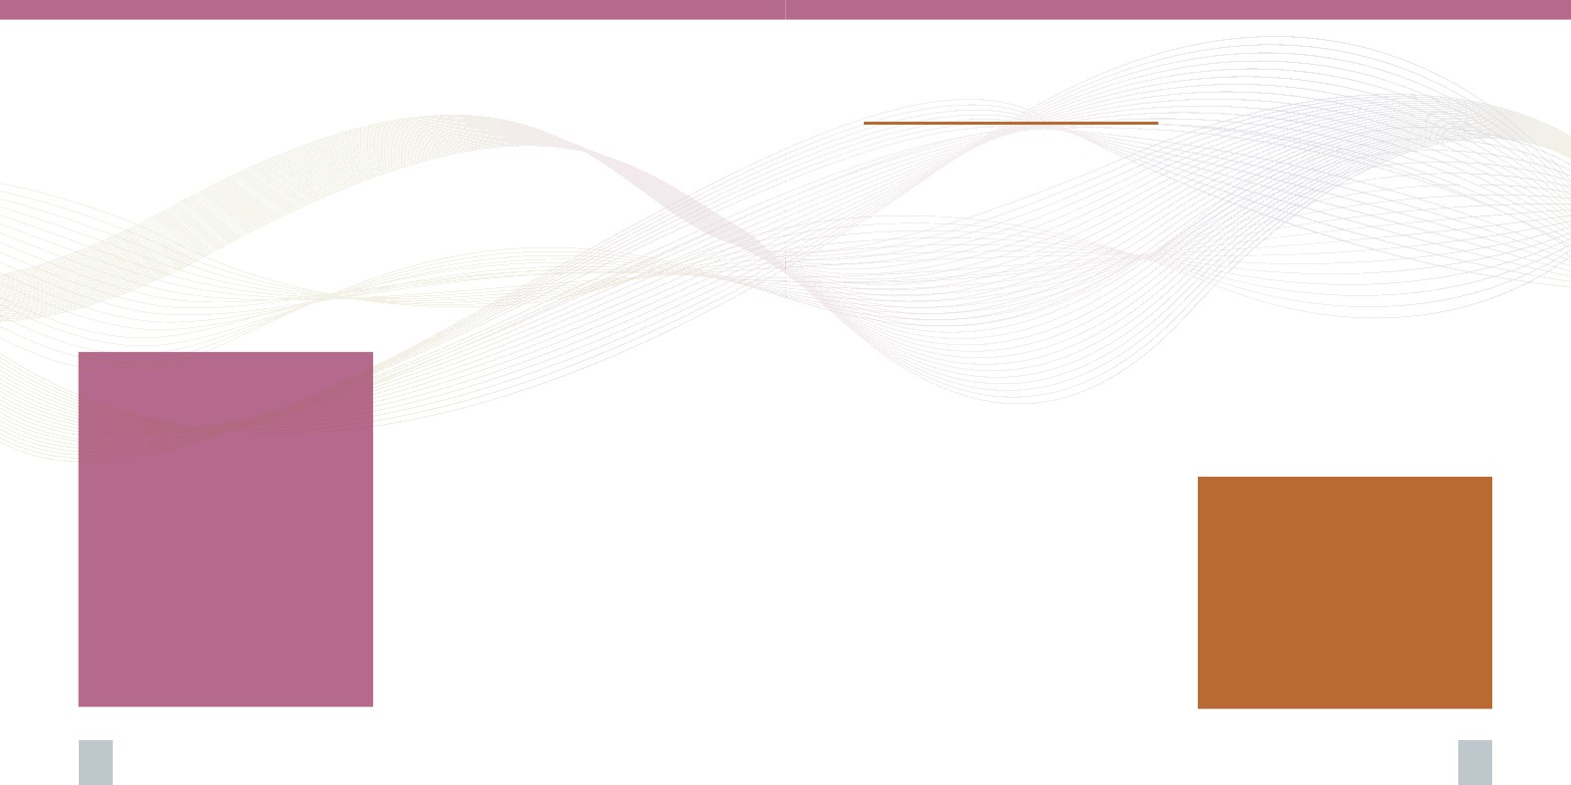
• Raise awareness on fertility, conception, child
rearing skills and acceptance of individual
circumstances;
• Focus on development of risk reduction skills
such as sexual assertiveness and discussing and
negotiating protection measures.
Health Promotion approaches used will emphasise
active learning techniques which aim to:
• Address cognitive, attitudinal and affective
factors;
• Build motivation to change or to adopt a health
behaviour;
Facts & Figures:
• Condoms are the only
contraceptive method proven
to reduce the risk of sexually
transmitted infections, including
HIV
• According to the EHIS study in
2008, 8.5% of the sexually active
population in Malta used condoms
specifically as a way of preventing
sexually transmitted diseases
• 78.2% said they never used
condoms as a form of prevention
against STIs
Source: EHIS (2008) Department of Health
Information and Research
• Address environmental and/or social barriers
that may inhibit change;
• Be sensitive to local culture, diversity, values
and context;
• Be based on mainstream peer-reviewed scientific
evidence;
• Provide outreach opportunities for all
vulnerable target groups as well as minorities;
• Involve face-to-face small group work with peer
support;
• Include workshops in different settings and
aimed at specific target groups such as school
leavers and people living in relative poverty;
• Utilise modern technological tools to provide
informal learning opportunities on sexual
health issues and concerns.
5.1.iii Including Sexual Health Promotion
in Primary Care
Professionals across a range of services,
particularly those in primary care settings, can
play an important part in providing consistent
and integrated information, which needs to be
synchronised with the content of all initiatives
delivered through the Health Promotion Unit. All
initiatives and reforms within primary care in
Malta need to be screened in view of embracing
this contention.
5.2 Secondary/tertiary prevention
and curative services
The indicators of sexual health call for other
services, such as those pertaining to pregnancy
planning and pregnancy/childbirth education,
prevention and treatment of sexually transmitted
infections initiatives, cervical cytology screening
tests setups, and services to prevent and respond
to sexual violence.
All services are to address medical, psychological,
ethical and social needs in as user friendly a
manner as possible, including the development
of outreach services for clients, particularly those
with special needs. All services are to:
a. Take client need, as the point of departure in
determining service development, provision,
monitoring and evaluation;
b. Be friendly to all various ages, and easily
accessible to and all inclusive (non-
discriminatory) of all sections of society, taking
into account for example all socio-economic
inequalities, sexual orientations, people with
disabilities, victims of rape, prisoners and
detainees, and sex workers;
c. Be evidence-based, which will include the use
of standard national guidelines developed by
authorised entities;
d. Respect client’s confidentiality at all times;
e. Maintain records keeping to a high standard,
to provide maximum benefit in client
management, to facilitate audit, and secure
and record the process of obtaining valid
consent;
f. Continually monitor, audit and evaluate their
activities in order to maintain and improve
performance.
These services require, as an essential prerequisite,
adequate leadership and appropriately trained
professional and supporting staff, who must be
obliged to maintain their skills and competencies
through continuing professional development
opportunities. As with most other areas of health,
the multiple factors which influence sexual health
in any society render it its characteristic transient
dynamic nature, which translates into a requisite
for all staff to update periodically, in an attempt
to remain abreast with the developing nature,
As with most other areas of health,
the multiple factors which influence
sexual health in any society render
it its characteristic transient
dynamic nature, which translates
into a requisite for all staff to update
periodically, in an attempt to remain
abreast with the developing nature,
challenges, and facets associated
with sexual health
20
21

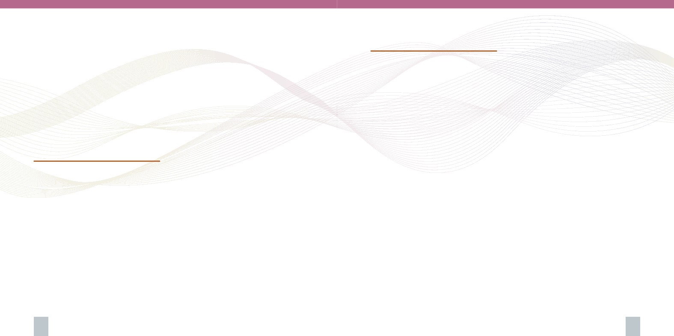
challenges, and facets associated with sexual
health. This in turn obliges the Ministry to secure
the provision of the referred continuing professional
development opportunities for all staff.
Close collaboration with local and overseas
educational and training entities is recommended,
in view of the taxing costly nature of the provision
and uptake of such opportunities. Participation
of staff in exchange programmes is therefore
recommended, as is the Leonardo EU programme.
This integrative exercise would need to be
preceded by a comprehensive evaluation of
the prevalent quantity and quality of all the
respective individual services. Indicated needs
for changes will be carried out accordingly.
One possible way forward may be to migrate
all the currently prevalent services into a single
clinic, which would potentially offer more
comprehensive sexual health care services,
when the resources and contexts permit so. This
sexual health clinic will be easily accessible to all,
including through the use of relevant technology,
as is the internet
Services from such a one-stop clinic will include:
• A genitourinary medicine clinic;
• Contraception advice;
• Protection against sexually transmitted
infections;
• Cervical cytology screening tests;
• Referral for testicular examination as clinically
indicated;
• On-the-spot pregnancy testing;
• Advice and counselling on sexual issues and
responsibilities, with referral as necessary;
• Advice and counselling on STIs, including HIV
and referral as necessary;
• Advice and treatment for common clinical
sexual problems;
• Referral to other professionals/services beyond
the single stop clinic, as indicated.
5.4 Training the relevant professions in
sexual health promotion
This policy advocates the need for training of
professionals across a range of sectors. Opportunities
for training in sexual health need to be channelled
towards health care professionals, teachers,
counsellors, religious workers, psychologists, youth
workers, social workers, and others whose work
involves the direct addressing of and discussion
about sexuality and sexual health. Before reviewing
the characteristics of educational programmes, it
is important to consider the needs to which these
programmes ought to be directed: the development
of appropriate attitudes, knowledge, and skills.49
5.4.i Attitudes
In order to develop a better understanding of
sexual problems, it is necessary for professionals
to develop healthy attitudes to sexuality. An
understanding by the professional of his/her
own sexuality and a rational approach to his/
her own sexual problems will help him/her to be
better able to deal with the problems of others. It
is also necessary for the professional to be aware
of and to accept the wide range of variation in
sexual behaviour so that he/she can transmit this
assurance to clients who seek help for what they
consider to be abnormal behaviour in themselves
or their partners. The need for change in attitudes
is recognized as being particularly important.
5.4.ii Knowledge
In order to approach the topic with confidence,
health professionals must themselves have
accurate scientific knowledge regarding the facts
of human reproduction and human sexuality;
they must know what are common sexual
problems met are and how to deal with them, and
they must know when the solution of a problem
is beyond their ability and requires referral to a
specialist.
5.4.iii Skills
To enhance his or her ability to help those people
who ask for help in the solving of problems
related to sexuality, it is essential for the health
professional to develop the necessary skills in
the art of communication and of good listening.
He/she must be able to use the appropriate
terminology without embarrassment, must be able
to deal with the problem faced by the individual,
must be able to develop a good interpersonal
relationship and establish rapport with him/her
in a non-judgemental way and with sympathy
and with sensitivity. An important development
in this respect is the attempt to assist the relevant
professionals to adopt the appropriate use of
language with their clients, consistent with the
respective socio-cultural context.
5.3 A One-stop-“shop” sexual health
service approach
Currently, there are a number of key stakeholders
in sexual health care provision within both the
public and the private health sectors. These
include primary health care, reproductive
health care, obstetric/gynaecological care, the
urology department, the infectious diseases
unit and the genitourinary clinic. A need and
feasibility assessment process for the integration
and networking of these sectors is indicated in
the belief that further complementation of the
individual services may enhance the outcomes of
the respective individual initiatives, with respect
to both effectiveness and efficiency. The evidence
supporting the integration of services into a one-
stop entity is, as yet, limited but favourable. The
efficacy of such entities are still being studied.
22
23

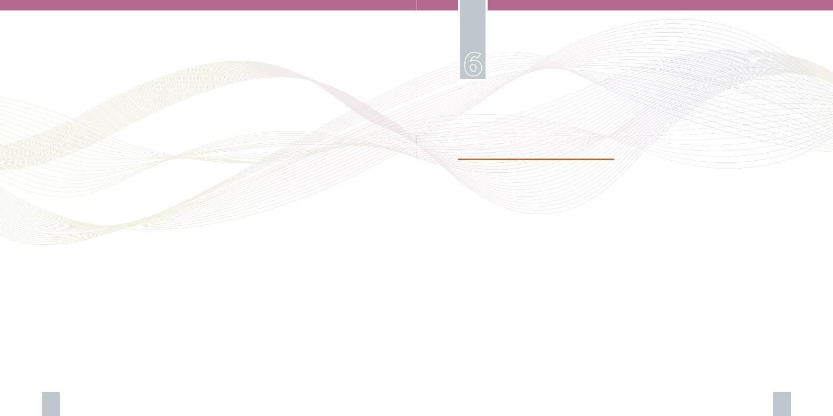
Amongst other factors, the age of the learner is
widely held to be one of the central determinants
of the nature and content of an educational
programme regarding sexual health. There
appears to be a general consensus in the literature
that holding the ability to appropriately pitch a
sexuality and relationships education programme
to the respective age/s of a learning audience, is a
pre-requisite to favourable learning outcomes of a
programme.
Skills appropriate to this area differ only very
slightly from those that should be developed
during the training of any doctor, nurse or
educator. It can nevertheless be pointed out that
the general orientation toward specific clinical
tasks and techniques in the usual training
of health professionals is less appropriate
for personnel dealing with sexual problems,
where the ability to listen and/or a number
of counselling techniques, are to be more
predominant.
Sexuality and Relationships Education
6.1 The purpose and goals of sexuality
education
With the advent of HIV and AIDS in the 1980s
the nature of sexuality education gained
much attention. Seeking a socially, politically
and culturally acceptable raison d’être for
this education practice continues to provide a
significant challenge. One major debate evidenced
in recent literature is whether sexuality and
relationships education should be driven by moral
ideologies, or by scientific approaches showing
evidence of effectiveness, regardless of values
and morality, or both. 50, 51 The main issue with
the latter stand point is that ‘what works’ and is
‘effective’ remains debatable. 52 Very often, the
success of sexuality education is measured by
statistical trends in teenage pregnancies and STIs.
It has been widely argued that sexuality education
should not be a negative process that attempts to
frighten youths, but should take into account the
positive aspects of sexual relationships. 53, 54, 55.
The purpose of sexuality education has also been
extended to include learning about psychological
well-being by enhancing young people’s ability to
deal with their emotions. Indeed it has also been
suggested that thus sexuality and relationships
education ought to be an element within a
broader objective of developing ‘emotionally
intelligent citizens’. 56, 57
Emotional intelligence, which describes more or less
the same concept as emotional literacy, has been
defined as:
“the ability to understand ourselves and other people,
and in particular to be aware of, understand, and use
information about the emotional states of ourselves
and others with competence. It includes the ability to
understand, express and manage our own emotions,
and respond to the emotions of others, in ways that
are helpful to ourselves and others.” 58
24
25

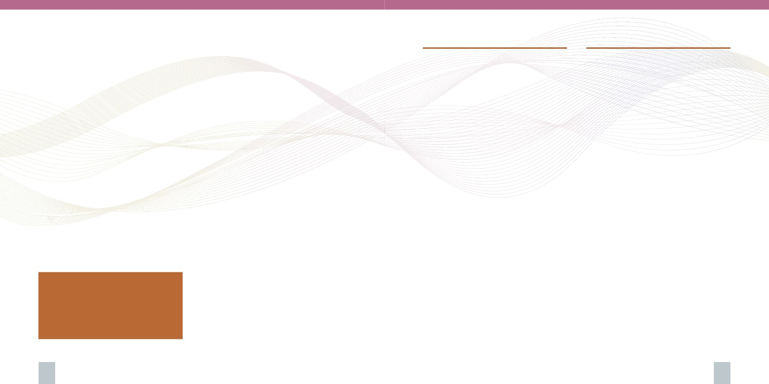
The sexuality and relatiohships education
framework prevalent in Malta needs to be timely
evaluated against the backdrop of this modern
wider and more holistic approach to sexuality
education.
The National Minimum Curriculum59 which
is a legally binding document for all Maltese
schools, addresses learning needs related to
Human Sexuality in Objective 6. This document
identifies the knowledge, capabilities and
attitudes underpinning a true understanding
of human sexuality. This is covered in various
subject syllabi at schools including the Personal
and Social Development (PSD) lessons, Religious
Education lessons, Science or Biology lessons and
Home Economics amongst others, imparting
knowledge / information, skills, values and
attitudes related to sexual health, sexuality and
relationships. However, evidence emanating from
16 focus groups with young people in different
schools across Malta and Gozo, conducted as
part of a local large scale empirical research
The sexuality education framework
prevalent in Malta needs to be timely
evaluated against the backdrop of a
modern wider and more holistic
approach to sexuality education
study,60 indicates that sexuality and relationships
education on the Maltese islands remains
scanty and uncoordinated across the schools,
primarily due to limited and restricted time-table
time for its delivery (especially through PSD
lessons), a wide-spread lack of preparedness and
effective technical skills by teachers and other
educational professionals to discuss sexuality
and sexual health matters with young people,
lack of professional education resources, lack
of coordination between the different subject
teachers addressing sexuality and sexual health,
lack of coordination with parents, and the
lack of national policy that outlines the targets
and standards of sexuality and relationships
education to be delivered in literally all schools
across Malta and Gozo. This calls for further
research, evaluation, quality assurance and
monitoring of sexuality and relationships
education practices, locally, in terms of:
a.The purpose of sexuality and relationships
education
b.Approaches to learning
c. Methods of teaching and learning
d. Sources of information and knowledge
e. Content
f. Timing of learning
g. Learning resources
6.2 Parental and guardian involvement
Parents and guardians are crucial role models
in the upbringing and development of children.
These will be directly involved in the provision
of sexuality and relationship education to their
children. It is therefore imperative that they
receive parenting skills training, information
and support to fulfil their role. They are the
key people to help their children cope with
the emotional, social and physical aspects
of growing up and preparing them for the
challenges and responsibilities that sexual
maturation brings. The development of specific
educational programmes, both formal and
informal, are necessary to secure essential skills
in communicating effectively with their children
about sexuality and sexual health issues.
Schools are to work in partnership with parents,
consulting them on the content of sexuality and
relationships education programmes. Parents
and guardians need to know that the school’s
sexuality and relationships education programme
will complement and support their role as
parents, whilst also giving them the opportunity
of furthering their personal knowledge and skills.
The prevalent services and initiatives being
offered largely through the education and social
sectors are to be periodically evaluated and
developed further as indicated by the respective
structured evaluation and monitoring excercises.
6.3 The media
The policy acknowledges the significant influence
that the media has on the public in today’s world.
Against this backdrop, the need for comprehensive
educational opportunities in partnership with the
media are recommended to positively promote
a consistent approach and philosophy towards
sexuality, built on the guiding principles of this
policy. This is a key component of any strategy
aiming to combat possible unfavourable scenarios
of having members of the public travel through
clouds of partial information, misinformation and
exploitation that they may find from the media.
The potential of the media to contribute
effectively to optimal sexual health is widely
acknowledged and therefore strongly indicates
towards the referred partnership with health
educational initiatives.
26
27


Research, Evaluation
and Quality Assurance Policies
Future Considerations
Ongoing research and evaluation is an essential
component of any policy or service provision.
Research helps to identify new trends and
concerns while assessing need for further services
and interventions. Therefore, all programmes
and interventions carried out with the purpose of
enhancing people’s sexual health, ranging from
health promotion to educational and counselling
needs, and from secondary and tertiary
prevention interventions to curative medical care,
need to be audited and reviewed. Such an exercise
will assess their degree of success and effectiveness
in achieving pre-established goals and targets.
This should in turn guide future interventions and
allocation of funds.
Enhanced co-operation with other countries,
the EU and the WHO in the context of research
initiatives needs to be actively sought and
developed. The recommendations pertaining to
research initiatives have been noted along this
document. The consolidation of the recommended
various research initiatives by one steering entity
is being advised, in that such consolidation is
believed to maximise efficiency of use of resources
in curtailing duplication, repetition and wastage
of limited resources available to pursue the noted
research initiatives. The terms of reference of the
referred steering entity and the members within it
are to be determined accordingly, following wider
consultation, after the publication of this policy.
Quality service delivery standards and protocols
with pre-established targets and objectives need
to be introduced for quality assurance in clinical
service provision, including for contact tracing
and pre- and post- test counselling (such as in
genito-urinary clinic service, sexual health clinics,
sexual violence / rape response services, etc.)
and for sexuality and relationships education
provision (such as in schools).
Reference has been made already to the
characteristic transient and dynamic nature
of sexual health. In view of this nature, issues,
challenges and facets associated with and arising
around sexual health will always be in a state of
flux and evolvement in the future.
The phenomena of globalisation and increased
people migration across countries is increasingly
bringing to light the importance of cultural
competence across all sectors, including
sexual health, and moreover the importance
of acknowledging the needs of evolving
multicultural societies and addressing them
accordingly. For example, Female Genital
Mutilation (FGM) is one of many realities arising
around sexual health which needs to be addressed
more comprehensively in Malta, as a result of an
increase in the numbers of residents originating
from societies where such practices are known
to be prevalent. Government needs to establish
a framework which will be responsible for the
detection of the specific needs of minorities within
the population of Malta.
In the absence of a rigorous framework and
measures which seek to detect the needs, issues
and demands of minority groups, the rights of
such individuals for optimal health care will
be compromised. Complementary legal and
regulatory framework of such practices and
services, and the training of professionals and
supporting staff in skills and knowledge needed to
address the demand of minority groups, need to
be established accordingly.
Another phenomenon which is bound to have
an impact on sexual health is the evolving
nature of the health care team across the globe.
Scenarios comprising of exclusively doctors and
nurses are rapidly being replaced by scenarios
consisting of health care teams, varying from
28
29

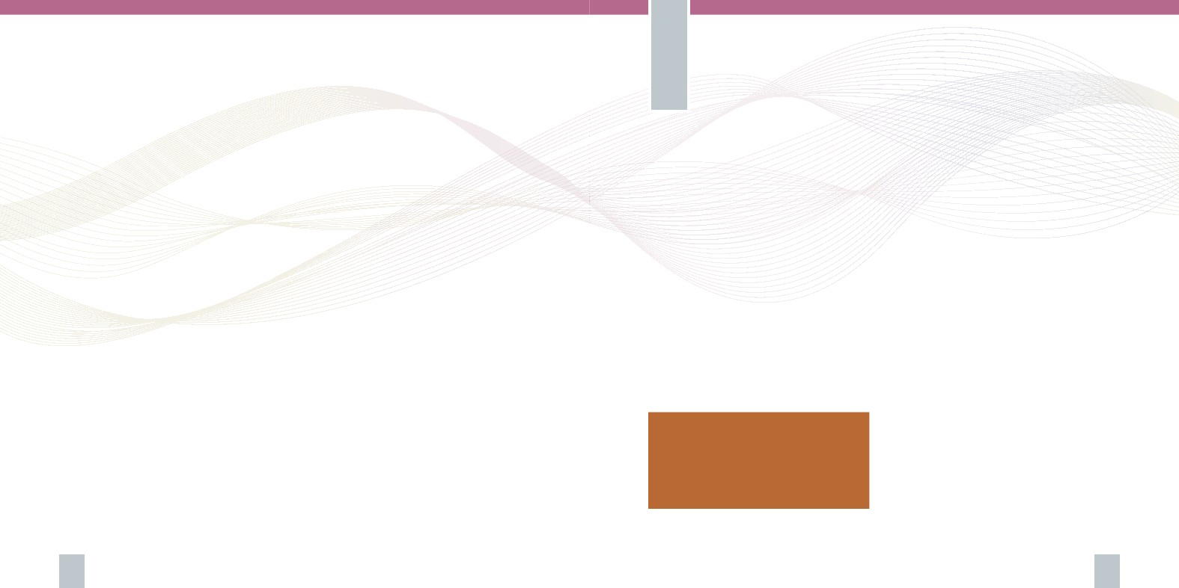
a small number of three or four different
professionals to larger teams endorsing a variety
of professionals, holding qualifications in varying
and narrow specialised fields of practice, as for
example are health counsellors as opposed to
counsellors. As a result of a booming array of
local and overseas educational and training
opportunities, the nature of the health care team
in Malta is also gradually changing. In addition,
existent professions are continually revising and
extending their respective roles. Any policy would
need to be periodically calibrated in tune with
such evolving contexts, in an attempt to remain
relevant.
Conclusion
In being a first for the specific context of Malta,
this sexual health policy seeks to comprehensively
determine the pathway that needs to be pursued in
an attempt to effectively enhance the sexual health
of the population. In summary, the policy identifies
the major sexual health indicators, and drawing on
evidence, it seeks to establish avenues of addressing
the identified indicators.
An avenue comprises a defined beginning and
an end point. This policy clearly highlights the
end points of the avenues; the sexual health
indicators, and recommends constructive ways of
seeking to reach the noted end points. The next
step for the country comprises the determination
of the starting points of the respective avenues.
In the absence of sound evidence regarding the
various facets of sexual health, such as accurate
behavioural patterns and prevalence of disease,
the need for varied research activity is strongly
indicated.
An extensive research exercise which would
seek to explore the social and behavioural facets
of sexual health of people living in Malta is
needed. In addition, an audit research initiative
which would seek to elicit evidence regarding the
prevalent monitoring and surveillance practices
in the country, and the legislative and quality
assurance structures within which sexual health
medical and education services exist, is strongly
called for. All research activity would need to fall
under the umbrella of a recognised authoritative
national entity, such as the Research Ethics
Committee of the University of Malta, and be
The indicated research and the noted
recommendations within this policy
will translate into an effective strategy
for the enhancement of sexual health
across the nation, now and in the future.
30
31


steered by the Ministry of Health at the helm of
such activity. This would secure the adequate
recognisance of the moral, cultural and ethical
sensitivity of the nature of subject of the research
study, to the specific context of Malta.
In providing an accurate snapshot of the current
situation, the collective outcome of such research
activity will determine all the referred starting
points of the respective avenues identified in
this policy. Recommendations for the successful
trespassing of the gap between starting points
and end points across avenues are found within
the policy. The indicated research and the
noted recommendations within this policy will
translate into the basis of an effective strategy
for the enhancement of sexual health across the
nation, now and in the future. The publication of
this policy is being complemented by a series of
workshops that will be launched and co-ordinated
by the Ministry. The contribution of all entities
and representatives from across all the population
towards the building of a comprehensive sexual
health strategy for the specific context of Malta,
will be secured through the referred workshops.
References
1
EC – Director General Health & Consumers (2010) Sexual
Health Policy at EU Level (http://ec.europa.eu/health/
sexual_health/policy/index_en.htm. Accessed on 17
October 2010)
2 WHO (1975). Technical Report Series Nr. 572, 1975 World
Health Organization: Genève
3 WHO (2006). Defining sexual health: report of a technical
consultation on sexual health, 2831 January 2002.
World Health Organization: Genève (http://www. who.
int/reproductive-health/publications/sexualhealth/
index.html. Accessed 30 November 2007). WHO (2010).
Measuring sexual health: conceptual and practical
considerations and related indicators. World Health
Organization: Genève
4 WHO (2010). Measuring sexual health: conceptual and
practical considerations and related indicators. World
Health Organization: Genève
5 United Nations (1994). Report of the International
Conference on Population and Development. New York
(A/CONF.171/13/Rev.1).
6 Hughes G, Catchpole M, Rogers PA et al. (2000)
Comparison of risk factors for sexually transmitted
infections: results from a study of attendees at three
genitor-urinary medicine clinics in England. Sex Trans.
Inf. Vol.76(262-267)
7 Teenage Pregnancy, Report by the Social Exclusion Unit.
London: Stationery Office
8 EC – Director General Health & Consumers (2010) Sexual
Health Policy at EU Level (http://ec.europa.eu/health/
sexual_health/policy/index_en.htm. Accessed on 17
October 2010)
9 United Nations (1994). Report of the International
Conference on Population and Development. New York
(A/CONF.171/13/Rev.1).
10 WHO (2004). Reproductive Health Strategy. Geneva,
World Health Organisation.
11 WHO (2006). Defining sexual health: report of a technical
consultation on sexual health, 28–31 January 2002.
Geneva, World Health Organization (http://www. who.
int/reproductive-health/publications/sexualhealth/index.
html. Accessed 30 November 2007).
12 WHO (2008). National-level monitoring of the
achievement of universal access to reproductive
health: conceptual and practical considerations and
related indicators. Report of a WHO/UNFPA Technical
Consultation, 13-15 March 2007, Geneva, World Health
Organisation.
13 WHO (2010). Measuring sexual health: conceptual and
practical considerations and related indicators. World
Health Organization: Genève
14 Health Promotion Division of the National Assembly for
Wales (2002). A strategic framework for promoting sexual
health in Wales.
15 Abela, A.M. (1998). Secularised Sexuality: youth values in
a city-island. Social Values Studies. Union Print: Malta
16 Incidence measures the rate of occurrence of new cases of
a disease or condition calculated as the number of new
cases in a specified time period (usually a year)
17 Poulin, C. and Graham, L. (2001) The association between
substance use, unplanned sexual intercourse and other
sexual behaviours among adolescent students. Addiction
Vol.96: 607-621.
18 Kaljee, L.M., Genberg, B.L., Minh, T.T., Tho, L.H., Thoa,
L.T.K. and Stanton, B. (2005) Alcohol use and HIV
risk behaviours among rural adolescents in Kanh Hoa
Province Viet Nam. Health Education Research, Vol.20(1):
71-80.
19 Lavikainen, H.M., Lintonen, T. and Kosunen, E. (2009)
Sexual behaviour and drinking style among teenagers:
a population based study in Finland. Health Promotion
International Vol.24(2):108-119.
20 Wellings, K., Nanchahal, K. and Macdowall, W. (2001)
‘Sexual Behaviour in Britain: early heterosexual
experience’, Lancet, 358, pp.1843-1850.
32
33

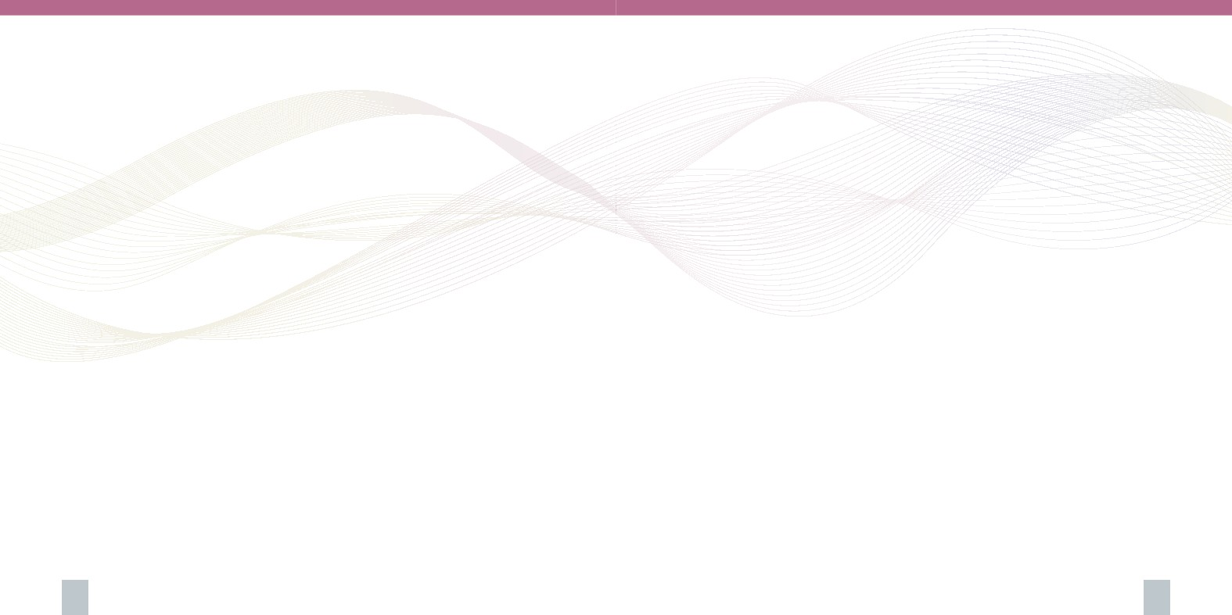
21 Hirst, J. (2008) Developing sexual competence? Exploring
strategies for the provision of effective sexualities and
relationships. Sex Education. Vol.8(4): 399-413
22 SIECUS (1996). Guidelines for Comprehensive Sexuality
Education. 2nd Edition New York: SIECUS Publications
23 Ministry of Education (1999). Creating the future together
- The National Minimum Curriculum. Klabb Kotba Maltin:
Malta.
24 DfEE (2000). Sex and Relationship Education Guidance:
Curriculum and Standards. Nottingham: DfEE
25 UNESCO (2009). International Technical guidance on
Sexuality Education: An evidence-informed approach for
schools, teachers and health educators. France: Unesco
26 Halsted, J.M. & Reiss, J. (2003). Values in Sex Education.
London: Routledge Falmer.
27 Halstead, J.M. and Taylor, M.J. (2000). The development
of values, attitudes and personal qualities: A review of recent
research. Slough: NFER
28 Bugeja, R. (2010). Assessing young people’s learning
needs related to sexuality and relationships on the Maltese
islands: a multi-dimensional approach. Unpublished
Thesis submitted for the degree of Doctor of Philosophy.
University of Southampton: United Kingdom.
29 Wellings, K., Nanchahal, K. and Macdowall, W. (2001)
‘Sexual Behaviour in Britain: early heterosexual
experience’, Lancet, 358, pp.1843-1850
30 Wiley, D.C. (2002) The ethics of abstinence-only and
abstinence-plus sexuality education. Journal of School
Health, Vol.72(4): 164-167
31 Mturi, A.J. and Hennink, M.M. (2005) Perceptions of sex
education for young people in Lesotho. Culture, Health and
Sexuality Vol.7(2): 129-143
32 Wellings, K., Wadsworth, J., Johnson, A.M., Field,
J., Whitaker, L. and Field, B. (1995) Provision of sex
education and early sexual experience: the relation
examined, British Medical Journal Vol.311:417-420
33 Mueller, T.E., Gavin, L.E. and Kulkarni, A. (2008)
The association between sex education and youth’s
engagement in sexual intercourse, age at first intercourse,
and birth control use at first sex. Journal of adolescent
Health Vol.42:89-96
34 UNAIDS (1997) Impact of HIV and Sexual Health Education
on the Sexual Behaviour of Young People: A Review Update.
UNAIDS Best Practice Collection, Key Material (Geneva:
Joint United Nations Programme on HIV/AIDS).
35 UNESCO (2009). International Technical guidance on Sexuality
Education: An evidence-informed approach for schools, teachers
and health educators. France: Unesco
36 Klanger, B., Tyden, T. and Ruusuvara L. (1993) Sexual
behaviour among adolescents in Uppsala, Sweden. J Adolesc
Health. 1993 Vol.14: 468-474
37 DeHovitz, J.A., Kelly, P., Feldman, J., et al. (1994) Sexually
transmitted diseases, sexual behaviour, and cocaine use in
inner city women. American Journal of Epidemiology, 1994;
Vol.140: 1125-1134
38 Wellings, K., Nanchahal, K. and Macdowall, W. (2001)
‘Sexual Behaviour in Britain: early heterosexual experience’,
Lancet, 358, pp.1843-1850
39 Fatusi, A. And Wang, W. (2009) Multiple sexual partnership
mediates the association between early sexual debut and
sexually transmitted infection among adolescent and young
adult males in Nigeria. European Journal of Contraception
and Reproductive Health Care. Apr;14(2):134-43.
40 Warner, L., Stone, K., Macaluso, M., Buehler, J.W. and
Austin, H.D. (2006). Condom Use and Risk of Gonorrhea and
Chlamydia: A Systematic Review of Design and Measurement
Factors Assessed in Epidemiologic Studies. Sexually Transmitted
Diseases, January 2006, Vol. 33, No. 1, p.36–51
41 Burazeri, G., Roshi, E. and Tavanxhi, N. (2004) Does
knowledge about sexually transmitted infections increase
the likelihood of consistent condom use? Preventive Medicine.
Vol.39(2004): 1077-1079
42 Agius, P.A., Dyson, S., Pitts, M.K., Mitchel, A. and
Smith, A. (2006) Two steps forward and one step back?
Australian secondary students’ sexual health knowledge
and behaviours 1992 - 2002. Journal of Adolescent Health
Vol.38(2006): 247-252
43 Trani, F., Gnisci, F., Nobile, C.G. and Angelillo, I.F. (2005)
Adolescents and sexually transmitted infections: knowledge
and behaviour in Italy. Journal of Paediatric Child. Health
Vol.41: 260-264
44 Jones, N.R. and Haynes, R. (2006) The association between
young people’s knowledge of sexually transmitted diseases
and their behaviour: a mixed methods study. Health, Risk
and Society. Vol.8(3): 293-303
45 Biro, F.M., Rosenthal, S.L. and Stanberry, L.R. (1994)
Knowledge of gonorrhoea in adolescent females with a
history of STD. Clinical Paediatrics, Vol.33: 601-605
46 World Association of Sexual health (2009) Press Release on
Human Rights Day - 10th December 2009.
47 Downs, J.S., Bruine de Bruin, W., Murray, P.J. and
Fischhoff, B. (2006) Specific STI knowledge may be
acquired too late. Journal of Adolescent Health. Vol.38: 65-
67
48 Ministry of Education, (1999). National Minimum
Curriculum - Creating the future together. Klabb Kotba
Maltin: Malta.
49 WHO/OMS (1993) Education and treatment in human
sexuality: the training of health professionals. Technical
report series nr. 572. Report of a WHO meeting. World
Health Organisation: Genève
50 Blake, S. and Frances, G. (2001) Just Say No! to Abstinence
Education: Report of a Sex Education Study tour to the United
States. London: National Children’s’ Bureau.
51 Weaver, H., Smith, G. and Kippax, S. (2005) ‘School-based
sex education policies and indicators of sexual health
among young people: a comparison of the Netherlands,
France, Australia and the United States’, Sex Education, 5
(2), pp. 171-188.
52 Bugeja, R. (2010). Assessing young people’s learning
needs related to sexuality and relationships on the Maltese
islands: a multi-dimensional approach. Unpublished
Thesis submitted for the degree of Doctor of Philosophy.
University of Southampton: United Kingdom.
53 Moore, M.J. and Rienzo, B.A. (2000) Utilising the SIECUS
Guidelines to assess sexuality education in one state:
content scope and importance. Journal of School Health,
Vol.70(2): 56-60
54 Mellanby, A.R., Newcombe, R.G., Rees, J. and Tripp, J.H.
(2001) A comparative study of peer-led and adult-led
school sex education. Health Education Research: Theory and
Practice, Vol.16(4): 481-492
55 Hirst, J. (2004) Researching young people’s sexuality
and learning about sex: experience, need, and sex and
relationship education. Culture, health and sexuality.
Vol.6(2): 115-129
56 Social Exclusion Unit (1999) Teenage Pregnancy. London:
The Stationery Office
57 Blake, S. and Katrak, K. (2002) Faith, Values and Sex
and Relationship Education. London: National Childrens’
Bureau.
58 Weare, K. (2004) Developing the Emotionally Literate School.
London: Paul Chapman Publishing
59 Ministry of Education, (1999). National Minimum
Curriculum - Creating the future together. Klabb Kotba
Maltin: Malta.
60 Bugeja, R. (2010). Assessing young people’s learning
needs related to sexuality and relationships on the Maltese
islands: a multi-dimensional approach. Unpublished
Thesis submitted for the degree of Doctor of Philosophy.
University of Southampton: United Kingdom.
34
35


“A society that fosters an environment that is
conducive to persons attaining their maximum
potential for health and well-being”
Our mission is to protect and promote the health of the people of the Islands of
Malta. We are working to protect individuals and communities against the spread
of disease, injuries, and environmental hazards while promoting and encouraging
healthy behaviours and enforcing the laws and regulations pertaining to public
health. The Health Division is dedicated to assuring the accessibility, quality and
sustainability of the public health services and resources.
The Ministry for Health, the Elderly and Community Care
36

