Report of the Civil Alliance for Rights and Feminism ( CARF) in Yemen on the Implementation of the Convention on the Elimination of all Forms of Discrimination against Women (CEDAW)

September 2021

Index:
Introduction.........................................................................................................................3
General Context................................................................................................................4-5
The Transitional Peace Process............................................................................................6
The Constitutional Framework...............................................................................................7
Access to Justice................................................................................................................7-9
The National mechanism for women's advancement......................................................9-10
Special temporary measures................................................................................................10
Stereotypes and harmful practices..................................................................................10-11
Participation in political and public life... .....................................................................11-13
Woman's participation in judiciary.....................................................................................14
Woman’s participation in security corps............................................................................14
Nationality..........................................................................................................................15
Education.......................................................................................................................... 16
Employment..................................................................................................................16-17
Social Security...................................................................................................................17
Healthcare................................................................................................................... 18-19
Objectives of the development plan 2030…....................................................................20
Rural Women...................................................................................................................20
The disadvantaged groups of women...............................................................................21
Marriage and family relations..........................................................................................22

Introduction
This report is the first for the Civil Alliance for Rights and Feminism on the extent of Yemen's implementation for the Convention on the Elimination of all Forms of Discrimination Against Women.

In the preparation of the report, the Alliance counted on an action plan which included implementing a training course for the members of the Alliance on the convention and preparing the report, collecting and analysing the information, appointing a Report Drafting Committee, organizing workshops for the purpose of discussing and enriching the draft and approving of the final version of the report.
The report has faced a number of difficulties and complications in collecting data and information from the relevant parties and if the data was not classified on the basis of gender and non-updated or as in studies that depend on samples of limited focus and scope.
The Alliance extended it’s thanks and appreciation to the Office of the High Commissioner for Human Rights and the German Friedrich-Ebert foundation - Yemen Office, for their cooperation in providing the necessary support for the completion and submission of the report.

Maha Awadh
Wogood for Human Security
Alliance Coordinator
Yemen- Aden

1. The General Context

Yemen is in a very difficult and the complex situation of crises resulting from conflict and war, which is reflected even more on the situation of the women and girls, as Yemen occupies the 155th penultimate rank in the global index of the gender gap for 2021 compared to the index 115 in 2006, despite the intensive efforts and programs in this aspect.
The security situation in Yemen has deteriorated even further during the period of 2014 - 2021, with a slight disparity between one governorate and another, with the continuation of the economic blockade, legal marginalization, destruction of infrastructure especially the service sectors, and the absence of the political will in woman's issues, as well as the practices of restricting freedom of expression and movement, and the increasing Sectarian strife and religious extremism, the significant deterioration of the economic and social situation can be noticed after the price of the US dollar has reached 1030 riyals, which was reflected on the humanitarian suffering with the increased prices of food, medicine and fuel, and the inability of millions to buy basic living necessities. There are 4.6 million women and 5.5 million girls in need to be helped by the year 20212 and the women dependant families face food insecurity despite the international and regional declaration of support for Yemen with billions of dollars, and yet the impact of these amounts has not appeared on these conditions in general or on the performance of state institutions that suffer from weakness and rampant corruption.

From March 2020 to June 2021 Yemen has witnessed many military events that led to a displacement movements in new areas in Abyan, Al Hudaydah, Marib, Al Jawf, Taiz and Al Dhale’, most of them were women, not to mention the large number of civilian women who were victims of the bombing of residential neighbourhoods since the beginning of the war, the number of victims had reached (1333) between dead and injured, including “528” dead, and “805” injured, in addition to the death and injury of 109 women as a result of mine explosions in grazing areas and farms, according to the statistics of the National Investigation Committee. The security incidents also resulted in an additional multiplicity of armed groups, particularly in Aden, Abyan and Lahij that affected the safety freedom of male and female citizens and the implementation of the Riyadh Agreement is still faltering which has exacerbated the tensions and the deterioration of services in the areas under the legitimate government and the parties supported by the Arab alliance.

Women suffer due to the deterioration of the legal protection system including the judiciary and security services, the strikes of the judiciary in some of the liberated governorates and the temporary capital Aden has increased the number of violence cases against women especially sexual abuse of all kinds. As well as threats to female activists and defenders who play a prominent role and demand better protection of rights and protest against the poor conditions.
Generally, no strategy has been adopted to protect women and girls during conflict or in response to the collapse of the peace process.

Recommendations:
1. Obligating all parties of the conflict to protect woman and implement Security Council resolutions related to the protection of women from all forms of violence acts during armed conflicts, especially sexual abuse.
2. Bind the country to enact urgent resolutions that protect women during and after conflicts and to harmonize them with the International Convention on the Elimination of All Forms of Discrimination as well as to establish a mechanism for its implementation.
3. The review of the policies and procedures that cause gender-based discrimination and violence and apply principles of due diligence to protect women and girls, and to also develop and implement programs by law enforcement agencies and those providing legal and social services.
4. Adopt transparency regarding the mechanism by which the aids provided to Yemen are issued.

2. The Transitional Peace Process
- The years of the war have changed the structures of the country’s institutions as it is no longer reflects an interest in gender equality, and caused to the continuous deterioration of women's human rights.
Steps taken to adopt a national action plan to implement resolution 1325 and the other subsequent resolutions on women, peace and security.
- The Ministry of Social Affairs and Labor led the process of preparing the National Action Plan on Women, Peace and Security (2020-2022). The steps taken were to write an initial draft by the technical team followed by the issuance of Council of Ministers' resolution No. (106) for the year 2018, for a National Committee , as the resolution of the Council of Ministers No. (106) of 2018 in the formation of a national committee to discuss the draft, and the Regression Council Resolution No. (75) of 2019 was issued approving the National Action Plan for Women Peace and Security, without allocating a budget, and despite having two years pass on the plan, it has not yet been implemented.

Recommendations
- Redrafting the National Action Plan to include the implementation of the Convention on the Elimination of all Discrimination against Woman and the Declaration of Beijing, as well as the resolutions on women, peace and security .
- Adopting the participation approach in the national action plan from the national and local actors, civil society organizations, feminist groups, academic institutions, and others.
- Provide the national action plan with a budget for implementation.

3. The Constitutional Framework
- The Constitution Drafting Committee consisted of 17 members, with the participation of 4 women to 13 men, i.e. the proportion of women is 23.5% specialized in the legal field, social and political sciences and gender. However, the constitution's draft did not define or prohibit all forms of discrimination against women, as it still reflects strict referencing regarding the women's rights, impose jurisprudences on them and leaves room for retrogressive interpretation, along with a clear defect in the texts related to women in the variance from one text to another. It also reflects the retreat of the Constitution Drafting Committee from what was approved in the outcomes of the National Dialogue from the Rights and Freedoms Team.

Recommendations:

- Redrafting the constitution’s articles with a focus on comprehending the variables of the stage and women's needs for protection.
- Adding female experts in constitutional jurisprudence, male or female politicians, civil society and feminist organizations.

4. Access To Justice
- Hundreds of women in a number of governorates were subjected to arbitrary arrests because of their political attitudes, social and humanitarian activities. They were deprived of their rights to freedom of expression and were subjected to forms of torture. As currently a number of (403) female prisoners and detainees in the central prisons of the capital municipality, which is in the top of the list with a number of (200) as well as Al-Hodeida, Marib, Aden, Taiz and Hadramout, they were deprived of their rights to access justice and fair trial due to the lack of legal support in all governorates, and the litigation’s slow pace of procedures by judges and the frequent strikes.
- The work of the judiciary has stopped due to the judicial strike and the compulsory closing of the courts and the supreme court imposed by the Southern Judges Club in Aden, Abyan and Hadhramaut since March 2021, as thousands of women were affected in cases of expenditure, custody, requests for limited inheritance and pension issues. In addition, the accumulation of dozens of accused women in criminal investigations centers in Aden, without referring their cases to the judiciary or transferring them to prison.

- The halt of civil and feminist organizations in providing legal aid to women held in prisons during the years 2015-2016-2017, due to war conditions and transformation of organizations' programs from the development to the relief side, and had partially returned in some governorates such as the capital municipality, Aden, Taiz and Hadramout.
Table No. (1) Shows the number of women imprisoned in the central prisons of the Yemeni governorates
Governorate | Number of  detainees | Number of  Prisoners | Number of children accompanying  their mothers
Capital municipality |  | 200 | 28
Aden | 23 | 15 | 4
Abian |  | 1
Taiz |  | 14
Ibb |  | 41 | 6
Mukala |  | 13 | 5
AlMahra |  | 1
Marib |  | 13 | 4
Hodeida |  | 86 | 7
Source: private
The capital municipality comes at top of list of imprisoned and detained women with a number of "152", followed by Al-Hodeida with "86" women. Most of the women detainees and prisoners in those prisons are still under investigation, even though most of them have been in there for more than two years without trial, and most of them were arrested on immoral and difficult-to-prove charges, including the charge of the so-called shameful act and adultery, in addition to charges of prostitution and intelligence for parties in the conflict, as well as the arrest of women participating in protests, activists in humanitarian and development work, or the women whose male relatives are participating in war or economic exploitation. Most women's sections in the prisons of Yemen lack all necessary medical care and treatments while a number of pregnant women are within the prisoners, as some of them are in the final months of pregnancy and some have given birth. Children who accompany their mothers in prison are deprived of the rights to education and vaccination from the spreading diseases, as well as their basic need for food and hygiene, in breach of the law. And yet a number of women remain in prison despite the end of their sentence in violation of the law, under the pretext that a male guardian needs to be present to receive the female prisoner.

Recommendations:
- Activating and supporting the judicial aid project in the Ministry of justice for the benefit of poor women, victims of violence and female detainees.
- Ensuring the right to integrated health and nutritional care for women detainees and prisoners, especially pregnant and lactating women.
- Provide suitable and serviced shelters for released women whose families refuse for them to return to their homes.
- Releasing women convicted after the end of their legal sentence, similar to the males, according to the law.
- Provide female staff when investigating imprisoned women.
- Opening reserve detention sites in all of the governorates.
- The coordinating and joint cooperation between government agencies, non-governmental organizations and feminist regarding judicial assistance.

5. The National mechanism for women's advancement
5.1 Women's National Committee:
It has continued its work until the end of 2016, after which the reality of the National Committee changed by placing it under the administration of the de facto authority in Sana'a, but despite the legitimate government’s reinstating the women’s national committee in the temporary capital Aden, it did not work to reinstate the Supreme Council for Women.

5.2 The National Human Rights Institution:
The government has not made steps to establish an independent national body for the promotion and protection of human rights according to Paris Principles.

5.3 The National Committee to Investigate Human Rights Violations:
This committee was established as a temporary national mechanism to investigate violations related to international humanitarian law and human rights law in accordance with Republican Decree No. 140 for the year 2012 and its amendments. The Decree had obligated the committee to work with the international conventions such the Convention on the Elimination of All Forms of Discrimination against Women, and giving a minimum of 30% of women in the composition of the committee. Currently, the committee consists of 9 individuals, including 4 women, but the committee needs a strategy to integrate gender.

Recommendations:
- The necessity to restores the governmental institutional framework for the Supreme Council for Women and the National Committee for Women.
- Working to establish an independent national human rights body in accordance with Paris Principles, and defining the mechanism and criteria for selecting members, taking into account the gender in the national institution and to guarantee it’s independence.
- Developing a gender strategy in the work of the National Committee to Investigate Human Rights Violations.

6. Temporary special measures

There are no temporary special measures, and the feminist movement is working to push for positive discrimination that helps women to participate effectively in political life.

Recommendations:
- Applying the quota system to achieve women's participation in peace negotiations, the political process, reconstruction and construction efforts.

7. Stereotypes and harmful practices:
- There is no legal framework criminalizing gender-based violence. The government has also failed to adopt! a domestic violence bill that.
- The societal environment pressures the opportunities of protection for women and their ability to obtain them, including the process of reporting domestic violence.
- A number of girls and women face honor-based violence, as well as husbands murdering their wives and there are no official statistics on this violence.
- The Humanitarian Needs Report for 2018 said that (60,000) women are at risk of sexual violence, including rape. According to the United Nations Office for the Coordination of Humanitarian Affairs, the recorded amount of incidents of gender-based violence increased by 63% in the first quarter of 2016 compared to the first quarter of 2015. It also increased by 36% during the year 2017, and the 2018 report mentioned that 12.9 million people need protection, and that nearly 3 million women are exposed to the risks of gender-based violence. Violence also prevails in the public space, and increased during the conflict, where the majority of it is carried out by the host community (or the host family), or in camps for the displaced, and by armed individuals belonging to one of the parties.
- Forced marriages and divorces have increased since 2014 up till 2021, and have increased in prevalence due to the war, and the deterioration of the economic situation.
- The misleading media affects women's issues and the exploitation of women in media mobilization for the conflicting parties.

Recommendations:
- Criminalize domestic violence, without pardoning the punishment when the victim’s guardians concede.
- Detect and document honor-based violence.
- Provide shelters for abused and homeless women at the level of all governorates with integrated services.
- Activate a hotline for guidance on gender-based violence.
- Form women protection committees in all governorates.
- Reinforcement the role of professional and impartial media that supports women's issues and expresses their reality and efforts in peace endeavors.

8. Participation in political and public life
Looking into the process of negotiations that took place after the war, Security Council Resolution 2216 was unresponsive to gender, the participation of women took place in the third round of negotiations in Kuwait in 2016 and was limited to the participation of 3 women with a percentage of 10%.
Negotiations courses | The govt. delegation |  | Ansar Allah group “Houthis”. Delegation
Negotiations courses | women percentage | men percentage | Women percentage | Men percentage
Geneva Jun. 2015 | 0% | 100% | 6,25% | 93,75%
Geneva Dec.2015 | 8,33% | 91,67% | 8,33% | 91,67
Kuwait Aug. 2016 | 10% | 90% | 6,25% | 93,75%
Geneva Sep. 2018 | 14,2% | 85,8% | 0% | 100%
Stockholm Dec. 2018 | 14,2% | 85,8% | 0% | 100%
A table showing the percentage of women in comparison to that of men in the discussion sessions

The Kingdom of Saudi Arabia sponsored discussions between the legitimate government and the transitional council that led to the conclusion of Riyadh agreement, on 5th of November, 2019. Discussions were limited to the conflicting political parties, and the delegations were made up of 100% of men.
Although the outcomes of the dialogue conference stipulated that the participation of women should not be less than 30%, we see that the appointments since 2014 contradict this, as only 3 female ministers were appointed in the governmental competencies in 2014, and this represents 7%, and only two women were appointed in the 2015 and 2018 governments 6.8%, in the formation of the government of competencies of 2020, women faced the violation of the right to equality through marginalization and exclusion (0%).

8-1 Participation of women in the committees emanating from the peace talks
After the peace talks in Stockholm 2018, it was agreed to form 3 committees, namely the prisoner exchange committee, Taiz Committee and the redeployment committee in Hodeida. As well as committees to implement the Riyadh agreement, all of these committees were composed of individuals belonging to the conflicting parties, and there isn’t any representation of Yemeni women.

8-2 Participation of women in security and military committees:
Women were not represented in the membership of any of the supervisory, security and military committees that were formed from the first round of the Geneva negotiations "1" 2016, the Stockholm Agreement of 2019 as well as the Riyadh Agreement committees.

8-3 Participation of women in local peace building:
Women and feminist organizations have played a major role in promoting local peace, as the Association of Abductee’s Mothers has contributed to the release of 566 abductees, detainees and the forcibly disappeared persons. Women have also participated in Humanity Relief Efforts for the internally displaced and war-affected families.

8-4 Participation of women in parties:
There is no update in the data for women in parties, except for the elections of the Socialist Party Authority in Taiz governorate, where there were only 3 women in the party.

8-5 Participation of women in the diplomatic corps:
The data showed that the representation of women at the level of the high diplomatic corps is very small, as at the present time there are only 3 female ambassadors, and as for the data provided by the Ministry of Foreign Affairs it also includes female ambassadors who retired.

Current Position | Males | Females | Total | Women Percentage
Minister | 4 | - | 4 | -
Ambassador | 168 | 11 | 179 | %6.1
Minister Plenipotentiary | 70 | 6 | 76 | %7.9
Counsellor | 53 | 3 | 56 | %5.4
First secretary | 123 | 25 | 148 | %16.9
Second secretary | 74 | 17 | 91 | %18.7
Third secretary | 104 | 27 | 131 | %20.6
Diplomatic attaché | 53 | 12 | 65 | %18.5
Administrator | 170 | 25 | 195 | %12.8
Total | 819 | 126 | 945 | %13.3
The Source: Ministry of Foreign Affairs 2018

Recommendations:
- Allocating a minimum of 30% for women in the public and political fields and peace negotiations, negotiating delegations and all peace committees and political processes for the transitional period.
- Take measures to ensure that the peace agenda responds to gender, and formal consultation with women in the negotiation process, including rural women and conflict survivors, to ensure that their priorities are addressed in any political settlement.
- Obligating the government to rehabilitate and build the women's capacities working in the diplomatic corps.

8-6 Participation of women in the judiciary:
There is a slight improvement in women’s participation in the judiciary by issuing decisions to promote women, especially since mid-2017. There is currently one female judge in the Supreme Court compared to “42” male judges and “2” female judges in the courts of appeal with the rank of head of a division, which is the second civil division and the second personal division, 3 female judges were also appointed to preside over the courts of first instance “taxes, juveniles and primary.” The number of women working in the judiciary is 36, compared to 310 male judges, and 42 women are members of the prosecution, compared to 466 male prosecutors. .
A number of "36" females compared to "264" males was admitted to the Higher Institute of the Judiciary.
Recommendations:
1. Updating and developing the work of the judiciary in various scientific and practical fields and in the field of judicial studies and research.
2. Raising the capabilities of women working in the judiciary.
3. Involving female judges and administrators in decision-making centers and in the Supreme Judicial Council, by no less than 30%.
4. Involving female judges in specialized courts according to their competence and capabilities.
5. Activating the previous Cabinet Resolution No. (107) for the year 2010 to keep pace with developments.

8-7 Women’s participation in the security corps:
The current number of women working in security reflects the image of the low presence of women in the most important security and law enforcement institution, where there are 14 women at the rank of officer, 5 at the rank of captain, 6 at the rank of lieutenant, and 94 women at the rank of warrant officer. During the past three years, 453 new women have joined the women's police, and 500 are employed in the interior ministry, and two of the women are currently holding the position of general managers in the departments of women and child protection and information management as the highest positions in the security corps.
Recommendations:
1. Integrating gender into security sector reform.
2. Building women's security capabilities through training and rehabilitation in specialized security and military fields.

9. Nationality
- Although the Law No. 6 of 1990 was amended by the Law No. 25 of 2010 regarding nationality, a Yemeni mother has the right to grant her nationality to her children from a foreign husband, however, the data was not provided by the concerned party a result of the data system being in Riyadh, and there are still obstacles that the women face when granting their nationality to their children in retroactive effect that is limited by a period of time in the law, also those women married to foreigners without the prior approval of the Minister.
- The legal discrimination between women and men continues in the matter of equal acquisition of nationality on the basis of marriage.

Recommendations
- Extending the period of Yemeni women’s benefit in granting their nationality to their children with retroactive effect as compensation for the period of suspension in the implementation of the law.
- Amending the law to abolish the requirement of prior approval from the minister for Yemeni women married to foreigners for previous cases from the issuance of the law.
- Amending the Nationality Law to achieve equality between men and women regarding the ability to pass on their nationality to their spouses.

10. Education
The war had its harmful effects on the education process in Yemen. 5.6 million children of them were (52% girls). They need help in education in the year 2021, as more than 1,600 schools have become unusable due to the destruction caused by the military operations in the governorates of Saada, Hajah, Hodeidah and parts of Al-Dhalea and Lahj, yet they did not renovate the schools that were bombed in Aden, Taiz and Abyan.

The schools were being used as buildings hosting internally-displaced persons or occupied by armed men for military purposes. Furthermore due to the spread of Covid19, the education process had stopped for almost 6 months.

The displaced families have difficulties in getting their children to school due to various reasons, including lack of documents and limited capacities of the classrooms. The Office of the United Nations High Commission for Human Rights has included internally displaced persons in the list of people who are likely to have difficulties in obtaining an education with a percentage of (29%).

Recommendations:
- Rebuild and recreate the appropriate school environment and determine the parties and tasks in the process of construction and selecting the most appropriate choice.
- Activate the role of the private sector in supporting and providing poor families with school supplies and uniforms.
- Encourage the care for teaching the displaced and those with special needs and providing them with all facilities in schools.

11. Employment
11.1 Unemployment:
Central Agency statistics in 2013-2014 showed that the percentage of men outside the labor force was (34.6%) of 15 years old and over, and (94.0%) of women 15 years old and over. In the same year, the Central Agency stated that the gender gap between women and men outside the labor force is about 172%, and the (parity index) is about 272%, meaning that for every 100 men outside the labor force, they are matched by about 272 women outside the labor force.
The current conflict has devastated the Yemeni economy, leaving millions of Yemenis unable to afford basic necessities; The economic collapse led to a lack of livelihoods, as the Yemeni economy shrank by an estimated 50%, and female employment decreased by 28%, and on a national scale a 43% decrease occurred in the percentage of women’s employment in Sana’a to the private sector, which was the most affected by the war, while in Aden a number of working women has increased by 11%. As for the projects of companies owned by women, 42% of the companies owned by women have mostly closed due to material damage, as well as loss of capital and the lack of electricity and fuel.
11.2 The arbitrary exclusion of women after the war:
Since 2015, after the fighting stopped in Aden, the temporary capital, many female employees were dismissed from their governmental positions, especially those who were at the rank of general manager / director of administration / head of department, as well as many school principles, and military employees, on the pretext that they represent the previous system, and most of them were replaced by men and few women in most ministries and facilities and we have been informed about them (Ministry of Finance / Central Bank / Ports of Aden / Civil Service and Insurance / High Schools in Crater / Sheikh Othman districts) and the imposition of a system of arbitrary replacement in the areas of de facto authorities’ rule for many jobs in the government and security sectors .
All approved jobs, especially in sovereign facilities, were not subjected to official procedures and direct supervision by the Service Office and the Labor Office, where 85% of these jobs are male jobs. There are 137 jobs through the Ministry of Civil Service, 75% of which were occupied by males, even though it is an official job, it was not subjected to the procedures and conditions of differentiation for the public job.

Recommendations:
- Treatment of the social and economic structures and cultural stigmas that have constrained women's participation in the workforce.
- Conducting studies to ascertain the extent of the resulting conflict-driven changes in the workforce of women.
- Returning jobs that were confiscated and replaced arbitrarily with other persons in the areas of the de facto authorities.

12. Social security
The war caused the suspension of the work of social welfare institutions during the period 2015-2017 and their branches were bombed and destroyed in Abyan and Al Dhale’e and others were broken into in Lahj, Shabwa and Mukalla. In 2017, the World Bank intervened to support the disbursement of aid through UNICEF, to which the database available since 2014 was transferred and the disbursement was done through intermediary companies for cash transfers to beneficiaries according to the categories defined by the law, and although the war doubled the number of beneficiaries covered by the law, including the affected women, however they were not included in social care.
Recommendations:
- Carry out reforms in the social protection systems in Yemen, including legislation, regulations and new systems that fit the new stage
- Updating the database to ensure the inclusion of the expected cases, including the affected women, according to the categories defined by the law.
- Prepare a strategy for social protection in Yemen.
- Strengthen the relationship between the social safety net and establish a coordination mechanism.
- Build an effective partnership between civil society organizations and the social safety net.

13. Health and health care
The conflict in Yemen has led to an unprecedented deterioration in the health situation, and the United Nations Population Fund’s response report in February 2018 indicated that 16.4 million people lack basic health services, 500 maternal deaths per 100,000 live births between the years 2019-2020 compared to 148 Maternal deaths in 2013, 71% is the percentage of anemic pregnant and lactating women, 75,000 pregnant women are at risk of complications, and 1.1 million pregnant women suffer from severe malnutrition.
Many health workers still do not realize the woman's right to health care and ask the husband's consent, especially to perform deliveries, despite the wife's consent and her urgent need to perform the operation in difficult deliveries and caesarean sections.
The information of the National AIDS Control Program, according to the 2009 World Health Organization reports, indicates that the prevalence rate does not exceed 0.02%, and because of the armed conflict, many residents have been displaced and new cases have appeared in the governorates hosting the displaced, for example, Marib governorate, where reports indicate for the years 2018-2019 to the registration of about of (45) cases, while the reports for the past years did not exceed (2) cases.
The number of registered cases have reached (7,854) by December 2020, of which 2471 are under care.
Number of cases enrolled in treatment centers up till December 2020
Governorate | No. of cases under care | No. of cases under treatment
Sana'a | 3165 | 1772
Hodeida | 557 | 269
Mukalla | 200 | 119
Taiz | 259 | 169
Aden | 506 | 337
Total | 4928 | 2926

COVID-19 pandemic:

- With the spread of the pandemic in Yemen, female (doctor, worker, student and volunteer) persevered in their work and did not abandon their functional and humanitarian role even with the lack of means of prevention, which in turn caused the death of several female doctors, nurses and workers.
- Under the influence of the pandemic, private medical institutions have reduced the number of their employees, tightened conditions, including reducing financial benefits, and the woman were the first victims in such or other measures
- In the vaccination against the virus, women were not taken into consideration when determining the vaccination centers, for how far the centers are or the nature of the place, and there was no effect on the process of awareness and no urge for vaccination, especially for women, with the existence of a counter-campaign questioning and calling for its rejection.
- Closing many small and medium enterprises that were either owned, managed by women or having women working there, and the result was a decline and loss of job opportunities and sources of income.
Recommendations:
- Pay more attention to reproductive and sexual health programs and provide support for effective services in maternity, family planning and education.
- Raising the awareness for sexually transmitted diseases, especially HIV-AIDS, in light of the spread of drugs and poverty, which led to some young boys and girls to fall victims of sexual profanity.
- Support civil society organizations to activate their role in raising awareness and providing comprehensive preventive intervention programs after the programs stopped due to the change of the grant to the emergency grant.
- Issuing a circular for the health staff to stop requesting the husband's consent to perform a delivery on the wife.
- Dealing with people living with HIV/AIDS without stigma or discrimination.
- Activate the PCR and CD4 unit, especially since the devices are available in 5 governorates Aden, Sana'a, Al Hudaydah, Hadramout, and Taiz, due to the lack of operational solutions from the International Organization for Migration (IOM), the recipient of the grant.

14. The objectives of the 2030 Development Plan
There is no 2030 development Plan, and Yemen was ranked 179th in the Human Development Report for the year 2020 out of a total of 189 countries. Yemen is facing the largest humanitarian crisis in the world. Poverty and unemployment indicators have risen and expanded, resulting in serious social and economic problems.

Recommendations
- Prepare the 2030 development plan for Yemen on the basis of partnership.
- Combine the emergency humanitarian aids approach and the development approach.
- Coordinating efforts and adopting strategies that allow affected individuals and communities to regain their autonomy and concern for the right to development.

15. Rural women

- The poverty rate is 72% among families headed by women at the rural level, while the poverty rate among families headed by women is 20.1% at the urban level.
- Since before the crisis less than 1% of agricultural land was owned by women. Also, on average, female agricultural workers earn 30% less than male farmers.
- After the outbreak of the war in 2015, the agricultural sector in Yemen was affected, which made male and female farmers abandon their farms .In 2015, about 40% of male and female farmers abandoned their agricultural lands, which increased the loss of livelihoods.
Recommendations:

- Treatment of the direct causes for food insecurity and malnutrition ensuring access to adequate food and ensuring standards of living.
- Ensuring the rights of the rural women, including participation in decision-making, access to services, goods and resources, and responding to their needs in economic recovery programmes.

16. Disadvantaged groups of women
16.1 Marginalized Women's Status:
- The low percentage of marginalized women who know how to read and write, and because of the significantly low education level, the weak educational and craft skills and abilities, many of the women work in sweeping and cleaning the streets, and a large number of them work in the profession of begging, which exposes them to the risk of sexual harassment and rape, especially girls.
- Marginalized women receive less nutrition and health care, while they are more vulnerable to disease and malnutrition. They do not participate in the elections effectively because of the high rate of illiteracy and the poor awareness, and they do not run as candidates in the elections. As well as a high percentage of them do not have personal identification cards that recognize their right to citizenship, they also do not have the right to personal security, and their privacy is exposed to violqations and violence, such as rape and lack of justice due to the bias of the perpetrators, who mostly belong to tribes.
- Marginalized women are deprived of access to social care.

Recommendations:
- Endure the rights and the protection of the marginalized women, and enable in all of the political, economical and educational life aspects.

16.2 Displaced Women:
The percentage of women and children is 73% of the total number of displaced people of 4 million, and displaced women and girls are exposed to violence from the host community, and by the displaced themselves, including abuse, verbal and sexual harassment, discrimination and stigma, the reports have indicated the spread of sexual violence and child marriages in the displaced families, especially the marginalized families, and all this occurs in the absence of all kinds of services provided to victims of violations, particularly in cases of physical assault, sexual harassment and threats, as well as the culture of shame prevents women from reporting crimes of sexual violence, which leads to the continuation of this violence.

Recommendations:

- Enhancing the access of displaced women to protection services, activating case management for the competent authorities and providing psychological and social support.
.

17. Marriage and family relations

- The Personal Status Law did not specify the age of marriage despite its inclusion of the outcomes of the dialogue, and in most cases, women do not have the freedom to choose a husband with their complete and absolute will. A woman may not sign her marriage contract without her guardian, and only the judge may marry those who do not have a guardian.
- The ongoing war has led to a deterioration in the living situation of families, and a number of heads of families have married off their underage daughters as a kind of adaptation to the economic conditions. Reports have confirmed that Yemeni girls are being sold as brides after being smuggled across the border to the Sultanate of Oman.

Rights during marriage and it’s annulment:
- Most women suffer from difficulties accessing justice in all types of cases, especially in cases related to personal status (marriage, annulment, alimony and custody) such cases remain pending in the courts for a long time, as a result of litigation procedures before the courts in the wife’s request for annulment, as well as the conditions and evidence attached to it and to prove it.
- Prolongation of adjudication of alimony cases, even though they are urgent cases according to the law, in addition to the difficulty of executing judgments after their issuance, and as a result of the cultural heritage of Yemeni families, some wives are subjected to domestic violence upon requesting annulment, and in some cases they are subjected to physical violence and marital rape.
- The phenomenon of males depriving females of the legal inheritance continues in some regions of Yemen.

Recommendations:
- Improve the legal and social protection system by harmonizing the formal and traditional legal systems with international standards of human rights for women and child and strengthening protection of equality within the family.

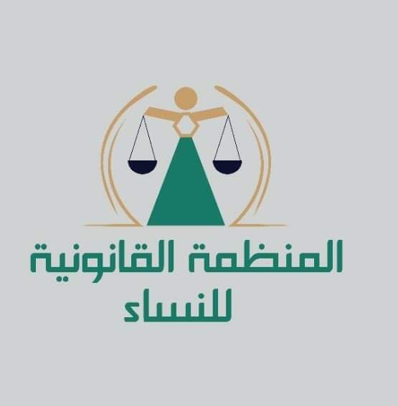
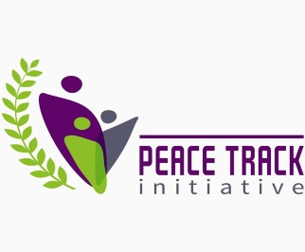

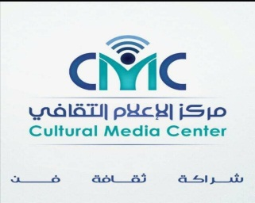
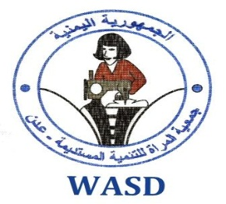
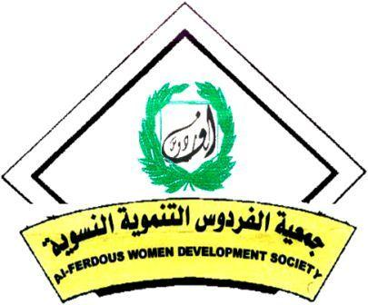
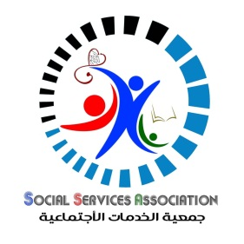
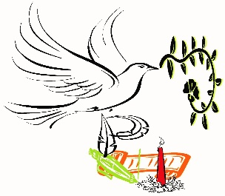
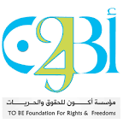
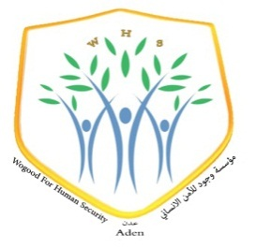
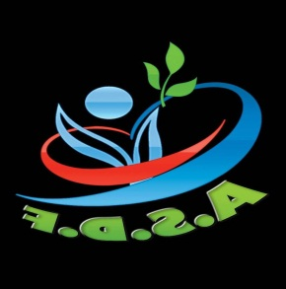

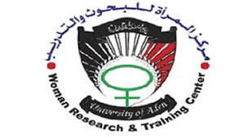
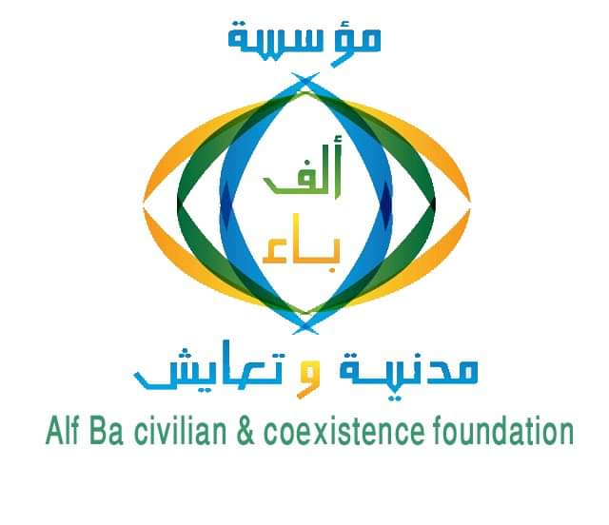
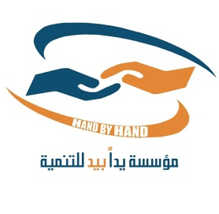

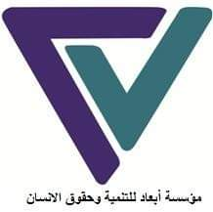

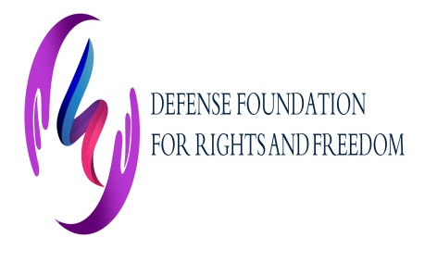
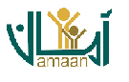


The press release issued by the National Commission of Inquiry in 7th of March 2021
The press release issued by the National Commission of Inquiry in 7th of March 2021
OCHA Report 2017 Overview: Yemen, 2016, p. 11, available at: http://reliefweb.int/sites/reliefweb.int/files/resources/YEMEN٪202017٪20HNO_Final.pdf
Report of a survey report on monitoring cases of violations gender-based violence and harm to women prepared by the National Women's Committee, July 2016
https://www.wilpf.org/portfolio-items/yemeni-women-map-the-road-to-peace/
Ministry of Planning and International Cooperation, Bulletin of Economic and Social Developments in Yemen - Issue (59) April 2021
https://carpo-bonn.org/wp-content/uploads/2018/10/Rethinking-Yemen%E2%80%99s-Economy-policy-brief-8.pdf
Ministry of Civil Service
Ministry of Planning and International Cooperation, Bulletin of Economic and Social Developments in Yemen - Issue (59) April 2021
Ministry of Planning and International Cooperation, Bulletin of Economic and Social Developments in Yemen - Issue (59) April 2021
care-international.org/files/files/YemenGenderReport171116.pdf
Report of a survey report on monitoring cases of violations gender-based violence prepared by the National Women's Committee, July 2016.
Internal Displacement Monitoring Centre, Global Report on Internal Displacement 2016, page 25-26
Law No. 20 of 1992 (Personal Status Law), Article 40
Al Shaibany, S. and Al Wasmi, N., “Child marriage on the rise as conflict in Yemen continues”, The National, 17 April 2018, available at: https://www.thenational.ae/world/mena/child-marriage-on-the-rise-as-conflict-in-yemen-continues-1.722499.
Civil Procedures and Enforcement Law Article (239)

