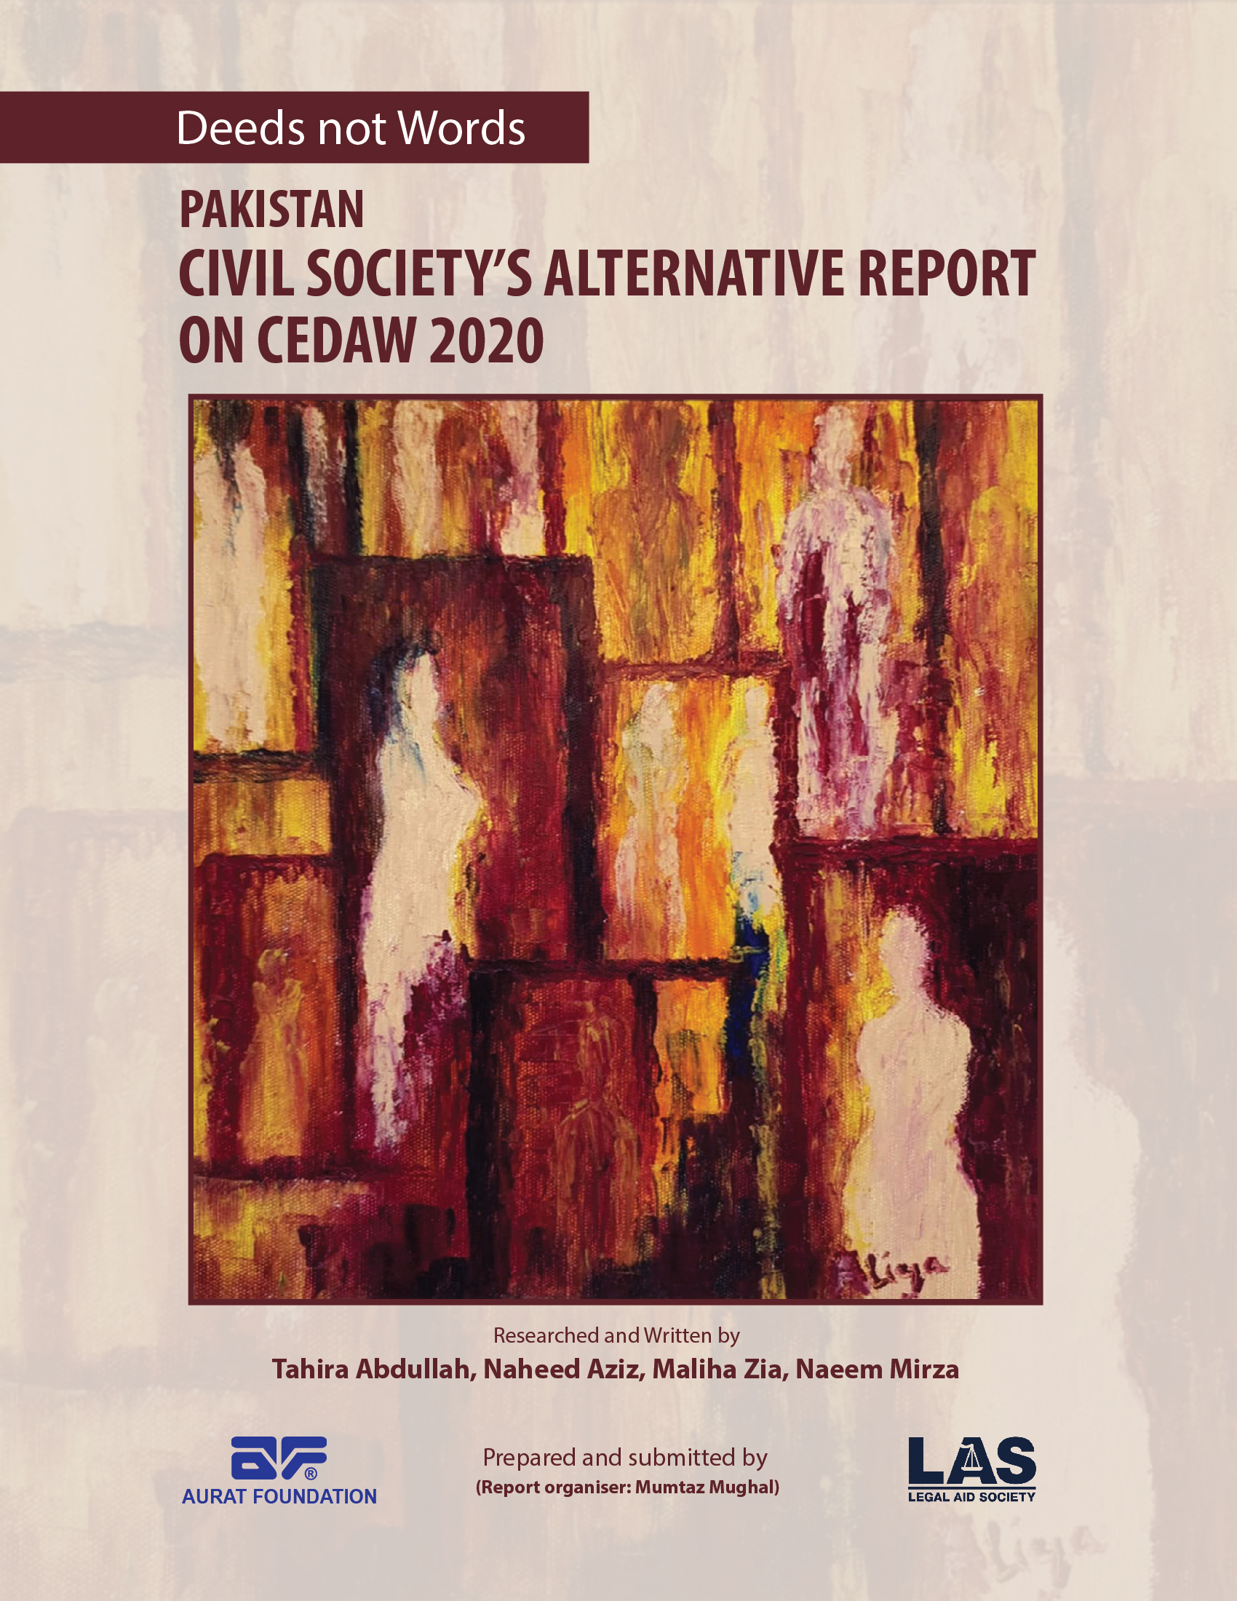

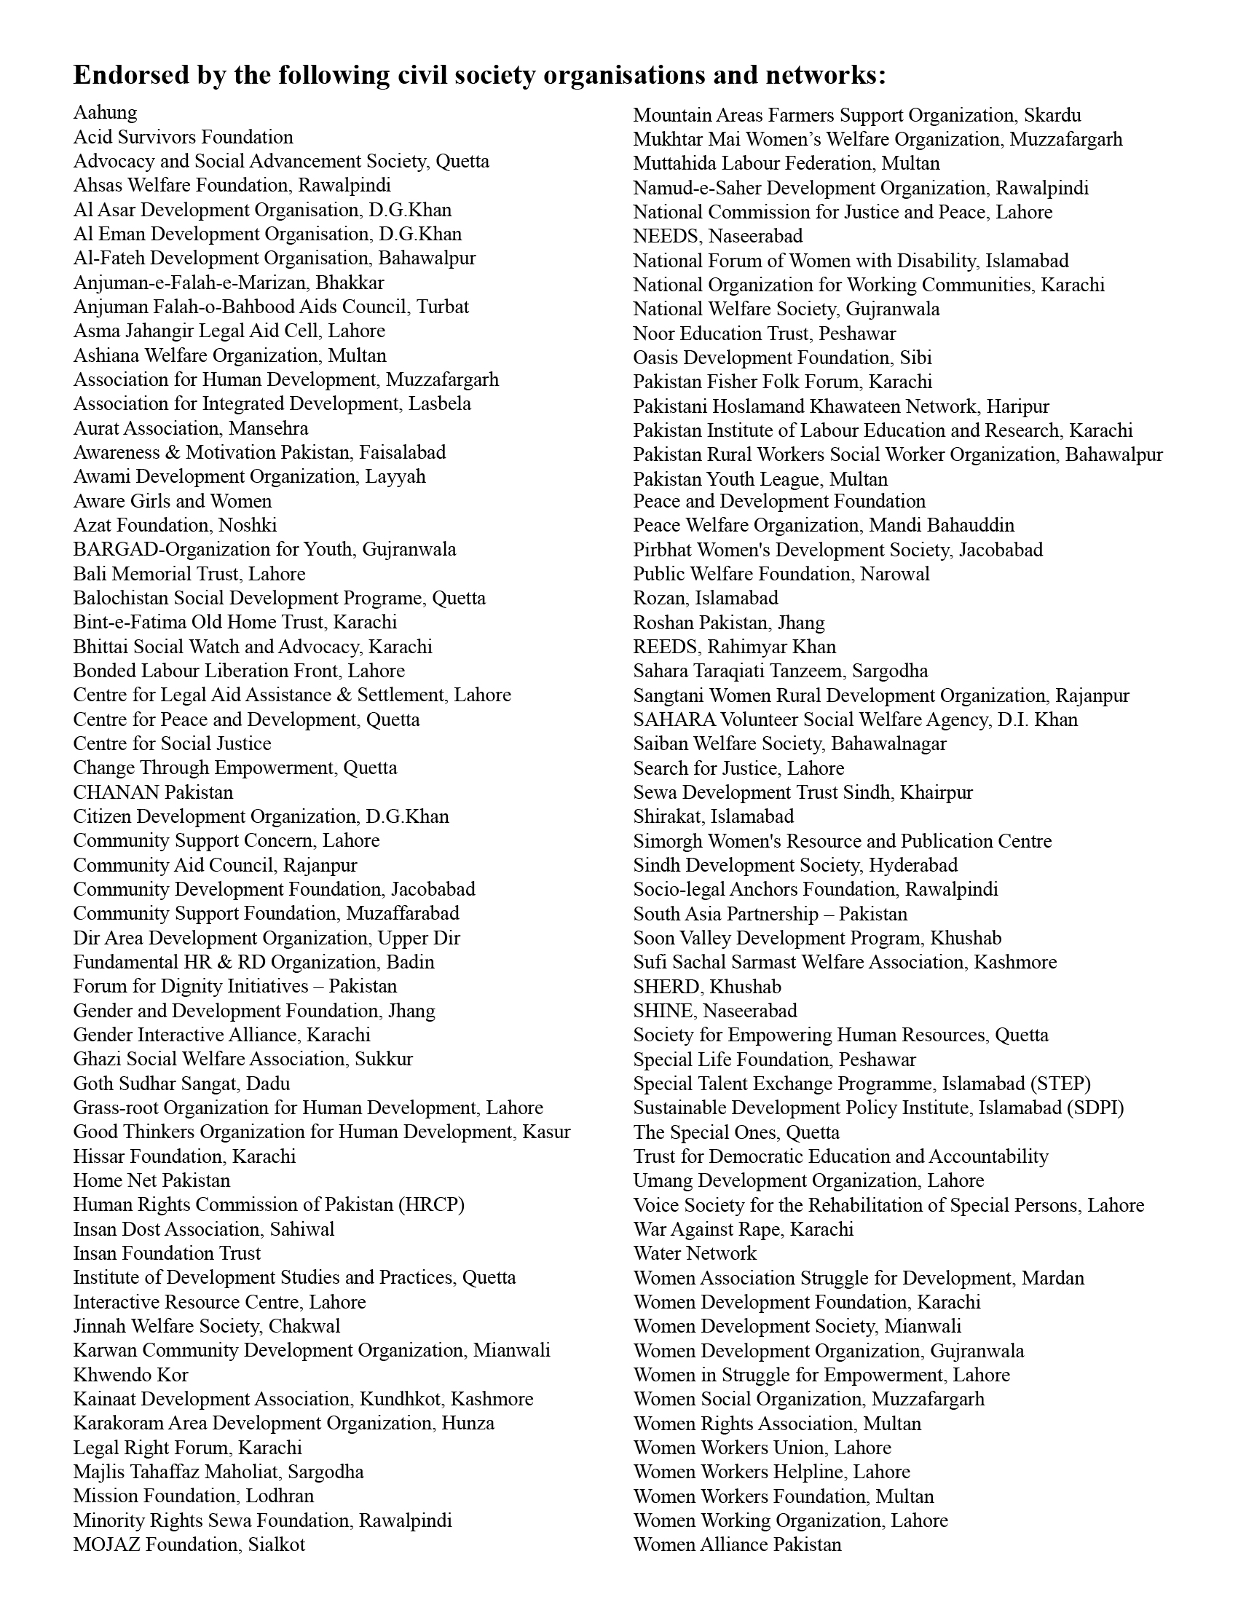

Introduction:
This 2020 Alternative Report (Pakistan) covers women’s critical concerns in relation to their rights as enshrined in the Pakistan Constitution. Besides responding to the CEDAW Committee’s 2013 and 2019 Observations, this Report draws attention to key issues emerging since the submission of Pakistan’s Fifth Periodic Report (October 2018). That Report cites outdated statistics, e.g., Articles 10, 11, 12, 13 and 14 (2012-2017 data). Key information ignored, includes the 2017 Population Census and several 2018 Reports’ data: Annual Status of Education Report (ASER), Labour Force Survey (LFS), Labour Force Participation Rate (LFPR) and Pakistan Demographic and Health Survey (PDHS).
This Report has been prepared in light of the following documents:
- List of issues and questions regarding the Fifth Periodic Report from the UN CEDAW Committee (31 July 2019 C/PAK/Q/5).
- Pakistan’s Fifth Periodic Report (March 2013 to March 2017) submitted 9 October 2018 (C/PAK/5).
- Additional information Pakistan provided, after Committee’s COs (26 November 2015: C/PAK/CO/Add.1).
- The Committee’s COs on the Fourth Periodic Report (27 March 2013 C/PAK/CO/4).
Due to CEDAW Committee’s word count limitation, this Report omits Articles 3, 4, 5, 6, 8, 15. Other NGOs’/Networks’/ CSOs’ Shadow Reports are complementary, adding their specific focus on the Articles.
The Government’s responses in the Fifth Report give the impression that it has complied fully with CEDAW Articles in letter and spirit. Ground realities belie these tall claims. We appreciate some progress, e.g. enactment of women-friendly laws at federal and provincial levels, including positive amendments in electoral laws. Much of the credit goes to civil society, human rights activists’ advocacy and proactive initiatives, women legislators, Status of Women Commissions (CSWs). Yet, there exist many unresolved issues within the bitter reality that women and girls risk being discriminated against, humiliated, raped, and “dishonour”-killed, on any pretext that offends patriarchal and misogynist mindsets. There are signs of regression instead of progression in several respects. The National Machinery for women’s advancement is not fully functional or effective; illegal 'jirgas' and 'panchayats' continue to wreak havoc with women’s lives. Enforcement of positive pro-women legislation is not pursued seriously.
State Party Report shortcomings also include: failure to respond adequately to the Committee’s COs and Recommendations; uneven representation or omission of provincial initiatives; use of outdated, and/or disputed data instead of credible independent national and global data-sets on varied dimensions of gender inequality; and failure to mention linkages to the SDGs. It does not identify, measure, analyse substantive change or improvement resulting from new laws and policies, as per adequacy of implementation, coverage, access to, or effectiveness of services.
This Alternative Report recognizes the resilience, courage and initiatives of women and girls in private and public spheres, legislators, minorities, persons with disability (PWDs) and transgender individuals (TGIs), taking action to reclaim their rights. We hope that federal and provincial governments will acknowledge the harsh realities facing half the population and undertake concrete actions in compliance with the State’s commitments under CEDAW.
Article 1 - Definition of ‘discrimination’:
(CEDAW/C/PAK/CO/4 March 2013 para) (CEDAW/C/PAK/5, October 2018: paras 35, 36), (CEDAW/C/ PAK/Q/5 October 2018, paras 47, 53)
The GoP response to repeated CEDAW Committee’s COs asking for incorporation of a definition of discrimination in the Constitution remains inconsequential in the Fifth Report, as in all previous periodic reports, indicating the GoP’s lack of political will to comply with this measure. The GoP states that Article 25 of the Constitution covers the discrimination aspect on various grounds, also presenting as evidence, some court judgements based on CEDAW principles. This is a weak premise. Court judgements cannot substitute for the Constitution. These could be of split nature and remain liable to misinterpretation and alteration. Many discriminations still exist in the Constitution and the laws, e,g. parallel judicial systems (jirgas, panchayats, Hudood Ordinances, half testimony of women and waiver of Qisas). Other discriminations are not defined in the Constitution e.g. those related to PWDs and TGIs, minorities, refugee women and freedom of ‘conscience.’ The absence of a definition of discrimination has created a policy vacuum for uniform positive provincial legislation after the Devolution of Powers Plan.
Critical Need
- The GoP (through Parliament) to forthwith insert a representative and intersecting definition of discrimination in the Constitution.
Article 2 - National Machinery for the Advancement of Women:
(CEDAW/C/PAK/CO/4, March 2013 paras 17, 18, 19, 25), (CEDAW/C/PAK/5 October 2018: para 6, 12, 19, 61-69) (CEDAW/C/ PAK/Q/5 July 2019, para 4),
National and provincial CSWs - Khyber Pukhtunkhwa (KP), Punjab and Sindh, and provincial implementing agencies (line ministries, Women’s Development and Social Welfare Departments) face financial, administrative and human resource challenges. The Balochistan Commission is notified but not established.
Particularly in 2019, the Commissions’ functionality suffered from delayed appointments of Chairs and/or members – KP January to end-May, Punjab end-May to date after summary removal of the Chairperson without due procedure, NCSW October to date.
Lack of SoPs for NCSW’s dealings with its administrative Ministry (Human Rights), other key Ministries, Divisions and the Women’s Parliamentary Caucus negatively affects streamlining of contacts. The coordination mechanism established to harmonize inter-provincial approaches suffers from resource shortages. NCSW staff approval and recruitment faced prolonged delays. Approved professional staff posts are still vacant. Service rules were approved after a seven year delay. Business Rules are awaited for the National, Punjab and Sindh Commissions. Financial autonomy is undermined by underfunding and budget cuts, forcing the CSWs to survive with volunteers, and donor funded activities. These indications of low government priority raise concerns that future Chairs and members could be selected based on political affiliations, ending neutrality of approaches.
Inadequate achievement of women’s advancement is due to lack of conceptual clarity among implementers, outdated databases, missing or unclear policies, plans, limited resources and poor management capacity.
Information about MoHR plans, activities of the provincial CEDAW and other Treaty Implementation Cells, is not accessible to civil society/NGOs neither are implementation reports of National and Provincial Policies/Plans.
Critical Needs
- A well-resourced and empowered Balochistan Commission.
- Reinforcement and empowerment of Women’s Commissions and implementing entities, with clarity of mandates, plus adequate and secure funding.
- Timely appointment and capacity building of personnel, provision of clear rules of business, and operating protocols.
- Awareness creation and engagement of all stakeholders with regular, systematic and well documented information sharing.
- Reinforced planning and communication linkages between MoHR, Parliamentary Caucuses, Commissions, Federal and Provincial Line Ministries, and Civil Society.
Article 7 - Women’s Participation in Political and Public Life:
(C/PAK/CO/4 March 2013 para 8) CEDAW/C/ PAK/Q/5 October 2018 paras 32-43, 146, 151) (CEDAW/C/PAK/5: July 2019 paras 6, 12, 19),
Social, economic and administrative issues impede Pakistani women’s political participation at all levels. Affirmative legislative action, long term advocacy of women’s rights activists, the CSW’s, and the recent proactive approach of the Election Commission of Pakistan (ECP), are yet to yield optimum results. In the World Economic Forum 2020 political participation ranking, Pakistan stands at 93 compared to 37 in 2006.
The 2018 General Elections had 12.5 million less women than men on the electoral rolls, being without Computerized National Identity Cards (CNICs) – the essential requirement for voter registration. The Elections Act 2017 provides for the ECP to take proactive measures to register women as voters in low registration areas, but does not place a similar legal responsibility on the National Database and Registration Authority (NADRA) to proactively register all citizens. Despite ECP’s post-election voter registration acceleration, by April 2019 the gender gap was 12.6 million.
The quota for women’s reserved seats is still 17% in the National Assembly (NA), Provincial Assemblies (PAs) and the Senate, and none for women of the Islamabad Capital Territory (ICT), minority women, PWDs, or TGIs. Women on reserved seats are selected by their Parties and not directly elected by women. Absence of the direct election modality at all political and legislative levels reduces women’s representative authority, and the seriousness of male colleagues towards them.
Political Parties are unmindful of - including women as members, building their capacity, encouraging their candidacy, or their induction as members and chairs of committees. The Elections Act 2017 bound Political Parties to allocate a minimum of 5% of tickets to women for general seats (instead of the recommended 15%). Most assigned a bare minimum, mostly for non-winnable seats, without support for their electoral campaigns. Of the 446 women candidates (289 party ticket holders, 175 Independents) for general seats they won only 8 NA seats and 9 PA seats. The NA has 20.23% women, the Senate 19.23%. Parties which did not allocate women general seat tickets were not penalized (2018).
Due to women’s lack of independent resources, and high Nomination Paper Filing Fees, less women stood as Independents in 2018, compared to 2013. Among 157 Party nominations for reserved NA/PA minority seats, women got 7 and only one won. One Dalit woman won a Senate seat, and one Hindu woman a Sindh Assembly reserved seat. The number of PWD and TGI candidates was negligible
Women’s overall turnout was 10% lower than men but negligible in some areas, due to socio-cultural constraints, poor physical design, and conditions at some polling centres – insensitive handling, lack of security, and inadequately segregated services. Observers recommended reinforcement of grassroots level election awareness/education, better facilities for female election staff, and gender sensitization of security personnel.
Experience has proved the benefits of women’s local government (LG) participation, for them and their communities. Options for this have declined. LG elections have been delayed for over a year in Balochistan, KP and Punjab. While ICT and all new provincial LG Acts included 33% seats for women, provincial Acts don’t ensure this at all tiers, except for Balochistan. Sindh has this only at the top tier. In Punjab and KP, elimination of the district tier reduced the overall number of women councillors. Among the 5% seats allocated for representatives of religious minorities, youth and peasants/workers, there is no specific quota for women.
Critical Needs
- Accelerated NADRA-ECP gender gap reduction voter registration campaigns.
- Amending the Elections Act 2017 to:
  - institute the direct mode of elections for women on reserved seats; increase reserved seats for women in all legislatures, adding seats for PWD women and men and TGIs; more minority seats stipulating a percentage allocation for minority women; NA/Senate: 1 seat each for ICT women;
  - bind political parties to allocate 15% tickets for general (winnable) seats to women; include - 33% women in all organizational structures at all levels, at least 33% women in the list of 2,000 members required by the ECP at the time of enlistment;
  - include proactive outreach in NADRA’s mandate to register all eligible citizens, especially rural and minority women, PWDs, TGIs.
- Timely action by ECP and Local Administrations to ensure physical access for women PWDs at polling stations based on Election 2018 Observers’ reports/recommendations.
- Sustained/improved Inclusive Education for women, special interest groups, students, LG Councillors, minority women, PWDs, TGIs, election managers and staff.
- Amending LG Acts to raise the number of women and special interest seats, expedite elections, and empower councillors, especially women.
Women in Public Positions
The World Economic Forum Report 2020 estimates that “only 5% of senior and leadership roles are held by women in Pakistan” (based on old data). Most women in public positions are in the health, education and service sectors. The number of women working as government civil servants and in commercial and development organizations within and outside the country, has multiplied, but not in proportion to the number of qualified women. They are also challenged by low promotion options. Statistics on placements against allocated quotas are calculated in numerical terms, not by differential post levels, nor updated or made widely accessible. The only Gender Management Information System (GMIS) (Punjab) is dormant since May 2019.
Gender ratios of Cabinet members range between Federal 6:36, Punjab 2:43, Sindh 2:18. No women in Balochistan, KP cabinets. Women chair five of 33 NA and one of 34 Senate Standing Committees. The gender ratio among Parliamentary Secretaries is 12:33. Provincial ratios of Standing Committee Chairs are: Balochistan 6:12, KP 3:31, Punjab 10:14, Sindh 2:17.
There is no quota for women judges. There is a significant number in lower courts. In the superior judiciary women constitute about 5%, including the Chief Justice of the Balochistan High Court, but none in the Supreme Court. There is one high ranking policewoman (Additional Inspector-General), one woman among ECP Board members, and one among its senior staff (Additional Director-General).
Women are 9% of Vice-Chancellors of 130 plus Public Sector Universities. There are many women bankers, but the only woman President of a Bank was replaced by a man, as also the Permanent Representative to the UN. Women head three of over 100 media organizations. Among ambassadors/high commissioners they constitute roughly 12% of the total. Few Boards and Corporations are headed by women though there is a quota for one woman in each. 13 women were listed by the CEO Club among 100 top performing CEOs in 2017. Women’s Chambers of Commerce exist in several cities.
Critical Needs
- Preparation of a comprehensive regularly updated, easily accessible data base on quotas filled for women, as per service tiers.
- Activation of the Punjab GMIS, and early institution of similar systems – at federal level and in other provinces.
- Review of updated information for planning to increase and enhance women’s role in public positions.
Article 9 – Nationality:
(CEDAW/C/PAK/CO/4, para 16.a.)
Efforts have continued since 2000, to remove the discriminatory clause (Section 10, sub-section 2) of the Pakistan’s Citizenship Act 1951 which entitles the foreigner-wife of a Pakistani male to apply for citizenship, but not to the foreigner-husband of a Pakistani woman. In its 2018 appeal the NCSW again asked for its elimination, declaring sub-section 2 as discriminatory as per CEDAW Articles 1, 2, 15, 16. The Law Division is considering this.
Current coverage shortfalls in civil registration systems cause deprivation of citizenship rights. Gaps in birth registration undermine age verification. The CNIC is a prerequisite for all official transactions. Besides the absence of outreach in the underfunded NADRA’s mandate, the inadequacy of its fixed registration centres and mobile vans further restricts access of women in remote areas, migrants, internally displaced persons (IDPs), TGIs, and PWDs affected by financial, social and mobility constraints.
Critical Needs
- Alignment of the Citizenship Act with CEDAW Articles of gender non-discrimination.
- Regularization of Civic Registration Systems.
- Amended mandate and enhanced funding for NADRA’s outreach operations.
Article 10 - Education and Training:
(CEDAW/C/PAK/CO/4, paras 27, 28) (CEDAW/C/PAK/5 October 2018, paras 123-142) (CEDAW/C/PAK/Q/5 July 2019, para 13)
The Fifth Report contains several errors of omission/commission, e.g., no mention of ASER/2017-18 data; linkages between SDG-4 indicators and provincial Education Sector Reform Plans, especially curricula; textbooks; teachers’ recruitment, training, placement; monitoring education quality via learning outcomes and student attainments; teachers’ absenteeism; girls’ dropout rates; PWDs, TGIs and minority girls.
Serious misstatements include: “zero tolerance for corporal punishment;” “… changed medium of instruction in public schools from Urdu to English in 2014 …bring public schools at par with private schools…”; “The percentage of women in public sector universities is higher than that of men…” Large budget allocations, infrastructure and staff recruitments are claimed, without citing verifiable sources/references. Missing concerns relate to girls’ high dropout rates due to poverty, safety/security, Child Sexual Abuse (CSA)/Gender-Based Violence (GBV), underage marriage and negative societal attitudes.
Critical Needs
- Increasing provincial education budgets substantially – with disbursement data reporting.
- Objectively verifiable data regarding reported numeric increases in: girls-only schools with boundary walls, toilets, water, women-only teachers; co-education/“gender-free” primary schools.
- Increasing girls’ enrolment/retention through: Benazir Income Support Programme (BISP) enhanced conditional cash transfers (CCTs) upon evidence of girls’ enrolment/retention; expanding WFP’s food-for-education grant programme in poverty-mapped districts.
- Focused interventions to eradicate: poverty; forced girl-child labour/sale/trafficking/ prostitution and underage marriage; gender disparities: girls’ low enrolment and high dropout rates even at primary level.
- Countering reasons for the disproportionately higher numbers of girls out of school/ married/pregnant, due to high insecurity, kidnapping, GBV, harassment, CSA (including alarming increases in murder following rape/incest).
- Special protection of minority girls to address increased incidents of kidnapping, forcible religious conversion and forced marriage/rape; thus, decreased enrolment/increased dropout.
- Facilitating physical access to mainstream schools, resources and an enabling environment for physically- and mentally-challenged students, through provision of safe public transport.
- 2018 National Education Policy Framework: addressing the absence of attention to a major re-think/re-set in the direction/ideology/content of public school curricula and textbooks, regarding removal of stereotyped gender portrayals; inculcating respect for minorities, TGIs, PWDs, pluralism, diversity, peace and human rights; including Life Skills-Based Education (LSBE), environment/climate change, population, demography components; removing hate-mongering, war-glorification content; providing technical vocational skills training.
- Questioning non-implementation of the 20-point National Action Plan’s education-related components including religious seminaries (madrassas); also addressing education experts' and civil society's substantive critique of the NEPF/2018 re. “uniform curriculum” issues.
Article 11 - Employment:
(CEDAW/C/PAK/CO/4, March 2013 paras 29, 30 (CEDAW/C/PAK/5 October 2018 paras 143-178) (CEDAW/C/PAK/Q/5 July 2019 paras 14, 15)
Pakistan’s Fifth Report contains vague unreferenced/unsourced claims of increased Female Labour Force Participation Rate (FLFPR) in “many male-dominated spheres”.
It contains serious misstatements and grandiose claims: “5% [employment] quota for women is optimally complied with”; “maternity and paternity leave”, “working women hostels”, “daycare facilities”, “financial assistance”, “female labour inspectors”, among others.
The annual LFS continues to undercount/omit women’s major work categories, due to: LFPR definition issues of “formal/informal” workers and “organized/unorganized” sectors of employment, thereby excluding productivity of millions of women from the GDP; biased patriarchal attitudes of male statisticians – devaluing women’s work – unworthy of counting; male household-heads not reporting women’s work to male surveyors, considering them “unpaid family helpers”.
Labour Force Survey (LFS) 2017-18 data (see 2 GoP/LFS tables below):
LFPR: male 48.43%; female (FLFPR): 25.03%;
Employed (age above 10 years in major industries/public services): men: 78.06%; women: 21.94%;
Unemployment rate (age above 10 years): men: 76.01% women: 23.99%.
PERCENTAGE DISTRIBUTION OF EMPLOYED PERSONS 10 YEARS OF AGE AND OVER
BY MAJOR SECTORS OF EMPLOYMENT AND SEX 2017-18
TABLE-21
Major sectors of Employment | All Areas |  |  | Rural |  |  | Urban
Major sectors of Employment | Total | Male | Female | Total | Male | Female | Total | Male | Female
1 | 2 | 3 | 4 | 5 | 6 | 7 | 8 | 9 | 10
PAKISTAN | 100.0 | 78.06 | 21.94 | 66.03 | 48.18 | 17.85 | 33.97 | 29.88 | 4.09
Agriculture | 38.49 | 23.75 | 14.74 | 36.44 | 22.18 | 14.26 | 2.06 | 1.57 | 0.49
Non-Agriculture | 61.51 | 54.31 | 7.20 | 29.60 | 26.00 | 3.59 | 31.91 | 28.30 | 3.60
Formal | 17.23 | 15.20 | 2.03 | 7.12 | 6.31 | 0.80 | 10.11 | 8.88 | 1.23
Informal | 44.28 | 39.11 | 5.17 | 22.48 | 19.69 | 2.79 | 21.80 | 19.42 | 2.38

PERCENTAGE DISTRIBUTION OF UNEMPLOYED PERSONS 10 YEARS OF AGE AND OVER
WHO WERE NOT AVAILABLE FOR WORK DUE TO CERTAIN REASONS 2017-18
TABLE-34
Reasons of Non-availability for work | All Areas |  |  | Rural |  |  | Urban
Reasons of Non-availability for work | Total | Male | Female | Total | Male | Female | Total | Male | Female
1 | 2 | 3 | 4 | 5 | 6 | 7 | 8 | 9 | 10
PAKISTAN | 100.0 | 76.01 | 23.99 | 61.48 | 46.04 | 15.44 | 38.52 | 29.97 | 8.55
Illness | 48.84 | 33.03 | 15.81 | 31.01 | 20.24 | 10.77 | 17.82 | 12.78 | 5.04
Will take a job within a month | 10.68 | 9.58 | 1.10 | 5.19 | 4.98 | 0.21 | 5.49 | 4.59 | 0.90
Temporarily Laid off | 6.53 | 4.78 | 1.74 | 3.96 | 2.87 | 1.09 | 2.57 | 1.92 | 0.66
Apprentice and not willing to work | 33.95 | 28.62 | 5.34 | 21.32 | 17.94 | 3.37 | 12.64 | 10.67 | 1.96
Reasons for girls/women/TGIs’ lack of access to employment opportunities: education, skills training; lack of mainstreaming/integration in all economic sectors include entrenched patriarchy, segregation, seclusion, gendered division of labour-role-perceptions, inadequate women’s hostels/ mobility/transport constraints; GBV issues; child/forced marriage/pregnancy; modern slavery/ bonded/forced labour.
Only Sindh province has enacted the Home-Based Workers Act (2018); Sindh approved the policy (2016), as well as Punjab (2017).
Despite ratification of ILO Conventions 100 (Equal Remuneration) and 111 (Employment Discrimination), Pakistan still abdicates responsibility to enforce them via legislation, policy and strict monitoring for compliance.
Critical Needs
- Respecting/valuing/counting women’s economic productivity/GDP-contribution linked to Article 13-14 and SDGs.
- Legislation to change the definition of the formal "labour force" – to include women farmers; foresters, livestock/dairy farmers, fisherfolk; home-based and domestic workers.
- Recruitment/training women enumerators for LFPR data collection to: elicit accurate information for LFS; sex-disaggregated data (FLFPR); inclusion of PWDs/TGIs/rural agricultural women's work/productivity in LFPR and GDP data.
- Establishing holistic linkages with Articles 13-14; the SDGs; and national/provincial multi-year Economic Development Plans; compliance with Article 11.
- Registering women workers, especially farmers, home-based and domestic workers for: decent living (not unpaid/minimum) wages; equal wages as men to eliminate discrimination in participation/remuneration/advancement; Workers’ Welfare Funds, social security, insurance; pensions; healthcare.
- Ensuring labour laws-driven safe/humane work environment/facilities - separate functional washrooms, common-rooms, potable water, child day-care, hostels, transport.
- Special measures re: women-headed households (WHHs) to: reduce rural women’s increasing burden of work/responsibilities, particularly following male migration; recognize women formally as household heads, not designating other men (e.g. father-/brother-in-law) as proxy heads.
- Increasing public employment quotas for women, with strict compliance: PWDs; minorities 5%; Sindh/Punjab 15% to 25%; Balochistan/KP: 0-25%; linked to SDG-1&8.
- Ratifying ILO Convention-177+R-198 (home-based workers) and C-189 (domestic workers); national surveys; legislation/policy (pending since 2008), in ICT, Balochistan, KP, Punjab.
- Legislation: relaxing age limits for women’s entry/re-entry into formal employment post-reproductive cycle; non-lapsable seniority status during sanctioned, paid maternity leave.
- Including women officers in all committees: recruitment, sexual harassment inquiries, to prevent unjust “compromise settlement” pressures (as per 2010 Anti-Harassment Act).
- Increasing creation of climate change-resilient sustainable livelihoods/employment for rural families by investing in: organic (non-GMO) agriculture, dairy-farming/livestock for biomass fuel technology, solar/wind energy, agro-industry, irrigation water conservation technology, water purification for domestic use.
- Increasing access to credit, vocational training, public-private partnerships.
- Eradicating beggary/prostitution/sale/trafficking/slavery/bonded labour.

Article 12 - Women’s and Girls’ Health and Reproductive Health Rights:
(CEDAW/C/ PAK/Q/5 October2018 paras 151-164) (CEDAW/C/PAK/Q/5 July2019 paras 16-17)
Gaps in the Fifth Report include omission of: reproductive/sexual health rights (SRHR); 2+ million annual unsafe (aka illegal) abortions; Maternal Mortality Ratio (MMR) data, despite CEDAW Committee’s previous queries and Population Census/2017 and PDHS/2017-18. Included: maternal (Ob/Gyn-related) healthcare.
Nutrition gets one brief paragraph. Ignored: Health/RH needs of girl children, PWDs, TGIs; mental health issues; religious minority women/girls; IDPs, migrants, refugees, women/girls in emergencies (conflicts/natural disasters). HIV/AIDS gets short shrift. GBV/VAWG is not perceived as a health/SRHR issue. There is no mention of federal/provincial RH draft laws, or Pakistan’s strong commitments under ICPD (1994-2019).
Omissions: provincial Health (DoH) and Population Welfare (DoPW) Departments are still separate, running vertical programmes in competitive silos, with unnecessary duplication, overlap, wastage. Provincial/federal health budgets cited, are financial allocations, not actual disbursements/expenditures/mid-year budget cuts, falling woefully short of Pakistan’s health/ SRHR critical needs.
Serious misstatements: “Free medical care and medicines for all diseases are provided to all patients including women in all government hospitals … without discrimination.”
Critical Needs
- Merging provincial Population and Health entities into one Department, reducing funds wastage and operational duplication (RH services/staff/outlets).
- Ensuring updated statistics and mandatory inclusion of MMR data collection in all future health/RH surveys, especially PDHS.
- Demonstrating political commitment to tackle the alarming population explosion (PGR 2.4%, not GoP’s 1.9%); following-up on GoP’s statement at 25th ICPD Conference (Nairobi 2019).
- Formulating comprehensive primary health/SRHR policies; providing quality services and counselling to all women/girls/TGIs, especially in rural/urban low income areas, not to married women only.
- Filling the well-documented high unmet need for contraception – ease of access/affordability; thereby reducing abortions and Population Growth Rates.
- Enacting comprehensive mental health legislation and policy for free evaluation/ treatment/rehabilitation; trained sensitive/caring professionals.
- Focusing on specific needs of vulnerable women/girls, including minorities, PWDs, TGIs, and remote rural populations. Implementing the 2011-ratified Convention on Rights of Persons with Disabilities (UNCRPD).
- Focusing on information/education/communication programmes for preventive and basic health services (prioritizing SRHR/STIs/RTIs/HIVAIDs), not curative/tertiary healthcare.
- Revising education/training curricula/textbooks of all medical/paramedical institutions to focus on all the above concerns.
- Increasing budgets/expenditures of the combined Health/Population Department to 5% of GDP; increasing locally-resident staffing, commodities, information/education/training; and including LSBE components in school curricula.
Articles 13 & 14 – Economic/Social Benefits; Rural Women; Food/Nutrition; Environment/Climate-Change:
(CEDAW/C/PAK/CO/4, March 2013, paras 30, 34) (CEDAW/C/PAK/5 October 2018, paras 165-193) (CEDAW/C/PAK/Q/5 July 2019 paras 18, 19)
Pakistan’s Fifth Report gives low priority to Poverty. It excludes SDG-1 and rights-based economic development; ignores credible independent national/global data-sets on gender inequality, poverty, rural women, farmers, food insecurity, nutrition, environment/climate change; does not cite GoP’s Pakistan Economic Survey (PES/2018)’s poverty “reduction” data - contradicting available credible evidence-based independent research. PES now omits a separate “Poverty” chapter; referred instead in Chapter 15: “Social Protection” – perceiving poverty “alleviation” in the “charity” mode rather than a challenge for human empowerment and sustainable economic development.
It describes unconditional and conditional cash transfers (UCTs/CCTs) under BISP (which is not a poverty reduction programme, simply a social security safety net), and other “welfare” measures, rather than women/girls/TGIs’ economic empowerment through medium-/long-term mainstreaming programmes for poverty eradication, which ought to be an imperative under SDG-1. The requirement is not charity cash transfers, but the means to earn cash. Subsequently, responding to CEDAW Committee’s COs/2013, Punjab economic empowerment initiatives were cited (PAK/Addendum/2015).
The Report ignores Feminization of Poverty (FoP) – officially recognized 3:1 female/male ratio. The BISP’s CCT initiative is a fraction of what is needed to counter large-scale FoP. It ignores Pakistan’s Multidimensional Poverty Index (MPI), especially rural FoP, malnutrition/hunger. In fact, poverty is rising; estimated 9 million additional people (75% women), will fall below the poverty line (2019-2022), “equivalent to an increase in the incidence of poverty of almost 4.5 percentage points.” Overall poverty data range: 24% to 33%, with MPI around 50%. Food inflation: 16.5%. Over 52% population is food-insecure, as per UN and NGO studies.
The Report omits: negative impacts on rural women/children, of the IFI-imposed structural adjustment conditionalities, especially removal of basic needs/utilities subsidies; cross-cutting nexus of binding CEDAW commitments with SDGs. It omits PES statement: “landless farmers are mostly women”. Poverty and hunger are inextricably linked, and one definition of poverty is based on daily calorific needs vs. intake per capita.
It omits: the situation of rural women, comprising 64% of the female population; almost all working in agriculture, livestock, dairy, forestry, fisheries/aquaculture, horticulture, local crafts; fetching fuelwood and impure non-potable water for domestic use. 75% of the female labour force (agricultural workers), remain unpaid and uncounted; women farmers are defined as “informal family helpers”; home-based workers, domestic staff, bonded/forced/enslaved labourers remain invisible.
It omits: heavily disadvantaged rural girl children, unwanted, uneducated, suffering: ill-health, child labour, early/forced marriage, repeated pregnancies; marital rape, GBV, brutal traditional customs to settle tribal feuds and prevent property inheritance.
Critical Needs
- Legislation to change the definition of formal labour force, to count Pakistan’s 64% (67 million) rural agricultural women as Workers and Farmers; including them in the formal labour force data (LFPR) of the annual LFS; recognizing their economic contribution and productivity in the national accounts (GDP); ending all forms of bonded/slave, forced, unpaid exploitative labour.
- Registering women formally as farmers – becoming eligible for workers’ rights/benefits: (i) decent living wages, health/SRHR/OSH, insurance, pensions, social security, child support (for first two children); membership of farmers’ unions/cooperatives/associations; (ii) agricultural extension training by women trainers.
- Recognizing women farmers’ need for assets ownership – leading to access to affordable credit and union membership. Granting all women farmers minimum one acre of arable land (starting with de facto women-headed households, widows/divorcees/single women), with title deeds in their own names.
- Collecting accurate district-disaggregated data on rural women and poverty: number; age; occupation; land-ownership; dependents; education; fertility (TFR) status, (using global poverty and MPI definitions re. income, calorie intake).
- Formulating two distinct policies: short-term social protection; long-term poverty eradication, with viable employment-creation programmes; disaggregated rural-urban poverty markers for BISP eligibility criteria, reference UCTs. Linking this to a comprehensive, integrated, multi-sectoral policy for rural women’s empowerment, with agro-industry development to decrease rural/urban migration.
- Addressing the root causes of Feminization of Poverty (FoP) – not through patriarchal, patronizing social safety nets; but substantively, through: ending women’s traditional relegation to health/education sectors; enabling/facilitating women’s mainstreaming/ integration in all sectors of national (rural/urban) economic development; industry, manufacturing, agri-business, food-industry, engineering, information technology, trade, commerce, energy, environment/CC and services sectors.
- Providing rural women/girls/TGIs access to free, quality health/SRHR services/counselling; compulsory, free, quality education up to age 16 as pre-requisites for ending FoP.
- Establishing gender-responsive budgeting (GRB) mechanisms in all public sector departments/programmes, to institutionalize/mainstream rural women/girls’ economic empowerment and SDGs participation, focusing on young women: technical entrepreneurship training; affordable credit. Imposing agricultural income tax on large landholding farmers to finance rural poverty eradication programmes.
- Ensuring: the First Women’s Bank Limited (FWBL) is: not privatized; rendered viable again; providing affordable credit to rural agricultural women. Other entities, e.g. Khushali Bank, Agricultural Development Bank of Pakistan, Pakistan Poverty Alleviation Fund and Rural Support Programmes/Network need to support FWBL’s focus on women and FoP.
- Correlating Poverty data with Food Insecurity/Hunger (using UN World Food Programme’s geographic maps), via links with BISP markers; poverty reduction initiatives; focused, substantive State measures: providing (i) short-term free/subsidized staples (ration cards) to identified food insecure districts during famine/drought/flood seasons (e.g. Tharparkar/Sindh); (ii) ending widespread FoP, gender inequality in income/assets ownership, and hunger through work-creation programmes.
- Establishing rural women's Community/Village Organisations, food and dairy cooperatives. Promoting rural women’s participation in Local Governments and other decision-making entities/councils/committees.
- Instituting Pakistan-specific Environment/Climate Change (CC) intervention: engendering all CC dimensions; multi-sectoral approach to adaptation, mitigation and disaster risk reduction (DRR), to preserve bio-diversity, achieve food security, increase agricultural productivity through: sustainable organic farming; rejecting giant Multi-National Corporations’ imposed Genetically-Modified Organisms (seeds/crops); promoting women’s traditional seed-preservation and food-conservation.
- Rejecting fossil fuels; providing rural women credit and information technology to install alternate energy sources: solar/wind/biogas; reforestation; irrigation-water-conservation technologies; drinking-water-purification technologies; eliminating inorganic/chemical fertilizers/pesticides for sewerage/sanitation/hygiene improvements.
- Reducing the 2.4% population growth rate.
Article 16 – Marriage and Family Relations:
(CEDAW/C/PAK/CO/4 March 2013 paras 37, 38) (CEDAW/C/PAK/5 October 2018, paras 194 -200). CEDAW/C/PAK/Q/5 (July 2019, para.13)
Implementation of marriage and family laws remains weak. The Fifth Report does not provide substantive information on actions to create equality within marriage for women, particularly relating to the Committee’s specific COs/Recommendations.
Restitution of Conjugal Rights is used 99% of the time against women as a control mechanism, or as a revenge tactic, succeeding only in 4.7% court cases, resulting in extending already prolonged trials and additional costs. It violates fundamental human rights of privacy, dignity, equality; violating rights to freedom of choice, autonomy and agency.
Laws addressing domestic violence (DV) or spousal violence are insufficient for deterrence without effective implementation. PDHS 2017-2018 reports that 42% women and 40% men interviewees agree that wife-beating is justified under specific circumstances.
Only the Sindh Child Marriage Restraint Act 2013 raised the marriage age for girls to 18 years. It remains 16 years elsewhere: child marriage is considered legally “valid”, but must be made “void” or “voidable.”
The notoriously anti-women/girls Jirgas/Panchayats have long been declared illegal by the Supreme Court, yet some provinces have formalized them as a form of Alternate Dispute Resolution (ADR). Such structures, with untrained, misogynist, insensitive male mediators, do not provide the neutral, gender-sensitive oversight and mediation required in family cases, as communities exert huge social pressure for pushing women to reconcile or give up rights due to unequal status.
In all provinces the protection system and supporting structures are inadequate.
Critical Needs
- Implementing positive women-friendly laws; high priority to verifiable results.
- According women equal rights of divorce under Muslim and other personal laws (vide Algerian and Tunisian post-divorce maintenance laws). Some Pakistani court judgements support and recognize the reciprocal benefits a wife may receive post-marriage for her contribution during marriage.
- Repealing the legal provision of Restitution of Conjugal Rights in personal laws of various communities/sects.
- Taking socio-cultural measures to decrease tolerance for and commission of DV and IPV.
- Harmonizing the age at marriage of girls at 18 years across the country (e.g. Sindh), as supported by Islamic interpretations and medical evidence in particular. Justice sector actors must adopt a sensitive approach, recognizing children in child marriages as victims and not as consenting adults using their free will. They must not adopt a “protectionist approach” arising from their own internal biases, based on a culture of attaching shame to victims. Provide shelter, education, health to support child brides post-marriage until they reach adulthood.
- Amending Guardianship and Custody laws to recognize single mothers’ rights as guardians; particularly protecting their right to re-marry without impacting their guardianship/custody of male/female children.
- Taking legislative and administrative action to end legal recognition of Jirgas/Panchayats as an ADR system.
General Recommendation 19 - Violence against Women (VAW):
(CEDAW/C/PAK/CO/4 March 2013 paras 16 e., 21, 22). (CEDAW/C/PAK/Q/5 July 2019 para 9,) (CEDAW/C/Pak/5 Oct 2018 paras 72-96)
Different forms of violence persist in Pakistan, difficult to quantify without credible data. The available figures demonstrate high GBV rates at 24.8% per annum (PDHS 2017-18); also in Social Policy and Development Centre 2019 report (high prevalence of IPV).
The PDHS collected limited DV data as per WHO guidelines. Out of 14 modules, DV was just one set of questions, thus there is minimal data. No other mechanism exists for regular GBV data collection. The GMIS/data collection on GBV by the Punjab Commission on the Status of Women can be replicated for regular data/information collection, e.g. Gender Parity Report (separate VAW section).
Focus on legislation as the prime solution to eliminating VAW/GBV is ineffective. Evidence-based research demonstrates that focusing on law without additional supporting initiatives results in lack of real, sustainable change. Crisis centres and support mentioned in Pakistan’s Fifth Report only serve temporary immediate needs and are numerically inadequate; no long-term support services or options are available.
As directed by the Honourable Chief Justice of Pakistan, Gender-Based Courts are being set up across the country in each province based on existing pilot model GBV courts, resulting in specialized gender training for judges at the Punjab Judicial Academy. These courts have had some success in establishing mechanisms and supportive approaches for VAWG/GBV survivors. However, there is concern that this is compartmentalization, taking the focus away from mainstreaming responses, and sensitizing the general public on VAWG/GBV.
The National Policy on Ending Violence against Women (NPE-VAW) with its holistic perspective, is welcomed. Efforts for collaboration between different departments is essential, in particular the investigation actors, i.e. police, medico-legal officers, forensic investigators and public prosecutors, who currently work in silos.
As a preventive measure, the Government of Sindh has committed to integrate the Life Skills-Based Education (LSBE) curriculum, developed by the NGO Aahung, into its primary school curriculum, for awareness and protection of children from sexual abuse. It is still in process.
The Pakistan Penal Code, through the Criminal Law (Amendment) (Offences relating to Rape) Act 2016, demands non-disclosure of the names of victims/survivors of rape, attempted rape, “unnatural offences” or sexual abuse. However, the First Information Report and medico-legal reports are public court documents. Further, there is no law/policy to provide a pseudonym.
Critical Needs
The GoP must look beyond legislation to measure the impact of efforts to eliminate VAWG and GBV through:
- Consistent, regular GBV/VAWG-related data collection, disaggregated by sex, age, district, category of violence, among others, to eliminate the currently scattered, disorganized, unanalysed information. Permanent GMIS and data collection systems must be available in all provinces, without dependence on the Status of Women Commissions.
- Strengthening protection systems for VAWG/GBV victims/survivors to provide a seamless service. Focus to be placed on provision of long-term shelter for women as opposed to temporary shelter only for the crisis timespan; separate shelters for girls who may require long-term care, e.g. child brides. Options such as low-cost housing, or half-way houses, for violence victims/survivors to be explored to support and facilitate women venturing out on their own.
- Allocating required resources to different initiatives under the NPE-VAW, with well defined, verifiable, closely monitored indicators.
- Gender-sensitization training of key justice sector actors: first responders, police, medico-legal officers, public prosecutors, court staff and judiciary. The Supreme Court, High Courts and other overseeing authorities to put in place regular qualitative monitoring and assessment of trainees.
- Assessing the types of cases brought to Gender-Based Courts, with close monitoring of how courts address and dispose of them.
- Instituting a multi-departmental, coordinated, holistic approach, to respond to VAWG/GBV, with all concerned actors working collaboratively in creating an effective prosecution case; developing a case management system, where all actors have access and are able to submit e-reports and evidence, in addition to hard copies, to allow for smoother investigation process.
- Completion of adoption and scaling up Aahung’s LSBE initiative; adoption and replication by other provinces and ICT.
- Acknowledging women’s economic empowerment as a core mechanism for prevention of violence. Additionally, employing women in the job market; ensuring a safe environment; establishing their leadership skills; support for housing for women and their children.
- Adopting zero tolerance for all forms of VAWG/GBV. No compromises or out of court settlements to be allowed. Justice sector institutions must continue with cases as the aggrieved parties, in order to take the pressure for compromise/settlement off the victim/survivor or her family. The police must not encourage such compromises and strict action must be taken against those who do so. The judiciary must consciously not accept compromises in cases that are non-compoundable under the law; especially in women's property inheritance cases.
- Revising core training curricula of police, medico-legal officers and judiciary personnel; gender-sensitizing them all for mainstreaming pro-women appropriate behaviour, as opposed to a stand-alone subject. For public prosecutors and the judiciary, specific training to be provided on interviewing girl child survivors, as opposed to conducting general GBV interviews.
- Formulating measures for implementation of laws; developing protocols to ensure confidentiality, e.g. a system to provide pseudonyms for under-trial cases.

Withdrawal of ‘Declaration’ upon State accession to the Convention:
(CEDAW/C/PAK/CO/4 March 2013, para 9, 10) (CEDAW/C/PAK/5: October 2018, para 18), (CEDAW/C/ PAK/Q/5 July 2019, para 23)
The Fifth Report claims that consensus is yet to be reached on withdrawing the Declaration. The State rationale for this demonstrates lack of political will.
Critical Need
- The State to withdraw the Declaration, to create enabling circumstances for full CEDAW implementation in letter and spirit.

Ratification of CEDAW Optional Protocol:

(CEDAW/C/PAK/CO/4 March 2013 para 39) (CEDAW/C/Pak/5 Oct 2018 para 18) (CEDAW/C/ PAK/Q/5 para 23)
The Optional Protocol was not ratified, depriving Pakistani women of the right to lodge complaints to the UN CEDAW Committee, individually or collectively, to redress their grievances in relation to CEDAW provisions.
Critical Needs
- Compliance with repeated directions of the CEDAW Committee to ratify the Optional Protocol;
- Accepting the amendment as per CEDAW Article 20 (1), to allow more flexible time to the CEDAW Committee to meet annually.

*********

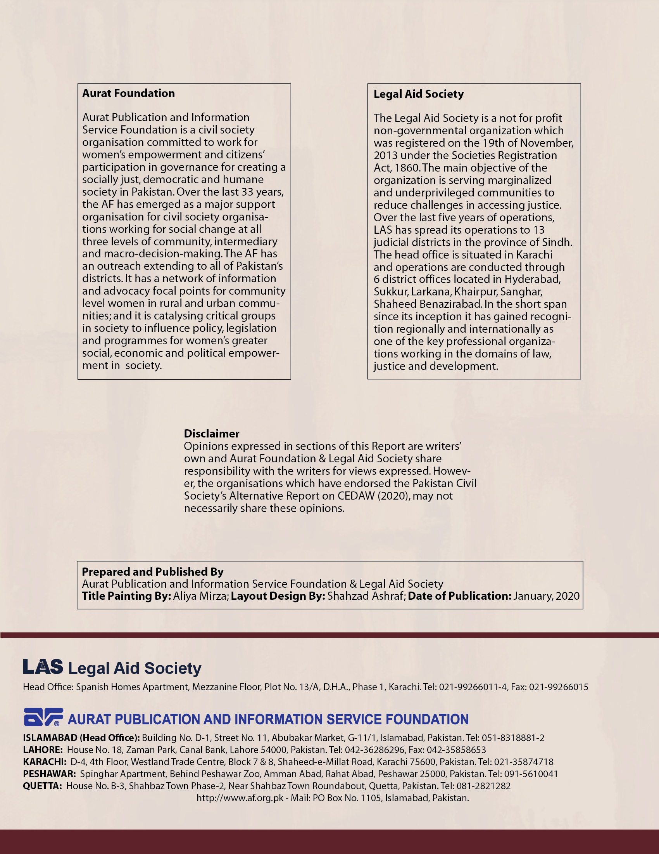

Feudal and tribal illegal arbitration structures
Retribution/compensation laws
NCSW Annual Report (2018-2019)
“NCSW/HBS Women in Elections 2018 Report”, “The Gender Gap in the Electoral Rolls: Barriers to CNIC Registration”, DAI 2018
http://www.ecp.org.pk
www.gop.org.pk
NCSW Annual Report Jan 2018-June 2019
‘Gender Gap in the Electoral Rolls: Barriers to CNIC Registration’ 2018, DAI/Tabeer, &’NCSW/HBS Women in Elections 2018 Report’.
Particularly History, Pakistan Studies, Social Studies, Urdu, English textbooks [Peter Jacob/ T. Abdullah studies, 2012-19].
LSBE: the Committee is requested to kindly use this culturally-acceptable euphemism, rather than calling for conventional Sex Education and contraceptives availability in schools.
OPHI, SPDC, Dr. Hafeez Pasha, Dr. Shahid Hassan Siddiqui et al.
Dr. Hafeez Pasha, “Growth & Inequality in Pakistan” (FES, Oct.2019)
https://tradingeconomics.com/pakistan/food-inflation
“Rural Women in Pakistan status Report 2018” (UNW, NCSW, CGaPS, GoCanada).
Women farmers working as unpaid “family helpers” in agriculture, livestock, dairy, fisheries/aquaculture.
Qamar, Naima; Zia, Maliha; Khan, Tara. “De-Constructing Conjugal Rights in Pakistani Law”, 2019, Karachi, Legal Aid Society.
Tuharat Firdos v. Imtiaz Khan (2019 CLC 1562); Abdul Rashid v. Shahida Parveen (2013 YLR 2616)
As per the officially-approved GoP police training curriculum developed by NGO Rozan.
See Article 11 and 13-14.

