Intersex Genital Mutilation
Human Rights Violations Of Children
With Variations Of Reproductive Anatomy

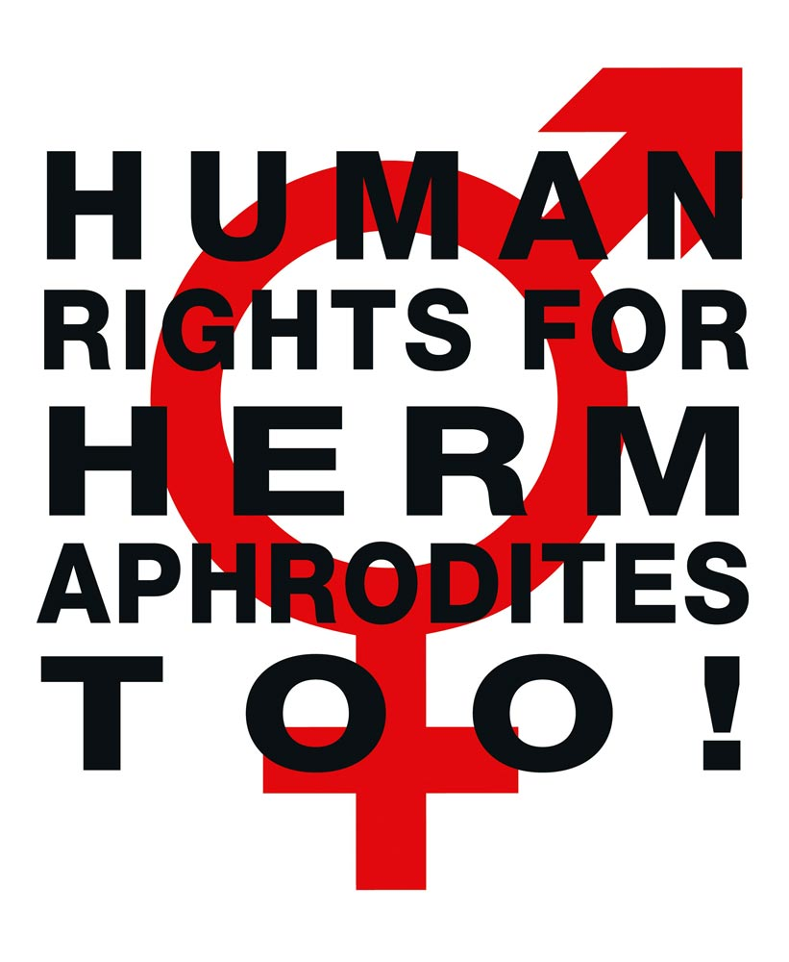

NGO Report (for Session)
to the 7th Report of Austria on the Convention against Torture (CAT)
Compiled by:

StopIGM.org / Zwischengeschlecht.org (International Intersex Human Rights NGO)
Markus Bauer, Daniela Truffer
Zwischengeschlecht.org
P.O.Box 1318
CH-8031 Zurich
info_at_zwischengeschlecht.org
https://Zwischengeschlecht.org/
https://StopIGM.org

March 2024

This NGO Report online:
https://intersex.shadowreport.org/public/2024-CAT-Austria-NGO-Intersex-StopIGM.pdf

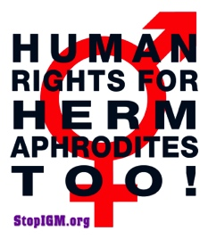

Executive Summary
All typical forms of IGM practices are still widespread in Austria today, facilitated and paid for by the State party via the public health care system, and practiced with impunity. Survivors of IGM continue to be denied access to justice and reparations due to lack of effective legal prohibition and the statutes of limitations.
Austria is thus in breach of its obligations under CAT to (a) take effective legislative, administrative, judicial or other measures to prevent involuntary, non-urgent surgery and other medical treatment on intersex persons without the effective, informed consent of those concerned, causing severe mental and physical pain and suffering, and (b) to ensure impartial investigation, access to redress, and the right to fair and adequate compensation and rehabilitation for victims (arts. 2, 12, 14 and 16, General Comments 2 + 3).
This Committee, as well as CRC and CRPD have already considered IGM in Austria as constituting inhuman treatment and a harmful practice. Nonetheless, to this day the Austrian Government fails to act.
In total, UN treaty bodies CAT, CCPR, CRC, CRPD, and CEDAW have so far issued 90 Concluding Observations recognising IGM as a serious violation of non-derogable human rights, typically obliging State parties to enact legislation to (a) end the practice and (b) ensure redress and compensation, plus (c) access to free counselling. Also, the UN Special Rapporteurs on Torture (SRT) and on Health (SRH), the UN High Commissioner for Human Rights (UNHCHR), the World Health Organisation (WHO), the Inter-American Commission on Human Rights (IACHR), the African Commission on Human and Peoples’ Rights (ACHPR) and the Council of Europe (COE) recognise IGM as a serious violation of non-derogable human rights.
Intersex people are born with Variations of Reproductive Anatomy, including atypical genitals, atypical sex hormone producing organs, atypical response to sex hormones, atypical genetic make-up, atypical secondary sex markers. While intersex people may face several problems, in the “developed world” the most pressing are the ongoing Intersex Genital Mutilations, which present a distinct and unique issue constituting significant human rights violations.
IGM practices include non-consensual, medically unnecessary, irreversible, cosmetic genital surgeries, and/or other harmful medical procedures that would not be considered for “normal” children, without evidence of benefit for the children concerned. Typical forms of IGM include “masculinising” and “feminising”, “corrective” genital surgery, sterilising procedures, imposition of hormones, forced genital exams, vaginal dilations, medical display, involuntary human experimentation and denial of needed health care.
IGM practices cause known lifelong severe physical and mental pain and suffering, including loss or impairment of sexual sensation, painful scarring, painful intercourse, incontinence, urethral strictures, impairment or loss of reproductive capabilities, lifelong dependency of artificial hormones, significantly elevated rates of self-harming behaviour and suicidal tendencies, lifelong mental suffering and trauma, increased sexual anxieties, and less sexual activity.
For 30 years, intersex people have denounced IGM as harmful and traumatising, as western genital mutilation, as child sexual abuse and torture, and called for remedies.
This Thematic NGO Report was compiled by the international intersex NGO Zwischengeschlecht.org / StopIGM.org. It contains Suggested Recommendations (see p. 21).
NGO Report (for Session) to the 7th Report of Austria
on the Convention against Torture (CAT)

Table of Contents

IGM Practices in Austria (p. 7-21)

Executive Summary 3
A. Introduction 5
1. Austria: Intersex Human Rights, LOIPR and State Party Report 5
2. About the Rapporteurs 5
3. Methodology 6
B. Precedents: Concl Obs, UPR, LOIPR, State Party Report 7
1. Previous Concluding Observations 7
a) Inhuman Treatment: CAT 2015 (CAT/C/AUT/CO/6, paras 44–45) 7
b) Harmful Practices: CRC 2020 (CRC/C/AUT/CO/5-6, para 27(a)-(b)) 7
c) Freedom from Torture: CRPD 2023 (CRPD/C/AUT/CO/2-3, paras 39-40, 71(b)+72) 8
2. Universal Periodical Review (UPR) 8
a) 2021 3rd Cycle Recommendations supported by Austria (A/HRC/47/12) 8
3. Current 7th CAT Cycle: LOIPR and State Party Report 9
a) 2017 List of Issues (LOIPR) (CAT/C/AUT/QPR/7, para 30(a)+(b)) 9
b) 2020 State Party Report under LOIPR (CAT/C/AUT/7, paras 284-293) 9
C. IGM in Austria: State-sponsored and pervasive, Gov fails to act 12
1. Lack of legal protection for intersex persons, impunity of perpetrators 12
2. Austria’s commitment to “protect intersex children from violence and harmful practices” 12
a) UNHRC45 Statement, 01.10.2020 12
b) UNHRC48 Statement, 04.10.2021 12
c) UNHRC54 Statement, 04.10.2023 13
3. IGM practices persist 13
a) IGM 3 – Sterilising Procedures: Castration / “Gonadectomy” / Hysterectomy 14
b) IGM 2 – “Feminising Procedures”: Clitoris Amputation/“Reduction”, “Vaginoplasty” 14
c) IGM 1 – “Masculinising Surgery”: Hypospadias “Repair” 16
4. Ministerial “DSD Guidelines” allowing IGM doctors to continue with impunity 18
5. Legal prohibition of IGM stalled by Coalition Government 19
D. Suggested Recommendations 21

A. Introduction

1. Austria: Intersex Human Rights, LOIPR and State Party Report
Austria has been reviewed by CAT (2015), CRC (2020) and CRPD (2023) with all Committees recognising IGM in Austria as constituting cruel, inhuman or degrading treatment or torture and a harmful practice.
IGM practices were mentioned in the LOIPR (para 30), asking about measures to prevent non-urgent procedures, as well as redress and compensation for victims. In its State Party Report (para 284-293) the Austrian Government lists and extensively quotes several laws, however, none of them directly relate to, let alone prevent and sanction IGM practices on children, with the exception of Section 173 Austrian Civil Code which explicitly legalises substitute decision-making in the case of intersex infants: “In the absence of the required decision-making capacity, the consent of the person who is the minor child’s legal representative in matters of care and education is required.” (para 284)
To this day, Austria continues to deny the serious nature of the violations constituted by IGM practices, and refuses to take effective legislative, administrative, judicial or other measures, including prohibition under Criminal Law, to protect intersex children from cruel, inhuman or degrading treatment and harmful practices.
This NGO Report demonstrates that the persisting harmful medical practice on intersex persons in Austria – advocated, facilitated and paid for by the State party, and practiced with impunity –, as well as the ongoing denial of access to justice and reparations for IGM survivors, constitute serious breaches of Austria’s obligations under the Convention.

2. About the Rapporteurs
This NGO report has been prepared by the international intersex NGO StopIGM.org / Zwischengeschlecht.org:
- StopIGM.org / Zwischengeschlecht.org is an international intersex human rights NGO based in Switzerland, working to end IGM practices and other human rights violations perpetrated on intersex people, according to its motto, “Human Rights for Hermaphrodites, too!” According to its charter, StopIGM.org works to support persons concerned seeking redress and justice and regularly reports to relevant UN treaty bodies, often in collaboration with local intersex advocates and NGOs, substantially contributing to the so far 90 Treaty body Concluding Observations recognising IGM as a serious human rights violation.
StopIGM.org has been active in Austria since 2011, documenting the ongoing practice, publicly confronting individual perpetrators and hospitals, has been consulted by the CRC NHRI Child and Youth Advocates Austria (KIJOE), supporting IGM survivors to testify at the UN, and has previously reported on IGM in Austria to CAT in 2015 (in collaboration with VIMÖ – Verein Intergeschlechtlicher Menschen Österreich), to CRC in March and December 2019, and to CRPD in 2018 and 2023.
The Rapporteurs would like to acknowledge the work of pioneering Austrian intersex advocate and IGM survivor Alex Jürgen. And we would like to acknowledge the work of the Austrian Intersex NGO VIMÖ – Verein Intergeschlechtlicher Menschen Österreich, and the work of the Austrian NGO Plattform Intersex.

3. Methodology
This thematic NGO report is an update to the 2017 CAT NGO Report for LOIPR by the same Rapporteurs, based on their 2023 CRPD NGO Report.

B. Precedents: Concl Obs, UPR, LOIPR, State Party Report
1. Previous Concluding Observations
a) Inhuman Treatment: CAT 2015 (CAT/C/AUT/CO/6, paras 44–45)
Intersex persons
44. The Committee appreciates the assurances provided by the delegation that surgical interventions on intersex children are carried out only when necessary, following medical and psychological opinions. It remains concerned, however, about reports of cases of unnecessary surgery and other medical treatment with lifelong consequences to which intersex children have been subjected without their informed consent. The Committee is further concerned at the lack of legal provisions providing redress and rehabilitation in such cases (arts. 14 and 16).
45. The State party should:
(a) Take the legislative, administrative and other measures necessary to guarantee the respect for the physical integrity and autonomy of intersex persons and to ensure that no one is subjected during infancy or childhood to non-urgent medical or surgical procedures intended to decide the sex of the child;
(b) Guarantee impartial counselling services for all intersex children and their parents, so as to inform them of the consequences of unnecessary and non-urgent surgery and other medical treatment to decide on the sex of the child and the possibility of postponing any decision on such treatment or surgery until the persons concerned can decide by themselves;
(c) Guarantee that full, free and informed consent is ensured in connection with medical and surgical treatments for intersex persons and that non-urgent, irreversible medical interventions are postponed until a child is sufficiently mature to participate in decision-making and give effective consent;
(d) Undertake investigation of instances of surgical interventions or other medical procedures performed on intersex persons without effective consent and ensure that the persons concerned are adequately compensated.

b) Harmful Practices: CRC 2020 (CRC/C/AUT/CO/5-6, para 27(a)-(b))
Harmful practices
27. With reference to joint general recommendation No. 31 of the Committee on the Elimination of Discrimination against Women/general comment No. 18 of the Committee on the Rights of the Child (2014) on harmful practices and recalling the concluding observations of the Committee against Torture (CAT/C/AUT/CO/6 para. 45) the Committee recommends that the State party:
(a) Prohibit the performance of unnecessary medical or surgical treatment on intersex children where those procedures may be safely deferred until children are able to provide their informed consent;
(b) Gather data with a view to understanding the extent of these harmful practices so that children at risk can be more easily identified and their abuse prevented;

c) Freedom from Torture: CRPD 2023 (CRPD/C/AUT/CO/2-3, paras 39-40, 71(b)+72)
Freedom from torture or cruel, inhuman or degrading treatment or punishment (art. 15)
[…]
39. The Committee is concerned about the continued performance of sex-reassignment surgery on intersex children.
40. The Committee recommends that the State party enact a legal ban on non-live-saving sex-reassignment medical intervention on intersex children.
[…]
Statistics and data collection (art. 31)
71. The Committee notes with concern:
[…]
(b) The lack of disaggregated data, including in relation to the situation of lesbian, gay, bisexual, transgender and intersex persons with disabilities, refugees and stateless persons with disabilities, persons with disabilities in refugee-like situations, persons with disabilities under temporary protection, children with disabilities (in particular concerning education), women and girls with disabilities and persons with disabilities in institutions.
72. The Committee recommends that the State party develop a comprehensive national disability data framework to ensure appropriate, nationally consistent measures for the collection, interpretation and public reporting of disaggregated data on the full range of obligations under the Convention, in particular with regard to lesbian, gay, bisexual, transgender and intersex persons with disabilities, refugees and stateless persons with disabilities, persons with disabilities in refugee-like situations, persons with disabilities under temporary protection, children with disabilities, women and girls with disabilities and persons with disabilities in institutions.

2. Universal Periodical Review (UPR)
a) 2021 3rd Cycle Recommendations supported by Austria (A/HRC/47/12)
139.128 Strengthen the legislative framework to expressly prohibit any practice that modifies a person’s sexual characteristics without well-founded medical reasons or without the full consent of that person (Uruguay);
139.130 End harmful practices, including forced and coercive medical interventions, to ensure the bodily integrity of children with intersex variations (Iceland);
139.131 Prohibit any practice that modifies a person’s sex characteristics without irrefutable medical reasons and the full and informed consent of the person affected (Malta);

3. Current 7th CAT Cycle: LOIPR and State Party Report
a) 2017 List of Issues (LOIPR) (CAT/C/AUT/QPR/7, para 30(a)+(b))
Article 16
[...]
30. In the light of the Committee’s previous concluding observations (para. 45), please provide updated information on:
(a) The measures taken to ensure that no child is subjected to non-urgent medical or surgical procedures intended to decide the sex of the child; that such procedures are postponed until the child is mature enough to make a fully informed decision; and that all intersex persons subjected to such procedures without their consent are adequately compensated;
(b) The procedures for informed consent for surgical interventions and whether that includes independent counselling, inter alia, by intersex persons and their organizations.

b) 2020 State Party Report under LOIPR (CAT/C/AUT/7, paras 284-293)
AS. Reply to paragraph 30 (a) of the list of issues
284. Section 173 Austrian Civil Code (Allgemeines Bürgerliches Gesetzbuch, ABGB) regulates the consent to medical treatments of minors. Pursuant to Section 173 (1) consents to medical treatments can only be granted by the child having decision-making capacity itself; if in doubt, such decision-making capacity is deemed to exist in case of minors having reached the age of discretion (14 year of age and above). In the absence of the required decision-making capacity, the consent of the person who is the minor child’s legal representative in matters of care and education is required.
285. If a minor child having decision-making capacity consents to a treatment, which usually results in a severe or lasting negative impact on a person’s physical integrity or personality, the treatment can only be made if also the person who is the minor child’s legal representative in matters of care and education consents to such treatment (Section 173 (2) Austrian Civil Code).
286. The consent of the child having decision-making capacity as well as the consent of the person responsible for care and education are not required if the treatment is so urgent that the delay in connection with obtaining consent or approval would endanger the life of the child or would be connected with a risk of severe damage to health (so-called imminent danger provision; Section 173 (3) Austrian Civil Code).
AT. Reply to paragraph 30 (b) of the list of issues
287. Medical treatment of adult persons without decision-making capacity is regulated by Sections 252–254 Austrian Civil Code. The medical treatment of a person of full age who does not have decision-making capacity requires the consent of the Vorsorgebevollmächtigter (i.e., the person appointed under an enduring power of attorney) or Erwachsenenvertreter (i.e. the relevant person’s elected, statutory or court-appointed representative) whose sphere of influence comprises this matter. In addition, even a person not having decision-making capacity at the time of the treatment must be informed of the reasons for and the importance of the medical treatment to the extent possible and bearing in mind the person’s well-being. If the person not having decision-making capacity makes it known to his/her Vorsorgebevollmächtigter or Erwachsenenvertreter (hereinafter “respective representative”) or to the doctor that he/she rejects the medical treatment or its continuation, the consent given by the respective representative becomes subject to approval by the court.
288. In this context, medical treatment refers to a diagnostic, therapeutic, rehabilitative, obstetrical or disease prevention measure carried out by a doctor or at a doctor’s order. The provisions apply mutatis mutandis also to similar measures carried out by members of other health professions regulated by law (Section 252 (1) Austrian Civil Code).
289. Decision-making capacity is deemed to exist if the patient is capable of understanding the reason for and the importance of the treatment and can form his/her will on that basis. The patient thus must be capable of understanding the consequences of his/her actions in the respective context (cognitive element), forming his/her will on that basis (volitive element) and acting accordingly.
290. A special provision (Section 255 Austrian Civil Code) regulates the sterilisation of adult persons without decision-making capacity: The respective representative must not consent to a medical treatment which aims at the permanent infertility of the represented person not having decision-making capacity, unless otherwise, due to a permanent physical condition, danger to life or the risk of severe damage to health or great pain exists. Furthermore, the consent given by the respective representative is subject to approval by the court.
291. Reference is made to the 2017 Opinion of the Bioethics Commission of the Federal Chancellery on Intersexuality and Transidentity.
292. In addition, attention is being drawn to the special protection of certain groups of persons under the Federal Act on the Performance of Aesthetic Treatments and Surgeries. [15]
293. Section 7 of the Federal Act on the Performance of Aesthetic Treatments and Surgeries thus stipulates the following:
“(1) Performing aesthetic treatments or surgeries on persons up to the age of 16 is inadmissible.
(2) Aesthetic treatments or surgeries on persons above the age of 16 but under the age of 18 may be performed only if
1. written consent has been granted by the parent or guardian in a verifiable and written form (pursuant to Section 6 (2)) based on an adequate and comprehensive medical consultation (pursuant to Section 5), and
2. written consent has been granted, in a verifiable and written form (pursuant to Section 6 (2)) by the patient who, based on an adequate and comprehensive medical consultation (Section 5), is capable of understanding the nature, importance, consequences and risks of the aesthetic treatment or surgery and forming his/her will on that basis.
In case of an aesthetic surgery, in addition, an assessment as to any mental disorders including a consultation by a clinical psychologist, a psychiatric or psychotherapeutic specialist or a specialist for child and adolescent psychiatry must be carried out in a verifiable form before the procedure. The presence of a mental disorder classifiable as illness precludes performing the procedure if such prior consultation showed that the wish to perform the procedure results from the disorder.
(3) Aesthetic treatments or surgeries on persons who, due to a mental illness or a comparable impairment of their ability to make decisions, have a statutory representative in matters of their medical treatments, may be performed only if written consent has been granted by the patient in a verifiable and written form (pursuant to Section 6 (2)) to the extent that, based on an adequate and comprehensive medical consultation (Section 5), the patient is capable of understanding the nature, significance, consequences and risks of the aesthetic treatment or surgery and forming his/her will on that basis. If the patient is not capable of making a decision, the statutory representative must, based on an adequate and comprehensive medical consultation (Section 5), grant his/her consent in verifiable and written form.
(4) If consent is withdrawn by persons above the age of 16 but under the age of 18 or by persons who, due to a mental illness or a comparable impairment of their ability to make decisions, have a statutory representative in matters of their medical treatments, and such withdrawal takes place no later than one week before the date of the treatment or the surgery, no financial disadvantage shall arise to the patient.
(5) An aesthetic treatment or surgery on persons above the age of 16 but under the age of 18 or on persons who, due to a mental illness or a comparable impairment of their ability to make decisions, have a statutory representative in matters of their medical treatments may be performed no earlier than 4 weeks after the required consents have been obtained ((2) and (3)).”
[15] Federal Act on the Performance of Aesthetic Treatments and Surgeries (Bundesgesetz über die Durchführung von ästhetischen Behandlungen und Operationen, ÄsthOpG).

C. IGM in Austria: State-sponsored and pervasive, Gov fails to act
1. Lack of legal protection for intersex persons, impunity of perpetrators
In Austria (CAT/C/AUT/CO/6, paras 44-45; CRC/C/AUT/CO/5-6, para 27(a)-(b); CRPD/C/AUT/CO/2-3, paras 37-38, 69-70), same as in the neighbouring states of Germany (CAT/C/DEU/CO/5, para 20; CCPR/C/DEU/CO/7, paras 20+21; CRPD/C/DEU/CO/1, paras 37-38; CEDAW/C/DEU/CO/7-8, paras 23-24; CRC/C/DEU/CO/5-6, para 24(c); CRPD/C/DEU/CO/2-3, paras 39-40), Switzerland (CAT/C/CHE/CO/7, para 20; CAT/C/CHE/CO/8, paras 37-38; CRC/C/CHE/CO/2-4, paras 42-43; CEDAW/C/CHE/CO/4-5, paras 24-25, 38-39; CCPR/C/CHE/CO/4, paras 24-25; CRC/C/CHE/CO/5-6, para 29(b)+(c); CRPD/C/CHE/CO/1, paras 35(c)+36(c), 10(a); CEDAW/C/CHE/CO/6, paras 55(f)+56(d)), Liechtenstein (CEDAW/C/LIE/CO/5, paras 35+36(c); CRC/C/LIE/CO/3-4, para 24 (b)+(c)), and the Czech Republic (CRC/C/CZE/CO/5-6, para 28), and in many more State parties, there are
- no legal or other protections in place to ensure the rights of intersex children to physical and mental integrity, autonomy and self-determination, and to prevent IGM practices
- no measures in place to ensure data collection and monitoring of IGM practices
- no legal or other measures in place to ensure the accountability of IGM perpetrators
- no legal or other measures in place to ensure access to redress, justice and rehabilitation for adult IGM survivors
To this day, in Austria all forms of IGM practices remain widespread and ongoing, persistently advocated, prescribed and perpetrated with impunity by state funded University and public Children’s Hospitals, advocated and paid for by the State via the public health system.
2. Austria’s commitment to “protect intersex children from violence and harmful practices”, “investigate abuses”, “ensure accountability” and “access to remedy”
a) UNHRC45 Statement, 01.10.2020
On occasion of the 45th Session of the Human Rights Council the State party initiated a public “Joint Statement led by Austria on the Rights of Intersex Persons” calling to “protect […] intersex adults and children […] so that they live free from violence and harmful practices. Governments should investigate human rights violations and abuses against intersex people, ensure accountability, […] and provide victims with access to remedy.”
b) UNHRC48 Statement, 04.10.2021
On occasion of the 48th Session of the Human Rights Council the State party supported a public follow-up statement reiterating the call to end harmful practices and ensure access to justice:
“Intersex persons also need to be protected from violence and States must ensure accountability for these acts. […]
Furthermore, there is also a need to take measures to protect the autonomy of intersex children and adults and their rights to health and to physical and mental integrity so that they live free from violence and harmful practices. Medically unnecessary surgeries, hormonal treatments and other invasive or irreversible non-vital medical procedures without their free, prior, full and informed consent are harmful to the full enjoyment of the human rights of intersex persons.
We call on all member states to take measures to combat violence and discrimination against intersex persons, develop policies in close consultations with those affected, ensure accountability, reverse discriminatory laws and provide victims with access to remedy.”
c) UNHRC54 Statement, 04.10.2023
On occasion of the 54th Session of the Human Rights Council the State party supported a public follow-up statement reiterating the call to prohibit harmful practices and inhuman treatment and to ensure access to justice:
“4. Because their bodies are perceived as different, intersex persons, including children, face stigma, misconception and violence, such as forced, coercive, irreversible and non-vital medical interventions. These include so-called “normalising” surgeries that can have life-long negative impacts on their physical and mental health. These harmful practices should be urgently stopped. Human rights of intersex persons need to be respected, so that they can live free from violence, cruel, inhuman, or degrading treatment and harmful practices. [...]
8. We call on all States to increase efforts to combat violence, harmful practices and discrimination on the basis of sex characteristics, address their root causes, and implement protective laws and policies in close consultations with those affected, in order to ensure the full realization of human rights of intersex persons.”
3. IGM practices persist
Despite above mentioned pledges to end IGM, to this day, in Austria all forms of IGM practices remain widespread and ongoing, persistently advocated, prescribed and perpetrated by the state funded University Hospitals, and paid for by the State via the public health system.
In addition, also in 2024 Austrian medical bodies continue to endorse international medical guidelines prescribing all forms of IGM practices (see below).

Currently practiced forms of IGM in Austria include:
a) IGM 3 – Sterilising Procedures:
Castration / “Gonadectomy” / Hysterectomy /
Removal of “Discordant Reproductive Structures” / (Secondary) Sterilisation
Plus arbitrary imposition of hormones
The Austrian Urological Society (Österreichische Gesellschaft für Urologie und Andrologie, ÖGU) endorses the 2023 Guidelines of the European Association of Urology (EAU), which include the current ESPU/EAU “Paediatric Urology” Guidelines 2023 of the European Society for Paediatric Urology (ESPU) and the European Association of Urology (EAU), chaired by Innsbruck paediatric urology head surgeon Prof Dr Christian Radmayr, which stress:
“The issue of whether gonads should be removed and the timining of such surgery remains controversial and has been altogether questioned in some forms of DSD. Patients with, for example, CAIS benefit from the presence of testicles and the resultant aromatisation of the naturally occuring testosterone to oestrogens. The risk of malignant gonadal transformation in this subcategory is low (1.5%) with cases of malignancy first appearing after the second decade of life, thus allowing for the safe deferal of gonadectomy until after puberty [1248, 1249].”
Further, regarding “whether and when to pursue gonadal or genital surgery”, the Guidelines refer to the “ESPU/SPU standpoint on the surgical management of Disorders of Sex Development (DSD)”, which advocates “gonadectomies”:
“Testes are either brought down in boys or removed if dysgenetic with tumour risk or in complete androgen insensitivity syndrome or 5 alpha reductase deficiency. Testicular prostheses can be inserted at puberty at the patient’s request.”
b) IGM 2 – “Feminising Procedures”: Clitoris Amputation/“Reduction”,
“Vaginoplasty”, “Labiaplasty”, Dilation
The Austrian Urological Society (Österreichische Gesellschaft für Urologie und Andrologie, ÖGU) endorses the 2023 Guidelines of the European Association of Urology (EAU), which include the current ESPU/EAU “Paediatric Urology” Guidelines 2023 of the European Society for Paediatric Urology (ESPU) and the European Association of Urology (EAU), chaired by Innsbruck paediatric urology head surgeon Prof Dr Christian Radmayr. In chapter 3.17 “Disorders of sex development”, despite admitting that “Surgery that alters appearance is not urgent” and that “adverse outcomes have led to recommendations to delay unnecessary [clitoral] surgery to an age when the patient can give informed consent”, the ESPU/EAU Guidelines nonetheless explicitly refuse to postpone non-emergency surgery, but in contrary insist to continue with non-emergency genital surgery (including partial clitoris amputation) on young children based on “social and emotional conditions” and substituted decision-making by “parents and caregivers implicitly act[ing] in the best interest of their children” and making “well-informed decisions […] on their behalf”, and further explicitly refusing “prohibition regulations” of unnecessary early surgery, referring to the 2018 ESPU Open Letter to the Council of Europe (COE), which further invokes parents’ “social, and cultural considerations” as justifications for early surgery (p. 2).
Notably, some Austrian IGM doctors publicly claim to have abandoned IGM 2 (however, they conveniently continue to refuse to disclose relevant statistics, for example in an October 2019 news report based on an interview with Vienna IGM doctor Stefan Riedl:
“In the past, interventions were carried out as soon as possible, today a reconsideration has taken place in medicine and irreversible interventions are avoided as far as possible, according to medical experts last week at the European Congress for Paediatric Endocrinology in Vienna. […]
‘In all other cases [i.e. IGM 2] – based on the right to physical integrity – the patient is allowed as much time as possible until puberty or later,’ explains Riedl. If the prospective teenager is not yet sure of his or her gender identity when puberty sets in, it is also possible to delay puberty by administering hormone blockers.”
However, such unsubstantiated claims fly in the face of recent statistics presented by another Vienna IGM doctor at the September 2019 “European Congress for Paediatric Endocrinology” in Vienna mentioned in above quote (i.e. the 58th Annual Meeting of the European Society for Paediatric Endocrinology ESPE):
“Genital surgery has been performed in 251 (76%). Clitoral surgery been performed in 231 (92%), vaginal surgery in 204 (81%) and a combination of clitoral and vaginal surgery had been performed in 186 (74%). Of the 251 who had surgery, 18 (7%) had vaginal but no clitoral surgery whilst 42 (17%) had clitoral but no vaginal surgery. Mean age at first surgery was 2.5 years (0-15), with clitoral surgery and vaginal surgery at 2.6 years (range) and 3.2 years (range), respectively. […] The Chicago Consensus Statement on DSD (comparison of data before and after 2006) did not have any significant influence on the timing or probability of surgery.”
What’s more, Riedl’s unsubstantiated claims fly in the face of a survey presented by Riedl himself and fellow Vienna IGM doctor Alexander Springer, documenting preference for early “clitoral surgery” by IGM doctors much in line with above ESPE statistics:
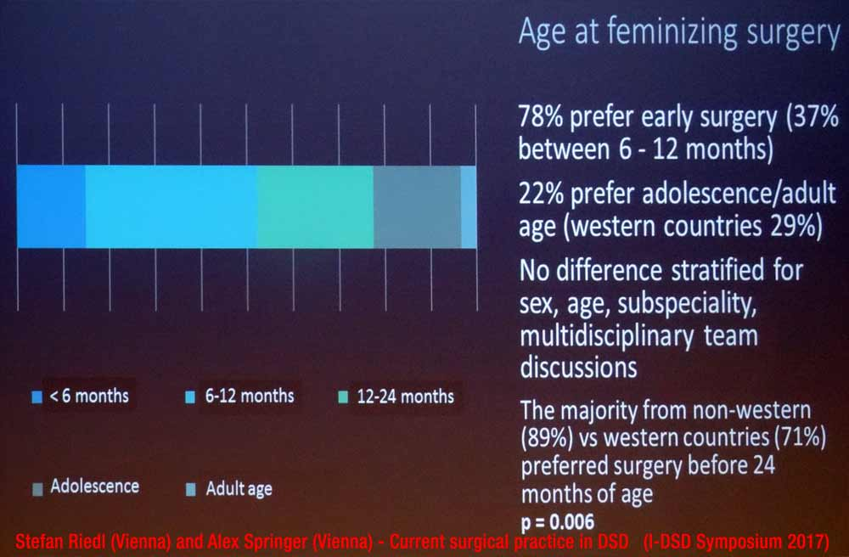
c) IGM 1 – “Masculinising Surgery”: Hypospadias “Repair”
The Austrian Urological Society (Österreichische Gesellschaft für Urologie und Andrologie, ÖGU) endorses the 2023 Guidelines of the European Association of Urology (EAU), which include the current ESPU/EAU “Paediatric Urology” Guidelines 2023 of the European Society for Paediatric Urology (ESPU) and the European Association of Urology (EAU), chaired by Innsbruck paediatric urology head surgeon Prof Dr Christian Radmayr. In chapter 3.6 “Hypospadias”, the ESPU/EAU Guidelines’ section 3.6.5.3 “Age at surgery” explicitly promotes, “The age at surgery for primary hypospadias repair is usually 6-18 (24) months.” – despite admitting to the “risk of complications” and “aesthetic[…]” and “cosmetic” justifications.
To this day, Austrian University Clinics still promote “early surgical correction” for hypospadias.
For example, a paediatric urologist and Professor of Paediatric Surgery at the Paediatric Urology department of the Medical University of Vienna AKH states on its private homepage under “Paediatric urological diseases”, “The treatment for hypospadias is surgery. From a paediatric point of view, early surgery is recommended (around the age of 1).”
Similarly, the Ordensklinikum Linz (Religious Hospital Linz) promotes on its homepage under “specialised paediatric surgery”:
“The treatment of hypospadias consists of surgical correction of the malformation. In very severe cases, several operations may be necessary. We also recommend preoperative treatment with a locally effective (ointment) testosterone preparation for selected patients.
The ideal time for the operation is around the first birthday, as the stress on the child - since it is not yet in a sex-specific development phase - is low.”
In addition, a 2019 medical article by IGM doctors from the Departments of Pediatric Surgery and Urology of the Medical University Vienna promotes even more experimental “surgical techniques”, and further offers revealing insights on the frequency of IGM 1 and the harmful consequences:
“Materials and Methods: This is a consecutive single team (2 surgeons) retrospective series. Between 2014 and 2017, 250 patients underwent hypospadias repair […]. Median age at first stage was 1.5 (0.5–22.1) years […].
Results: The total complication rate was 22.9%. […]”
This continued preference for “early surgical correction” is also in line with a previous survey presented by partly the same Vienna IGM doctors:
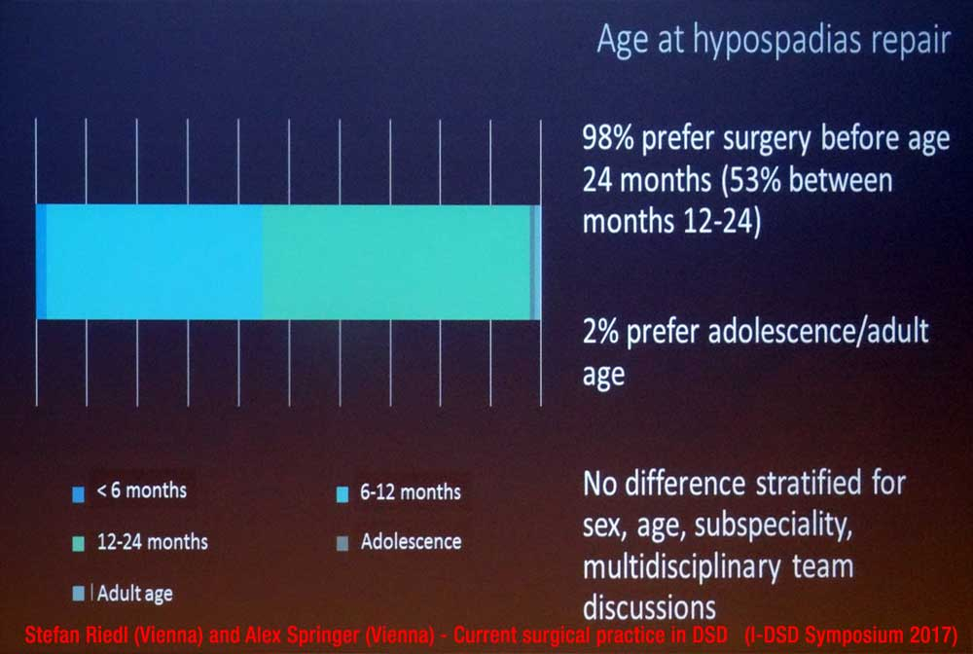
And it is further confirmed in the October 2019 news report based on an interview again with Vienna IGM doctor Stefan Riedl:
“certain cases are treated early – in addition to medically necessary hormone treatment, these include hypospadias repair or the removal of functionless gonads”
4. Ministerial “DSD Guidelines” allowing IGM doctors to continue with impunity
An alarming new trend is the increasing misrepresentation of IGM as “health-care issue” instead of a serious violation of non-derogable human rights, and the promotion of “self-regulation” of IGM by the current perpetrators (i.e. IGM doctors, Health Ministries and other related actors and bodies) – instead of effective measures to finally end IGM practices.
Unfortunately, this has now also been the case in Austria:
Without public announcement, in September 2019 the Ministry of Health published on its homepage a longwinded, 95-page “Medical DSD Guideline”. While its title “Recommendations on variations of sex development” clearly alludes to the vastly superior (and much more to the point) 2012 Swiss Bioethic Recommendations which support prohibition of IGM under criminal law and to address obstacles to access to justice, namely the statutes of limitations, and further the Ministry has to be commended to have also consulted with Austrian intersex advocates, unfortunately, it has to be clearly said that in the end the Ministry sided with the IGM doctors and failed to support the demands of intersex people.
Tellingly, while the “Guideline” contains a 9-page section “5 Legal basis for variations of sex development” (p. 20-28) which even mentions the “prohibition of torture (Art. 3 ECHR)” (p. 20) and “the possible [!] right to redress after interventions that have subsequently turned out to be severely traumatising and restricting the quality of life” (p. 19), it conveniently fails to refer to the 2015 CAT Concluding Observations to Austria on intersex and IGM (CAT/C/AUT/CO/6, paras 44-45).
What’s more, the “Guideline” repeats the usual unsubstantiated claims of “considerable change” in the medical practice “in recent decades” (p. 23).
Accordingly, Austrian intersex advocates have clearly and officially “criticise[d] double standards” of the “Guideline”:
“A definite refusal of non-consensual and medically unnecessary treatments is missing here [i.e. within the “Guideline”] and there [i.e. in recent unsubstantiated public claims of “change” by IGM doctors, see above], and so these continue to be carried out.”
Namely, Platform Intersex Austria (PIÖ) legal expert Eva Matt further observed:
“The problem is that the various contributions in the paper partly contradict each other strongly. In everyday medical practice, very different therapy plans can be justified by this paper. There is no legal security for the physical autonomy of intersex people.”
And Association of intersex people Austria (VIMÖ) member Tinou Ponzer stated:
“For twenty years, medical guidelines have spoken of a restrictive approach to surgery and of involving self-help groups. Unfortunately, in the peer support we have to find out again and again that this is not yet the case in practice in 2019.”
Nonetheless, it has to be expected that Austrian Government representatives will still claim “we have now this wonderful new Guideline and everything is well” – while at the same time refusing to disclose data on the actual current practice in Austria (as evidenced in the State Party Report), let alone to finally take effective measures against harmful practices on intersex children, namely by criminalising the practice and to address obstacles to access to justice and redress, namely the statutes of limitations (see below).
5. Legal prohibition of IGM stalled by Coalition Government
On 09.06.2021, the Equal Treatment Committee of Austria’s Parliament unanimously adopted the Motion for a Resolution 1594/A(E) “Protection of intersex children and adolescents from medically unnecessary treatment of their sexual characteristics”, further calling on the Government to disclose data on surgery and other treatments on intersex children to the Parliament. On 16.06.2021, the National Council supported the Motion (183/E XXVII. GP). Both steps have been warmly welcomed by Austrian intersex NGO VIMÖ and allies.
These preliminary steps to prohibit IGM practices were also duly noted by Austrian IGM doctors.
However, to this day no corresponding Draft Law has materialised. Also, so far the Government failed to disclose the demanded data on surgery on intersex children (same as in the State Party Report). According to media reports, a Bill has been drafted, but has been stalled for more than half a year now within the Coalition Government.
In order to urge the Government to finally put forward a Draft Law, on 17.05.2023 the intersex NGO VIMÖ submitted an Open Letter co-signed by 73 Austrian NGOs.
In addition, on 14.06.2023 the Austrian intersex NGO VIMÖ submitted a Petition with currently 7’482 signatories to the Austrian Government on occasion of a peaceful protest, again urging the Government to advance a Draft Law.
However, so far, still no Draft Law has materialised.
There we would like to urge the Committee to address IGM practices in Austria in the forthcoming 79th Session, and to sternly remind Austria of its obligations under the Convention to adequately protect intersex children against IGM practices constituting inhuman treatment (see next page).

D. Suggested Recommendations

The Rapporteurs respectfully suggest that, with respect to the treatment of intersex persons in Austria, the Committee includes the following measures in their recommendations to the Austrian Government:

Intersex Genital Mutilation
While welcoming Parliamentary Motions to protect intersex children, the Committee remains seriously concerned about cases of unnecessary and irreversible surgery and other medical treatment on intersex children without their informed consent, which can cause severe suffering, and the lack of legal protections, redress and compensation in such cases (arts. 2, 12, 14 and 16).
The Committee recommends that the State party:
- Adopt clear legislative provisions that explicitly prohibit the performance of involuntary, deferrable surgical or other medical procedures on intersex infants and children;
- Extend the statute of limitations to enable criminal and civil remedies;
- Provide adequate counselling and support for families of intersex children;
- Provide health care and psychosocial support to intersex persons who have been subjected to involuntary procedures;
- Systematically collect data on the number of irreversible surgical and other procedures that are performed on intersex children, disaggregated by age, type of intervention, and geographic location.

https://Zwischengeschlecht.org/ English homepage: https://StopIGM.org
https://zwischengeschlecht.org/post/Statuten
https://intersex.shadowreport.org
https://stopigm.org/post/IAD-2016-Soon-20-UN-Reprimands-for-Intersex-Genital-Mutilations
https://www.interfaceproject.org/alex-jurgen
https://www.berlinale.de/external/programme/archive/pdf/20060735.pdf
https://www.austrianfilms.com/news/bodytintenfischalarm_ein_gespraech_mit_elisabeth_scharang_und_alex_juergenbody
http://www.m-media.or.at/gesellschaft/alex-jurgen-mein-korper-wurde-gebastelt/2013/11/05/index.html
https://www.tagblatt-wienerzeitung.at/nachrichten/chronik/oesterreich/700353_Ich-haette-gerne-wieder-was-sie-mir-weggeschnitten-haben.html
https://vimoe.at/
https://www.plattform-intersex.at/
https://intersex.shadowreport.org/public/2017-CAT-LoIPR-Austria-NGO-Zwischengeschlecht-Intersex-IGM.pdf
https://intersex.shadowreport.org/public/2023-CRPD-Austria-NGO-Intersex-StopIGM.pdf
Currently we count 90 Concluding observations on IGM practices for 24 State parties in Europe, South America, Asia and Oceania, see https://StopIGM.org/post/IAD-2016-Soon-20-UN-Reprimands-for-Intersex-Genital-Mutilations
Statement initiated by Austria (and supported by 34 other States) during the 45th Session of the Human Rights Council on 1 October 2020, https://www.dfat.gov.au/international-relations/themes/human-rights/hrc-statements/45th-session-human-rights-council/joint-statement-led-austria-rights-intersex-persons
Statement supported by Austria (and 52 other States) during the 48th Session of the Human Rights Council on 4 October 2021, https://www.bmeia.gv.at/oev-genf/speeches/alle/2021/10/united-nations-human-rights-council-48th-session-joint-statement-on-the-human-rights-of-intersex-persons/
Statement supported by Austria (and 55 other States) during the 54th Session of the Human Rights Council on 4 October 2023, https://finlandabroad.fi/web/geneve/current-affairs/-/asset_publisher/h5w4iTUJhNne/content/general-debate-item-8/384951
For general information, see 2016 CEDAW NGO Report France, p. 47. https://intersex.shadowreport.org/public/2016-CEDAW-France-NGO-Zwischengeschlecht-Intersex-IGM.pdf
https://uroweb.org/guidelines/endorsement/
https://d56bochluxqnz.cloudfront.net/documents/full-guideline/EAU-Guidelines-on-Paediatric-Urology-2023.pdf
Ibid., p. 94
Ibid., p. 93
P. Mouriquand, A. Caldamone, P. Malone, J.D. Frank, P. Hoebeke, “The ESPU/SPU standpoint on the surgical management of Disorders of Sex Development (DSD)”, Journal of Pediatric Urology vol. 10, no. 1 (2014), p. 8-10, http://www.jpurol.com/article/S1477-5131(13)00313-6/pdf
For general information, see 2016 CEDAW NGO Report France, p. 48. https://intersex.shadowreport.org/public/2016-CEDAW-France-NGO-Zwischengeschlecht-Intersex-IGM.pdf
https://uroweb.org/guidelines/endorsement/
https://d56bochluxqnz.cloudfront.net/documents/full-guideline/EAU-Guidelines-on-Paediatric-Urology-2023.pdf
Ibid., p. 89
Ibid., p. 93
Ibid., p. 93
Ibid., p. 93
Ibid., p. 94
https://www.espu.org/images/documents/ESPU_Open_Letter_to_COE_2018-01-26.pdf
Der Standard (21.09.2019), “Geschlechterentwicklung: Was Ärzte tun, wenn ein Neugeborenes weder Mädchen noch Bub ist” (“Sex development: What doctors do when a newborn is neither a girl nor a boy”), https://www.derstandard.at/story/2000108887801/was-aerzte-tun-wenn-ein-neugeborenes-weder-maedchen-noch-bub
Doris Hebenstreit (Department of Urology, Hanusch Krankenhaus, Vienna), Faisal Ahmed, on behalf of the contributing centres within the I-DSD registry and I-CAH registry, Alexander Springer (Medical University Vienna), Christoph Krall, Nils Krone, Niels Birkebaek, Tatjana Milenkovic, Birgit Koehler, Christa Flueck, Ruth Krone, Antonio Balsamo, Rodolfo Rey, Carlo Acerini, Alya Guven, Tulay Guran, Feyza Darendeliler, Sabah Alvi, Marta Korbonits, Walter Bonfig, Eduardo Correa Costa, Richard Ross, Violeta Iotova, Daniel Konrad, Jillian Bryce, Hedi Claahsen van der Grinten, Liat de Vries, “Contemporary surgical approach in CAH 46XX – Results from the I-DSD/I-CAH Registries”, presentation at ESPE 2019, see Abstract Book, p. 96, https://www.karger.com/Article/Pdf/501868
Photo of presentation slide: Stefan Riedl (Vienna) and Alex[ander] Springer (Vienna) -Current surgical practice in DSD: results of the COST/DSDnet surgery survey, presentation at 6th I-DSD Symposium Copenhagen, 29.06.2017, see programme p. 5, https://web.archive.org/web/20191214214059/https://www.gla.ac.uk/media/Media_533778_smxx.pdf
For general information, see 2016 CEDAW NGO Report France, p. 48-49, https://intersex.shadowreport.org/public/2016-CEDAW-France-NGO-Zwischengeschlecht-Intersex-IGM.pdf
https://uroweb.org/guidelines/endorsement/
https://d56bochluxqnz.cloudfront.net/documents/full-guideline/EAU-Guidelines-on-Paediatric-Urology-2023.pdf
Ibid., p. 27
Ibid., p. 29
Ibid., p. 28
Ibid., p. 28
https://www.kinderuro.at/ordination
https://www.ordensklinikum.at/de/patienten/medizinische-schwerpunkte/kinderspezialchirurgie/harnroehre/hypospadie/
Ursula Tonnhofer, Manuela Hiess, Martin Metzelder, Doris Hebenstreit, and Alexander Springer (2019), “Midline Incision of a Graft in Staged Hypospadias Repair–Feasible and Durable?”, Frontiers in Pediatrics, 2019; 7: 60, p. 1, https://www.ncbi.nlm.nih.gov/pmc/articles/PMC6423900/pdf/fped-07-00060.pdf
Photo of presentation slide: Stefan Riedl (Vienna) and Alex[ander] Springer (Vienna) -Current surgical practice in DSD: results of the COST/DSDnet surgery survey, presentation at 6th I-DSD Symposium Copenhagen, 29.06.2017, see programme p. 5, https://web.archive.org/web/20191214214059/https://www.gla.ac.uk/media/Media_533778_smxx.pdf
Der Standard (21.09.2019), “Geschlechterentwicklung: Was Ärzte tun, wenn ein Neugeborenes weder Mädchen noch Bub ist” (“Sex development: What doctors do when a newborn is neither a girl nor a boy”), https://www.derstandard.at/story/2000108887801/was-aerzte-tun-wenn-ein-neugeborenes-weder-maedchen-noch-bub
Federal Ministry of Labour, Social Affairs, Health and Consumer Protection (2019), “Empfehlungen zu Varianten der Geschlechtsentwicklung” (“Recommendations on variations of sex development”), https://www.sozialministerium.at/dam/jcr:3e0dc44d-0464-42ed-ad1d-c3562ec8c873/empfehlungen_varianten_der_geschlechtsentwicklung.pdf
Swiss National Advisory Commission on Biomedical Ethics (NEK-CNE) (2012), Zum Umgang mit Varianten der Geschlechtsentwicklung. Ethische Fragen zur “Intersexualität” (“On the management of varations of sex development. Ethical issues relating to “intersex”), English version see https://www.nek-cne.admin.ch/inhalte/Themen/Stellungnahmen/en/NEK_Intersexualitaet_En.pdf
Ibid., see Recommendation 12, p. 19
“In recent decades, opinions about what is medically indicated in the case of a Variation of sex development and what is in the best interest of the child have changed considerably.”
Association of intersex people Austria (VIMÖ) (07.10.2019), Press release: “Gesundheitsministerium veröffentlicht Empfehlungen zu Varianten der Geschlechtsentwicklung” (“Ministry of Health publishes recommendations on variations of sex development”), https://www.ots.at/presseaussendung/OTS_20191007_OTS0140/gesundheitsministerium-veroeffentlicht-empfehlungen-zu-varianten-der-geschlechtsentwicklung
Ibid.
Ibid.
https://www.parlament.gv.at/dokument/XXVII/I/896/fnameorig_982576.html
https://www.parlament.gv.at/aktuelles/pk/jahr_2021/pk0692#XXVII_A_01594
https://www.parlament.gv.at/gegenstand/XXVII/A/1594
https://www.parlament.gv.at/dokument/XXVII/A/1594/imfname_971331.pdf
https://www.parlament.gv.at/gegenstand/XXVII/E/183
https://www.parlament.gv.at/dokument/XXVII/E/183/fnameorig_984853.html
https://vimoe.at/2021/06/09/juni-2021-parlament-fordert-regierung-auf-intergeschlechtliche-kinder-zu-schuetzen/
https://www.ots.at/presseaussendung/OTS_20210609_OTS0130/hosi-salzburg-genitalverstuemmelung-an-intergeschlechtlichen-menschen-stoppen
Springer A (2022), “56.9 Intersex-Gesetz in Österreich” (“Intersex Law in Austria”), presentation at 63rd Annual Meeting of the Austrian Society of Surgery, Eur Surg (2022) 54 :S1–S139, p. S90 (p. 90 in PDF), https://link.springer.com/content/pdf/10.1007/s10353-022-00763-x.pdf
“According to the answer to a parliamentary question by Justice Minister Alma Zadic (Greens) from April, a corresponding bill has been in political coordination since autumn 2022 and lies with the coalition partner ÖVP.”, news ORF.at (2023), “Gesetz zum Schutz intergeschlechtlicher Kinder gefordert” (“Law for the protection of intersex children called for”), 17.05.2023, https://orf.at/stories/3317021/
https://vimoe.at/2023/05/17/mai-2023-offener-brief-an-ministerinnen-zum-schutz-intergeschlechtlicher-kinder-und-jugendlicher/
https://vimoe.at/wp-content/uploads/2023/06/OffenerBriefMai2023.pdf
https://mein.aufstehn.at/petitions/schutzen-sie-intergeschlechtliche-kinder-und-jugendliche?source=homepage&utm_medium=promotion&utm_source=homepage
https://vimoe.at/2023/06/09/juni-2023-uebergabe-der-petition-am-14-06-2023-um-815-uhr-vor-dem-parlament/
https://vimoe.at/2023/06/14/juni-2023-vimoe-an-oevp-und-gruene-schuetzen-sie-endlich-intergeschlechtliche-kinder-und-jugendliche/

