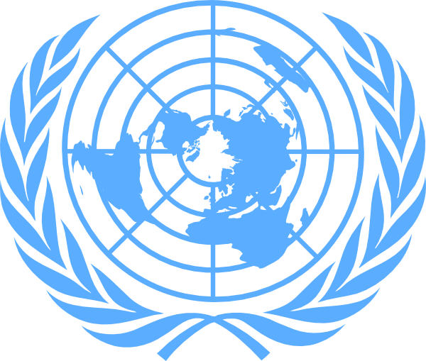

Mr. Bruno Donat,
Chief, UNMAS Geneva office

Committee on the Rights of Persons with Disabilities

UNMAS Statement on Victim Assistance

Monday, 17 August 2020
UNOG, Geneva

Committee on the Rights of Persons with Disabilities
UNMAS Statement on Victim Assistance
17 August 2020

Mr. Chair,

Thank you for giving me the opportunity to provide an update on the work of the UN Mine Action Service, UNMAS, in promoting the rights of persons with disabilities. UNMAS is mandated to coordinate the mine action work of the United Nations System as Chair of the Inter-Agency Coordination Group on Mine Action and is also the global coordinator for the Mine Action Area of Responsibility within the Global Protection Cluster led by UNHCR.

Distinguished members of the Committee,

An important pillar of mine action is Victim Assistance, which consists of actions to meet the immediate and long-term needs of survivors of explosive ordnance accidents, families of the injured or deceased, and communities affected by explosive ordnance. Assistance includes, but is not limited to, emergency and continuing medical care; physical rehabilitation; psychological and psychosocial support; socio-economic inclusion; and laws and public policies that promote effective treatment, care and respect for the rights of all persons with disabilities.

In addition to the Convention on the Rights of Persons with Disabilities (CRPD) and other international human rights treaties, international humanitarian law provides elements of the legal framework for Victim Assistance. The Anti-Personnel Mine Ban Convention and Protocol V on Explosive Remnants of War of the Convention on Certain Conventional Weapons require States Parties to provide assistance for the care and rehabilitation, and social and economic reintegration, of victims of mines and explosive remnants of war. The Convention on Cluster Munitions, adopted after the CRPD, obliges States Parties to provide ‘age- and gender-sensitive assistance, including medical care, rehabilitation and psychological support, as well as provide for their social and economic inclusion.’

The United Nations Policy on Victim Assistance in Mine Action (2016) and the UN Mine Action Strategy 2019-2023 are based on this legal framework, the principles of accessibility and non-discrimination, and the integration of victim assistance into broader humanitarian and development efforts. These principles are equally enshrined in the draft International Mine Action Standards on Victim Assistance, which underpin all UN mine action operations worldwide.

The Inter-Agency Standing Committee Guidelines on the Inclusion of Persons with Disabilities in Humanitarian Action launched in 2019 call upon mine action personnel to include persons with disabilities in setting priorities for the mine action sector, including in community liaison and land release, and the design of mine action proposals and trainings.

Mr. Chair,

As part of its work on victim assistance in 2019, UNMAS assisted in the development of the first draft of Afghanistan’s new Disability Strategy, which aims to ensure that the specific needs of women, girls, men and boys are considered by actors within the sector.

UNMAS also assisted the Federal Government of Somalia with drafting and launching a Disabilities and Victim Assistance National Plan of Action.

In Colombia and Sudan, survivors of mines and explosive remnants of war accidents and persons with disabilities have received physical rehabilitation, socioeconomic and psychological support from UNMAS and our local NGO partners.

In the Syrian Arab Republic, where according to available data, approximately one out of three explosive ordnance survivors suffer at least one limb amputation, UNMAS assisted in the provision of emergency medical care to increase the rate of survival, as well as in trauma surgery, pain management, physical rehabilitation, prosthesis and orthotics services.

Ladies and gentlemen,

Let me conclude by stressing that UNMAS will continue to advocate for more inclusive societies and for the integration of victim assistance into broader humanitarian and development efforts. In view of the current pandemic and the additional challenges it poses, the UN system must redouble its collaborative efforts with organizations of persons with disabilities to meet the needs and realize the rights of all persons with disabilities.

Thank you. OVER

Mr. Danlami Umaru Basharu, Director, Anglo-Nigerian Welfare Association for the Blind (ANWAB).

