Article 11 § 2 - Human Right to Adequate Food

In the III report submitted by Brazil as a State party to the CESCR in 2020 (BRAZIL, 2020), the efforts to implement public policies and programs aimed at combating hunger and ensuring food security and nutrition between the periods of 2003 to 2015 are well elucidated. Starting from 2003, with the Zero Hunger Program, the fight against hunger became a priority, leading to the establishment of the National System for Food and Nutrition Security. This system is guided by the principles of the human right to food and food sovereignty, intersectorality, and social participation.

In paragraph 22 of the list of questions to the Brazilian State (2021), the Committee questions the reasons for the increasing poverty rates, even with the hunger-combating measures mentioned in the III report, and asks the State to explain how such measures, like the Brazil Without Misery (BSM) plan, truly impact the intended beneficiaries. In response to this query, in paragraph 140, the Brazilian State only mentions the complexity of the problems involved, the vast geographical size of the territory, and responds to the questions based on research that addresses the results of BSM (2011-2015) in rural areas. Contrary to the Brazilian State's assertion that "the results can also be used as a basis for urban areas," the study's author makes several caveats that these results cannot be generalized and differ significantly from urban indices.

Between 2011 and 2015, the Brazil Without Misery Plan integrated a set of actions related to public policies, recognizing the complexity of social vulnerabilities. It debated the universalization versus targeting of public policies, recognizing the need for specific strategies for groups and sectors of society not yet included in social inclusion processes. The Plan was organized around three pillars: ensuring immediate income to overcome extreme poverty, providing access to public services to improve education, health, and social protection conditions, and promoting inclusion in productive activities to enhance work capabilities and income opportunities among the poorest families.
According to the National Household Sample Survey (PNAD) by the Brazilian Institute of Geography and Statistics (IBGE), severe food insecurity in the country decreased from 6.9% in 2004 to 3.2% in 2013 (IBGE, 2014), and in 2014, Brazil was removed from the United Nations' Hunger Map. These and other advancements are documented in the State of Food Insecurity in the World Report (FAO, 2014). It is emphasized that these achievements were thanks to the implemented programs and public policies, underscoring the vital role of social participation in these advancements. Addressing poverty requires an ongoing and long-term process that involves investments in inequality reduction policies, along with strategies to sustain the effects of these actions. It is essential to balance policies aiming for quick impact and visible short-term results with structural policies designed to break the cycle of poverty.

However, both in the III report (2020) and in the response to the committee (2022), the Brazilian State omitted actions that contradict this policy direction and directly contribute to the increase in poverty: the successive changes and cuts in public policies since 2016, following the impeachment of President Dilma Rousseff (coup). The Brazilian State has undergone various changes, adjustments, and reductions in its operations throughout history, which is part of the dynamics of policy development. However, what sets the dismantling processes between 2016-2022 apart from other moments of transformation or elimination of specific areas and policies is the extent of the disruption, the variety of affected sectors, and the speed at which established institutional arrangements and structures from the past decades were put into question during the analyzed period. For us, this is a key aspect in explaining the return of poverty indices.

To elucidate the impact of the dismantling on the increase in food and nutrition insecurity, we will present some analyses and data from programs related to food and nutrition that were mentioned by the Brazilian State in the III report (2020) and in the responses (2022) to the CESCR's questions. In paragraph 143, the Brazilian State mentions "two areas of action by the Federal Government that deserve attention in combating hunger and promoting food and nutrition security: policies aimed at increasing income, such as the real increase in the minimum wage and the progressive expansion of the Family Grant Program (PBF), and actions aimed at active searching and mapping of traditional and specific population groups, such as strengthening the Cadastro Único (CadÚnico)." However, analyzing the real increase in the national consumer price index (INPC) provided by IBGE, there were no real increases in 2017, 2018, and 2021, and the subsequent years after the coup had low real increase values when compared to the periods prior to the coup. This shows that there was no prioritization of improving people's income. We've included the indices in Table 01 for better visualization.

Table 01 - Real increase in minimum wage considering the previous year's INPC

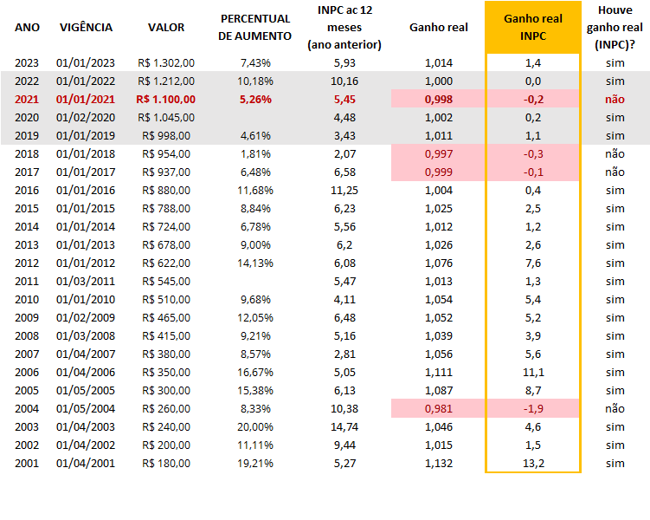

Alongside the fact that the minimum wage in these years had very low increases and in some years were below inflation, there was also a freeze on the average value of the benefit (PBF), which remained at R$ 190 per family between 2018 and 2020, with no adjustment to account for inflation. This led to a decrease in the purchasing power of beneficiaries. In 2019, the government of President Jair Bolsonaro announced the suspension of over 1 million benefits due to suspected irregularities but did not disclose the data or reasons for the measure. The reduction in the number of families assisted by the program decreased from 14.1 million in December 2016 to 13.2 million in December 2020. Additionally, there was an increase in the waiting list to join the program, reaching over 1 million families in 2019. The lack of transparency and clear criteria for program management led to allegations of fraud, misappropriation, and political use of resources. In August 2021, the government issued a provisional measure that revoked the Bolsa Família program and created the Auxílio Brasil, an attempt to replace the program with a new name and format, without considering the studies and evidence of the positive results of Bolsa Família.

In the List of Issues in relation to the third periodic report of Brazil (2021), when addressing Article 11, the Committee on Economic, Social and Cultural Rights questions the Brazilian State about the constitutional recognition of the right to food and its possible implications. In this regard, the following comments are made.

The constitutional recognition of the right to food by the Brazilian State in 2010 was a fundamental milestone for the consolidation of food and nutrition security policies in the country. In that year, the regulation of the Organic Law on Food and Nutrition Security through the establishment of the National Policy on Food and Nutrition Security was the driving force behind the development of public policies for access, production, and distribution of food through an intersectoral, integrated, and participatory strategy. Notable in this process are movements towards implementing the National System for Food and Nutrition Security, created in the previous decade; the first National Food and Nutrition Security Plan (2012-2015); and the role of organized civil society in the National Council for Food Security (Consea) and in National Conferences on Food and Nutrition Security. A remarkable result of these policies and achievements was the removal of Brazil from the hunger map in 2014. This set of policies and results is mentioned in the Brazilian State's report from April 2020.

However, it is widely recognized that a significant part of this foundation of policies, actions, and instances has been abandoned and/or changed since 2015, especially after 2019. In this year, the dissolution of Consea as the first act of the elected government was illustrative of what would follow in the field of food and nutrition security, including substantial budget reductions, omissions, and changes in the most important policies in the field, as mentioned in paragraphs 144-146 of the Brazilian Report (BRAZIL, 2020).

Graph 1 - Budget for Food and Nutritional Security Actions in Brazil 2012-2021 (R$)
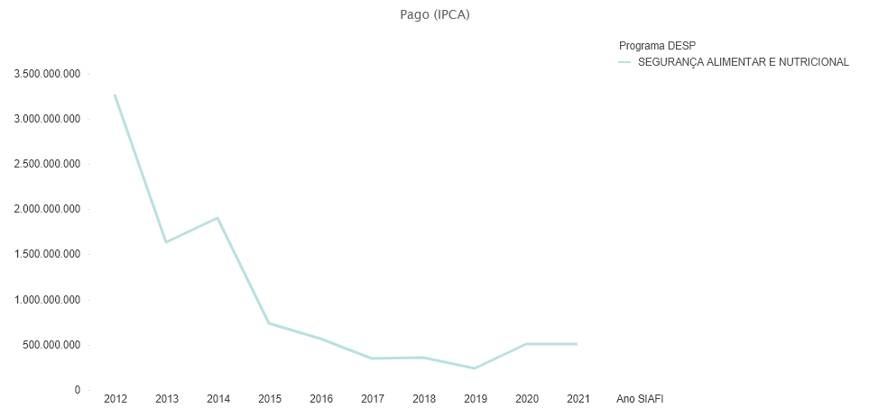
Source: SIGA Brasil, 2023.

Contrary to what was stated by the Brazilian response in paragraph 145 of the 3rd periodic report, the approval of the II National Plan for Food and Nutrition Security in 2017 did not secure a budget of R$ 98.6 billion for the continuation of food security. On the contrary, the amount disbursed during this period was R$ 946.8 million, less than 1% of the total projected for the three years. Among the main consequences of these policy choices is the significant percentage increase in malnutrition in the Brazilian population and the growth in the number of people facing severe or moderate food insecurity, breaking the trajectory of access to food in Brazil that characterized the previous period. Graphs 2 and 3 illustrate these trends.

Graph 2 - Prevalence of malnutrition in Brazil (%, three-year average)
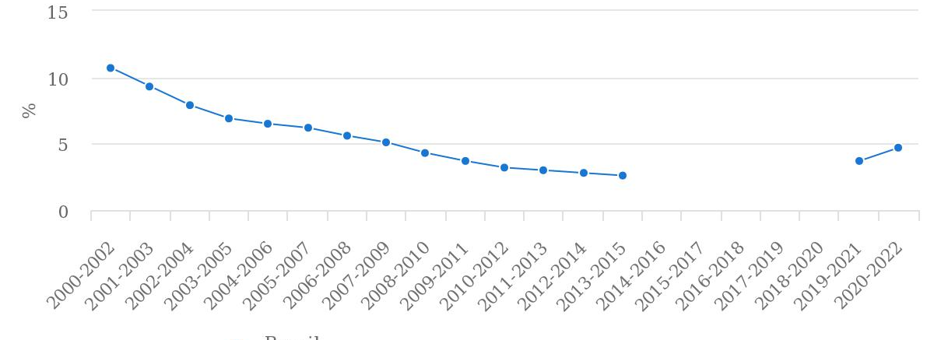
Source: FAOSTAT (August 2023).

Graph 3 - Number of people in severe or moderate food insecurity in Brazil (in millions of people, three-year average)
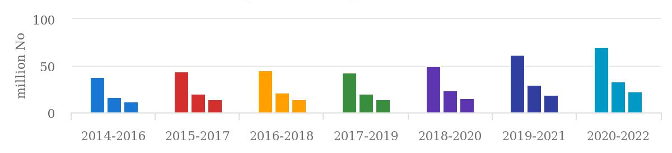
Source: FAOSTAT (August 2023).

In summary, this situation exemplifies the fact that the responses provided in April 2019 and April 2022 by Brazil concerning the list of questions related to its third periodic report on Article 11 of the ICESCR contain significant omissions regarding the array of food and nutrition security policies that once characterized hunger-fighting actions in the country. Simultaneously, they reflect the double process of discontinuity and distortion of specific policies that persisted, like the PAA/Alimenta Brasil and PNAE. Thus, it is possible to understand how the Brazilian State's omissions and deliberate actions have contributed significantly to the dire situation where approximately 70.3 million people in the country currently experience food insecurity.

Mentioned in the Third Periodic Report (2020, paragraph 149) and in the Replies of Brazil to the List of Issues in Relation to its Third Periodic Report (2022, paragraphs 142 to 144) as a noteworthy action in the field of ensuring the right to food, the Food Acquisition Program (PAA) faced a marked reduction in resources since 2015, despite its significance for combating food insecurity and promoting small-scale farmers in the country. According to a study conducted by the National Association of Agroecology (2022), the budget allocated to the PAA experienced a noticeable decrease from R$ 1.3 billion in 2012, which was the year with the highest financial support, to only R$ 135 million in 2021. This decrease is accompanied by a considerable drop in the number of beneficiary families, affecting both participating farmers and families receiving donated food. In this context, the value claimed by the Brazilian State of R$ 4.8 billion over ten years for this program (paragraph 144, 2022) was primarily allocated between 2011 and 2015, with a substantial decline from 2016 onwards. This is evident from data on the overall execution of the Program, which saw a significant decline in support for family farmers and the financial resources allocated to them between 2011 and 2021.

The transition to the Alimenta Brasil Program, positively mentioned in the official statement of the Brazilian government (2022, 142), elicited criticism from over 200 organizations and social movements that issued an open letter to the National Congress in 2021, expressing their opposition to this change in the program. The main criticisms are related to the lack of regulation, the termination of the seed acquisition modality, and the lack of innovations, which, according to experts, civil society organizations, and social movements, do not justify the modification of the program itself. In terms of resource allocation, the Alimenta Brasil Program intensified the declining trend observed in the PAA. In 2022, the budget allocated for Food Acquisition and Distribution for Food and Nutrition Security was only R$ 101.2 million (adjusted for IPCA inflation).

The National School Feeding Program (PNAE) is correctly cited in the Third Periodic Report (2020, paragraphs 146-147) as one of the main contributions to realizing the human right to food in the country, reaching over 40 million Brazilian students. However, the report omits the stagnation of the per capita values provided to students (per capita values), which remained the same nominal values from 2017 to 2021, ranging from 0.36 to 1.07 per student/day. Simultaneously, food prices increased significantly over the same period, as illustrated in Graph 4.

Graph 4 - Food prices in Brazil, 2017-2021

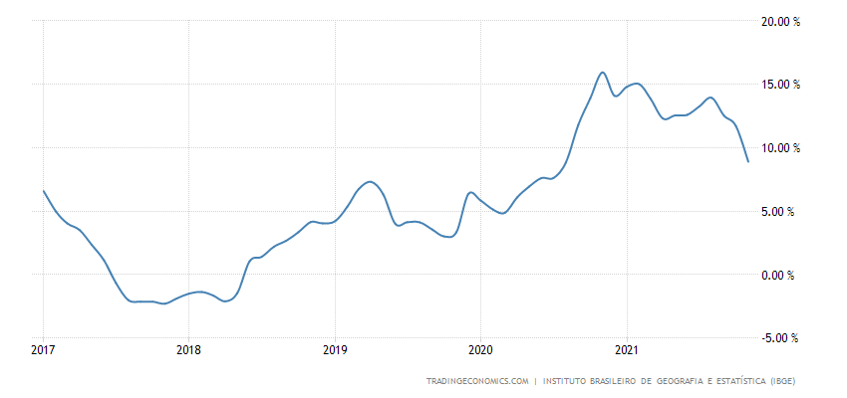
Source; Instituto Brasileiro de Geografia e Estatística (IBGE).

The stagnation of per capita values in the PNAE during a period of rising food prices significantly decreased the quantity and quality of food offered in schools. This represents the lack of effective commitment by the Brazilian State to a policy for combating hunger and food insecurity, particularly among children and adolescents. Essential for guaranteeing the human right to food in earlier periods, the provision of adequate meals in Brazilian schools was severely affected by this omission at a critical time for Brazilian families.

The Brazilian State did not address the question posed by the Committee on Economic, Social, and Cultural Rights regarding the impacts on the right to food and health resulting from exposure to pesticides. If addressed, it would have been difficult to conceal the extent of the regression in this area.

According to the Annual Bulletin on Production, Import, Export, and Sales of Pesticides in Brazil, produced annually by the Brazilian Institute of the Environment and Renewable Natural Resources (Ibama), total pesticide sales in Brazil have steadily increased from 306,785 tons in 2009 to 720,869 tons in 2021. Moreover, 94.36% of these formulated products fall within the I, II, and III classes of environmental risk, meaning they are dangerous, highly dangerous, or very highly dangerous to the environment, in addition to having various harmful and proven adverse effects on health. Concerning the monitoring of health risks caused by pesticides, it is very concerning that the Program for Analysis of Pesticide Residues in Food (PARA) suspended its activities between 2020 and 2022. Established in 2001 to assess pesticide residue levels in plant-origin foods, this public health surveillance tool is crucial for transparency and protecting consumer health amid the significant rise in consumption of hazardous substances.

Conclusions/Contribution to the Committee

Understanding and describing how public policies are dismantled is not easy. Differentiating between changes that naturally occur in state actions and planned actions to halt or eliminate specific policies and issues is necessary, as was the case in Brazil. There's no way to ensure that sectors or policies are not targets of intentional dismantling. Despite this, it seems relevant to delve into analyses of strategies that could enhance the stability and sustainability of policies while reducing the impact of discontinuity in government interventions on structural problems that characterize Brazil, such as rising inequalities or the lack of consistent socioeconomic development.

In Brazil, democratic and social dismantling went hand in hand, leading the country into an unimaginable situation. It is crucial to note that alongside these actions, a strong narrative opposing the realization of human rights and criminalizing human rights movements, organizations, and actors emerged within Brazilian society. This sequence of events began with an unjustified coup against a president, proceeded with the approval of labor and social security reforms that undermined the rights of the poorest workers, and culminated in the passing of a Constitutional Amendment that imposed an absurd ceiling on social public spending at a time when the most vulnerable population needed support the most. This sequence culminated in over half of the population in one of the world's most capable food-producing countries experiencing some level of food insecurity.

It would be important for the Committee to make a strong statement during periods of global economic crisis, emphasizing the responsibility of State parties to respect, protect, and fulfill economic, social, cultural, and environmental rights.

References

Brazil. 2020. Third periodic report submitted by Brazil under articles 16 and 17 of the Covenant, due in 2014. Report submitted to the Committee on Economic, Social and Cultural Rights. Geneva: UN, 23 July 2020.

Coalizão Direitos Valem Mais. 2022. NOTA TÉCNICA PLOA 2023. Propostas de Emendas Parlamentares. Disponível em:https://direitosvalemmais.org.br/wp-content/uploads/2022/11/nota-ploa2023-compr.pdf. Acesso em 23/08/2023.

Committee on Economic, Social and Cultural Rights. 2021. List of issues in relation to the third periodic report of Brazil. E/C.12/BRA/Q/3.

FAO, IFAD, and WFP. 2014. The State of Food Insecurity in the World 2014. Strengthening the enabling environment for food security and nutrition.Rome, FAO.

FAO, IFAD, UNICEF, WFP, and WHO. 2023. The State of Food Security and Nutrition in the World 2023. Urbanization, agrifood systems transformation and healthy diets across the rural–urban continuum. Rome, FAO.

FIAN Brasil. 2017. Da democratização ao golpe: avanços e retrocessos na garantia do DHANA no Brasil. Disponível em: https://fianbrasil.org.br/baixe-o-informe-da-democratizacao-ao-golpe-avancos-e-retrocessos-na-garantia-do-dhana-no-brasil/ . Acesso em 23/08/2023.

FIAN Brasil. 2022. Nota Técnica 1/2022 - O Dhana e o Programa Alimenta Brasil: Riscos e Retrocessos nas Compras Públicas de Alimentos da Agricultura Familiar. Disponível em: https://fianbrasil.org.br/wp-content/uploads/2022/02/NTecnica1_2022_FianBrasil_comAlteracoes.pdf. Acesso em 21/08/2023.

Available at: https://portaldatransparencia.gov.br/download-de-dados. Access: August 23, 2023.
FAO, IFAD, and WFP. 2014. The State of Food Insecurity in the World 2014. Strengthening the enabling environment for food security and nutrition.Rome, FAO.
BRAZIL, 2020. Third periodic report submitted by Brazil under articles 16 and 17 of the Covenant. Report submitted to the Committee on Economic, Social and Cultural Rights. Geneva: UN, 23 July 2020.
In paid values, adjusted for inflation.
FAO, IFAD, UNICEF, WFP, and WHO. 2023. The State of Food Security and Nutrition in the World 2023. Urbanization, agrifood systems transformation and healthy diets across the rural–urban continuum. Rome, FAO.
SECRETARIA NACIONAL DE INCLUSÃO SOCIAL E PRODUTIVA RURAL (SEISP). Available at: https://aplicacoes.cidadania.gov.br/vis/data3/data-explorer.php. Access: August 21, 2023.
FIAN Brasil. 2022. Nota Técnica 1/2022 - O Dhana e o Programa Alimenta Brasil: Riscos e Retrocessos nas Compras Públicas de Alimentos da Agricultura Familiar. Available at: https://fianbrasil.org.br/wp-content/uploads/2022/02/NTecnica1_2022_FianBrasil_comAlteracoes.pdf. Access: August 20, 2023.
Coalizão Direitos Valem Mais. 2022. NOTA TÉCNICA PLOA 2023. Propostas de Emendas Parlamentares. Available at:https://direitosvalemmais.org.br/wp-content/uploads/2022/11/nota-ploa2023-compr.pdf. Access: August 20, 2023.
IBAMA’s Information panel on pesticides. https://www.gov.br/ibama/pt-br/assuntos/quimicos-e-biologicos/agrotoxicos/paineis-de-informacoes-de-agrotoxicos/paineis-de-informacoes-de-agrotoxicos. Access: August 19, 2023.

