São Paulo, August 28, 2023.

To
Committee on Economic, Social and Cultural Rights

Ref. Contributions for consultation on NGO´s participation

Jô Clemente Institute (“IJC”) is a non-profit civil society organization, founded in 1961, dedicated to the inclusion of people with intellectual disabilities. Among other issues, it also acts in the defense and guarantee of the rights of persons with disabilities at the national and international level. In 2021, the IJC was granted consultative status at ECOSOC. The organization has been expanding its advocacy work, consolidating its innovative and cutting-edge vision since 2009, when Brazil ratified the UN Convention on the Rights of Persons with Disabilities ("CRPD") with constitutional status. The Alana Institute (“Alana”) is a Brazil-based global organization that promotes integral development and children's rights through advocacy, litigation, and communications at national and international level. In 2021, the Alana was granted consultative status at ECOSOC. Thus, in order to contribute to the Committee on Economic, Social and Cultural Rights, the IJC presents here its contributions, mainly focusing on the specificities related to policies for people with disabilities.

NEWBORN SCREENING

- We recognize the great importance of neonatal screening in the early diagnosis of diseases. For this to happen efficiently, it is essential to guarantee an adequate structure for the full implementation of the expanded heel prick test.
- An essential part of this project involves the necessary training of professionals. This means investing in training, providing the skills and knowledge needed to carry out the tests accurately and carefully. This investment in personnel is intrinsically linked to improving laboratory infrastructures.
- In turn, improving laboratory infrastructures through modern, well-equipped laboratories ensures that tests are carried out efficiently and reliably. This improvement works in parallel with broadening the participation of civil society in the National Neonatal Screening Program.
- The inclusion of different sectors of the community ensures an increasingly holistic and inclusive approach, which is in line with our suggestion to broaden partnerships with Civil Society Organizations.
- Furthermore, partnerships with civil society help to leverage resources and spread knowledge, making the program more robust and successful. This robustness must be supported by clear metrics and transparent progress reports.
- Transparency reinforces trust in the program and allows for continuous evaluation of its success. In addition, the involvement of parents and guardians in the screening process, as well as the expansion of the heel prick test, are essential components.
- Since education and awareness of the importance of neonatal testing are crucial to the effectiveness of the program. This effectiveness is reinforced by extending the heel prick test to a wider range of pathologies.
- Extending the heel prick test to a wider range of pathologies is a significant step. It will ensure that more children can be diagnosed and treated at an earlier stage. For this expansion to be possible, adequate funding and continued government support are essential.
- Adequate funding and ongoing government support is necessary for the initiative to succeed. This will ensure that the necessary resources are available to implement and sustain the program.
- In summary, the Jô Clemente Institute is committed to excellence in neonatal screening. With the combination of trained professionals, solid infrastructure, societal participation, and transparency, as well as financial and governmental support, we can make significant advances in child health.

INCLUSIVE EDUCATION

- Paragraph 10 of the List of Issues in relation to Brazil's Third Periodic Report by the Committee on Economic, Social and Cultural Rights asks about the compatibility of the emphasis of Federal Decree No. 10.502 of 30 September 2020 on special education with the right to inclusive education.
- We would like to bring to the attention of distinguished Committee members that inclusive education has solidified as a public policy, a fact reflected in the data: between the years 2010 and 2020, the number of students with disabilities in basic education surged from 702.6 thousand to 1.3 million children. This is a significant advancement, yet it was met with a threat when, in September 2020, Decree No. 10,502 was published, establishing the Public Policy for Special Education, aiming to segregate students with disabilities into special classrooms. The Decree faced legal challenges through a Direct Action of Unconstitutionality in the Supreme Federal Court and received amicus curiae from organizations advocating for children's rights. The norm was suspended by interim decision and in January 2023, after a massive advocacy from civil society organizations, the Decree was revoked.
- Even so, it is important to emphasize that approximately nine out of ten Brazilians believe that schools become better when including children with disabilities. This is revealed by an unprecedented survey conducted by Datafolha, titled "What the Brazilian Population Thinks About Inclusive Education," commissioned by the Alana Institute. The report was released on October 15, 2019 (Teacher's Day). It gathers perceptions from people across the country regarding the theme. According to the survey, the Brazilian population generally holds favorable opinions about the inclusion of children with disabilities in regular schools.
- The study examined opinions regarding topics such as the inclusion of children with disabilities in schools and the training and interest of educators in the subject matter. Likewise, aspects like prejudice faced by people with disabilities in schools were explored, among others. 86% believe that schools improve with inclusive education. Furthermore, 76% believe that children with disabilities learn more by studying alongside children without disabilities.
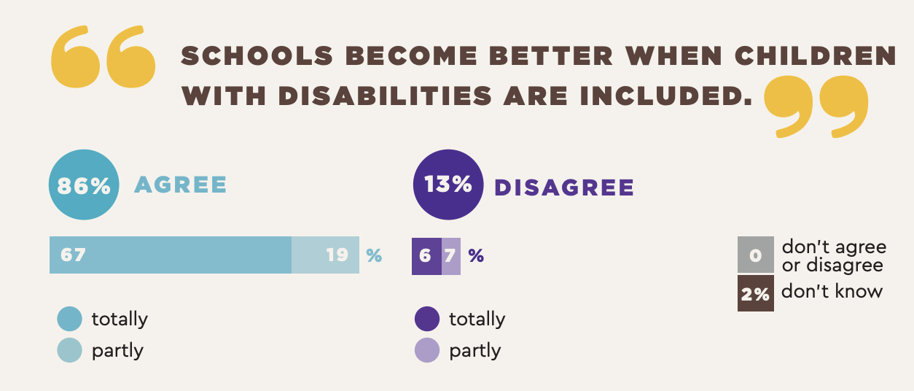
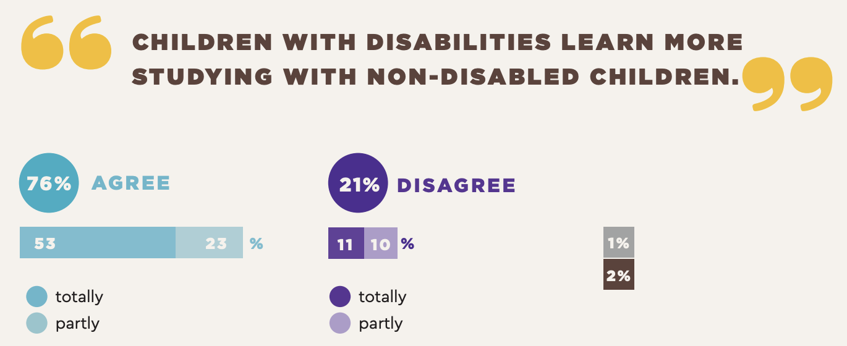

- Education is a fundamental (Article 6, Federal Brazilian Constitution), inalienable, and non-negotiable right, recognized for all Brazilian citizens, with or without disabilities, guaranteed as both the responsibility of the State and the family, with the collaboration of the entire society, for the full development of the individual, their preparation for citizenship, and their qualification for work (Article 205, Federal Brazilian Constitution). From this perspective, to ensure the right to education for students with disabilities, it is necessary to mitigate factors that limit or impede their enjoyment; recognize disability as an element of diversity; respect individuals in their peculiarities; not discriminate and ensure equal access and participation in school, meaning that education must be inclusive.
- However, in certain sectors of society, there still exists a notion that the best place for children with disabilities would be within their own homes or in separate classes and schools. Children with disabilities, global developmental disorders, and giftedness/high abilities, which comprise 7.3% of the population aged 7 to 14, continue to face this perspective, historically, they have been among the groups deprived of the assurance of the right to education.
- Considering this context, despite the revocation of Decree No. 10.502, another threat to the right to inclusive education for children with disabilities is homeschooling, which has been brought up in subnational regulations. With the implementation of homeschooling, there is a potential regression to a discriminatory paradigm that has already been overcome.
- Considering that we respectfully requests the Committee to recommend the State of Brazil on the following:
- Take measures to ensure mandatory training for all teachers (beyond special education teachers) in teaching children with disabilities, and incorporate inclusive education as an integral part of primary teacher training curricula in universities to ensure that the values and principles of inclusive education are disseminated at the beginning of teacher education and careers;
- Take necessary actions to ensure that early childhood education policies are fully inclusive, promoting access, providing necessary support, and actively addressing barriers for children with disabilities, who are currently in situations of exclusion;
- Approve legislation mandating that all children with disabilities attend regular preschools rather than special preschools and schools, and that they have priority in enrollment.
- We propose the enhancement of the "National Policy for Special Education within the Perspective of Inclusive Education" in line with the needs of current times. The active participation of representative groups of persons with disabilities will be essential to ensure that their voices are heard and their needs met.
- This alignment to the Convention on the Rights of Persons with Disabilities ensures an inclusive and conscious approach, ensuring that educational practices are in line with international human rights standards.
- We highlight the importance of Specialized Educational Assistance. This is an area that needs continuous attention and investment to provide tailored and personalized educational support to students with special needs.
- Ensuring adequate resources is another critical aspect to promote the full participation of students with disabilities. This includes access to appropriate teaching materials, assistive technology, and support by specialized professionals.

We hope that our comments will contribute to guaranteeing the rights of persons with disabilities, and we make ourselves available for any clarifications and additional contributions through the email deisianapaes@ijc.org.br and leticia.silva@alana.org.br.

Deisiana Campos Paes Stella Reicher
Advocacy Supervisor Legal Consultant
of Instituto Jô Clemente of Instituto Jô Clemente

Ana Claudia Cifali Letícia Carvalho SIlva
Legal Coordinator Lawyer and International Advisor
of Alana Institute of Alana Institute

​​FRENTE PELA VIDA. National Plan to Confront the Covid-19 Pandemic. Available at: https://frentepelavida.org.br/uploads/documentos/PEP-COVID-19_v3_01_12_20.pdf. Accessed on August, 17, 2023.
Alana Institute. What Brazilians thinks about inclusive education Available at: https://alana.org.br/wp-content/uploads/2021/01/relatorio_educacao_inclusiva_INGLES.pdf. Accessed on August, 17, 2023.
Ibid.
Census 2010 Guide, People with Disabilities." Available at: https://inclusao.enap.gov.br/wp-content/uploads/2018/05/cartilha-censo-2010-pessoas-com-deficienciareduzido-original-eleitoral.pdf. Accessed on August, 17, 2023.

