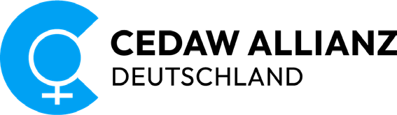

CEDAW

Alternative Report

With reference to the Ninth Periodic Report submitted by the Federal Republic of Germany on the Convention on the Elimination of All Forms of Discrimination against Women
(CEDAW)

April 2023

Publishing information
Published by
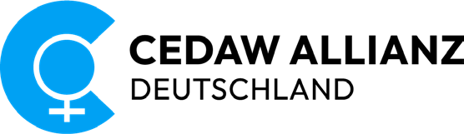

Editor
Editorial team of CEDAW Alliance Germany
Proofreading
Laura Gey, Juliane Rosin, Juliane Zinke
Deutscher Frauenrat (National Council of German Women’s Organizations)
English translation
Heather Kimber
Layout
Poli Quintana – www.interlinea.de
Print
Laserline
Translation, layout, accessibility and printing are funded by
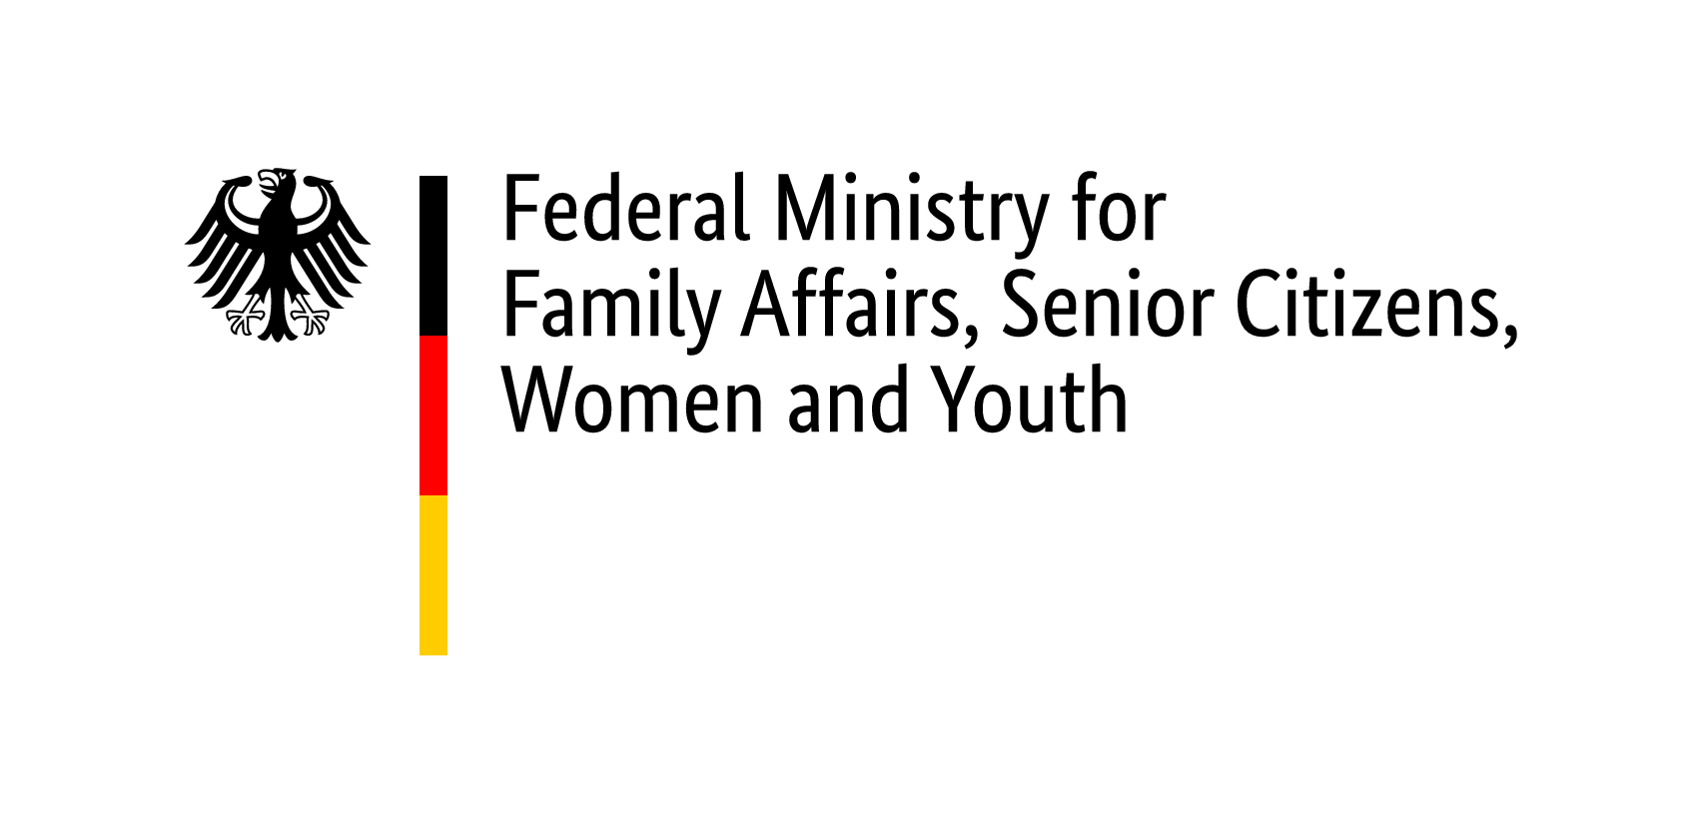

Report available from
www.cedaw-allianz.de

CEDAW Alliance Germany is a partner of the Deutscher Frauenrat (National Council of German Women’s Organizations)
Axel-Springer-Str. 54a, 10117 Berlin
www.frauenrat.de

Berlin, April 2023

Members of CEDAW Alliance Germany

Aktion Pink Deutschland e. V.
Anwältinnen ohne Grenzen e. V. (Lawyer Women Without Frontiers) Arbeitsgemeinschaft Sozialdemokratischer Frauen
Arbeitskreis Frauengesundheit in Medizin, Psychotherapie und Gesellschaft e. V.
Bundesarbeitsgemeinschaft (BAG) kommunaler Frauenbüros und Gleichstellungsstellen
bff: Bundesverband Frauenberatungsstellen und Frauennotrufe – Frauen gegen Gewalt e. V. Bundesarbeitsgemeinschaft Täterarbeit Häusliche Gewalt e. V.
Bundesverband der Mütterzentren e. V. (Federation of Mother Centres) Bundesverband Trans* e. V.
Business and Professional Women (BPW) Germany e. V.
DaMigra e. V. – Dachverband der Migrantinnenorganisationen (Umbrella organization of migrant women’s associations)
Deutscher Frauenrat e. V. (National Council of German Women’s Organizations) Deutscher Frauenring e. V.
Deutscher Gewerkschaftsbund (German Trade Union Confederation) Discover Football / Fußball und Begegnungen e. V.
Doctors for Choice Germany e. V.
Frauenhauskoordinierung e. V. (Association of Women’s Shelters)
GenderCC – Women for Climate Justice e. V.
GMEI – Gender Mainstreaming Experts International Intergeschlechtliche Menschen e. V.
JUMEN e. V. – Juristische Menschenrechtsarbeit in Deutschland
KOK – Bundesweiter Koordinierungskreis gegen Menschenhandel e. V. (German NGO Network against Trafficking in Human Beings)
Marie-Schlei-Verein e. V. (Women for development cooperation) Mother Hood e. V.
Politischer Runder Tisch der Frauen / Geschlechtergerechtigkeit Magdeburg
pro familia Bundesverband e. V. (central branch)
pro familia Landesverband Berlin e. V. (Berlin regional association) Sozialverband Deutschland e. V.
UN Women Deutschland e. V. (UN Women Germany) Verband berufstätiger Mütter e. V.
Verein der in der DDR geschiedenen Frauen e. V.
Weibernetz e. V.
Women Engage for a Common Future e. V.
Zentrale Informationsstelle Autonomer Frauenhäuser

Severability Clause
Responsibility for the observations and demands made in this alternative report is borne by the members of CEDAW Alliance Germany according to their respective remit and objectives. CEDAW Alliance Germany is committed to producing a united alternative report from a civil-society perspective. However, this does not mean that all members bear responsibility for all the judgements and recommendations expressed herein.

Note on Writing Style
CEDAW Alliance Germany uses asterisks (*) for gender-specific terms in order to overcome gender stereotypes and incorporate diverse gender identities.

CONTENTS
ABBREVIATIONS 4
- INTRODUCTION 5
- FOR DIVERSITY AND INTERSECTIONALITY – AGAINST MULTIPLE DISCRIMINATION 6
- INSTITUTIONAL MECHANISMS 7
- WORK AND FAMILY LIFE 10
- VIOLENCE AGAINST WOMEN* AND GIRLS* 15
- HEALTH 20
- INTERNATIONAL HUMAN RIGHTS OF WOMEN* 23
Sources 27

ABBREVIATIONS

BGB German Civil Code
CEDAW Convention on the Elimination of All Forms of Discrimination against Women
COP Conference of the Parties
DNS German Sustainability Strategy
DRG Diagnosis-related group
EU European Union
FGM/C Female genital mutilation/cutting
GG Basic Law for the Federal Republic of Germany
GDR German Democratic Republic
ICRMW International Convention on the Protection of the Rights of All Migrant Workers and Members of Their Families
IKI International Climate Initiative
ILO International Labour Organization
LGBTIQ* Lesbian, gay, bisexual, trans, inter, queer and more
NAP German National Action Plan
NGO Non-governmental organization
SDGs Sustainable Development Goals
StGB German Criminal Code
UN United Nations
UNFCCC United Nations Framework Convention on Climate Change

INTRODUCTION

Impacts of the Covid-19 pandemic
The Covid-19 crisis and the political measures employed to tackle it have had a dramatic impact on gender equality in Germany, resulting in a reversion to traditional gender roles. Women* have faced and continue to face multiple family and professional burdens – with long-term consequences for their income, career prospects, pensions and health. This excess burden is particularly heavy for single parents – 90 percent of whom are female* in Germany.
When schools and childcare facilities closed it was primarily mothers* who filled the gap. Women* are performing more unpaid care work on average than previously, and in many cases reduced their paid working hours. As women* are more likely to hold “mini-jobs” they are also more likely to suffer from pandemic-related loss of income. Since the majority of key workers are women*, they in particular have been working under very challenging conditions, and paid below-average wages, in professions that are particularly onerous and hazardous to health during times of crisis.
Domestic violence rises in times of crisis due to social isolation and financial worries. The heightened need for counselling services and women’s refuges has not been adequately met. On the contrary, the already inadequate accessibility of safe houses and advice services has worsened.
In general, the pandemic and the political measures to fight it have revealed and exacerbated existing equality deficits. Women* bear a large share of the burden of the pandemic while their needs have been inadequately factored into the political response.

Impacts of climate change
Climate change has made itself felt in Germany too, with an increase in extreme weather events and natural disasters. Women* and girls* are frequently exposed to greater risks and burdens than men* and boys*. Environmental crises and climate emergencies exacerbate gender equality and worsen multiple discrimination.
We welcome the fact that the federal government’s Coalition Agreement contains ambitious arrangements regarding the Paris Agreement; however, its environment and climate policy are not linked to the promotion of gender equality.
Germany’s Ninth Periodic Report makes no reference to the impact of climate change on women’s* rights in either the national or international context. Merely citing the fact that the federal government’s interministerial equality strategy makes explicit reference to international gender equality frameworks and agreements does not constitute a sufficiently gender-sensitive response to the crisis.
For Germany to achieve more gender-equitable policies in the areas of climate change mitigation, adaptation and financing, it urgently needs to establish an interministerial task force with the primary task of mainstreaming the issues of sustainability and gender equality. This should result in a whole-of-government commitment to gender budgeting and gender impact assessments of all planned climate change mitigation and adaptation measures. It is crucial that women* and LGBTIQ* people are not regarded as passive, vulnerable groups but that their expertise in the areas of climate disaster mitigation and management is recognized and that they are granted decision-making powers so that existing gender expertise is drawn on in the development of climate policy.

FOR DIVERSITY AND INTERSECTIONALITY – AGAINST MULTIPLE DISCRIMINATION

CEDAW text: Articles 1 and 2
CEDAW general recommendations: Nos. 18, 25(12), 26, 27(13) and 28(18) CEDAW Committee concluding observations of 2017: Nos. 18 (b) and 44 Ninth Periodic Report submitted by Germany: Nos. 1, 7, 9, 11, 14 and 19

Discrimination doesn’t happen in isolation but as part of a complex web of social categories. The experiences of women* who suffer from intersectional discrimination are not adequately recognized. They include, for example: women* with disabilities and/or chronic conditions; people with diverse gender identities and physical bodies; queer women* and girls*; women* and girls* who live in child and youth services facilities, social inclusion facilities, or facilities for women* with disabilities; women* exposed to discrimination due to their age or social background; female* refugees and migrants; homeless women*; women* at risk of addiction; women* affected by material poverty; and women* affected by racism. Multiple discrimination and structural disadvantages are rarely tackled in a targeted manner. In practice there is no binding intersectional overall concept for equality policy.
While the federal government has declared its commitment to intersectional equality policy, the many and various forms that discrimination takes must still be tackled institutionally and structurally as well as through a series of special provisions.
CEDAW Alliance Germany demands:
- Consistent implementation of CEDAW in Germany for all women* and girls*, with due regard to intersectional approaches. This shall include regular dialogue with the participation of CEDAW Alliance Germany.
- Mandatory embedding of intersectionality in the elaboration of equality policy activities at all levels of federal, state and municipal government, across all ministries and departments
- Promotion of studies – including qualitative studies – into the situation of women* suffering from intersectional discrimination, and raising of public awareness of this type of discrimination
- Increased personnel and financial resources and greater powers for the Federal Anti-Discrimination Agency
- Action to ensure German states enact anti-discrimination laws where these have not yet done so

INSTITUTIONAL MECHANISMS

Gender mainstreaming
CEDAW Committee concluding observations of 2017: Nos. 17 (a), 17 (b), 18 (a) and 18 (b)
Ninth Periodic Report submitted by Germany: No. 3 – Application under the federal system
Ninth Periodic Report submitted by Germany: No. 7 – National machinery for the advancement of women

CEDAW Alliance Germany welcomes the equality strategy adopted by the federal government and the Federal Equality Foundation (Bundesstiftung Gleichstellung). However, there are still no structures in place for implementing the equality strategy in the ministries, neither is there a concrete action plan for achieving the objectives. Moreover, there is no cohesion between state, municipal and EU equality policies.
CEDAW Alliance Germany demands:
- Comprehensive introduction of fully funded gender mainstreaming at all levels of government
- Fleshing out of the equality objectives with a statutory basis and an action plan, and assessment of the plan through independent monitoring on the basis of indicators, with civil society participation and expertise
- Analyses of gender mainstreaming processes from an intersectional perspective; consideration of the interrelationship between different forms of discrimination; and involvement of affected groups in developing the relevant measures
- Greater investment in equality policy measures and gender-sensitive public procurement
- Enhanced political participation of all women* through gender parity laws (parity on all committees)
- Gender-sensitive organization in parliaments1
- Incorporation of a CEDAW national action plan in the federal government’s equality strategy, furnished with concrete measures, goals, indicators and benchmarks, in consultation with civil society
- Coordinated implementation of a gender-equitable green care economy analogous to the Green Care Deal at European level, as a guiding principle for all ministries

Gender budgeting
CEDAW Committee concluding observations of 2017: Nos. 17 (c) and 18 (c)
Ninth Periodic Report submitted by Germany: No. 7 – National machinery for the advancement of women

Gender budgeting is barely addressed at federal level. The concept has not been introduced or trialled, and current equality policy impact assessments are inadequate. The conclusions of available feasibility studies with model calculations are not being implemented. The Spending Review constitutes an ex-post analysis of individual expenditure from a gender perspective, but the impact of such expenditure remains unclear. The introduction of gender budgeting in some German states has shown that it is political will that counts, not the law of public finances. It has also demonstrated that gender budgeting is in line with public finance law and practice.
CEDAW Alliance Germany demands:
- Assessment of all new policies and laws with regard to the extent to which they advance gender equality (gender impact analysis; ex-ante and ex-post assessments)
- Underpinning of all budgeting with objectives in line with human rights agreements, qualitative and quantitative indicators, and benchmarks
- Implementation of gender budgeting in the federal budget and creation of an implementation plan under the leadership of the Federal Ministry of Finance, with NGO and expert participation
- Establishment of a new financial and economic order with care work as a central focus and public spending reflecting this prioritization

Women’s and equality commissioners
CEDAW text: Articles 12-14
Ninth Periodic Report submitted by Germany: No. 3 – Application under the federal system

Women’s and equality commissioners are responsible for fostering full attainment of the principle of equality before the law, which is enshrined in Article 3(2) of the German Basic Law (GG). With the appointment of the commissioners, a legal entity was created that does not exist in this form anywhere else in Europe or, indeed, the world. The commissioners operate across Germany in municipalities, state and federal ministries and their subordinate agencies with the task of exposing structural discriminatory barriers for women* both inside and outside public-sector structures. They advise government agencies and politicians on how to eliminate discrimination against women* and propose and initiate the corresponding policy responses. Their legal status, tasks and remit are specified in federal and state laws and municipal constitutions; however, these frameworks still differ fundamentally from one another. The impact and scope for action of the women’s and equality commissioners depend on the extent of their statutory underpinning, the framework conditions, and the availability of resources.
There is still no uniform national legislation on the deployment of women’s and equality commissioners or on the structural framework and resources for their work. What’s more, frequently a reduction in locally available resources is discernible. Also, there is no equality law governing the private sector and neither is there any obligation on companies to appoint equality commissioners.

CEDAW Alliance Germany demands:
- Passing of uniform national legislation, devised jointly by the federal and state governments, to establish a framework for women’s and equality commissioners. The most far-reaching provisions should serve as the benchmark.
- Reversal of cuts to funding for women’s and equality commissioners made in favour of other commissioner roles at a cost to women’s* equality
- Enactment of equality legislation covering the private and social sectors, including an obligation to appoint in-house women’s and equality officers
- Appointment of permanent, full-time women’s and equality commissioners at municipal level with a remit to bring about de facto equality, including the necessary and appropriate staff and financial resources
- Ability of women’s and equality commissioners to act independently. They must be able to perform public relations activities without external interference.

Equal protection of human rights within the federal system
CEDAW text: Articles 1 and 2
CEDAW general recommendations: Nos. 11 and 12
CEDAW Committee concluding observations of 2017: Nos. 11 and 12 Ninth Periodic Report submitted by Germany: No. 2 – Implementation
Ninth Periodic Report submitted by Germany: No. 3 – Application under the federal system

Neither the federal nor the state governments have adopted or enforced the CEDAW Committee’s recommendations for federally coherent implementation of protection of the equal human rights of girls* and women*.
CEDAW Alliance Germany demands:
- Establishment of a federal-level cross-party commission on the protection of the human rights of all women* and girls*
- Funding to establish consistent human rights protection at federal, state, municipal and EU level

WORK AND FAMILY LIFE

Pandemic exacerbates inequalities in work and family life
Ninth Periodic Report submitted by Germany: No. 8 – Temporary special measures Ninth Periodic Report submitted by Germany: Nos. 15 (a), 15 (b) and 15 (g) – Employment

The Covid-19 pandemic has shown that the normal functioning of the economy and the state cannot be taken for granted. For society to weather crises successfully, all its members must operate in the spirit of solidarity, togetherness and mutual care.
CEDAW Alliance Germany demands:
- Pledges that political decisions will be based on an holistic concept of work that includes unpaid care work and gainful employment
- Clear reflection of care work and unpaid domestic work in measurements of national economic output
- The application of legal provisions on equality in voluntary work too

Right to remote working
The Covid-19 pandemic brought forth a rise in remote working. Remote working allows employees to balance their work and family lives and, if the conditions are right, favours more balanced distribution of care work and housework. However, employees should not be expected to work remotely at the same time as taking care of their children or home schooling.2
CEDAW Alliance Germany demands:
- The legal right to self-determined remote working, with collective bargaining agreements and worker participation in decision-making
- Guaranteed equal access to remote working for men* and women*
- Strict compliance with and monitoring of legal requirements governing working hours
- Rules on the right of employees to be unreachable at certain hours, including sanctions for non-adherence
- Legal frameworks covering health and safety, further training, data security, data protection, and reimbursement of expenses

Reform of mini-jobs
The precarious nature of so-called “mini-jobs” became particularly evident during the Covid-19 pandemic. Unlike people in employment subject to social security contributions, people working in mini-jobs are not entitled to compensation under a furlough scheme (Kurzarbeitsgeld). More than 60 percent of people in exclusive marginal employment are women*.3
CEDAW Alliance Germany demands:
- Reform of the mini-job system to ensure social security for all forms of employment from the very first working hour

Equality between women* and men* at work
Ninth Periodic Report submitted by Germany: Nos. 15 (e), 15 (g) and 15 (h) – Employment, and No. 14 – Education

Balancing work and family life is enough of a challenge for anyone in gainful employment. The hurdles are that much higher for mothers* and women* who perform care work, especially if they are also single parents. To this day, for many women* the birth of their first child leads to tangible disadvantages for their career and financial independence.
Despite legal entitlement to childcare for offspring under three, there are nowhere near enough childcare places to provide this for everyone who needs it. Public infrastructure for relieving the burden of caregiving in the home is inadequate.
The pandemic has increased the burdens on many workers, particularly those in the social and personal services sectors. This is especially true for women* subjected to multiple discrimination.
CEDAW Alliance Germany demands:
- Systematic alignment of the federal government’s equality policy actions with the earner-carer model to ensure that both women* and men* in a partnership are able to earn a living independently
- Greater obligations on employers to provide family-friendly working conditions
- Transformation of the concept of “Ehegattensplitting” (splitting the difference in spousal income for tax purposes) into individual taxation with a transferrable tax-free allowance
- Support for women* of all qualification levels on the labour market
- Provision of appropriate employment in line with their qualifications for migrant and refugee women* and women* with long career breaks
- Improved recognition of educational and professional qualifications gained abroad and efforts to prevent women* being compelled to work in jobs with lower qualification requirements
- Reduced intersectional discrimination through a requirement for anonymous job application procedures

Fairer distribution of gainful employment and care work
Ninth periodic report submitted by Germany: No. 9 – Stereotypes

Dismantling gender roles and stereotypes is a prerequisite for the fair distribution of paid employment and unpaid care work on the basis of a mutually respectful partnership. Such efforts must be pursued further, as the economic and social consequences of the traditional division of labour weigh heavy – on women* in particular.
CEDAW Alliance Germany demands:
- More months of individual, non-transferrable parental leave and allowance, with financial incentives for a fairer division of the transferrable months of parental leave
- Higher, more dynamic minimum and maximum sums
- Corresponding adjustment of all parental allowance rules for single parents
- Effective reduction of the poverty risk rate for single parents so that children in single-parent families are able to grow up in economically stable circumstances
- Paid leave of absence for the second parent around the time of the birth
- Wage compensation for time spent caring for sick or elderly relatives, analogous to parental leave
- More professional care services and local respite services for caregivers
- Options in collective and statutory labour law for flexible management of working time according to phase of life, e. g. through legislation granting people the right to flexibly adapt their working hours

Wage justice and greater appreciation for social occupations
Ninth Periodic Report submitted by Germany: No. 15 (a) – Employment, and Nos. 14 (a) and 14 (c) – Education

In its report, the federal government references the closing gender pay gap, but it is currently not clear whether this is a medium or long-term trend. Due to the pandemic, progress in closing the pay gap may be accompanied by a long-term worsening of the working time situation for employed women*.4 Wage justice must be established in all social and female-dominated occupations.

CEDAW Alliance Germany demands:
- Further development of the wage transparency law (Entgelttransparenzgesetz) into an effective wage justice law
- Closure of the gender pay gap and the migration gender pay gap
- Greater right to participation for works and staff council committees in workplace equality concepts
- The right to file a representative action in order to achieve equal pay
- Due recognition of all female-dominated social and personal services jobs through remuneration that reflects the true value of the work performed
- Incentives to make it easier for men* to access female-dominated occupations
- Introduction of the Comparable Worth Index as a standard for gender-equitable valuation of work
- Wider scope of binding collective wage agreements, especially for care work
- Continued efforts towards a minimum wage that is 60 percent of the median salary
- Government subsidies for household-related services

Women* in the digital world of work
Ninth Periodic Report submitted by Germany: No. 15 (a) – Employment and No. 4 – Legislative and policy framework

Women* working for digital platforms are increasingly doing so under precarious conditions. There is currently no firmly established legal framework regulating the gig economy. A situation must not be allowed to develop whereby women* are disadvantaged in the digital transformation.
CEDAW Alliance Germany demands:
- Social and labour law protections for people working for digital platforms
- Creation of a legal framework for digital freelancers including minimum levels of social and labour law protection
- Improved digital access rights for advocacy groups, greater worker participation and wider scope of binding collective wage agreements, and the introduction of legislation on the right to file a representative action
- Inclusion of workers in the digital economy in the German General Act on Equal Treatment (Allgemeines Gleichbehandlungsgesetz)
- Research into gender relations within the digital platform sector
- Protection of women* from gender-specific cyber-violence

Poverty in old age and the economic consequences of divorce and separation
CEDAW Committee concluding observations of 2017: No. 50 (d)5
Ninth Periodic Report submitted by Germany: No. 15 (c) – Employment
Ninth Periodic Report submitted by Germany: No. 17 – Economic empowerment of women

The federal government states that the “basic pension” (Grundrente) primarily benefits women*. However, many women* remain excluded from a true appreciation of their life’s work.
Contrary to the assertion made in the federal government’s interim report, women* divorced in the GDR have not received any financial support.
Since 2023 the federal government has been addressing the injustices against GDR divorcees and Jewish “quota refugees” through its “hardship fund” (Härtefallfonds). The federal budget provides 50 percent of this fund. Another 50 percent is supposed to be provided by state governments but this has not yet happened. The criteria exclude 90 percent of affected women* aged 80 and older, which explicitly goes against CEDAW’s recommendations of 2017.
CEDAW Alliance Germany demands:
- Employment providing a living wage and independent pensions that guard against poverty
- Increased pension entitlement without means testing for women* who have paid into the statutory pension insurance, raised children or cared for dependents
- A study to examine the economic consequences of divorce and separation, especially for single parents
- Urgent and fair measures to protect Jewish “quota refugees” from the former Soviet Union against poverty
- Retroactive inclusion of Jewish “quota refugees” in the law on foreign pensions (Fremdrentengesetz), with appropriate consideration in pension calculations of years worked in the country of origin
- Compensation for Jewish refugees for gender-specific labour market discrimination resulting from a lack of recognition of professional qualifications and correspondingly low pension entitlements
- Adequate compensation in line with CEDAW’s recommendations for women* divorced in the GDR and other affected parties
- Removal of exclusion criteria and conversion of the “hardship fund” into an equity fund
- Continued urging from the UN-CEDAW Committee on the German government to create a pension supplement and access to compensation for GDR divorcees

VIOLENCE AGAINST WOMEN* AND GIRLS*

Support structures for women* affected by violence
CEDAW general recommendations: No. 19
CEDAW Committee concluding observations of 2017: No. 25
Ninth Periodic Report submitted by Germany: No. 11 – Gender-based violence against women

There is no comprehensive nationwide network of specialized counselling and no disabled-accessible, multilingual network of assistance that goes beyond specialized counselling (e. g. health services, the gathering of forensic evidence, trauma support, therapy, perpetrator counselling). There is a lack of intersectional, inclusive, structurally funded protection measures. This particularly affects women* with disabilities; female* refugees and migrants; homeless women*; women* at risk of addiction; people with diverse gender identities and sex characteristics; and queer women*.
While the state and municipal governments are responsible for ensuring protection and setting up support structures, there is no national prevention strategy addressing violence against women* and girls*. The worrying femicide rate is largely ignored.
CEDAW Alliance Germany demands:
- An effective intersectional and interministerial national strategy for combating violence against women* and girls*
- Establishment of a national coordinating office in line with the Istanbul Convention
- A national, comprehensive and adequately funded network of specialized, disabled-accessible counselling services offering prompt assistance and support, intervention following police action, and support in cases of sexualized violence
- Other national, disabled-accessible, multilingual, diversity-oriented, easy-access support services such as healthcare services for women* and girls*, (anonymous) forensic evidence gathering, and therapy offers
- Recognition of the concept of femicide and a stricter sentencing framework for these crimes
- Expansion of work with offenders and incorporation as a complementary measure in protection

Limited access to women’s refuges and shortage of places
CEDAW Committee concluding observations of 2017: Nos. 25 and 26
Ninth Periodic Report submitted by Germany: No. 11 (h) – Gender-based violence against women

Germany requires around 15,000 additional women’s refuge places to provide support services in line with the Istanbul Convention.6 This shortage of places is compounded by additional hurdles as funding is only available for individuals who pay social security contributions. This excludes students, trainees, and women* with precarious residence status, while women* with their own income must pay for themselves. Very few women’s refuges are disabled-accessible. Trans women, trafficked women*, women* in need of additional assistance, and women* with addiction problems, a history of psychiatric treatment, older sons and/or multiple children are rarely offered places because of a lack of appropriate accommodation and staffing.7
CEDAW Alliance Germany demands:
- A legal basis for uniform national funding of women’s refuges. Two funding models should be explored: funding of institutions irrespective of individual case profiles; and funding of the protection provided by a women’s refuge via public service laws.
- Women’s refuges across the entire country offering comprehensive, needs-based support services in line with the Istanbul Convention
- Immediate removal of the obstacles to obtaining a refuge place imposed by immigration and asylum law
- Intensive commitment to making all women’s* refuges disabled-accessible
- Rules obliging federal, state and municipal governments to play an active role in the expansion and funding of women’s refuges

Custody and visitation rights in cases of domestic violence
Ninth Periodic Report submitted by Germany: No. 22 (a) – Marriage and family relations

Protection against violence is not aligned with legislation governing the rights of children – either in law or in practice. Violent acts against women* and children and abuse of children are not given primary weight in custody and visitation decisions over the rights of the perpetrator.8 Decisions taken under the provisions of the protection against violence act (Gewaltschutzgesetz) – for example, restraining orders – are undermined by the simultaneous granting of visitation rights.
CEDAW Alliance Germany demands:
- Avoidance of shared custody in cases of domestic and sexualized violence
- Imperative application of the regulatory options laid down in Sections 1626a, 1671 and 1684 of the German Civil Code (BGB) in custodial and visitation proceedings
- Suspension of visitation rights for the duration of court orders issued in accordance with the protection against violence act (Gewaltschutzgesetz) and restrictions on visitation once the order has expired until the individuals affected have worked through the trauma and their state is stable
- Obligation for all professionals and judges involved in family law proceedings to undergo ongoing further training

Human trafficking
CEDAW text: Article 6
CEDAW general recommendations: No. 38
CEDAW Committee concluding observations of 2017: Nos. 29 and 30
Ninth Periodic Report submitted by Germany: No. 12 – Trafficking and exploitation of prostitution

At the national level, various ministries are responsible for particular aspects of human trafficking. There is no overall political coordination, nor is there a comprehensive anti-trafficking strategy. Many of the relevant legal provisions, such as the right to residence being dependent on a victim’s willingness to testify in court, are not aimed at victim protection and victims’ rights but rather at obtaining stable witnesses and usable testimony in criminal proceedings.
CEDAW Alliance Germany demands:
- Development and implementation of a national action plan to fight all forms of human trafficking and protect all victims
- A federal coordinating office
- Adequate, long-term financing of counselling centres and the expansion of the support system for victims of human trafficking
- Improved identification of victims (especially in typically inaccessible areas such as domestic care)
- Improved access to protection, support and welfare
- Training on human trafficking for personnel in law enforcement and the judiciary
- A preventive approach that offers women* with migrant backgrounds easier access to regulated employment

Cyber-violence
CEDAW general recommendations: Nos. 12 and 19
Ninth Periodic Report submitted by Germany: No. 11 (g) – Gender-based violence against women

Recent years have seen a massive escalation in gender-specific cyber-violence. Girls* and young women* in particular are being increasingly exposed to gender-specific cyber-violence. Crime statistics do not record a breakdown of these offences.
CEDAW Alliance Germany demands:
- A long-term, effective strategy to tackle cyber-violence, developed by experts working with government and non-governmental actors
- Additional staff in law enforcement and the judiciary to facilitate investigations and prosecutions
- Regular training of staff at government agencies
- Appropriate funding and staffing of specialized counselling services for women* and girls* affected by cyber- violence

Female genital mutilation/cutting (FGM/C)
CEDAW Committee concluding observations of 2017: Nos. 23 and 24
Ninth Periodic Report submitted by Germany: Nos. 10 (b), 10 (c) and 10 (d) – Harmful practices

The number of women* and girls* at risk from female genital mutilation (FGM) in Germany has increased sharply.9, 10

CEDAW Alliance Germany demands:
- A national action plan against FGM
- Systematic integration of ongoing vocational courses on gender-specific violence – including FGM – in initial and further training of the relevant professional groups
- Indication of FGM – in particular infibulation (known as type III FGM) – in a pregnant woman’s* maternity log to ensure appropriate care (with her* express consent)
- Multilingual, easy-access information about support services in all appropriate locations (e. g. local authorities, doctors’ surgeries, advice centres, schools)
- Nationwide funding for anti-FGM projects and improved services, information, advice and support
- A national campaign to raise awareness of the problem

Psychological and emotional abuse
Ninth Periodic Report submitted by Germany: No. 11 (g) – Gender-based violence against women

Psychological abuse is not defined as a stand-alone criminal offence under German law.

CEDAW Alliance Germany demands:
- Criminalization of the intentional conduct of impairing a person’s psychological integrity, in line with the Istanbul Convention (including non-physical forms of domestic and sexualized abuse and threats made to victims of human trafficking and/or their family members)

Female* refugees
Ninth Periodic Report submitted by Germany: No. 21 – Refugee and asylum seeking women

Women* in communal accommodation are exposed to a greater risk of violence. Practical experience suggests that it has become increasingly rare for gender-related persecution to be recognized as grounds for asylum. This also applies to lesbian, intersex and trans women*. Often, their statements are not deemed credible or they are advised to seek supposed “internal flight” alternatives within their country of origin.
CEDAW Alliance Germany demands:
- Long-term, non-concentrated accommodation for particularly vulnerable refugees
- Binding violence protection concepts in refugee accommodation, particularly for groups at greater risk of experiencing violence
- The presence of anti-violence coordinators on the ground and availability of an effective complaints mechanism
- Early identification of vulnerable groups and prioritization of their rapid accommodation in a safe space
- Classification of women* as a “particular social group” in line with the Geneva Convention Relating to the Status of Refugees so that those affected by gender-specific persecution (e. g. human trafficking, FGM, forced marriage) receive protection
- Abolition of Section 87 of the Residence Act, relating to the duty to transfer data and information to local immigration offices
- Establishment or expansion of diversity management strategies, including diversity officers at the relevant institutions

HEALTH

Sex and gender matter: proper consideration of women* in health research and practice; women*-specific information
CEDAW text: Article 12
CEDAW general recommendations: No. 24
CEDAW Committee concluding observations of 2017: No. 37

Basic research and clinical findings often reveal significant differences in the ways illnesses affect men* and women* and in the effects and side-effects of medical treatment. Although the sex of the patient is usually documented, it is recorded only as a binary category and not sufficiently evaluated when it comes to treatment recommendations. If sex- and gender-specific aspects are not considered throughout research cycles, from initial application to final implementation in treatment, women* will be at a disadvantage: without sex- and gender-specific data, it is not possible to provide evidence-based treatment for women* or enable women* to make an informed decision and weigh up the benefits and risks – as required by the Act on Patient Rights (Patientenrechtegesetz).
CEDAW Alliance Germany demands:
- Implementation of systematically sex- and gender-sensitive medical research and research funding by the federal and state governments. This requires consistent gathering and analysis of sex- and gender-specified data on sickness and health. Fulfilment of these standards should be a prerequisite for approval and financing.
- Sex- and gender-differentiated analysis of healthcare provision and healthcare quality reporting, including intersectional aspects
- Structures and resources for sex- and gender-specific – and thus women-specific – research and treatment, to be applied in prevention, screening, diagnosis, treatment, rehabilitation and palliative care, including training modules for healthcare professionals in aspects related to sex and gender
- All guidelines of medical and scientific associations, all health information and decision aids to be sex- and gender-specific and users to be directly involved
- Sex- and gender-sensitive and non-discriminatory development and deployment of artificial intelligence in healthcare, ensuring transparency and greater participation by women* and including risk assessments for gender discrimination, with subsequent certification
- Inclusion of medical measures for gender reassignment in the German Social Code

Reproductive health and self-determination
CEDAW text: Article 12
CEDAW general recommendations: No. 24
CEDAW Committee concluding observations of 2017: Nos. 23 (d), 37 (b) and 38 (b)
Germany interim report 2019
Ninth Periodic Report submitted by Germany: No. 16 (b) – Health

Section 218 of the German Criminal Code (StGB) stigmatizes and criminalizes women* and their doctors. The stipulation that women* obtain counselling prior to having an abortion places an additional burden on counsellors. This law is harmful to women*, violates their sexual and reproductive rights, and represents a form of discrimination on the basis of sex. Legislators do not restrict the reproductive rights of men* in any comparable way. The decisions of women* are called into question; they are deemed untrustworthy.
Germany ratified CEDAW and endorsed the Programme of Action adopted at the International Conference on Population and Development in Cairo in 1994. That means it advocates sexual and reproductive rights both internationally and domestically. The continued existence of Section 218 ff. of the StGB is entirely at odds with that stance.
CEDAW Alliance Germany demands:
- Reform of abortion laws (Section 218 StGB) to align with international human rights agreements
- An end to the criminalization of women* and doctors
- Abolition of compulsory counselling and the obligatory three-day waiting period
- The right to counselling in all aspects of sexuality and pregnancy, reproductive rights and sexual health
- Availability of evidence-based information on abortions, including the various abortion options and procedures; prohibition of deliberate misinformation on the internet, defamation of individual doctors, and “pavement harassment” of women* intended to discourage them from exercising their right to abortion
- Guaranteed access to free and safe abortions
- Comprehensive nationwide provision of medical abortions and guaranteed affordable access to Misoprostol in the required and approved dose for abortions as well as for other medical indications such as post-bleeding
- Training of all gynaecologists in all abortion procedures as a mandatory part of their training
- Free contraception for all, with the federal government contributing an appropriate share of the costs
- Counselling on all aspects of sexuality and pregnancy for all those who want it
- Provision and support of sex education measures

Care deficits in maternity care
CEDAW text: Article 12
CEDAW general recommendations: No. 24
Ninth Periodic Report submitted by Germany: No. 16 (b) – Health

Maternity care in Germany must be refocused on women’s* innate capacity for childbearing. To this day, childbirth is highly pathologized, with excessive emphasis on risks. Maternity care still does not adequately focus on women* and their needs. It is not sufficiently evidence based and does not follow the evidence-based guidelines.
CEDAW Alliance Germany demands:
- Full implementation of the national health goal “Gesundheit rund um die Geburt” (“birth-related healthcare”)
- Coordination between all relevant ministries on a national transformation process for maternity care
- Structural measures to counter violence in maternity care; systematic monitoring of traumatic experiences and their long-term consequences
- Needs- and performance-based remuneration; removal of all false incentives within the current DRG system to intervene in childbirth; consideration of alternative financing models, in particular with regards to appropriate financing for midwife-led units in hospitals
- Removal of structural hurdles to cooperation between all relevant perinatal professionals
- Enabling of all women* to exercise their legal entitlement (Sections 24d and 24f of the German Social Code) to make choices concerning midwife care and where they give birth, by creating options and removing obstacles
- Training of professionals on shared decision-making and implementation of the legal obligation to fully informed consent, as enshrined in medical law (Section 630d of the Civil Code), where needed in the patient’s native language. This should be taught in further training.

Environmental protection and climate change
CEDAW text: Article 2
CEDAW general recommendations: No. 37

The consequences of climate change have an above-average impact on the health of women* and place greater burdens on their daily lives. Elderly and pregnant women* are particularly vulnerable to extreme weather events. For example, premature births are more likely in extreme heat.
CEDAW Alliance Germany demands:
- Acceleration of efforts nationwide to improve air quality and climate protection in order to reduce respiratory conditions and allergies in women* and children and reduce negative impacts on elderly and pregnant women*
- Equal participation of women* in all federal climate protection programmes

INTERNATIONAL HUMAN RIGHTS OF WOMEN*

Beijing Platform for Action, Agenda 2030, Generation Equality, EU policy
CEDAW text: Article 2
Optional Protocol to CEDAW: Article 13
CEDAW Committee concluding observations of 2017: Nos. 9 and 10
Ninth Periodic Report submitted by Germany: No. 5 – Extraterritorial obligations

EU law and policy targeted at achieving gender equality would gain additional value if CEDAW were used as an essential international legal framework for formulating legislation.11 Of particular concern are the gaps in action and funding regarding SDG 5, “Gender Equality”. With the internationally recognized 2030 Agenda (cf. 7.4) and the Beijing Platform for Action, there is a normative framework for action. We welcome the feminist development policy guidelines as an expression of serious intent to alter the way development cooperation is directed. It is gratifying to note that the current stances and intersectional feminist discourse of civil society in the Global South and North have been incorporated. What is required now is for other areas, in particular economics and finance, to follow suit. The German government must live up to its leadership responsibility within the Action Coalition on Economic Justice and Rights and promote gender equality within the Global Acceleration Plan for Gender Equality.
CEDAW Alliance Germany demands:
- Employment of the strategies developed by the Action Coalition at national and international level
- Regular, transparent evaluation of measures and action plans implemented to safeguard the human rights of women* on the basis of gender-specific data and gender impact assessments
- Substantial participation of young women* in Generation Equality Forum processes, using power analyses to expose and adjust power imbalances12
- Use of CEDAW as a major legal framework for formulating EU legislation

Business and human rights (extraterritorial obligations)
CEDAW text: Article 2
CEDAW general recommendations: Nos. 15 and 16
CEDAW Committee concluding observations of 2017: Nos. 15 and 16
Ninth Periodic Report submitted by Germany: No. 5 – Extraterritorial obligations

Improving gender equality worldwide requires policies that address the structural disadvantages facing women* working both formally and informally in global value chains. Equal participation of men* and women* and the fair distribution of time, money and power require collectively negotiated wages and minimum wages, social security, decent working conditions for men* and women* around the globe, and policies targeted at eliminating discrimination.
At the same time, there is a need for continued efforts to introduce a gender-responsive supply chain law covering civil liability and to ratify ILO Convention 190, which sets binding minimum standards on combatting violence and harassment in the workplace.
The UN Migrant Workers Convention (ICRMW) is a fundamental international human rights treaty that has not, however, been signed by the German government. There are severe shortcomings in the protection of the rights of migrants in Germany, in particular the right to work, the right to health, and the right to education. Migrants find themselves confronted by a foreign language and culture in their country of destination and tend not to know their rights.
CEDAW Alliance Germany demands:
- An obligation for companies to exercise due diligence throughout the supply chain in accordance with the UN Guiding Principles on Business and Human Rights, to implement CEDAW and ensure that their suppliers do the same
- Efforts to ensure that companies analyse their own risks, take appropriate action, and report on the action taken. In cases of violation of the rules, the rights of affected people must be strengthened through civil liability provisions.
- German advocacy of an effective supply chain law in the EU that obligates companies to ensure gender- sensitive implementation
- Obligation of companies to implement ILO Conventions 100, 111 and 190 and to take a gender-sensitive approach to risk and impact analyses that considers multiple discrimination and gender-based violence
- Protection of employees from gender-based violence in the workplace and recognition of their sexual and reproductive health and rights worldwide as a part of occupational health and safety strategies
- Appointment of a Commissioner for Business and Human Rights
- Immediate ratification of the ICRMW and mandatory provision of information and legal advice for migrant workers, as well as ratification of the optional protocol to the UN Social Covenant
- Support and funding for women’s rights organizations and human rights defenders so that they can advocate for the rights of women* working in the informal economy

7.3. Women, peace and security
CEDAW text: Articles 1, 2, 12
CEDAW general recommendations: Nos. 28 and 37
CEDAW Committee concluding observations of 2017: Nos. 15, 16 (d), 26 (d) and 26 (g) Ninth Periodic Report submitted by Germany: No. 6 – Women, peace and security

Germany remains the fourth-largest arms supplier in the world, after the United States, Russia and France.13 Disarmament is long overdue, alongside a ban on exporting arms, in particular to crisis regions.
In February 2021, the German Government passed the third German National Action Plan (NAP) on the implementation of the Women, Peace and Security agenda.14 This document represents a distinct improvement over the two previous NAPs as it states that the perspectives and expertise of women* and girls* should be incorporated in peace and security policy, development cooperation, and humanitarian aid. CEDAW Alliance Germany expressly welcomes the historic progress made in the 2021 Coalition Agreement, when the federal government committed to a feminist foreign policy and to ambitiously implementing the NAP.

CEDAW Alliance Germany demands:
- The pursuit of peace in German feminist foreign policy with a focus on gender-sensitive civilian crisis intervention
- The end of arms exports and a comprehensive disarmament policy as a core component of crisis and conflict prevention
- Involvement of civil society in evaluating the 3rd NAP and drafting the 4th NAP
- Introduction of gender budgeting in foreign policy and humanitarian aid
- High prioritization in domestic policy on protecting refugees and ensuring their human rights are respected, particularly with a view to their accommodation in reception centres

7.4 Sustainable Development Goals (SDGs) and climate change
CEDAW text: Articles 2, 7
CEDAW general recommendations: Nos. 28 and 37
CEDAW Committee concluding observations of 2017: Nos. 16, 18 (c) and 52 Ninth Periodic Report submitted by Germany: No. 23 – Additional information

Sustainability
The Ninth Periodic Report states that the most recent updated version of Germany’s Sustainable Development Strategy (DNS) of March 2021 takes account of gender aspects as part of its gender mainstreaming approach. But the DNS and the federal government’s affirmed position of November 2022 do not live up to the international 2030 Agenda’s pledge that no one will be left behind, as they do not take account of gender-based discrimination and vulnerability to environmental and climate-related hazards.
CEDAW Alliance Germany demands:
- Development of gender-justice indicators and gender-specific disaggregation of data in the implementation of the DNS to gain information about gender discrimination with regard to access to natural and societal resources and unequal responsibility (especially with regard to mobility poverty and energy poverty) and effectively fighting that through political means
- Targeted promotion and safeguarding of access to natural resources and social participation for women* and women’s organizations in the areas of rural development

The climate and climate finance
CEDAW Alliance Germany welcomes the establishment by the Conference of the Parties of the UNFCCC (COP27) of a Loss and Damage Fund. Germany must increase its contribution to this and other multilateral funds to fight climate change and its consequences. Its bilateral development cooperation and financial cooperation should primarily take the form of non-repayable grants rather than loans. This is necessary to enable developing countries to start investing in their social and healthcare systems once again. Otherwise, it will be women* above all who bear the brunt of the climate catastrophe and the breakdown of the social welfare system.15 In line with the principles of its feminist foreign and development policy, the German government must uphold the rights of women* to participate in advisory and decision-making processes within the new financial architecture.

CEDAW Alliance Germany demands:
- Commitment by Germany to reduce emissions as part of its efforts to move away from fossil fuels and nuclear energy; abolition of all subsidies for practices that are harmful to the environment and the climate, particularly in the agricultural sector
- Commitment by Germany to provide substantially more support within the Green Climate Fund to policies and financial approaches that channel climate financing directly to women* and marginalized communities at local level (“Enhanced Direct Access”)
- Increased, direct support for women’s, human rights and feminist organizations that have not yet been able to adequately benefit from the International Climate Initiative (IKI)
- Proactive support for the further development of the UNFCCC Gender Action Plan in order to tackle the gender-specific impacts of multiple global crises

Sources
- Inter-Parliamentary Union (2016): “Evaluating the gender sensitivity of parliaments: A self-assessment toolkit”, https://www.ipu.org/resources/publications/toolkits/2016-11/evaluating-gender-sensitivity-parliaments-self- assessment-toolkit (last consulted on 20 February 2023).
- Federal Statistical Office of Germany (2022): “Qualität der Arbeit: Erwerbstätige, die von zu Hause aus arbeiten”, https://www.destatis.de/DE/Themen/Arbeit/Arbeitsmarkt/Qualitaet-Arbeit/Dimension-3/home- office.html (last consulted on 20 February 2023). The statistics are from 2019. “The highest proportion of remote working is performed by people in professions dominated by freelancers and men. 30.3% of managers […] work from home.”
- WSI (2021): “Coronakrise: Weniger Minijobs, Hans-Böckler-Stiftung” (Ed.). Böckler Impuls. 12/2021. p. 7.
- Aline Zucco, Yvonne Lott (2021): “Stand der Gleichstellung: Ein Jahr mit Corona”, WSI der Hans-Böckler-Stiftung (Ed.). WSI Report Nr. 64, 03/2021. pp. 8–12.
- State survey conducted as part of a workshop organized by the round table “Gemeinsam gegen Gewalt an Frauen” on 30 November 2018.
- BMFSFJ (2012): “Bericht der Bundesregierung zur Situation der Frauenhäuser, der Fachberatungsstellen und an- derer Unterstützungsangebote für gewaltbetroffene Frauen und deren Kinder”, pp. 63–69. https://www.bmfsfj.de/resource/blob/93350/e8f90d2446d01af18a3c88a110200457/bericht-der-bundesregierung-zur-situation-der-frauenhaeuser-data.pdf (last consulted on 4 April 2023).
- Susanne Nothhafft (2009): “Kinder sind keine Inseln: Zur Synchronisierung des Gewaltschutzes im Familiensystem, 7. Kinderschutzforum Köln”, Die Kinderschutzzentren (Ed.). Die Jugend(hilfe) von heute. Helfen mit Risiko, pp. 283–306.
- BMFSFJ (2020): “Ministerin Giffey stellt Zahlen zu weiblicher Genitalverstümmelung vor”, https://www. bmfsfj. de/bmfsfj/aktuelles/presse/pressemitteilungen/ministerin-giffey-stellt-zahlen-zu-weiblicher- genitalverstuem melung-vor-156804 (last consulted on 20 February 2023).
See also: BMFSFJ (2020): “Weibliche Genitalverstümmelung: An die 67.000 Frauen und Mädchen in Deutsch- land betroffen”, https://www.bmfsfj.de/bmfsfj/aktuelles/alle-meldungen/an-die-67-000-frauen-und-maed- chen-in-deutschland-betroffen-156806 (last consulted on 20 February 2023).
- Jann Nestlinger, Patrick Fischer et al. (2017): “Eine empirische Studie zu weiblicher Genitalverstümmelung in Deutschland. Daten – Zusammenhänge – Perspektiven”, https://www.netzwerk-integra.de/wp-content/
uploads/2021/07/Eine-empirische-Studie-zu-Genitalverstuemmelung-in-Deutschland.pdf (last consulted on 20 February 2023). See also: https://www.netzwerk-integra.de/ (last consulted on 20 February 2023).
- Violeta Neubauer (2011): “How Could the Convention on the Elimination of All Forms of Discrimination Against Women (CEDAW) be Implemented in the EU Legal Framework?” European Parliament. Directorate General
for Internal Policies (Ed.): Policy Department for Citizens’ Rights and Constitutional Affairs: Gender Equality, https://www.europarl.europa.eu/RegData/etudes/note/join/2011/453193/IPOL-FEMM_NT(2011)453193_ EN.pdf (last consulted on 25 February 2023).
- Generation Equality Forum: “Young Feminist Manifesto”, https://gefyouthmanifesto.wixsite.com/website (last consulted on 25 February 2023).
- Pieter D. Wezeman, Alexandra Kuimova et al. (2021): “Trends in International Arms Transfers”, Stockholm International Peace Research Institute (Ed). SIPRI Fact Sheet, 03/2021. pp. 1–2. https://sipri.org/sites/default/ files/2021-03/fs_2103_at_2020_v2.pdf (last consulted on 25 February 2023).
- “Frauen, Frieden, Sicherheit. Zivilgesellschaftliche Stellungnahme zum Dritten Nationalen Aktionsplan” (2021), https://www.frauenrat.de/wp-content/uploads/2021/04/Stellungnahme-NAP-04.21-als-PDF.pdf (last consulted on 25 February 2023).
- Liane Schalatek (2021): “Core Steps to Increase Quality and Quantity of Gender-Responsive Climate Finance”, paper for UN Women Expert Group Meeting, Heinrich Böll Stiftung Washington, D.C., https://www.unwomen. org/sites/default/files/Headquarters/Attachments/Sections/CSW/66/EGM/Expert%20Papers/Liane%20 SCHALATEK_CSW66%20Expert%20Paper.pdf (last consulted on 25 February 2023).

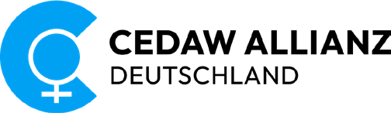

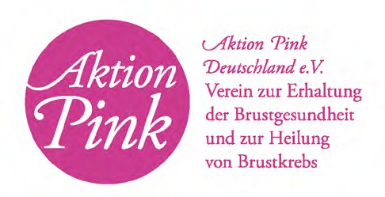

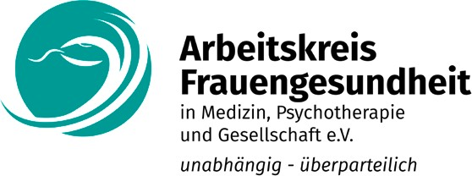

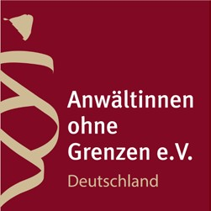

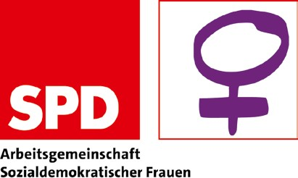

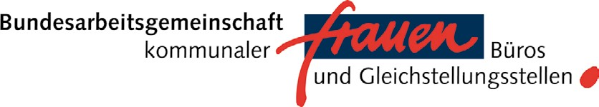



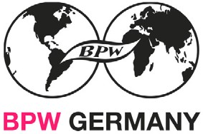

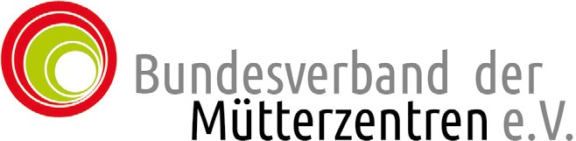

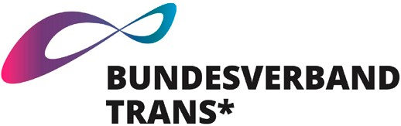

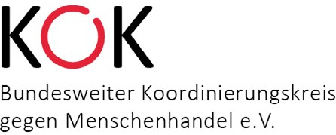

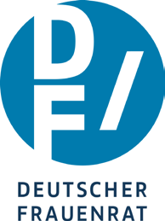

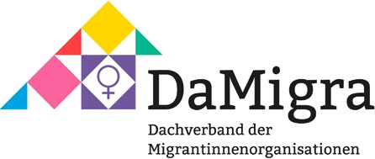

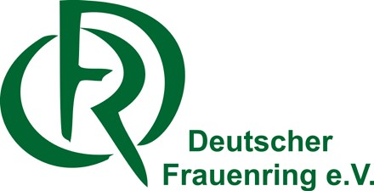

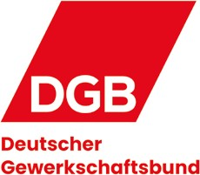



DOCTORS FOR CHOICE GERMANY


