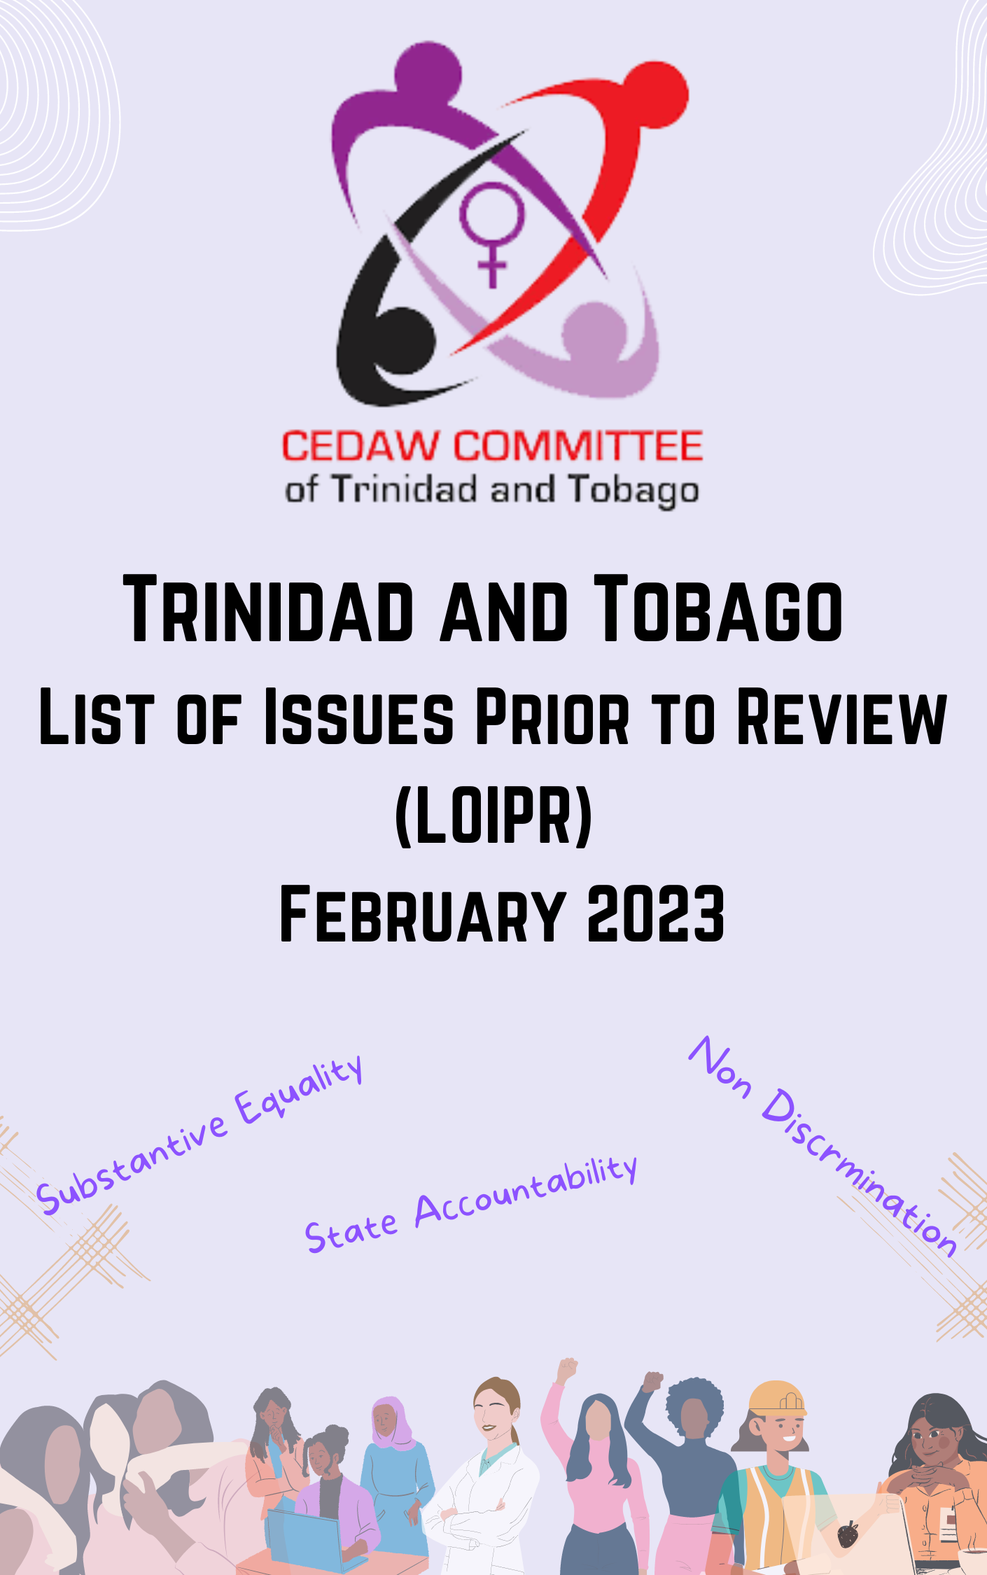

Trinidad and Tobago Review - 2023
Civil Society Submission

BACKGROUND
Trinidad and Tobago is a twin-island Republic located seven miles (12km) off Venezuela on the north-eastern coastline of South America. Trinidad and Tobago achieved Independence in 1962 and joined the Commonwealth. The official spoken language is English, with a small percentage of Hindi, French patois and other dialects spoken. The people are primarily of African or East Indian descent.

The Government of Trinidad and Tobago (GORTT) ratified the Convention on the Elimination of all forms of Discrimination of Women (CEDAW) in January 1990. Since ratification, Trinidad and Tobago submitted country reports in 2001 and 2015. The most recent report encapsulating periods IV to VII was reviewed by the Committee in June 2016. Concluding Observations and Recommendations made to the GORTT following the 2016 review can be found here.

Following reporting in 2001 and 2015, the GORTT implemented recommendations emanating from the relevant concluding observations, wholly or in part. In this aspect, therefore, the GORTT has made strides toward fulfilling the principles of Equality, Non-Discrimination, and State Accountability through policy implementation. These include: -
- The Gender Based Violence (GBV) unit was established in the Trinidad and Tobago Police Service (TTPS)
- The Sexual Offenders Registry created by the Amendment Act came online in January 2020; the Central Registry on Gender Based Violence.
- An Inter-ministerial committee was approved by cabinet to coordinate strategies to address Gender Based Violence
- The Sexual Offences (Amendment) Act was approved in 2019 and amended the Sexual Offences Act of 1986
- The National Workplace Policy on Sexual Harassment produce by the Ministry of Labour.
- A draft National Policy on Gender and Development (NPGD) went to Cabinet in 2018)
- The Marriage Act (Amendment) (2017)
- Vision 2030 was approved by Parliament in 2017
While progress is commendable, substantive equality remains elusive in women’s development.
Trinidad and Tobago is provisionally scheduled to be reviewed by the CEDAW Committee in 2023.
CEDAW Committee of Trinidad and Tobago (CCoTT)
CCoTT is an ECOSOC accredited non-governmental organisation registered under the 1995 companies act of Trinidad and Tobago, focused on Advocacy, Education and Public Awareness on and for the sustainable implementation of the principles of the Convention for the Elimination of All forms of Discrimination Against Women (CEDAW). CCoTT’s submission is guided by the following objectives:
- To identify potential topics that the Committee should consider in preparation of the List of Issues Prior to Reporting (LOIPR) to be submitted to the GORTT.
- To create a List of Issues Prior to Reporting (LOIPR)
- To develop questions with supporting material to be submitted to the Committee for consideration in their review along with the LOIPR
Using a collaborative approach, CCoTT utilises the recommendations advanced at state periodic reviews to ensure compliance within a national and human rights context. Civil society organisations collaborate to identify areas covered by CEDAW which require specific attention and action from the GORTT. Further, this civil society collective will identify issues highlighted in previous reviews that have not been fully addressed by the State.

Methodology
To achieve its objectives the CCoTT applies a collaborative approach to monitoring, evaluation, and reporting. This methodology outlines a clear process for action.
- leverage CCoTT sub-committees; review reports compiled after the 2016 review.
- compile list of key areas of concern from those sub-committees' reports.
- construct questions related to those areas of concern for the Committee’s consideration in creating its LOIPR.
- monitor GORTT's response to the questions within the nine-month period following their receipt of the questions

Identified Issues
- Gender-based violence against women
  - Shelter for women in need
  - Enforced protection of women in danger (how are breaches of protection orders investigated, prosecuted, and punished
  - Legislative and policy change regarding training and public education
  - Femicide
  - Media sensitization
  - Reinforcement of the system through investigation & data collection
- Participation in political and public life- Full and Equal Participation (Legislative provisions on participation in political and public life)
  - Active Participation in Political life
    - Leadership on Committees
    - Candidates, Elected, Appointed
  - Family Leave
  - Diplomatic Appointments
  - Availability of Data
  - Violence Against Women in Politics at all levels and including Digital violence.
- Employment - Equality in Employment (comprehensive approach to transforming the informal sector considering the systemic inequalities highlighted during the initial pandemic and the need to build back better.
  - Status on the outcome of COVID Build back better Committee re: informal sector
- Disadvantaged groups of women - (marginalised women suffer from many interconnecting forms of discrimination (An intersectional Approach is needed).
  - Girls, Women with Disabilities, Rural Women, Migrant Women, LGBTQI Communities - Integrate and reference with other groupings (Race, Class, Ethnicity)
- Education/SRHR - There is a great need for fixed proposals for Comprehensive Sex Education for young people. Religious and Faith based bodies influence, which is impacting young people’s right to information to make appropriate choices. Ensure training programmes for teachers and parents.
  - Comprehensive Health Education
  - Better integrated into school curriculum
  - Disaggregated by age (under 18)
  - Consideration of the Gilliclick Competency Model be proposed for caregivers to assist young people in making decisions as well as supporting them with their choices, in line with the Convention on the Rights of the Child’s position on the evolving capacities of young people to make decisions.
  - Access to contraceptive services for sexually active young persons
  - Introduction of programmes which encourage men to participate in family planning programmes to better support their partners and avoid unwanted pregnancies.
  - Health Care (Abortion/Unwanted pregnancy/Termination). Need to rethink the abortion laws i.e., e Offences against the Person Act (1925) and allow women to have access to services especially in the cases of rape and incest. Women should have more bodily autonomy and be able to make decisions on whether they wish to have an abortion. (*Access to safe abortions for persons under the age of 18 without parental consent).
  - Health Care - LGBTQI persons are still discriminated against. Ensure that there are safe spaces for them to access SRHR services.
- Ratification of the Optional Protocol

Questions based on list of Issues Identified
- Gender-Based Violence in Trinidad and Tobago
In Trinidad and Tobago, the Crime and Problem Analysis Unit (CAPA) of the T&T Police Service (TTPS) showed that between 2008 and 2018 there were 1434 reports of rape. This unit further revealed that there were approximately 19,078 reports relating to domestic violence incidents between 2000 and 2013. Approximately 75 percent of these reports involved female victims. Additionally, CAPA notes that for the same period, 131 domestic violence-related deaths were reported, of which 56 percent were female.
Status of Shelters The 2018 National Women's Health Survey for T&T found that one in three women in the country said they experienced intimate partner violence. Out of 14 shelters in Trinidad and one in Tobago, four shelters were closed primarily due to a lack of funding, and to date the sister isle of Tobago has no women’s shelter.
The UNICEF Action To End Child Sexual Abuse (CSA) and Exploitation claims that one in eight (1 in 8) of the world’s children (12.7%) had been sexually abused before reaching the age of 18 (2020, 5). In the early 2000s, a prevalence study found that CSA is high in the Caribbean; in a survey of 15,695 students aged 10–18 years from nine countries, 47.6% of girls reported having been subjected to sexual abuse (Halcón et al., 2003). A decade later, in a 2012 UNICEF study on sexual violence against children in the Caribbean reported that globally 14% of girls (150 million) below 18 years had experienced forced sexual intercourse and other forms of violence involving touch. In 2019 Trinidad and Tobago Children’s Authority reported, 4333 cases of abuse and maltreatment, with 23.5% involving sexual abuse. According to statistics provided by CAPA, children in residential care in Trinidad and Tobago, have been subject to consistent abuse, with sixty-nine reports recorded with authorities across Trinidad and Tobago of abuse of children resident at community residences between the years 2015 to 2021.
An investigation team was established in 2021 and the report noted that there were 39 children's homes, care facilities, and centres in Trinidad and Tobago. The report also found that as of July 2021, out of a residential population of 620 children 225 of these children resided in children's homes which did not meet the basic standards set by the Children's Authority for licensing and other reflected systematic shortcomings that facilitated child abuse.
Q. What is the status of Shelters in Trinidad and Tobago? How many model shelters are fully operational on each island? What is the capacity of each shelter, inclusive of age and gender of children allowed? How are the shelters staffed/equipped to accommodate children of all genders? Who will provide oversight of these shelters?
- How has the system been reinforced since 2016: how are cases of gender-based violence against women and girls investigated; perpetrators prosecuted; and Central Registry on Domestic Violence consistently updated with detailed and disaggregated data on the victims, perpetrators, and relationships?
- What is the status of the Inter-ministerial committee approved by the cabinet to coordinate strategies to address GBV?
- How has the public including the media been sensitised and educated on the issues of Gender Based Violence and Violence against Women and Girls?
- What provisions are in place to specifically provide assistance and support to women and girls who are victims of trafficking?
- What is the status of the recommendations emanating from the 2021 investigation?

- Education/SRHR
Human sexuality is an integral part of human life and as such cannot be separated from other aspects of life and is an important part of who we are. Sexual health, physical health, mental health and overall well-being are all positively associated with sexual well-being, sexual self-esteem and sexual pleasure. Therefore everyone must have the necessary information and education in order to make informed and responsible decisions, form healthy relationships, and take care of their bodies. Sexuality education has positive effects, including increasing young people's knowledge and improving their attitudes toward sexual and reproductive health and behaviours, and how to build healthy interpersonal relationships.

Compelling evidence worldwide illustrates the benefits of high-quality, curriculum-based Comprehensive Sexuality Education (CSE) in empowering youth to take control of and make informed decisions about their sexual health and relationships. In the Foreword of a recently conducted Formative Assessment of Comprehensive Sexuality Education within the Health and Family Life Education (HFLE) Curriculum in the Caribbean, which included Trinidad and Tobago, Malgorzata Wasilewska, Ambassador, Delegation of the European Union to Barbados wrote, “Scientific research has demonstrated the benefits of CSE for children and the society. These include delayed sexual initiation, reduced risk-taking, increased use of contraception, and improved attitudes related to sexual and reproductive health.”
Q. What progress has been made by the Ministry of Education to update the HFLE curriculum to increase access to comprehensive sexuality education for adolescents?
- What are the current challenges identified by the Ministry of Education (MOE) in supporting the amendment of the HFLE curriculum?
- How has the State advanced the Committee’s recommendation to intensify efforts to provide effective access for women and girls to comprehensive information on sexual and reproductive health and rights including on the use of modern forms of contraception, in order to reduce the high rate of teenage pregnancy?
- What progress has been made to increase access to safe abortion services?
- Is the State considering developing policy in line with Gillick Competency and Fraser Guidelines, to allow sexually active young women under the age of 18 to have access to contraceptive products in order to avoid unplanned pregnancies which may lead to unsafe abortion practices?
- In a report by Canadian human trafficking and Migrant Consultant, Dr. Cleophas Justin Pierre, Trinidad, and Tobago ranked 26th globally for rape with 18.48 per 100,000 inhabitants. The Trinidad and Tobago Police Service data for rape, incest and other sexual offences, shows that there were 352 cases in 2019, 372 in 2020 and 366 in 2021. Is the State considering a review of its abortion law to allow women and girls to have access to safe abortion services in cases of rape and incest, at a minimum?

- 2030 Agenda for Sustainable Development
In recommendation forty-four of the Concluding observations of the combined IV to VII report of Trinidad and Tobago, the Committee called for the realisation of substantive gender equality, in accordance with the provisions of the Convention, throughout the process of implementation of the 2030 Agenda for Sustainable Development. Vision 2030 - which provides a general outline of the GORTT’s plan to facilitate Substantive Development in Trinidad and Tobago was approved by Parliament in 2017.
Q. What specific plans and mechanisms are in place to realise substantive equality in accordance with the provisions of the Convention, throughout the process of implementation of the 2030 Agenda for Sustainable Development?
- How is progress based on the 2030 Agenda shared with the public to ensure full engagement particularly on matters of women’s rights?
- How is gender defined and integrated into the work programs of each Ministry and how is this captured and monitored?
- How are women’s issues addressed within gender integration into the work programs of the Ministries.
- How is Gender Responsive Budgeting (GRB) aligned and being reflected in the National budget, and in each Ministry’s budget.

- Employment
The gender pay gap and sexual harassment remain significant issues for women in the workplace. This was highlighted in ILO in 2018 which showed that the pay gap between men and women ranged from 8.9 % for technicians and associate professionals and up to 34.7% for service and shop sales workers. More recently the COVID -19 pandemic exacerbated this gap as a result of the shutdown of non-essential services. While the Equal Opportunity Commission was established to address workplace discrimination, it does not include sexual harassment or sexual orientation. Despite there being a National Workplace Policy on Sexual Harassment, there is still no enacted legislation, nor are there effective policies for inside and outside of the workplace on sexual harassment. It is notable that there have also been observations on violence and harassment against migrant workers as documented in the IOM Monitoring Migrants Presence: Trinidad and Tobago Round 2 September 2019 survey.
Q. What structural and legislative approaches have been undertaken by the GORTT since the 2016 review to affect transformational change in the informal sector of employment?
- Elimination of structural inequalities and occupational segregation
- Reduction of gender wage gap
- Inclusion of domestic workers in the Industrial Relations Act
- Comprehensively address sexual harassment in the workplace
- Employ data collection on sex discrimination in the workplace.
- Enforcement of compliance with labour laws
- Protection of migrant workers

- Disadvantaged Groups of Women
Marginalised women suffer from many intersecting forms of discrimination. Recommendation Thirty-Eight (38) of the 2016 Concluding Observations report states ‘(38.) The Committee is concerned about the situation of female-headed households, widows, older women and women with disabilities, who often suffer intersecting forms of discrimination, especially with regard to access to employment, health care and social services. It notes with regret the limited information provided by the State party in this regard.’
In recommendation (39.) the Committee requested the State party to include, in the next periodic report, detailed information, including disaggregated data and information on specific programmes and achievements, on the situation of female headed households, widows, older women and women with disabilities.’

Subsequent to the Draft National Policy on Gender and Development (NPGD) being laid in Parliament, Cabinet agreed that the draft policy ‘be used as the official government policy pending its final adoption’. Currently, the NPGD outlines several policy measures intended to decrease barriers and inequalities faced by women considered disadvantaged inclusive of the collection, collation and analysing of national sex-disaggregated agricultural data, to identify the gender differentials as such.
Q. What measures have been taken by the GORTT to ensure that women and girls from disadvantaged groups (female headed households, widows, older women,
women with disabilities and gender non-conforming persons) have access to employment, health care and social services; inclusive of their ability to access and participate in programmes intended to positively impact their lives.
- What data can the state provide on these groups of women and girls?
- What information can the GORTT provide on the success of programmes implemented to assist these groups?

- Full and Equal Participation in political and public life
Equal representation of gender on Trinidad and Tobago’s national, subnational, and local elected bodies has progressed steadily over the past decades. This has largely been due to the advocacy of women’s organisations appealing to the good sense of political party leadership. The Committee, in recommendation 25 of the 2016 CEDAW review, recommended that the State party introduce measures, including temporary special measures in accordance with article 4 (1) of the Convention and the Committee’s general recommendations No. 25 (2004) and No. 23 (1997) on women in political and public life, such as statutory quotas, in order to accelerate the full and equal participation of women in elected and appointed bodies, including the judiciary, senior positions in the diplomatic service and academic institutions. And further, that the State party should adopt prescriptive measures in order to preserve the progress achieved in the representation of women in Parliament and to introduce maternity leave for parliamentarians.
Q. What measures have been taken by the State to accelerate women’s full and equal participation in elected and appointed positions ?
- Has the State party considered the adoption of a comprehensive definition of discrimination against women in the national legislation in line with article 1 of the convention?
- What provisions have been made for family leave under the Maternity Protection Act for elected and appointed officers in line with article 4(1) of the Convention and the Committee’s General Recommendation No. 25.
- What strategies have been put in place to achieve substantive equality by 2030?
- Has the GORTT considered the establishment of an ethics committee to provide oversight for the development of a code of conduct which will include campaign behaviour and behaviour in office, review and make recommendations on the code of conduct; and enforcement of the code of conduct.

- Optional Protocol
The Optional Protocol to the Convention on the Elimination of All forms of Discrimination Against Women (OP-CEDAW) establishes complaint and inquiry mechanisms for CEDAW. By ratifying the Optional Protocol, a State recognizes the competence of the Committee on the Elimination of Discrimination against Women to receive and consider complaints from individuals or groups within its jurisdiction.
The Protocol contains two procedures: (1) A communications procedure allows individual women, or groups of women, to submit claims of violations of rights protected under the Convention to the Committee. The Protocol establishes that in order for individual communications to be admitted for consideration by the Committee, a number of criteria must be met, including that domestic remedies must have been exhausted. (2) The Protocol also creates an inquiry procedure enabling the Committee to initiate inquiries into situations of grave or systematic violations of women’s rights. In either case, States must be party to the Convention and the Protocol. The Protocol includes an "opt-out clause", allowing States upon ratification or accession to declare that they do not accept the inquiry procedure. Article 17 of the Protocol explicitly provides that no reservations may be entered to its terms.
In the Concluding Observations of the 2016 review, the Committee encouraged the GORTT to ratify the Optional Protocol to the Convention and to accept, as soon as possible, the amendment to article 20 (1) of the Convention concerning the meeting time of the Committee.
Q. What specific steps by the GORTT toward ratifying the CEDAW Optional Protocol were taken?

CEDAW Committee of Trinidad and Tobago (CCoTT) is an ECOSOC accredited volunteer non-governmental organisation incorporated under the 1995 companies act, focused on Advocacy, Education and Public awareness on and for the sustainable implementation of the principles of the Convention for the Elimination of All Forms of Discrimination against Women (CEDAW). Using a collaborative approach, we utilise the recommendations advanced at state periodic reviews to ensure compliance within a national human rights context.

