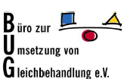

Alternative report for the

UN Committee for the Elimination of all forms of Discrimination Against Women
CEDAW
concerning the German governmental report
during the 85th session

Submitted by:
Büro zur Umsetzung von Gleichbehandlung – BUG
(Bureau for the Implementation of Equal Treatment)
Greifswalder Str. 4
10405 Berlin
Webpage: www.bug-ev.org

Contact person:
Vera Egenberger – Director
Mail contact:
vera.egenberger@bug-ev.org
Phone:
0049 30 688 366 18

Special thanks go to Rabia Küçükşahin for her support in developing this shadow report and Sara Borasio and for Frances Grimm proof-reading the text.

Contents

A. Issues 3
1. Introduction 3
2. Gender Stereotypes (Art. 4 and 5 of the CEDAW) 4
3. Education (Art. 10 of the CEDAW) 5
4. Employment (Art. 11 of the CEDAW) 6
4.1 Public service employment 7
4.2 Private sector employment 7
B. Recommendations to comply with CEDAW standards 8
C. Appendices 10
Appendix 1: Perception of Islam in Germany in 2019 10
Appendix 2: Opinion on Islam and Muslims 11
Appendix 3: Percentage of Muslim women wearing a headscarf 12
Appendix 4: Reasons why Muslim women wear a headscarf 13
Appendix 5: Reasons not to wear a headscarf 14
Appendix 6: Comparison of response rates for a job interview 15

BUG suggests that the CEDAW Committee asks Germany to further clarify the following issues:

A. Issues

1. Introduction
General recommendation No. 28 of CEDAW published 2010 states in paragraph 18 that “intersectionality is a basic concept for understanding the scope of the general obligations of States parties contained in article 2. The discrimination of women based on sex and gender is inextricably linked with other factors that affect women, such as race, ethnicity, religion or belief, […]. Discrimination on the basis of sex or gender may affect women belonging to such groups to a different degree or in different ways to men. States parties must legally recognize such intersecting forms of discrimination and their compounded negative impact on the women concerned and prohibit them. They also need to adopt and pursue policies and programmes designed to eliminate such occurrences, including, where appropriate, temporary special measures in accordance with article 4, paragraph 1, of the Convention and general recommendation No. 25.”

In a survey conducted in Germany in 2019, 52% of the participants considered Islam as a threat. 13% of those surveyed considered it appropriate to ban Muslims from immigrating to Germany (Appendix 1). More than 40% indicated they would not accept a family member marrying a Muslim.
A survey conducted by the Evangelical Church in 2018 indicates that every second person shares the opinion that Islam does not fit into German society. Around 45% of those surveyed responded they are against a Muslim mayor in their community (Appendix 2).
In assessing the situation of Muslim women, it is apparent they face intersectional forms of discrimination, combining experiences of racism and gender discrimination. Therefore, intersectionality should be part of the analysis of the German Report by the CEDAW Committee.
Currently between 5.3 and 5.6 million Muslims live in Germany. This corresponds to between 6.4 and 6.7% of the total population of 83.17 million people. 48% of the Muslim population are women. Approximately 30% of these Muslim women in Germany wear a headscarf (see Appendix 3). 88% of these women wear the veil as their religious identity and duty (Appendix 4). A recent study conducted by the Federal Office for Migration and Refugees shows that 35% of women who sometimes or never wear a headscarf also cited fear of being disadvantaged at school, in training or at work. Fear of harassment and verbal abuse was reported by 13% of those women as reasons for not wearing a headscarf (Appendix 5).
This alternative report presented by the Bureau for the Implementation of Equal Treatment is particularly focused on the discrimination of Muslim women in relation to gender and religion in Germany.
Over 25 years of debates have taken place in Germany concerning the legal prohibition of wearing a religious headscarf in professional life, such as medical staff, teachers or in the judiciary. There are three central decisions of the Federal Constitutional Court (Bundesverfassungsgericht) concerning this matter. While the first two decisions relate to teachers wearing a headscarf, the third decision touched upon a headscarf-wearing law trainee. The first decision of the Constitutional Court dating back to 2003, outlined that a ban of headscarves is not violating the German Constitution. Consequently, many Länder, holding decision making powers on any schooling matters, enacted their individual legal frameworks. Some of them allowed teachers wearing a headscarf and other prohibited it.
In 2015, the Federal Constitutional Court decided in a new court case that a headscarf ban in public services would only be proportionate if there was a sufficiently concrete risk of danger to disturb peace at school.
In 2020, a third decision was taken by the Constitutional Court allowing the restriction of wearing a headscarf during a legal traineeship at court in Hesse. Several Länder have now made provisions that legal trainees (and sometimes also court staff not performing state duties) are not allowed to wear a headscarf in the courtroom. Those Länder are Baden-Wuerttemberg, Hesse, Lower Saxony, North Rhine-Westphalia, and Bavaria.

2. Gender Stereotypes (Art. 4 and 5 of the CEDAW)
Efforts by the German Government towards overcoming gender stereotypes against Muslim women in accordance with Article 5 of the CEDAW are not reflected in the governmental report to CEDAW. Therefore, it can be assumed that no such activities have been undertaken by the German government.
Women wearing headscarves for religious reasons are at high risk for gender and religious discrimination. They are seen by mainstream society as being “oppressed by their families” and unwilling to integrate into society. Muslim women are also often portrayed as dangerous, as the headscarf is seen to be a symbol of radical Islamism. Through these stereotypes Muslim women are disadvantaged and discriminated against in public and political life, employment and education and are at risk of facing gender-based hate-motivated crime.
According to the definition of the ICERD, racial discrimination encompasses not only unequal treatment but also hate-motivated crimes. In Germany, racist hate crime is captured in the category of ‘politically motivated crime’. The Criminal Police Reporting Service records 732 Anti-Muslim hate crimes in 2021: 71 of them were violent crimes, of which 43 involved bodily harm. Muslim women wearing a headscarf are at higher risk of experiencing verbal and physical violence, as the headscarf is a visible sign of gender and religion. However, the collected data does not consider gender. Reports from the Federal Anti-Discrimination Agency (FADA) show that 75.8% of verbally and physically violent discrimination was reported in the public and leisure sector by headscarf-wearing Muslim women. In many cases, bullying, racist or other derogatory statements were also reported.
Article 5 of the CEDAW states that laws must not reinforce gender stereotypes. However, Germany has several laws - as already mentioned above - at federal and state levels banning Muslim women from wearing a headscarf in areas of public service. Therefore, there are hardly any headscarf-wearing Muslim women in such public offices. As a result, there is no substantial evidence that women who wear headscarves are neutral in their tasks. The image of Muslim women seems to be based solely on ascriptions and stereotypes. It generates a social stigma based on gender and religion, which also leads to a violation of their right to self-determination, agency, and autonomy. Especially when headscarf-wearing women must make a choice between wearing a headscarf and employment. This stigma denies their capacity and sanity to be able to make decisions for themselves as a woman.
As there are hardly any statistical data concerning ethnic minorities in Germany, there are none about the representation of Muslims in public life, let alone of headscarf-wearing Muslim women in political life. However, there is anecdotal evidence that there are very few Muslim women with a headscarf in political parties or political positions. The reason for this is the likelihood of prejudices and bias against Muslim women wearing a veil.

3. Education (Art. 10 of the CEDAW)
Part of the study ‘Experiences of discrimination in Germany’ commissioned by FADA evaluated a total of 1,655 cases of discrimination experiences in the educational sector. In this field Muslims in particular experience discrimination. The report speaks about a day-care refusing headscarf-wearing mothers, bullying and poorer performance evaluation of students due to the attribution to the Muslim religion in schools and universities.
From September 2019 until August 2021 the Contact Point for Protection against Discrimination in Schools (ADAS) in Berlin conducted a quantitative study on the experiences of Muslim students at Berlin schools in dealing with religious diversity. Although the surveyed enjoy going to school on average, most of them (78%) feel treated unequally and have the feeling that they must do more at school than others because of their background. Almost half of them (47%) have this feeling quite or very strongly. More than half of them (62%) stated that there are teachers or educators at their school who make negative comments about certain religions. The negative comments related almost exclusively (92%) to Islam. In 15% of the cases, negative statements are made frequently or regularly. The greater part of the negative reactions, e.g. in the form of stereotypical and derogatory remarks, were made by teachers and in some cases school administrations and primarily addressed headscarf-wearing Muslim girls and young women.
Statements made by female Muslim pupils during the interviews for the above-mentioned study:
“There are always negative comments and when you do well, the teachers are surprised but still give a lower grade than e.g. Germans.”
“Another teacher asked me in front of the whole class if I hadn’t joined ISIS after all.”
“I was not transferred to next grade level because of my headscarf.”

4. Employment (Art. 11 of the CEDAW)
CEDAW recommends in its 33rd General Recommendation in paragraph 15 concerning women’s access to justice that State Parties shall “confront and remove barriers to women’s participation as professionals within all bodies and levels of judicial and quasi-judicial systems and providers of justice-related services, and take steps, including temporary special measures, to ensure that women are equally represented in the judiciary and other law implementation mechanisms as magistrates, judges, prosecutors, public defenders, lawyers, administrators, mediators, law enforcement officials, judicial and penal officials and expert practitioners, as well as in other professional capacities.”

4.1 Public service employment
In June 2021, the “Law Ruling the Appearance of Civil Servants and Modifications of other related Employment Regulations” (Gesetz zur Regelung des Erscheinungsbilds von Beamtinnen und Beamten sowie zur Änderung weiterer dienstrechtlicher Vorschriften) was enacted. The law restricts in §34 civil servants working in federal states institutions from exercising their profession when they wear a headscarf as this is “objectively likely to impair confidence in the neutral exercise of their duties.” This new law originates from a Federal Administrative Court’s ruling regarding a police officer with tattoos depicting unconstitutional symbols (a swastika). In this case it became obvious that there is a need for a legal basis to ban unconstitutional tattoos and behaviour. As a result, the law now also rules that religious symbols such as a Muslim headscarf are equally banned. This equates unconstitutional symbols with religious ones. This new piece of law now affects Muslim women in public offices at the federal level wearing a headscarf, particularly judges, states attorneys, police officers, and soldiers.
Similar cases occurred at the Länder level: A headscarf-wearing law trainee was denied conducting court sessions, taking evidence, representing the public prosecutor, and chairing an administrative hearing committee because of wearing a veil. Therefore, she filed a constitutional complaint against this prohibition. In its decision in 2020, the Federal Constitutional Court focused rather on the role of a judge then of a law trainee and did not take Art. 33(3) of the Constitution into account, which states that “neither the enjoyment of civil and political rights nor eligibility for public office nor rights acquired in the public service shall be dependent upon religious affiliation. No one may be disadvantaged by reason of adherence or non-adherence to a particular religious denomination or philosophical creed.” The Constitutional Court in this decision outlines that it is to be respected when Länder define more restrictive legal frameworks concerning religious symbols.

4.2 Private sector employment
In 2015, the UN Committee against All Forms of Racial Discrimination expressed that they are “particularly concerned at reports of the ethno-religious discrimination of Muslim women in gaining access to work opportunities.”
A study conducted in 2016 states that Muslim women with a Turkish name who wear a headscarf must apply four times as often to be invited to a similar number of job interviews as applicants with a German name not wearing a headscarf (Appendix 6).
According to an expert report by the FADA, the headscarf is “predominantly considered undesirable or even incompatible with professional activity” for many employers. Various counselling centres reported cases in which women were advised to take off their headscarves, as this is the only way to integrate them into the labour market.
The following case in the private sector employment displays that regulations are made in everyday working life to prohibit female employees from wearing their headscarves.
A cashier working for a drugstore has worn a headscarf since 2014. When she did not comply with her employer’s request to take off the headscarf, she was assigned to another position that allowed her to wear the headscarf. In July 2016, she received instructions from her employer to appear at her workplace without showing any conspicuous large-scale signs of religious, political or ideological beliefs. The CJEU specified that rules such as in this case are disproportionate and therefore constitute indirect discrimination based on religion or belief.

B. Recommendations to comply with CEDAW standards
Current legal protection against gender and religious discrimination does not fully comply with CEDAW standards and needs to be analysed.
Therefore, BUG suggests the Committee to ask the German Government:
- Will existing laws be amended to guarantee that headscarf-wearing Muslim women have equal access to employment, to participate in public life, in decision-making processes and in holding public offices in the judiciary?

- Beyond the legal framework, which measures will be taken by school authorities to ensure that headscarf-wearing Muslim girls and women are not discriminated against at school, in training, at work or by governmental institutions?

- Will temporary positive measures be introduced to achieve equal participation of Muslim women in employment, in public life, in decision-making processes and in holding public offices in the judiciary?

- How will the Government of Germany ensure that discrimination complaint mechanisms according to §13 of the General Equal Treatment Act (AGG) are also providing meaningful analysis of Muslim women experiencing discrimination in accessing and within employment.

- Does the German Government mainstream an intersectional approach to gender and religion in policy- and law-making procedures?

BUG would like to invite the CEDAW Committee to consider the following recommendations:
- The German Government repeals laws prohibiting headscarf-wearing for civil servants and encourages the states (Länder) to repeal their laws prohibiting headscarf-wearing Muslim women from holding a public office in the judiciary.

- The German Government shall introduce temporary positive measures to achieve equal participation of Muslim women in employment, in public life, in decision-making processes and in holding public offices in the judiciary.

- The German Government shall introduce measures to ensure that intersectional approaches are applied in policy- and law-making processes.

- The German Government is asked to initiate research and data collection concerning the representation of Muslim women in public and political life.

- The German Government shall collect data on violence based on gender and especially women facing intersectional discrimination like Muslim women.

C. Appendices

Appendix 1: Perception of Islam in Germany in 2019

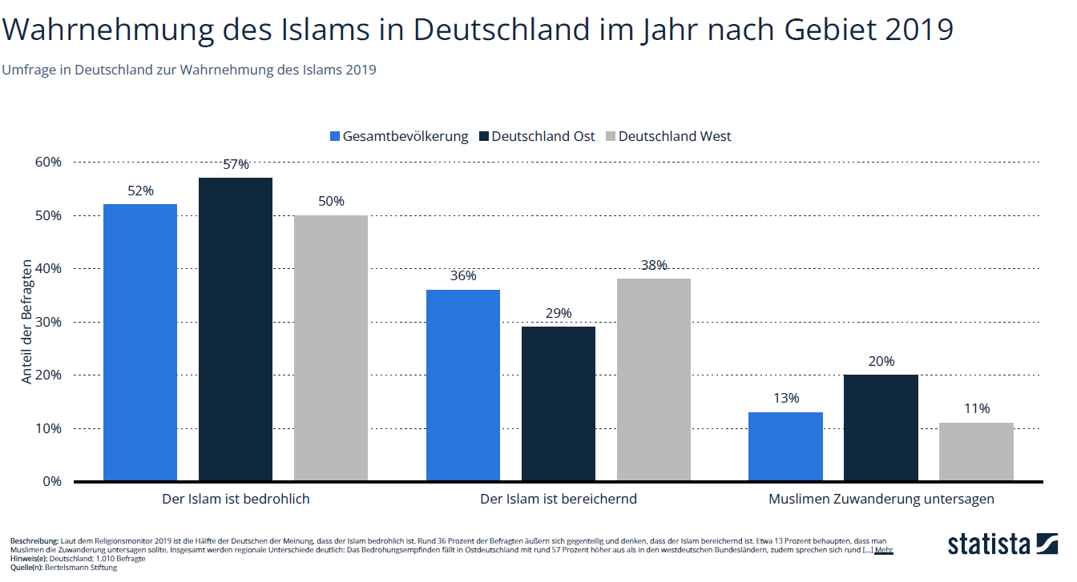

German | English
Der Islam ist bedrohlich | Islam is a threat
Der Islam ist bereichernd | Islam is enriching
Muslimen Zuwanderung untersagen | Forbid Muslims to immigrate
Gesamtbevölkerung | Total population
Deutschland Ost | East Germany
Deutschland West | West Germany

Appendix 2: Opinion on Islam and Muslims
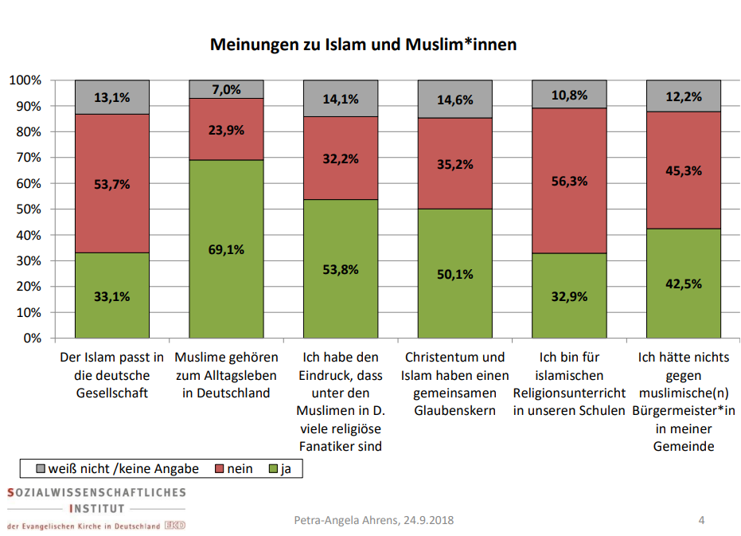

Der Islam passt in die deutsche Gesellschaft | Islam fits into German society
Muslime gehören zum Alltagsleben in Deutschland | Muslims belong to everyday live in Germany
Ich habe den Eindruck, dass unter den Muslimen in D. viele religiöse Fanatiker sind | I have the impression that among the Muslims in G. there are many religious fanatics
Christentum und Islam haben einen gemeinsamen Glaubenskern | Christianity and Islam share a core of belief
Ich bin für islamischen Religionsunterricht in unseren Schulen | I am in favor of Islamic religious education in our schools
Ich hätte nichts gegen muslimische(n) Bürgermeister*in in meiner Gemeinde | I would not mind a Muslim mayor in my community

Appendix 3: Percentage of Muslim women wearing a headscarf

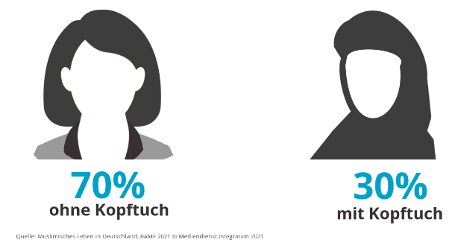

70 % ohne Kopftuch | 70 % without headscarf
30 % mit Kopftuch | 30 % with a headscarf

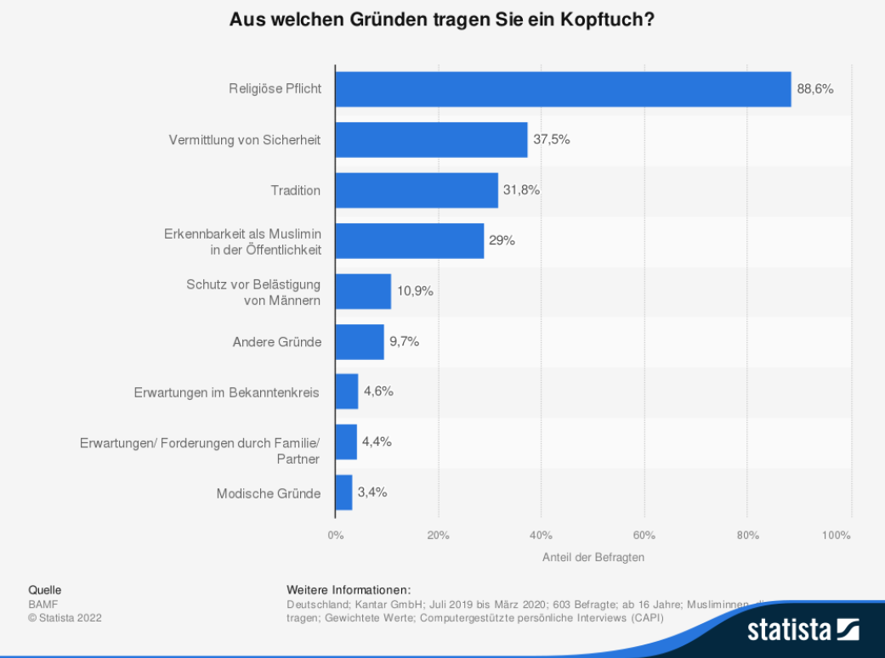
Appendix 4: Reasons why Muslim women wear a headscarf

Religiöse Pflicht | Religious duty
Vermittlung von Sicherheit | Mediation of security
Tradition | Tradition
Erkennbarkeit als Muslimin in der Öffentlichkeit | Recognizability as a Muslim in public
Schutz vor Belästigung von Männern | Protection against male harassment
Andere Gründe | Other reasons
Erwartungen im Bekanntenkreis | Expectations of circle of acquaintances
Erwartungen/Forderungen durch Familie/Partner | Expectations of family/partner
Modische Gründe | Fashion reasons

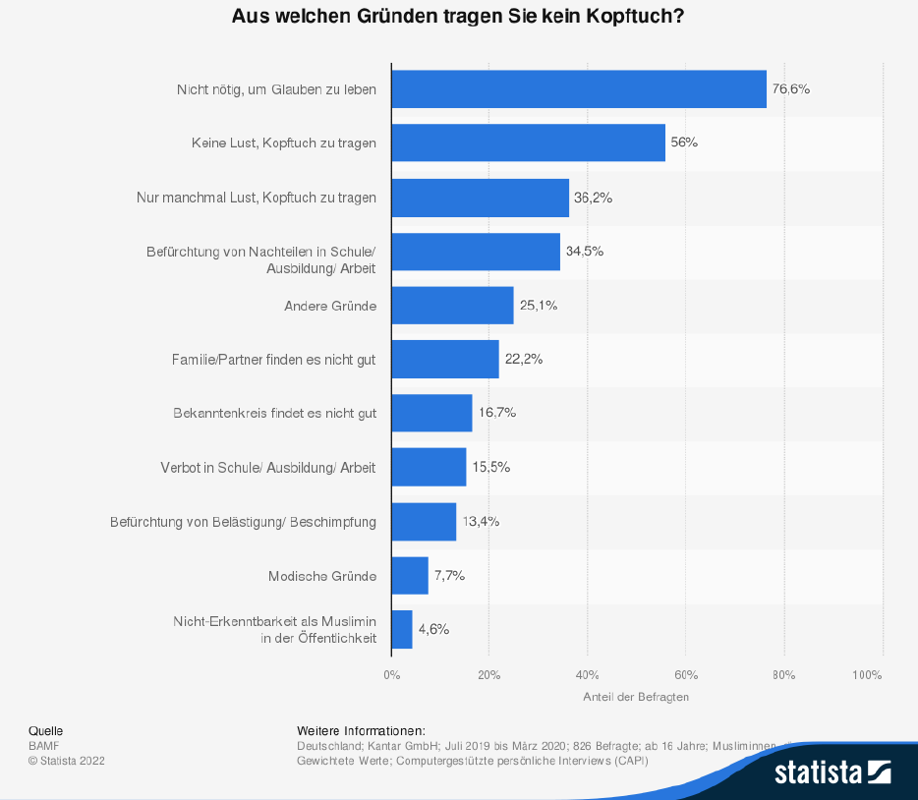
Appendix 5: Reasons not to wear a headscarf

Nicht nötig um Glauben zu leben | Not necessary to live faith
Keine Lust, Kopftuch zu tragen | Do not want to wear a headscarf
Nur manchmal Lust, Kopftuch zu tragen | Only sometimes feel like wearing a headscarf
Befürchtung von Nachteilen in Schule/Ausbildung/Arbeit | Fear of disadvantages in school//training/work
Andere Gründe | Other reasons
Familie/Partner finden es nicht gut | Family/partner do not like it
Bekanntenkreis findet es nicht gut | Circle of acquaintances do not like it
Verbot in der Schule/Ausbildung | Prohibited in school/training
Befürchtung von Belästigung/Beschimpfung | Fear of harassment/abuse
Modische Gründe | Fashion reasons
Nicht Erkennbarkeit als Muslimin in der Öffentlichkeit | Unrecognizable as a Muslim in public

Appendix 6: Comparison of response rates for a job interview

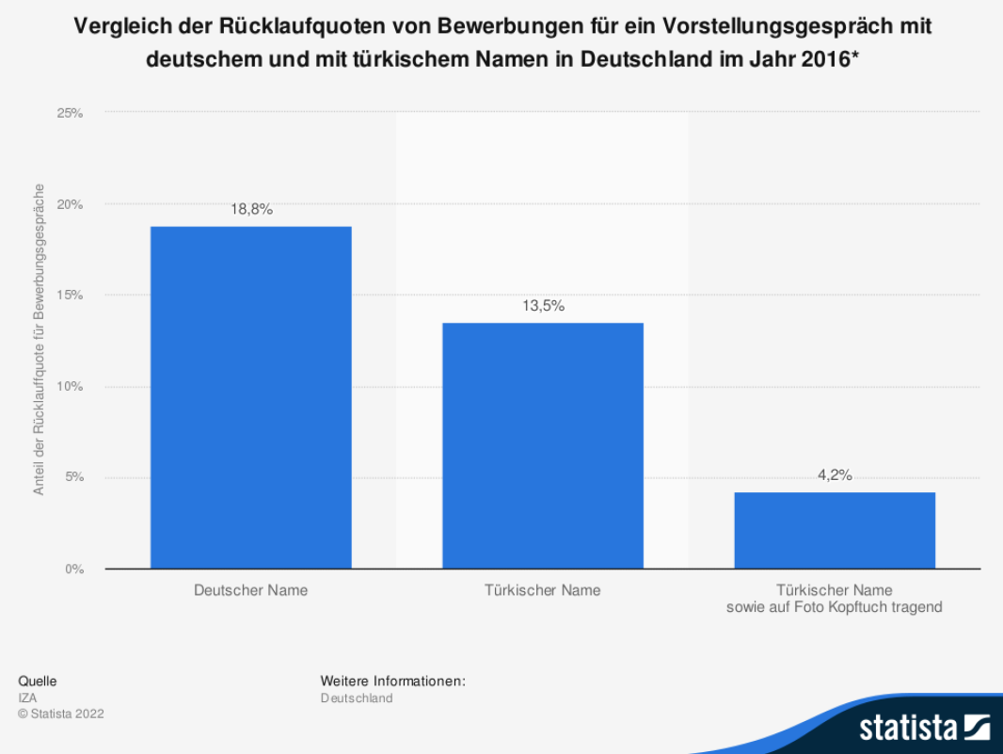

Deutscher Name | German name
Türkischer Name | Turkish name
Türkischer Name sowie auf Foto Kopftuch tragend | Turkish name and wearing headscarf in the photo

CEDAW/C/GC/28, marginal no. 18.
Bertelsmann Religionsmonitor (2019): Weltanschauliche Vielfalt und Demokratie, p. 13, 77 f.
Sozialwissenschaftliches Institut der Evangelischen Kirche in Deutschland (2018): Islam und Muslim*innen in Deutschland, p. 4
BAMF (2021): Muslimisches Leben, p. 37, 48.
Ibid., p. 117.
Ibid., p. 122.
Cases brought to Court regarding the Nurse: Labour Court Cologne of 6 March 2008 case number 19 Ca 7222/07; the cashier and the nursery schoolteacher: CJEU of 15.7.2021 case number: C-804/18 and C-341/19.
BVerfG, Judgment of the Second Senate of 24 September 2003, case number: 2 BvR 1436/02; BVerfG, Order of the First Senate of 27 January 2015, case number:1 BvR 471/10.
BVerfG, Order of the Second Senate of 14 January 2020, case number: 2 BvR 1333/17.
See footnote 8.
Länder with legal restrictions on for headscarves for teachers listed below in chronological order: Baden-Wurttemberg (01.04.2004), Lower Saxony (29.04.2004), Saarland (23.06.2004), Hesse (18.10.2004), Bavaria (23.11.2004), Berlin (27.01.2005), Bremen (28.06.2005), North Rhine-Westphalia (13.06.2006).
See footnote 8.
See footnote 9.
Shooman (2014): „weil ihre Kultur so ist“, p. 83-99.
Ibid.
BMI/BKA: Politisch motivierte Kriminalität im Jahr 2021, p. 11.
FADA (2017): Diskriminierungserfahrungen in Deutschland, p. 220f.
Ibid., p. 122.
Ibid., p. 142 ff., 291.
ADAS (2021): Religion und Glauben an der Schule, p. 6.
Ibid., p. 7.
Ibid.
Ibid., p. 30, 33.
CEDAW/C/GC/33, marginal no. 15 (f).
Bundesgesetzblatt: Bundesbeamtenstatusgesetz, issued on 06.07.2021, p. 2250.
Beamtenstatusgesetz, § 34 (2).
BVerwG, judgement of 11. November 2017, case number: 2 C 25.17.
Constitution, Art. 33 (3).
See footnote 9, marginal no. 102.
CERD/C/DEU/CO/19–22, marginal no 14.
Weichselbaumer (2016): Discrimination against Female Migrants Wearing Headscarves, p. 12f.
FADA (2010): Diskriminierung aufgrund der islamischen Religionszugehörigkeit im Kontext Arbeitsleben, p. 8.
FADA (2017): Diskriminierung in Deutschland, p. 381.
CJEU of 15.7.2021 case number: C-341/19.

