
THEMATIC REPORT ON ARTICLE 16
QATAR

73rd CEDAW Session
Geneva, Switzerland
July 2019

Musawah
15 Jalan Limau Purut, 59000 Kuala Lumpur, Malaysia
Tel: +603 2083 0202Fax: +603 2202 0303
Email: musawah@musawah.org
Website: www.musawah.org

Table of Contents
A. INTRODUCTION 3
B. LEGAL BACKGROUND 3
C. KEY ISSUES, LIVED REALITIES, ISLAMIC JURISPRUDENCE, AND REFORM 4
1. FAMILY LAW BASED ON DISCRIMINATORY FRAMEWORK 4
2. EARLY & CHILD MARRIAGE 5
3. WOMEN'S CAPACITY TO ENTER INTO MARRIAGE 6
4. POLYGAMY 7
5. DIVORCE RIGHTS 8
6. GUARDIANSHIP OF CHILDREN 10

Annexe 1: Justification for reform 12
Annexe 2: Musawah Vision for the Family 14

A. INTRODUCTION

Musawah, the global movement for equality and justice in the Muslim family, submits this Thematic Report on Article 16 and related concerns for consideration by the CEDAW Committee in its review of the Government of Oman, reporting before the 73rd CEDAW Session in July 2019.
In particular, this report examines Qatari laws and practices that enforce de jure and de facto discrimination against women in the following areas: legal framework of the Qatari Family Law, women’s equal capacity to enter into marriage, child marriage, polygamy, divorce rights and guardianship of children. Musawah would like to acknowledge the vital input and feedback from national advocates into this report.

B. legal background

According to 2010 statistics on demographics, 67% of Qatar’s 2.3. million population are Muslims. 90% of Qatar’s Muslim population are Sunnis, majority of whom follow the Hanbali school of fiqh (jurisprudence). 10% of the Muslim population are Shi’as.
Qatar obtained independence in 1971 from its status as a British protectorate. The country has a mixed legal system incorporating both civil law and Islamic law. Shari’ah is one of the sources of Qatari legislation, and is applied to aspects of family law, inheritance, and certain criminal acts.
In terms of constitutional rights, Article 1 of the Constitution of the State of Qatar (effective June 9, 2005) declares that Islam is the state religion, and provides that, ‘the Islamic Shari‘ah is the main source of its legislations’. Article 21 of the Constitution states that, ‘The family is the basis of the society. A Qatari family is founded on religion, ethics, and patriotism. The law shall regulate adequate means to protect the family, support its structure, strengthen its ties, and protect maternity, childhood, and old age.’
QATARI FAMILY LAW
The Qatari Family Law (QFL) is the main codified law that governs matters relating to marriage and family relations of the Muslim majority population in Qatar. In the absence of codified law that sufficiently address a particular matter of personal status of Muslims, according to Articles 3 and 4 of the QFL, the rules of Hanbali jurisprudence (fiqh) apply.

As per Article 4 of the QFL, marriage and family relations of Muslims of other schools of thoughts apart from Hanbali as well as marriage and family relations of Qatar’s non-Muslim minority communities are governed by their own laws, unless they request for the QFL to apply to them.

The Qatari government cited the apparent inconsistencies between the provisions of CEDAW it has reservations to and Islamic law, Qatari law (family and citizenship) as well as established practices as the main reason for the reservations.

The Government of Qatar stated in its 2019 Replies to the List of Issues & Questions of the CEDAW Committee that “The Qatari Family Act (No. 22 of 2006) does not contain any provisions that discriminate against women.”

LACK OF PROGRESS ON REFORM OF QFL
In the 2014 Concluding Observations on marriage and family, the CEDAW Committee recommended to the Qatar government to repeal discriminatory provisions in the family law and ensure that it protects the equal rights of women and men in all matters relating to marriage and family relations, including with regard to their right to freely enter into marriage, as well as inheritance, divorce and custody of children. The Committee also recommended for Qatar to amend legislation to abolish polygamy and raise the minimum age of marriage for girls to 18 years.
Musawah would like to bring to the attention of the CEDAW Committee that there has been no notable change to the situation of discrimination that Qatari women face under the QFL, from what was last reported in 2014.
In the Qatar State Party report to the CEDAW Committee it was reported that four women have assumed membership in the Shura (Advisory) Council. While this is a positive development, activists note that in practice they have no legislative power and simply approve what is passed onto them. The role therefore is highly limited. Furthermore, the prevailing status quo with regard to unequal rights for women in marriage and family matters is a matter of significant concern that warrants attention.

C. KEY ISSUES, LIVED REALITIES, ISLAMIC JURISPRUDENCE,

AND REFORM

1. FAMILY LAW BASED ON DISCRIMINATORY FRAMEWORK

Article 9 of the QFL defines marriage as a “legitimate contract between a man and woman on the basis of sustainability, and its aim is cohabitation and securing chastity”. Article 56 promotes mutual, respect, kindness and intimacy between spouses to conserve that family’s welfare (including with the parents and relatives of the spouses) and ensure the best possible development of the children.

However despite these provisions, and despite Article 35 of the Constitution that guarantees equality, the QFL provides for a marital framework based on ‘reciprocal’ or ‘complementary’ rights (as opposed to ‘equal’ rights) between the two spouses, whereby in return for maintenance and protection from her husband, a wife is expected to obey him.

Article 57 provides that a husband must; (i) provide his wife with a dower (mahr) as well as permanent financial maintenance (nafaqa); and (ii) permit her to visit her parents and relatives. The husband is also not entitled to intervene in his wife’s private property. Article 58 provides that the husband is entitled to: (i) the care and obedience of his wife; (ii) his wife’s duty to be responsible for the household and looking after their children. Article 61 reiterates the husband’s duty to provide his wife with adequate financial maintenance.

The QFL continues to recognize ‘disobedience’ of a wife as grounds for adverse marital consequences. Article 69 states that a “disobedient” wife risks losing her financial maintenance. A wife is deemed “disobedient” if she: (i) refuses to surrender herself to her husband without legitimate reason; (ii) refuses to move to the marital home without legitimate reason; (ii) leaves the marital home without legitimate reasons; (iv) refuses to travel with her husband when moving to another dwelling without legitimate excuse; (v) travels without the permission of her husband; (vi) works outside the home without the permission of her husband, unless he is abusing his right in preventing her from working.
Changing realities of Qatari women: According to the Qatar State Party report and response to the List of Issues and Questions, Qatari women have and continue to hold several senior leadership and supervisory positions. They have held ministerial positions as well as served as deputy ministers and department heads at ministries, judges, chief prosecutors and prosecutors. Qatari women play various roles in the fields of education, health, law, journalism, aviation, banking, finance, and tourism. The Qatari government must ensure that the Qatari family law reflects the shifting realities of Qatari women and their roles in families and society.

RECOMMENDATIONS

We recommend the CEDAW committee to urge the State party to:
- Ensure men and women the same right to enter marriage, including repealing discriminatory laws, regulations, and practices requiring for a guardian’s consent or approval.
- Eliminate all provisions that refer to disobedience (nushuz) of women as a grounds on which she risks losing her right to financial maintenance.
- Consider Family Codes in other Muslim contexts such as Morocco, Algeria and Turkey as examples for reforming QFL to promote equality in the Muslim family.

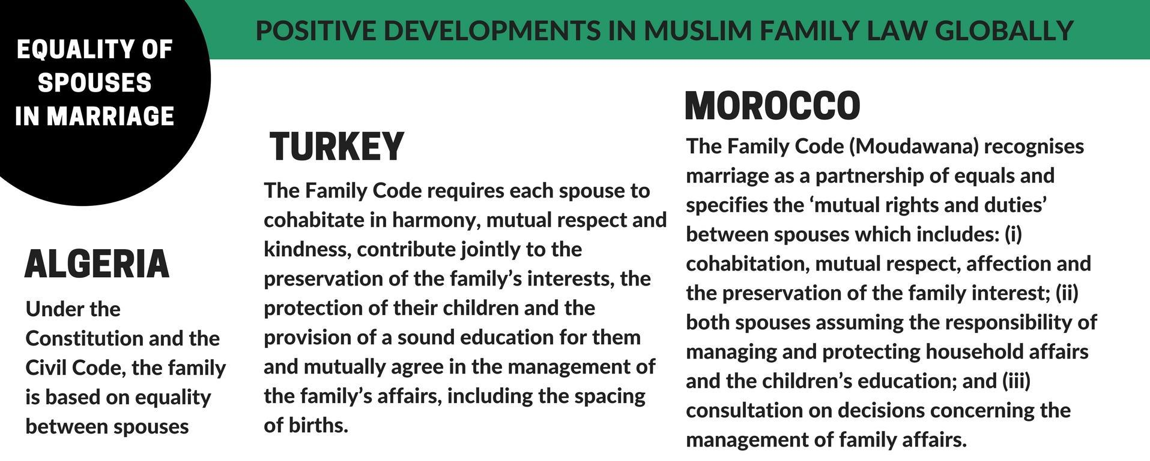

2. EARLY and child MARRIAGE

The minimum legal age for marriage is 16 for females and 18 for males as per Article 17 of the QFL. However, Article 17 also provides that girls and boys below 16 and 18 respective may marry after:
(i) the approval of their guardians; (ii) verification of the consent from both parties to the marriage contract; and (iii) the permission of a competent Judge.

There is no consistent criteria used to determine a judge’s interpretation of ‘proper’ justification to permit marriage for girls under 16; it is also unclear how a minor might consent to such a marriage. Further information is unavailable on how many marriages have been approved for girls below 16, the ages of husbands in said marriages, and the specific criteria used by judges to validate these marriages. The law does not stipulate an absolute minimum age below which a marriage may not be authorised. The minimum legal age for marriage is below the legal age of civil majority. Under Article 189 of the QFL, the legal age of civil majority is 18 for both females and males.

RECOMMENDATIONS

We recommend the CEDAW committee to urge the State party to:

- Enforce 18 years as the absolute minimum age of marriage for Muslim girls and remove all legal loopholes that allow for exceptions.

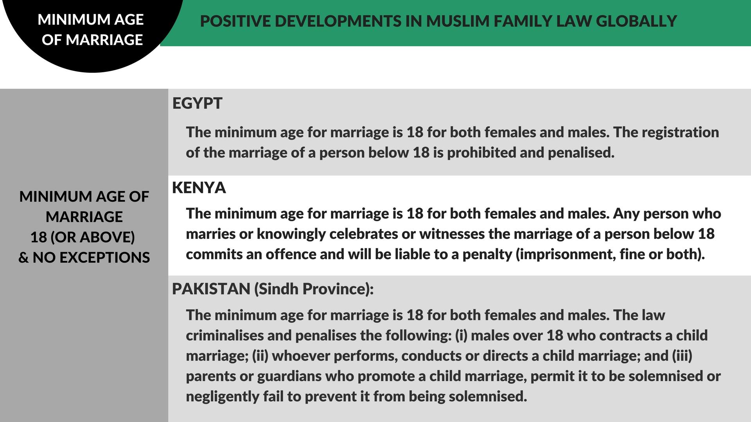

3. Women’s capacity to enter into marriage

Regardless of her age, a prospective bride requires the consent of a marital guardian (wali) to enter into marriage. The guardian must be Muslim and must be the prospective bride’s father followed by the agnate grandfather, son, full brother, paternal half-brother, full uncle and then paternal uncle.

If the guardian opposes the marriage, the prospective bride may seek the authorisation of a judge to get married. The judge may authorise the marriage after considering the suitability of the marriage and determining that the marriage is in the interest of the couple.

Pursuant to Article 53 of the QFL, both spouses may stipulate any condition in their marriage contract so long as the conditions: (i) are not inconsistent with the essence of marriage; and (ii) do not contradict Shari’ah or Qatari law. An aggrieved spouse may file for divorce for breach of a condition in the marriage contract.

Conditions that may be stipulated in the marriage contract to include:

- The wife must be allowed to continue to study or work;
- The husband cannot take another wife without the permission of the wife;
- The wife will not be required to accompany her husband on his travels;
- The husband and wife agree to jointly own assets acquired during the marriage;
- The wife is delegated the right to divorce (isma).

According to information from Qatari advocates, it is not common for a woman to bring a case to court to obtain permission to marry if her guardian objects to her marriage for fear of family or societal backlash.

RECOMMENDATIONS

We recommend the CEDAW committee to urge the State party to:
- Ensure women have an equal right to enter marriage without a guardian’s permission;
- Train and educate law enforcement officers, judges and, social workers to receive women’s complaints and provide them with required legal and social assistance.

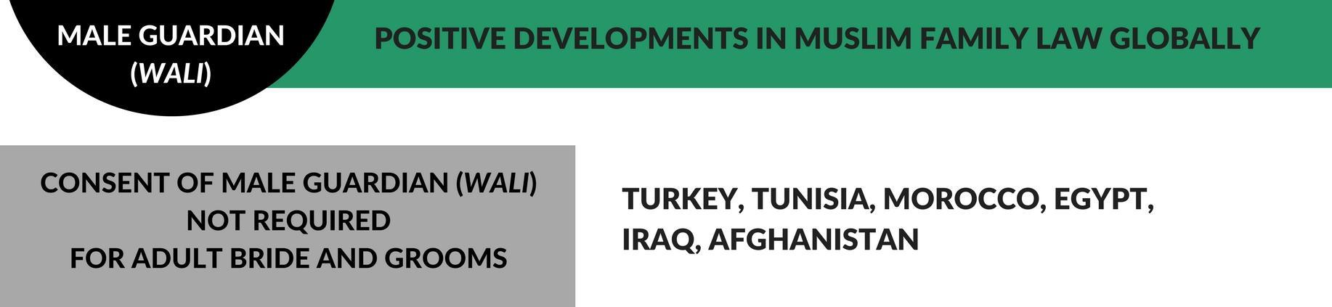

4. POLYGAMY

A Muslim man may marry up to four wives at one time without much restrictions. Article 14 requires a marriage registration officer (notary) to ensure that the new wife is aware of the husband’s financial capabilities before registering the marriage. If the husband and wife agree to proceed, the officer may not refuse to register the marriage. Article 14 also provides that in all cases, existing wives must be informed of the marriage after its conclusion. Article 25(2) prohibits a man from marrying more than four wives at one time. Article 57(6) requires that a husband treat multiple wives fairly.

Article 66 provides that the wife shall have no right to accommodate her children from another husband in her marital home, unless: (i) they have no custodian other than herself or they would be disadvantaged by parting with her; and (ii) the husband has agreed to that expressly or impliedly. However, Article 66 provides that the husband shall have the right to accommodate his parents and his children from other women with his wife in the marital home if he is responsible for their support, provided that she may not be disadvantaged. A woman may stipulate in the marriage contract that her husband may not take another wife. If the husband breaches this term of the marriage contract, the woman may seek judicial divorce.
According to information on the ground, it is not common practice for a woman to stipulate in the marriage contract that her husband may not take another wife because Shari’ah allows a man to have up to four wives at one time. This shall not prevent the wife to request divorce if she incurred damages arising out of such polygamous marriage.
Polygamy poses significant emotional, financial, and physical harm to women and families. Polygamy often results in inequality between wives; negative emotional consequences for both first and successive wives, as well as their respective children; economic difficulties; and greater levels of conflict and violence within families. Furthermore, the threat of polygamy can be used as a powerful means of control of the wife by the husband

RECOMMENDATIONS
We recommend the CEDAW committee to urge the State party to:
- Amend QFL to prohibit polygamy by Qatari Muslim men, following examples of other Muslim countries which have abolished the practice in the best interest of family well-being.

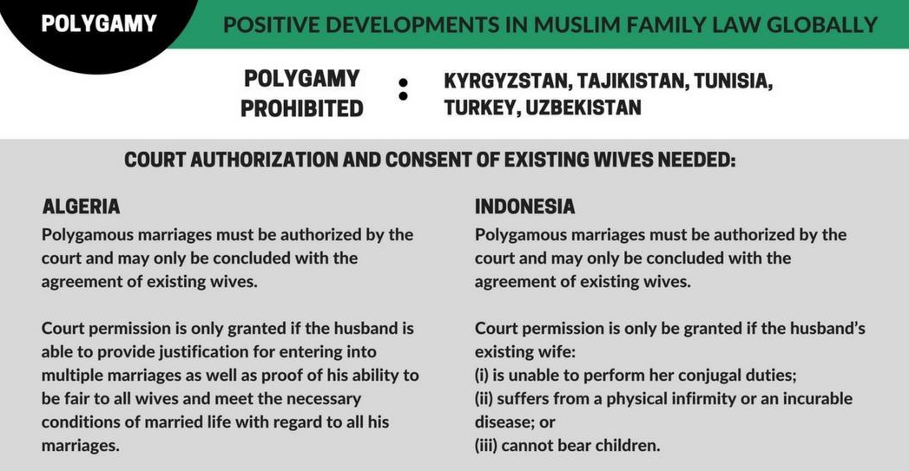

5. DIVORCE RIGHTS

The QFL provides for different mechanisms for divorce for husband and wife.

(i) Unilateral repudiation by the husband (talāq)
A husband may unilaterally repudiate a marriage, which may be which may be effectuated: (i) verbally or in writing; (ii) with or without reason; (iii) with or without the presence of the wife; and (iv) inside or outside the court room. If the husband wishes to pronounce the repudiation before a judge, the judge will attempt to reconcile the parties before the husband makes the pronouncement. If the husband pronounces the repudiation outside the court, the repudiation may be proved by evidence or admission and it must be communicated to the wife.

A husband may delegate his unilateral right to divorce to his wife (isma) through a stipulation in the marriage contract, thus permitting her to pronounce talāq upon herself (talāq-i-tafwid).

The registration of divorce is mandatory and a standard procedure must be followed. However, non-registration of a divorce does not necessarily invalidate the divorce. Pursuant to Article 113 of the QFL, a non-registered divorce may be proven by petition to a court and the wife must be informed.

(ii) Judicial divorce (fasah) by the wife

Valid grounds for seeking a judicial divorce by a wife include a husband’s: (i) non-payment of the dower (mahr) prior to consummation of the marriage; (ii) failure to provide maintenance; (iii) incurable or severe physical or mental illness; (iv) prolonged absence without reasonable excuse or disappearance; (v) imprisonment of more than two years (wife may seek divorce after one year); (vi) failure to copulate with his wife for more than four months (ila); (vii) act of comparing his wife with another woman with whom he is forbidden to marry (zihar); (viii) accusation under oath of adultery by wife (lian); (vii) failure to convert to Islam should he be non-Muslim.

In addition, a wife may seek divorce on the basis of detriment which makes it impossible for her to continue with marital life. In the case of a divorce petition based on detriment, if the claim of harm is proven and reconciliation between the spouses is impossible, the judge will grant a divorce and decide on the amount of compensation due to the wife. If the claim of detriment is not proven and the wife insists on her claim, the judge must appoint two arbitrators (one from the husband’s family and one from the wife’s family) who will attempt to reconcile the couple. If reconciliation is impossible, the arbitrators will submit a report to the judge on their attempts to reconcile the couple and their opinion on the extent to which each of the spouses contributed to the breakdown in the marriage. The judge will then review the report and either appoint two new arbitrators to start the reconciliation afresh or a third arbitrator to assist the existing two or proceed to make the appropriate ruling.

Generally, if the source of the dispute is:
- The husband, shared or cannot be determined, the judge will grant a divorce without property to be given by one party to another;
- The wife, the judge will grant a divorce with the appropriate value of property to be given by the wife to the husband as determined by the judge.

RECOMMENDATIONS
We recommend the CEDAW committee to urge the State party to:

- Amend the QFL to ensure that men and women have the equal right to divorce, including the grounds for and procedures in obtaining divorce;
- Procedurally divorce must only be obtained through court authorization.

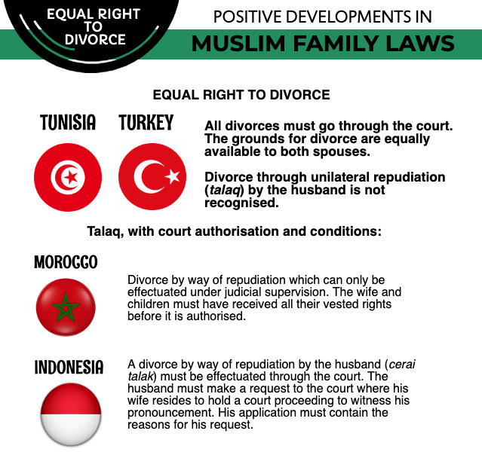

6. GUARDIANSHIP OF CHILDREN

The QFL is silent on the person with the priority right to guardianship of the children in a marriage. Nevertheless, it is implied in the QFL that the priority right to guardianship of the children belongs to father through various provisions as follows:

- Article 26 of the QFL provides that the matrimonial guardian shall be the father followed by the paternal grandfather and thereafter a line of male relatives as stipulated in the law;
- Article 75 provides that the father is responsible for child support. Article 178 provides that the mother is entitled to a custody payment upon divorce from the guardian until her custody of a daughter’s terminates. The amount of such payment is to be calculated based on the status of the guardian of the child under custody and the custodian;
- Article 170 allows judges to consider the interests of the child in allowing custody to remain with the mother upon her remarriage;
- Article 171 provides that the mother must allow the guardian or agnate to perform his duties as a guardian to supervise the good upbringing of the child and protect him from wrongdoing, and to provide the best medication and education to prepare him for his future;

- Article 176 provides that the guardian of the child may retain the child’s passport. However, the mother must be given the passport when she wishes to travel with the child. A judge may order that the mother be granted the right to keep the passport if it is likely that the father may not provide her with the passport in a timely manner when needed;
- Article 180 provides that the child must reside in the country of the guardian, unless the mother is a foreigner;
- Article 183 provide that guardianship will cease if the father or guardian of the child cannot discharge his duties of supervision, education and schooling towards the child under custody by reason of the custodian taking the child, without permission of the guardian, to reside with her in a country which is difficult to reach, unless the court deems the interest of the child requires otherwise.
According to activists, in practice mothers are often granted the right to custody. This demonstrates that the courts have a lot of power and can overcome the laws if they use *children's welfare* as a reasoning. However, this may be a reflection of the gender stereotypes that assume mothers will be better caregivers. It is thus important to improve the awareness and knowledge of judges and to have more female judges in courts.

It must be noted that no data is available on how many women with young children remarry after divorce; how often mothers lose custody of their children upon remarriage; how often judges are called to consider the ‘best interest’ of the child; and whether specific, consistent, and fair criteria is used by judges to determine the ‘best interest.’ Furthermore, there is no evidence of sound sociological research that justifies the assumption that a mother’s remarriage sufficiently challenges the ‘best interest’ of the child.

RECOMMENDATION
We recommend the CEDAW committee to urge the State party to:
- Recognize that both men and women under the Shari’ah- based law should have equal rights with respect to their children;
- Article 26 and 178 of QFL should be amended to grant equal rights of legal guardianship to both mothers and fathers based on the best interest of the child regardless of mother’s marital status;
- Improve gender sensitivity training of judges and implement a scheme for more female judges to enter the judicial profession.

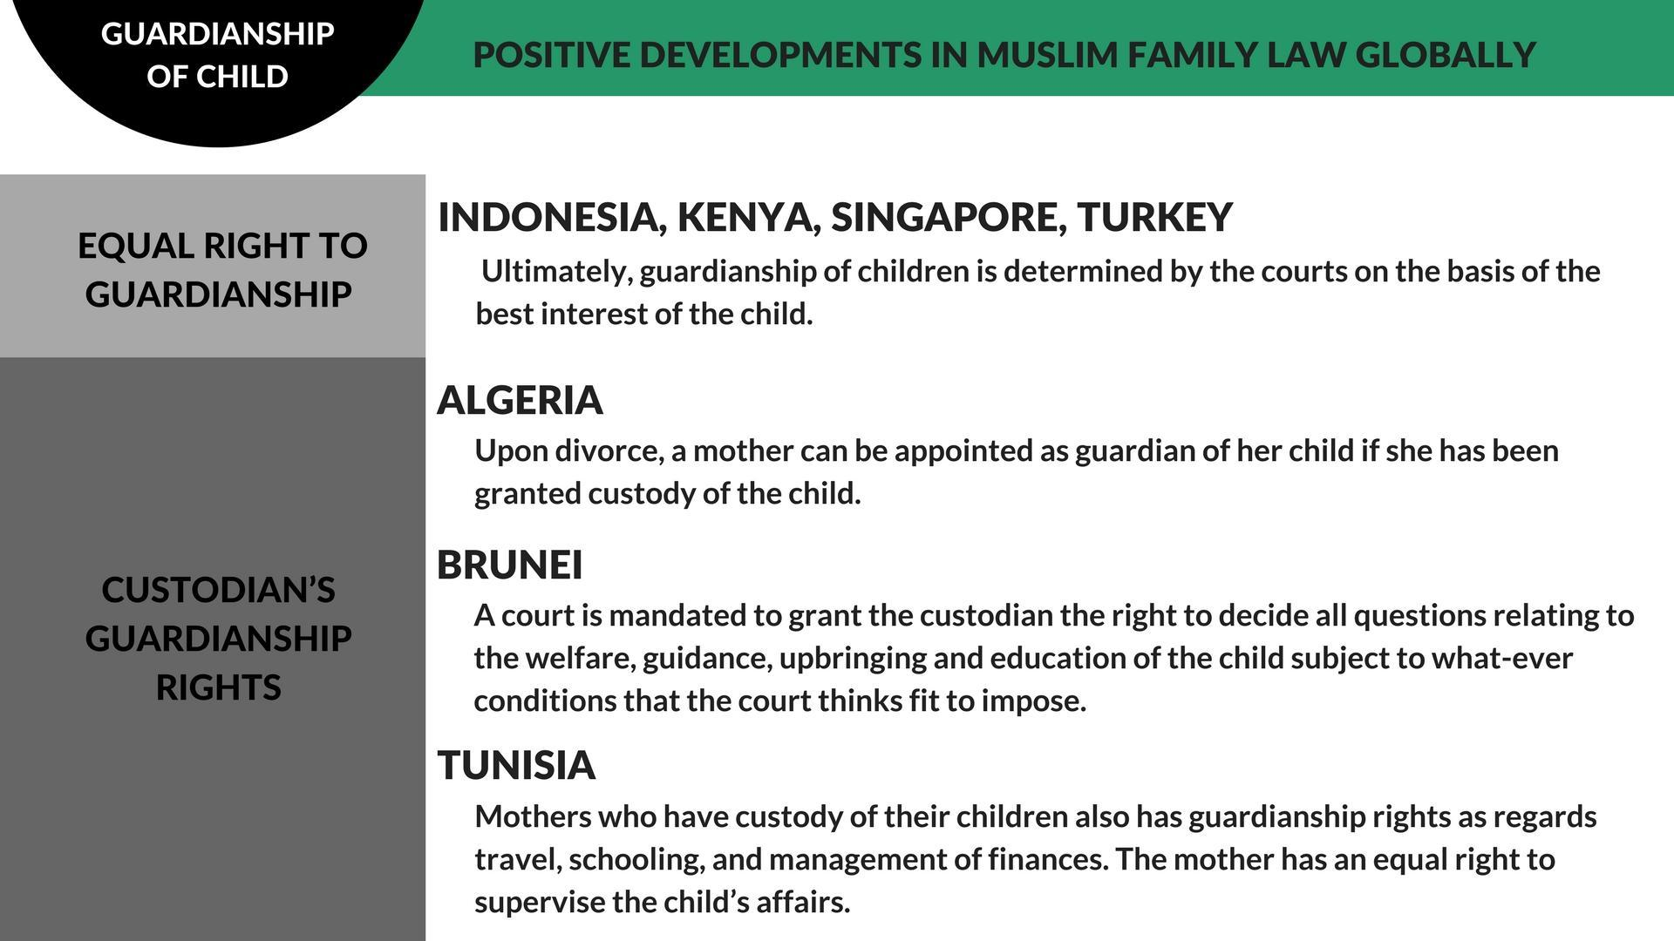

Annexe 1: justification for reform

Equality in marriage

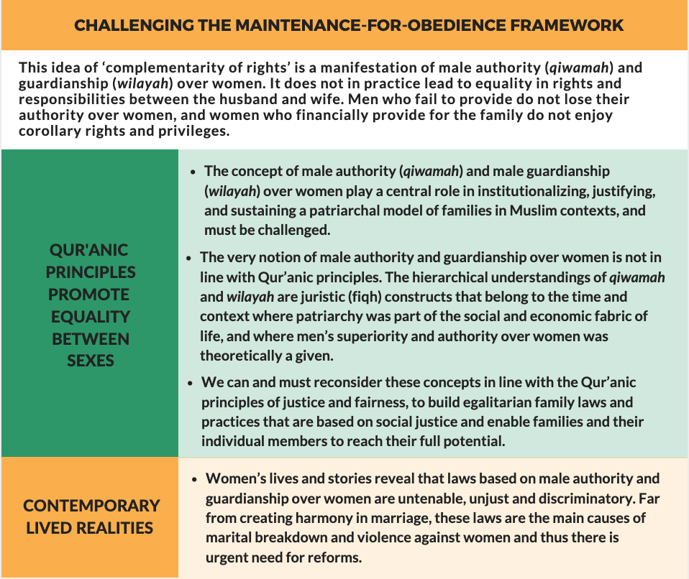

Minimum age of marriage as 18 years

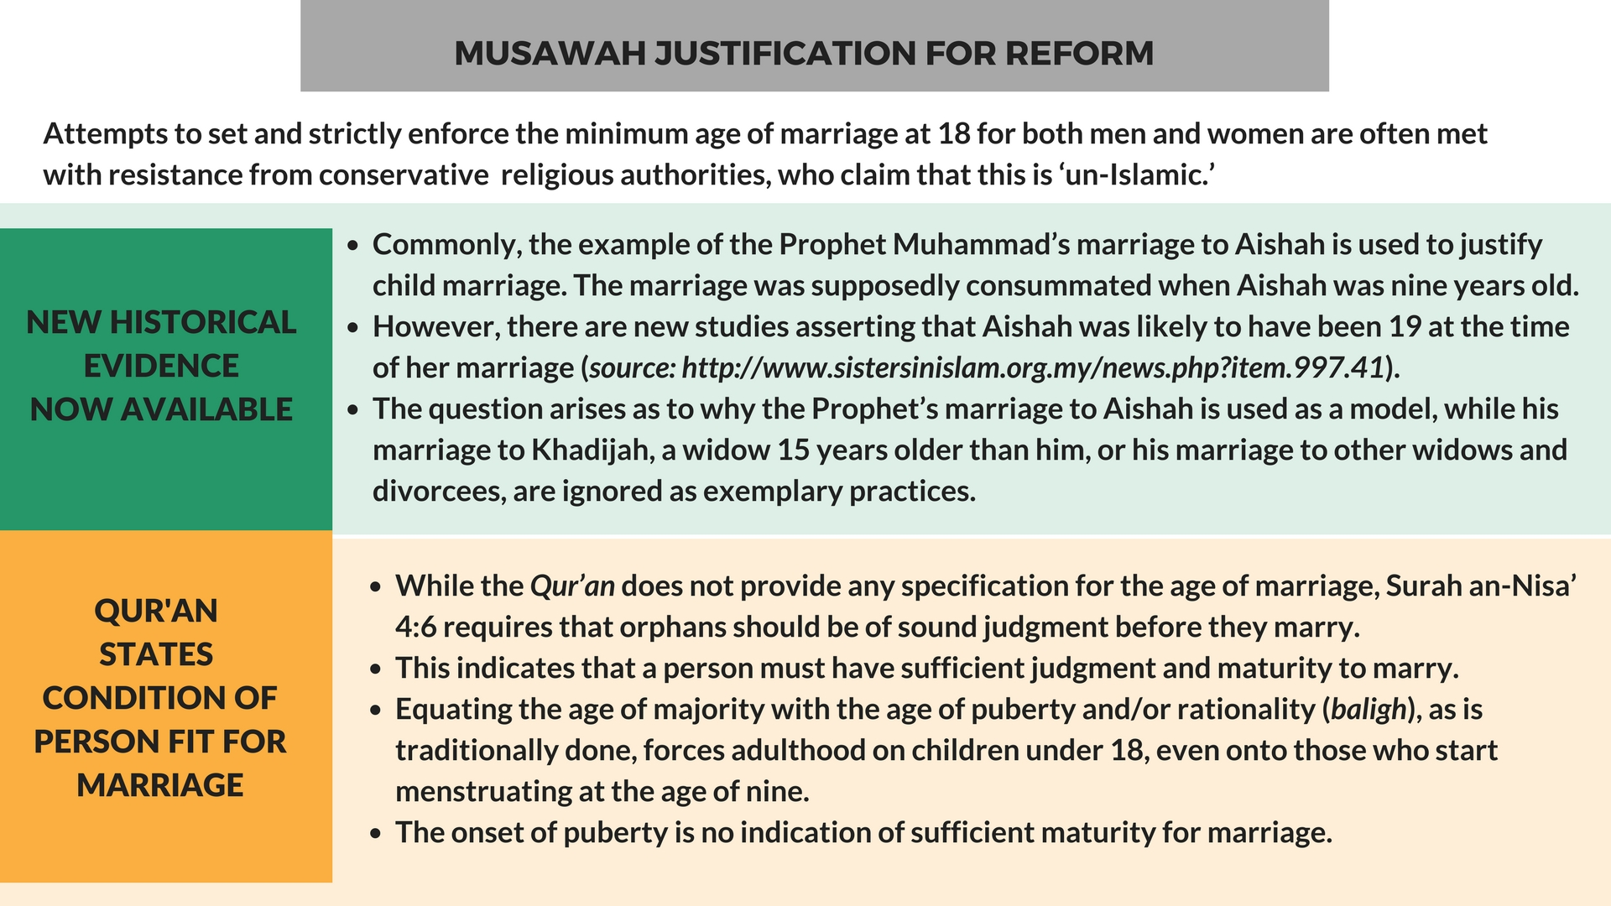

Women’s equal capacity to enter into marriage

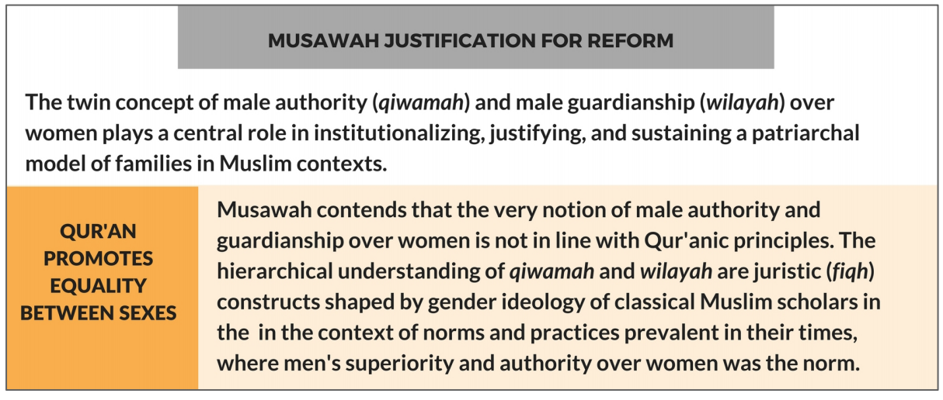

Abolishment of polygamy
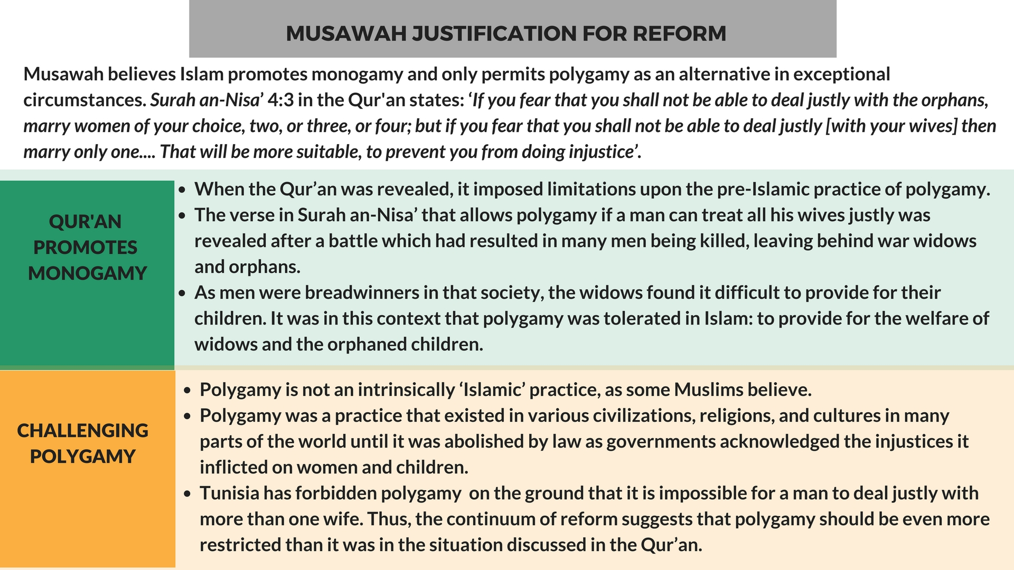

Fairness and equality in divorce
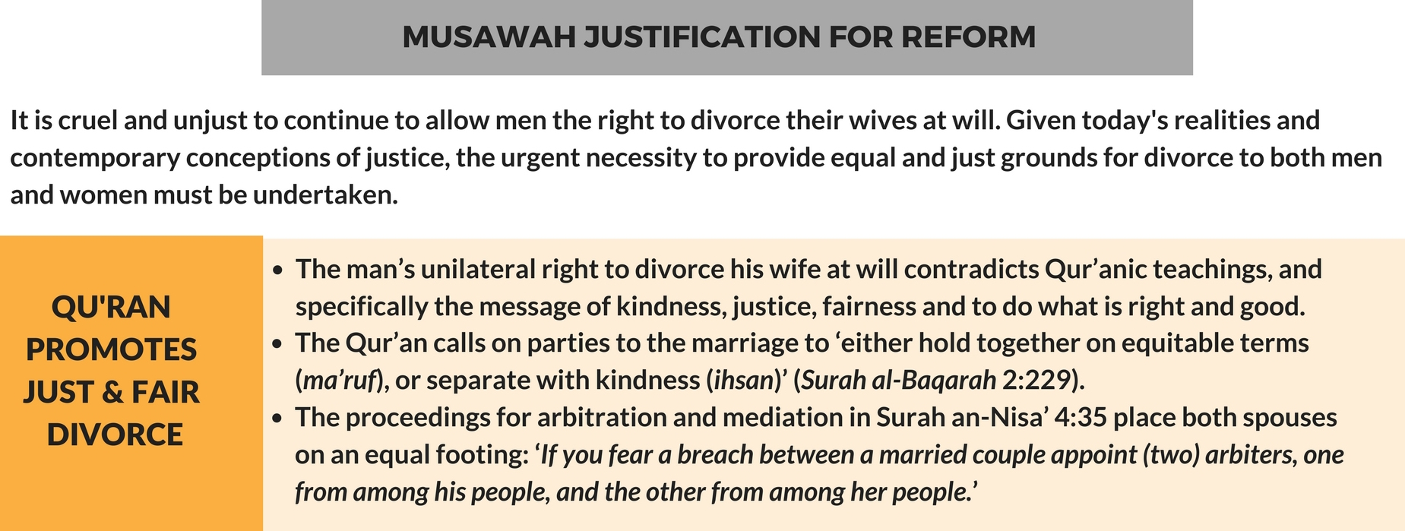

Annexe 2: MUSAWAH VISION for the family
Musawah asserts that in the twenty-first century, there cannot be justice without equality. Many provisions in Muslim family laws, as defined by classical jurists and as reproduced in modern legal codes, are neither tenable in contemporary circumstances nor defensible on Islamic grounds. Not only do these family laws fail to fulfill the Shari’ah requirements of justice, but they are being used to deny women rights and dignified choices in life. These elements lie at the root of marital disharmony and the breakdown of the family.
Musawah believes that Qur’anic principles and the richness of the Islamic juristic tradition enable us to formulate Muslim family laws today that are egalitarian and reflect the needs of contemporary societies. Islamic teachings and universal human rights standards, including the CEDAW Convention, are fully compatible and are dynamic and constantly evolving, based on changing times and circumstances. Inspired by the Qur’anic vision of justice and gender relations, Musawah contends that gender equality and non-discrimination can only be achieved with laws that transform power relations in the family and in society in the direction of just outcomes.
It is our hope that the CEDAW Committee will encourage Governments everywhere, and particularly those purporting to speak for and in the name of Islam and Muslim communities, to:
- Recognize the diversity of opinions, laws and practices in the Muslim world and the growing scholarship in Islam that recognizes equality and justice and the possibility and necessity for reform of Muslim family laws today.
- Promote human rights standards as intrinsic to the teachings of Islam, national guarantees of equality and non-discrimination, and the lived realities of men and women today.
- Encourage open and inclusive public debate regarding diversity of opinion and interpretations in Muslim laws and principles relating to family laws and practices.

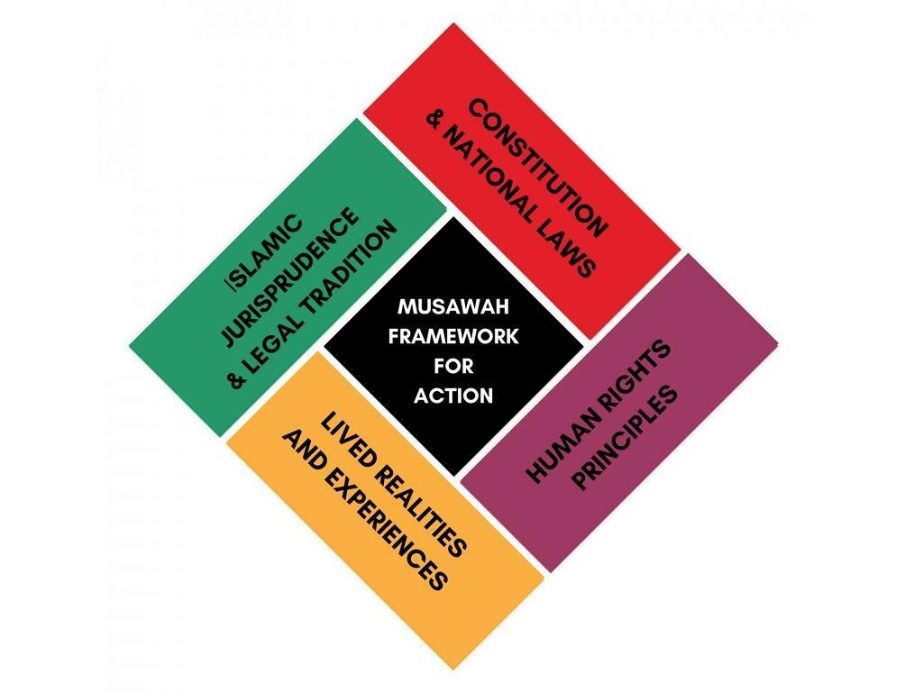

World Population Reviews – Qatar http://worldpopulationreview.com/countries/qatar-population/
Constitution of the State of Qatar (2005) http://www.parliament.am/library/sahmanadrutyunner2019/Qatar.pdf
Family Law (2006), http://www.rwi.uzh.ch/oe/cimels/law/countries/qatar/Law_22_2006_2558.pdf
Articles 3, 4 of the Family Law (2006), http://www.rwi.uzh.ch/oe/cimels/law/countries/qatar/Law_22_2006_2558.pdf
Article 4 of the Family Law (2006), http://www.rwi.uzh.ch/oe/cimels/law/countries/qatar/Law_22_2006_2558.pdf
United Nations Treaty Collection Website, https://treaties.un.org/Pages/ViewDetails.aspx?src=TREATY&mtdsg_no=IV-8&chapter=4&clang=_en
CEDAW Committee Concluding Observations on Qatar 2014 – CEDAW/C/QAT/CO/1 https://tbinternet.ohchr.org/_layouts/15/treatybodyexternal/Download.aspx?symbolno=CEDAW%2fC%2fQAT%2fCO%2f1&Lang=en
Second periodic State Party report submitted by Qatar to the CEDAW Committee CEDAW/C/QAT/2 https://tbinternet.ohchr.org/_layouts/15/treatybodyexternal/Download.aspx?symbolno=CEDAW%2fC%2fQAT%2f2&Lang=en
Articles 9, 56-58, 61, 69 of the Family Law (2006), http://www.rwi.uzh.ch/oe/cimels/law/countries/qatar/Law_22_2006_2558.pdf
Second periodic State Party report submitted by Qatar to the CEDAW Committee CEDAW/C/QAT/2 https://tbinternet.ohchr.org/_layouts/15/treatybodyexternal/Download.aspx?symbolno=CEDAW%2fC%2fQAT%2f2&Lang=en
Article 17 of the Family Law (2006), http://www.rwi.uzh.ch/oe/cimels/law/countries/qatar/Law_22_2006_2558.pdf
Article 189 of the Family Law (2006), http://www.rwi.uzh.ch/oe/cimels/law/countries/qatar/Law_22_2006_2558.pdf
Article 26 of the Family Law (2006), http://www.rwi.uzh.ch/oe/cimels/law/countries/qatar/Law_22_2006_2558.pdf
Articles 27, 29 of the Family Law (2006), http://www.rwi.uzh.ch/oe/cimels/law/countries/qatar/Law_22_2006_2558.pdf
Article 53 of the Family Law (2006), http://www.rwi.uzh.ch/oe/cimels/law/countries/qatar/Law_22_2006_2558.pdf
Qatar State party report, U.N. Doc. CEDAW/C/QAT /1 (2012), paras. 421, 425, 438, http://www.ohchr.org/en/hrbodies/cedaw/pages/cedawindex.aspx
Information obtained from Qatari advocate, April 2017
Article 14 of the Family Law (2006), http://www.rwi.uzh.ch/oe/cimels/law/countries/qatar/Law_22_2006_2558.pdf
Article 25(2) of the Family Law (2006), http://www.rwi.uzh.ch/oe/cimels/law/countries/qatar/Law_22_2006_2558.pdf
Article 57(6) of the Family Law (2006), http://www.rwi.uzh.ch/oe/cimels/law/countries/qatar/Law_22_2006_2558.pdf
Article 66 of the Family Law (2006), http://www.rwi.uzh.ch/oe/cimels/law/countries/qatar/Law_22_2006_2558.pdf
Article 53 of the Family Law (2006), http://www.rwi.uzh.ch/oe/cimels/law/countries/qatar/Law_22_2006_2558.pdf; Qatar State party report, U.N. Doc. CEDAW/C/QAT /1 (2012), para. 421, http://www.ohchr.org/en/hrbodies/cedaw/pages/cedawindex.aspx
Information obtained from Qatari advocate, April 2017
Articles 106-117 of the Family Law (2006), http://www.rwi.uzh.ch/oe/cimels/law/countries/qatar/Law_22_2006_2558.pdf
Article 109 of the Family Law (2006), http://www.rwi.uzh.ch/oe/cimels/law/countries/qatar/Law_22_2006_2558.pdf
Article 113 of the Family Law (2006), http://www.rwi.uzh.ch/oe/cimels/law/countries/qatar/Law_22_2006_2558.pdf
Information obtained from Qatari advocate, February 2017
Article 113 of the Family Law (2006), http://www.rwi.uzh.ch/oe/cimels/law/countries/qatar/Law_22_2006_2558.pdf
Article 123-128, 137-143-155 of the Family Law (2006), http://www.rwi.uzh.ch/oe/cimels/law/countries/qatar/Law_22_2006_2558.pdf
Article 129 of the Family Law (2006), http://www.rwi.uzh.ch/oe/cimels/law/countries/qatar/Law_22_2006_2558.pdf
Article 129-134 of the Family Law (2006), http://www.rwi.uzh.ch/oe/cimels/law/countries/qatar/Law_22_2006_2558.pdf
Articles 26, 75, 171, 176, 178, 180, 183 of the Family Law (2006), http://www.rwi.uzh.ch/oe/cimels/law/countries/qatar/Law_22_2006_2558.pdf

