Adriana Tontsch
Sandäckerstraße 19
90537 Feucht
Germany

E-Mail:
adrianatontsch1@gmail.com

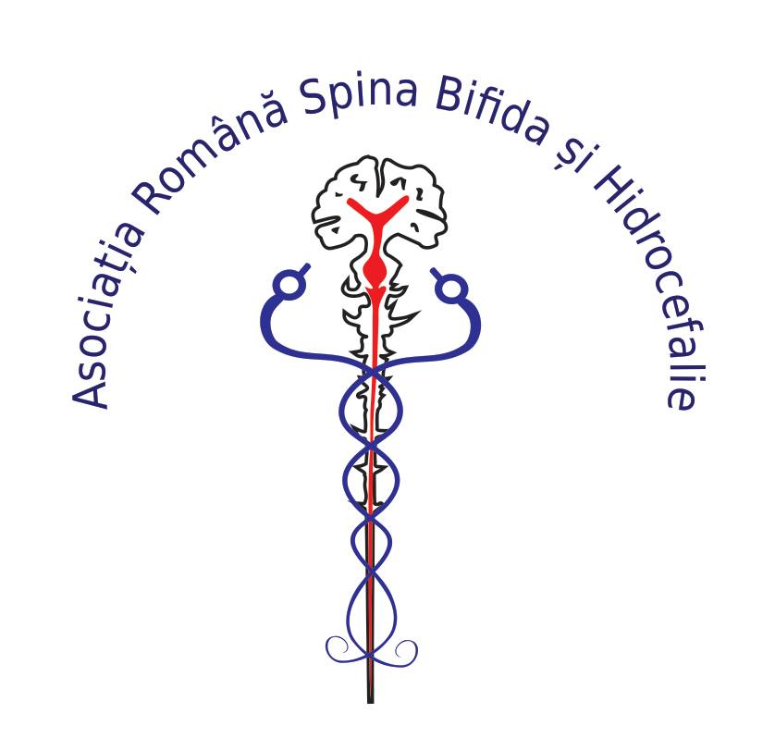

Association for Spina Bifida/Hydrocephalus in Romania
Represented by Adriana Tontsch
Founder and president

Report to the Committee on Economic, Social and Cultural Rights.
Date: 02.09.2021

Cristian
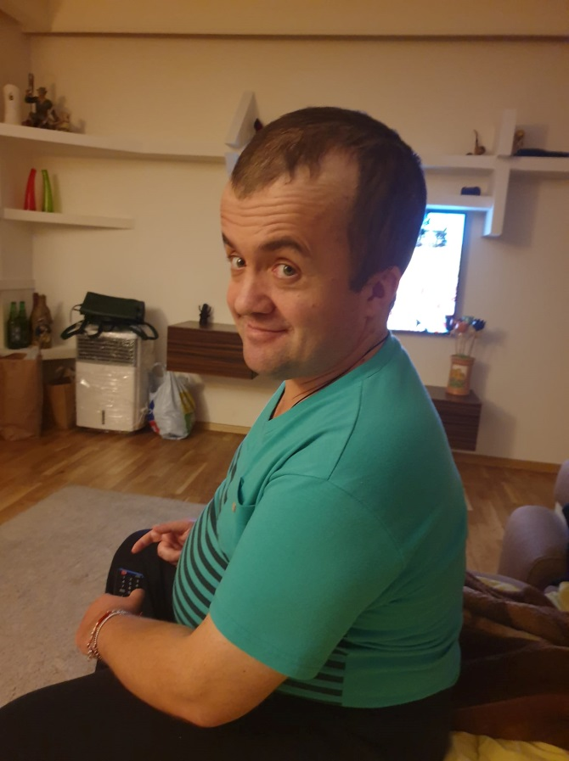

„My expericnce with the health care system was hard and dificult. When I was born, the medical staff told my parents to let me die because I am disabled and only „vegetable”. This is the usual discrimination and insult for us people with Hydrocephalus and or spina bifida. Also the family made pressure on my parents to abandon me. However, despite all the discrimination we are fighters and managed the insults like”thickhead”,” cripple” or huge queuing. We made and paid tests in private hospitals many years. This was my only chance to survive . My parents and my sister made great efforts to earn enough money and to cover the costs.
Unfortunately, under current circumstances and I refer here in particular the health system in Romania, we have no chance to have a normal life.
People make fun of us, because of our disability. No priorities for persons with disabilities in the hospitals, no specialized centers but we need special counseling and psychological support for us and our family. Every year we have to go to the commission for social services in order to obtain a disability certificate for social welfare benefits.
There are no specialized centers for treatments and there it is a need for psychological counseling for both parents and people with disabilities.”

Table of content

Introduction 2
Right to health 2
Social protection 5
Education 7
Employment 10

Introduction
ARSBH is an apolitical, non-governmental, non-profit organization with legal status.
FUNDAMENTAL GOAL: Improve the health of children born with spina bifida and hydrocephalus in Romania
This report from the Association for Spina Bifida and Hydrocephalus in Romania has been made on behalf of persons with spina bifida and Hydrocephalus, parents with children diagnosed with this conditions and associations of parents with rare diseases.
This report informs the Committee on Economic, Social and Cultural Rights about issues related to the situation of persons with disabilities in Romania, especially about the children and adults with spina bifida and hydrocephalus.
The focus of this report reflects practices that impact the lives of persons with disabilities regarding the access to health, social protection, education and employment. There are significant concerns and common barriers experienced by persons with disabilities and parents.

Right to health:
Health care in Romania is considered as one of the Europe’s worst. Scarce resources, lack of interest and ignorance by politicians and government have resulted in failing medical care. “The budget for health care for 2019 was 49,65 billion RON (over 10,5 billion Euro). Romania has the lowest budget for healthcare among the EU member state”.
Romania has the highest child mortality in the European Union. In 2018 there were 6.0 deaths per 1,000 births registered.
The law 448/2006, regarding protection and promotion of the rights of persons with disabilities, Chapter II, Rights of persons with disabilities, part 1, Health and rehabilitation, Article 10, ensure that “persons with disabilities receive free medical assistance, inclusive free drugs, both outpatient treatments as well as during hospitalization, under the health insurance system, under the condition of framework contract”.
According to the law persons with disabilities in Romania benefit from free medical assistance, recovery treatment and drugs. Nevertheless, disabled persons lack access to health care services. The costs for indispensable medicine, assistive technology, computed tomography, magnetic resonance tomography, screening, rehabilitation therapy, psychotherapy have to be paid by persons with disabilities or family. Many persons have no access to medical services because these are unaffordable. Since 2005 the Association for spina bifida and hydrocephalus in Romania provided and donated to the hospitals over 1,500 shunts and system drainage, paid for computed tomography, magnetic resonance tomography and assistive technologies.
Health inequities experienced by persons with disabilities especially the children and adults with spina bifida and hydrocephalus, their parents or families.
- cost of drugs and services
- insufficient health care funds
- lack of information regarding health care services and treatment
- stigma and dehumanization of persons with disabilities, especially children with spina bifida and hydrocephalus by medical staff.
- staff attitude
- communication barriers
- insufficient or absence of equipment
- poor or inadequate contact for referral to specialists and rehabilitation services
Specific comments and advices were made regarding the health status of the newborn with spina bifida and hydrocephalus. A large number of parents reported in detail what the physicians communicate about the diagnosis and their child:
- Your child has to be placed in an institution to die
- Your child will be his whole life a vegetable
- Let your child die
- Your child is a monster
- Let your child here in the hospital to die
- Go home and produce another child
- The state pay too much money for a vegetable like your child

All this aspects have relevant impact on child live, health and development. The treatment, in many cases is made too late when irreversible damage to the brain has already occurred. The method to communicate the diagnosis and the inappropriate behavior regarding suggestion and recommendation for no treatment is for many parents frustrating.
Question for State Party
- Please provide information on necessary measures to guaranty the access to health services for persons with disabilities in Romania, especially for children and adults with spina bifida and hydrocephalus.
- What steps are being taken to forbid discrimination based on disability by health care providers?
- Please explain measures to prohibit stigma and dehumanization among medical staff by children with spina bifida and / or hydrocephalus.
- What actions is the State Party taking to reduce waiting list and address the consequences of delays on children’s health effects and quality of life?

Assistive technologies are another financial burden for persons with disabilities and their families. The costs for assistive technologies affect considerable the small budget of the families. Only a little part of the costs is covered by the statutory health insurance.
The persons with disabilities and parents complained about the support of basis assistive technologies. The assistive technologies are partially available but the government funds them partially.
Significant issues:
- Waiting list to obtain assistive technology such as wheelchairs, shoes, or orthopedic products.
- Limited selection or poor quality of the products by all three categories of assistive technologies.
- Many assistive technologies can only be provided by private companies
- Government funds the assistive technology partially or not funds.
- Government support on assistive technologies is often inadequate and bureaucratic
- The Romanian health system provides physiotherapy in clinical departments, special outpatient departments and private rehabilitation institution and rehabilitation at home.

Access to rehabilitation services
Rehabilitation services cause additional expenses by persons with disabilities and their family. Rehabilitation services offered by public and private institution reveal significant discrepancy between them. Several numbers of affected persons expressed that they discontent with the services offered by public institutions. The service quality is described as inadequate, insufficient, and expensive. The staff is not highly qualified and there is lack of knowledge and interest.
Scare resources, poverty, lack of knowledge, inadequate infrastructure, inadequate and inaccessible transport are also factors that reduce access to health services.
Question for State Party
- How will the Romania Government ensure all children and adults with disabilities receiving assistive technologies and rehabilitation therapies free of charge according to the law?
- How will the Romania Government regulate that health services are sufficiently funded in order to support persons with disabilities and their needs are accomplished in time and effective way?
- Please provide information what assessments has been made of the impact of health services costs including rehabilitation programs and assistive technologies assumed by persons with disabilities and their families.

Social protection
Romania still faces difficulties in organizing a real and efficient system of social services that respond to the needs of citizens.
Adults and children with disabilities receive monthly support. The monthly allowance is very low and the persons with disabilities are at risk of poverty.
According to the European Semester Report-Country Report Romania 2020” Child poverty in Romania remains among the highest in the EU, affecting 38.8% of children compared to an EU average of 24%.

The montly allowance:
- RON 350 (circa 71 Euro) for an adult with a severe disability;
- RON 265 (circa 54 Euro) for an adult with a profound disability.
The monthly complementary personal budget is:
- RON 150 (circa 31 Euro) for an adult with a severe disability;
- RON 110 (circa 23 Euro) for an adult with a profound disability;
- RON 60 (circa 13 Euro) for an adult with a medium disability.

The family or statutory representative of a child with a severe, profound, or medium disability also receives a complementary personal budget for as long as they care for, look after and maintain the child, equal to:
- RON 300 (circa 61 Euro)for a child with a severe disability;
- RON 60 (circa 13 Euro) for a child with a medium disability.
- Allowance as an alternative to the personal assistant (indemnizație de însoțitor)
- RON 175 (circa 36 Euro) for a child with a profound disability;

An adult with a severe disability can choose between having a personal assistant and receiving an allowance. The personal assistant may receive a net salary paid from public funds starting from RON 1,263 (circa 256 Euro) based on an individual labor contract. The amount of the allowance also amounts to RON 1,263 (circa 256 Euro)
The main issues met by persons with disabilities are financial difficulties, medical evaluation commission and lack of support.
The persons with disabilities and personal assistant receive the monthly allowance usually from the town hall in the county. Many town halls have not enough financial funds to pay for them. Therefore, numerous persons with disabilities not received their allowance. The same situation is also by the personal assistant, no salary and many are unemployed. The consequences for persons with disabilities are feared.
Many mayors are overstrained with the budget and expect to receive the financial funds as the law as require. The budget is distributed from the government.
In Romania social services and benefits are granted in agreement with the category and type of disability. The certificate of the disability is issued after a complicated evaluation based on different criteria such as medical, social, and psychological aspects.
Spina Bifida and hydrocephalus is a disease classified as incurable, rare and one that should be managed throughout life as a chronic condition. Many parents expressed their dissatisfaction regarding social protection. Most of them described the evaluation commission not only as excessive bureaucracy but also with negative experiences such as humiliation, insults, they spend too much time for the documents, desperation, fears, anger and poverty. There are only a few that were forced to address their rights by the court for justice. Most of them renounced to get any social benefits because of the excessive bureaucracy, lack of knowledge and poor financial situation.
Question for State Party
- Please provide information on measures to ensure the financial benefits for children and adults with disabilities.
- How will the Romania Government protect and support the needs of children with special needs and disabilities?
- Please explain how children and adults with disabilities affected by poverty will be protected and supported.
- Please provide information on short break services for parents or other people they care for children with disabilities.

Education
Law no 448/2006 „regulates the rights and obligation of disabled persons granted for the purpose of their social integration and inclusion”.
Art. 16. –
(1) The education of disabled persons shall be an integral part of the national
education system, coordinated by the Ministry of Education, Research and Youth.
(2) The education of disabled persons shall be made through:
a) special education units;
b) the individual integration in mass educational units, including in units teaching in the language of national minorities;
c) compact special classes or groups, integrated in mass school and pre-school units;
d) educational services through support/itinerant teaching staff;
e) domicile school education until the graduation of high school studies, but not later than the age of 26, by the care of the Ministry of Education, Research and Youth;
f) "hospital bed" education during hospitalization;
g) educational alternatives.
Based on the official statistics (Ministry of Labor and Social Protection, Ministry of Education and Research) in Romania are over 70,000 children with disabilities. Many of them do not attend schools. 29,433 of every 70,000 children with disabilities are enrolled at schools acording to data of Ministry of education.
There are just 1,358 support teachers for all that children. Many counties have only one support teacher for 150 disabled children.
In Romania, due to the law, the children with disabilities have access to different form of education decided by the type and degree of disability, in special education system or mainstream education. Special education is structured according to the type of disability. The attestation of the type and degree of disability is regulated by the Child Protection Commission. The Child Protection Commission is an institution subjected to the county councils.

(4) The access to educational units of disabled children, including of the children with a handicap, and of those with school adaptation difficulties shall be made by the decision of the child protection commission, which issues the school and/or professional orientation certificate, based on the complex evaluation report drafted by the complex evaluation service within the county or Bucharest municipality sectors general social assistance and child protection divisions.

Parents are playing an important role by the decision what type of education their children will receive. The choice between inclusive education and specials schools is made by parents. The right option which types of school parents choose for their children is depending on many factors like child’s special needs, personality, learning skills, strengths, weakness, etc. In Romania, additional factors contribute to a decision against special schools because shame, lack of knowledge, fears, poverty, old and stagnant beliefs, and extremely weak quality of education.
The right to inclusive education for children with disabilities in mainstream schools is granted by the low.
Many parents reported about issues regarding dificulties by the application for kindergarten and schools. The mainstream schools and kindergarten are not prepared and willing to grant accessibility for children with disabilities.
Inclusive education for children with disabilities still remains a great bitterness for parents and children. The system used different methodologies to segregate and select them.
The children with special needs, especially the children with spina bifida are confronted with many obstacles by access to education:
- Lack of transportation facilities
- Lack of equipment (elevator)
- Lack of social services
- Lack of training for teachers to better understand the needs of children with disabilities and issues caused by disabilities.
- Many of them are not accepted by pupils and teachers

The most barriers identified are physical and psychological.
Many parents and children experienced discrimination day to day. They are rare realized that what is happening is against the law and feel unable to do something about it. Schools are public institution and forced by the law to take reasonable measures to eliminate physical barriers that disable children might have when they visit the school.

Physical barriers: steps, stairways, curbstone, toilets and washing facilities and lifts.
Psychological barriers: hostile attitude, beliefs, misconceptions, prejudices, lack of information.

Physical accessibility to schools for children with spina bifida doesn’t really exist. Many children with spina bifida experience incontinence, bowl and bladder. This aspect of health has an important influence on the quality of life and affects their social life. Lack of facilities and needs in the school can limits them from participation effectively in social activities. Children with continence problems necessitate unlimited access to adequate toilet facilities during the day in the school. Inadequate toilet facilities and limited access have a great impact on children’s education, development, and health. Because of lack of inadequate toilets in the schools, many children are not able to manage the continence issues in the bowl and bladder.

The possible social effects on children are disastrous:

- stigma associated with loss of urine or feces when bladder or bowl control happened especially in public. The consequences of this inaptitude to keep control over their continence marks the children and their well- being. Feelings like shame and discomfort often dominate the daily life. In many cases, the classmate’s reaction related to this unpleased experience might subject the child with incontinence to hostility, to laugh, isolation and marginalization.
Those children are not only stigmatized but also discriminated and dehumanized due to the cultural virtues and rules:
- Limitation on social contacts
- Limitation on social activities
- The academic potential could be at risk
- Interrupting learning
- Social isolation
- The risk to abandon school
Possible health effects being wet or soiled:
- Skin problems
- Pressure wounds
- Overloaded bowl
- Kidney damage
- Infections

Children or young people with special needs require special arrangements and assistance. They must be treated with respect, dignity and their privacy. The arguments clearly show that the children with spina bifida that attend the school have no adequate facilities. In concrete terms, they are forced to stay for hours wet and soiled in the school.

Question for State Party
- What plans are in place to improve adequate toilet facilities for children with spina bifida?
- Please provide information on support children’s health and wellbeing in schools, especially for children with spina bifida regarding special arrangements and assistance.
- What action will Romania take to ensure transportation facilities for children with physical disabilities?
- Please explain measurements to prohibit selection and segregation of children with disabilities including addressing fundamental inequalities stemming from educational system.

Employment:
In Romania are living over 800,000 (70,000 are children) persons with disabilities. In 2017 the rate of employment of persons with disabilities was 3,59%. Romania is the countrie with the lowest rate of employment of persons with disabilities in the European Union.
According to data of Autoritate Nationala pentru Drepturile Persoanelor cu Dizabilitati(ANDPDAC) only 17% of persons with disabilities in Romania are employed. The available statistics shows that only 43,000 persons with disabilities have ajob. Taking into account that the number of persons with disabilities registered are 826,000, over 417,000 have the employment age and of those, 167,000 persons were registered with a hadicap degree I and II and not able to work. In conclusion, only 17% of them are employed.

Timea
„I am 32 years old and have hydrocephalus. I finished the medical pharmacy school. But I never worked in this sector. I worked as an entry operator, processing and validation data, receptionist, distributor and operator for computers and network. I am searching for a job for the last two years. I also have been waiting five years to find a job. When I worked, I was employed only for a short period which means a few months.When I go for an interview to same companies, the persons responsible for human resources pretend I never was there. I never had the chance to work in my sector for whom I was trained because nobody wanted to occupy me. Now, if I want to make a new application in my sector, I have to be re-certified and need an internship for three months. The certificate is valid for just four years. I went to school for nothing. At the moment I am not employed. My request is: the employers not to discriminate us disabled persons and to employ correct and not based on connection.

Question for State Party
- How will the Romania Government protect and support persons with disabilities affected by unemployment?
- What steps are being taken to integrate persons with disabilities into the labor market?
- Please explain measures to prohibit discrimination against persons with disabilities on labor market.

https://www.oecd-ilibrary.org/docserver/f345b1db-en.pdf?expires=1630324047&id=id&accname=guest&checksum=24CFDC232FD6022E75B68EE6CB9B7EDA
https://china-cee.eu/2019/03/21/briefing-improvements-in-the-health-care-sector-due-to-an-increased-budget/
https://ec.europa.eu/eurostat/de/web/products-eurostat-news/-/ddn-20200309-1
https://www.legislationline.org/download/id/7082/file/Romania_Law_protection_promotion_rights_disabled_persons_2006_am2008_en.pdf
https://www.europarl.europa.eu/RegData/etudes/etudes/join/2013/474430/IPOL-LIBE_ET(2013)474430_RO.pdf
https://www.youtube.com/watch?v=U7zN2zKopmk&t=88s
https://eur-lex.europa.eu/legal-content/EN/TXT/PDF/?uri=CELEX:52020SC0522&from=EN
https://ec.europa.eu/social/main.jsp?catId=1126&intPageId=4757&langId=en
https://www.digi24.ro/stiri/actualitate/social/primaria-ploiesti-a-ramas-fara-bani-pentru-indemnizatiile-persoanelor-cu-handicap-1191264
https://www.bistriteanul.ro/video-paul-stir-an-nou-problema-veche-nu-stim-cum-platim-asistentii-personali-ai-persoanelor-cu-handicap/
https://www.legislationline.org/download/id/7082/file/Romania_Law_protection_promotion_rights_disabled_persons_2006_am2008_en.pdf
https://www.edumedical.ro/peste-30-000-de-copii-cu-dizabilitati-nu-merg-la-scoala/
https://www.researchgate.net/publication/333045075_Practices_and_attitudes_regarding_the_employment_of_people_with_disabilities_in_Romania
https://adevarul.ro/economie/stiri-economice/analizA-doar-17-romanii-cudizabilitati-integrati-piata-muncii-1_5f9807415163ec42714332e8/index.html

