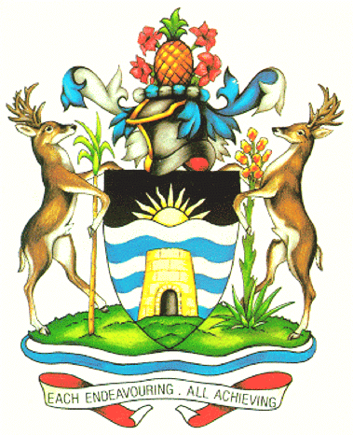

GOVERNMENT OF ANTIGUA AND BARBUDA
Permanent Mission to the United Nations
305 E. 47th Street, 6th Floor
New York, N.Y. 10017

Telephone: 212-541-4117
Fax: 212-757-1607
Email: unmission@ab.gov.ag

PM/NS/005/2019

The Permanent Mission of Antigua and Barbuda to the United Nations presents its compliments to the Office of the United Nations High Commissioner for Human Rights and has the honour to recall that Antigua and Barbuda is scheduled to present its fourth and seventh periodic reports to the Committee on the Elimination of Discrimination against Women, during its seventy-second session on February 20, 2019 at the United Nations Office in Geneva.

In this regard, the Permanent Mission has to honor to inform that the delegation is as follows:

Head of Delegation: Honourable. Samantha Nicole Marshall
Minister of Social Transformation, Human resource Development and Youth and Gender Affairs
St. John’s, Antigua

Delegates: Ms. Farmala Jacobs
Executive Director Ag.
Directorate of Gender Affairs
St. John’s, Antigua

Ms. Asha Challenger
Third Secretary
Permanent Mission of Antigua and Barbuda to the United Nations
New York, New York

The Permanent Mission of Antigua and Barbuda to the United Nations wishes to avail its of the opportunity to renew to the Office if the United Nations High Commissioner for Human Rights the assurances of its highest consideration.

Office of the United Nations High Commissioner for Human Rights
Geneva

February 12, 2019

