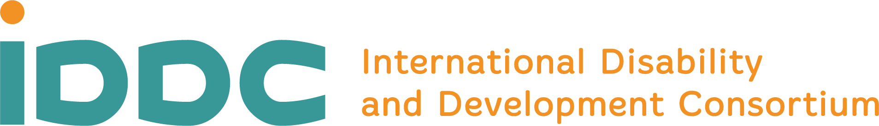

IDDC statement at the 25th Session of the CRPD
The International Disability and Development Consortium (IDDC) is a network of civil society organizations promoting disability inclusion in global development.
During the past sixteen months, we have worked with the International Disability Alliance (IDA) and other partners, launching the COVID-19 Disability Rights Monitor and a series of campaigns to denounce multiple human rights violations experienced by persons with disabilities during the pandemic, particularly women and girls and people living in institutional settings.
Supported by the United Nations Partnership on the Rights of Persons with Disabilities, we have published a report titled ‘Adjust and Respond’, aimed at providing practical guidance to United Nations agencies and governments to ensure a disability inclusive pandemic response, in line with the Convention on the Rights of Persons with Disabilities.
Recently, IDDC and IDA have also launched a campaign calling on governments, United Nations agencies and the private sector to prioritize access to COVID-19 vaccinations for persons with disabilities globally.
We worked closely with the World Health Organization and Member States on the Resolution on the highest attainable standard of health for persons with disabilities, which was adopted at the 74th World Health Assembly (WHA) in May 2021. The Resolution sets a new landmark for the right to health of persons with disabilities around the world. It strongly aligns with the Convention, particularly with Articles 23, 25 and 26 - and calls for an inclusive approach to strengthening health systems, in order to truly build back better.
Recognizing the disproportionate impact of the pandemic on persons with disabilities, the Resolution specifically calls on governments to ensure plans for emergency preparedness, response and recovery are inclusive of the needs of persons with disabilities. The Resolution also urges Member States to address barriers and discriminatory practices that prevent access to health care on the basis of free and informed consent, including rehabilitation and assistive technologies, health information and cross-sectoral public health interventions, as part of national efforts towards universal health coverage. Member States are further urged to collect health-related data, disaggregated by disability and other relevant factors, and to meaningfully engage persons with disabilities in the development of relevant policies and programmes.
If we are serious about building back better, now is the time to invest in the development of quality, resilient, accessible and inclusive health systems.
We call on the Committee on the Rights of Persons with Disabilities to promote the implementation of the Resolution as an essential prerequisite to build back better, and as a framework for the attainment of the highest standard of health for persons with disabilities, as mandated by the Convention.
Madame Chair, going forward, we rely on your leadership to ensure the implementation of the Resolution is recognised as a priority for the Committee and integrated in all your work with Member States.
As we strive to build back better, IDDC remains available to collaborate with the Committee to ensure the full realization of the right to health for all persons with disabilities.

