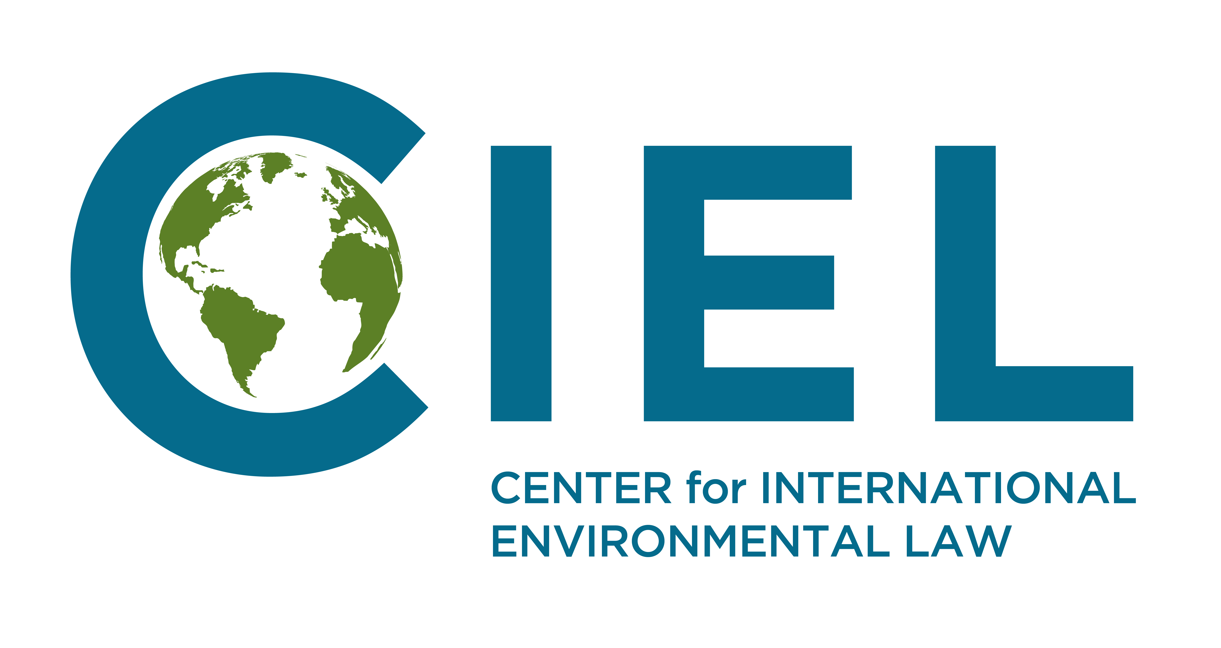
Briefing Note to the Committee on Economic, Social and Cultural Rights, prior to the adoption of the List of Issues Prior to Reporting

Norway’s energy policy and its obligations under the International Covenant on Economic, Social and Cultural Rights

Norway’s current oil and gas extraction and export policy contributes significantly to climate change and thereby results in adverse climate-induced impacts on multiple rights protected by the Covenant, such as the rights to health, food, water and sanitation. Consequently, these policies infringe Norway’s obligations under the International Covenant on Economic, Social and Cultural Rights. In this context, we urge the Task Force to question Norway regarding:
- given that the extraction and export of fossil fuels unavoidably results in the emission of greenhouse gases, how does the State Party reconcile the continuing and expanding extraction of oil and gas, including in the Arctic, and inevitable climate-induced impacts on economic, social and cultural rights within Norway and extraterritorially, with the obligations provided under the Covenant?
.
Climate Change and the Protection of Economic, Social and Cultural Rights
Climate change will detrimentally impact the rights to health, food, housing, water and sanitation. These foreseeable impacts trigger human rights obligations and responsibility among all duty bearers. Failure to prevent foreseeable human rights harm caused by climate change, including mobilizing maximum available resources in an effort to do so, constitutes a breach of this obligation. The Special Rapporteur on the environment has underlined that:
‘The foreseeable adverse effects of climate change on the enjoyment of human rights give rise to duties of States to take actions to protect against those effects. Human rights obligations apply not only to decisions about how much climate protection to pursue, but also to the mitigation and adaptation measures through which the protection is achieved.’
The CESCR has recognized these risks and the consequent State obligations and has urged States to take measures to mitigate and adapt to climate change, including in relation to fossil fuel extraction. These human rights impacts will be felt around the world, but disproportionately upon disadvantaged and marginalized groups whose economic, social and cultural rights States already struggle to fulfill. Given that the overwhelming majority of oil and gas supplied to the global commodity chain ends as emission of greenhouse gases, the vast amounts of greenhouse gases embedded in oil extracted in Norway will impact the economic, social and cultural rights of persons living both within Norway and outside of its national boundaries.
Key findings from the IPCC report on Global Warming by 1.5c of Warming
On the 8th October 2018, the Intergovernmental Panel on Climate Change released its Special Report on the impacts of global warming of 1.5 °C above pre-industrial levels and related global greenhouse gas emission pathways. The report represents the international scientific consensus regarding climate change and climate policies and has been endorsed by all governments – Norway included – on the 6th of October.
The report highlights that maintaining the increase of temperatures to 1.5ºc in 2100 is an imperative as an increase of temperature of more than 1.5ºc would imply that the human rights of millions of additional persons are undermined and would increase the likelihood of systemic and large-scale climatic risks.
The report confirms that, if governments decide to act decisively and as a matter of urgency, it is likely that the increase of temperatures could be kept below this “defense line”. This requires however rapid and far-reaching transitions in all economic sectors – including that the energy sector transitions away from fossil fuels.
To avoid relying on geoengineering technologies – which the report identifies as being associated with high risks of adverse impact on land, energy, water and food if deployed at a large scale, a rapid decrease of the consumption of all oil fossil fuels and their quasi-elimination from the energy sector by 2050 is required.
Norway’s oil and gas export context
Norway is Europe’s largest producer and exporter of oil and gas. The Norwegian government has recently offered 56 new licenses for the exploration and extraction of fossil fuels, including in new areas further north into the Arctic and the Barents Sea allowing for exploration further north than any previous licenses. These new licenses would result in increase in the country’s oil and gas extraction, resulting in inevitable and significant additional emissions of greenhouse gases from their combustion. Additionally, they would lock-in decades of investments in infrastructures thereby leading to a long-term allocation to resources away from clean energy sectors. Consequently, such exploitation would have a significant impact on the climate.
The country has implemented policies to reduce emissions of greenhouse gases emitted from its national territory. However, the emissions reported by Norway under international climate reporting obligations only account for greenhouse gases emitted within the Norwegian territory and therefore do not account for the contribution to climate change that the extractions and exports of fossil fuels would unavoidably result in. The emissions resulting from the consumption of Norway’s oil and gas exports are equivalent to about 500 million metric tons (Mt) of CO₂. By contrast, Norway reported national emissions of approximately 50 Mt in 2016.
The annual climate footprint of Norwegian’s energy exports is consequently about 10 times bigger than its domestic footprint. In terms of exporting emissions, Norway is the 7th largest exporter of greenhouse gas emissions in the world– highlighting the need to focus upon its emissions exports as a major source of climate impacts. Not only is the country refusing to consider the phasing out of fossil fuels extraction but by providing new licenses it guarantees that Norway will continue to extract oil and gas for several additional decades.
Recent recommendations adopted by other human rights treaty bodies in relation to the extraction and exports of fossil fuels by Norway

While each committee is only mandated to review the fulfilment by the State Parties of its obligations under the human rights treaty to which each committee is related, comparing recommendations made by other committees can also provide comparative information regarding the scope of application of these instruments, particularly in the context of activities affecting similarly the rights protected by more than one of the human rights treaties.

Committee on the Elimination of Discrimination Against Women – November 2017

Extra-territorial obligations

[The Committee] is concerned that continuing and expanding extraction of oil and gas in the Arctic by the State party and its inevitable greenhouse gas emissions undermines its obligations to ensure women’s substantive equality with men, as climate change disproportionately impacts women, especially in situations of poverty, since they are more reliant on natural resources for their livelihoods than men and have lesser capacity to deal with natural hazards.

The Committee recommends that the State party review its climate change and energy policies, and specifically its policy on extraction of oil and gas, to ensure it takes into account the disproportionate negative impacts of climate change on women’s rights.

Committee on the Rights of the Child – June 2018

Environmental Health
In the light of the State party’s exploitation of fossil fuels, the Committee recommends that it increase its focus on alternative energy and establish safeguards to protect children, both in the State party as well as abroad, from the negative impacts of fossil fuels.

Responsibility for oil and gas exports
As it has been established, the continued emissions of fossil fuels impacts upon the capacity to progressively realize economic, social and cultural rights – both in Norway and extra-territorially. As the overwhelming majority of petroleum is used as fuel, there is no doubt that the Norwegian Government has knowledge of the predictability of the harm that will result from the export of fossil fuels extracted in its territory.
CESCR has recognised that responsibility for the human rights impacts of climate change is shared by the countries exporting fossil fuels. In 2017 CESCR in its concluding observations on Australia recommended that the state review its coal export policy in the context of climate change. This recommendation implies that countries are responsible for the human rights impacts of the fossil fuels they export, and thus have a responsibility to limit such exports. This is also in line with a previous recommendation of CESCR which recognized the responsibility of states for the human rights impacts of another hazardous export, arms.
Norway, as an exporter of fossil fuel exporter must therefore review its oil and gas export policies and avoid to grant new licenses for the extraction of fossil fuels under its jurisdiction to avoid locking in decades more of fossil fuel supply and greenhouse gases emissions. In the following it will be affirmed that international law or the international climate regime do not limit the scope of the obligations of Norway under the ICESCR.
Relationship with the climate treaty regime
Obligations under the UNFCCC and Paris Agreements and commitments to fulfill those obligations do not absolve states of their obligations under human rights treaties. Through the State reporting procedure, the Committee has expressed concerns about the carbon dioxide emissions of an individual party, despite the State party’s commitments as a developed country under the United Nations Framework Convention on Climate Change and the Kyoto Protocol, as well as its nationally determined contribution under the Paris Agreement. Furthermore, the committee has also recommended that an individual State party “increase its efforts to reduce greenhouse gas emissions and set national targets with time-bound benchmarks”, “pursue alternative and renewable energy production” and “review [their] position in support of coal mines and coal exports.” As a result, nothing in the climate treaty system precludes Norway from responsibility for the climate impacts of its fossil fuel extraction and exports.

As the committee noted in its 2018 statement on the release of the IPCC Special Report on Global Warming by 1.5c, “human rights mechanisms have an essential role to play in protecting human rights by ensuring that States avoid taking measures that could accelerate climate change, and that they dedicate the maximum available resources to the adoption of measures that could mitigate climate change. (…) A fundamental shift in the global energy order is urgently required from hydrocarbon to renewable energy sources, in order to avoid dangerous anthropogenic interference with the climate system and the significant human rights violations that such interference would cause.”

This short briefing note was prepared by the Center for International Environmental Law (CIEL) in cooperation with partners in the country under review. For any additional information: Sébastien Duyck sduyck@ciel.org (+41786966362)

Human Rights Council, Analytical Study at para 32.
Ibid
ibid. at para 48.
A/HRC/25/53
E/C.12/AUS/CO/4 (CESCR, 2009)
E/C.12/AUS/CO/5 (CESCR, 2017), paragraph 12.
http://www.ipcc.ch/report/sr15/
IPCC Special Report on Global Warming by 1.5c, Summary for Policymakers, finding C B.1, B.2 and B.5
IPCC Special Report on Global Warming by 1.5c, Summary for Policymakers, finding C 2.2
IPCC Special Report on Global Warming by 1.5c, Summary for Policymakers, finding C 3.4
IPCC Special Report on Global Warming by 1.5c, Summary for Policymakers, Figure SPM 3.b
Energy Policies of IEA Countries: Norway (International Energy Agency, 2017), 15.
See The Sky’s Limit Norway: Why Norway Should Lead the Way in a Managed Decline of Oil and Gas Extraction, http://priceofoil.org/2017/08/09/the-skys-limit-norway-why-norway-should-lead-the-way-in-a-managed-decline-of-oil-and-gas-extraction/
Ibid
CEDAW/C/NOR/CO/9
CRC/C/NOR/CO/5-6
E/C.12/AUS/CO/5 (CESCR, 2017)
E/C.12/GBR/CO/6, (CESCR, 2016), paragraph 12.
E/C.12/AUS/CO/5 (CESCR, 2017)
E/C.12/RUS/CO/6, (CESCR, 2017)
E/C.12/CAN/CO/6 (CESCR, 2016); E/C.12/AUS/CO/5 (CESCR, 2017)
E/C.12/AUS/CO/5 (CESCR, 2017)

