Intersex Genital Mutilation
Human Rights Violations Of Children
With Variations Of Reproductive Anatomy

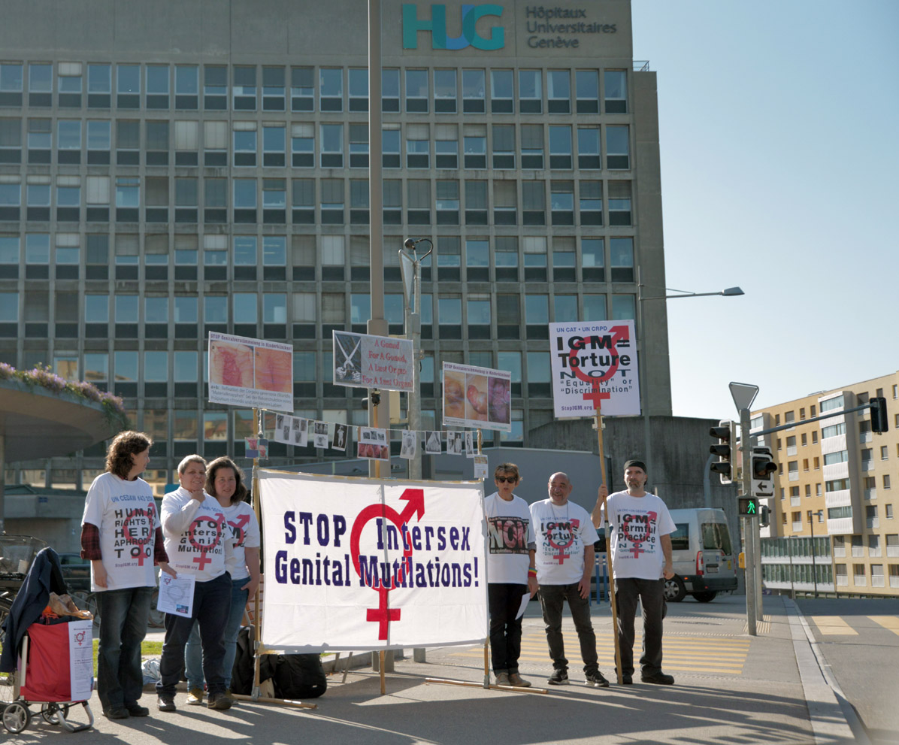

NGO Report (for Session)
to the 1st Periodic Report of Switzerland on the
Convention on the Rights of Persons with Disabilities
(CRPD)
Compiled by:

StopIGM.org / Zwischengeschlecht.org (International Intersex Human Rights NGO)
Markus Bauer
Daniela Truffer
Zwischengeschlecht.org
P.O.Box 1318
CH-8031 Zurich
info_at_zwischengeschlecht.org
https://Zwischengeschlecht.org/
https://StopIGM.org/

Intersex.ch (Peer Support Group)
Daniela Truffer
kontakt_at_intersex.ch
https://intersex.ch/

Verein SI Selbsthilfe Intersexualität (Parent’s Peer Support Group)
Karin Plattner
Selbsthilfe Intersexualität
P.O.Box 4066
4002 Basel

February 2022

This NGO Report online:
DOCX: https://intersex.shadowreport.org/public/2022-CRPD-Swiss-NGO-Zwischengeschlecht-Intersex-IGM.docx
PDF: https://intersex.shadowreport.org/public/2022-CRPD-Swiss-NGO-Zwischengeschlecht-Intersex-IGM.pdf

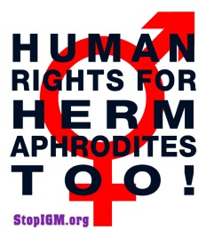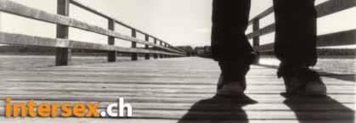
Executive Summary
All typical forms of IGM are still practiced in Switzerland today, facilitated and paid for by the State party via the “Swiss Federal Invalidity Insurance” and its “List of Birth Defects”, which is also evident in the Replies to the LOI and recent developments since our previous Report.
CRC, CCPR, CAT and CEDAW have already recognised IGM in Switzerland as a serious violation, namely harmful practice and inhuman treatment. Instead of taking appropriate action, Switzerland openly and explicitly “rejects” to implement the Concluding Observations, downgrading and trivialising the practice as a mere “discrimination” or “health” issue instead. Emboldened by such official protection, Swiss IGM doctors publicly insist to continue.
This Committee has repeatedly recognised IGM as a serious violation in Concluding observations, LOIs and General Comments. IGM practices in Switzerland constitute the same or similar violations as those previously specified and addressed by CRPD.
In total, UN treaty bodies CRC, CEDAW, CAT, CCPR and CRPD have so far issued 57 Concluding Observations on IGM, typically obliging State parties to enact legislation to (a) end the practice and (b) ensure redress and compensation, plus (c) access to free counselling. Also, the UN Special Rapporteurs on Torture (SRT) and on Health (SRH), the UN High Commissioner for Human Rights (UNHCHR), the World Health Organisation (WHO), the Inter-American Commission on Human Rights (IACHR), the African Commission on Human and Peoples’ Rights (ACHPR) and the Council of Europe (COE) recognise IGM as a serious violation of non-derogable human rights.
Intersex people are born with Variations of Reproductive Anatomy, including atypical genitals, atypical sex hormone producing organs, atypical response to sex hormones, atypical genetic make-up, atypical secondary sex markers. While intersex people may face several problems, in the “developed world” the most pressing are the ongoing Intersex Genital Mutilations, which present a distinct and unique issue constituting significant human rights violations.
IGM practices include non-consensual, medically unnecessary, irreversible, cosmetic genital surgeries, and/or other harmful medical procedures that would not be considered for “normal” children, without evidence of benefit for the children concerned. Typical forms of IGM include “masculinising” and “feminising”, “corrective” genital surgery, sterilising procedures, imposition of hormones, forced genital exams, vaginal dilations, medical display, involuntary human experimentation and denial of needed health care.
IGM practices cause known lifelong severe physical and mental pain and suffering, including loss or impairment of sexual sensation, painful scarring, painful intercourse, incontinence, urethral strictures, impairment or loss of reproductive capabilities, lifelong dependency of artificial hormones, significantly elevated rates of self-harming behaviour and suicidal tendencies, lifelong mental suffering and trauma, increased sexual anxieties, and less sexual activity.
For 25 years, intersex people have denounced IGM as harmful and traumatising, as western genital mutilation, as child sexual abuse and torture, and called for remedies.
This Thematic NGO Report has been compiled by the international NGO StopIGM.org / Zwischengeschlecht.org, the Swiss peer support groups Intersex.ch and SI Selbsthilfe Intersexualität. It contains Suggested Recommendations (see p. 24).
NGO Report (for Session) to the 1st Report of Switzerland
on the Convention on the Rights of Persons with Disabilities (CRPD)

Table of Contents

IGM Practices in Switzerland (p. 6-24)

Executive Summary 3
A. Introduction 5
1. Intersex, IGM and Human Rights in Switzerland 5
2. About the Rapporteurs 5
3. Methodology 5
B. IGM practices in Switzerland: Updates to NGO Report for LOI 6
1. Switzerland: Still no protections for intersex people, State party refuses to act 6
2. IGM Practices continue with impunity 7
a) Endorsed International Guidelines prescribing IGM still in force 7
b) Secret National DSD Guidelines prescribing IGM still in force 8
c) “Multidisciplinary DSD Teams” still dominated by surgeons and endocrinologists 9
d) “Multidisciplinary DSD Teams” still prefer and practice early IGM 9
e) Swiss Cantonal and University Hospitals continuing IGM with impunity 10
f) Swiss IGM doctors experimenting on African intersex children 13
g) Swiss International DSD Symposia promoting IGM, including “live surgeries” 15
h) Cantonal parliamentary questions establishing that IGM persists 15
3. CRC 2021: Prohibition, support, reparations (CRC/C/CHE/CO/5-6, para 29(b)-(c)) 16
C. Fact-checking the Replies to the LOI 18
1. “Invalidity Insurance” (LOI para 1(a), Replies to the LOI para 2) 18
2. Consultation (LOI para 1(b), Replies to the LOI para 2) 18
3. Non-discrimination (LOI para 2(c), Replies to the LOI para 8) 19
4. Remedies (LOI para 12(e), Replies to the LOI para 38) 20
5. Rehabilitation (LOI para 13(e), Replies to the LOI para 45) 20
6. Prohibition, psychosocial support (LOI para 14(b), Replies to the LOI para 47) 21
7. Data collection (LOI para 14(b), Replies to the LOI para 48) 22
D. Suggested Recommendations 24
Annexe 1 – Intersex as “Invalidity”: Historical Medical Examples 25
1916–1950s: “Intersex = bastardisation” caused by “racial mixing”;
racist gynaecological diagnosis “intersexual constitution” 25
Baltimore and Zurich 1950: Start of systematic “genital corrections” 26
Zurich 1950s: Paediatric diagnosis “intersexuality”, Prader scales and
“surely justified” clitoris amputations based on psychosocial indications 27
Annexe 2 – IGM in Medical Textbooks: Current Swiss Practice 28
IGM 2 – “Feminising” Procedures: Partial Clitoris Amputation (Uni Geneva) 28

A. Introduction
1. Intersex, IGM and Human Rights in Switzerland
IGM practices are known to cause severe, lifelong physical and psychological pain and suffering, and have been repeatedly recognised by multiple UN treaty bodies including CRPD as constituting a serious violation, namely harmful practice, violence, inhuman treatment and violation of the integrity of the person. CRC, CAT, CEDAW and CCPR have already recognised IGM in Switzerland to constitute a serious violation accordingly.
This NGO Report provides updated and additional evidence that the current harmful medical practice on intersex persons in Switzerland persists, advocated and paid for by the State party via the “Swiss Federal Invalidity Insurance” and its “List of Birth Defects”, which is also evident in the Replies to the LOI, as demonstrated in the chapter discussing Switzerland’s replies. Also, it substantiates how Switzerland continues to refuse to take appropriate measures to remedy these violations since our previous Report for LOI.
2. About the Rapporteurs
This NGO report has been prepared by the Swiss-based international intersex NGO StopIGM.org / Zwischengeschlecht.org in collaboration with Swiss peer support groups Intersex.ch and SI Selbsthilfe Intersexualität:
- StopIGM.org / Zwischengeschlecht.org is an international intersex human rights NGO based in Switzerland, working to end IGM Practices and other human rights violations perpetrated on intersex people, according to its motto, “Human Rights for Hermaphrodites, too!” According to its charter, StopIGM.org works to support persons concerned seeking redress and justice and regularly reports to UN treaty bodies.
- Intersex.ch is a Swiss intersex peer support group founded in 2005.
- SI Selbsthilfe Intersexualität is a Swiss peer support group for parents of intersex children founded in 2003.
The Rapporteurs would like to thank Audrey Aegerter for additional research on Geneva doctors operating in Cameroon, on occasion of a secondment.
3. Methodology
This thematic NGO report is an update to the 2019 thematic CRPD NGO Report (for LOI) for Switzerland by the same rapporteurs.
It contains 2 Annexes with illustrations, text and sources on “Intersex as ‘Invalidity’: Historical Medical Examples” and “IGM in Medical Textbooks: Current Swiss Practice”.
B. IGM practices in Switzerland: Updates to NGO Report for LOI
This section documents recent developments not mentioned in our NGO Report for LOI and follows up to findings presented there.
1. Switzerland: Still no protections for intersex people, State party refuses to act
In Switzerland the lack of protections of intersex children from harmful practices and inhuman treatment remains unchanged. In particular, there are still
- no legal or other protections in place to ensure the rights of intersex children to physical and mental integrity, autonomy and self-determination, and to prevent non-consensual, medically unnecessary, irreversible surgery and other harmful treatments a.k.a. IGM practices
- no measures in place to ensure data collection and monitoring of IGM practices
- no legal or other measures in place to ensure the accountability of IGM perpetrators
- no legal or other measures to ensure access to redress and justice for adult IGM survivors
All forms of IGM practices remain widespread and ongoing – advocated, facilitated and paid for by the State party via the Swiss Federal Invalidity Insurance (Invalidenversicherung IV – Assurance Invalidité AI) according to its List of Birth Defects (Liste der Geburtsgebrechen –Liste des Infirmités Congénitales) covering intersex surgeries on children until the age of 20, but not for consenting adults.
At the same time, as also evident in the State report, the Swiss government continues to
- deny the ongoing practice,
- reject repeated UN recommendations by CRC, CAT, CEDAW, CCPR,
- claim “free psychosocial support” would be “impossible” to finance,
- claim the existing legislation would be sufficient to protect intersex children,
- refuse to take effective measures,
- enable perpetrator institutions to destroy medical records during “scientific review” of practice funded by the Swiss National Science Foundation (SNSF).
In particular, the Swiss government still officially rejects to implement CRC’s 2015 recommendations on harmful practices on intersex children, as documented in its 2018 report “Measures to close gaps in the implementation of the Convention on the Rights of the Child. Report of the Federal Council as a result of the recommendations of the UN Committee on the Rights of the Child to Switzerland of 4 February 2015”. Therefore, last year CRC again urged Switzerland to “[p]rohibit” IGM and to “[p]rovide […] support and reparations” (see p. 16-17).
Notably, the justification of the Federal Government for not implementing para 43(b) of the 2015 CRC Concluding Observations concerning harmful practices on intersex children, but to explicitly and officially “reject” it, was the Federal Government’s decision to prioritise civil registry reform instead, i.e. easier change of gender marker mostly for trans people (“Amendment of the Civil Code (CC; SR 210).”). Despite the fact that civil registry reform is in no way a remedy for IGM practices, and that intersex NGOs don’t call for it, but for effectively addressing harmful practices against intersex children.
2. IGM Practices continue with impunity
a) Endorsed International Guidelines prescribing IGM still in force
The Swiss Society of Urology (“Schweizerische Gesellschaft für Urologie – Société Suisse d'Urologie – SWISS UROLOGY”) still endorses the current 2021 Guidelines of the European Association of Urology (EAU), which include the – concerning IGM unchanged – current ESPU/EAU “Paediatric Urology” Guidelines 2021 of the European Society for Paediatric Urology (ESPU) and the European Association of Urology (EAU) which promote IGM practices.
In particular, regarding IGM 3: “removal of testes”, the guidelines stress:
“Individuals with DSD have an increased risk of developing cancers of the germ cell lineage, malignant germ cell tumours or germ cell cancer in comparison with to the general population.”
Further, regarding “whether and when to pursue gonadal or genital surgery”, the Guidelines refer to the “ESPU/SPU standpoint on the surgical management of Disorders of Sex Development (DSD)”, which advocates “gonadectomies”:
“Testes are either brought down in boys or removed if dysgenetic with tumour risk or in complete androgen insensitivity syndrome or 5 alpha reductase deficiency. Testicular prostheses can be inserted at puberty at the patient’s request.”
Also, the “2016 Global Disorders of Sex Development Consensus Statement”, which is co-authored by paediatric endocrinologist Christa Flück (Inselspital, University of Bern) and refers to the “ESPU/SPU standpoint”, advocates “gonadectomy” based on psychosocial indications, namely “gender of rearing”, in case of “ambiguous genitalia” or to “avoid gynecomastia” – even when admitting “low” cancer risk for CAIS (and despite explicitly acknowledging CRC/C/CHE/CO/2-4):
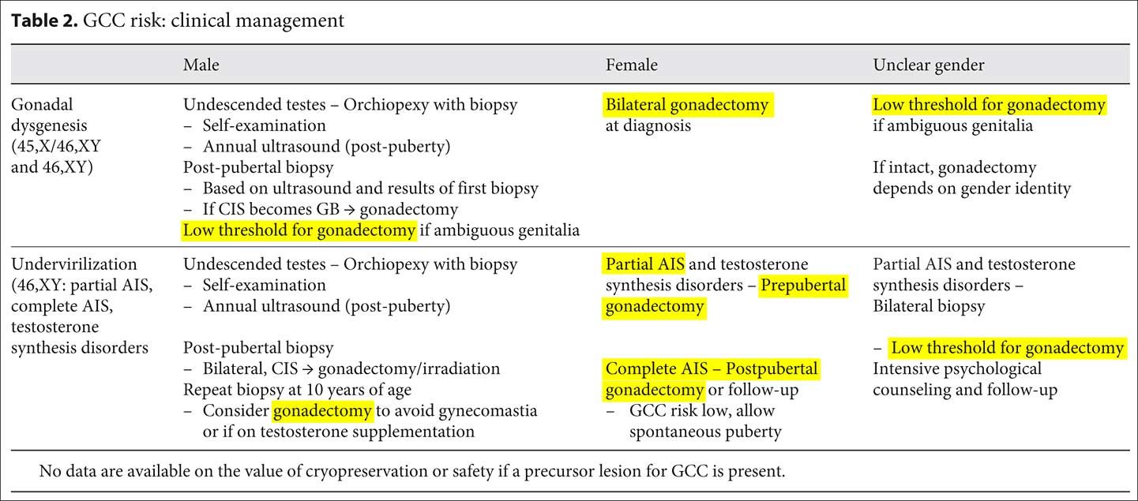
Source: Lee et al., in: Horm Res Paediatr 2016;85:158-180, at 174
Regarding IGM 2: partial clitoris amputation, in chapter 3.17 “Disorders of sex development”, despite admitting that “Surgery that alters appearance is not urgent” and that “adverse outcomes have led to recommendations to delay unnecessary [clitoral] surgery to an age when the patient can give inform consent”, the ESPU/EAU Guidelines nonetheless explicitly refuse to postpone non-emergency surgery, but in contrary insist to continue with non-emergency genital surgery (including partial clitoris amputation) on young children based on “social and emotional conditions” and substituted decision-making by “parents and caregivers implicitly act[ing] in the best interest of their children” and making “well-informed decisions […] on their behalf”, and further explicitly refusing “prohibition regulations” of unnecessary early surgery, referring to the 2018 ESPU Open Letter to the Council of Europe (COE), which further invokes parents’ “social, and cultural considerations” as justifications for early surgery (p. 2).
Regarding IGM 1: “masculinising” genital surgery / “hypospadias repair”, in chapter 3.6 “Hypospadias” the ESPU/EAU Guidelines’ section 3.6.5.3 “Age at surgery” explicitly promotes, “The age at surgery for primary hypospadias repair is usually 6-18 (24) months.” – despite admitting to the high “risk of complications” and “aesthetic[…]” and “cosmetic” justifications.
b) Secret National DSD Guidelines prescribing IGM still in force
The 2019 “Switzerland-wide agreement of DSD treatment teams” prescribing IGM practices if “the parents cannot bear to live with the ‘shame’” of having an intersex child remain in force. While the agreement itself is still kept secret and not published, the Press release and public interviews by doctors marking its introduction in spring 2019 make clear that it prescribes IGM.
c) “Multidisciplinary DSD Teams” still dominated by surgeons and endocrinologists
According to a 2018 poster by members of the “Working Group DSD of the Swiss Society for Pediatric Endocrinology and Diabetology (AG DSD SGPED)” presented at the 57th Annual Meeting of the European Society for Paediatric Endocrinology (ESPE 2018), the Swiss “Multidisciplinary DSD Teams” continue to be dominated by paediatric surgeons (“Ped. surgery”, “Ped. urology”) and paediatric endocrinologists (“Ped. endocrinology”):
The poster further admits, “specialized DSD psychologists and adult DSD specialists [are] lacking”.
d) “Multidisciplinary DSD Teams” still prefer and practice early IGM
According to a presentation at the September 2019 “European Congress for Paediatric Endocrinology” (i.e. the 58th Annual Meeting of the European Society for Paediatric Endocrinology ESPE) co-authored by a doctor from the Berne University Children’s Hospital and based on data of the I-DSD/CAH Registry (of which the Swiss IGM hospitals are members), the “Multidisciplinary DSD Teams” still prefer and practice early “feminising genital corrections” (IGM 2):
“Genital surgery has been performed in 251 (76%). Clitoral surgery been performed in 231 (92%), vaginal surgery in 204 (81%) and a combination of clitoral and vaginal surgery had been performed in 186 (74%). Of the 251 who had surgery, 18 (7%) had vaginal but no clitoral surgery whilst 42 (17%) had clitoral but no vaginal surgery. Mean age at first surgery was 2.5 years (0-15), with clitoral surgery and vaginal surgery at 2.6 years (range) and 3.2 years (range), respectively. […] The Chicago Consensus Statement on DSD (comparison of data before and after 2006) did not have any significant influence on the timing or probability of surgery.”
e) Swiss Cantonal and University Hospitals continuing IGM with impunity
“SwissPedNet – the Swiss Research Network of Clinical Pediatric Hubs” is the official clinical research organisation of the “Swiss Society of Paediatrics (SGP/SSP)” and includes 5 university children’s hospitals and 4 cantonal children’s hospitals. All of these 9 clinics continue to practice IGM:
- Basel University Children’s Hospital (UKBB)
The “Paediatric Surgery” homepage of the UKBB offers under “Urology” surgery for “Hypospadias” (IGM 1).
- Bern University Children’s Hospital (Inselspital)
The “Paediatric Urology” homepage of the Children’s Clinic of the Inselspital offers under “Diagnosis and treatment” “Hypospadias and reconstruction of the urethra: All forms of surgical correction incl. use of oral mucosa” (IGM 1).
- Geneva University Children’s Hospital (HUG)
The “Disorders of Sex Development” homepage of the Department for Paediatric Surgery of the HUG advocates “Treatment: [...] Important decisions about the direction of treatment will be made in consultation with the parents and then with the child according to his or her understanding and age. Treatment may be medical, surgical or a combination of both and may extend into adulthood.” (IGM 1-3).
The “Malformation of the penis” homepage of the Department for Paediatric Surgery of the HUG advocates “Treatment: [...] The definitive treatment is surgical, allowing in the same operation to correct the curvature of the penis and to bring the urinary meatus to the top of the glans by reconstructing the urethra. The foreskin is usually used for this, so the penis will look circumcised after the operation. Some reconstruction techniques require several operations. [...]
Prognosis: As the operation is performed on hypoplastic tissue, the rate of post-operative complications is significant. These are mainly healing problems, the most frequent of which are:
- Fistulas (leakage along the path of the reconstructed urethra)
- Dehiscence (partial or total reopening of the reconstruction)
- More rarely, stenosis (narrowing of the new urinary meatus)
The likelihood of complications depends on the extent of the initial damage.
Most complications require re-intervention.” (IGM 1)
The brochure “Your child is going to be operated on for hypospadias” of the Department for Paediatric Surgery of the HUG advocates “Reconstructive surgery is recommended to avoid difficulties during urination and cosmetic problems. The aim is also to prevent difficulties during the sexual act and the risk of infertility later on. The ideal age for the operation is between 1 and 2 years.” (IGM 1)
And a 2017 thesis “Management of disorders of sexual development: State of the art. A Surgeon’s perspective in Western Switzerland” by HUG paediatric surgeon Jacques Birraux openly promotes “early surgery” regarding “masculinization genitoplasty” (IGM 1), as well as “feminization genitoplasty” (IGM 2) (see also below, p. 28-29).
- Lausanne University Children’s Hospital (CHUV)
The “Paediatric Urology” homepage of the CHUV homepages states under “Most frequent reasons for consultation: […]
Problems affecting the genitals (pathological phimosis, hypospadias, penis curvature, synechia of the labia minora, etc.) […]
In an interdisciplinary team we also treat rarer conditions, such as
variations in sexual development […]
rare abnormalities of the genital tract (urogenital sinus, duplication of the internal genital tract...) […]” (IGM 1-2).
- Zurich University Children’s Hospital (Kispi Zürich)
The “Urology” homepage of the Children’s Hospital Zurich states:
“The urogenital tract is one of the organ systems most frequently affected by congenital malformations. […]. Many malformations and diseases can be completely corrected by modern surgical (often microsurgical and endoscopic) interventions.”
Accordingly, under “Genitals / Urethra” the homepage offers surgery for diagnoses including “Hypospadias” (IGM 1) and “Forms of sex development” (formerly “correction of intersex genitals” ) (IGM 1-4).
The “Urology” homepage of the Children’s Hospital Zurich offers under “Full spectrum of diagnostics and therapy” “Surgeries on the external genitals: cryptorchidism (undescended testis), hypospadias and epispadias (urethral malformation), correction of intersex genitals” (IGM 1-3).
Further, the hospital’s online “Glossary” referred to from the “Urology” homepage under “Hypospadias” offers early “corrective surgery” based on psychosocial indications, namely for “psychological” and “aesthetic” reasons:
“Hypospadias is the most common congenital urological malformation in boys. It occurs in about 1:300 newborns and may be familial. […] The aim of the operation is to move the urethral opening to the tip of the glans with a normal urinary stream and to straighten the shaft of the penis with a satisfactory aesthetic result. Corrective surgery is preferably performed before the age of 18 months, for psychological reasons, or later, from the age of 5 years, or if the affected boy desires correction. From a medical point of view, a surgical correction can be performed at any age.”
- Aarau Cantonal Children’s Hospital
The “Range of services paediatric surgery” homepage of the Cantonal Hospital Aarau offers under “Urology”, “We treat among other things: Undescended testicles, […] Hypospadias, […] Penile curvature” (IGM 1), and under “Plastic surgery”, “We treat among other things: […] Gynecomastia” (IGM 4). Under “Urology”, the hospital further notes: “In urology, we maintain a close collaboration with […] [the] team from the Children's Hospital Zurich.”
- Lucerne Cantonal Children’s Hospital
The “Kidneys, urinary tract, bladder and genital organs in children and adolescents” homepage of the Lucerne Children’s Hospital offers:
“Paediatric surgery: Paediatric urology is a focal point
Paediatric urology covers the entire spectrum of diagnostics as well as non-operative (conservative) and operative treatment. Our services include the treatment of diseases, malformations and injuries of the kidneys and urinary tract and the male and female reproductive organs. We treat, among other things: […]
Malformations of the urethra (hypospadias, epispadias)
Undescended testis” (IGM 1)
- St. Gallen Cantonal Children’s Hospital (Eastern Switzerland Children’s Hospital)
The “Urology” homepage of the Eastern Switzerland Children’s Hospital offers under “Range of services: […]
Congenital urethral malformations are corrected according to the latest findings and also examined in terms of function during the course of the operation. A team consisting of surgeons, radiologists, hormone specialists and psychologists takes care of the family and the child according to need and the severity of the disease.”
And under “Conditions […]
Congenital urethral malformations [...]
Congenital undescended testicles [...]
Deformities of the genitals” (IGM 1-3)
And the current flyer for parents titled “Multiprofessional Consultation” in cases of “Disorders of Sex Development”, advocates under “Therapy”: “Corrective surgery” for “Hypertrophy of the clitoris” (IGM 2).
- EOC Ticino Cantonal Children’s Hospital (Ente Ospedaliero Cantonale Ticino)
Since 2004, the EOC offers “hypospadias repair” (IGM1) in Bellinzona.
f) Swiss IGM doctors experimenting on African intersex children
A paediatric surgeon from the Geneva University Children’s Hospital, Jacques Birraux, personally experimented on at least 487 African intersex children in Yaoundé (Cameroon) performing IGM 1-3, including on a 5-year-old African intersex child to establish a “new surgical technique” for IGM 2: “vaginoplasty”. He is often aided and abetted by Claude Le Coultre, a fellow paediatric surgeon, and/or Sophie Dahoun, a fellow geneticist from the Geneva University Hospital, the latter partly acting as co-authors in above referenced publications, as well as in other relevant publications concerning IGM practices performed by European doctors on intersex children in Cameroon.
Above referenced medical experimentation and IGM practices on intersex children in Cameroon are financed by the Geneva “charity” Children Action, which according to its homepage since 2010 organises “[t]wo to three surgical missions […] each year”. And according to information from the Geneva University Hospital obtained by the Human Rights Commission of the Parliament of the Canton of Geneva, intersex children from Cameroon are also sent to the Geneva University Hospital for IGM practices explicitly justified by psychosocial indications, arguably via the same “charity” Children Action:
“3 African patients, transferred within the framework of an agreement between the HUG and a humanitarian foundation. […] In this context, it is important to note that the overall context of DSD is very different in African countries, with children being stigmatised, sometimes even ostracised.”
Needless to say, these practices of mentioned Geneva doctors and the “charity” Children Action are strongly condemned by African intersex advocates, as well as the lack of access to redress for African intersex persons in such cases.

g) Swiss International DSD Symposia promoting IGM, including “live surgeries”
The Lucerne Cantonal Children’s Hospital facilitated the “14th Symposium of the Working Group Paediatric Urology of the German Society for Paediatric Surgery (DGKCH) and the Swiss Society for Paediatric Urology (swissPU) 2017” in Lucerne including “live surgery”, namely “Hypospadia subcoronaria”, “Modified MAGPI”, “Hypospadia penilis” (IGM 1), performed at the Lucerne Children’s Hospital.
And the Berne University Children’s Hospital (Inselspital) facilitated the international
“8th I-DSD Symposium 2021”, including a session on “hypospadias repair” (IGM 1).
h) Cantonal parliamentary questions establishing that IGM persists
While the Federal and Cantonal Governments continue to deny that IGM practices persist, and also in the Replies to the LOI (para 48) claims “only a few cases of intersex-related operations” per year, a 2020 reply by the Zurich Cantonal Government to a Parliamentary question revealed much higher numbers, namely 85-135 IGM procedures practiced annually at the Zurich University Children’s Hospital alone, all of them paid for by the Swiss Federal Invalidity Insurance (IV).
To this day, the Great Council of the Republic and Canton of Geneva remains the only Parliament in Switzerland to pass a prohibition of IGM practices in 2019 by adopting two motions calling on the Cantonal government to explicitly “prohibit” the “mutilations of intersex persons” (see also our LOIPR NGO Report, p. 14). Notably, during the debate before the adoption, both a member of the Great Council and a member of the Cantonal government proclaimed that at the Geneva University Hospital (HUG) allegedly there had been “no operations since 2012”. Unfortunately, this is far from the truth (see also above p. 10-11, 13-14). However, in October 2019 the Cantonal Government (Conseil d’État) refused to implement the motions, again under the pretext that IGM allegedly has not been practised for a long time. Only in 2020, after an Open Letter by StopIGM.org, resulting media coverage and an Urgent Parliamentary Question initiated by StopIGM.org, the Cantonal Government finally acknowledged in a response the persistence of IGM and promised further investigation:
“Indeed, surgeries for VSD that did not respect ethical recommendations were performed at the HUG during the period 2010-2018. The State Council is currently undertaking a fact-finding exercise with the HUG and the Swiss Invalidity Insurance in order to establish the facts.”
So far, however, these promises have not been fulfilled.
3. CRC 2021: Prohibition, support, reparations (CRC/C/CHE/CO/5-6, para 29(b)-(c))
Last year, the Committee on the Rights of the Child (CRC) examined the human rights record of Switzerland under the Convention, following up on its ground-breaking 2015 recommendations on intersex children (CRC/C/CHE/CO/2-4, paras 42-43, see Report for LOI, p. 6).
During the interactive dialogue, CRC expert Mr. José Angel Rodríguez Reyes asked about measures taken to prevent involuntary genital surgeries on intersex children which “can be considered as genital mutilation” and to implement the previous CRC Concluding Observations.
In reply, the Swiss delegation as per usual denied the ongoing practice, including by changing the subject to “sex assignment” and “gender identity”, alleging the ongoing practice was “in principle” already unlawful while at the same time confirming the substituted decision-making by (often overwhelmed) parents, and further reaffirming the Government’s refusal to adopt a specific prohibition (see also Report for LOI, p. 25):
“The Swiss government does not consider it necessary to adopt a specific legal basis to prohibit sex assignment surgery on newborns. No medical intervention can be performed on a patient without his or her free and informed consent, and such consent requires the capacity to discern. Considering that a newborn does not have this capacity, it is up to the legal representatives to consent to the medical intervention, and as the decision on gender identity is a strictly personal right, this means that the parents cannot represent the child in this matter. Therefore, it is generally accepted that sex assignment interventions where the child’s sex is undetermined at birth cannot be decided by representation, but that it is necessary to wait until the child has the necessary discernment to make this decision him/herself, unless an early intervention is necessary for the child's good. If it is not necessary to safeguard the health or life of the child who is incapable of discernment, the surgical intervention of sex assignment constitutes in principle an unlawful bodily injury. As an example, I will just mention the, we have developed the training of specialists in the sector. That is all.”
As a result, CRC reaffirmed its position on non-consensual intersex genital surgery and other unnecessary treatment on intersex children as a harmful practice in its latest Concluding Observations to Switzerland, inter alia explicitly calling for a prohibition and for reparations (CRC/C/CHE/CO/5-6, para 29(b)-(c)):

D. Violence against children (arts. 19, 24 (3), 28 (2), 34, 37 (a) and 39) […]
Harmful practices
29. The Committee welcomes the measures taken to combat female genital mutilation and to implement the federal programme to combat forced marriage, and recommends that the State party: […]
(b) Prohibit the performance of unnecessary medical or surgical treatment on intersex children where those procedures may be safely deferred until children are able to provide their informed consent;
(c) Provide social, medical and psychological services, as well as adequate counselling, support and reparations, to families with intersex children;
C. Fact-checking the Replies to the LOI
1. “Invalidity Insurance” (LOI para 1(a), Replies to the LOI para 2)
A. Purpose and general obligations (arts. 1-4)
1. Please provide information on:
(a) Effective mechanisms and practical measures taken to review and harmonize laws and policies through the Conference of Cantonal Governments to adhere to the Convention, including ensuring that the concept of disability is consistent with the Convention and that stigmatizing language such as “invalid” is removed;
Reply to paragraph 1 (a) of the list of issues (CRPD/C/CHE/Q/1)
1. The Confederation and the cantons regularly exchange information in the framework of the National Dialogue on Swiss Social Policy, through, for example, the multi-year “Autonomy” programme. The cantons coordinate their activities in the various conferences of directors, and the Conference of Cantonal Directors of Social Affairs is represented on the working groups on disability policy and the “Autonomy” programme.
Fact: The stigmatising language e.g. of the “Swiss Federal Invalidity Insurance” (“Invalidenversicherung (IV)”, “Assurance-invalidité (AI)”, “Assicurazione per l’invalidità (AI)”) remains unchanged (as also corroborated by the Replies to the LOI, para 45).
What also persists unchanged is the framing and “treating” of intersex people as “invalids” in need to be “cured” or “corrected” surgically, often with racist, eugenic and suprematist undertones (see below, p. 25-27, and Report for LOI, p. 14-16).
2. Consultation (LOI para 1(b), Replies to the LOI para 2)
A. Purpose and general obligations (arts. 1-4)
1. Please provide information on: […]
(b) Mechanisms established and the human and financial resources available at the federal, cantonal and municipal levels for meaningful consultation with persons with disabilities, including persons with disabilities with diverse sexual orientations and gender identities and intersex persons with disabilities, through their representative organizations, regarding the design and monitoring of legislation and policies aimed at implementing the Convention;
Reply to paragraph 1 (b) of the list of issues
2. The public consultation procedure allows civil society to express its views on the legislative reforms under way. This is the preliminary phase of the legislative procedure during which the drafts are put for comments to the cantons, the main political parties, the umbrella associations of the municipalities, towns and mountain regions, the umbrella associations for businesses and other interested parties. Anyone, whether invited to or not, can comment on the drafts under consultation. Recently, associations of lesbian, gay, bisexual, transgender and intersex persons and persons with disabilities have expressed their views on the draft revision of the Civil Code aimed at opening civil marriage to all, as well as on the government bill transmitted to Parliament on 6 December 2019 concerning change of sex on the civil register; they will also be able to express their views on the Arslan and Ruiz postulates, which call for the introduction of a third sex category. Under the “Autonomy” programme, the Confederation and the cantons are looking at ways of enhancing the inclusion of persons with disabilities and their organizations in the procedures for drafting and monitoring the implementation of laws.
Fact: While it is true that our NGO is frequently consulted on our own expense (including travelling to Berne for meetings) regarding issues that have nothing to do with preventing and prohibiting IGM, namely the above mentioned “civil marriage”, “third sex category”, “change of sex on the civil register”, as well as on “sexuality”, “sexual offences” and “HIV prevention” etc., we note that we’re never consulted on our actual concern IGM practices, and are regularly fobbed off when we try to raise it.
3. Non-discrimination (LOI para 2(c), Replies to the LOI para 8)
B. Specific Rights
Equality and non-discrimination (art. 5)
2. Please provide information on: […]
(c) Measures taken by the Federal Council to respond to the recommendations of the Swiss Centre of Expertise in Human Rights in its study about access to legal protection in cases of alleged discrimination, including gaps in the field of private law and with regard to the rights of lesbian, gay, transgender and intersex persons (CRPD/C/CHE/1, para. 35).
Reply to paragraph 2 (c) of the list of issues
8. The Government conducted a comprehensive review of the protection against discrimination provided under the law, described in its report of 25 May 2016. It considered that the civil law currently in force provides sufficient protection against discrimination. Protection against discrimination on the grounds of sexual identity or sexual orientation can be derived from the general rules (protection of personal privacy in general in civil law, protection of personal privacy of the employee, protection against unfair dismissal in labour law or unfair termination of a tenancy agreement; cf. list of issues, para. 21 (b)). On 9 February 2020, the people of Switzerland agreed to extend the criminal provision against discrimination (Criminal Code, art. 261 bis) to include discrimination based on sexual orientation.
Fact: Intersex is NOT THE SAME as “sexual identity or sexual orientation”, no matter how often the Federal Government (and other actors) insist on publicly misrepresenting it as such (see also our Report for LOI, p. 16-17). Notably, regarding the mentioned art. 261bis, the Federal Government explicitly objected to include intersex (while earlier the Legal Affairs Committee of the National Council LAC-N tellingly had proposed to “include” intersex under “sexual identity”). While as long as IGM practices continue with impunity for our NGO discrimination issues are not a priority, we nonetheless don’t agree with the assessment of the Government that for intersex people “the civil law currently in force provides sufficient protection against discrimination”.
4. Remedies (LOI para 12(e), Replies to the LOI para 38)
Freedom from torture or cruel, inhuman or degrading treatment or punishment (art. 15)
12. Please provide information on: […]
(e) Criminal and civil remedies available to persons with disabilities, including intersex persons with disabilities, who have undergone involuntary sterilization or unnecessary and irreversible medical or surgical treatment, procedures to access medical records and whether remedies are subject to any statutes of limitations.
Reply to paragraph 12 (e) of the list of issues
38. On 6 July 2016, the Government adopted a position on the report of the National Ethics Commission for Human Medicine entitled “Approach to take on variations in sexual development: ethical issues on intersexuality”. The Government specified that premature or unnecessary medical or surgical interventions are contrary to the right to respect for physical integrity. Wherever possible, any decision on a proposed treatment that will lead to irreversible consequences must be postponed until the child has reached a sufficient level of maturity to be able to express his or her own views. The decision on one’s own sexual identity is an absolute and strictly personal right of the child, which the child’s parents cannot exercise in his or her place (Civil Code, art. 19 (2)).
Fact: Once more, the State party conveniently fails to actually answer the question, and again changes the subject to “sexual identity”. As demonstrated in this NGO Report and in our Report for the LOI, and corroborated by the absolute lack of relevant case law, in Switzerland there are still no de facto criminal and civil remedies available to survivors of IGM practices, and the statutes of limitations prevent victims from going to court.
5. Rehabilitation (LOI para 13(e), Replies to the LOI para 45)
Freedom from exploitation, violence and abuse (art. 16)
13. Please provide information on: […]
(e) Measures taken to promote the physical, cognitive and psychological recovery and rehabilitation and social reintegration of intersex persons who have undergone involuntary procedures, including those who underwent irreversible surgical procedures as children with parental consent, and steps taken to ensure that such measures are covered by medical insurance.
Reply to paragraph 13 (e) of the list of issues
45. Intersexuality falls within the scope of invalidity insurance. For persons aged 20 and above, medical measures are covered by compulsory health insurance. The compulsory health insurance system guarantees benefits in the event of illness, accident or maternity. The scheme is based on peremptory and exhaustive legislation, and only those benefits defined in articles 25 to 31 of the Health Insurance Act are covered. Neither health promotion nor social reintegration measures are covered.
Fact: The “invalidity insurance” only pays for (harmful) surgery on intersex children, but not for psychosocial support and/or rehabilitation. Regarding the compulsory health insurance, the mentioned limitations indeed prevent IGM survivors from access to rehabilitation, leaving them to at least partly cover expenses for rehabilitation out of their own pocket (see our Report for LOI, p. 26).
6. Prohibition, psychosocial support (LOI para 14(b), Replies to the LOI para 47)
Protecting the integrity of the person (art. 17)
14. Please provide information on: […]
(b) Measures taken to ensure that no one is subjected to unnecessary medical or surgical treatment during infancy or childhood (CRC/C/CHE/CO/2-4, para. 43 (b); CAT/C/CHE/CO/7, para. 20 (a); CEDAW/C/CHE/CO/4-5, para. 25 (c); and CCPR/C/CHE/CO/4, para. 25) […].
Reply to paragraph 14 (b) of the list of issues
47. The Government believes that current practice respects the rights of intersex people. To the extent possible, a child must be old enough to express his or her views when a treatment that can have irreversible consequences is proposed. According to experts, the current framework ensures that the best interests of the child take precedence over medical interventions and treatments. It is important to note the statement issued by the National Advisory Commission on Biomedical Ethics in December 2016 [sic!]: “The support provided to the families concerned has been improved in Switzerland and the recommendations of the National Advisory Commission on Biomedical Ethics, as well as international standards, are respected as far as possible. In principle, parents who find themselves in this difficult situation are now given counselling and support by an interdisciplinary team, from the time of the birth of the child. Thus, all decisions regarding treatment and interventions must be made with the child’s well-being in mind and in the context of shared decision-making.”
Fact: Contrary to what the Government “believes”, in Switzerland IGM practices persist with impunity, and therefore the “current practice” does not “respect the rights of intersex people” at all. What’s more, the Government’s longstanding denials of the ongoing human rights violations of intersex people are a matter of public record same as the Government’s persistent refusal to take appropriate measures to stop IGM, namely to enact a prohibition under criminal law to end the impunity (see above, p. 16, and Report for LOI, p. 23-25), as stipulated inter alia in relevant CCPR, CAT, CRC and CEDAW articles, General Comments and previous Concluding Observations to Switzerland (see above, p. 17, and Report for LOI, p. 6-8).
Also, what the Government calls “decisions regarding treatment and interventions […] made with the child’s well-being in mind and in the context of shared decision-making”, remains in fact substitute decision-making, with “informed consent” typically obtained from parents finding themselves in a very vulnerable situation, many of them in a state of shock after the unexpected birth of an atypical child, completely uninformed due to the persisting societal taboo of intersex as a natural variation, often overwhelmed by feelings of guilt and shame, under undue pressure from doctors to “sign quickly” because “it’s the best for your child” and the “only chance to lead a normal life”. This is also corroborated in a 2022 newspaper interview with a leading paediatric surgeon:
“If the parents agree, the surgeon reduces the clitoris […] ‘The decision whether to operate is difficult. I often waver,’ says [paediatric surgeon] Gobet. ‘If we do nothing, the child will probably have a hard time. The effects of an atypical external genitalia on psychosexual development are unclear. Maybe one day the child will blame the parents for not having done anything to normalise it.’”
Regarding the allegedly improved “counselling and support” for “families concerned”, actually a quote taken from the 2016 position of the Central Ethics Committee (CEC) of the Swiss Academy of Medical Sciences (SAMW/ASSM/SAMS) on “Variations of Sex Development” (and not from the actual NEK-CNE recommendations!), in fact the 2016 position of the Government on the NEK-CNE recommendations explicitly claims “free psychosocial support” for persons and families concerned would be “impossible” to finance and therefore this NEK-CNE recommendation would not be implemented (see our NGO Report for LOI, p. 23). The ongoing lack of access to psychosocial support is also corroborated in a 2022 newspaper interview with a member of a “multidisciplinary DSD team”:
“It is important, [Jürg Streuli] said, that parents receive sufficient professional counselling and support. ‘Unfortunately, this is not or only incompletely covered by the health insurance companies. That is annoying,’ says Streuli. Operations, on the other hand, are paid for.”
7. Data collection (LOI para 14(b), Replies to the LOI para 48)
Protecting the integrity of the person (art. 17)
14. Please provide information on: […]
(b) […] data on the number of irreversible surgical and other procedures that are performed on intersex children, disaggregated by age and geographic location.
Reply to paragraph 14 (b) of the list of issues […]
48. There are no standard data available on this subject. According to a special analysis of hospital medical statistics, only a few cases of intersex-related operations concerning patients under the age of 18 years occurred in 2018.
Fact: As IGM practices are performed in specialised University and Cantonal Children’s Hospitals which bill them either to the “Swiss Federal Invalidity Insurance” or to the compulsory health insurance system, relevant data would indeed be available to the Government if it would be willing to collect and disseminate it. In fact, in a 2018 reply to a parliamentary question the Federal Government itself stated:
“The Federal Statistical Office (FSO) collects detailed data on all surgical procedures performed in hospital. […] These data can be broken down by year, canton, age and, in the inpatient sector, also by type of intervention and diagnosis.”
As to the claim of “only a few cases of intersex-related operations” (or the also often repeated claim of only “about 40” intersex children born in Switzerland annually), this is obviously not the whole truth, as substantiated by a 2020 reply by the Zurich Cantonal Government to a Parliamentary question referring to 85-135 IGM procedures practiced annually at the Zurich University Children’s Hospital alone (see above, p. 15).
D. Suggested Recommendations

The Rapporteurs respectfully suggest that, with respect to the treatment of intersex persons in Switzerland, the Committee includes the following measures in their recommendations to the Swiss Government:

Intersex Genital Mutilation
The Committee remains seriously concerned about cases of medically unnecessary and irreversible surgery and other treatment on intersex children without their informed consent, which can cause severe suffering, and the lack of redress and compensation in such cases.
The Committee recommends that the State party:
Art. 15
Adopt legal provisions and repeal time-limits in order to provide redress to intersex persons submitted to unnecessary and irreversible medical or surgical treatment, including adequate compensation and access to medical records
Art. 16
Ensure free physical, cognitive and psychological recovery and rehabilitation and social reintegration of intersex persons who have undergone involuntary procedures, including those who underwent irreversible surgical procedures as children with parental consent
Educate and train medical, psychological and education professionals on intersex as a natural bodily variation and on the consequences of unnecessary surgical and other medical interventions for intersex children.
Art. 17
Ensure that the State party’s legislation explicitly prohibits all forms of intersex genital mutilation in the criminal code.
Provide families with intersex children with adequate free counselling and support.
Systematically collect data on the number of irreversible surgical and other procedures that are performed on intersex children, disaggregated by age, type of intervention, and geographic location.
Annexe 1 – Intersex as “Invalidity”: Historical Medical Examples

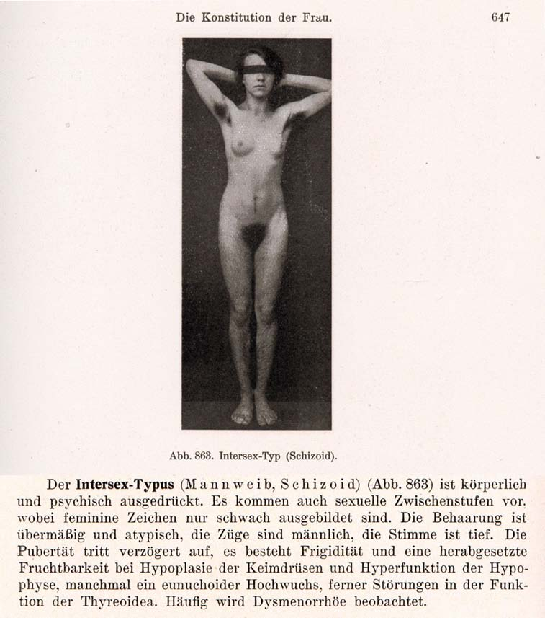
1916–1950s: “Intersex = bastardisation” caused by “racial mixing”;
racist gynaecological diagnosis “intersexual constitution”
The German geneticist Richard Goldschmidt (1878–1958) coined the terms “Intersex” and “Intersexuality” when publicising his experiments of crossbreeding “different geographic races” of gypsy moths, claiming to be able to produce “hermaphroditic” a.k.a. “intersex” specimens of any grade and shape at will, and thereafter extrapolating his findings to humans. Of Jewish descent, in 1936 Goldschmidt was forced to resign as director of the “Kaiser-Wilhelm-Institut für Biologie” in Berlin and emigrated to the United States. Despite Goldschmidt downplaying the “racial” background of his findings since the early 1930’s and later renouncing the underlying genetic theories altogether, the term “Intersex” and its “racial” implications prevailed. In 1924 the gynaecologists Paul Mathes (1871-1923, Austria) and Hans Guggisberg (180-1977, Switzerland) introduced the derived diagnosis “Intersexual Constitution” into human medicine, allegedly caused by “racial mixing”, “most frequent in Jews” and associated with “biological inferiority”, mental illnesses (see above “schizoid”), “hypertrophied clitoris” and a strict verdict “not fit for marriage.” It proved particularly popular among prominent eugenicists and Nazi doctors, including Fritz Lenz, Hans Naujoks, Lothar Gottlieb Tirala, Robert Stigler, Wilhelm Weibel, Walther Stoeckel, and kept being used in medical publications until the 1950s.
Sources: Wilhelm Weibel: Lehrbuch der Frauenheilkunde, 7th ed., Berlin/Wien 1944 p. 647 (photo), 648 (text).
Richard Goldschmidt: “Die biologischen Grundlagen der konträren Sexualität und des Hermaphroditismus beim Menschen”, in: Archiv für Rassen- und Gesellschaftsbiologie 12, 1916.
Paul Mathes, Hans Guggisberg: “Die Konstitutionstypen des Weibes, insbesondere der intersexuelle Typus”, in: Josef Halban, Ludwig Seitz: Biologie und Pathologie des Weibes. Bd.3, 1924.
Helga Satzinger: Racial Purity, Stable Genes, and Sex Difference: Gender in the Making of Genetic Concepts by Richard Goldschmidt and Fritz Lenz, 1916 to 1936. In: Heim et al. (ed.), The Kaiser Wilhelm Society under National Socialism, 2009.
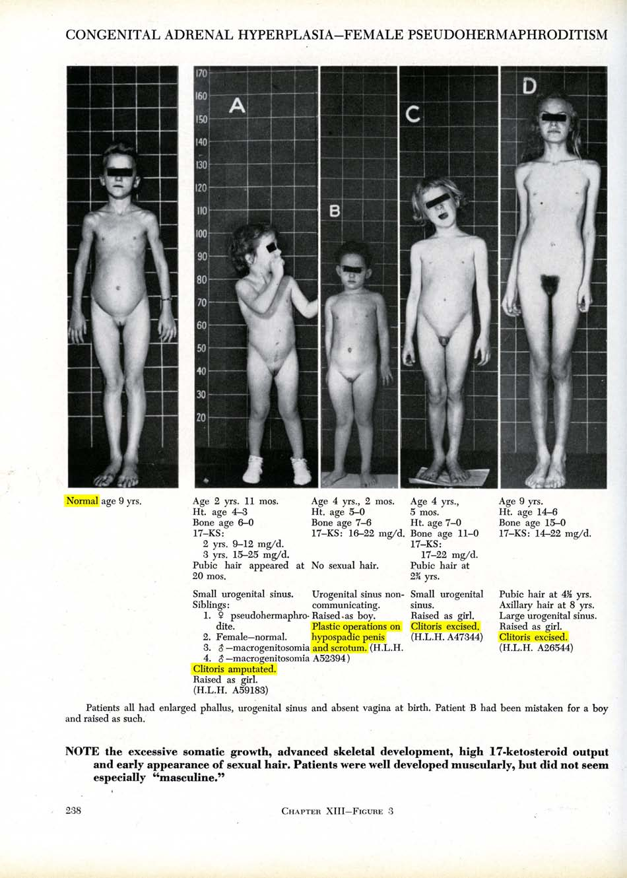
Baltimore and Zurich 1950: Start of systematic “genital corrections”
Lawson Wilkins (1894-1963), “The Father of Pediatric Endocrinology”, and teacher of the famous Swiss paediatric endocrinologist Andrea Prader in 1950, who then introduced the practice in Europe, was also the “inventor” of systematic cosmetic genital surgeries on children. As Wilkins’s monograph illustrates, in 1950 at Johns Hopkins in Baltimore, any child diagnosed “not normal” was submitted to drastic “genital corrections”, either “feminising” or “masculinising”. Often the psychologist John Money gets erroneously credited as having “invented” the systematic mutilations, however, it was Wilkins (and Prader) who started systematic surgeries; Money “only” delivered a “scientific rationale” five years after the fact.
Sources: Lawson Wilkins: The Diagnosis and Treatment of Endocrine Disorders in Childhood and Adolescence. Springfield, 1950.
Alison Redick: American History XY: The Medical Treatment of Intersex, 1916-1955, Dissertation 2004
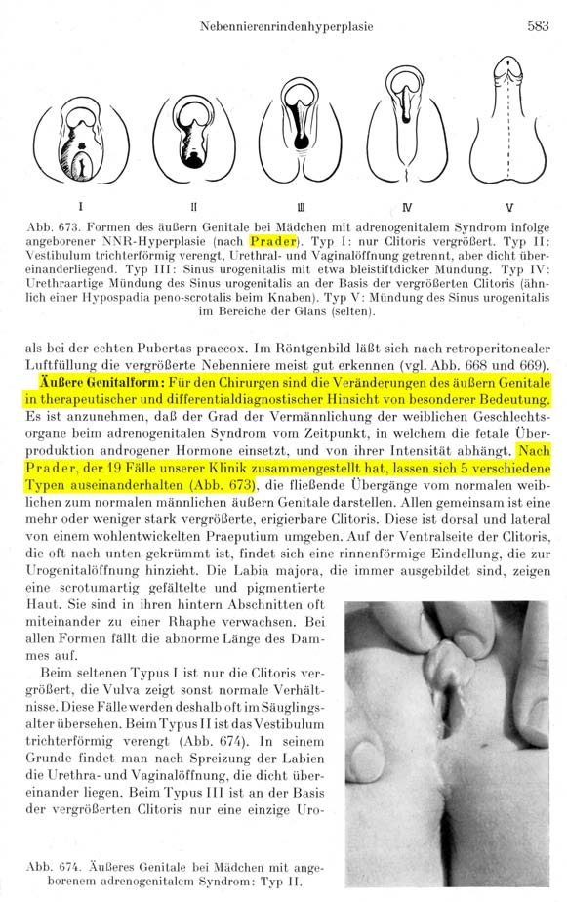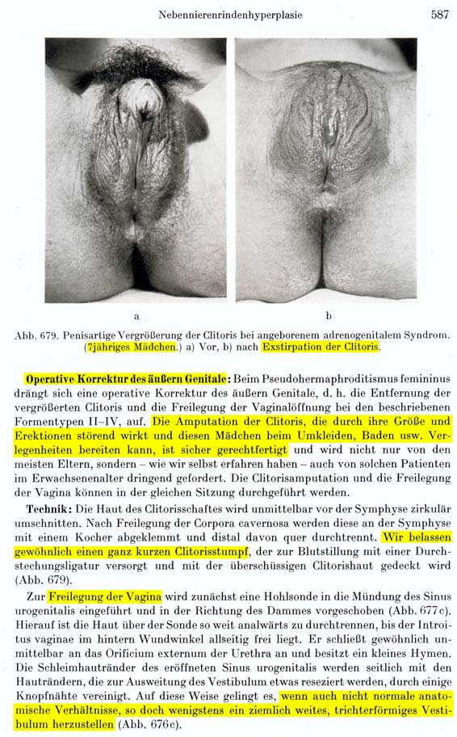
Zurich 1950s: Paediatric diagnosis “intersexuality”, Prader scales and
“surely justified” clitoris amputations based on psychosocial indications
The internationally renowned Swiss paediatric endocrinologist Andrea Prader (1919-2001) introduced the diagnosis “intersexuality” into paediatrics in his 1957 habilitation thesis, and later became the director Zurich University Children’s Hospital 1962-1986. The Swiss paediatric surgeon Max Grob (1901-1976) served as director of the Zurich University Children’s Hospital’s paediatric surgery unit 1939-1971, and in 1957 published his influential “Textbook on Paediatric Surgery” with contributing authors Margrit Stockmann (Luzern), and Marcel Bettex, then consulting paediatric surgeon in Zurich. Grob’s “Textbook”, indiscriminatingly hailed by the Zurich University Children’s Hospital until at least 2012, stressed the “special importance” of Andrea Prader’s newly developed systematic classification of “genital variations” (“Prader scales”) for surgeons. In its section on “surgical correction of the external genital” of children with 46,XX CAH, Grob stated, “the removal of the enlarged clitoris [...] suggests itself. [...] Technique: [...] Usually we leave a very short clitoris stump”. Grob proclaimed the psychosocial justifications for cosmetic genital surgery on intersex children still prevalent today: “The amputation of the clitoris, which may appear bothersome due to its size and erections, and may lead to embarrassment for these girls in the changing room or while swimming, is surely justified.” Grob became the founder and first president of the Swiss Society for Paediatric Surgery, and honorary member of the German, Austrian, British and U.S. societies. Grob’s recommendations in the “Textbook” (“surgical correction” in case of Prader Stages II–V, arguably devised with input by Prader himself), represented the global standard until the “Chicago DSD Consensus Conference” in 2005 (changing it to III–V).
Sources: Max Grob: Lehrbuch der Kinderchirurgie, with Margrit Stockmann and Marcel Bettex, Stuttgart, 1957, p. 583, 587.
Andrea Prader: Intersexualität, Habil. Univ. Zürich, Berlin 1957
Annexe 2 – IGM in Medical Textbooks: Current Swiss Practice
IGM 2 – “Feminising” Procedures: Partial Clitoris Amputation (Uni Geneva)
Source: Jacques Birraux (2017), “Management of disorders of sexual development: State of the art. A Surgeon’s perspective in Western Switzerland”. Thesis. Excerpt from “Feminization genitoplasty” (p. 33-35 in thesis, p. 30-32 in PDF), https://archive-ouverte.unige.ch/unige:103975

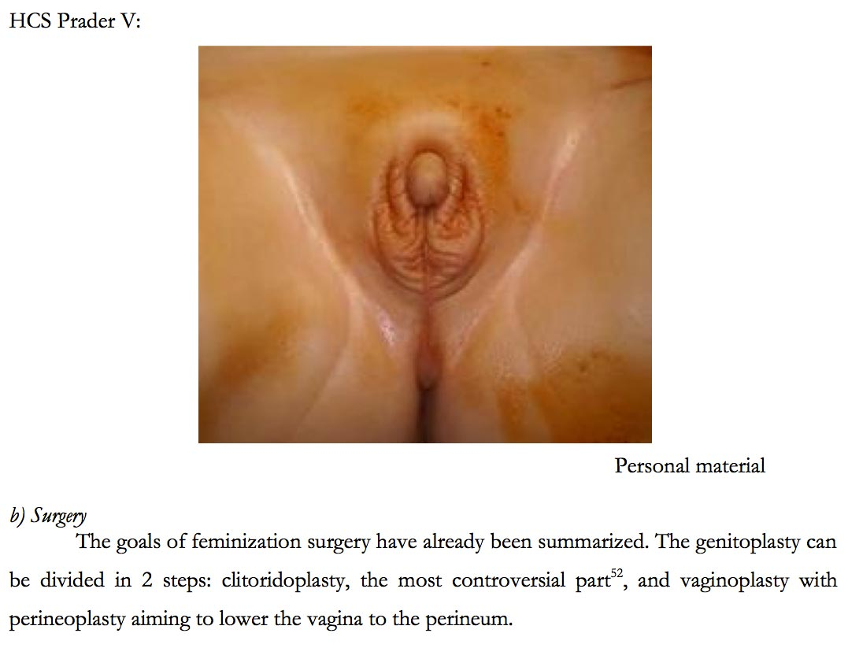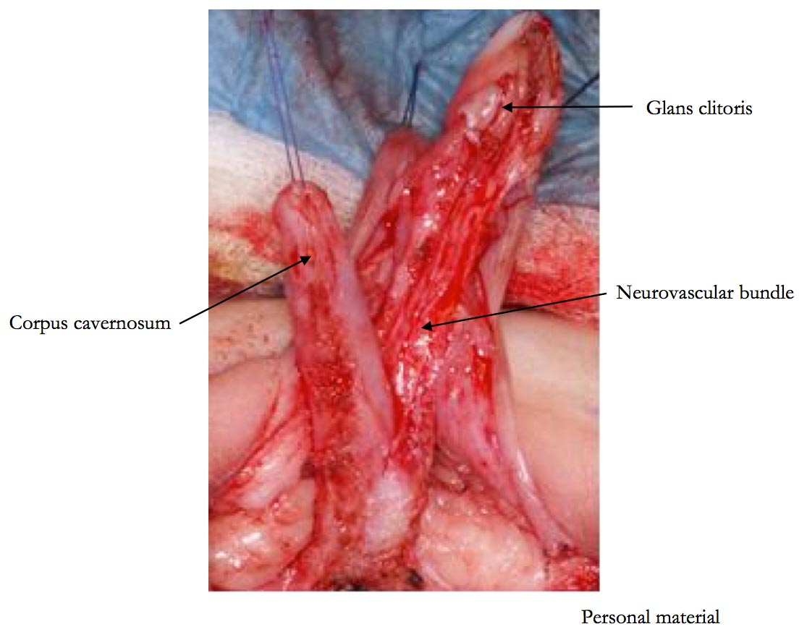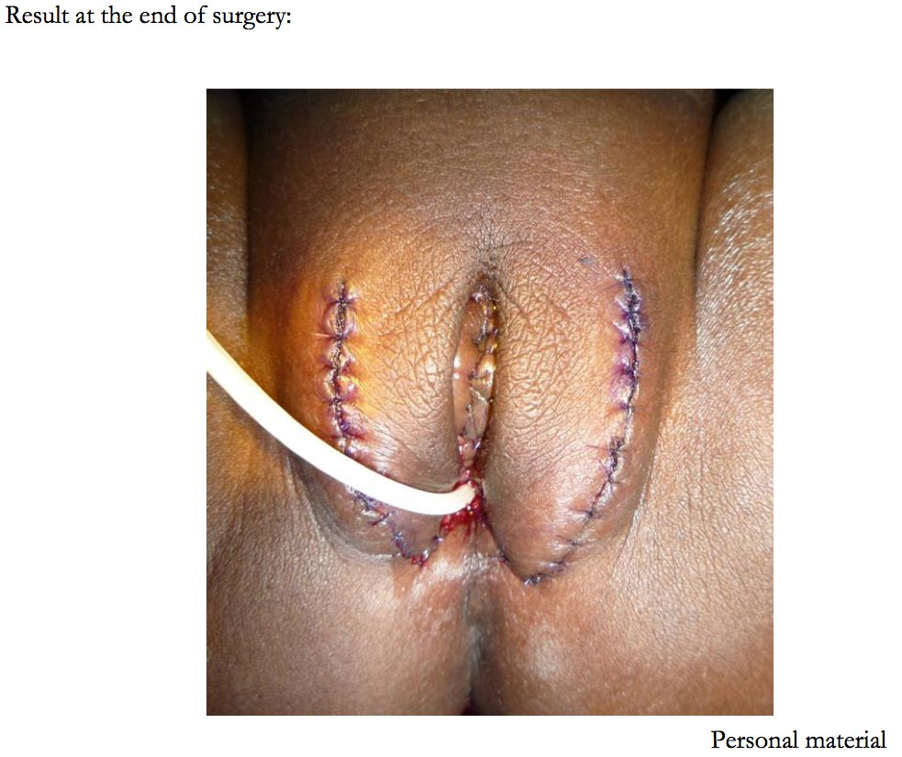

CAT, CRC, CRPD, SPT, SRT, SRSG VAC, COE, ACHPR, IACHR (2016), “End violence and harmful medical practices on intersex children and adults, UN and regional experts urge”, http://www.ohchr.org/EN/NewsEvents/Pages/DisplayNews.aspx?NewsID=20739&LangID=E
https://Zwischengeschlecht.org/ English pages: https://StopIGM.org/
https://zwischengeschlecht.org/post/Statuten
https://intersex.shadowreport.org/
https://intersex.ch/
http://intersex.shadowreport.org/public/2019-CRPD-LOI-Swiss-NGO-Zwischengeschlecht-Intersex-IGM.docx
Swiss National Advisory Commission on Biomedical Ethics NEK-CNE (2012), On the management of differences of sex development. Ethical issues relating to “intersexuality”, No. 20/2012, at 15-17, https://www.nek-cne.admin.ch/inhalte/Themen/Stellungnahmen/en/NEK_Intersexualitaet_En.pdf For the relevant numbers in the List of Birth Defects, see https://blog.zwischengeschlecht.info/pages/Kosmetische-Genitaloperationen-Ziffern-Liste-der-Geburtsgebrechen For relevant numbers in most frequent current IGM practices see 2017 CCPR Swiss NGO Report, p. 8-10, https://intersex.shadowreport.org/public/2017-CCPR-Swiss-NGO-Zwischengeschlecht-Intersex-IGM.pdf
Full report (19.12.2018), https://biblio.parlament.ch/e-docs/1901442546.pdf Media release (19.12.2018), “Convention on the Rights of the Child: Report on further measures for implementation”, https://www.admin.ch/gov/de/start/dokumentation/medienmitteilungen.msg-id-73468.html
p. 58 of the report (p. 68 in PDF)
https://uroweb.org/guidelines/endorsement/
https://uroweb.org/guideline/paediatric-urology/ https://uroweb.org/wp-content/uploads/EAU-Guidelines-on-Paediatric-Urology-2021-1.pdf
https://uroweb.org/guideline/paediatric-urology/#3_17_5
https://uroweb.org/guideline/paediatric-urology/#3_17_4
P. Mouriquand, A. Caldamone, P. Malone, J.D. Frank, P. Hoebeke, “The ESPU/SPU standpoint on the surgical management of Disorders of Sex Development (DSD)”, Journal of Pediatric Urology vol. 10, no. 1 (2014), p. 8-10, http://www.jpurol.com/article/S1477-5131(13)00313-6/pdf
Lee et al., “Global Disorders of Sex Development Update since 2006: Perceptions, Approach and Care”, Horm Res Paediatr 2016;85:158–180, https://www.karger.com/Article/Pdf/442975
Ibid., at 180 (fn 111)
https://uroweb.org/guideline/paediatric-urology/#3_17
https://uroweb.org/guideline/paediatric-urology/#3_17_4
Ibid.
Ibid.
https://www.espu.org/images/documents/ESPU_Open_Letter_to_COE_2018-01-26.pdf
https://uroweb.org/guideline/paediatric-urology/#3_6
https://uroweb.org/guideline/paediatric-urology/#3_6_5_3
https://uroweb.org/guideline/paediatric-urology/#3_6_5_1
Ibid.
For details and relevant quotes, see our 2019 CRPD Switzerland LOI NGO Report, p. 20
Grit Sommer, Daniel Konrad, Beatrice Kuhlmann, Dagmar L’Allemand, Franziska Phan-Hug, Michael Hauschild, Valerie Schwitzgebel, Paolo Tonella, Melanie Hess, Urs Zumsteg, Anna Lauber-Biason, Christa E. Flück, for the Working Group DSD of the Swiss Society for Pediatric Endocrinology and Diabetology (AG DSD SGPED) (2018), “Current medical care of children and adolescents with disorders of sex development in Switzerland”, poster P2-P346 at ESPE 2018, https://abstracts.eurospe.org/hrp/0089/eposters/hrp0089p2-p346_eposter.pdf
Doris Hebenstreit, Faisal Ahmed, on behalf of the contributing centres within the I-DSD registry and I-CAH registry, Alexander Springer, Christoph Krall, Nils Krone, Niels Birkebaek, Tatjana Milenkovic, Birgit Koehler, Christa Flueck (Pediatric Endocrinology, Diabetology and Metabolism, Department of Pediatrics, University Hospital Inselspital, University of Bern, 3010 Bern, Switzerland; Department of BioMedical Research, University Hospital Inselspital, University of Bern, Bern, Switzerland), Ruth Krone, Antonio Balsamo, Rodolfo Rey, Carlo Acerini, Alya Guven, Tulay Guran, Feyza Darendeliler, Sabah Alvi, Marta Korbonits, Walter Bonfig, Eduardo Correa Costa, Richard Ross, Violeta Iotova, Daniel Konrad, Jillian Bryce, Hedi Claahsen van der Grinten, Liat de Vries, Contemporary surgical approach in CAH 46XX – Results from the I-DSD/I-CAH Registries, presentation at ESPE 2019, see Abstract Book, p. 96, https://www.karger.com/Article/Pdf/501868
https://www.swisspednet.ch/header/about-us/
https://www.swisspednet.ch/header/collaborations
https://www.ukbb.ch/de/ukbb/abteilungen-dienste/chirurgie.php#anchor_9a0a567a_Accordion-Urologie Official english translation taken from: http://web.archive.org/web/20210116182738/https://www.ukbb.ch/en/ukbb/departments-services/surgery.php#anchor_9a0a567a_Accordion-Urology
http://www.kinderklinik.insel.ch/de/unser-angebot/urologie/
https://www.hug.ch/chirurgie-pediatrique/desordre-du-developpement-sexuel
https://www.hug-ge.ch/chirurgie-pediatrique/malformation-de-la-verge
https://www.hug-ge.ch/chirurgie-pediatrique/votre-enfant-va-etre-opere-hypospadias
See p. 37 in thesis, p. 40 in PDF, https://archive-ouverte.unige.ch/unige:103975
https://www.chuv.ch/fr/dfme/dfme-home/enfants-famille/specialites-medicales/chirurgie-de-lenfant-et-de-ladolescent/urologie-pediatrique
https://www.kispi.uzh.ch/kinderspital/fachkompetenzen/angebot-fuer-patientinnen-und-patienten/urologie
https://web.archive.org/web/20170110130505/https://www.kispi.uzh.ch/de/patienten-und-angehoerige/fachbereiche/urologie/Seiten/default.aspx#a=akk3
https://www.kispi.uzh.ch/de/patienten-und-angehoerige/fachbereiche/urologie/Seiten/default.aspx - a=akk3
https://www.kispi.uzh.ch/kinderspital/glossar#hypospadie
https://www.ksa.ch/zentren-kliniken/kinderchirurgie/leistungsangebot
https://www.luks.ch/standorte/standort-luzern/kinderspital/leistungsangebot-kinderspital/nieren-harnwege-blase-und-geschlechtsorgane-bei-kindern-und-jugendlichen
https://www.kispisg.ch/de/fachbereiche/kompetenzen/urologie
https://www.kispisg.ch/downloads/kompetenzen/endokrinologie/flyer_sprechstunde_eng_def.pdf
https://www.eoc.ch/en/Media-e-comunicazione/Comunicati/2004/Compie-5-anni-il-Servizio-cantonale-di-chirurgia--pediatrica.html#
Jacques Birraux (2017), “Management of disorders of sexual development: State of the art. A Surgeon’s perspective in Western Switzerland”. Thesis, see chapter “II. C) Acquired knowledge in Cameroon”, p. 7-13 (p. 10-16 in PDF), https://archive-ouverte.unige.ch/unige:103975
Céline M Girardin, Mirjam Dirlewanger, Frédérique Sloan-Béna, Serge Nef, Anne-Laure Rougemont, Jacques Birraux, Valerie M Schwitzgebel (2014), Geneva University Children’s Hospital, “46, XX Ovotesticular Disorder of Sex Development: Potential Role of 13q31.1”, poster P1-D3-97, 53rd Annual Meeting of the ESPE, https://abstracts.eurospe.org/hrp/0082/eposters/hrp0082p1-d3-97_eposter.pdf
Birraux Jacques (Paediatric Surgery, Department of Pediatrics Children's Hospital, University Hospital of Geneva, Switzerland), Dahoun Sophie, Rougemont-Pidoux Anne-Laure, Le Coultre Claude (University of Geneva, University Hospital of Geneva, Switzerland), Mouriquand Pierre, Plotton Ingrid, Morel Yves, Gay Claire-Lise; Tardy Véronique, Mouafo Faustin, Mure Pierre-Yves, “Gender Assignment in 46XX Ovotesticular DSD: Experience learned from a series of 16 consecutive children”. Manuscr Prep.
Jacques Birraux (Paediatric Surgery, Department of Pediatrics Children’s Hospital, University Hospital of Geneva, Switzerland), Faustin Tambo Mouafo, Sophie Dahoun (Department of Genetics, University Hospital of Geneva, Switzerland), Veronique Tardy, Yves Morel, Pierre Mouriquand, Claude Le Coultre (Paediatric Surgery, Department of Pediatrics Children's Hospital, University Hospital of Geneva, Switzerland), Pierre-Yves Mure (2015), “Laparoscopic-assisted vaginal pull-through: A new approach for congenital adrenal hyperplasia patients with high urogenital sinus”, Afr J Paediatr Surg 2015;12:177-80, https://www.afrjpaedsurg.org/article.asp?issn=0189-6725;year=2015;volume=12;issue=3;spage=177;epage=180;aulast=Birraux
Jacques Birraux (Paediatric Surgery, Department of Pediatrics Children’s Hospital, University Hospital of Geneva, Switzerland), Faustin Tambo Mouafo, Sophie Dahoun (Department of Genetics, University Hospital of Geneva, Switzerland), Veronique Tardy, Yves Morel, Pierre Mouriquand, Claude Le Coultre (University of Geneva, University Hospital of Geneva, Switzerland), Pierre-Yves Mure (2015), “Laparoscopic-assisted vaginal pull-through: A new approach for congenital adrenal hyperplasia patients with high urogenital sinus”, Afr J Paediatr Surg 2015;12:177-80, https://www.afrjpaedsurg.org/article.asp?issn=0189-6725;year=2015;volume=12;issue=3;spage=177;epage=180;aulast=Birraux
M.T.F. Felicien, F.K. Gacelle, S.A. Sadjo, E.C. Dikongue Dikongue, D.B. Gorduza, S. Dahoun (Department of Genetics, University Hospital of Geneva, Switzerland), C. Le Coultre (Paediatric Surgery, Department of Pediatrics Children's Hospital, University Hospital of Geneva, Switzerland), M. Boniface, A.O. Gervais, S.M. Aurelien, M. Pierre-Yves (2021), Génitoplastie féminisante dans les anomalies du développement sexuel de l’enfant pré-pubère et de l’adolescente au Cameroun. À propos de 9 cas, Progrès en Urologie, https://www.sciencedirect.com/science/article/pii/S1166708721000038
Sap, S., Mbono Betoko, R., Etoa Etoga, M., Mure, P., Morel, Y., Dahoun (Department of Genetics, University Hospital of Geneva, Switzerland), S., Mouafo Tambo, F., Moiffo, B., Sobngwi, E. & Koki Ndombo, P. (2020), Observational study of disorders of sex development in Yaounde, Cameroon. Journal of Pediatric Endocrinology and Metabolism, 33(3), 417-423, https://pubmed.ncbi.nlm.nih.gov/32069241/
Faustin Felicien, M. T., Nwaha Makon, A. S., Kamadjou, C., Fossi, G., Le Coultre, C. (Paediatric Surgery, Department of Pediatrics Children’s Hospital, University Hospital of Geneva, Switzerland), Andze, O. G., Sosso, M. A., & Mure, P. Y. (2016), Our experience of proximal hypospadias repair using the Cloutier-Bracka technique at the Gynaeco-Obstetric and Paediatric Hospital, Yaounde-Cameroon. African journal of paediatric surgery: AJPS, 13(4), 193–195, https://www.ncbi.nlm.nih.gov/pmc/articles/PMC5154226/
Sap, S., Mouafo. F., Sobngwi, E, Walburka Y, Dahoun, S. (Department of Genetics, University Hospital of Geneva, Switzerland), Morel, Y., Mure, PY., LeCoultre, C. (Paediatric Surgery, Department of Pediatrics Children’s Hospital, University Hospital of Geneva, Switzerland), Koki, PO. (2016), Poster “Disorders of Sex Genitalia in Yaounde: Difficult Questions, Which Answers?” at 55th annual ESPE conference, https://abstracts.eurospe.org/hrp/0086/hrp0086p2-p408
https://www.childrenaction.org
See “Malformations urologiques: En savoir +”, https://www.childrenaction.org/acces-aux-soins-1
See Annexe, p. 20, https://ge.ch/grandconseil/data/texte/M02491C.pdf
Julius Kaggwa, SIPD Uganda, personal communications, September 2015 and January 2020
https://docplayer.org/docview/67/57305366/#file=/storage/67/57305366/57305366.pdf
https://idsdorg.files.wordpress.com/2020/08/i-dsd-2021-bern-v3.0-1.pdf
Answer of the Cantonal Government KR-Nr. 37/2020, https://parlzhcdws.cmicloud.ch/parlzh5/cdws/Files/59a6b9dc8b7b4c118adde0d55c0968d1-332/1/pdf
Motion 2491 “to end the mutilations of intersex people”, http://ge.ch/grandconseil/search?search=2491 Motion 2541 “No more mutilations practiced on intersex people”, http://ge.ch/grandconseil/search?search=2541 Protocol of the Great Council of the Republic and Canton of Geneva (10 April 2019, 21:00-22:35, Item 123), http://ge.ch/grandconseil/sessions/seances-pv-lion/22/?session=66 See also statement of StopIGM.org to the Great Council (26.09.2018), https://stopigm.org/public/StopIGM-Geneve-M2491-mutilations-personnes-intersexes.pdf
See statements of Céline Zuber-Roy and Mauro Poggia, http://ge.ch/grandconseil/memorial/seances/020111/66/7/
Answer of the Cantonal Government M 2541-A, https://ge.ch/grandconseil/data/texte/M02541A.pdf Answer of the Cantonal Government M 2491-B, https://ge.ch/grandconseil/data/texte/M02491B.pdf
https://intersex.shadowreport.org/public/Lettre-ouverte-Mauro-Poggia-Mutilations-aux-HUG.pdf
https://www.rts.ch/play/tv/19h30/video/les-operations-sur-des-patients-intersexes-doivent-etre-consenties?urn=urn:rts:video:10816273
Urgent Written Question QUE 1201, https://ge.ch/grandconseil/data/texte/QUE01201.pdf
Answer of the Cantonal Government QUE 1201-A, https://ge.ch/grandconseil/data/texte/QUE01201A.pdf
See video recording of Session at 00:45:44, https://media.un.org/en/asset/k1n/k1nomm95h6
Reply on intersex children by Swiss delegation member Ms. Maryam Boutefah (Federal Office of Public Health FOPH). Unofficial translation from original French, see video recording of Session at 02:41:24, https://media.un.org/en/asset/k1n/k1nomm95h6
https://www.bsv.admin.ch/bsv/en/home/social-insurance/iv.html
https://www.bsv.admin.ch/bsv/en/home/social-insurance/iv/grundlagen-gesetze/leistungen-iv.html
https://www.ahv-iv.ch/en/Social-insurances/Glossary/term/invalidenversicherung-iv
https://www.zg.ch/english/individuals/labour/social-security-system-1/three-pillar-system-old-age-invalidity-survivors-1
https://www.sz.ch/public/upload/assets/21185/overview_social_security_system.pdf
https://www.vaud-welcome.ch/practical-information/pratical-information/insurance
https://www.zh.ch/content/dam/zhweb/bilder-dokumente/themen/gesundheit/krankenversicherung/confirmation_form_c_english.pdf
https://ethz.ch/students/en/studies/administrative/insurances.html
https://www.cvcicaisseavs.ch/en/employer/invalidity-insurance-ai.html
https://www.ohchr.org/Documents/Issues/Development/SR/visit-to-switzerland/fsio_overview.pdf
https://www.oecd.org/switzerland/33742823.pdf
https://ec.europa.eu/social/main.jsp?catId=1131&langId=en&intPageId=4826
https://www.ahv-iv.ch/de/Sozialversicherungen/Invalidenversicherung-IV
https://www.ahv-iv.ch/fr/Assurances-sociales/Assurance-invalidit%C3%A9-AI
https://www.ahv-iv.ch/it/Assicurazioni-sociali/Assicurazione-per-linvalidit%C3%A0-AI
See p. 2, 6: https://www.fedlex.admin.ch/filestore/fedlex.data.admin.ch/eli/fga/2018/1916/fr/pdf-a/fedlex-data-admin-ch-eli-fga-2018-1916-fr-pdf-a.pdf
Urs Hafner (2022), Zwischen den Geschlechtern, NZZ am Sonntag, 30.01.2022, p. 52, paywall: https://nzzas.nzz.ch/wissen/wie-zuercher-aerzte-intersexuelle-kinder-zur-normalitaet-zwangen-ld.1666977, PDF: https://blog.zwischengeschlecht.info/public/Hafner-Kispi-Intersex-Studie-SNF-30-01-22-S-52-NZZaS.pdf
See p. 3, https://www.samw.ch/dam/jcr:a3c30d76-dc01-4103-9fa5-16cdf37aa5e9/prise_de_position_assm_cce_dsd_2016.pdf
Urs Hafner (2022), Zwischen den Geschlechtern, NZZ am Sonntag, 30.01.2022, p. 52, paywall: https://nzzas.nzz.ch/wissen/wie-zuercher-aerzte-intersexuelle-kinder-zur-normalitaet-zwangen-ld.1666977, PDF: https://blog.zwischengeschlecht.info/public/Hafner-Kispi-Intersex-Studie-SNF-30-01-22-S-52-NZZaS.pdf
Interpellation 18.3470, https://www.parlament.ch/fr/ratsbetrieb/suche-curia-vista/geschaeft?AffairId=20183470
See e.g. 2020 CRC State Report, para 119.

