Joint Contribution for the 89th Session of the Convention on the Elimination of All Forms of Discrimination Against Women (CEDAW)

Discrimination Against Women and Social Rights in Cuba: Labor Guarantees and Sexual and Reproductive Rights
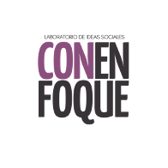
Report Led by: ConEnfoque

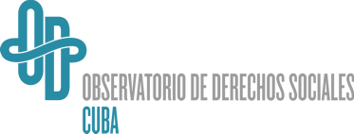


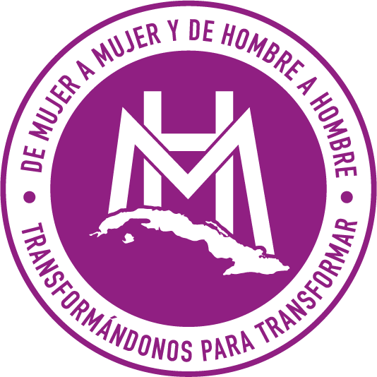
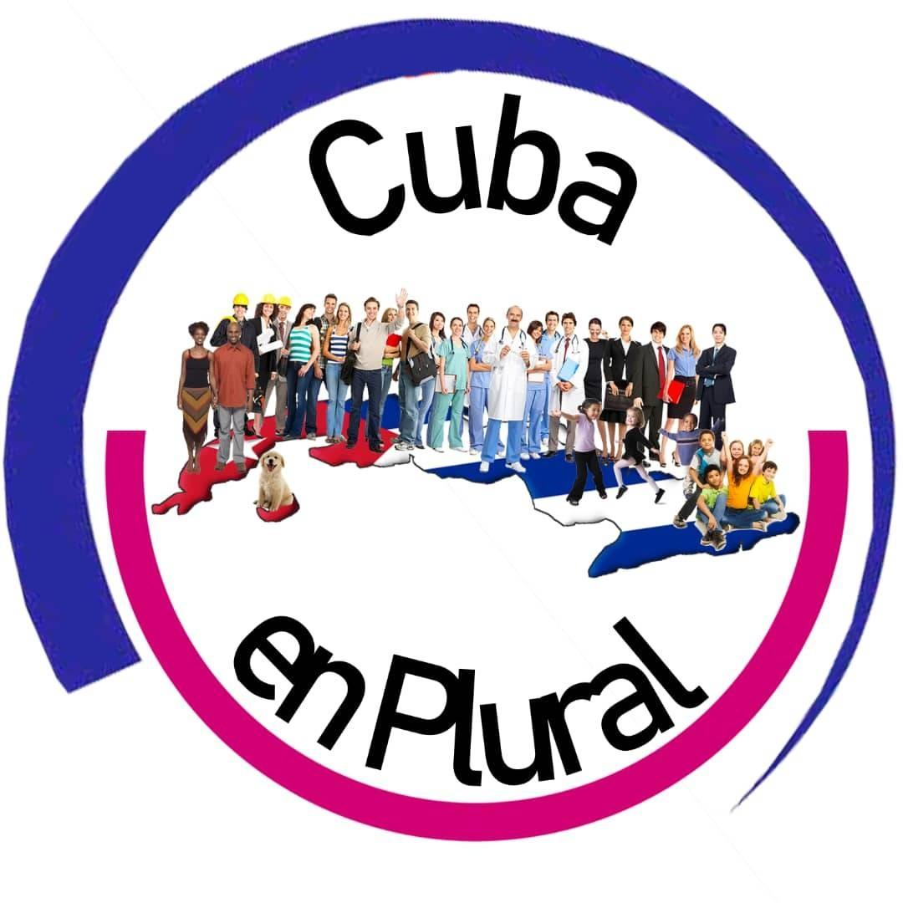

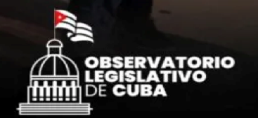
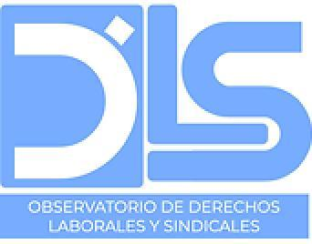
Authors: This report was written by ConEnfoque in collaboration with Observatorio Cubano de Derechos Humanos, Observatorio de Derechos Sociales de Cuba, 4Métrica, Cuido60, Observatorio de Derechos Laborales y Sindicales, Observatorio Legislativo de Cuba, De Mujer a Mujer y De Hombre a Hombre, Cuba en Plural.

Access to Employment and Labor Guarantees
- Regarding strategies and measures to promote formal employment access, the Ministry of Labor and Social Security, within the framework of the National Program for the Advancement of Women, aims to provide opportunities and potentials for women to have decent employment. Other initiatives, such as the Macroprogram for Human Development, Equity, and Social Justice—which includes the Decent Work Program—and the National Program 'Color Cubano' provide guidelines aimed at enhancing women's roles in employment. These programs also aim to eliminate any situation of vulnerability or disadvantage. However, despite normative progress, their implementation remains limited, fragmented, and without clear results.
- Briefly addressing the current context on the island, within the framework of the complex economic crisis exacerbated by issues related to energy, the effects of the COVID-19 pandemic in 2020, and the “Tarea Ordenamiento” (Ordering Task), the situation concerning employment is also alarming. According to data from the National Employment Survey published by the National Office of Information and Statistics (ONEI) in 2022, the Labor Force Participation Rate was 50.8%, which implies that just over half of Cubans aged 15 and older were part of the Economically Active Population.
- Delving into this last indicator, which refers to the sector of the working-age population providing labor for the production of goods and services, it has experienced a 4.2% reduction compared to 2020, indicating an increase in unemployment in the country. In other words, around 3,000,000 Cubans capable of working are unemployed and in a concerning labor limbo. The increasing labor shortage on the island is compounded by the fact that Cuba is the most aging country in the region, with 21.9% of the population being 60 years or older; correspondingly, almost half of the current workforce is between 45 and 60 years old.
- When focusing exclusively on women, the problem becomes more complex. According to the 2022 National Employment Survey, women make up 63.7% of the economically inactive population, while employment for that year was dominated by men at 61.8% and only 38.2% by women. Other revealing data indicates that, concerning micro, small, and medium-sized enterprises (MSMEs) on the island—which numbered around 4,096 in 2022—only 23.3% of their partners were women. Moreover, in self-employment, women represent only 34%, often as employees of the owner rather than as owners themselves.
- Regarding executive positions, in 2021, women occupied 31% of such roles, a decrease from 38.7% in 2020, even though women complete their studies more often than men and hold more university degrees, with 60% compared to 40% for men. The reasons behind these figures are related, among other things, to the daily activities performed by women that prevent them from actively participating in the labor market. Unpaid work and caregiving tasks play a significant role; of the total number of women in the Economically Active Population (1,168,035), 72.09% are engaged in these types of tasks and other household chores. This dynamic contrasts with that of economically inactive men, who are mostly in this situation due to studies, disability, or retirement.
- This trend worsens for rural women, who in 2019 represented 46.3% of the total rural population and only 26.1% of the economically active workforce. Moreover, more than 60% did not have a formal employment link, which does not mean they do not work. Indeed, they participate in various tasks related to animal care, farming, and caregiving, among others, which, although crucial for the development of the countryside and sustaining the economy, are neither paid nor considered work per se. According to the report "Ascenso a la raíz: La perspectiva local del Desarrollo Humano en Cuba 2019," around 98% of rural women engage in unpaid work, representing a significant portion of their personal time. This scenario relegates women living in rural areas, who daily face the burden of unpaid work, informality, and lack of opportunities, creating increasing economic dependence.
- The so-called sexual division of labor is exacerbated in these contexts, where women must prioritize time dedicated to home and family care. This is further complicated by limited options, where women's presence in land management and control is minimal, relying on male family members for property matters. According to the National Voluntary Report of Cuba to ECLAC (2022), in the rural sector, only 44,027 women are registered as land usufructuaries, representing 16% of the total, and 30,955 are landowners, accounting for 32% of total owners. Additionally, only 20% of the members of the National Association of Small Farmers are women.
- For those who participate in the formal labor market, the situation remains complex. According to the latest National Gender Equality Survey conducted in 2016, women worked approximately 22.06 hours per week, which is 12 hours less than men. This does not exclude them from being the primary caregivers for household tasks, which they must perform alongside their formal employment, including mainly meal preparation, home cleaning, and laundry tasks.
- The survey also revealed that more than 45% of men and 30% of women believe that daughters, mothers, and generally women are the ones who engage in domestic chores. Another significant figure is that over 90% of respondents consider women more suitable for jobs related to caregiving, cooking, and cleaning, as opposed to men.
- This situation has undoubtedly worsened in the context of the current Cuban economic crisis. According to reports from the Cuban Observatory on Human Rights (2020), women have been more vulnerable to the crisis, exacerbating their family, financial, and health situations. For instance, elderly women lead their households in 71% of cases. During the crisis, they had to shoulder greater responsibilities, and 23% also took on the care of other elderly individuals. This led to more complex family interactions, as women faced increased stress and challenges due to food shortages and household responsibilities. Additionally, Naranjo and Echavarría noted that the pandemic increased the demand for women's domestic labor. In Santiago de Cuba, for example, women were primarily responsible for the care of children and the elderly in over 60% of households, and 26% of respondents acknowledged the excessive domestic workload borne by women.
- An example of this is the dynamics surrounding education. During the pandemic, women took on new responsibilities as their children stopped attending school, and they had to engage in activities related to their children’s education without a reduction in their paid work. Hernández describes the crisis’ burden on women as part of a patriarchal dynamic that forced them to undertake tasks such as maintaining household hygiene, caring for children and the sick, demonstrating "creativity" to feed the family, and making efforts to acquire necessary products amidst scarcity. All while continuing with their routine tasks, whether through teleworking or, if required by their profession, leaving home to work. This has led to neglect of their physical and emotional health.
- While the situation is complex for women in general, from a differential perspective, besides rural women, other groups experience even greater complexities regarding work, such as racialized women. Compared to white women, racialized women face higher unemployment, greater participation in unskilled or service jobs, less access to foreign currency, and higher involvement in informal employment. Referring to the last population and housing census of 2012, among households headed by single women, 49.1% were Black women. Furthermore, according to the 2016 Census of Population and Housing by Skin Color, unemployment rates, when considering racial factors, show a slight disadvantage for racialized women, with a 4.4% rate for mestizo women and 3% for Black women.
- Considering the living conditions of the latter group, the study showed that Black families experience overcrowding, worse infrastructure, lower access to water, and greater use of shared bathrooms. The disadvantage faced by racialized women, which is a structural phenomenon extending to various areas where skin color becomes a differentiating factor, also translates into the labor sector. There is a noticeable gap in the types of jobs held: positions related to science and innovation are predominantly occupied by white women, while Black women are overrepresented in construction jobs. Additionally, they hold fewer leadership and managerial positions due to entrenched racial and gender biases. This issue also affects women with disabilities, who lack differential attention and clear strategies for their involvement in the labor sector, even though 7% of the Cuban population has some form of disability, with women being the majority.
- Regarding wage gaps, the Cuban government has not made public information about salary differences between men and women. However, independent sources provide some insight into the issue. The Latin American and Caribbean Women's News Service (SEMLAC) concluded in 2019 that the wage gap on the island is related to occupational segregation and the sexual division of labor, which assigns caregiving roles to women and limits their participation in the labor market. They state, “Women are the ones who miss work more often due to this reason, resulting in lost working hours and its implications for wages.
- Additionally, in 2018, for example, it was identified that the highest-paying economic activities were predominantly occupied by men. Furthermore, women only held 38.4% of executive positions, which are higher on the salary scale. Wage differences can also be observed through the taxation regime, which reflects the complexity of the activity performed and its corresponding income level. Lower levels are taxed under a simplified regime; by 2016, 73% of women with licenses to operate in the private sector were taxed under this regime, indicating that they have lower income levels.
- Referring to the dynamics and differentiating factors between the private and state labor sectors, the former created nearly twice as many jobs as the latter in 2022, with 226,704 compared to 79,912 respectively, according to the Ministry of Labor and Social Security. However, women represented only 34% of these positions. The private sector, better known as Self-Employment in Cuba, has indeed been a viable option for many women seeking job opportunities or wanting to increase their income. Nevertheless, it presents significant challenges, including job insecurity and the absence or precariousness of contracts. Many agreements are verbal, and there are no standards regarding wages. This situation is exacerbated for women, who, for example, lack guarantees during stages such as maternity. Despite the demand for employment and the island's economic crisis, many women sacrifice their labor rights to keep their jobs.
- Finally, it is essential to mention that, alongside this critical labor context for women, Cuba has yet to ratify the International Convention on Domestic Workers (No. 189) and the Convention on Violence and Harassment (No. 190). With the available information, it cannot be assured that any significant steps have been taken towards ratification.
Decree-Law: "On the Maternity of the Worker and the Responsibility of Families" and the Results Obtained
- Decree-Law 56 of 2021, titled "On the Maternity of the Worker and the Responsibility of Families," establishes standards to expand labor benefits for mothers. However, evaluating the progress made in its implementation is challenging without a proper study. In 2024, a modification was introduced that extends maternity leave until the child is 15 months old, representing a significant advancement in supporting families, especially mothers and their children. Previously, paid leave only covered up to 12 months of the child’s age, with an additional three months as unpaid leave.
- Despite the advances this regulation represents in recognizing the particular needs of mothers in the labor and family spheres, significant challenges remain in its application. Notable differences are observed between women employed in the state sector and those in the non-state sector. For instance, to access maternity economic benefits, state sector workers only need to be employed at the start of prenatal leave, regardless of the type of contract. In contrast, private sector workers must have contributed to the special regime during the 12 months preceding the start of leave. Another difference concerns the calculation of the economic benefit. Although the minimum wage is used as a reference when the salary and average contribution base are lower in both sectors, this rule does not apply in the non-state sector in certain situations, such as in the 100% benefit provided to pregnant women or monetary benefits for mothers with sick children.
- Lastly, an additional challenge under this regulation is the shortage of adequate childcare options, which is necessary for women to be able to work. The service provided by Child Circles in Cuba is insufficient, with approximately 43,000 requests from Cuban mothers waiting for a spot for their children in 2023, a process that is even more complicated for those not employed in the state sector. The government has expressed a desire to extend the so-called "childcare centers," an option that must be assumed by the workplaces and requested from the Ministry of Education. However, no significant progress has been evident (Tosar, 2023). In 2021, within the “For Cuban Rural Women” campaign, signatures were collected to open more Child Circles to provide over a million Cuban women living in rural areas the opportunity to access employment and achieve economic independence due to the limitations of unpaid care work. According to official data, in 2019 Cuba had 1,122 Child Circles, with a room for over 130,000 children, which is insufficient. Additionally, capacities were reduced in provinces such as Pinar del Río, Artemisa, Ciego de Ávila, and Guantánamo.
- Considering what has been addressed so far regarding women and employment, it is essential for the Cuban government to strengthen the implementation of current policies, such as the "National Program for the Advancement of Women." Although there are regulatory frameworks aimed at enhancing women's roles in employment, their application remains limited and fragmented. Therefore, it is recommended to establish clear monitoring and evaluation mechanisms to ensure these policies translate into concrete actions with tangible results.
- Moreover, it is crucial to recognize that one of the greatest barriers to female participation in the labor market is the lack of infrastructure and support regarding childcare. It is suggested to significantly expand the capacity of Child Circles and prioritize the creation of "childcare centers" across the country, which is vital for more women, especially those living in rural areas, to access formal employment and achieve economic independence. Additionally, the private sector has proven to be a significant source of job creation, so policies should be developed to ensure job security and women's rights in this sector, including maternity protection and the establishment of formal contracts with adequate salary standards.
- Reducing the gender gap in employment is also a priority. To achieve this, specific measures must be implemented to increase women's participation in formal employment, particularly in sectors where they are underrepresented, such as leadership roles and fields of science and innovation, which are often dominated by men due to gender and racial biases. Additionally, rural women, racialized women, and women with disabilities face additional barriers in the labor market. It is imperative for the government to design specific policies that address the needs of these groups, such as training programs in relevant skills and initiatives that facilitate their inclusion in formal employment.
- Transparency in information about salary gaps between men and women is also crucial. The government should publish data on this issue and develop policies to reduce these disparities. These policies should address occupational segregation and the unequal distribution of unpaid care tasks, which limit women's participation in the labor market. Furthermore, it is essential for Cuba to ratify the ILO Convention on Domestic Workers (No. 189) and the Convention on Violence and Harassment (No. 190), which would strengthen the legal framework to protect female workers, especially in vulnerable sectors.
- To promote gender equality from an early age, educational programs should be implemented to change traditional perceptions that limit women's job opportunities. These programs should include continuous training in high-demand areas. It is also crucial for the government to support rural women in accessing land ownership and other productive resources. Foster their inclusion in agrarian development programs and associations such as the National Association of Small Farmers, ensuring they receive the necessary support to take on leadership roles in their communities. Lastly, it is advisable for the government to establish comprehensive support centers offering psychosocial support, legal advice, and employment services for women facing difficulties in the labor market, especially those in vulnerable situations. These integrated and effectively applied measures could significantly improve the situation of women in the Cuban labor market, reducing gender inequalities and promoting more equitable development in the country.
Sexual and Reproductive Health
- The state of sexual and reproductive health and the promotion and prevention strategies for women on the island continue to face significant challenges. In Cuba, as of 2022, more than 17% of births are to women under 20 years old. Although the country has a low birth rate, fertility among Cuban girls under 18 has increased in the past 15 years. Specifically, regarding teenage pregnancies, the Cuban Parliament reported 7,953 pregnancies among girls aged 12 to 19 in the first half of 2023, out of a total of 41,761 reported nationwide. This situation is particularly concerning in rural areas, where, according to deputies, young mothers tend to share specific characteristics: they are poor, Black, and unemployed. This number represented 18.9% of pregnancies in Cuba in 2023, an increase of 291 cases (3.7%) compared to the 7,662 teenage pregnancies recorded in the same period of 2022. Provincial analysis reveals even more alarming figures: in Las Tunas, 22.7% of births are from underage mothers; in Camagüey, the percentage is 21.4%; in Granma, 20.4%; and in Holguín, 20.3%.
- In rural areas of Cuba, many adolescents face pressure to have children, either as a way to escape poverty or to emigrate if the father is a foreigner. According to deputies, mestiza and Black adolescents living in rural areas, without access to education or employment, are the most vulnerable to early pregnancies due to the lack of sexual and reproductive health services and gender inequalities that limit their options for terminating a pregnancy.
- Regarding abortions in general, in Cuba, these have decreased significantly between 1990 and 2021. Although there was a slight increase between 2007 and 2015, the numbers never returned to the levels of the 1980s. The highest number was recorded in 2015, with 91,500 abortions, which is slightly more than half of the peak reached in 1986. While Cuba has been a leader in treating abortion as a public health issue, recent years have seen other obstacles, such as the requirement to present a serological exam, including an HIV test, to access menstrual regulation.
- Since these exams usually take between a week and 21 days, many women may miss the opportunity to access this less risky method. Additionally, abortion services are not available in all municipalities, creating a disparity in access for women in rural and hard-to-reach communities. During the pandemic, some of these services were even suspended, according to citizen reports. Furthermore, the current shortage of medical supplies also impacts gynecological and obstetric procedures. Similar to other services, some people must provide materials or pay health center staff to ensure access to care, increasing the gap for the most disadvantaged populations.
- Although the Ministry of Health does not provide specific data on the age of women who have abortions, a study by demographer Matilde de la Caridad Molina reveals that the abortion rate among adolescents is higher than in other groups of women of childbearing age. In fact, among those under 20 years old, abortions exceed births. The Health Statistical Yearbook reports that in 2020, 61,886 abortions were performed, representing about 22 per thousand women aged 12 to 49 years, and approximately 37 voluntary interruptions per hundred pregnancies.
- Molina highlights several factors influencing adolescent fertility, such as the age of initiation of sexual activity, marriage, use of contraceptives, and frequency of abortion. The study also notes that the average age of adolescent mothers, between 10 and 19 years old, is 15.65 years, with an age difference of 8 years compared to their partners. Additionally, the provinces with the highest incidence of teenage pregnancies are located in the eastern part of the country, and births are more common among non-white adolescents, with at least seven years of schooling, who are often engaged in household duties. This reflects issues of school dropout, as most of these young women are married and live in rural areas. Generally, teenage motherhood can result from multiple factors and indicates, for example, insufficient legal and family protection, limited access to contraceptive methods, lack of adequate sexual education, or socioeconomic circumstances that restrict life plans and goals.
- Although educational programs and awareness campaigns have been promoted, these efforts have been insufficient. For example, the implementation of Resolution 16/2021, which approves the Comprehensive Sexuality Education Program with a gender and sexual and reproductive rights approach, has been postponed. The program, delayed since September 2021, aims to collaborate among families, schools, and media to prevent unwanted pregnancies, sexually transmitted diseases, and sexual exploitation. Additionally, it seeks to improve Cuban youth's ability to handle their sexuality freely, consciously, and responsibly. However, its implementation has been delayed until "the necessary conditions are created," with the COVID-19 pandemic used as justification.
- The shortcomings of initiatives addressing the issue are compounded by the scarcity of condoms. By 2021, in the informal market, the price of each condom ranged from 15 to 60 CUP, and this has increased mainly due to prolonged shortages. Condoms are also unavailable in pharmacies and international clinics. Offers in the black market are also scarce, and when available, they are often clearly imported or diverted from donations by international organizations such as WHO/PAHO or UNFPA. In August 2020, UNFPA donated 501,120 male condoms to Cuba for sexual and reproductive health services, in response to a request due to the high demand for contraceptive methods in the country. However, this donation represents only 8% of the approximately 6 million condoms used in Cuba each year.
- The persistent lack of condoms has led people to engage in unsafe sexual practices. Without access to condoms, the country's efforts to reduce STIs, HIV/AIDS, and teenage pregnancies are unsustainable. According to the Health Statistical Yearbook, in 2021, there were 398 deaths from HIV/AIDS in both sexes. In 2022, the Cuban News Agency reported an increase in HIV/AIDS cases in Santiago de Cuba, with 307 cases detected, and an increase in the incidence rate of STIs, including 894 cases of syphilis, 91 more than in 2021. There was also an increase in conditions such as genital herpes, urethral discharge, vaginal discharge, and lower abdominal pain.
- Additionally, unwanted pregnancies have also increased, especially among women under 18. Health authorities acknowledged a "serious social problem" and set a goal to reduce the rate to less than 50% and ensure 80% coverage in medical consultations. However, these objectives were not achieved. In 2019, Arie Hoekman, UNFPA representative for Mexico, Cuba, and the Dominican Republic, highlighted at a panel at the National Center for Sexual Education (Cenesex) in Havana that the global increase in unwanted pregnancies was partly due to the lack of contraceptive methods and a shortage of information. Although Cuba has worked to ensure sexual and reproductive rights, there have been declines in the purchase of male condoms since 2019, and the shortage of oral contraceptives has become more evident after the pandemic.
- In addition to the complex situation regarding condoms, there is also a scarcity of basic products for women such as sanitary pads and other items for menstrual bleeding. The prices of available products and the lack of adequate facilities in workplaces, schools, and other spaces exacerbate gender inequality. In the interior of the island, the situation is particularly critical. A recent report from the provincial newspaper Invasor in Ciego de Ávila revealed that, so far this year, no feminine hygiene products have been sold in the province's network of pharmacies, a situation that is repeated in almost all Cuban provinces. In Santiago de Cuba, these products have not been distributed since February 2023.
- Based on the above, to improve sexual and reproductive health for women in Cuba, it is suggested that the government adopt a comprehensive approach that addresses both structural barriers and the specific needs of the most vulnerable populations. Given the concerning rise in adolescent pregnancies, especially in rural areas and among Black and mestiza women, it is urgent to implement effective and accessible sexual and reproductive education programs. These programs should be designed with a gender and human rights approach, and it is crucial for the government to ensure the effective implementation of the Comprehensive Sexuality Education Program with a gender and sexual and reproductive rights approach, whose implementation has been delayed. The execution of this program should be prioritized, involving families, schools, and media to provide adequate information and prevent unwanted pregnancies.
- Additionally, it is essential for the government to improve access to contraceptive methods across the country, especially in rural areas where the scarcity of condoms and oral contraceptives has led to increased unplanned pregnancies and abortions among adolescents. To counter this situation, the government is urged to ensure a regular and affordable supply of these products, including equitable distribution across all provinces. Strengthening partnerships with international organizations, such as UNFPA, is also essential to ensure a continuous and sufficient supply of condoms and other contraceptive methods.
- The issue of unequal access to abortion services is another area needing immediate attention. It is crucial for the government to remove barriers such as unnecessary examination requirements that delay access to abortion procedures, which is especially critical for adolescents. Additionally, abortion services should be available in all municipalities, ensuring that women in rural and hard-to-reach areas have the same medical care opportunities as those in urban areas. Improving infrastructure and the supply of medical supplies for gynecological and obstetric procedures is also imperative to guarantee the quality of care.
- To address high adolescent fertility rates, the government could develop specific programs offering viable alternatives for young people in rural areas, such as access to education and employment, as well as support in making decisions about their reproductive health. These programs should include educational and economic opportunities that reduce the pressure of early motherhood to escape poverty. Furthermore, strengthening legal and family protection to prevent child and forced marriages, which contribute to high adolescent pregnancy rates, is necessary.
- Finally, it is crucial for the Cuban government to address the shortage of basic menstrual hygiene products, which severely affects the health and well-being of women, especially in more remote provinces. The distribution of these products should be prioritized, ensuring their availability in pharmacies and other points of access, and measures should be implemented to make them affordable for all women. Additionally, improving adequate facilities in workplaces, schools, and other spaces to ensure that women can manage their menstruation in a dignified and healthy manner is essential. These efforts should be accompanied by awareness and education campaigns on menstrual hygiene to de-stigmatize the issue and promote gender equity.

Laboratory of social ideas aimed at the promotion of Human Rights and the generation of capacities for research-action with a human rights and gender perspective. Website: https://conenfoque.org/ Contact: nastassjarojas@gmail.com
Organization founded by former political prisoners, Damas de Blanco and Cuban civic activists. Its mission is to defend human rights and promote a democratic state in Cuba. It documents and denounces human rights violations in areas such as civil, political, social and labor rights before public opinion and international institutions. Website: https://observacuba.org Contact: info@observacuba.org
Observatory that aims to be a monitoring tool for civil society and the international community through the systematic collection, analysis, production, and dissemination of information related to the state of social rights in Cuba, including poverty, health, employment, housing, education, food, etc. Its goal is to promote public debate and contribute to the development of decisions that improve the quality of life for Cubans. To date, it has published five reports on the state of social rights in the country and one on religious freedoms. Website: https://derechossocialescuba.com/ Contact: info@derechossocialescuba.com
Non-Profit Entity (ESAL) formed by researchers from different countries, working on cooperation and consulting projects. They monitor and denounce human rights violations in Cuba. Website: https://www.4metrica.org Contact: contacto@4métrica.com
Project on Aging, Care, and Rights in Cuba, which aims to monitor processes, actors, and institutions, as well as strengthen the capacities of civil society organizations to promote changes that help improve the situation of older adults and their caregivers. Website: https://www.cuido60.com/ Contact: contacto@cuido60.com
DemoAmlat initiative that aims to monitor the legislative and institutional activity of the National Assembly of People's Power (ANPP) and the Council of State of Cuba. Website: https://observatoriolegislativodecuba.org/ Contact: jesus.delgado@transparenciaelectoral.org
An organization with a broad ecclesial framework of action on human rights issues, specifically focused on addressing gender-based violence in Cuba. Contact: apostolcristinarodriguez813@gmail.com Web: https://sites.google.com/view/demujeramujerydehombreahombre/inicio
A platform by and for citizen sovereignty from the Network of Community Leaders, continuing the work of Propuesta2020. Contact: cubaenplural@gmail.com Website: Cuba en Plural | Facebook
A series of economic reforms implemented by the Cuban Government in 2021 that produced adverse results for the population. See: De Miranda, M. (2021, October 29).The “Tarea Ordenamiento” and exchange distorsion. Horizonte Cubano. Columbia Law School. La "Tarea Ordenamiento" y las distorsiones cambiarias | Cuba Capacity Building Project (columbia.edu)
Marín, O. (2023, July 27). What Do the Data from the National Employment Survey of Cuba Say? Periodismo de Barrio. https://periodismodebarrio.org/2023/07/que-dicen-los-datos-de-la-encuesta-nacional-de-ocupacion-de-cuba/
DDC. (2023a, February 21). It’s Not a Country for Young People: Only the Over-60s Group Grew in 2022 in Cuba. Diario de Cuba. https://diariodecuba.com/cuba/1676660069_45296.html
Herrera, A. (2022, August 29). Cuban Women in the Post-Pandemic Era: Worse Inequalities and Better Policies? OnCubaNews. https://oncubanews.com/opinion/columnas/palabras-migrantes/mujeres-cubanas-en-la-post-pandemia-peores-desigualdades-y-mejores-politicas/
Dixie, E. (2023, October 16). Cuba: Rural Women and the Unseen Work. SemMéxico. https://semmexico.mx/cuba-las-mujeres-rurales-y-el-trabajo-que-no-se-ve/
Programa de las Naciones Unidas para el Desarrollo. (2019). Rising to the Root: The Local Perspective on Human Development in Cuba. https://www.undp.org/sites/g/files/zskgke326/files/migration/cu/e8410c7932584dc7d061b3e0efd56372970560f375853f7bf751d0a7708a8dbd.pdf
Álvarez, M., Franco, M., Palmero, Y., Iglesias, M., & Díaz, Y. (2018). National Survey on Gender Equality (Results Report). Center for Women's Studies.
OCDH. (2020, June 8). Impact of Coronavirus on Cuban Women. Observa Cuba. https://observacuba.org/impacto-del-coronavirus-en-la-mujer-cubana/
Naranjo Sánchez, W. V., & Echevarría León, D. (2020). Vulnerability, Work, and Women in Terms of Social Protection: Lessons for Post-Pandemic Times in Cuba. Revista Novedades en Población, 16(32), 1-22.
Redacción SEMlac. (2022, March 3). Cuba: The Challenge of Reclaiming Domestic and Care Work. Ameco Press. https://amecopress.net/Cuba-El-desafio-de-reivindicar-el-trabajo-domestico-y-de-cuidados
Hernández, B. (2021). Women and COVID in Cuba: Building Resilience [Inter Press Service in Cuba]. IPS Cuba. https://www.ipscuba.net/debate/mujeres-y-covid-en-cuba-construyendo-resiliencia/
Herrera, A. (2022, August 29). Cuban Women in the Post-Pandemic: Worse Inequalities and Better Policies? OnCubaNews. https://oncubanews.com/opinion/columnas/palabras-migrantes/mujeres-cubanas-en-la-post-pandemia-peores-desigualdades-y-mejores-politicas/
Díaz, I. (2019, November 4). Income in Cuba: Gender Gap? (Part One) – Redsemlac. Red SemLac. https://www.redsemlac-cuba.net/redsemlac/economia/ingresos-en-cuba-brecha-entre-hombres-y-mujeres-primera-parte/
Barrez, J. (2022, October 8). Labor Situation of Women in Cuba. Alas Tensas. https://alastensas.com/observatorio/situacion-laboral-de-las-mujeres-en-cuba/
Boza, G. (2020, August 13). Private Sector: An Opportunity for Women's Empowerment. elTOQUE. https://eltoque.com/sector-privado-una-oportunidad-para-el-empoderamiento-de-la-mujer
DDC. (2021, April 11). “Sign for Childcare Centers Now,” a Campaign to Integrate Rural Cuban Women into the Workforce. Diario de Cuba. https://diariodecuba.com/derechos-humanos/1617896260_30211.html
Learn more at: https://eltoque.com/embarazos-adolescentes-en-cuba-por-que-altas-cifras

