

Submission to the Human Rights Committee at its 141st Session

June 2024

Geneva, Switzerland

INDIA
Submission by:

ADF International
Rue Pré-de-la-Bichette 1
1202 Geneva, Switzerland

Web: www.ADFinternational.org
Email: UN@ADFinternational.org

ECOSOC Special Consultative Status (2010)

Introduction
- ADF International welcomes the opportunity to provide information on the implementation by India of its obligations under Articles 2, 3, 6 and 26 of the International Covenant on Civil and Political Rights (ICCPR).
- Specifically, this submission draws attention to the continued prevalence of prenatal sex selection in India, which results in one of the most skewed sex ratios at birth in the world. It highlights the failure by authorities to effectively enforce laws prohibiting sex selection as well as related practices such as the misuse of prenatal diagnostics for sex determination. Furthermore, it addresses the deeply entrenched culture of son preference in the country, and in this regard emphasizes the need to redouble efforts to tackle these root causes of sex selection through appropriate policies and programmes.
- Right to life, freedom from discrimination and equal protection under the law
Background
- According to the United Nations Population Fund, an estimated 1.2 to 1.5 million female births were missing globally each year from 2015 to 2020 due to prenatal sex selection, typically involving the abortion of female unborn children. India averaged over 460,000 “missing” girls per year. This accounted for more than a third of all sex-selective abortions performed worldwide, totaling at least 9 million between 2000 and 2019.
- India has one of the most skewed sex ratios at birth in the world. National data on the sex ratio at birth (SRB) is provided by the Sample Registration System, which the government publishes on a three-year average basis. According to the latest National Family Health Survey, the SRB for the period 2019-21 is 929 females per 1,000 male births. While this represents a slight improvement from the previous survey for 2015-2017, which reported a SRB of 916 female births per 1,000 males, this ratio is still significantly skewed compared to the the natural SRB of approximately 952 females per 1,000 males.
- Furthermore, a regional breakdown reveals that the SRB is considerably more distorted in certain areas of the country. In particular, Punjab and Haryana have among the lowest SRBs in the country at 904 and 893 respectively. Even more concerning is Tamil Nadu, which saw a steep decline in female births from 954 to 878 during the aforesaid survey period, reflecting a worsening trend rather than improvement.
- It is worth noting that the SRB drops considerably for third children in a family compared to the first two, especially in contexts where the first or second child was female. Such greater incidence of sex-selective practices indicates that achieving a family composition that includes at least one boy is amongst the leading causes.
- Several laws have been enacted to address the severe decline in sex ratio in the country, notably the Pre-Conception and Pre-Natal Diagnostic Techniques (Prohibition of Sex Selection) Act 1994 (hereinafter, “the PCPNDT Act”). Other relevant legislation includes the Infanticide Regulation Act 1870, the Child Marriage Restraint Act 1929 and the Dowry Prohibition Act 1961.
- In its periodic report, the government of India stated that “In India the practices of sex determination and sex selection are strictly prohibited and punishable by law.” It further makes references to efforts by the government to ensure effective implementation of the PCPNDT Act in particular.
- While these laws do indeed prohibit sex selective abortion and related practices, they do not tackle the root causes of sex selection. Government programmes such as the “Beti Bachao, Beti Padhao” campaign have also inadequately addressed these underlying factors.
Pre-Conception and Pre-Natal Diagnostics Techniques Act
- Enacted in 1994, the Pre-Conception and Pre-Natal Diagnostics Techniques (Prohibition of Sex Selection) Act, is the primary piece of legislation intended to tackle prenatal sex selection.
- The PCPNDT Act prohibits all forms of sex selection, both before and after conception. It further regulates the use of prenatal diagnostic tools, including prohibiting the determination of the sex of the child, as well as advertisement related to sex determination. The Act also requires medical practitioners to produce and keep relevant records for at least two years, ensuring accountability for their use.
- The Act penalizes both the diagnostics facility or practitioner performing sex determination procedures, as well as any person seeking its use in this manner. The mother is presumed, unless the contrary is proved, to be under coercion by her spouse or relatives in the relevant criminal proceedings.
- In the absence of effective enforcement, this law has not been a sufficient deterrent as information pertaining to its blatant violation is routinely circulated in the news. As an example, in November 2023, Bengaluru police booked a doctor who had conducted 900 illegal abortions over three years as part of an elaborate sex determination and female foeticide racket across Bengaluru, Mandya and Mysuru in Karnataka.
Poor enforcement of the law prohibiting sex selection
- Responding to a query in the Lok Sabha (lower house of the Parliament), the Minister of State in the Ministry of Health and Family Welfare stated on record that only 615 cases had been registered under the Act between 2021-2024, of which convictions had been obtained in a paltry 82 cases. A case study done in Karnataka to examine the implementation of the Act since it came into force in 1994 revealed that only a hundred cases had been filed in the region to date, with that the state authorities securing convictions in just 15 of these cases. In Haryana, which has one of the worst SRBs, the registration of First Information Reports (FIRs) decreased from 271 cases in 2016 to just 85 in 2023.
- The government’s record on filing appeals against acquittals is equally dismal. In a public interest litigation (PIL) filed before the Supreme Court of India in 2022, it was highlighted that appropriate authorities were not appealing against orders of acquittal and taking proper legal action as required by the Act and the related rules. This is despite the mandate that any order of acquittal under the PCPNDT Act must be challenged by filing an appeal, revision, or other proceedings in higher courts by the appropriate authority within a period of 30 days.
- The PIL also mentioned that necessary steps had not been taken by the central and state governments to appoint the requisite number of appropriate authorities, which was a significant reason for the non-filing of appeals by the governments against the high number of acquittals.
- An 18-state detailed study examining the reasons for the poor implementation of the law in India revealed that most cases filed by the government under this Act suffer from, inter alia, a lack of witnesses and substantial evidence, inadequately prepared cases, and a shortage of designated courts to hear such cases. Many cases, once filed, are withdrawn by the relevant authorities on various pretexts. This contradicts Section 27 of the PCPNDT Act, which classifies offences under the Act as non-compoundable, meaning they cannot be withdrawn.
- Commenting on the lack of basic familiarity with the provisions of the law among law enforcement, the Delhi High Court in 2023 directed the District Appropriate Authorities, Investigation Officers, as well as Prosecutors in Delhi to be acquainted with the contents of the Act and related Rules. The court emphasized in particular the need for officials to be well-versed with those provisions pertaining to the legal procedure to be followed if a complaint is filed under the Act. Additionally, the appropriate authorities were instructed to be trained about their duties and powers in order to ensure the effective implementation of the statute. The court further noted that information regarding appropriate authorities and the procedure for filing a complaint under the Act was not easily accessible to the public at large.
Root causes of sex-selective practices in India
- Sex-selective practices in India are largely perpetuated by a culture of son-preference, and a corresponding daughter-aversion.
- Sons are preferred over daughters due to the roles that they assume as “providers” and “protectors” in their household and society. Sons are viewed as carriers of the family name, owners of family’s property and its traditions. Some religious and cultural practices are exclusively reserved for sons, especially at the death of the parents.
- In contrast, girls born to a family are colloquially referred to as “Paraya Dhan” (someone else’s property), referring to the idea that they would eventually move from their family home to their husband’s household. They are often viewed as an economic burden on the family, not least due to requiring the family to pay a dowry for their eventual marriage.
- These discriminatory attitudes towards girl children result in the unequal allocation of household resources, with sons receiving more food, education, and other basic needs. Young girls are also expected to care for their younger siblings, missing the opportunity to continue attending school and further their education. Women and girls perform the vast majority of unpaid care work for children and elderly family members, as well as household chores. These phenomena affect their education and employment opportunities, leaving them economically dependent on others, perpetuating the cycle of inequality.
Beti Bachao Beti Padhao
- The flagship government programme Beti Bachao Beti Padhao (Save the Girl Child, Educate the Girl Child) was launched in 2015 to generate greater awareness on the issue of sex selection and its root causes. However, it has not yielded substantive results so far.
- This can be attributed in part to the disproportionate spending by the government on media advocacy campaigns, which as a parliamentary committee report observed, accounted for 78.91% of the total budget during the period from 2016 to 2019. Central government funding under the programme was earmarked per district under six different components, namely innovation and awareness building, intersectoral consultation and capacity building, monitoring and evaluation, sectoral interventions in health and education respectively, and a small portion of flexible funding. However, this budget plan failed to be implemented given the disproportionate spending towards national-level media campaigns. The report pointed out that only about 25% of the funds allocated to the states and union territories under the scheme had been released by the central government, severely crippling their capacity to enact meaningful programs, particularly in the areas of promoting girls’ access to health and education.
- Consequently, this campaign did not properly emphasize the need to encourage greater educational opportunities for young girls, contrary it its commitment to this aim as an integral element of the scheme. It was unable to impact the gross enrolment ratio of girls in schools as it fell from 80.10 at the secondary level in 2015, at the launch of the programme, to 77.83 by 2020. The gross enrolment ratio of girls at the primary level was at 101.78 compared to a very low 50.84 at the higher secondary level in 2018-19, indicating a dramatic drop-out rate of roughly half of all female students. The Ministry of Education has admitted that this huge disparity is attributable to “lack of infrastructural facility in schools including lack of girls’ toilet facility, early marriage, and low aspirations related to girls’ education,” among other things.
Incompatibility with ICCPR Obligations
- Sex-selective practices constitute an egregious violation of the dignity and human rights of girl children, including their rights to life and to equality and non-discrimination.
- Article 6 of the International Covenant on Civil and Political Rights (ICCPR) guarantees the inherent right to life, establishing that “no one shall be arbitrarily deprived of his life.”
- Article 2 ICCPR establishes the obligation to respect and ensure the human rights of all individuals without distinction of any kind. Article 3 explicitly guarantees the equal rights of men and women. Finally, Article 26 requires States Parties to guarantee equal protection under the law and equal and effective protection from discrimination, including on the basis of sex.
- It is also highlighted that the aforementioned obligations should be read also in conjunction with other relevant and applicable international human rights law instruments, including the Convention on the Rights of the Child, which in its preamble notes that “the child, by reason of his physical and mental immaturity, needs special safeguards and care, including appropriate legal protection, before as well as after birth.”
- Consistent with its relevant obligations, the government of India must redouble its efforts to eliminate the widespread recourse to sex-selective abortion, including by ensuring the effective implementation of laws prohibiting this act and related practices, as well as by tackling the root causes thereof, notably the culture of son preference and daughter aversion.
- Recommendations
- Considering the above, ADF International respectfully requests the Human Rights Committee to include the following recommendations in its Concluding Observations on India:
  - Ensure the full and effective implementation of the Pre-Conception Pre-Natal Diagnostic Techniques (Prohibition of Sex Selection, PCPNDT) Act of 1994, including by increasing relevant human and financial resources for the prevention and prosecution of all acts covered under the Act;
  - Conduct intensive training and orientation on the provisions of the Pre-Conception Pre-Natal Diagnostic Techniques (Prohibition of Sex Selection, PCPNDT) Act of 1994 for all stakeholders concerned, including members of law enforcement and the judiciary;
  - Redouble efforts to promote awareness-raising and educational initiatives to eliminate prejudices and harmful practices perpetuating the culture of son preference in the country;
  - Take measures to promote and protect the equal and inherent dignity of women and girls, including by addressing the root causes of son preference.

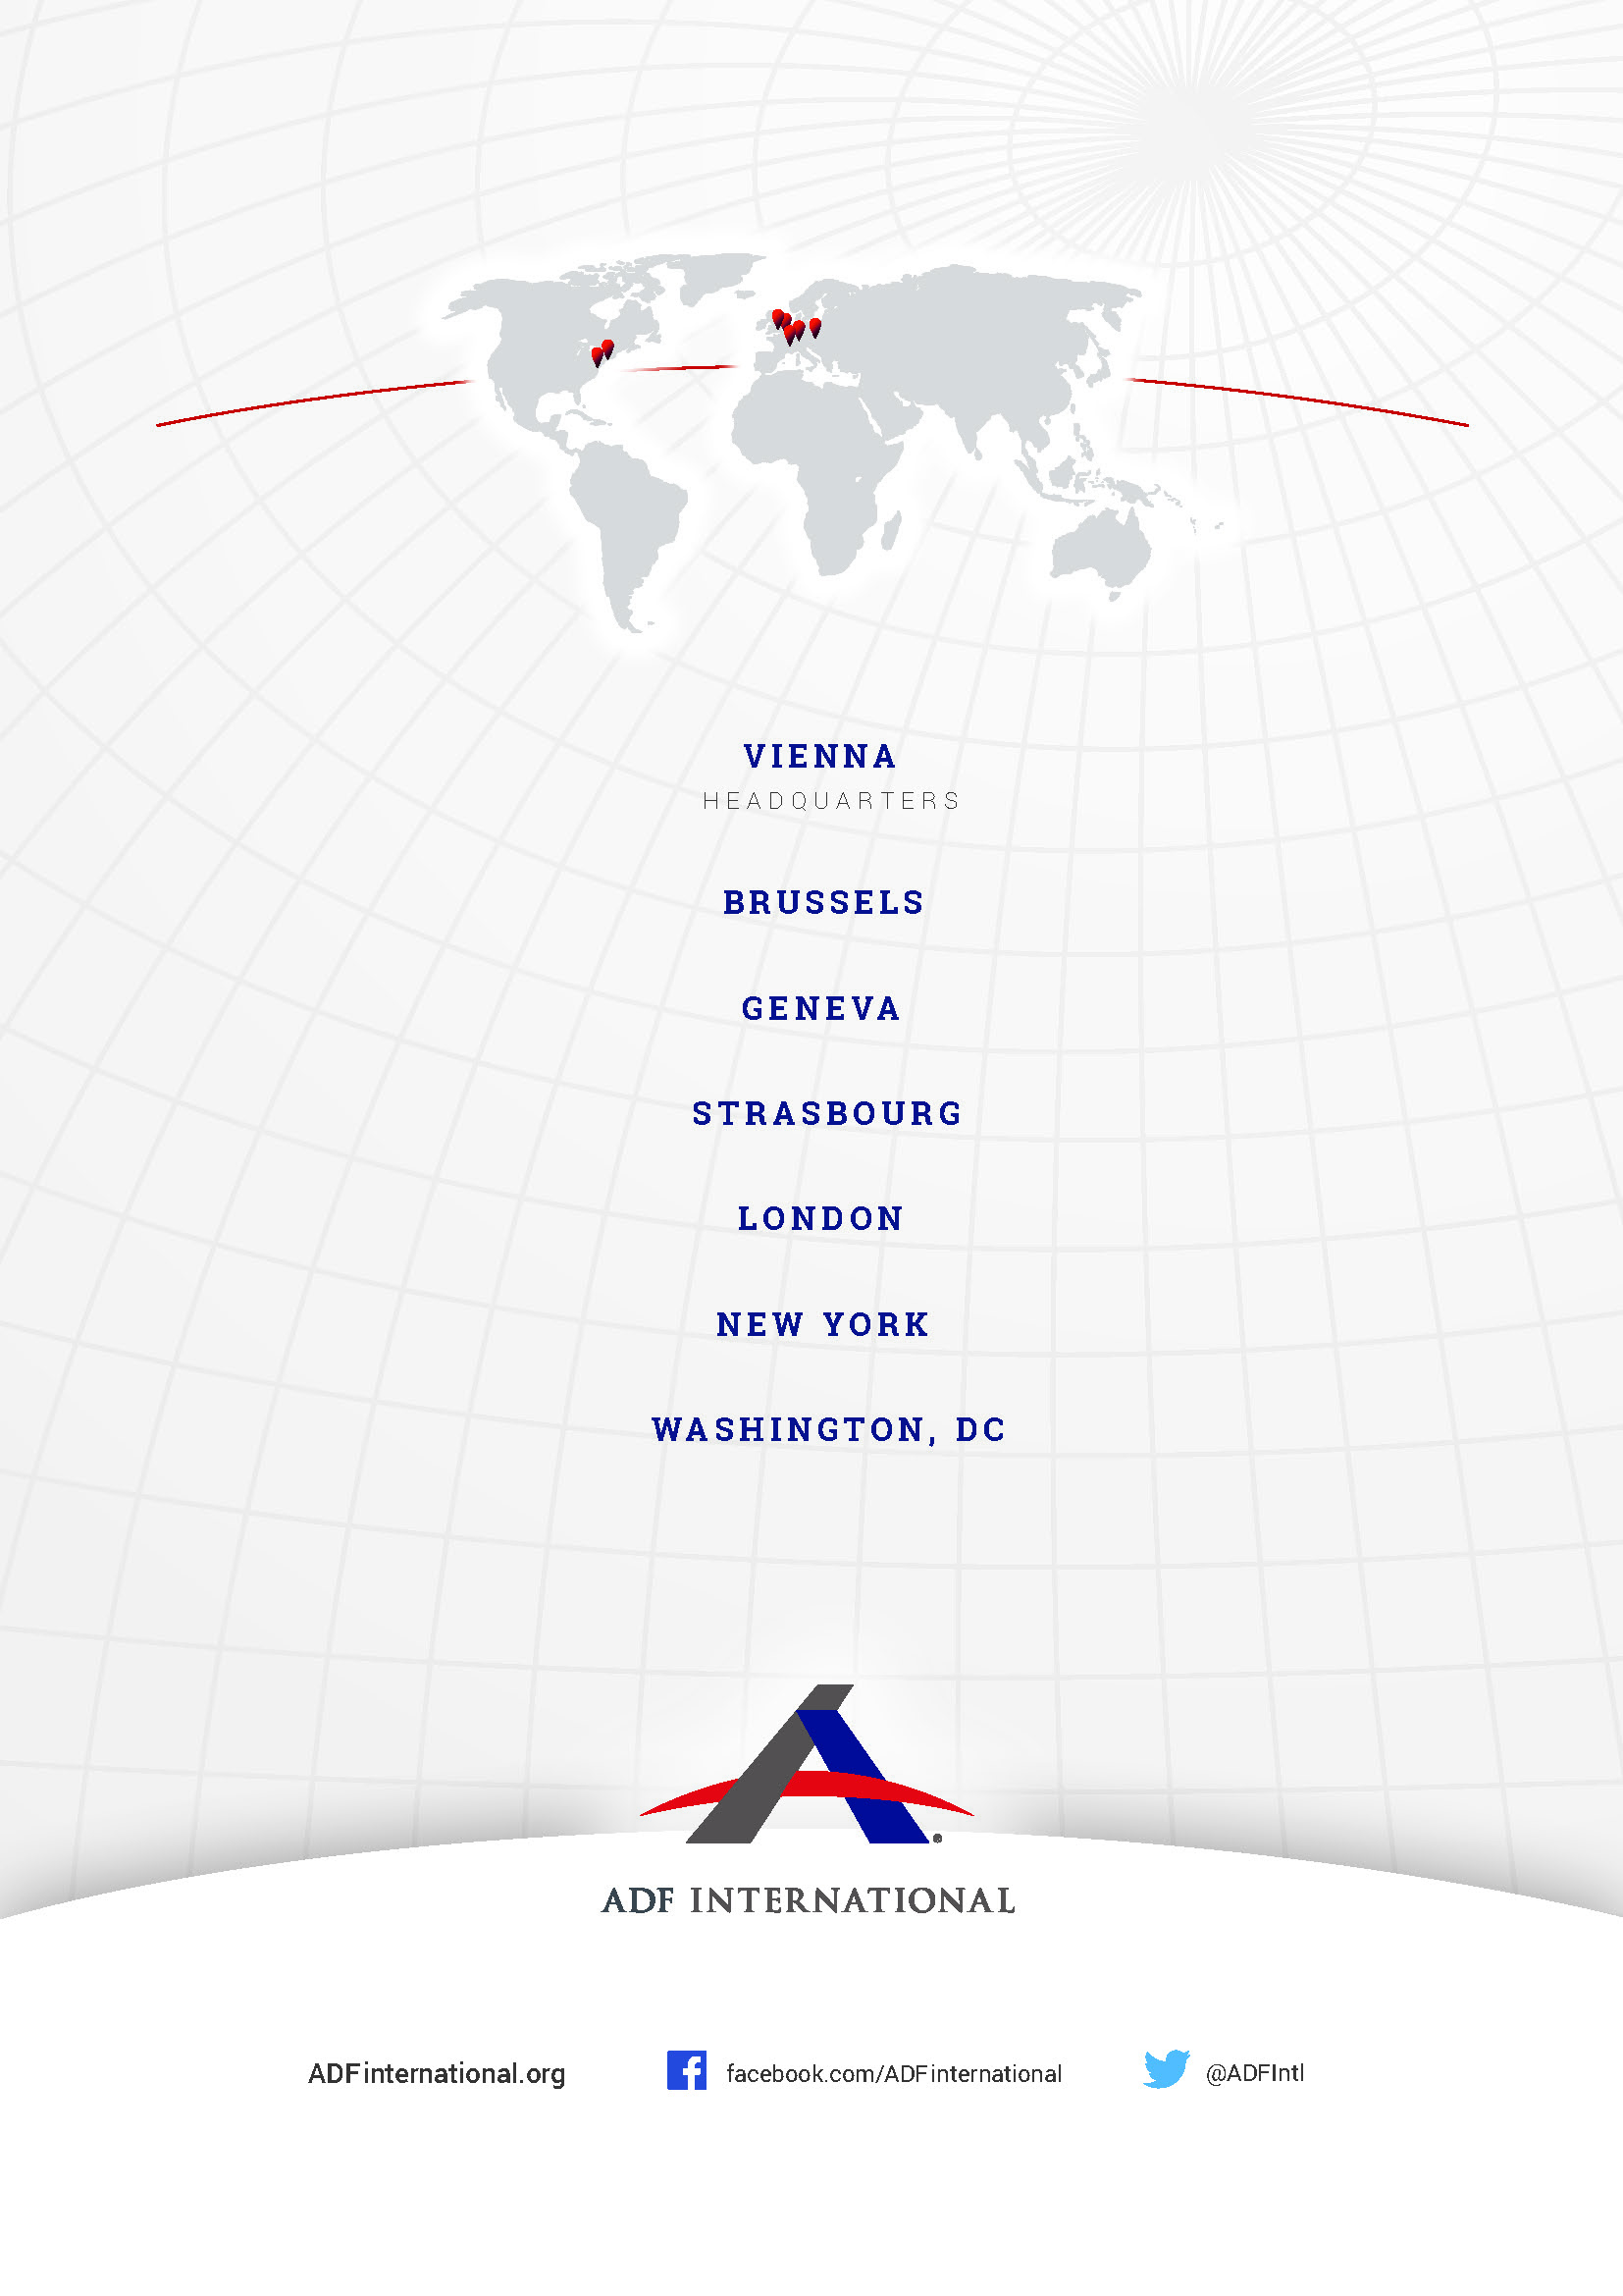

© 2024

UN Population Fund ‘State of World Population 2020’ (2020), https://www.unfpa.org/sites/default/files/pub-pdf/UNFPA_PUB_2020_EN_State_of_World_Population.pdf, p. 49-51.
Pew Research Center ‘India’s Sex Ratio at Brith Begins To Normalize’ (23 August 2022), https://www.pewresearch.org/religion/2022/08/23/indias-sex-ratio-at-birth-begins-to-normalize/.
World Bank ‘sex ratio at birth (male births to female births) - India’ (2022) https://data.worldbank.org/indicator/SP.POP.BRTH.MF?locations=IN.
UNFPA ‘Trends and Differentials in Sex Ratio at Birth in India Based on NFHS Data’ (September 2023) https://india.unfpa.org/sites/default/files/pub-pdf/analytical_paper_5_-_trends_and_differentials_in_sex_ratio_at_birth_in_india_based_on_nfhs_data_-_final_1.pdf.
Id.
Id.
Human Rights Committee ‘Fourth periodic report submitted by India under article 40 of the Covenant pursuant to the optional reporting procedure,’ (31 May 2022) CCPR/C/IND/4, 48.
Pre-Conception Pre-Natal Diagnostic Techniques Act 1994.
Id., art. 3A.
Id., arts. 4-6.
Id., art. 29.
Id., art. 23.
Id., art. 24.
B. Chetan, ‘Doctor who did 900 illegal abortions arrested’ (26 November 2023) Deccan Herald, https://www.deccanherald.com/india/karnataka/bengaluru/doctor-who-did-900-illegal-abortions-arrested-2785849.
India Ministry of Health and Family Welfare ‘Lok Sabha Question No.1202’ (9 February 2024) https://sansad.in/getFile/loksabhaquestions/annex/1715/AU1202.pdf?source=pqals.
A. Yasmeen ‘PCPNDT violations: Only 100 cases filed in last 21 years’ (14 December 2023) The Hindu, https://www.thehindu.com/news/cities/bangalore/pcpndt-violations-only-100-cases-filed-in-last-21-years/article67638299.ece.
B. Taskin, ‘Abortion black market, touts, scan vans — how Haryana’s ‘Beti Bachao’ is losing momentum’ (16 May 2024) The Print, https://theprint.in/the-fineprint/abortion-black-market-touts-scan-vans-how-haryanas-beti-bachao-is-losing-momentum/2086974/.
Shobha Gupta and & Another vs. Union of India, W.P.(C) No. 301/2022, Supreme Court of India (https://www.livelaw.in/top-stories/pcpndt-act-supreme-court-issues-notice-to-states-seeks-response-on-steps-taken-for-enforcement-232063)
See Rule 18A, sub-rule 5(vi), The Pre-Conception and Pre-Natal Diagnostics Techniques (Prohibition of Sex Selection) Rules, 1996.
Shobha Gupta and & Another vs. Union of India, W.P.(C) No. 301/2022, Supreme Court of India (https://www.livelaw.in/top-stories/pcpndt-act-supreme-court-issues-notice-to-states-seeks-response-on-steps-taken-for-enforcement-232063)
CYDA, PRAYATAN, ADITHI, VIMOCHANA, PHFI, ‘Implementation of the PCPNDT Act in India, Perspectives and Challenges’ (April 2010) https://www.wbhealth.gov.in/uploaded_files/PNDT/IMPLEMENTATION%20OF%20THE%20PCPNDT%20ACT%20IN%20INDIA.pdf
Pre-Conception Pre-Natal Diagnostic Techniques Act 1994, art. 27.
Manoj Krishan Ahuja vs. State of NCT of Delhi & Anr., CRL.M.C. 1352/2023 & CRL.M.A.5184/20, High Court of Delhi
N. Chakravarty et al., ‘Cultural and Social Bias Leading to Prenatal Sex Selection: India Perspective’ (13 June 2022) Frontiers in Global Women’s Health, https://www.ncbi.nlm.nih.gov/pmc/articles/PMC9234277/pdf/fgwh-03-903930.pdf, p.2-4.
Id.
Id.
Ministry of Women and Child Development ‘Beti Bachao Beti Padhao’ (2017) https://wcd.nic.in/bbbp-schemes.
Lok Sabha ‘Fifth report of the Committee on Empowerment of Women’ (December 2021) https://eparlib.nic.in/bitstream/123456789/835432/1/17_Empowerment_of_Women_5.pdf#search=pcpndt, p.52.
Id., p.51-52. See also A. Arora ‘Beti Bachao, Beti Padhao’ scheme: A critical analysis’ (19 October 2022) Observer Research Foundation, https://www.orfonline.org/expert-speak/beti-bachao-beti-padhao-scheme.
Lok Sabha ‘Fifth report of the Committee on Empowerment of Women’ (December 2021) https://eparlib.nic.in/bitstream/123456789/835432/1/17_Empowerment_of_Women_5.pdf#search=pcpndt.
ICCPR Art. 6
Id., art. 2.
Id., art. 3.
Id., art. 26.
Convention on the Rights of the Child (adopted 20 November 1989, entered into force 2 September 1990) 1577 UNTS 3 (CRC), preamble.

