BRIEFING ON UGANDA FOR THE COMMITTEE AGAINST TORTURE, SESSION 75 - November 2022
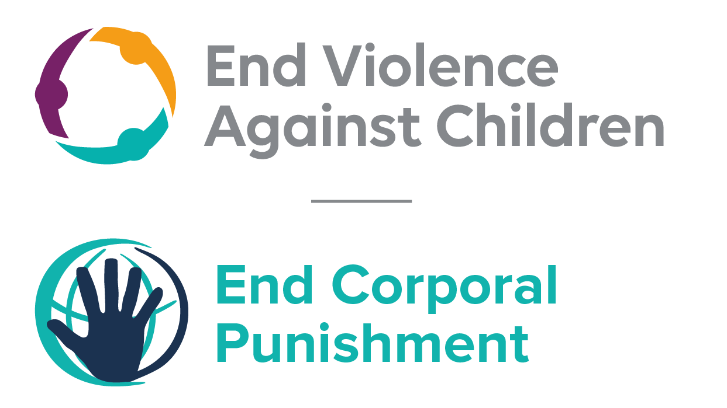
The Global Partnership to End Violence Against Children
September 2022

This briefing describes the legality of corporal punishment of children in Uganda. In light of the obligation under international human rights law to prohibit all corporal punishment of children, the recommendation of the UN Secretary General’s Study on Violence against Children, the repeated recommendations to prohibit all corporal punishment made to Uganda by the Committee on the Rights and other human rights treaty bodies, and considering the global commitment to ending all violence against children in the context of the 2030 Agenda for Sustainable Development, we hope the Committee will:
• in its concluding observations on the second report of Uganda, recommend that legislation is immediately enacted to explicitly prohibit corporal punishment of children in all settings including the home, and to repeal all legal defences for its use.

Summary of necessary legal reform to achieve full prohibition
Prohibition is still to be achieved in the home, alternative care settings and day care.
A right to administer “reasonable chastisement” is recognised under common law and protection from violence and abuse in the Children Act and other laws is not interpreted as prohibiting all corporal punishment. The near universal social acceptance of corporal punishment in childrearing necessitates clarity in law that no level of corporal punishment is acceptable. Prohibition should be enacted of all corporal punishment and other cruel or degrading forms of punishment, in the home and all other settings where adults have authority over children.

Alternative care settings – Prohibition of corporal punishment should be enacted in relation to all alternative care settings (foster care, institutions, places of safety, emergency care, etc).
Day care – Corporal punishment should be prohibited in all early childhood care (nurseries, crèches, family centres, etc) and all day care for older children (day centres, after-school childcare, childminding, etc).

- The report of Uganda to the Committee Against Torture

  - The second report of Uganda states that a Handbook on “Alternatives to Corporal Punishment” which introduces the concept of positive discipline was developed, published and disseminated throughout the country. However, the report does not refer to prohibition of corporal punishment of children in all settings.

- Current legality of corporal punishment in Uganda

  - Home: Corporal punishment is lawful in the home. A right to administer “reasonable chastisement” is recognised under common law. Provisions against violence and abuse in the Children (Amendment) Act 2016, the Constitution 1995, the Penal Code 1950 and the Domestic Violence Act 2009 do not prohibit all corporal punishment in childrearing.

  - A Government Children (Amendment) Bill was under discussion in 2015 which would have prohibited corporal punishment in the home and all other settings. However, it was tabled alongside a Private Members’ Bill – the Children (Amendment) (No. 2) Bill – which included prohibition in schools only. The Government Bill was later withdrawn, with the Minister of Gender, Labour and Social Development stating that the Private Member’s Bill “had hybrid provisions to sufficiently augment the current law”. The amendments as passed in March 2016 and assented to in June 2016 included a new article 42A which states that every child has a right to be protected against all forms of violence including physical and emotional abuse, and article 42B which states prevention and early intervention programmes “must focus on … developing appropriate parenting skills and the capacity of parents and caregivers to safeguard the wellbeing and best interest of the child, including the promotion of positive, nonviolent forms of discipline” – but they did not prohibit corporal punishment in childrearing. As the Government Bill to prohibit all corporal punishment was withdrawn, and there is no explicit intention of the Government to introduce further law reform, End Corporal Punishment no longer considers Uganda committed to prohibiting all corporal punishment of children without delay.

  - Uganda became a Pathfinder country with the Global Partnership to End Violence Against Children in 2016. This committed the Government to three to five years of accelerated action towards the achievement of Target 16.2 of the Sustainable Development Goals. A 2017 report from the Ministry of Gender, Labour and Social Development recommended that the Government implement the INSPIRE package, promulgate “legislation forbidding violent punishment of children by parents, teachers, and others” and promote positive discipline instead of corporal punishment. The National Parenting Guidelines, adopted in 2018, do not explicitly mention corporal punishment but do encourage the use of positive parenting.

  - Alternative care settings: There is no explicit prohibition of corporal punishment in alternative care settings.

  - Day care: There is no explicit prohibition of corporal punishment in early childhood care or in day care for older children.

  - Schools: Corporal punishment is unlawful in schools. In March 2016, the Children Act was amended with the insertion of a new article 106A: “Corporal punishment in schools. (1) A person of authority in institutions of learning shall not subject a child to any form of corporal punishment. (2) A person who subjects a child to corporal punishment commits an offence and is liable to imprisonment for a term not exceeding three years or to a fine not exceeding one hundred currency points or both.” As at March 2022, regulations to implement the law had not been finalised.

  - Penal institutions: Corporal punishment is prohibited as a disciplinary measure in penal institutions in the Prisons Act (2003, in force May 2006).

  - Sentence for crime: Corporal punishment as a sentence for crime was ruled unconstitutional in a 1999 Supreme Court ruling and is prohibited in article 94(9) of the Children (Amendment) Act 2016: “No child shall be subject to corporal punishment).”

Recommendations by human rights treaty bodies and during the UPR

  - CRC: In its concluding observations on the state party’s initial report in 1997, the Committee on the Rights of the Child recommended that Uganda gives “special attention” to corporal punishment in schools. In its concluding observations on the state party’s second report in 2005, the Committee recommended that Uganda prohibits corporal punishment in all settings.

  - CESCR: In its concluding observations on the state party’s initial report in 2015, the Committee on Economic, Social and Cultural Rights recommended that Uganda prohibits corporal punishment.

  - UPR: At the second cycle of the Universal Periodic Review of Uganda in 2016, a recommendation to prohibit violence against children in all settings was made and accepted by the Government.

1 February 2021, CAT/C/UGA/2, Second periodic report submitted by Uganda under article 19 of the Convention pursuant to the simplified reporting procedure, due in 2008, para 47
Statement by the Minister of Gender, Labour and Social Development to Parliament on the Amendment of the Children’s Act Cap 59
November 2017, Ministry of Gender, Labour and Social Development, Violence against Children in Uganda: Findings from a National Survey (2015), page 80
May 2018, Ministry of Gender, Labour and Social Development, The Uganda National Parenting Guidelines
Kyamanywa v. Uganda, Criminal appeal No. 16
21 October 1997, CRC/C/15/Add.80, Concluding observations on initial report, paras. 15 and 35
23 November 2005, Concluding observations on second report, CRC/C/UGA/CO/2, paras. 39 and 40
24 June 2015, E/C.12/UGA/CO/1, Concluding observations on initial report, para. 27
16 November 2016, A/HRC/WG.6/26/L.7, Draft report of the Working Group, paras. 115(14), 115(36), 115(58), and 115(71)

