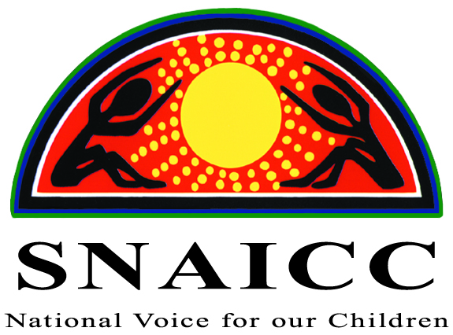
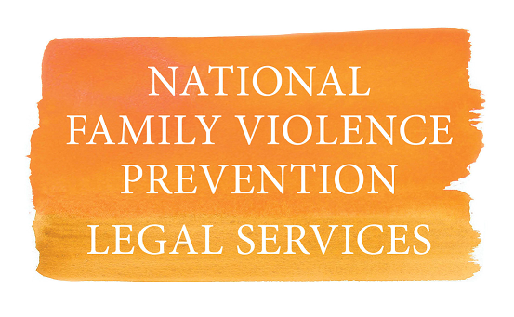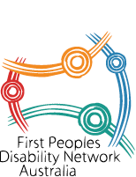

Joint statement of SNAICC – National Voice for our Children, the National Aboriginal and Torres Strait Islander Legal Services, the National Family Violence Prevention and Legal Services and First Peoples Disability Network to Committee on Economic, Social and Cultural Rights

25 February 2019

Aboriginal and Torres Strait Islander peoples, through their community-controlled representation, have long been excluded from Closing the Gap discussion.

The Australian Government has been engaged in a ‘refresh’ of the Closing the Gap agenda since December 2016. Aboriginal and Torres Strait Islander peak bodies and representatives have engaged at key points throughout the Refresh process, but have also raised significant concerns over a lack of real and meaningful involvement in the Closing the Gap agenda.

The decision of the Council of Australian Governments (COAG) at the end of 2018, led by the Prime Minister, to agree a formal partnership with Aboriginal and Torres Strait Islander people through their representative organisations on Closing the Gap is an historic milestone in the relationship between Governments and our Peoples. It has the potential to be a real game changer.

A Coalition of almost 40 Aboriginal and Torres Strait Islander peak bodies from across the nation has formed, providing legitimate community-controlled representation, to be signatories to the formal partnership arrangements on a refreshed Closing the Gap framework.

Through our members, we are accountable and in direct contact with communities at the local level. We also provide an unparalleled network through which communities can engage with governments in respect of the setting, implementing and monitoring of Closing the Gap targets.

This network is much more significant than any engagement that governments can achieve through its own consultations, and especially by government appointed Indigenous bodies and Indigenous public servants. We respect Indigenous public servants, advisers and board members but they cannot and should not represent us.

Governments must recognise the legitimacy of Aboriginal and Torres Strait Islander Community Controlled organisations, represented by their peaks at national and state/territory level.

The Coalition of Peaks have tabled a draft formal partnership agreement for the Commonwealth and State and Territory governments to consider.

The draft Partnership Agreement is designed to fulfil COAG’s undertaking to us and give effect to the new partnership on Closing the Gap.

Following the negotiation of the partnership agreement, we must advance the detail of the Closing the Gap framework. Four out of the seven Closing the Gap targets expired in 2018 and only two of the targets are on track in 2019 - see the Prime Minister's Closing the Gap Report, February 2019.

Leading Aboriginal and Torres Strait Islander organisations have consistently argued that targets will only succeed if they are accompanied by strong policies and programs designed to achieve them, led and overseen by Aboriginal and Torres Strait Islander peoples. Past failures to design and implement effective strategies to achieve the Closing the Gap targets have been confirmed by a February 2019 report from the Australian National Audit Office which found that while there has been consistency in reporting against the Closing the Gap targets, very little has been done to assess the effectiveness of the strategies that underlie them.

Further, the February 2019 Prime Minister's Closing the Gap Report found that only two of the seven targets are on track to be met. Aboriginal and Torres Strait Islander stakeholders have been clear that what is required is genuine investment in and support of Aboriginal and Torres Strait Islander community-controlled organisations to design and deliver the programs and services required to meet the targets.

SNAICC – National Voice for our Children, the peak body for Aboriginal and Torres Strait Islander children has called for targets to improve outcomes and address the key challenges faced by Aboriginal and Torres Strait Islander children. Specifically SNAICC have called for:

- an additional Closing the Gap target to eliminate the overrepresentation of Aboriginal and Torres Strait Islander children in out-of-home care by 2040; and

- strengthening the current Closing the Gap target on early childhood education to close the gap in the early childhood development domains contained in the Australian Early Development Census (AEDC) by 2030.

The National Aboriginal and Torres Strait Islander Legal Services (NATSILS) notes that the Commonwealth Government has never had a deadline for ending the over-incarceration of Aboriginal and Torres Strait Islander people - this is why Australia needs a national justice target to make progress to end this human rights injustice. Solutions to end over-imprisonment must be developed holistically alongside other areas of disadvantage in the Closing the Gap strategy - health, education, employment plus new areas - in order to create real change for future generations.

The new targets need to address the over-representation of Aboriginal and Torres Strait Islander people in Australia’s criminal justice systems. The Government should include national justice targets which seek to address the:

- Incarceration of adults: eliminate the over-representation of Aboriginal and Torres Strait Islander adults (18 years of over) under justice supervision (community-based and in prison) in 10 years.

- Incarceration of children: eliminate the over-representation of Aboriginal and Torres Strait Islander youth (10-17 years) under justice supervision (community-based and in prison) in 10 years.
In addition, family violence, child protection, disability and housing targets must be added to the Closing the Gap framework.

The National Family Violence Prevention and Legal Services (NFVPLS) Forum has called for a family violence target for some time, and one that is stand-alone. The draft Closing the Gap Refresh Targets set through COAG currently has a family violence target as a possibility – but not a definite - under the area of child protection.

- There must be a stand-alone family violence target that is in the area of family violence prevention and not under any other area. It must also be a target all levels of government take responsibility for – Federal, State and Territory governments. The development of a target must be led by Aboriginal and Torres Strait Islander organisations and relevant stakeholders.

Despite repeated advocacy from the First Peoples Disability Network (FPDN) and reassurances from the Commonwealth Government, disability continues to be forgotten as a specific area of focus under Closing the Gap.

For a policy that aspires to be evidence based, Closing the Gap has avoided engaging with any of the evidence that shows the acute disadvantage of Aboriginal and Torres Strait Islander people with disability. Access inequality is across all systems of support and the National Disability Insurance Scheme (NDIS) is headed down the same path. Overcoming Indigenous Disadvantage has conveniently fallen off the back of Closing the Gap, and it needs to be reconnected if it’s going to have any traction.

“Disability is a not just a new Closing the Gap target it must be recognised as a cross cutting target in the Closing the Gap refresh. Disability is not just a health issue, it is prevalent under all existing target areas: Families, children and youth, Housing, Justice, including youth justice, Health, Economic development, Culture and language, Education, Healing and Eliminating racism and systemic discrimination”, said FPDN CEO Damian Griffis.

FPDN receives a huge volume of intake from our community seeking support around serious barriers and issues they are facing in accessing the NDIS. FPDN will continue to push for a stand-alone target on disability to be introduced that also measures access to the NDIS.
FPDN has identified ten priorities to address disability inequity in Aboriginal and Torres Strait Islander Communities for the National Disability Strategy and NDIS.
The Government should include disability targets which seek to address the:

- equitable access to the NDIS by Aboriginal and Torres Strait Islander people with disability; and
- systemic inequality experienced by Aboriginal and Torres Strait Islander people with disability in accessing services across other Close the Gap target areas in health, education, employment; and in new target areas in justice and family violence.

Useful links

SNAICC Media Release December 2018
SNAICC Closing the Gap Submission
Australian National Audit Office Report , February 2019
NITV Open Letter on Partnership Approach
Prime Minister's Closing the Gap Report, February 2019
National Aboriginal and Torres Strait Islander Legal Services Media Release February 2019
FPDN Ten Priorities to Address Disability Inequity

