Thematic Report on SPAIN
Minors and Bullfighting
Group on Violence Against Children
Consejo Independiente de Protección de la Infancia (CIPI)
[Independent Council for Child Protection]
https://www.cipinfancia.org/,

Índex

- Methodology used for the preparation of the report.
- Final Observations: Bullfighting (2018).
- List of Issues Prior to Reporting (LOIPR) (2023).
- General Observation No. [XX] by the Committee on the Rights of the Child.
- State Report (2024).
- Observations on the State’s Response.
- Implementation of Previous Committee Recommendations.
- Data.
- Questions for Dialogue.
- Proposed Recommendations for the Final Observations.

1. Methodology Used for the Preparation of the Report

The report begins by recalling the Final Observations for Spain, the LOIPR, and the state’s response. It continues with our opinion on Spain's response, highlighting the country's total non-compliance and the entirely unjustifiable reasons for violating the Convention. Subsequently, questions for dialogue and recommendations for the Final Observations are proposed.
2. Final Observations: Bullfighting (2018)

This thematic report exclusively focuses on the Group on Violence Against Children (arts. 19, 24 (3), 28 (2), 34, 37 (a), and 39), specifically paragraph 25 of the Final Observations (CRC/C/ESP/CO/5-6):

Harmful Practices
Bullfighting
25. To prevent the harmful effects on children from bullfighting events, the Committee recommends that the State Party prohibit the participation of children under 18 as bullfighters and as spectators at bullfighting events.

3. List of Issues Prior to Reporting (LOIPR) (2023)
The Committee included this issue in the List of Issues Prior to Reporting (LOIPR), see (CRC/C/ESP/QPR/7):

Violence Against Children (arts. 19, 24 (3), 28 (2), 34, 37 (a) y 39)
20. Please provide information on the measures taken to prohibit children under 18 from participating as bullfighters in bullfighting events or attending them as spectators.

4. General Observation No. 26 by the Committee on the Rights of the Child

It is very important to emphasize that in the General Observation No. 26 of the Committee on the Rights of the Child (August 2023), a legally binding document for countries that have ratified the Convention on the Rights of the Child—the obligation to protect children from violence inflicted on animals has been globally extended and consolidated for all countries. Previously, this obligation was directed only at some State Parties. This General Observation states the following:

“Children must be protected from all forms of physical and psychological violence, such as domestic violence or violence inflicted on animals.”
As a signatory of the Convention on the Rights of the Child, Spain is directly obligated to protect children and adolescents from exposure to violence committed against animals, addressing the necessary legislative changes to prevent child exposure to violence in all cases and without exception, as their rights prevail over any other interest.

5. State Report (2024)

Spain's response in its report CRC/C/ESP/7 was as follows:

Minors at Bullfighting Events
152. The jurisprudence of the Constitutional Court clearly and unequivocally establishes that the responsibility for setting the conditions for minors’ attendance and/or participation in bullfighting events lies with the Autonomous Communities.

153. Except for the Autonomous Community of the Balearic Islands, which prohibits minors under 18 from attending bullfighting events, all other Autonomous Communities where bullfighting events are held, whether regulated (bullfights, rejoneo, novilladas, etc.) or popular events, allow minors to attend and/or participate in bullfighting events and bullfighting schools, subject to certain requirements, within their territorial scope..

6. Observations on the State's Response

First, we note that Spain is divided into 17 regions called Autonomous Communities (CCAA). According to the Spanish Constitution, certain powers belong to the State, while others belong to the Autonomous Communities (either exclusively or shared). Bullfighting is not mentioned in the Spanish Constitution.
Our opinion on the State’s response is as follows:

152. NO Constitutional Court ruling (STC) has addressed who is responsible for regulating the attendance and participation of minors at bullfighting events. The only relevant ruling, STC 177/2016, which annulled the ban on bullfights in Catalonia, references a Catalonian law that prohibited minors under 14 from attending bullfights, but this is merely an example used to distinguish between regulatory measures (which an Autonomous Community can implement) and prohibitive measures (which it cannot, and therefore the law was annulled). However, in no case does the Court attribute this competence to one administration or another.

153. Spain acknowledges that it is violating the Convention because the Autonomous Communities continue to allow minors to attend and/or participate in bullfighting events and bullfighting schools.

7. Implementation of Previous Committee Recommendations

The following points are highlighted:
1. Spain has NOT implemented the recommendation on bullfighting, using totally unfounded jurisdictional excuses.

2. The only measure approved in Spain that complies with the recommendation, which consists of prohibiting minors under 18 from attending bullfights in the Balearic Islands, as mentioned in the State report (point 153), is going to be repealed.

The Balearic Islands' Law 9/2017 of August 3, regulating bullfighting and protecting animals,, established in its article 12: “Minors under 18 are prohibited from attending bullrings when bullfighting events are held.”.

On June 4, 2024, the Parliament of the Balearic Islands approved the consideration of a bill to repeal the above article, which prohibits minors from attending these events. The repeal has enough parliamentary support to pass, and its publication in the Official Gazette could be imminent.
In practice, the debate over who holds this competence is preventing Spain from complying with the Committee's Final Observations, as exemplified below:
- In the vote that took place in the Assembly of the Autonomous Community of Madrid on July 5, 2018, on the Bill to prohibit minors under 18 from participating in bullfighting events to incorporate the Committee’s Final Observations, the required number of votes was not reached, citing the Assembly’s lack of competence since it was a “State matter.”
- In the vote that took place in the Congress of Deputies (Committee on the Rights of Children and Adolescents) on September 19, 2018, on the Non-Legislative Proposal urging the Government to promote the necessary legal reforms and mechanisms to incorporate the Committee’s Final Observations on bullfighting, the vote was again rejected, citing the State’s lack of competence, referring instead to the competences of the Autonomous Communities in this matter.
- In the vote that took place in the Congress of Deputies on May 20, 2021, on the Organic Law on Comprehensive Protection of Children and Adolescents against Violence (current Organic Law 8/2021 of June 4), the necessary number of votes was not reached to include an amendment to the current state bullfighting legislation to raise the minimum age to 18 years to participate in and attend bullfighting events. Throughout the entire process and also during the vote, it was argued that this was a matter for the Autonomous Communities.
However, we believe that the State IS COMPETENT to legislate on this matter for the following reasons:

a) Professional Bullfighters

In Spain, one can become a professional bullfighter before reaching the age of majority, at 16 years old, under the Workers’ Statute Law-Ley del Estatuto de los Trabajadores (2015), a state law whose Article 6 states: “The involvement of minors under 16 years old in public performances will only be authorized in exceptional cases by the labor authority, provided it does not pose a danger to their health or professional and human development.”

Therefore, the competence to implement the first aspect mentioned in the United Nations Observations is state-level.
b)

Bullfighting Schools
Bullfighting schools are registered in the Bullfighting Schools Registry of the Ministry of Culture (a state agency): Registro de Escuelas Taurinas, del Ministerio de Cultura (un organismo estatal), accessible at the following link:
https://sede.mcu.gob.es/casta/loadFiltroEscuelas.do?submit=PDF&denominacionEscuela
In Spain, the age to participate in bullfighting schools in practical lessons with live cattle is 14, according to Article 92.5 of Royal Decree 145/1996 of February 2, Bullfighting Regulations- Real Decreto 145/1996, de 2 de febrero, por el que se aprueba el Reglamento de Espectáculos Taurinos, which is a state-level decree.

Secondly, the competence to implement the other aspect of the United Nations Final Observations also falls to the State.
c) Minors' Access to Bullrings as Spectators

In Spain, different Autonomous Communities have limited the age for participating in and attending bullfighting events. However, we argue that the competence to implement this aspect is not necessarily of the Autonomous Communities, as child protection is not an exclusively autonomous competence.

The competence to comply with the measures urged by the United Nations does not rest exclusively with the Autonomous Communities. The Spanish State also has the capacity to intervene in this matter in its role to prevent and act to protect minors from violence and to comply with the international treaties ratified by Spain (Article 39 of the Spanish Constitution). All public authorities (state, regional, and municipal) are obliged to protect minors from exposure to and participation in the violence inherent in bullfighting events and bullfighting schools.
* Article 39: 4. Children shall enjoy the protection provided for in international agreements that safeguard their rights.

It is important to recognize the step taken by the Ministry of Culture in eliminating the National Bullfighting Award, but Spain must go much further and comply with the Convention on the Rights of the Child, General Observation No. 26, and the Final Observations.

8. Data

In Spain, the situation for minors is serious due to the number of bullfighting schools, their participation in private training sessions and public events, and their attendance at bullfighting events, including popular festivals where their physical and mental health is at risk.
Bullfighting Schools
Bullfighting schools, which have increased since 2018, continue to experience accidents involving minors. Currently, there are 76 bullfighting schools, compared to 55 schools in 2017 (when the previous report was submitted by the Franz Weber Foundation). Children learn bullfighting in official bullfighting schools and on private ranches, receiving theoretical and practical lessons with live animals. The practical lessons simulate a bullfighting event identical to the real thing.
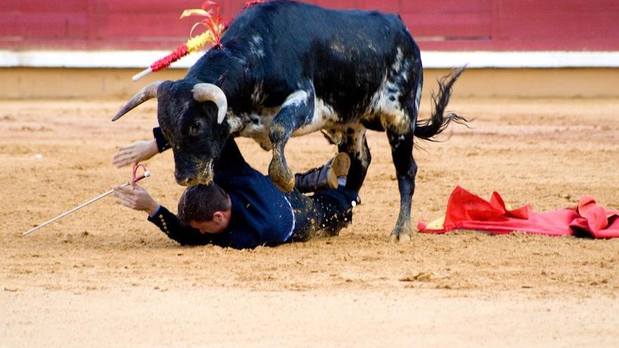
Report on Bullfighting Schools in Spain

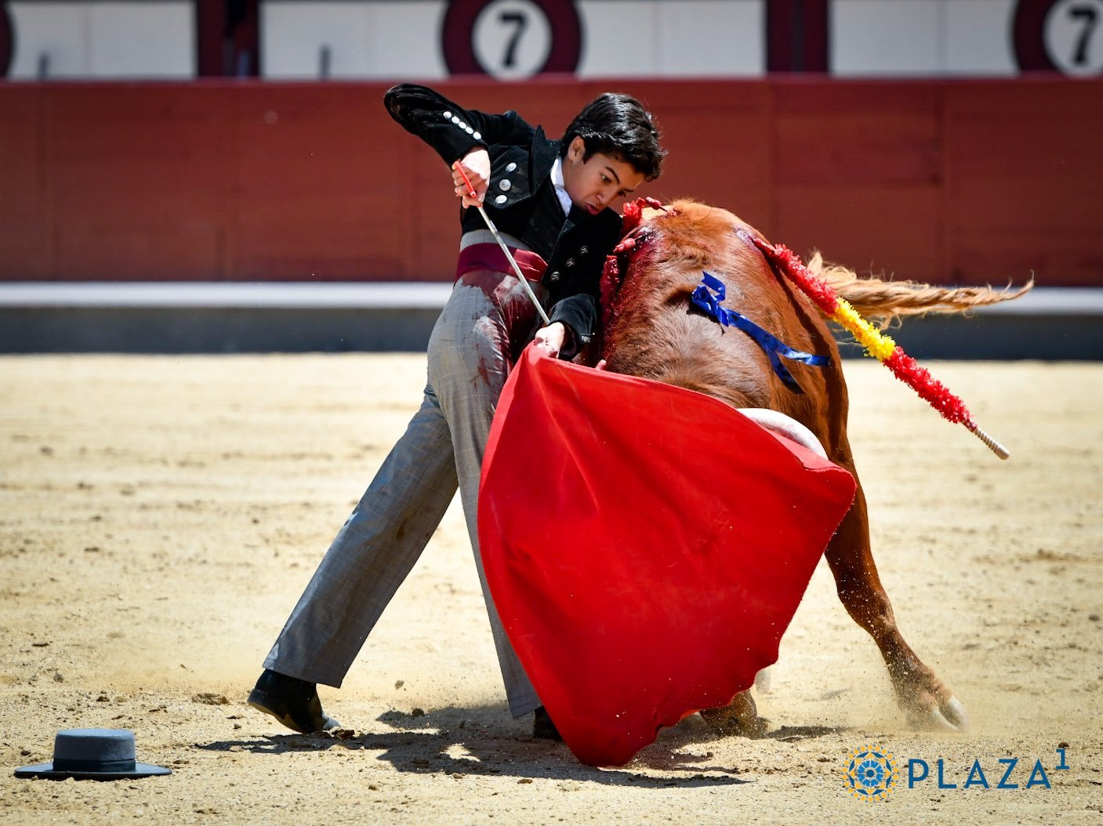
"Debut" and public presentation of the child Marco Pérez in the Madrid bullring, May 2023. https://www.elmundo.es/cultura/toros/2023/05/15/64622d20fc6c835d6c8b458d.html

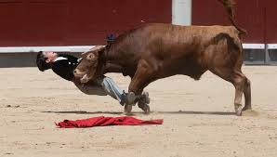
Practical lesson for young Marco Pérez https://www.larazon.es/cultura/toros/marco-perez-hace-historia-hoy-debut-ventas-15-anos_2023051564621e4b21596b00011c7c1c.html

Participation and Attendance in Popular Bullfighting Festivals
During the thousands of popular bullfighting festivals held across Spain, deaths of participants continue to occur, which minors can witness directly, or they themselves may be seriously injured or killed.

Attendance at Bullrings
There are 545 bullrings in Spain, with a total seating capacity of 1,266,649 spectators, including children. Minors continue to witness, live, severe goring and injuries to bullfighters during bullfights..

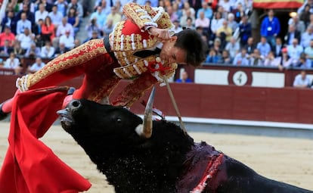
Zaragoza Bullring, May 2019.
https://elpais.com/cultura/2019/05/21/actualidad/1558456885_010544.html#

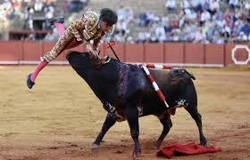
Seville Bullring, 2024. Severe Goring of Novillero.
https://www.diariodesevilla.es/toros/Grave-cornada-novillero-Marcos-Linares-Maestranza_0_1792921145.html

9. Questions for Dialogue

We have learned that at the state level, no legislation has been implemented to enforce the prohibition on minors accessing bullfighting events, whether as students at bullfighting schools or as spectators, on the grounds that the State lacks the competence to do so and that only the Autonomous Communities can legislate on this matter.
However, regulations have been enacted on these issues: for example, the National Bullfighting Regulations, which set the age for participating in practical lessons with live bulls at 14 years (a regulation that could be amended by the State), and the law that sets the minimum age for working at 16 years, provided that it does not pose a danger to the minor's health and human development, is also a state-level competence.
Additionally, I would like to remind you that all Spanish administrations are obliged to comply with Article 39 of the Constitution (which stipulates that in Spain, the rights of minors will be guaranteed as recognized by international treaties), and they cannot fail to protect minors by claiming that the protection of childhood and adolescence is a competence of the Autonomous Communities because they can regulate public events. Incidentally, the only Autonomous Community that had partially complied with the Committee's recommendation by prohibiting minors from entering bullrings has repealed this measure, doubling the non-compliance of all Spanish administrations.

What legislative and educational measures will Spain propose to avoid further non-compliance with the Convention?

10. Proposed Recommendations for the Final Observations

The State has the obligation to heed the United Nations' recommendations as it holds the competence to do so. To fulfil its obligations under the Convention, it is recommended that Spain raise the age to 18 years for bullfighting professionally, participating in, and attending bullfighting events, and being a student at bullfighting schools.
It is recommended that the Committee address Spain in the SAME manner as it did for Portugal (CRC/C/PRT/CO/5-6, 2019), adding the following highlighted text:

27. The Committee on the Rights of the Child recommends that the State Party, at both the state and Autonomous Community levels, set the age of 18 years for participating in bullfighting events, popular bullfighting festivals, and bullfighting schools without exception, as well as conduct awareness-raising activities among public officials, the media, and the general population about the negative effects on minors, including spectators, of the violence associated with bullfighting events and festivals.

http://tbinternet.ohchr.org/_layouts/treatybodyexternal/Download.aspx?symbolno=CRC%2FC%2FESP%2FCO%2F5-6&Lang=en
https://tbinternet.ohchr.org/_layouts/15/treatybodyexternal/Download.aspx?symbolno=CRC%2FC%2FESP%2FQPR%2F7&Lang=en
https://tbinternet.ohchr.org/_layouts/15/treatybodyexternal/Download.aspx?symbolno=CRC%2FC%2FGC%2F26&Lang=sp
https://tbinternet.ohchr.org/_layouts/15/treatybodyexternal/Download.aspx?symbolno=CRC%2FC%2FESP%2F7&Lang=en
https://www.boe.es/diario_boe/txt.php?id=BOE-A-2016-11124
https://www.boe.es/buscar/doc.php?id=BOE-A-2017-10542
https://www.boe.es/buscar/act.php?id=BOE-A-2015-11430
https://www.boe.es/buscar/act.php?id=BOE-A-1996-4945
El Ministerio de Cultura ha justificado dicha supresión con el objetivo de adaptar el listado a la evolución del sector creativo y cultural y atendiendo a las demandas sociales”. Noticia INTERcids. https://intercids.org/posicion-supresion-premio-nacional-tauromaquia/
https://salamancartvaldia.es/noticia/2019-02-04-uno-de-los-novilleros-del-bolsin-en-coma-inducido-tras-sufrir-un-accidente-de-vuelta-a-casa-68029
https://sede.mcu.gob.es/casta/loadFiltroEscuelas.do?submit=PDF&denominacionEscuela
https://www.eldiario.es/caballodenietzsche/escuelas-tauromaquia-maltrato-animal-legalizado_132_3889940.html
https://www.elmundo.es/comunidad-valenciana/2023/08/08/64d273a3e9cf4a25398b457d.html https://www.heraldo.es/noticias/aragon/teruel/2022/08/23/herido-grave-gea-albarracin-festejo-taurino-teruel-1595361.html https://www.levante-emv.com/comunitat-valenciana/2022/07/04/nino-doce-anos-uci-corneado-67940441.html https://www.latimes.com/espanol/deportes/articulo/2022-09-02/ola-de-muertes-en-espana-pone-fiestas-taurinas-bajo-la-lupa https://as.com/actualidad/sociedad/muere-un-hombre-por-una-cornada-en-los-bous-al-carrer-de-valencia-n/ https://www.lavanguardia.com/local/valencia/20220823/8477963/mueren-cinco-personas-mes-festejos-taurinos-valencianos.html
https://www.elmundo.es/cultura/toros/2024/05/01/663200ebe4d4d8b9188b45a3.html https://www.elmundo.es/cultura/toros/2024/06/02/665c988cfdddff86518b4590.html https://www.telemadrid.es/noticias/madrid/El-torero-Alejandro-Conquero-sufre-una-grave-cornada-en-Cenicientos-0-2587541274--20230814085659.html
https://tbinternet.ohchr.org/_layouts/15/treatybodyexternal/Download.aspx?symbolno=CRC%2FC%2FPRT%2FCO%2F5-6&Lang=en

