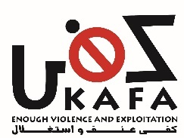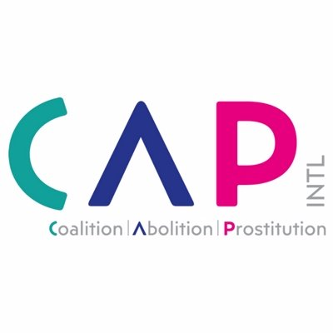

JOINT SUBMISSION OF KAFA (ENOUGH) VIOLENCE & EXPLOITATION
&
CAP – INTERNATIONAL

ON ARTICLE 6 TO THE COMMITTEE ON THE ELIMINATION OF DISCRIMINATION AGAINST WOMEN
FOR THE REVIEW OF LEBANON’S PERIODIC REPORT AT THE 81ST SESSION

Submitted on January 2022

Kafa (enough) Violence & Exploitation is a UN ECOSOC accredited Lebanese feminist organization established in 2005 that aims to create a society free of social, economic, and legal patriarchal structures that discriminate against women. Kafa’s work includes advocating for law and policies reform, influencing public opinion, conducting research and training, and empowering and supporting women and children victims of gender-based violence.

Kafa supports women in prostitution and those who are trafficked for the purpose of sexual exploitation through operating a helpline, providing social and legal support, and offering a shelter. Kafa is present at the police detention center providing socio-legal support to women who are arrested for prostitution related charges. Kafa has provided capacity building to hundreds of law enforcement officers on the issue of prostitution and trafficking for sexual exploitation, and has been educating the public on this issue and its linkages to violence against women.

www.kafa.org.lb

The Coalition for the Abolition of Prostitution (CAP International), in which Kafa is a member, is an advocacy vehicle for frontline NGOs and a global convener for change. The fundamental objective of CAP International is to advocate for the adoption and implementation of progressive domestic legislation and international standards that amplify efforts to: eliminate sexual exploitation of women and girls; deliver effective protection, support and exit options to prostituted persons and victims of trafficking; empower frontline services and survivors of prostitution.
http://www.cap-international.org/

INTRODUCTION

This submission covers the commercial sexual exploitation of women in Lebanon considering article 6 of CEDAW and its recommendations no. 19 and no. 38. The report basis itself on the principles laid down in the ensemble of the international human rights treaties and particularly CEDAW and the Convention of 1949 on the Suppression of Traffic in Persons and of the Exploitation of the Prostitution of Others.

Lebanon is far from effectively combatting women trafficking and sexual exploitation. This submission covers two key topics that have not been duly discussed in Lebanon’s official report. It examines closely the Artist Visa Scheme in Lebanon that sustains a large sex industry and the trafficking of women into the country and the consequent results on the holders of such visa. The report also lays down the contradictions and non-alignment of laws and policies on prostitution and human trafficking in Lebanon which render the protection of victims not efficient, and in many cases, non-existent.

- THE ARTIST VISA: A GOVERNMENTAL SCHEME FOR TRAFFICKING WOMEN INTO SEXUAL EXPLOITATION

Despite prostitution being legally prohibited in Lebanon, an average of 3,000 women are recruited to Lebanon each year through the Artist Visa Scheme as “entertainers in super night-clubs” to be sexually exploited in the country. Operated by the General Directorate of the General Security (DGGS), the 6-month so-called Artist Visa scheme systematically put migrant women under debts and restriction of movement that is formalized in a tripartite contract between the Artist, the night club owner, and the DGGS.

Artists are made indebted to their traffickers upon their arrival to Lebanon. Debt amounts are officially registered on the back of the contract signed by the Artist and the club owner at the DGSS headquarters, in the presence of authority officers – please refer to the contract back page in Annex 1. Debts include fees for the hotel, the medical tests (approximately $600 for six months), the residency fees, the taxes, the airfare ticket (which could amount to thousands of dollars depending on the country of origin), the medical insurance, the transportation, the stamps, and the photocopying documents for official procedures. Moreover, provision 4 of the contract makes the Artist obligated to pay expenses including fees that may result from being “off and sick” and “sickness days”.

Debt bondages imposed on Artists transform the women’s stay in Lebanon into a journey of debt reimbursement. Artists are supposed to pay them off from their salaries amounting to $800 per month on average. However due to large debts, Artists need to rely heavily on the tips provided by sex buyers in exchange for sex acts – tips that are optional since the regulations applied in the super night clubs require sex buyers to pay directly the fees for the sex acts to the Club’s owner or manager. This situation exposes women to more violence and/or degrading treatments by sex buyers, as women may take larger numbers of sex buyers and would accept any request to get more tips in order to pay up their debts.

Sex buyers in Lebanon follow an organized/coded ritual that avoid traffickers any criminal liability as well as clears authorities from the visible participation in the pimping of women. At the night-clubs, the sex buyer chooses one (or more) woman available in the venue and invites her to his table. If he wants to have sex with her, he needs to purchase a “bottle of champagne” (usually a virtual one) directly from the owner or manager of the club. The payment for the champagne is implicitly a free pass to engage in sex with the woman (i.e., an indirect payment for sex), but at a later time. The reason for that is that prostitution activities in Lebanon are prohibited. The sex buyer would then pick up the woman the following day from the hotel where she resides – during her “free time” (i.e., from 1pm to 7pm) – and have sex with her. If the woman is caught engaging in prostitution, no one else except her will be penalized since she has been freely engaging in prostitution during her “free time” without any coercion.

Women are denied bodily autonomy and other fundamental rights. Under the Artist Visa Scheme and related regulations, women have to take mandatory tests for pregnancy, HIV and STDs, and go through two medical examinations - the first time within 48 hours of entry into Lebanon and the second time after 3 months have elapsed. Medical and laboratory tests are conducted at the DGGS headquarters and by DGGS officer, and Artists are made to pay the fees. If any Artist is found pregnant or carrying any STD, the DGGS will directly deport her as per the regulations.

Women are also largely denied freedom of movement. Women are only allowed to stay in designated hotels by the DGGS. They are housed by groups of 4 or more in each room, and on a separate floor that has its own entrance or elevator and is not connected to other floors where regular clients are hosted. The floor is gated and is locked during the time where Artists are not allowed to get out from the hotel. According to the regulations in place, Artists are driven to the night-club at 10pm where they need to perform a dance show and sit with clients until 4am. Then they are driven back to their hotels and are not allowed to exit their residence between 5am and 1pm of the next day. They are only allowed “free time” out the hotel between 1 and 7 pm - a timeframe where sex buyers pick up the women for sex. Hotels need to keep records of the mobility of women to report to the authorities, and women are made to sign-in and out on a log at the hotel registry every time they need to exit or return to the hotel. Artists are also very closely supervised by the clubs and while they are provided with phones, their calls are monitored, and their passports are held by their club owners until they travel out of Lebanon. This situation makes the access to these women by NGOs and service providers, and vice-versa, virtually impossible.

Artists have no access to justice. The only authority the women Artists are in contact with –i.e. the DGGS – holds them hostage and puts them under debt bondage. As shown in Annex 1, Artists are requested to sign on a provision accepting to comply with the regulations of the establishment (i.e. the super night-club) without specifying any of these regulations, thus leaving the door to abuse of power. Additionally, Artists sign a contract that they cannot terminate unless in unspecified severe circumstances and only after the approval of the DGGS. If the woman is found to be engaged in prostitution or has complained about her stay in Lebanon, she is automatically deported by the DGGS, depriving her of any access to justice. This is also why, to our best knowledge, no case of women Artists have been brought up before the Lebanese courts.

RECOMMENDATION:

In light of the above, the Lebanese authorities – namely the DGGS are urgently requested to abolish the Artist Visa scheme and all related regulations as they violate the basic rights of visa holders as well as facilitate the trafficking of these women into sexual exploitation.

- THE CHAOS OF THE LEBANESE PENAL CODE: THE CRIMINALIZATION OF PROSTITUTED PERSONS AND VICTIMS OF TRAFFICKING

In December 2020, Lebanon increased the penalization of prostituted persons, thus discriminating even further against one of the most vulnerable groups of women in Lebanon – including refugees and migrants. In an unprecedented and unjustified move, the parliament amended article 523 of the Penal Code to increase the maximum sentence against persons in prostitution from one year to three years -i.e. from a misdemeanor to a felony.

Article 523 is problematic in many ways. It penalizes and denies justice to persons sexually exploited while considering them equally criminal, as those who profit from exploiting them. Article 523 stipulates that “any person who practices secret prostitution or facilitates it” shall be sentenced” to one to three years imprisonment and to a fine ranging from two to four times the minimum wage.

Moreover, article 523 is in clear contradiction with the Anti-Trafficking Law in Lebanon also known as Law No. 164 adopted in 2011. Under article 523, the exploitation of the prostitution of others is simply criminalized as a prostitution-related act (“facilitation”). However, exploiting the prostitution of women is strongly criminalized under the Law No. 164 as it fulfills very often the three elements (acts, means, and purpose) of the crime of human trafficking, and has a sentence up to 15 years of prison.

This contradiction has limited greatly the implementation of the Law No. 164 as it has led to a mislabeling of the conduct of traffickers by considering them facilitators, and consequently has lowered the charges and sentences for the same act: human trafficking. Along with the same logic, women who are sexually exploited by their traffickers, and who fall under the definition of human trafficking of Law 164, are still being prosecuted and penalized – thus double victimized – based on Article 523. More than this, a survey conducted by the “Legal Agenda” organization on cases of human trafficking in criminal courts in Beirut and Baabda in 2016-2017, concluded that in 75% of the cases connected to sexual exploitation, the prostituted women were prosecuted, and they were so in joint trials alongside their pimps who were charged with human trafficking (and not with “facilitating”).

More than 10 years after the passage of Law No. 164, law enforcement authorities and particularly the judiciary still fail to understand the issue of consent. Observations collected through Kafa’s follow-up of women detained for prostitution-related charges, and a closer look at the court rulings and decisions, show that the judiciary is still basing its rulings and decisions on a series of prejudices and misconceptions that result in overlooking elements of exploitation. For instance, the judiciary has denied the existence of coercion by the traffickers towards their victims because of the existence of “consent” by the victims for engaging in prostitution or the ability of the victims to move freely or the fact that the traffickers had split with them the money yielded from their exploitation.

On another level, it is important to mention that Lebanon used to be a reglementary country where prostitution was regularized according to the 1931 Law on Preserving Public Health from Prostitution. This law regulated prostitution in licensed brothels and enforced medical check-ups on women twice per week. While still formally part of the Lebanese law, the government has stopped implementing the 1931 law in the late 1970s and no brothel licenses have been issued since then. The country gradually moved to a legal framework where all forms of prostitution are de facto prohibited and are considered “clandestine” as per article 523 of the Penal Code. Similar to the regulations of the Artist Visa scheme, the 1931 law limits greatly the basic freedoms and rights of prostituted women and controls many aspects of their lives. For instance article 19 of the 1931 law stipulates:

“Prostitutes are allowed to leave their houses only from 9am to 4pm. The police have the right to prolong the above mentioned period on condition that it will not exceed 1 am, and after a license is given to them upon their request. It is absolutely forbidden for them to leave their houses on Sundays and official holidays. They are also forbidden to frequent public gatherings such as cafes, public gardens; or to veil their faces.” (Article 19, Law on Preserving Public Health from Prostitution, 1931)

Worth noting at the end, that Lebanon has not taken any measure to address the demand as highlighted in the UN trafficking protocol and CEDAW General Recommendation No. 38. On the contrary, sex buyers are granted impunity by Lebanese law. This is the reason why, until very recently, undercover policemen or external agents are hired by the authorities to have sex with women in exchange for money and then arrest them in flagrante delicto.

RECOMMENDATIONS:

In light of the above, Lebanon needs urgently to:

- Repeal all criminal measures that penalize prostituted persons as they are victims of a serious forms of violence and often are sexually exploited by pimps and traffickers. In particular, repeal Section of Article 523 of the Lebanese Penal Code, which criminalizes prostituted persons.
- Amend articles 523 and other relevant articles of the Penal Code such as 524, 525, 526 and 527 (which tackle the acts of luring, coercing a person into prostitution, and living off the earnings of the prostitution of others) to: a) criminalize all acts of pimping and the facilitation and recruitment of persons into prostitution, regardless of whether the victim consents, and b) significantly increase corresponding fines and the period of incarceration to be in accordance with the 2011 Anti-Trafficking law.
- Repeal the 1931 Law on Preserving Public Health from Prostitution as it violates the basic rights of prostituted women and is in contradiction with the Anti-Trafficking law.
- Conduct efforts to reduce the demand for paid sex acts and educate the public, and particularly sex buyers and potential sex buyers on the linkages between sexual exploitation and prostitution, and on the role they play in promoting and perpetrating women's sexual exploitation.

ANNEX 1: COPY OF THE DGGS CONTRACT (FRONT AND BACK PAGES) SIGNED BETWEEN THE SUPER-NIGHT CLUB OWNER AND THE WOMAN ARTIST

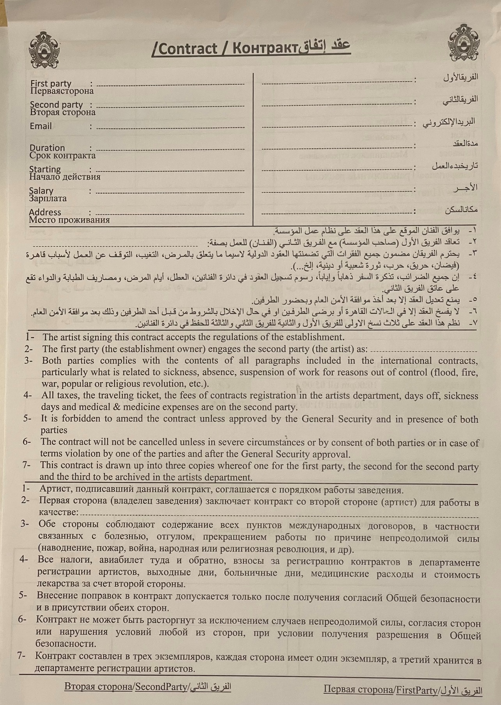

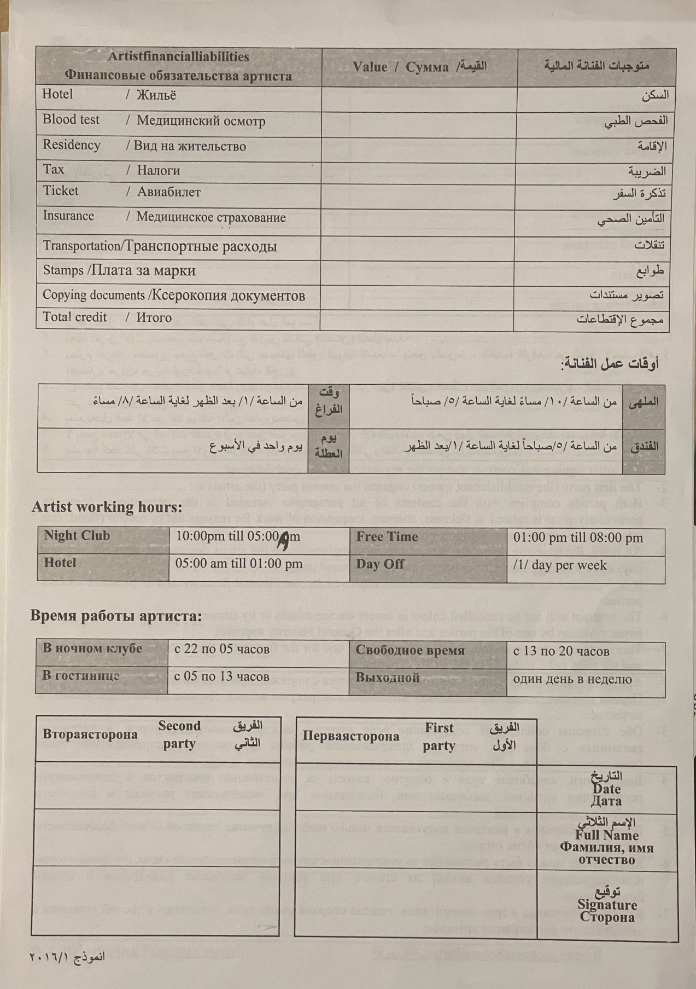

Records of the DGGS indicate that a total of 6,485 women Artists entered Lebanon during 2018 and 2019. Artists mostly come from eastern European countries and particularly Russia and Ukraine.
Super Night-Clubs” is a Lebanese version of cabaret and strip clubs where only foreign women Artists are allowed to be employed as entertainers, and only men are allowed to enter as clients
Provision 4 of the contract reads “All taxes, the traveling ticket, the fees of the contract registration in the artists department, days off, sickness days and medical & medicine expenses are on the second party”.
Source: DGGS communication to Kafa dated April 4, 2013.
The Artist Visa Scheme and related regulations are stipulated in the governmental decree 10267 (issued on August 6, 1962) and in a series of DGGS regulations printed in a booklet under the title of “Female Working in Nightclubs, Unmedical Massage and Modeling”. While the booklet is not published online, some regulations can be found on the DGGS website, on this link: https://www.general-security.gov.lb/en/posts/46 (last accessed on January 10, 2022)
See for instance see N. Saghieh and G. Frangieh, Prostitution: A Moral Crime or a Crime of Exploitation? An Analysis of 228 Cases of Women Charged with the Crime of Clandestine Prostitution, (in Arabic) Kafa (enough) Violence & Exploitation, 2013.
Lebanon forbids all forms of prostitution since the late 1970s, whether clandestine or not. More details are included below in this report.
The amended Article 523 of the Lebanese Penal Code reads: “Anyone who repeatedly incites a person, male or female, under the age of 21 to debauchery or immoral acts, or helps and facilitates the commission of such acts, shall be sentenced to one to three years imprisonment and a fine ranging from two to four times the minimum wage.”
G. Frangieh, Beirut Criminal Court: No Punishment for Victims of Trafficking, Legal Agenda, 21 March 2018. https://english.legal-agenda.com/beirut-criminal-court-no-punishment-for-victims-of-human-trafficking/ (Last accessed on January 10, 2022).
G. Frangieh, Preconceptions Overshadow Sexual Exploitation, Legal Agenda, 13 October 2018. https://english.legal-agenda.com/preconceptions-overshadow-sexual-exploitation/ (Last accessed on January 10, 2022).

