Request for statistical information
- This paper responds to the request of the United Nations Human Rights Committee, received on Wednesday 16 March 2016, for further statistical information following the examination of New Zealand's Sixth Periodic Report under the International Covenant on Civl and Political Rights.
Family violence
- The Committee has requested the following information on family violence:
- Updated data (2014 and 2015) disaggregated by age, sex, disability, geographic location, ethnic origin and socioeconomic background on the number of cases of gender-based violence, family violence, spousal rape,
- Updated data (2014 and 2015) on the number of prosecutions and convictions regarding gender-based violence, family violence, and spousal rape, and
- Updated data disaggregated by age, sex, disability, geographic location, ethnic origin and socioeconomic background on domestic violence deaths.
- The relevant information is summarised below. Further detail can be found in the attached spreadsheet entitled “Family-Related Violence”. The New Zealand Goverment does not hold the information disaggregated by disability and socioeconomic background.

Cases and convictions for male assaults female offences
- In 2014/15, there were 3,142 cases for adults aged 17 plus where a male assaults female offence was the most serious offence in the case. Sixty-nine percent of those cases resulted in a conviction. The number of cases for male assaults female offences has declined markedly since 2008/09 when there were 5,032 cases (a 38% reduction). The percentage of cases resulting in a conviction varied from 66% to 73% between 2008/09 and 2014/15.
- A total of 455 (15%) of all male assaults female cases in 2014/15 were withdrawn, this accounts for almost half of all male assaults female cases which did not result in a conviction.
- In 2014/15, Māori accounted for 49% of the total number of male assaults female cases, while adults of Pasifika and European/Other ethnicities accounted for 13% and 37% respectively of cases.

Cases and convictions for spousal rape and attempted spousal rape offences
- In 2014/15, there were 6 cases for adults aged 17 plus for spousal rape, and 3 cases for attempted spousal rape offences. Fifty percent of spousal rape cases resulted in a conviction while no attempted spousal rape cases were convicted.
- Since 2008/09, of the 45 cases for spousal rape, 29% resulted in a conviction, while only 1 (7%) of the 14 cases for attempted spousal rape cases were convicted.
- Seven out of the 45 cases (16%) for spousal rape since 2008/09 were withdrawn, while 6 out of 14 cases (43%) for attempted spousal rape cases were withdrawn.
- From 2008/09 to 2014/15, Māori accounted for 10 out of 45 spousal rape cases (22%), while Pasifika and European/Other adults accounted for 8 and 26 cases respectively.
- Over the same seven-year period, 4 out of 14 attempted spousal rape cases (29%) were Māori, while adults of Pasifika and European/Other ethnicities accounted for 2 and 7 cases respectively.
- The alleged offender was female in only 1 spousal rape and 1 attempted spousal rape case from 2008/09 to 2014/15.

Homicide Victims
- The data presented in the ‘Homicide Victims’ worksheet attached shows that, in the 12 months ending June 2015, there were 17 reported victims of homicide offences, where the offender was a family member. Six victims were male and 11 were female. Homicide offences include murder, attempted murder, and manslaughter.
- Seven of the alleged offenders were partners of the victim, while 4 alleged offenders were parents and children of the victims respectively. A further 2 victims were family members not further defined.
- For all homicide victims in 2014/15, where the offender was a family member, 2 were Māori, 4 European, 7 of Other ethnicities, and 4 of Unknown ethnicity.
- Four of the victims were aged 20-24, three were aged 45-49, three were aged 0-4, and two were aged 35-39. The remainder were scattered across various age groups.
- New Zealand Police is divided into 12 districts, 9 in the North Island and 3 in the South Island. Seen in the map below. The number of homicide victims per District is set out below.

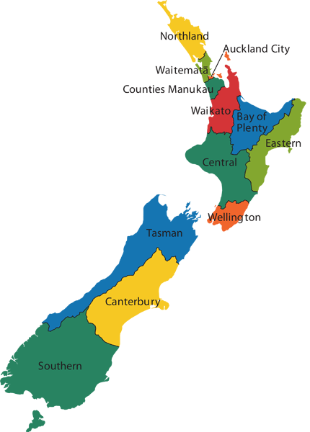
Police District | Number of victims
Northland District
Waitemata District | 1
Auckland City District | 3
Counties/Manukau District | 3
Waikato District | 1
Bay Of Plenty District
Eastern District | 2
Central District | 5
Wellington District | 2
Tasman District
Canterbury District
Southern District
Total | 17

- Comparable data on victims of crime is not available prior to July 2014.
Child Abuse
- The Committee has requested “Updated data on the number of prosecutions and convictions regarding child abuse”.
- The relevant information is provided below. Further information on convictions and prosecutions can be found in the attached spreadsheet entitled “Victims of Assault Aged Under 20”.
Assault-related offences
- Assault-related offences are defined as homicides (murder, attempted murder, and manslaughter), sexual assault, abduction and kidnapping, and other assault offences.
- In the 12 months ending June 2015, out of a total of 10,382 unique children and young people (aged 0-19 years) who were victims of assault-related offences, 4,546 (44%) resulted in State action within 30 days of the offence being reported or otherwise becoming known to police.
- Third-two percent of these state actions were Court action and 12% were non-Court action. The relevant authorities took no further action in 23% of the remaining offences and 33% investigations have not been finalised.
Age of victims
- Fifty percent of children and young people who were victims of assault-related offences were aged 15 to 19. Thirty percent of victims were aged 10 to 14, while 12% were aged 5 to 9.
- Almost 80% of children and young people were victims of assaults, with most of the remainder being victims of sexual assault.
Relationship of offender to victim
- Forty-one percent of the alleged offenders of assault-related offences on children and young people aged under 20 were known to the victim, compared with 5% of offenders who were strangers. Over half of alleged offenders were either not identified or not stated or inadequately described by the victims.
- Twenty-seven percent of alleged offenders were family members, with just over half of these being parents.
Findings of abuse and neglect
- Information on substantiated findings of abuse and neglect is provided in the graphs below. Note that ‘substantiated findings’ includes findings of emotional, physical and sexual abuse or neglect. This is a count of distinct children and young people.
Graph 1 | 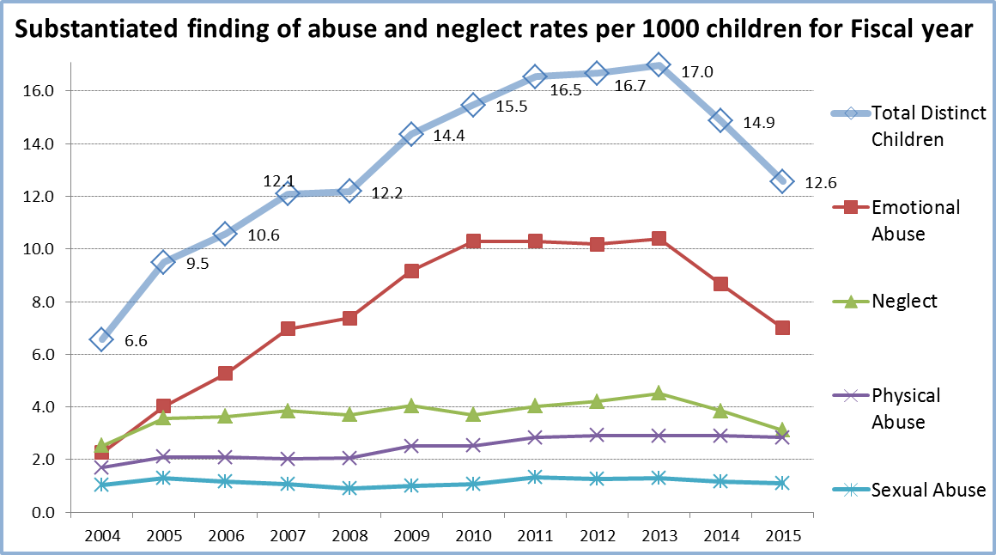
After rising significantly before 2010, rates of substantiated emotional abuse and neglect findings stabilised and have substantially declined in 2014-15 (Graph 1). The number of substantiated findings is driven by both the underlying level of abuse in society and how the care and protection system responds. The recent declines may be due to a reduction in the rate of child maltreatment (due to improving socio-economic conditions, improving family functioning and reporting) and changes in reporting.
Graph 2 | 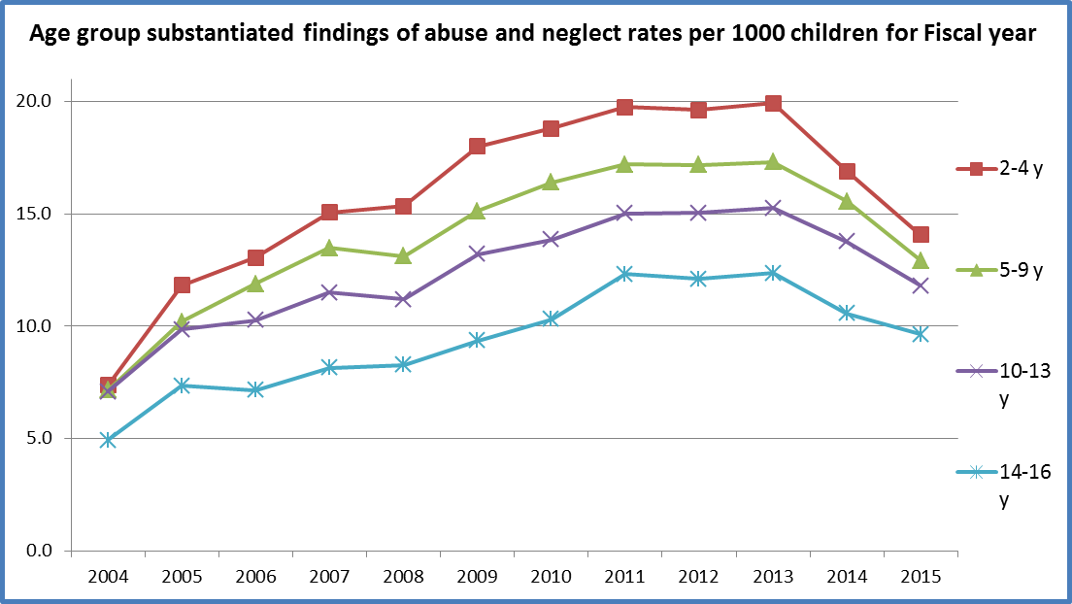
Younger age groups are at greater risk of abuse and neglect. The 0-1 age group has not been included because this group includes mothers with unborn children (Graph 2).
Bullying and cyber-bullying
- The Committee has requested “Updated data on the number of reported cases of bullying in schools and cyber-bullying”.
- The Government does not regularly collect information on reported cases of bullying in schools or cyber-bullying because schools are self-managing. However, information collected from previous surveys is provided below.
- The University of Auckland conducted the New Zealand Youth 2000 surveys of secondary schools (roughly ages 13-17) in 2001, 2007 and 2012. Results appear to suggest that rates of bullying have decreased, albeit only slightly, over time. Nine percent of male students reported they had been bullied at least weekly in 2001, compared to 5% in 2007 and 2012. The number of female students who reported frequent bullying has remained stable at around 5% over the 3 surveys.
- In 2012, some students received nasty or threatening messages on their mobile phone (12%) and/or on the internet (9%) and received unwanted sexual material (e.g. pornographic images, videos or words) on their mobile phone (8%) and/or on the internet (6%). This information cannot be directly compared to the surveys from previous years due to differences in the way the data was collected.
Māori representation on the Judiciary
- The Committee has requested “Updated data on the number of Māori judges at each level”.
- In the Higher Courts there are two Judges who identify as Māori from 53 Judges. In the District Courts, 18 out of 163 Judges identify either as Māori or as Māori and another ethnicity. There are is also one Samoan Judge, one Indian Judge, one Chinese Judge, and one Judge who identifies as Iraqi and British.
Māori representation in the Police force
- The Committee has requested “Updated data on the number of Māori police officers in each rank”.
- The relevant data is displayed below.
Māori Officers by Rank
Constabulary Group | Total number of Māori Officers | Total number of all Officers
Authorised Officer | 12 | 312
Traffic Officer | 1 | 6
Constable | 743 | 6479
Sergeant | 118 | 1433
Senior Sergeant | 42 | 474
Commissioned Officer | 33 | 329
Numbers of Māori in Prisons
- The Committee has requested “Updated data on the number of Māori women and men in prison, disaggregated by age”.
- This information is provided below. The numbers of non-Māori women and men in prison, disaggregated by age is also provided.
Numbers of Māori in Prisons
Māori | Remand |  | Total Remand | Sentenced |  | Total Sentenced | Grand Total
Age Group | Men | Women |  | Men | Women
Under 20 | 79 | 9 | 88 | 109 | 8 | 117 | 205
20-24 | 260 | 16 | 276 | 501 | 38 | 539 | 815
25-29 | 275 | 31 | 306 | 601 | 43 | 644 | 950
30-34 | 196 | 21 | 217 | 508 | 39 | 547 | 764
35-39 | 146 | 11 | 157 | 390 | 43 | 433 | 590
40-44 | 148 | 4 | 152 | 311 | 19 | 330 | 482
45-49 | 85 | 4 | 89 | 298 | 24 | 322 | 411
50-54 | 48 | 1 | 49 | 207 | 16 | 223 | 272
55 and over | 34 | 0 | 34 | 212 | 14 | 226 | 260
Total | 1271 | 97 | 1368 | 3137 | 244 | 3381 | 4749
Numbers of non-Māori in Prisons
Non-Māori | Remand |  | Total Remand | Sentenced |  | Total Sentenced | Grand Total
Age Group | Men | Women |  | Men | Women
Under 20 | 69 | 5 | 74 | 59 | 3 | 62 | 136
20-24 | 194 | 10 | 204 | 375 | 29 | 404 | 608
25-29 | 203 | 24 | 227 | 533 | 28 | 561 | 788
30-34 | 187 | 9 | 196 | 417 | 23 | 440 | 636
35-39 | 123 | 8 | 131 | 371 | 19 | 390 | 521
40-44 | 107 | 8 | 115 | 352 | 25 | 377 | 492
45-49 | 73 | 4 | 77 | 338 | 31 | 369 | 446
50-54 | 42 | 6 | 48 | 242 | 13 | 255 | 303
55 and over | 50 | 3 | 53 | 523 | 22 | 545 | 598
Total | 1048 | 77 | 1125 | 3210 | 193 | 3403 | 4528

Other includes Asian, Indian, African, Latin American and Middle Eastern.

