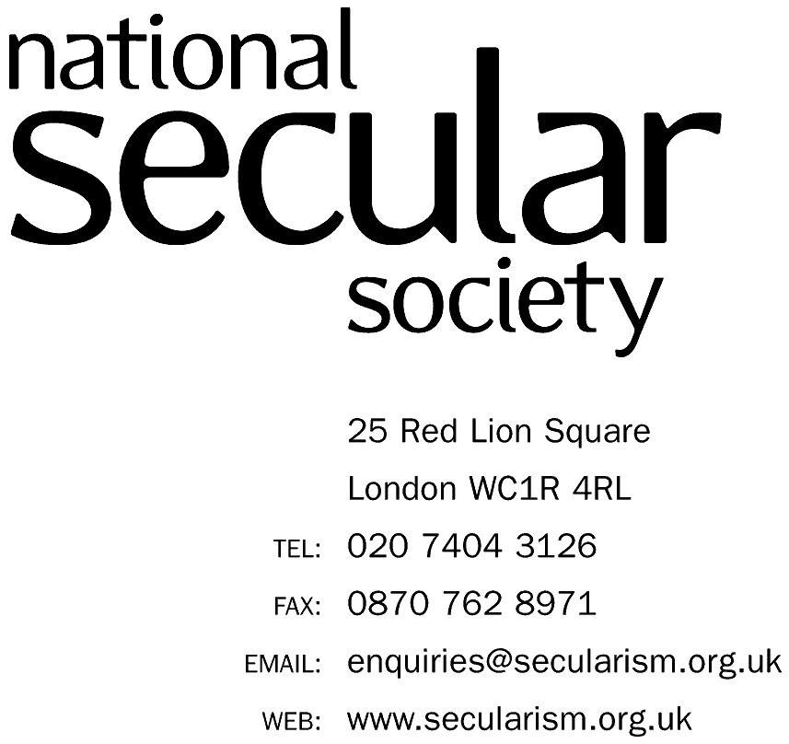


UNITED NATIONS CONVENTION ON THE RIGHTS OF THE CHILD

ALTERNATIVE REPORT ON MOZAMBIQUE

PREPARED BY THE (UK) NATIONAL SECULAR SOCIETY

FOR THE 82nd SESSION

OCTOBER 2018

THERE IS NO TABLE OF CONTENTS AS ALL MATERIAL RELATES TO CLUSTER 4.

4 Civil Rights and Freedoms (Article 19)

Authors
- This report has been prepared by the UK National Secular Society’s (NSS) President, Keith Porteous Wood, and NSS Council member Josephine Macintosh. She has spoken for the NSS at the United Nations Human Rights Council (UNHRC). Mr Porteous Wood made several representations, both verbal and written at the UNHRC 2009-2013 to encourage the Holy See to file its long-overdue second periodic report so it could be examined by the Committee. After it had done so, we submitted evidence to the Committee to assist it in compiling its concluding observations. We have submitted numerous other alternative reports to assist the Committee’s examination of other State parties, particularly in the field of clerical abuse of minors.
Methodology and general approach
- The NSS works for the separation of religion and state, and for equal respect for everyone's human rights so that no one is either advantaged or disadvantaged because of their religion or belief. We have been in special consultative status with the United Nations Economic and Social Council since 2016.
- The purpose of this submission is to create, in the interests of justice and the victims of such abuse, a more level playing field so that religious institutions do not enjoy privileges that allow much abuse to go unpunished and victims/survivors to be denied protection, treatment and rehabilitation provided for under Articles 19, 34 and 39 of the Convention.
- Our work mentioned above relative to the Holy See and other state parties has led us to conclude that clerical abuse is much more widespread in ecclesiastical organisations than is realised and such abuse is often concealed for decades.
The state party has a substantial Christian population and Catholicism is the largest religious grouping.
- Australia’s Royal Commission into Institutional Responses to Child Sexual Abuse reported in 2018 and it provided a great deal of evidence corroborating widespread clerical abuse of minors for decades, indeed centuries.
- Although we have only identified limited evidence of clerical abuse in the state party (shown in the Appendix), this may be because insufficient investigations have been carried out, possibly as a result of obstruction by religious bodies or those supporting them (this problem was identified in Australia), or even the media feeling under pressure not to report religious scandal.
- As we have detailed in alternative reports in recent years on other state parties, the real levels of abuse will be considerably higher than that reported, partly because of the decades-long delay customary between abuse of minors and them mustering sufficient confidence to report it as adults. Vows of secrecy, repeated denials and aggressive legal action taken by clerical organisations are key factors in maintaining concealment. This allows abuse to continue unchecked, perpetrators (and those shielding them) to evade justice and victims/survivors to be denied compensation and help.
- We also recognise that much abuse (sexual and other violence by adults) against minors is not institutional but familial and institutional abuse also occurs in non-ecclesiastical institutional environments. Clearly, credible accusations, wherever they occur, should be pursued with the full force of the law. We also readily acknowledge that abuse in ecclesiastical organisations is not limited to Catholic or Christian organisations.
- We urge the Committee to consider the implications of such abuse being prevalent in varying and generally alarming degrees across all denominations and religions throughout the world. This is manifest from even a cursory examination of criminal and media reports, particularly in countries with less restricted media, and is confirmed both by the Australian Commission’s report and in Chapter 7 of Child Sexual Abuse in the Catholic Church: An Interpretive Review of the Literature and Public Inquiry Reports, compiled by Prof Desmond Cahill and Dr Peter Wilkinson of the Centre for Global Research School of Global, Urban and Social Studies, RMIT University, Melbourne, and published August 2017. Page 15 of the report concludes “Many thousands of lives across the world have been badly damaged, if not destroyed, in the continuing and tragic saga of the sexual abuse of children [in the Catholic Church].”
POTENTIAL EXTENT AND CHARACTERISTICS
(Numbers in parenthesis are references to page numbers in the Australian Commission’s report.)
- The Commission’s findings echo (and implicitly corroborate our earlier reports on) other Western countries with significant Catholic populations by concluding that a significant majority, 58.6%, of institutional abuse is in religious institutions and a significant majority of that is in Catholic institutions, particularly residential institutions. (13)
- The extent and nature of abuse in religious institutions is based on Australian Commission report: The abuse occurred in religious schools, presbyteries and rectories, confessionals, residential religious institutions such as (often isolated and remote) orphanages, children’s homes and missions, in places of worship or during religious activities “such as a confessional, a priest’s residence or a ritual bathhouse”. The sexual abuse took many forms, including rape. It was often accompanied by physical or emotional abuse. …”(9), (17-19) “…survivors on average took 23.9 years to disclose and 33 years to claim” (15).
“Of all Catholic priests included in the survey who ministered between 1950 and 2010, taking into account the duration of ministry, 7 per cent were alleged perpetrators.” In one order this exceeded 40% and three others exceeded 20%. 90 per cent of alleged Roman Catholic perpetrators were male (31) as were most victims/survivors.
Confession/confessionals were a major problem in the Catholic Church. “We heard about priests misusing the practice of religious confession to facilitate child sexual abuse or to silence victims. Survivors told us about experiencing sexual abuse as children in the confessional at their church.” (20)
We are not aware of any reason why clerical abuse, whether Catholic or of another denomination or religion, should be minimal in the state party when it is so prevalent in so many other countries with significant Catholic populations.
EFFECT ON SURVIVORS (ALSO TAKEN FROM THE ABOVE AUSTRALIAN REPORT, WITH PAGE NUMBERS IN PARENTHESIS)
- “For many [victims of abuse], the harm was irreparable”. “… The impacts can be intergenerational and can affect entire communities. (21 and 32)
“Some survivors described ‘clusters’ of suicides in affected communities. In some cases, we heard about children who took their own lives.” (21) “Some … became pregnant after being sexually abused as children by people in religious ministry …. this led to miscarriage … forced adoption, abortion or marriage”. (21) Survivors were routinely disbelieved, by their religious communities and even by their parents, those in religious power falsely denied the abuse and survivors who disclosed their abuse were routinely threatened, punished or shunned. (20-23)
- Typically, the abuse suffered by survivors is compounded by:
(a) their perpetrator escaping justice, often because of the unwillingness of the secular authorities to tackle it and
(b) difficulty in obtaining compensation, which is obstructed by religious organisations even when they know the claim is justified, or if not by an institution, the abuser often being without financial means.
In both instances, statutes of limitation, both criminal and civil, often prevent prosecution and settlements.
The destruction of records also impedes prosecutions and settlements. Bishop Accountability reports “Other Catholic Dioceses Have Destroyed Incriminating Priest Personnel Files”. This gave rise to a USA-wide legal proscription in 2018 “Federal Government Tells Catholic Bishops Not to Destroy Sex Abuse Documents.
Our recommendations seek to ameliorate both problems.
TYPICAL INSTITUTIONAL RESPONSES (ALSO TAKEN FROM THE ABOVE AUSTRALIAN REPORT, WITH PAGE NUMBERS IN PARENTHESIS)
- This was denial, and failure to report Catholic perpetrators to civil authorities, even to punish them internally; indeed, some were later promoted or retired without penalty. They were frequently moved to places unaware of their abuse history, putting more children at risk. (9-10, 23-28)
Our own experience over decades and from all over the world is that we have yet to find a religious organisation to which the above descriptions do not largely if not entirely apply.
- And even when secular authorities received reports, they frequently failed to act (52).
- No leadership from the Church – neither the current Pope, nor his predecessors, the Curia or most other Catholic leaders, have an impressive record in tackling abuse. He has failed to use his authority to direct the Church worldwide to report suspected abusers and provide evidence to secular authorities, as the CRC Concluding Observations on the Holy See’s 2nd periodic report called for. Instead, the Holy See attacked the Committee for its report. Archbishops around the world are being defrocked and/or criminally convicted for abuse or covering it up. We can provide additional evidence to justify these claims on request. Furthermore, The Australian Commission concluded that “Bishops have close relationships with clergy in their dioceses, which at times clearly affected their response to allegations.”
- Catholic religious orders seem to be completely autonomous and a law unto themselves and few if any are subject to oversight and most act solely in their own interests rather than in those of those in their care. The almost countless number of such orders a major factor. This problem is identified by Prof Cahill, a Catholic academic from RMIT in his 400-page informative study Child Sexual Abuse in the Catholic Church: An Interpretive Review of the Literature and Public Inquiry Reports
- “We have concluded that there were catastrophic failures of leadership of Catholic Church authorities over many decades, particularly before the 1990s.” (32)

CAUSES AND AGGRAVATING FACTORS – A BRIEF SUMMARY, FOCUSSING MAINLY ON THE CATHOLIC CHURCH WHERE THE HIGHEST LEVELS OF ABUSE WERE FOUND
- The huge power imbalance between children and religious figures creates opportunities for abuse and the ability to cover it up. Religious organisations, seeking to hold themselves out as moral leaders will be obsessive about covering up abuse. Having adherents and/or protectors in powerful positions in the community including in politics, the arms of justice and the media will enable pressure to be brought to reinforce the secrecy. The film Spotlight (about Boston Massachusetts) illustrated this.
- Clericalism/Priest/Imam superiority is a major factor: them being considered both by children and parents as “representatives of God” leads to them being treated with extreme deference.
- Further factors increasing the risk of abuse in religious institutions and their propensity to cover it up, including institutionally include: “closed” communities; and children coming “from religious families where sex was a taboo subject”, compounded by them “receiv[ing] very little sex education” (20 and 412). We have included a recommendation on this.
- The absence of mandatory reporting of institutional abuse is a major contributory factor in many countries. We remain convinced that the absence of mandatory reporting is a major contributory factor. If organised and resourced appropriately, it is a valuable, indeed essential, tool to help reduce such endemic abuse. According to Mandate Now, a reputable organisation based in the UK:
“A recent survey of 62 nations involved 33 developed nations, and 29 developing nations. The survey found, overall, that, according to Daro, D, (ed), World Perspectives on Child Abuse, 7th ed, International Society for the Prevention of Child Abuse and Neglect, Chicago, 2006, p 26.:
81.8% of the developed nations had some form of mandatory reporting;
78.6% of the developing nations had some form of mandatory reporting;
Combined, 80.3% of the nations participating had some form of mandatory reporting.”
- Even if reported levels of such abuse in the state party are less than in other countries, the measures we are proposing will harm no one, could be helpful to some and are designed to prevent abuse occurring in future.

RECOMMENDATIONS –
The State Party should:
- (a) Introduce mandatory reporting of abuse in institutions with criminal sanctions, but without exemption for the confessional. Where an individual has a position of personal trust towards children below the age of 18 and while such children are in their care, and the individual has reasonable grounds for knowing or suspecting the commission of physical or sexual abuse or abuse by way of wilful neglect on such children, the State party should make it mandatory to report this to the authorities designated to protect children within seven days. If, however, the child is considered to be in danger of harm or significant harm, the matter should immediately be reported to the police. Failure to so report shall constitute a criminal offence for which there should be an appropriately serious penalty.
(b) Take action to make it mandatory, including in clerical environments, for all known and suspected child sexual abusers in institutions to be removed promptly from post and from any contact with children, and the matter reported urgently to regional or state authorities as described in (a) above.
(c) Eliminate arbitrary statutory time bars on criminal convictions and civil claims in respect of abuse of minors, which will nevertheless remain subject to the normal standards of proof and thresholds of evidence.

- Eliminate of arbitrary statutory time bars on criminal convictions and civil claims in respect of abuse of minors, which will nevertheless remain subject to the normal standards of proof and thresholds of evidence.

- Create a criminal offence with an appropriately severe penalty for destroying files and other evidence relating to abuse of minors. If files are sent out of the state party’s jurisdiction, e.g. to the Holy See, they should be copies, which we accept may well contradict Roman Catholic canon “law”, and the originals should remain under state party’s jurisdiction.
- Conduct and publish a nationally representative prevalence study on a regular basis to establish the extent of child maltreatment in institutional and non-institutional contexts in the state party.

- Review sex education at all levels to warn of abuse in an age-appropriate way. This should include an imaginative use of social media.
- Introduce information and help-seeking services to support people or organisations who are concerned they may be at risk of sexually abusing children. The design of these services should be informed by the Stop It Now! model implemented in Ireland and the United Kingdom.
- Introduce information and help seeking services about abuse of minors for parents and other members of the community concerned that:
i. an adult they know may be at risk of perpetrating child sexual abuse
ii. a child or young person they know may be at risk of sexual abuse or harm
iii. a child they know may be displaying harmful sexual behaviours.
- Require each religious institution to make provision for family and community involvement by publishing all policies relevant to child safety in notices at each location and on its website, providing opportunities for comment on its approach to child safety, and seeking periodic feedback about the effectiveness of its approach to child safety. All should include contact details for external secular agencies to whom complaints should be directed.
- Require that any person in religious ministry or lay person working in a religious environment who is the subject of a complaint of child sexual abuse which is substantiated on the balance of probabilities, or who is convicted of an offence relating to child sexual abuse, should be permanently removed from ministry or from working in any religious institution. Religious institutions should also take all necessary steps to effectively prohibit the person from in any way holding himself or herself out as being a person with religious authority.
- Take appropriate measures to promote physical and psychological recovery and social reintegration of a child victim of: any form of neglect, exploitation, or abuse; torture or any other form of cruel, inhuman or degrading treatment or punishment, as per article 39 of the Convention on the Rights of the Child. We recommend that this should include appropriate compensation.
APPENDIX

Catholic priest suspended for abusing teenage girl – Mozambique
8:42 CAT | 05 Sep 2018

The vicar-general of the Catholic diocese of Xai-Xai in southern Mozambique, Rafael Simbine, has confirmed the suspension of a Xai-Xai priest for sexually abusing a 16 year old girl.
He told the Maputo daily “Noticias”, that the bishop of Xai-Xai, Lucio Muandula, signed a decree on 20 August suspending the priest, Calisto Chivite, from all religious activities, not merely in Mozambique, but anywhere on the planet.
The decree noted that he began his affair with the girl in 2015, when she was just 16. The girl (who was not named) is now 19 and pregnant.
“Considering that these actions gravely offend against his condition as a priest of the Catholic Church, he is suspended until the disciplinary process is concluded”, the bishop’s decree declared.
A spokesperson for the Attorney-General’s Office (PGR) told “Noticias” that a team of prosecutors will be sent to Xai-Xai to investigate the sexual abuse committed by Chivite. This could lead to a criminal case against him.

CRC/C/VAT/CO/2, 31 January 2014 (Speaking for International Humanist and Ethical Union) https://www.secularism.org.uk/uploads/iheu-submission-to-the-uncrc-march-2013.pdf https://www.secularism.org.uk/uploads/holy-see-pack-unhrc.pdf
https://www.childabuseroyalcommission.gov.au/sites/default/files/final_report_-_volume_16_religious_institutions_book_1.pdf
Ibid page 52
Ibid page 56.
https://www.rmit.edu.au/content/dam/rmit/documents/news/church-abuse/child-sex-abuse-and-the-catholic-church.pdf
https://www.childabuseroyalcommission.gov.au/sites/default/files/final_report_-_volume_16_religious_institutions_book_1.pdf numbers in parenthesis are page numbers in this book.
http://www.bishop-accountability.org/news3/2005_04_24_Arellano_ShreddinOther.htm
https://www.nytimes.com/2018/10/26/us/catholic-bishops-sex-abuse.html
https://www.thejournal.ie/religious-abuse-compensation-3278789-Mar2017/
https://www.rmit.edu.au/content/dam/rmit/documents/news/church-abuse/child-sex-abuse-and-the-catholic-church.pdf page 304
Mandate Now, ‘Why we exist’. Available at: http://mandatenow.org.uk/why-we-exist/
https://clubofmozambique.com/news/catholic-priest-suspended-for-abusing-teenage-girl-mozambique/

