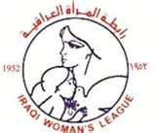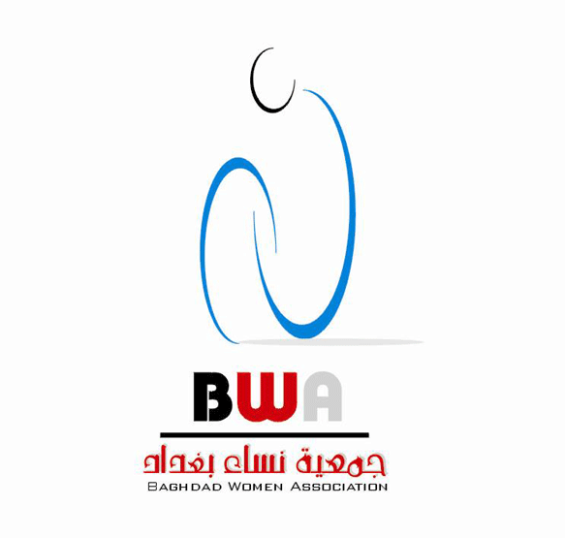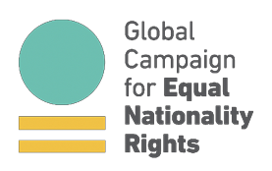

Committee on the Elimination of Discrimination against Women
Human Rights Treaties Division (HRTD)
Office of the United Nations High Commissioner for Human Rights (OHCHR) Palais Wilson - 52, rue des Pâquis
CH-1201 Geneva
Switzerland
By E-mail: cedaw@ohchr.org
30 September 2019

Re: Information on Iraq for Consideration by the Committee on the Elimination of Discrimination against Women at its 74th Session (21 October - 8 November 2019)
Dear Distinguished Committee Members,
We respectfully submit this letter in advance to the Committee on the Elimination of Discrimination against Women (“the Committee”) for consideration during its 74th session (21 October - 8 November 2019). Equality Now, the Baghdad Women Association (BWA), the Iraqi Woman’s League, the Coalition of Women MPs from Arab Countries to Combat Violence against Women, and the Global Campaign for Equal Nationality Rights request that this letter be used to supplement Iraq’s 7th State Party periodic report to the Committee. Our joint submission expresses our great concerns about the continued sex-based discrimination against Iraqi women married to foreigners who are not able to pass on their nationality to their spouses under the Iraqi Nationality Law No. 26/2006. Iraqi women are also denied the right to pass on their nationality to children born outside Iraq on an equal basis with Iraqi men. We are also concerned about the exemption from punishment under the Iraqi Penal Code of offenders, including rapists, who marry their victims and the suggested amendments to the Personal Status Law No. 188 of 1959 which would encourage polygamy and child marriage.

Equality Now is an international human rights organization working to protect and promote the rights of women and girls worldwide since 1992. Baghdad Women Association (BWA) is a non-profit organization working in Iraq to combat all forms of violence against women and girls and ensure legal protection, equality, respect, and all human rights for women and girls. The Iraqi Woman’s League is a non-governmental civil society association providing women access to employment and vocational training, as well as physical and mental health services. The Coalition of Women MPs from Arab Countries to Combat Violence against Women is an independent organization established in December 2014 and has members from both legislative chambers from 13 Arab countries. The Global Campaign for Equal Nationality Rights mobilizes international action for the removal of gender-discriminatory provisions from all nationality laws, through its coalition of national, regional and international organizations and activists, including steering committee members Equality Now, Equal Rights Trust, the Institute on Statelessness and Inclusion, UNHCR, Women’s Learning Partnership and Women’s Refugee Commission.

Discriminatory provisions in the Nationality Law

We welcome the amendments made to Article 3 of the Nationality Law in 2006, which established the equal right of an Iraqi father and mother to transfer their nationality to their children. While we welcome this step, other provisions remain discriminatory and require further legislative amendments to ensure that the State meets its obligations under Article 9 of the Convention and in accordance with the recommendations set out in its General Recommendation 32 on the gender-related dimensions of refugee status, asylum, nationality and statelessness of women. An unmarried mother cannot pass her nationality to her child born outside the country on an equal basis with an unmarried father (unless the father is stateless or unknown/except under certain conditions) (Art.4); a foreign mother who was born in the country cannot pass her nationality to a child born in the country on an equal basis with a foreign father to a child born in the country (Art.5); a married woman cannot pass her nationality to a foreign spouse on an equal basis with a married man (her husband can apply for naturalization under normal procedures with reduced or waived) (Arts. 7 & 11); a married mother cannot pass her nationality to a child born outside the country (unless the father is stateless or unknown/ except under certain conditions (Art.4)). We also note that if an Iraqi father loses his Iraqi nationality, his minor children shall consequently lose that nationality (Article 14(II)).

Gender discrimination in Iraq’s nationality law can also result in the children of Iraqi women being rendered stateless when they cannot acquire their father’s nationality. This can occur for a variety of reasons. Those rendered stateless face obstacles in accessing economic and social rights and have a heightened risk of exploitation, human trafficking, and early and forced marriage. Typically, stateless persons also face barriers in obtaining identity documentation; increased risk of arbitrary arrest and indefinite detention; discrimination and marginalization; and barriers to accessing formal employment and justice. We reiterate the Committee’s Concluding Observations on the combined fourth to sixth periodic report of Iraq, where it was recommended that Iraq “amend the discriminatory provisions of Act No. 26 (2006), namely articles 4, 7 and 11, in order to ensure that women and men enjoy equal rights to acquire, transfer, retain and change their nationality, in line with article 9 of the Convention”.

Impunity for Rapists - Article 398 and Article 41 of the Iraq’s Penal Code No. 111 of 1969

Article 398 states that if an offender, having committed crimes including rape and statutory rape, and then lawfully marries the victim, any legal action becomes void and any investigation or other procedure is discounted. If a sentence has already been passed in respect of such action, then the sentence will be quashed. This sex discriminatory provision is believed to have been introduced for the purposes of ‘preserving the honor and dignity’ of the victim and her family. Repealing Article 398 would be a big step towards ending the re-victimization of survivors and ensuring perpetrators of sexual violence face appropriate punishment. This will enable the Government of Iraq to ensure its legislation is in compliance with the requirements as under international human rights law which requires the provision of equal protection under the law to survivors of sexual violence.

In 2017, Parliamentarian Intisar Aljubory, supported by the Coalition of Women MPs from Arab Countries to Combat Violence against Women, submitted a proposal to fully repeal Article 398 which was signed by sixty-six of her fellow MPs. In October 2017, the Coalition
of Women MPs from Arab Countries sent a letter to the Iraqi Speaker of the House demanding the repeal of Article 398. In March 2018, the Coalition started a campaign to repeal the Article headed by MP Intisar Aljubory and Women for Peace in Iraq, with the support of the Westminster Foundation for Democracy. In recent years, many international organizations, including the Coalition of Women MPs, WFD, Equality Now and UN Women, as well as local organizations such as Kafa, ABAAD, WCLAC and LECORVAW, have also actively participated in similar successful campaigns to end the so-called “marry-your-rapist” laws. These efforts have led to the repeal of comparable laws in neighboring countries including Jordan, Lebanon, Tunisia in 2017 and Palestine in March 2018. Additionally, other countries in the region such as Bahrain are in the process of revoking such provisions. The UN High Commissioner for Human Rights has stated “there is no place in today’s world for such hideous laws,” and Iraq is no exception. In addition, the Human Rights Committee in its Concluding Observations on the fifth periodic report of Iraq in 2015, expressed concern at the Iraqi Criminal Code provisions which allow the exoneration of rapists if they marry their victims. The Committee urged Iraq to “swiftly amend its legislation to guarantee adequate protection of women against violence, … allowing for the exoneration of rapists who marry their victims…”.

Another discriminatory provision in the Iraqi Penal Code includes Article 41 which permits the beating of wives and children. It stipulates that “there is no crime if the act is committed while exercising a legal right.” The following examples are considered to be in exercise of a legal right: the punishment of a wife by her husband and the disciplining by parents and teachers of children under their authority within certain limits prescribed by law or by custom. This provision contradicts Article 29 of the Iraqi Constitution and the concern expressed by your committee in paragraph 13 of the Concluding Observations on the fifth periodic report of Iraq about the persistence in legislation of discriminatory provisions against women, such as those contained in the Criminal Code and in the Personal Status Act.

Child Marriage and Polygamy – Personal Status Law No. 188 of 1959

The Government of Iraq is also considering a new bill introduced in November 2017, which proposes discriminatory amendments to the Personal Status Law No. 188 of 1959. If passed, the bill would authorize religious sects to define the rights of women and girls in accordance with their beliefs. Some religious sects would support lowering the age of marriage to nine years old, given their interpretations of the Quran and belief that puberty signifies marital readiness. According to UNICEF, 1 in 5 girls are married off as children every year in Iraq. Amending the Personal Status Law No. 188 of 1959 will only serve to increase girls’ risk of child marriage and subsequent abuses including early and forced pregnancy, domestic violence, poverty, and limited education and career opportunities.

In addition, on 7 January 2018, MP Muhsen El Sadoon, the Head of the Legal Committee in Parliament submitted a new bill that would encourage polygamy. The proposed Article states that the Iraqi government will pay married men five million Dinar (approx. $ 4250) if he marries a widow, a divorced woman or a woman who is 30 years old or older and a virgin. The proposed bill would further threaten the stability of families and create a wide range of economic and social problems.

Iraq has an international legal obligation as a party to multiple human rights treaties and as a participant in the UN Sustainable Development Goals, particularly goals 5 and 10, to ensure that its laws are aligned with international and regional standards such that women and girls are free from sexual violence and child marriage.

Suggested questions for the State Party

We would respectfully urge the Committee to raise with the Iraqi government the following questions with regard to violations of the Convention on the Elimination of All Forms of Discrimination against Women addressed in this letter:

- What plans does the government have to remove the remaining discrimination in the Nationality Law No. 26/2006 in order to ensure that women and men enjoy equal rights to acquire, transfer, retain and change their nationality, in line with Article 9 of the Convention?

- What are the government’s plans to revoke Article 398 of the Iraqi Penal Code No. 111 of 1969 and ensure that perpetrators of sexual violence are appropriately prosecuted?

What steps will the government take to ensure that the age of marriage remains at 18 years of age and that polygamy is outlawed in all circumstances?

- What are the government’s plans to repeal Article 41 of the Iraqi Penal Code that sanctions domestic violence?

Recommendation for Action by the Government of Iraq

We respectfully urge the Committee to call on the government of Iraq to address sex-based discrimination in its Nationality Law, Penal Code and Personal Status law:

- Amend the remaining discriminatory articles in the Nationality Law
- Revoke Article 398 of the Penal Code
- Repeal Article 41 of the Penal Code
- Remove any discrimination on the basis of sex in law.

Thank you very much for your kind attention, and please do not hesitate to contact us if we can provide further information.

Sincerely,

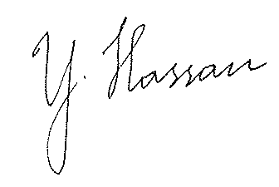

Yasmeen Hassan Liza Hido Intisar Mayali
Global Director Director Iraqi Women League
Equality Now Baghdad Women Association

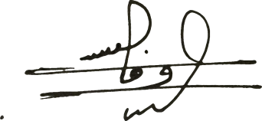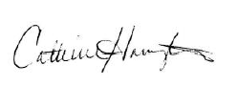

Wafa Bani Mostafa Catherine Harrington
Chairperson Global Campaign for Equal Nationality Rights
Coalition of Women MPs
from Arab Countries to Combat Violence against Women

https://undocs.org/CEDAW/C/IRQ/CO/4-6
https://www.ohchr.org/EN/NewsEvents/Pages/DisplayNews.aspx?NewsID=21987&LangID=E
Ibid 1
CCPR/C/IRQ/CO/5

